The explained circuit of a water level controller circuit is based on a timer circuit whose time delay is first adjusted to match the filling time of the tank, as the the tank fills, the timer delay also simultaneously lapses and its output switches OFF the water pump.  
Actually the circuit was requested to me by Mr. Ali Adnan who is one of the fans of this blog. Let's first hear what he had to say:  
  
"Hi, Swagatam I like your blog very much. I have a problem which i think is common in every home, the problem is: I have a Water Pump(which sucks water from bore) installed at my home, when my brother switch on the water pump he always forget(u know bhulakar one:P) to switch it off back:( and water tank gets over flowed and water runs in upper portion of our house:(  
I want you to help me to design a timer circuit to automatically turn off the pump at given time. I am not expert in electronics but i like to play with electronic and knows very well how to solder and always trying to do some little experiments with help of your blog. Please provide me the circuit for above sited problem with complete parts list and diagram."  
  
So as you all know I cannot turn down honest requests, therefore sat down to design the following circuit, let's study its functioning details:  
  
The **CIRCUIT DIAGRAM** of this water level timer controller circuit utilizes a single versatile IC 4060 for generating the required time delay.  
P1 is initially adjusted through some trial and error so that it exactly matches the filling time of the water tank which needs to be monitored.  
  
The circuit is initiated by pressing the push button SW1 when the N/O contacts of the relay are bypassed.  
This momentarily switches ON the transformer which powers the IC instantaneously.  
This instantly triggers the transistor and also the relay which takes over and latches ON the circuit.  
Now the circuit holds ON even after the push button is released, everything happens within half a second.  
The above operation also simultaneously switches ON the pump motor which starts pushing water in the tank.  
Once the timer counting finishes, pin #3 becomes high, T1 conducts and switches OFF T2 and the relay.  
The relay contacts reverts to its original state switching OFF the motor as well as the the entire circuit, halting the motor pump and hopefully inhibits the tank from overflowing.

[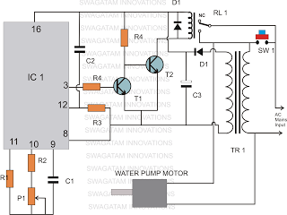](http://3.bp.blogspot.com/-og5qPzr6Ioc/T5F_zVXMgqI/AAAAAAAABIA/KSrQtaGVZzQ/s1600/semi+automatic+water+level+timer+circuit.png)

Parts procured by Ali Adnan

[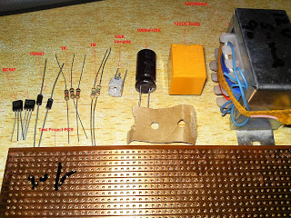](http://2.bp.blogspot.com/-EtNM2PIX338/T5jq2cy3duI/AAAAAAAABKk/F1_ijnauMG4/s1600/parts+for+the+circuit.jpg)

Parts List  
  
R1, R3 = 1M, 1/4 watt CFR  
R2 = 1K, 1/4 watt CFR  
R4(T1 base) = 22K, 1/4 watt CFR  
R4(T2 base) = 10K, 1/4 watt Cfr  
P1 = 1M preset horizontal  
C1 = 1uF/25V  
C2 = 1uF/25V non polar, any type will do  
C3 = 1000uF/25V  
D1, D2 = 1N4007,  
Relay = 12V/SPDT/contact current as per motor specification  
SW1 = Bell push type of button  
IC1 = 4060  
T1 = BC547  
T2 = 8050, or 2N2222  
TR1 = 0-12V/500mA  
  
The above circuit was also built and appreciated by Mr.Raj Mukherji, one of my friends and a keen follower of this blog. Let's learn more about his experience with the circuit.  
  
Hi Swagatam,  
  
Thank you very much for the timer circuit.   
  
I have made the prototype on a general purpose PCB and so far found it to work accurately for my purpose: 5 min, 10 min and 15 min delay respectively (with the P1 set at 15.4 Kohms for 5 min delay etc). I am planning this weekend to house it in a 4x6 box and test it on actual load.  
  
So far, I was looking at the above comments and would like to add something regarding the question raised by Mr. Khan on the relay. For my purpose, I am intending to use this timer on an AC 50 Hz, 220 - 240 volts, Crompton Greaves self priming mono-set pump, type - Miniwin II, 0.37 Kwatt/0.50 HP. So, I have purchased a 12 volt SPST relay which has a contact current tolerence of ~7 Amps. I think this is sufficient for my purpose and also for any kind of small pumps/loads. Isn't it?  
  
I will definitely share with you the picture of the completed project.  
  
Thank you,  
Kind regards,  
Raj Kumar Mukherji   
  
My answer to Raj:  
  
Hi Raj,  
  
That's great! Thank you very much for the update.  
  
A 7amp contact would mean a maximum capacity of 7*220 = 1540 watts, that's probably more than sufficient for the purpose.  
  
I am sure the pictures that you will send will be loved by the other readers also, so please do send them here for publication.  
  
Yes, surely the link will be very useful for the readers who would want to learn the timing calculation more accurately.   
  
Thanks and Best Regards.  
  
**PCB Layout for the Above Circuit, Designed and Submitted By Mr. Raj Kumar Mukherji:**  
  
**(Component-side view)**

[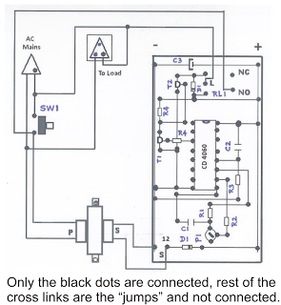](http://2.bp.blogspot.com/-1dAFGC4EzNo/T5lxDH8J7SI/AAAAAAAABLI/ialBu5_QFPI/s1600/water+level+timer,+pcb+layout.png)

**Pictures of the completed water level timer controller prototype, sent by Mr. Raj Kumar Mukherji:**

[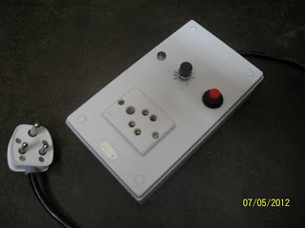](http://2.bp.blogspot.com/-EsGC6dnELgc/UXimjWUyuYI/AAAAAAAAEAw/pEW1VOkzRDM/s1600/CD_4060_based_timer_9be8549fa77bb7793263_1.jpg)

[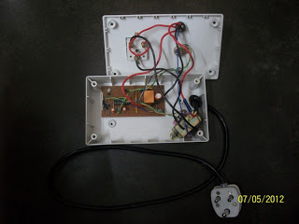](http://3.bp.blogspot.com/-FkQYTfNuq60/UXimjkU0ZGI/AAAAAAAAEA4/AFnvzCpBki8/s1600/CD_4060_based_timer_9be8549fa77bb7793263_2.jpg)

[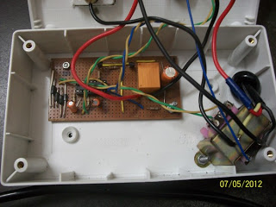](http://3.bp.blogspot.com/-faMygmBR03M/UXimjtgRRxI/AAAAAAAAEA0/zAt2bDE3lTw/s1600/CD_4060_based_timer_9be8549fa77bb7793263_3.jpg)

[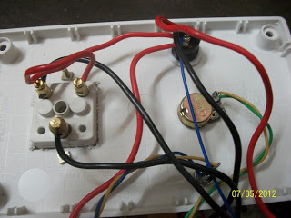](http://2.bp.blogspot.com/-vfgiVwu9fKo/UXimlaD1wWI/AAAAAAAAEBM/7JyWwJbrdAY/s1600/CD_4060_based_timer_9be8549fa77bb7793263_4.jpg)

[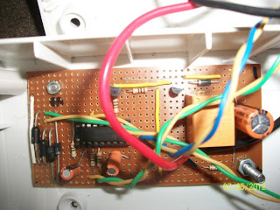](http://1.bp.blogspot.com/-n_jSTdM5I5s/UXimleEHqrI/AAAAAAAAEBI/MfL-bVpTZ2k/s1600/CD_4060_based_timer_9be8549fa77bb7793263_5.jpg)

The following diagram shows how the above circuit may be used with a solar panel supply,  and with a DC motor connected at the output. The design was requested by Mr. Mehmet

[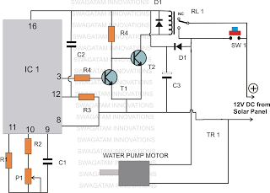](http://4.bp.blogspot.com/-0QMy1fMG32g/UTrAmbPsOlI/AAAAAAAADe0/t013XLqb2vY/s1600/water+level+timer+controller+circuit+using+solar+panel.png)