[Tutorial](https://www.youtube.com/watch?v=GZvSYJDk-us&t=6210s)

**What is api?**

[An**API**is a set of programming code](https://www.altexsoft.com/blog/engineering/what-is-api-definition-types-specifications-documentation/) that enables data transmission between one software product and another. It also contains the terms of this data exchange.

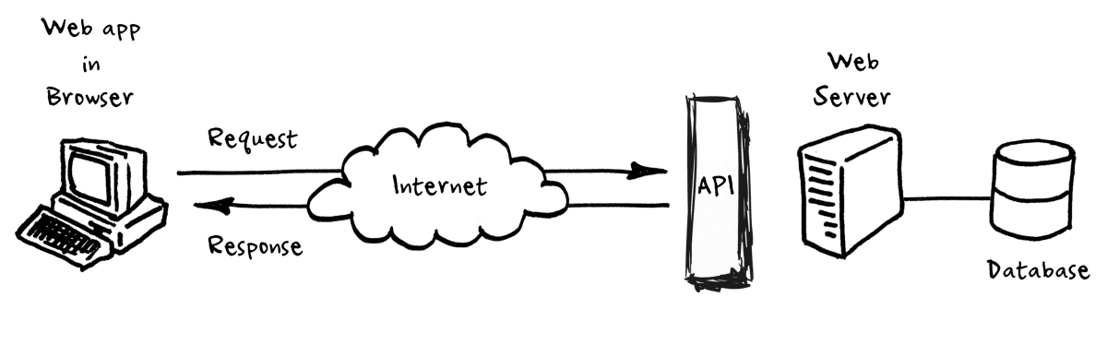

Let’s start with a simple example: human communication. We can express our thoughts, needs, and ideas through language (written and spoken), gestures, or facial expressions. Interaction with computers, apps, and websites require user interface components – a screen with a menu and graphical elements, a keyboard, and a mouse.

Software or its elements don’t need a graphical user interface to communicate with each other.

## **Types of APIs**

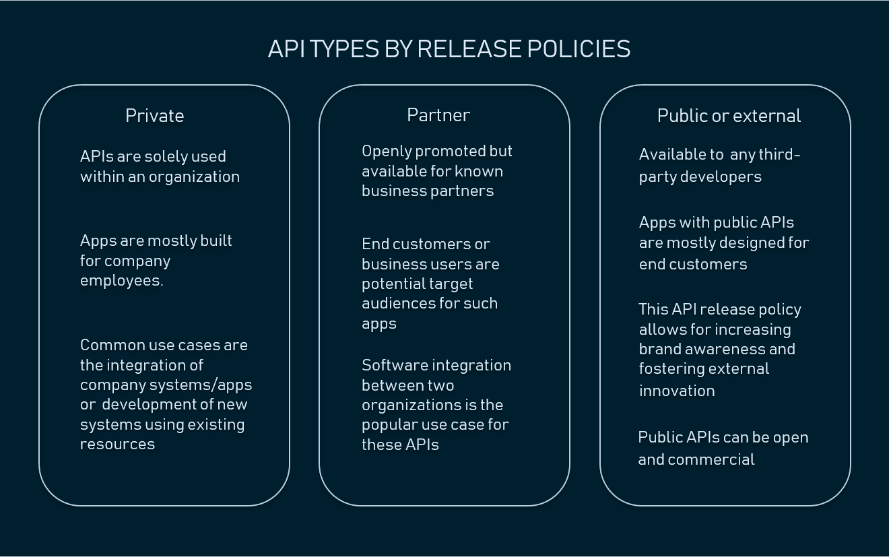

### **APIs by use cases**

APIs can be classified according to the systems for which they are designed.

Database APIs. Database APIs enable communication between an application and a database management system.

Operating systems APIs. This group of APIs defines how applications use the resources and services of operating systems. Every OS has its set of APIs, for instance, [Windows API](https://docs.microsoft.com/en-us/windows/desktop/apiindex/windows-api-list) or Linux API ([kernel–user space API](https://www.kernel.org/doc/html/v4.15/userspace-api/index.html)and [kernel internal API](https://www.kernel.org/doc/html/latest/media/media_kapi.html)).

Remote APIs. Remote APIs define standards of interaction for applications running on different machines. In other words, one software product accesses resources located outside the device that requests them, which explains the name.

Web APIs. This API class is the most common. Web APIs provide machine-readable data and functionality transfer between web-based systems which represent [client-server architecture](https://www.techopedia.com/definition/438/clientserver-architecture).