
Assignment - 03
John the Ripper

CEH & VAPT

SUBMITTED BY
Md Sayem Mottakee
Roll: 30

Table of Contents

Task 1: 3
Task 2: 6
Task 3: 7
Task 4: 7
Task 5: 8

Task 1:

Hash: 2e728dd31fb5949bc39cac5a9f066498
Text: biscuit
PoC:
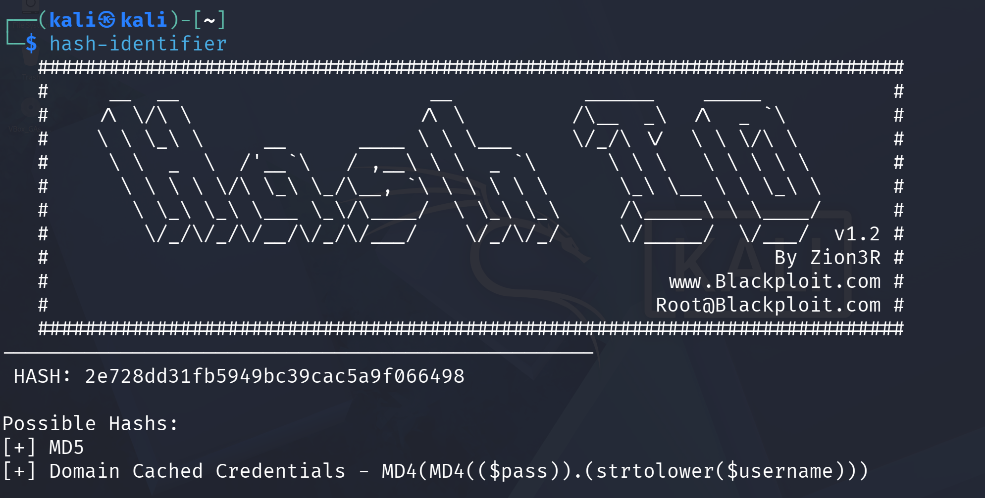
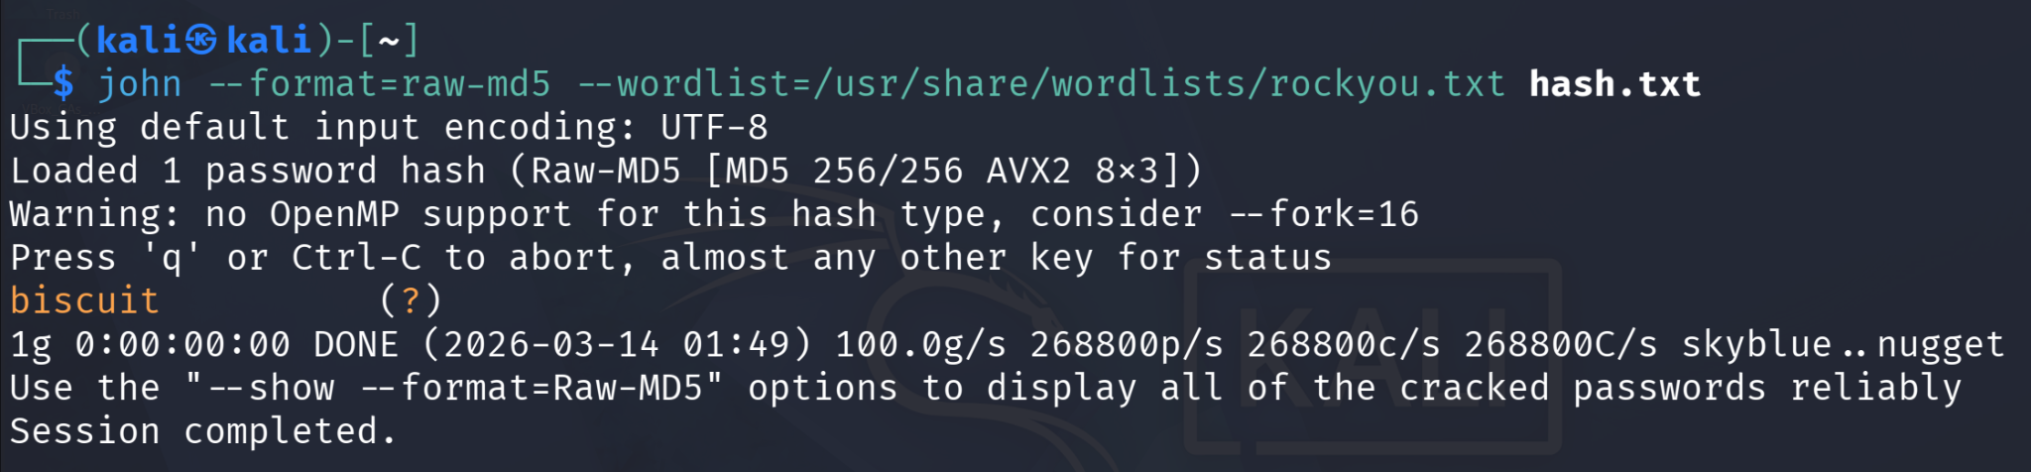
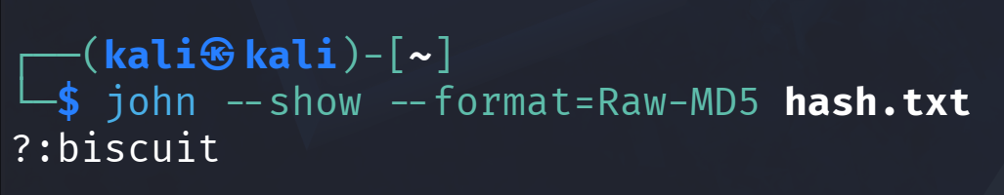

Hash: 1A732667F3917C0F4AA98BB13011B9090C6F8065
Text: kangeroo
PoC:
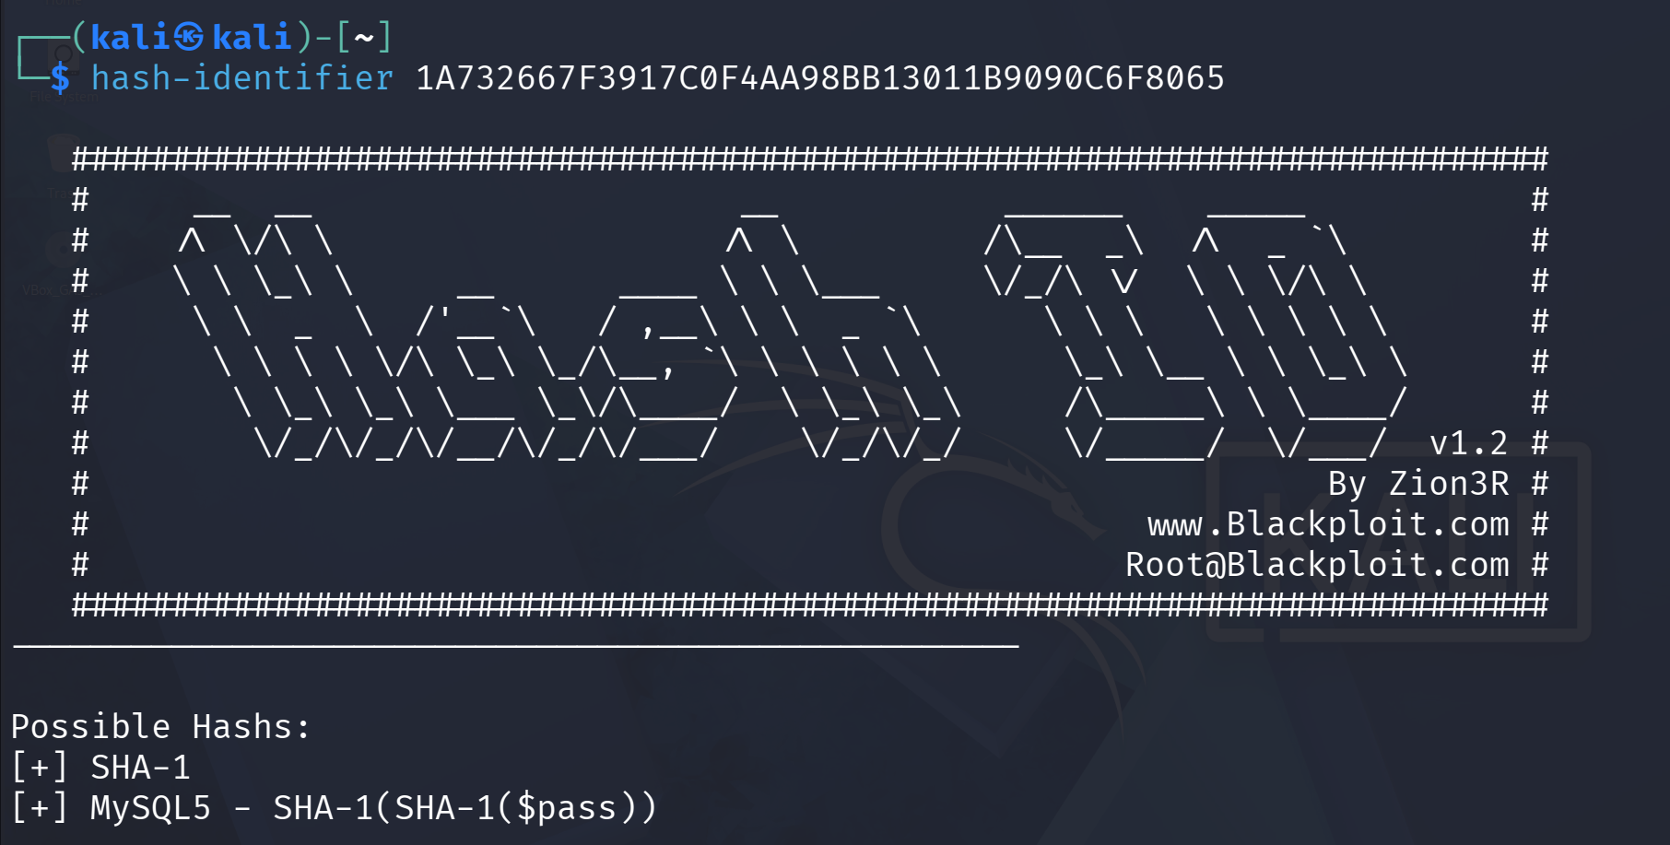
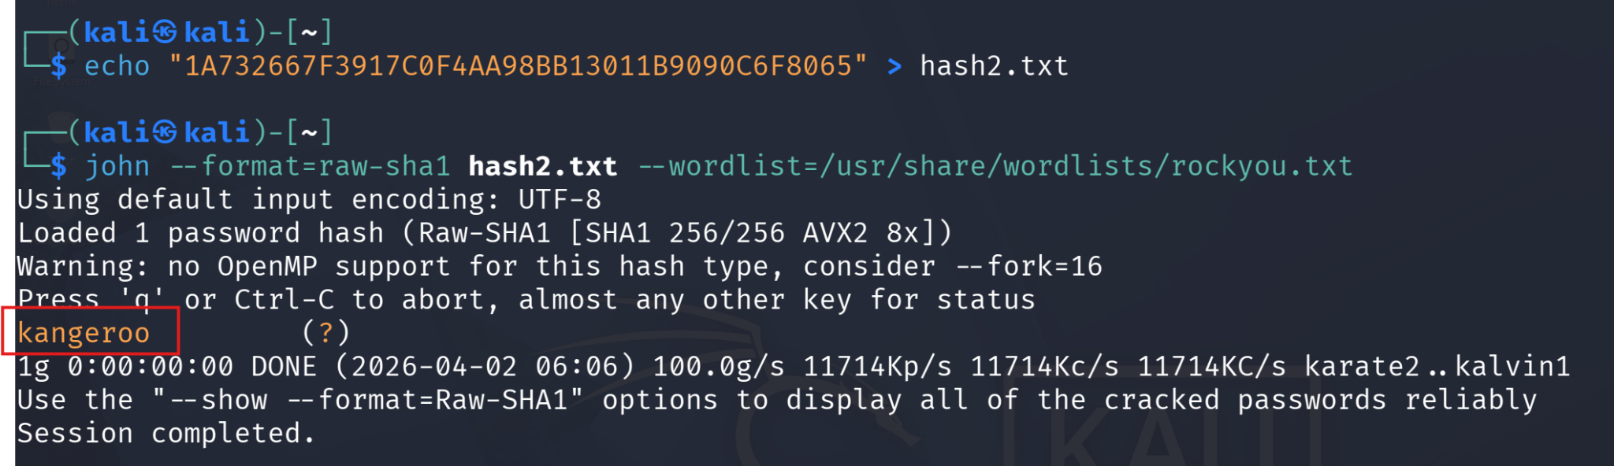

Hash: D7F4D3CCEE7ACD3DD7FAD3AC2BE2AAE9C44F4E9B7FB802D73136D4C53920140A
Text: microphone
PoC:
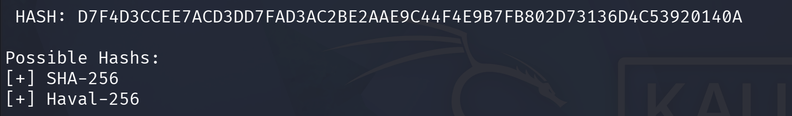
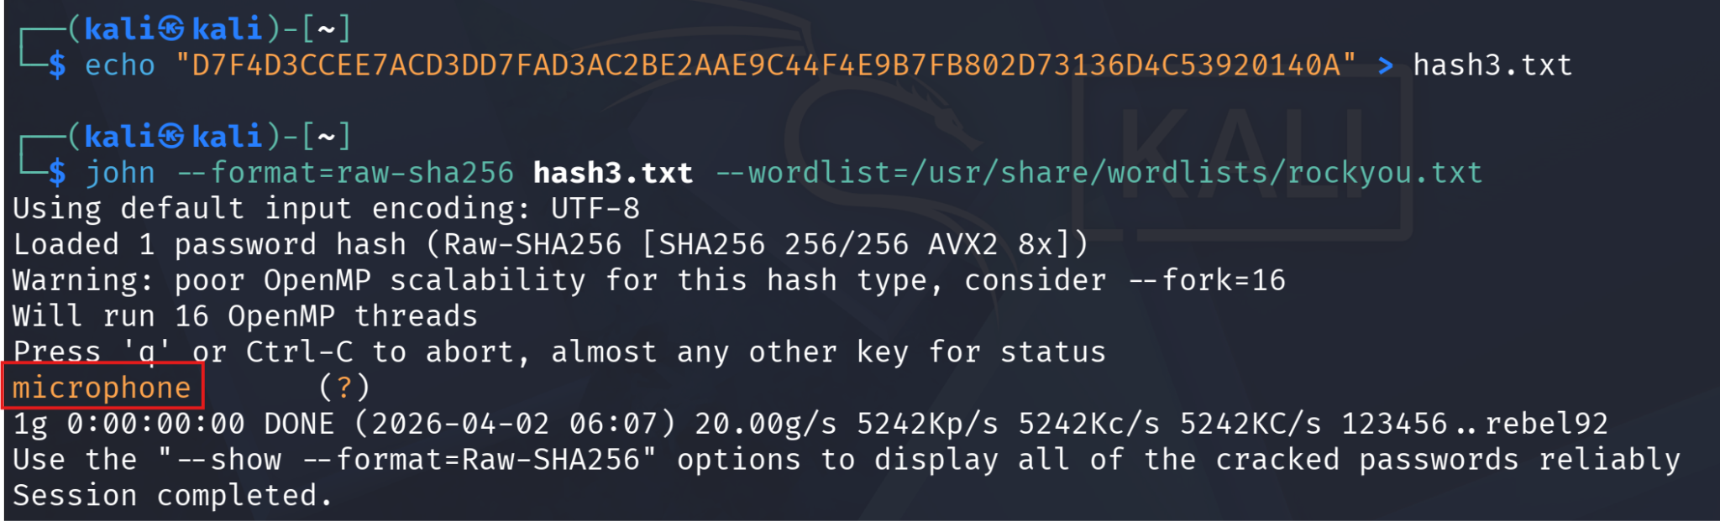

Hash: c5a60cc6bbba781c601c5402755ae1044bbf45b78d1183cbf2ca1c865b6c792cf3c6b87791344986c8a832a0f9ca8d0b4afd3d9421a149d57075e1b4e93f90bf
Text: colossal
PoC:
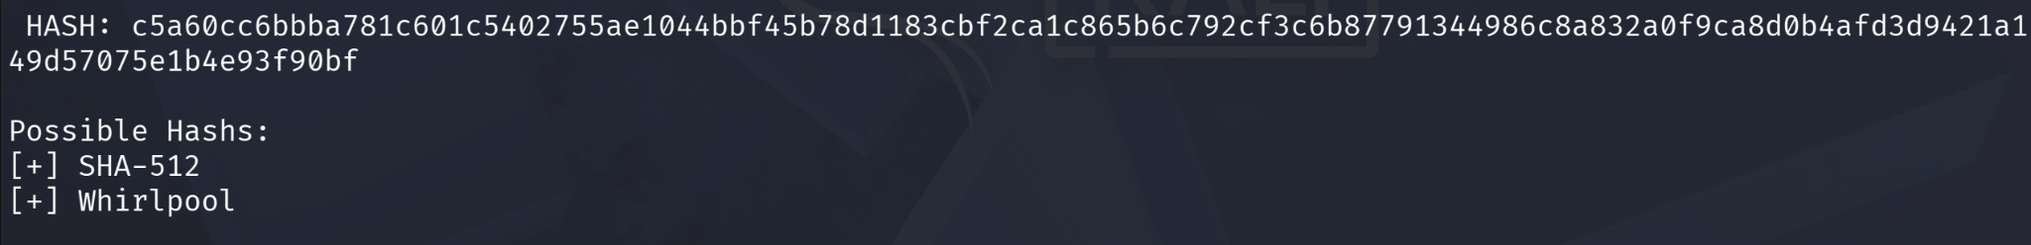
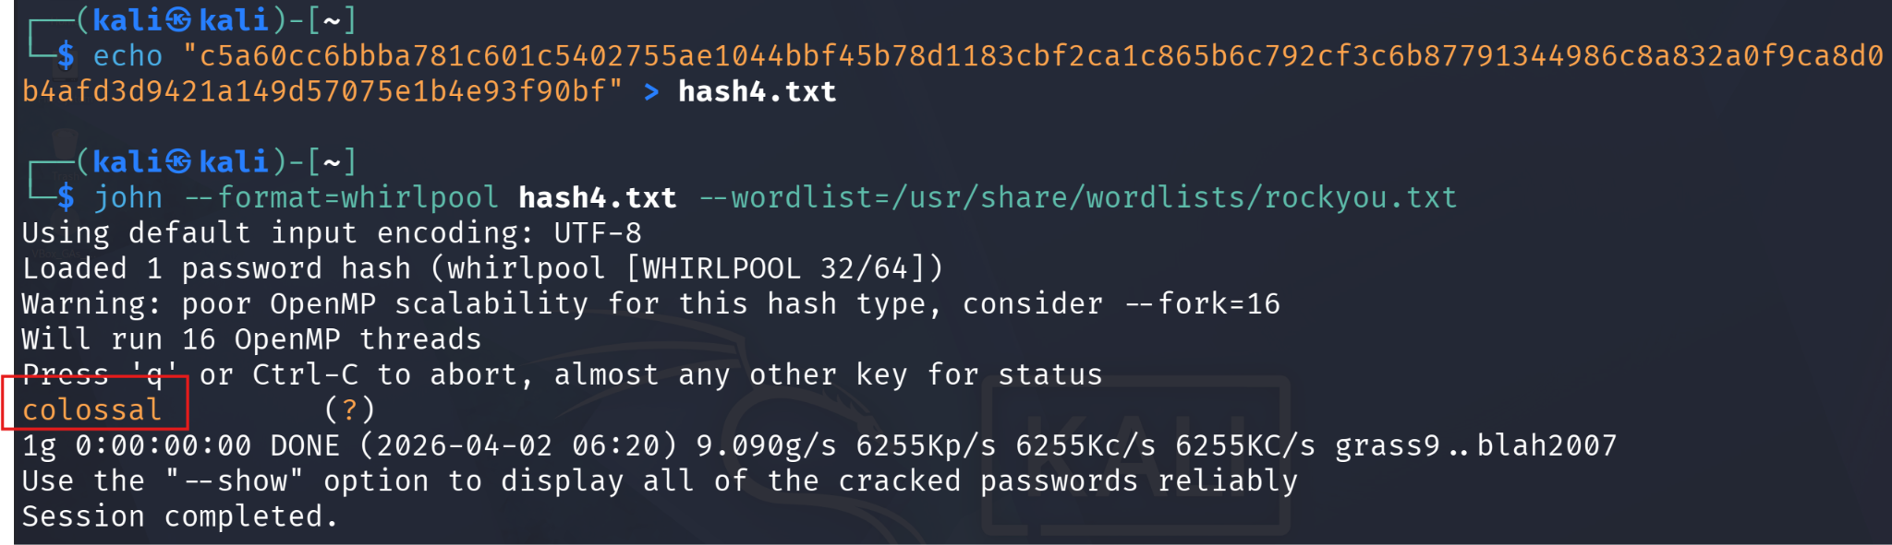

Hash: 5460C85BD858A11475115D2DD3A82333
Text: mushroom
PoC:

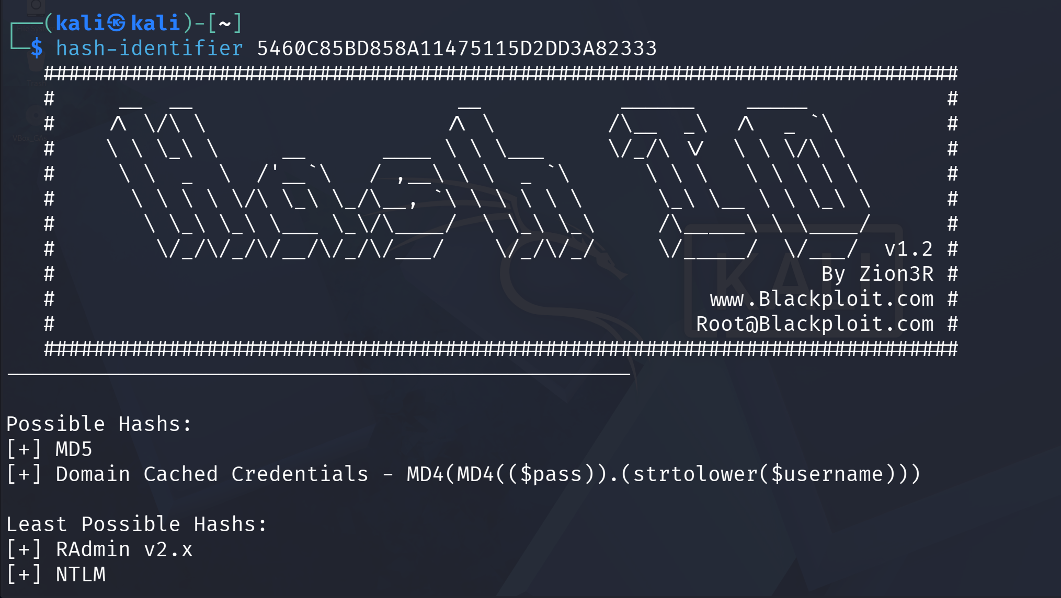
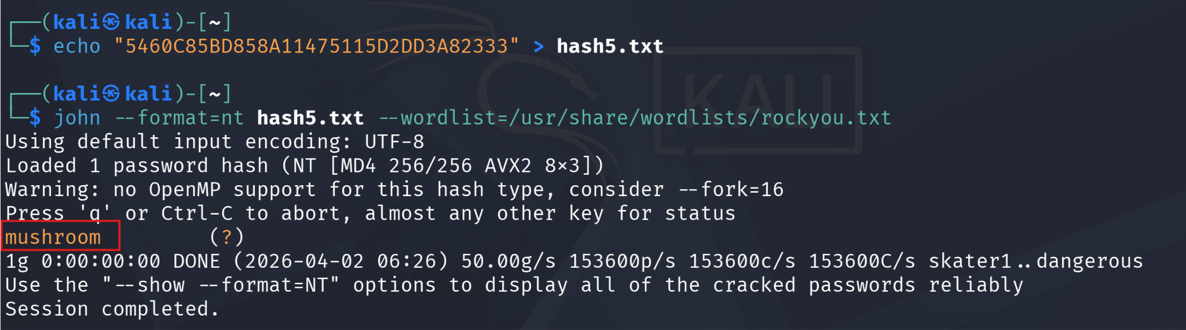

Task 2:

Password crack of etc/passwd & etc/shadow file
Ans: 1234
PoC:
- The /etc/shadow file contains the password hash: root:$6$Ha.d5nGupBm29pYr$...
- The $6$ prefix indicates: SHA-512 crypt
- The hash is saved to a file: echo 'root:$6$Ha.d5nGupBm29pYr$...' > hash.txt
- The hash is cracked using John the Ripper:
john --format=sha512crypt hash.txt --wordlist=/usr/share/wordlists/rockyou.txt
- The tool performs a dictionary attack and retrieves the password
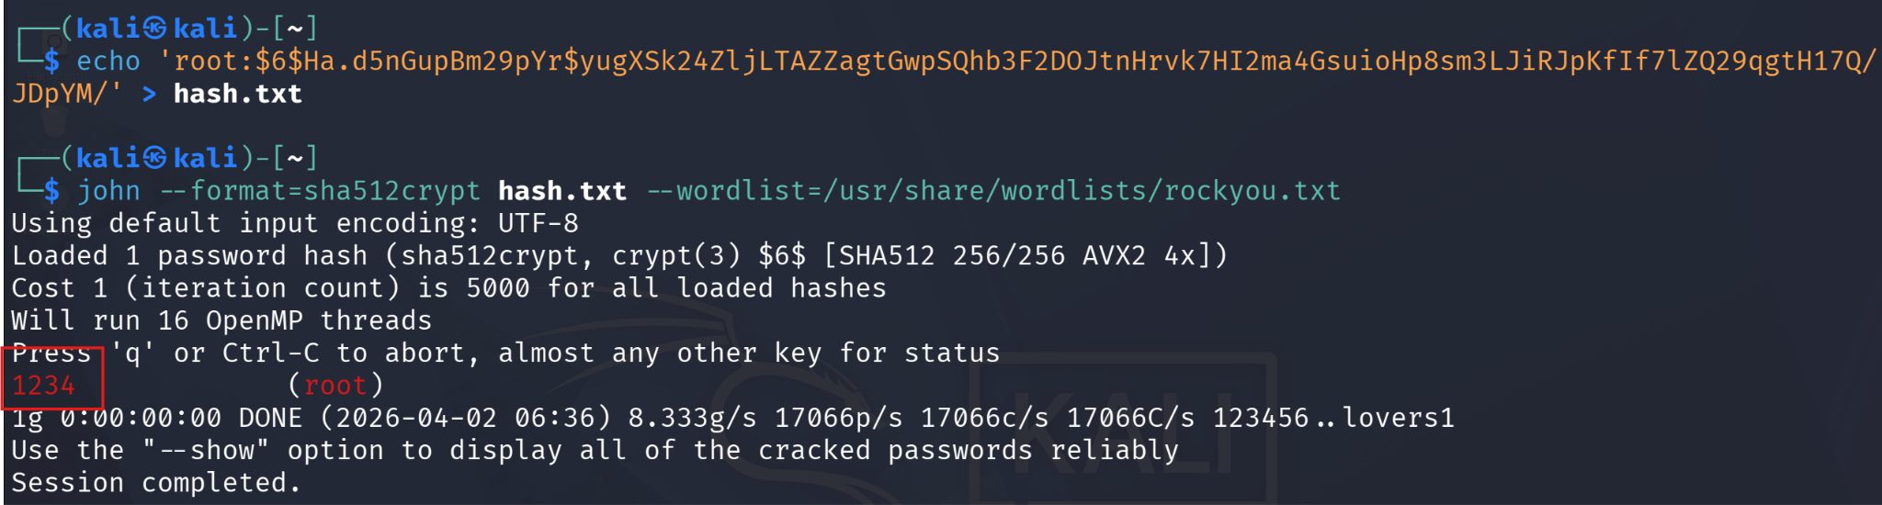

Task 3:

Crack the Single crack mode password for user Joker’s
Ans: Jok3r
PoC:
- The given hash is: 7bf6d9bb82bed1302f331fc6b816aada
- Hash length (32 hex) indicates: MD5
- Username provided: Joker
- The hash is saved in format required for single mode: echo "Joker:7bf6d9bb82bed1302f331fc6b816aada" > hash.txt
- The hash is cracked using Single Crack Mode in John the Ripper: john --single --format=raw-md5 hash.txt
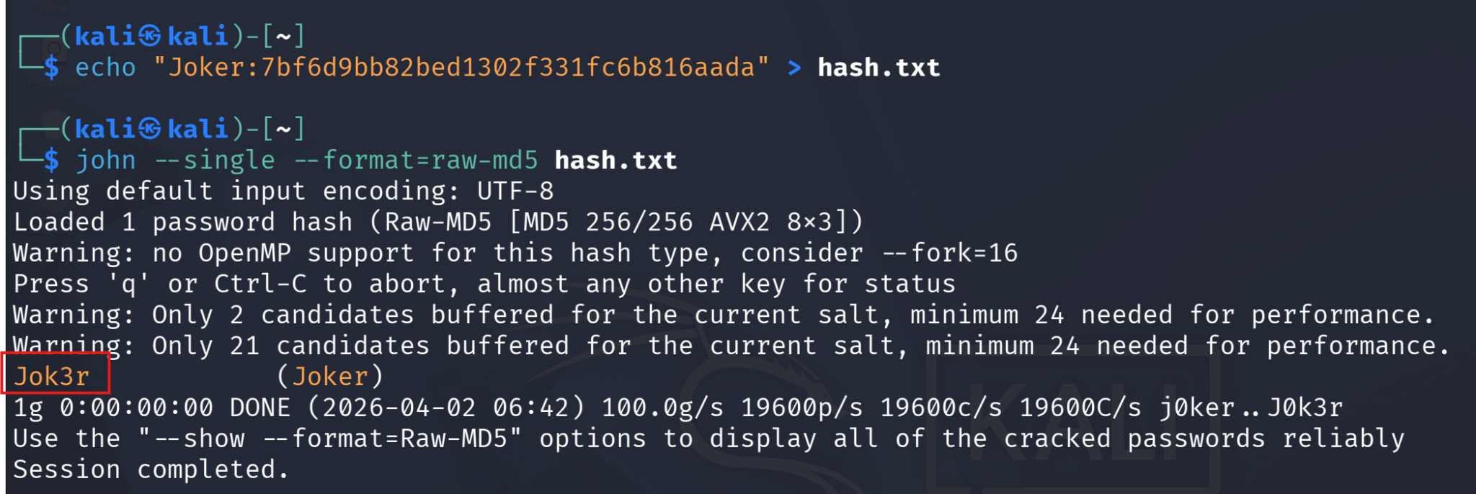

Task 4:

Create a Password Protected ZIP File and then crack it.
Ans: pass123
PoC:
- file is created: echo "This is a secret file" > secret.txt
- A password-protected ZIP file is created: zip -e test.zip secret.txt
  - Password used: pass123
- The ZIP file hash is extracted: zip2john test.zip > ziphash.txt
- The hash is cracked using John the Ripper:
john ziphash.txt --wordlist=/usr/share/wordlists/rockyou.txt
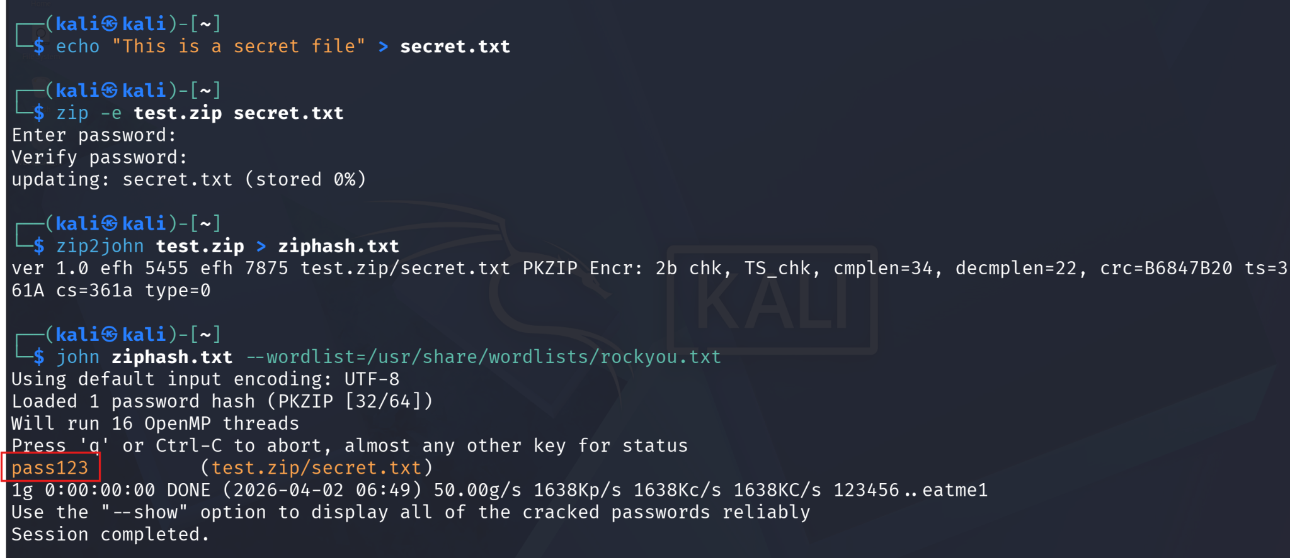

Task 5:

Create a Password Protected RAR File and then crack it.
Ans: password
PoC:
- A file is created: echo "This is a secret rar file" > secret.txt
- A password-protected RAR file is created: rar a -p test.rar secret.txt
  - Password used: password
- The RAR file hash is extracted: rar2john test.rar > rarhash.txt
- The hash is cracked using John the Ripper:
john rarhash.txt --wordlist=/usr/share/wordlists/rockyou.txt
