
Assignment-01
Web Pentesting and Bug Hunting - Batch-20

Basic Cryptography & Steganography

SUBMITTED BY
Md Sayem Mottakee
Student Id: CB-2025-862

SUBMITTED To
Tareq Ahamed Jony
Instructor, Cyber Bangla Academy

Room: Crack the hash 3
Task 1 : Level 1 3
Task 2: Level 2 5
Room: c4ptur3-th3-fl4g 8
Task 1: Translation & Shifting 8
Task 2: Spectrograms 14
Task 3: Steganography 15
Task 4: Security through obscurity 16
Room: Cicada-3301 Vol:1 17
Task 2: Analyze The Audio 17
Task 3: Decode the Passphrase 18
Task 4: Gather Metadata 20
Task 5: Find Hidden Files 21
Task 6: Book Cipher 22
Task 7: The Final Song 25
Room: Intro to Digital Forensics 26
Task 1: Introduction To Digital Forensics 26
Task 2: Digital Forensics Process 27
Task 3: Practical Example of Digital Forensics 27
Room: Digital Forensics Case B4DM755 30
Task 2: Case B4DM755: Details of the Crime 30
Task 3: Practical Application of the Digital Forensics Process 31
Task 4: Case B4DM755: At the Scene of Crime 32
Task 5: Introduction to FTK Imager 33
Task 6: Using FTK Imager to Acquire Digital Artefacts and Evidence 34
Task 7: Case B4DM755: At the Forensics Laboratory 35
Task 8: Post-Analysis of Evidence to Court Proceedings 40

Room: Crack the hash


Task 1 : Level 1
Q1: 48bb6e862e54f2a795ffc4e541caed4d
Ans: easy

Q2: CBFDAC6008F9CAB4083784CBD1874F76618D2A97
Ans: password123

Q3: 1C8BFE8F801D79745C4631D09FFF36C82AA37FC4CCE4FC946683D7B336B63032
Ans: letmein

Q4: $2y$12$Dwt1BZj6pcyc3Dy1FWZ5ieeUznr71EeNkJkUlypTsgbX1H68wsRom
Ans: bleh

Q5: 279412f945939ba78ce0758d3fd83daa
Ans: Eternity22

Poc:
- The website https://crackstation.net/ is open. All the given hashes are entered and the Crack Hashes button is clicked.
- CrackStation uses its own built-in wordlist to match the hashes and displays the output as hash, hash type, and result (real word). From the output, it can be observed that all hashes are cracked except the 4th hash.
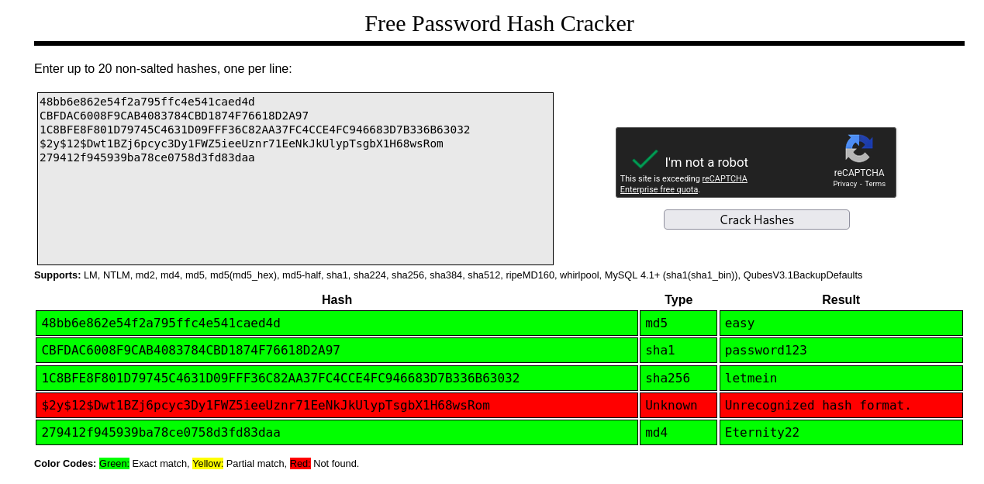
- To identify the hash type, the following command is used: hashid -m "\$2y\$12\$Dwt1BZj6pcyc3Dy1FWZ5ieeUznr71EeNkJkUlypTsgbX1H68wsRom"
  - hashid: a tool used to identify the type of a hash.
  - -m: displays the corresponding Hashcat mode number for the identified hash.
  - \ is used before $ to escape special characters.
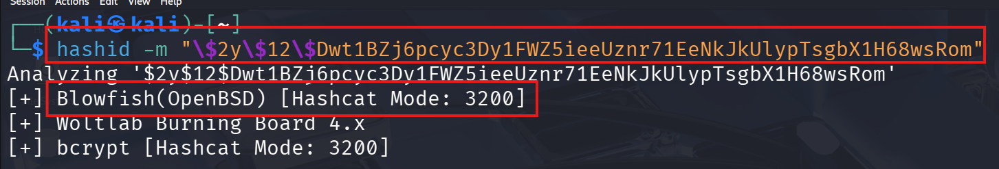
- The output identifies the hash as Blowfish (OpenBSD) and shows Hashcat Mode: 3200.
  - Hashcat Mode 3200: specifies the Blowfish (OpenBSD) hashing algorithm used by Hashcat.
After identifying the hash type, the hash is cracked using the following command: hashcat -m 3200 "\$2y\$12\$Dwt1BZj6pcyc3Dy1FWZ5ieeUznr71EeNkJkUlypTsgbX1H68wsRom" rockyou.txt
  - hashcat: a password‑cracking tool used to recover plaintext passwords from hashes.
  - -m 3200: tells Hashcat to use the Blowfish (OpenBSD) hash mode.
  - rockyou.txt: a commonly used password wordlist.
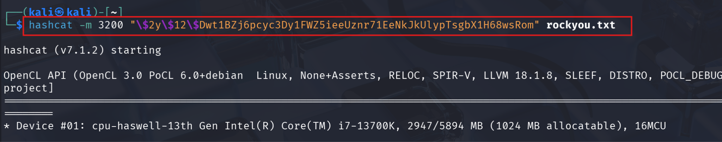
- Using this command, the hash is successfully cracked and the plaintext password is obtained.
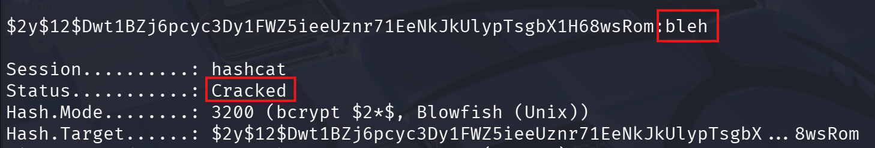
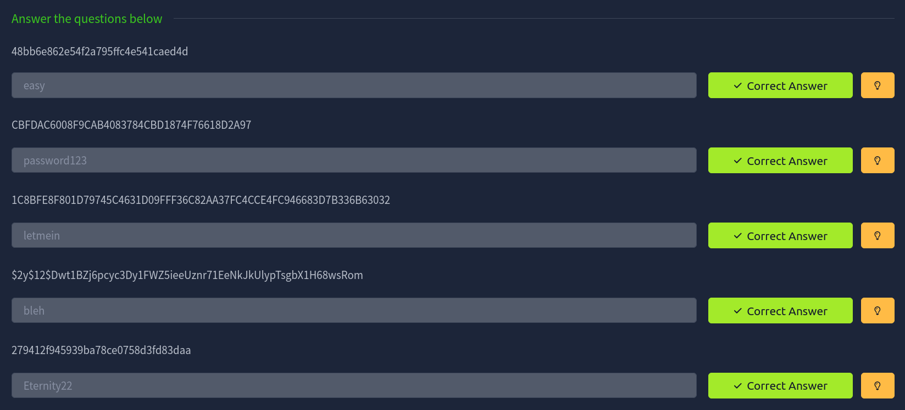

Task 2: Level 2
Q1: Hash: F09EDCB1FCEFC6DFB23DC3505A882655FF77375ED8AA2D1C13F640FCCC2D0C85
Ans: paule

Q2: Hash: 1DFECA0C002AE40B8619ECF94819CC1B
Ans: n63umy8lkf4i

Q3: Hash: $6$aReallyHardSalt$6WKUTqzq.UQQmrm0p/T7MPpMbGNnzXPMAXi4bJMl9be.cfi3/qxIf.hsGpS41BqMhSrHVXgMpdjS6xeKZAs02.
Salt: aReallyHardSalt
Ans: waka99

Q4: Hash: e5d8870e5bdd26602cab8dbe07a942c8669e56d6
Salt: tryhackme
Ans: 481616481616

Poc:
- The website https://crackstation.net/ is used to solve the first two hashes. The hashes are entered into the input field and the Crack Hashes button is clicked. CrackStation matches the hashes using its built‑in wordlist and displays the cracked results.
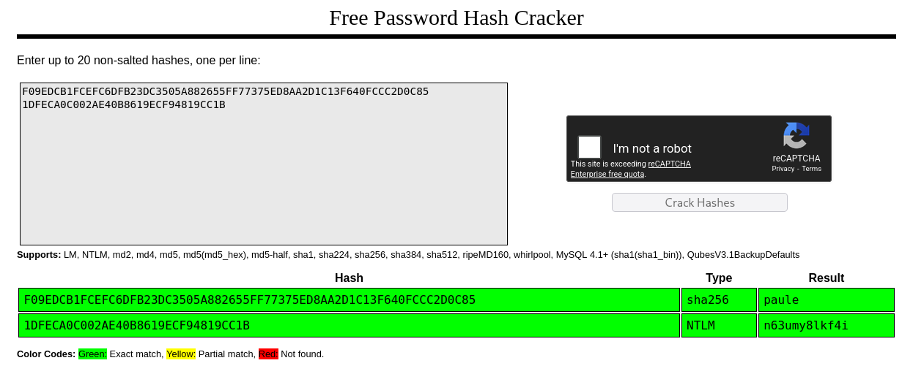
- For the next hash, hashid is used to identify the hash type. Based on the output, Hashcat mode 1800 is selected.
  - Hashcat mode 1800: represents the SHA‑512 (Unix) hashing algorithm.
- The identified hash is then cracked using Hashcat with the following command:
hashcat -m 1800 <hash> rockyou.txt
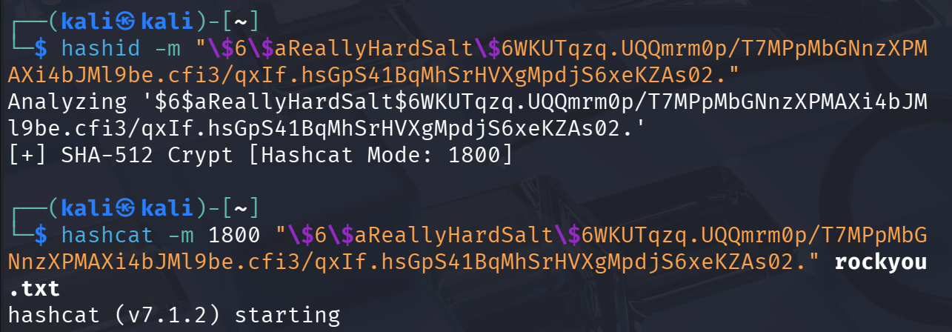
- The rockyou.txt wordlist is used to perform the cracking process.
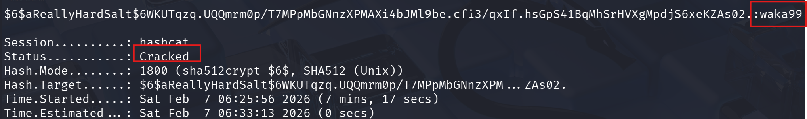
- For the last hash, the website https://hashes.com/en/decrypt/hash is used. This website supports hashes that include a salt.
  - hashes.com: an online hash‑cracking service that uses large databases and wordlists to match hashes, including salted hashes.
- The hash and its corresponding salt are provided on the website, and the cracked result is displayed after processing.
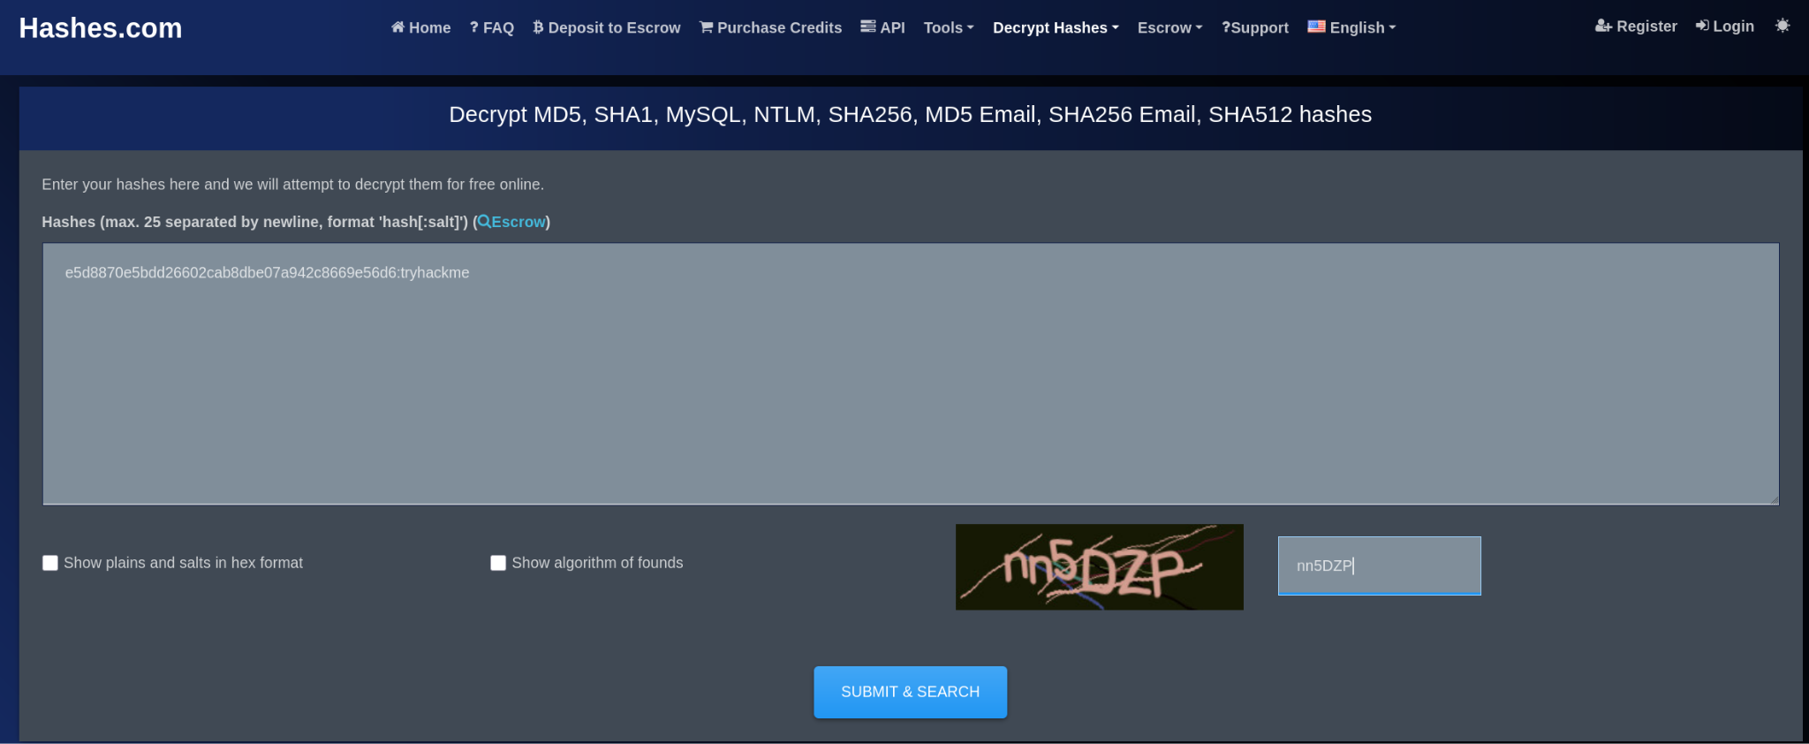
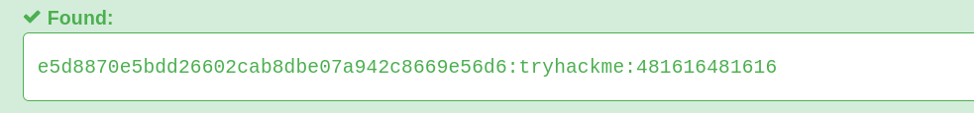
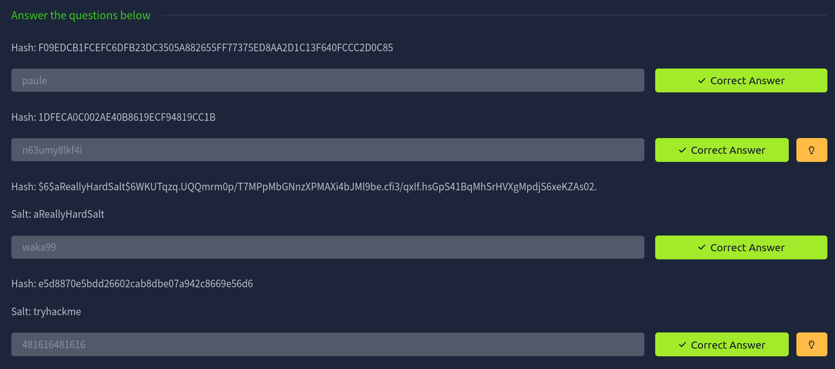

Room: c4ptur3-th3-fl4g



Task 1: Translation & Shifting
Q1: c4n y0u c4p7u23 7h3 f149?
Ans: can you capture the flag?

Q2: 01101100 01100101 01110100 01110011 00100000 01110100 01110010 01111001 00100000 01110011 01101111 01101101 01100101 00100000 01100010 01101001 01101110 01100001 01110010 01111001 00100000 01101111 01110101 01110100 00100001
Ans: lets try some binary out!
Poc:
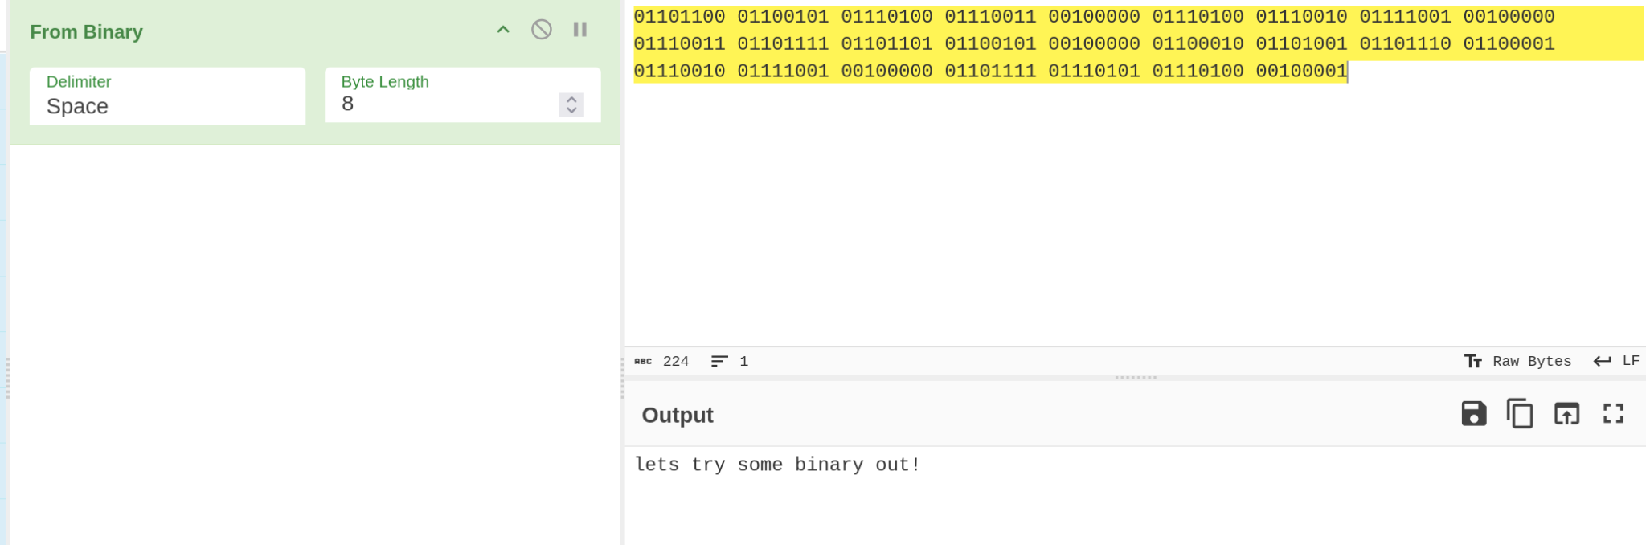

Q3: MJQXGZJTGIQGS4ZAON2XAZLSEBRW63LNN5XCA2LOEBBVIRRHOM======
Ans: base32 is super common in CTF's
Poc:
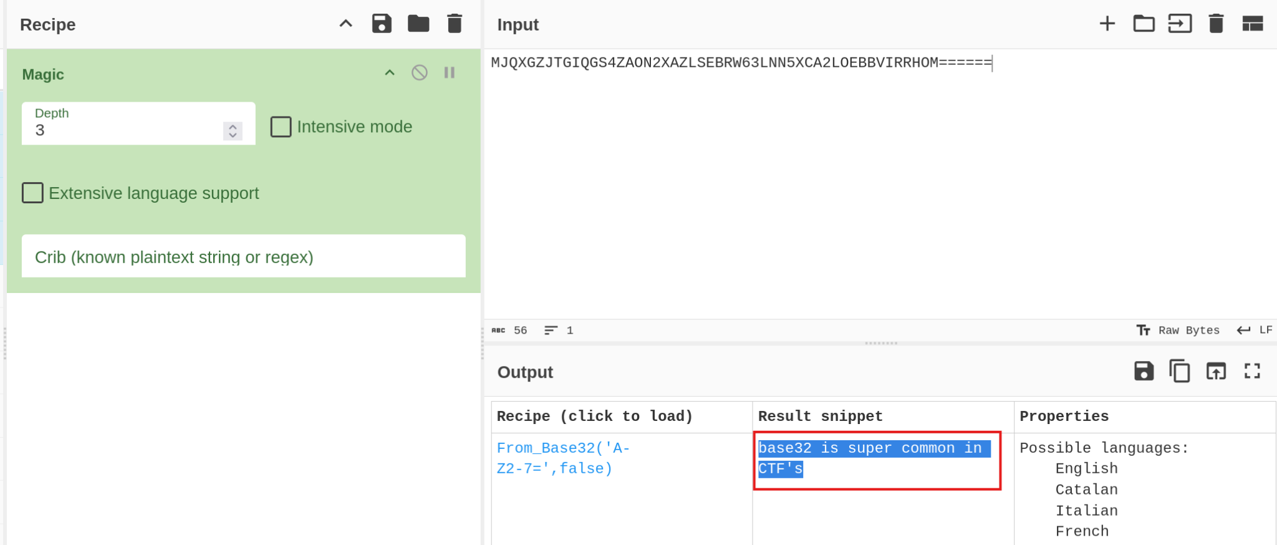

Q4: RWFjaCBCYXNlNjQgZGlnaXQgcmVwcmVzZW50cyBleGFjdGx5IDYgYml0cyBvZiBkYXRhLg==
Ans: Each Base64 digit represents exactly 6 bits of data.
Poc:
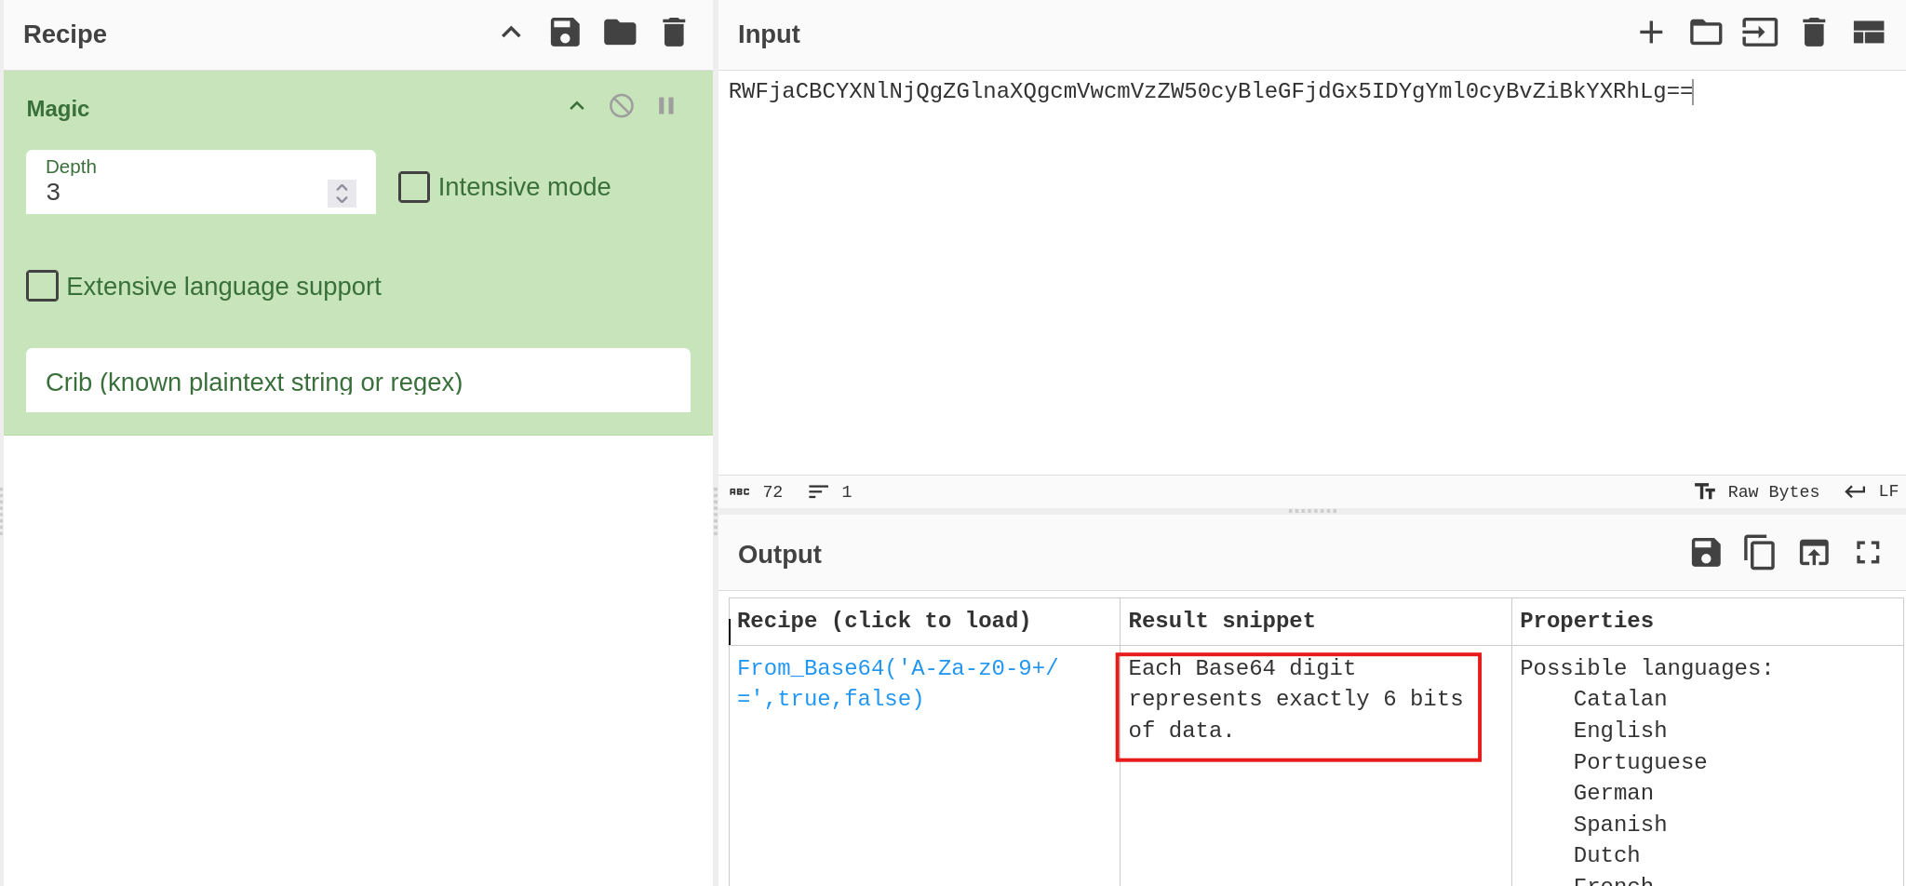

Q5: 68 65 78 61 64 65 63 69 6d 61 6c 20 6f 72 20 62 61 73 65 31 36 3f
Ans: hexadecimal or base16?
Poc:
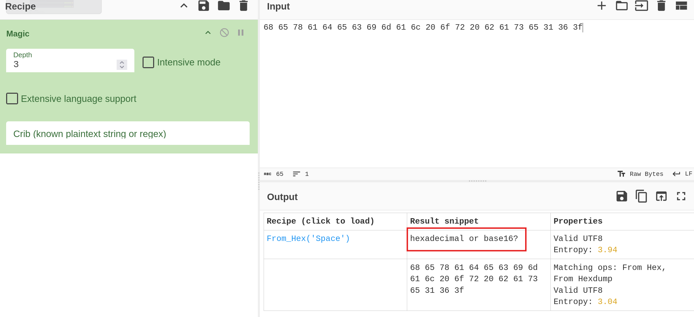
Q6: Ebgngr zr 13 cynprf!
Ans: Rotate me 13 places!
Poc:
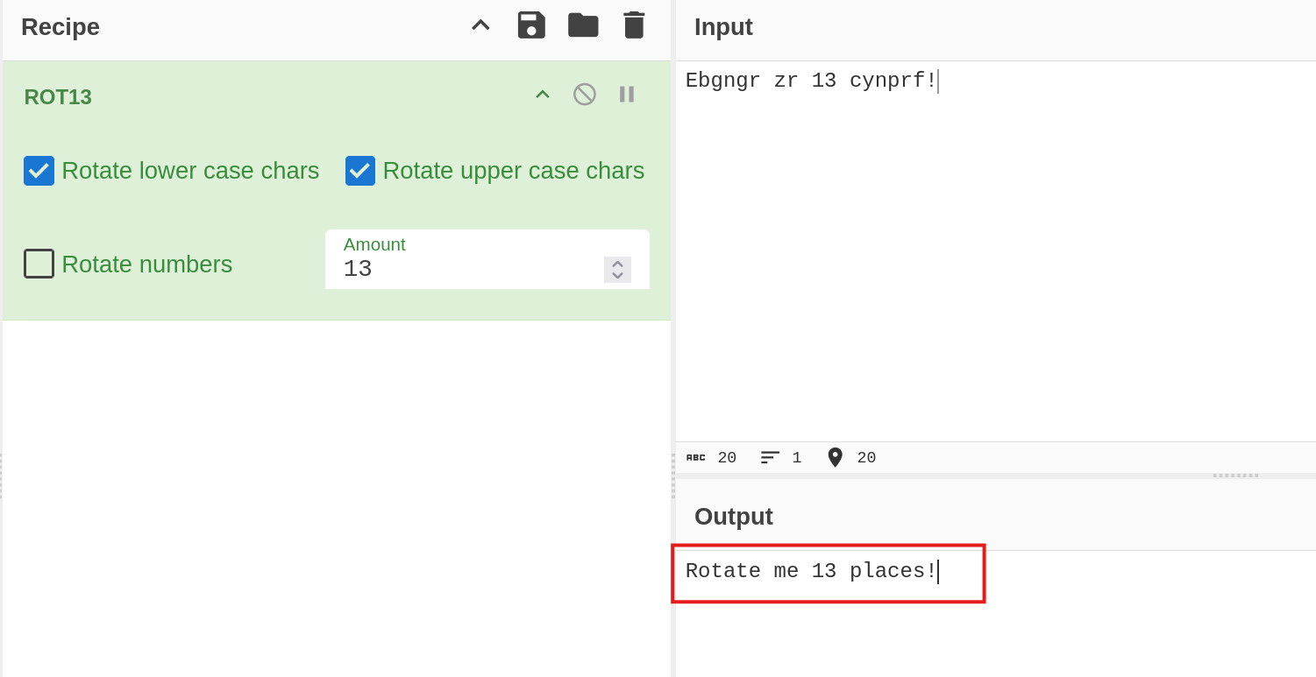

Q7: *@F DA:? >6 C:89E C@F?5 323J C:89E C@F?5 Wcf E:>6DX
Ans: You spin me right round baby right round (47 times)
Poc:
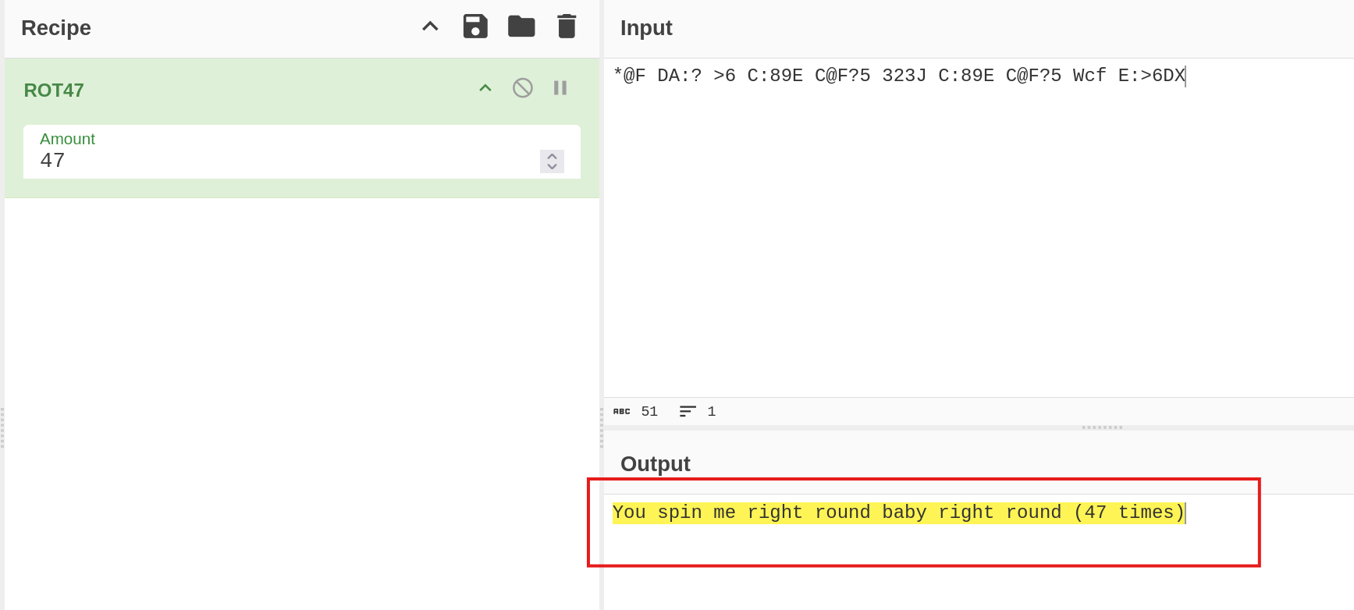

Q8 :- . .-.. . -.-. --- -- -- ..- -. .. -.-. .- - .. --- -.
. -. -.-. --- -.. .. -. --.
Ans: telecommunication encoding
Poc:
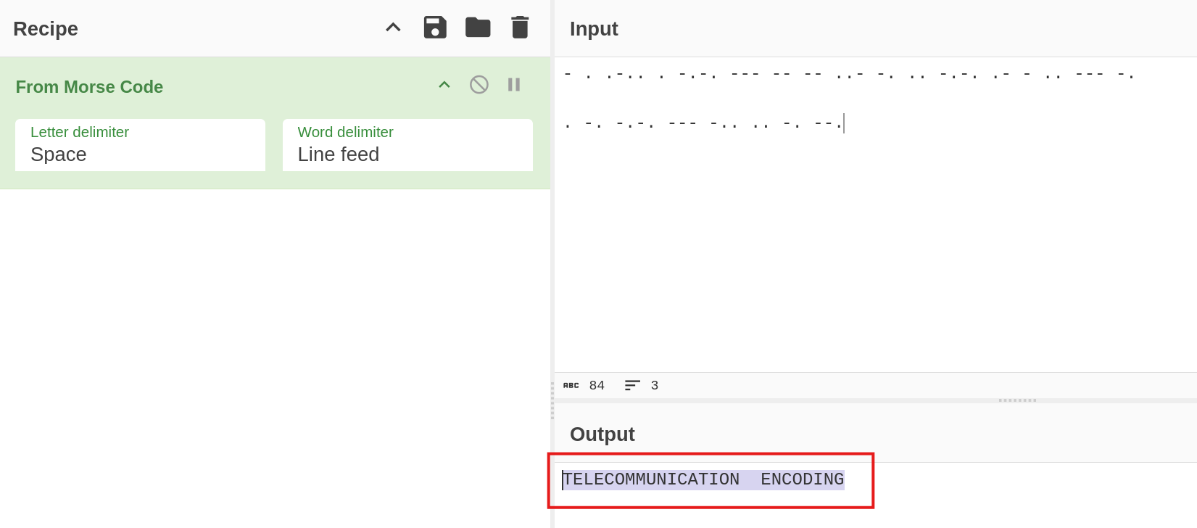
Q9: 85 110 112 97 99 107 32 116 104 105 115 32 66 67 68
Ans: Unpack this BCD
Poc:
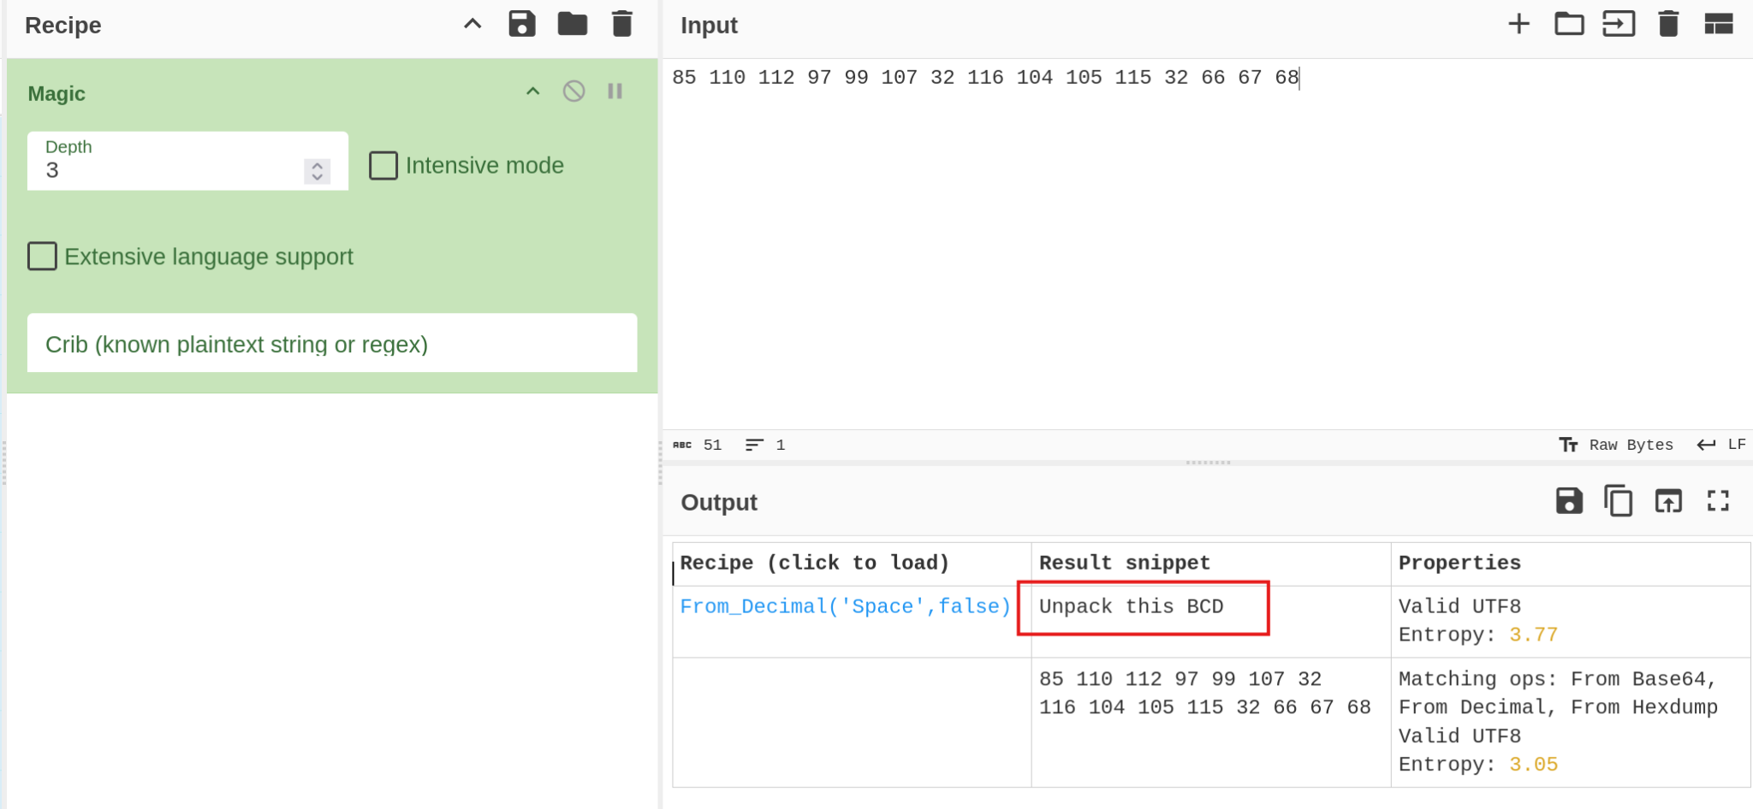

Q10: LS0tLS0gLi0tLS0gLi0tLS0gLS0tLS0gLS0tLS0gLi0tLS0gLi0tLS0gLS0tLS0KLS0tLS0gLi0tLS0gLi0tLS0gLS0tLS0gLS0tLS0gLi0tLS0gLS0tLS0gLi0tLS0…..
Ans: Let's make this a bit trickier…
Poc:

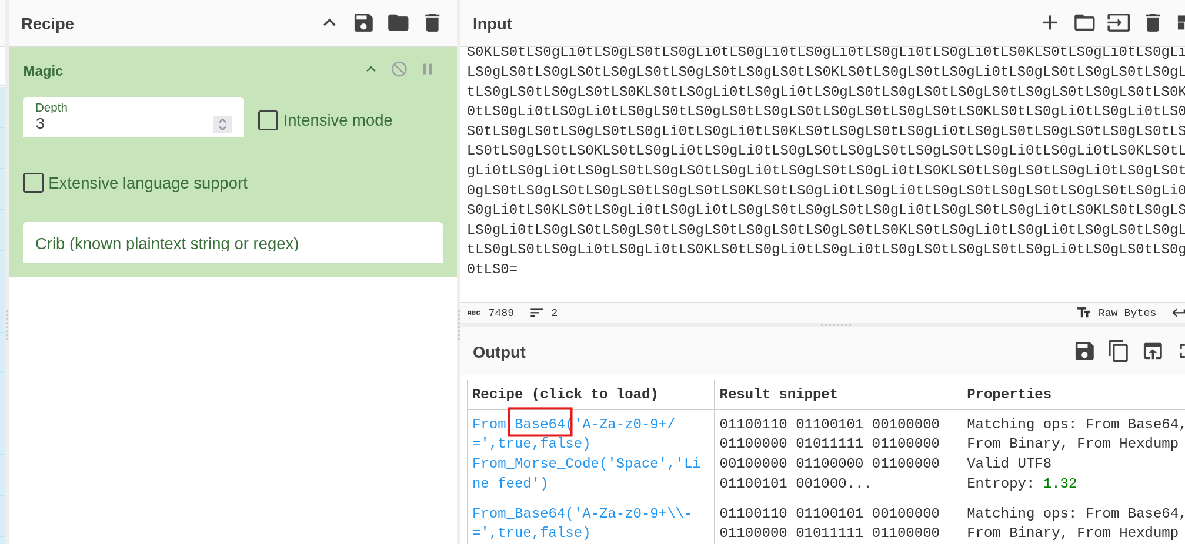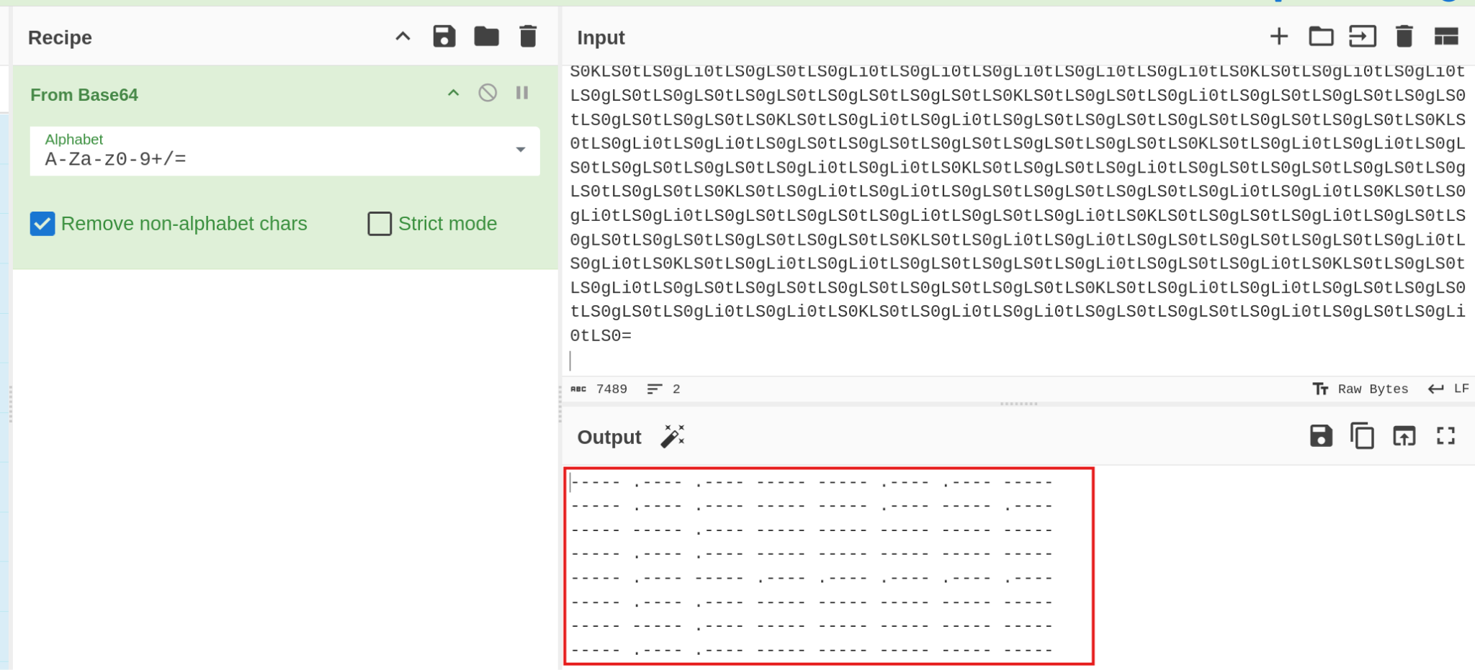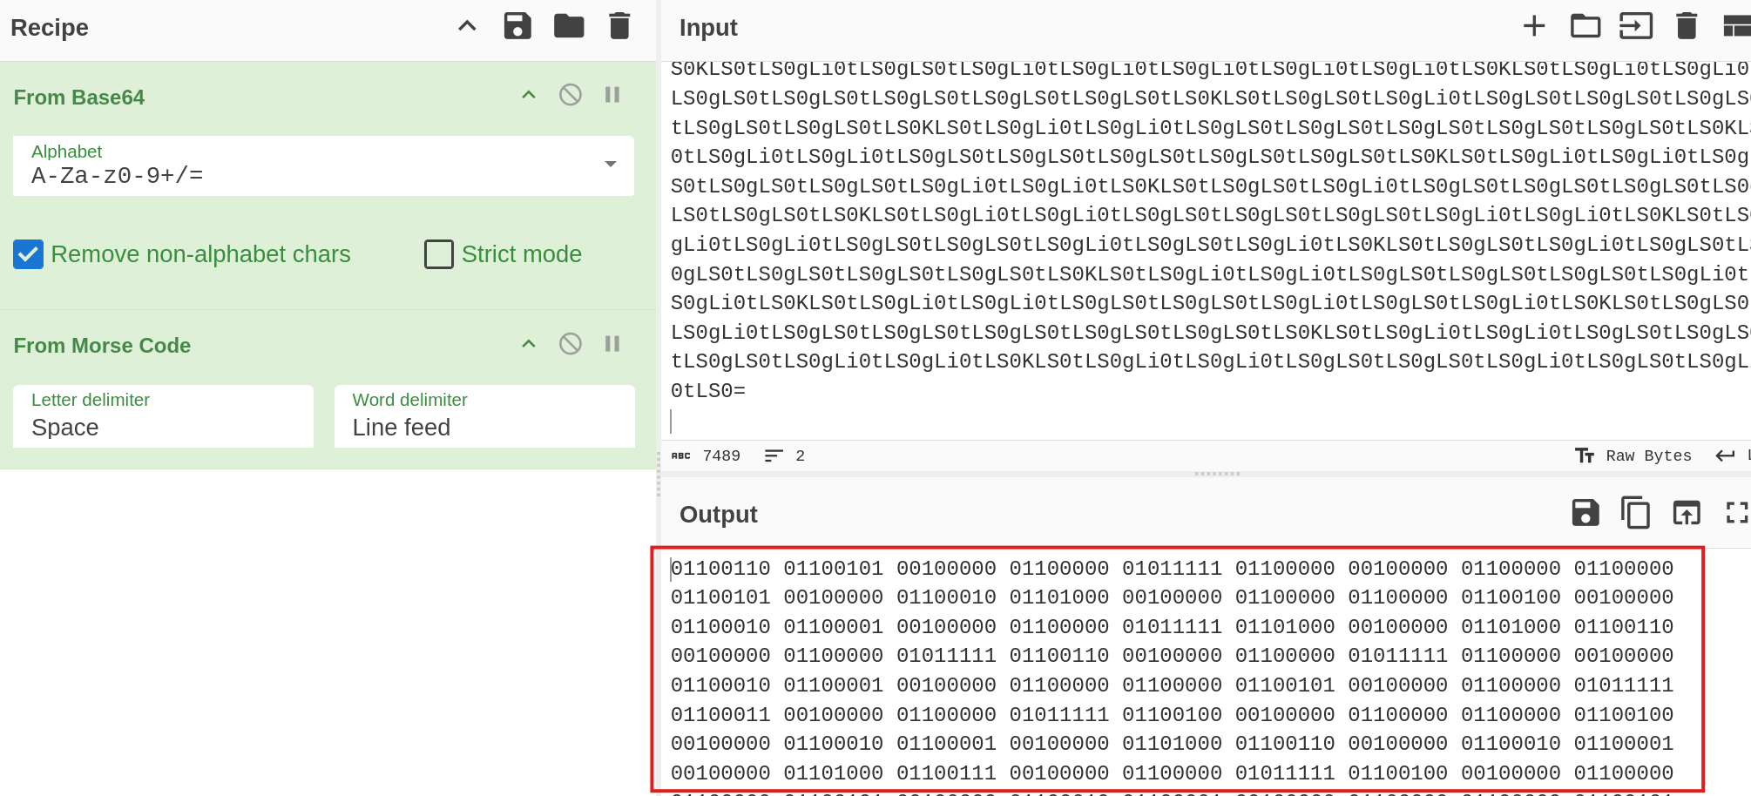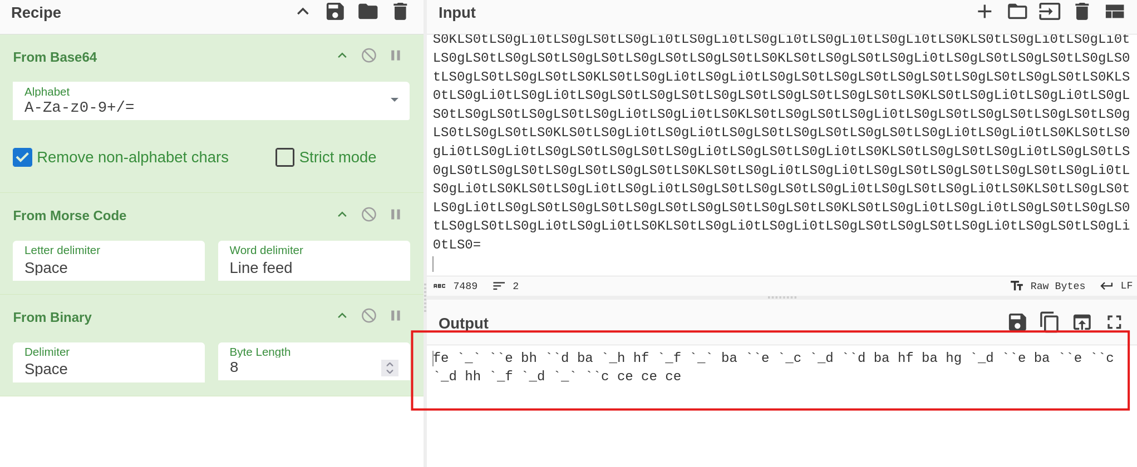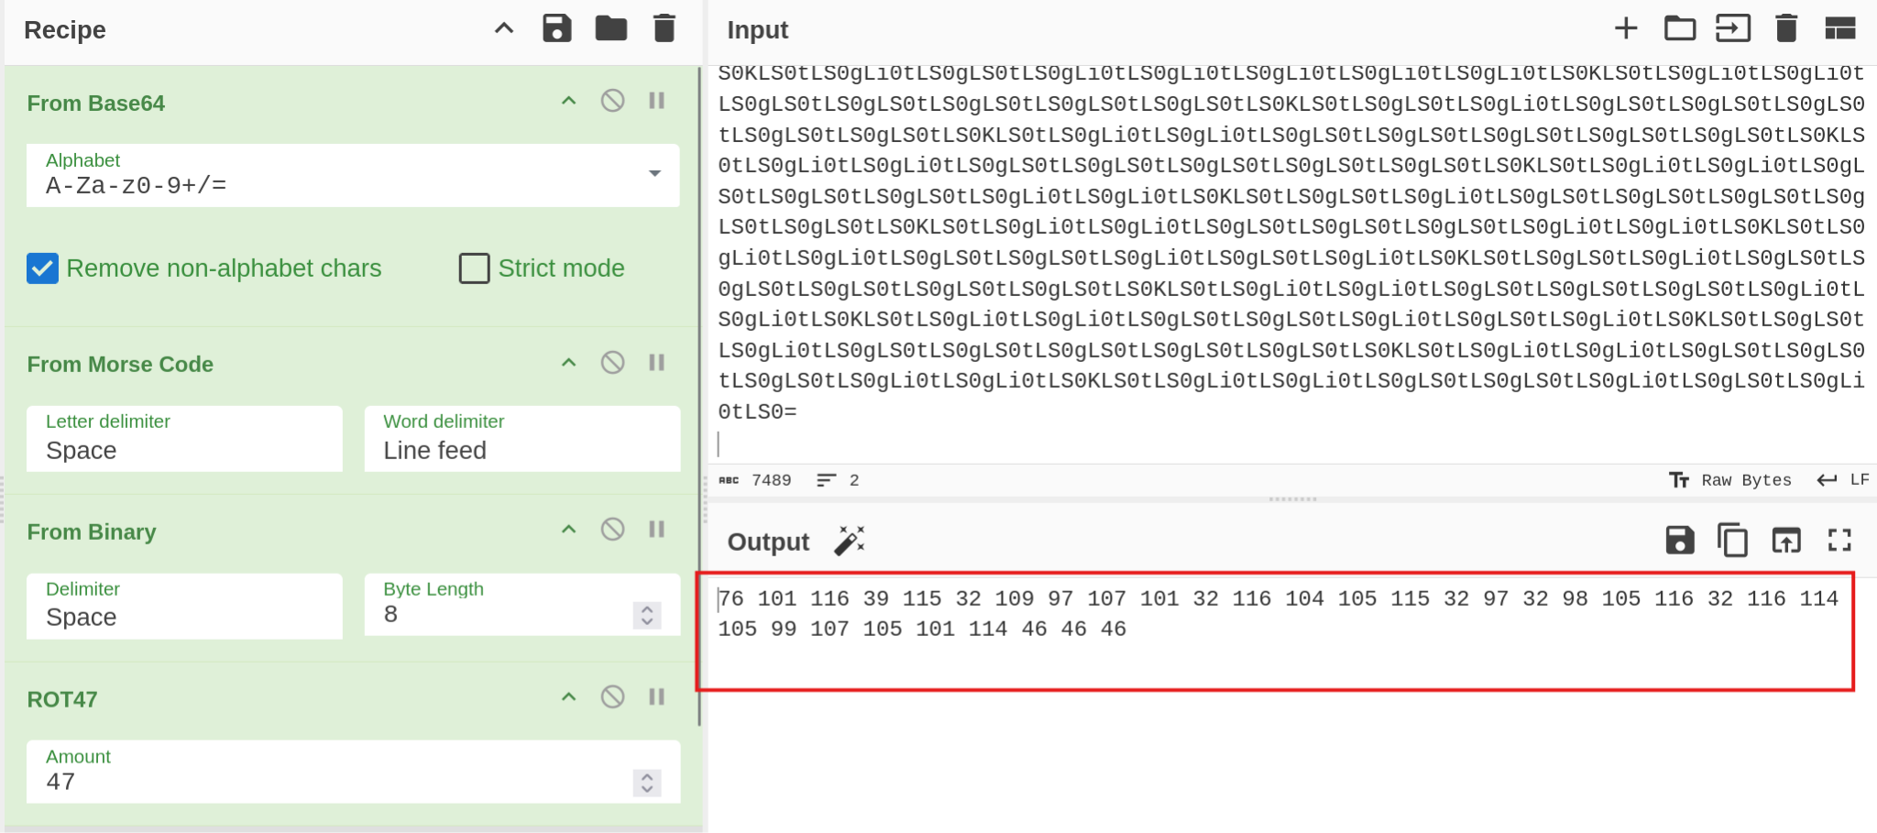

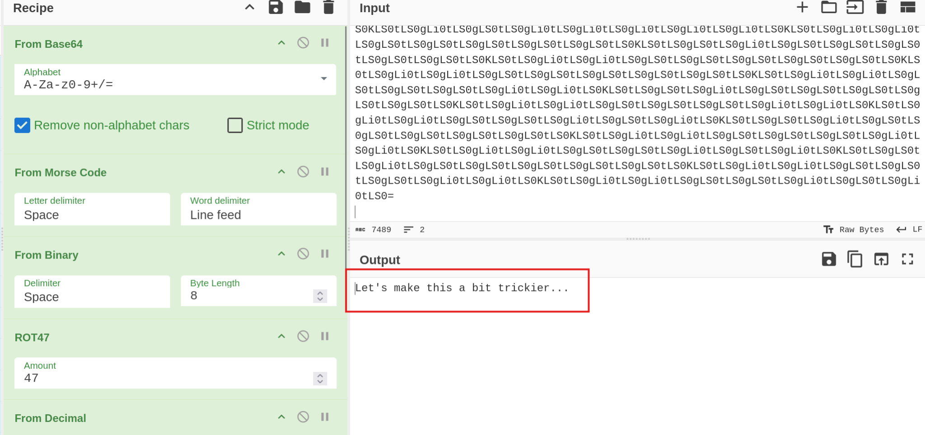
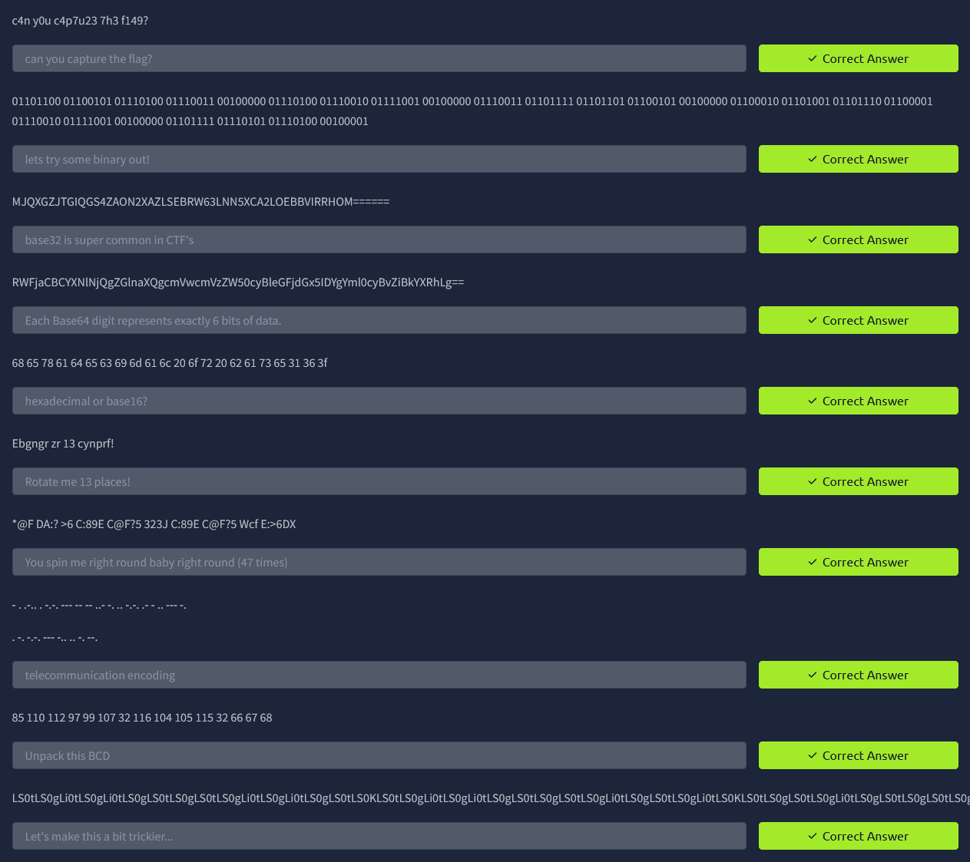

Task 2: Spectrograms
Q1: Download the file & write the hidden message
Ans: Super Secret Message
Poc:
- The Sonic Visualiser tool is opened.
- The downloaded audio file is loaded into Sonic Visualiser.
From the menu, the Spectrogram layer is added to visualize the frequency spectrum of the audio.
- After applying the spectrogram view, the hidden text message becomes visible within the spectrogram image.
- The displayed hidden message reads: “Super Secret Message.”
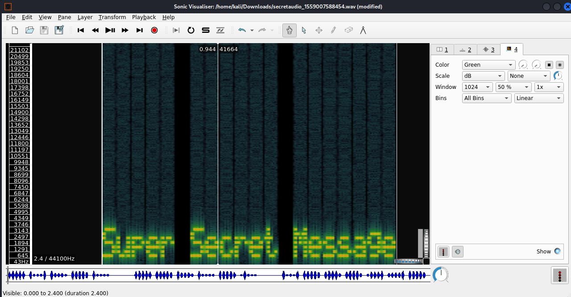

Task 3: Steganography
Q1: Decode the image to reveal the answer.
Ans: SpaghettiSteg
Poc:
steghide extract -sf stegosteg_1559008553457.jpg
The steghide tool attempts to extract the hidden data from the specified image file.
- extract : used to retrieve embedded data
- -sf : specifies the stego file (the image containing hidden data)
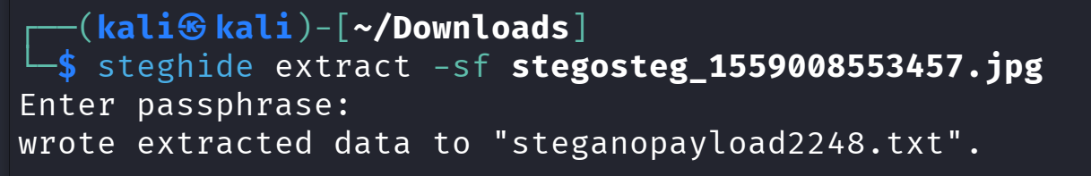
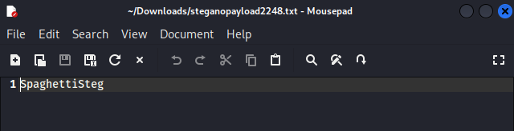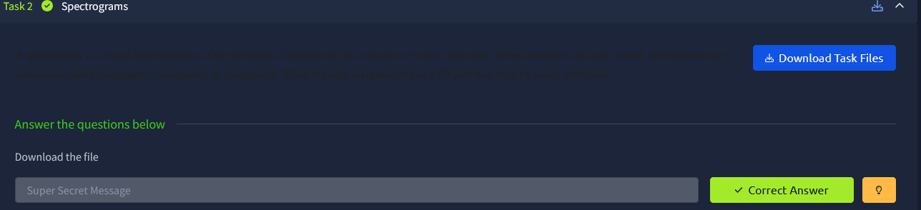

Task 4: Security through obscurity
Q1: Download and get 'inside' the file. What is the first filename & extension?
Ans: hackerchat.png
Poc:
cat meme_1559010886025.jpg
The cat command displays the contents of the file in the terminal. Scrolling through the output reveals the hidden/appended message located at the end of the image file.
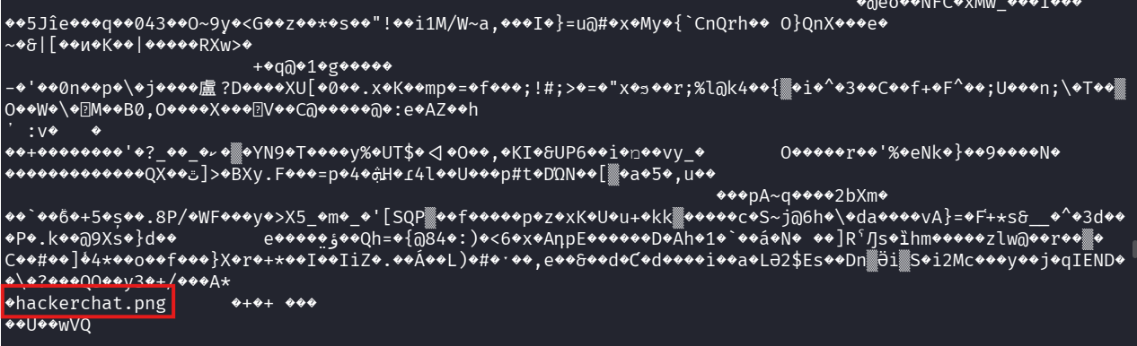
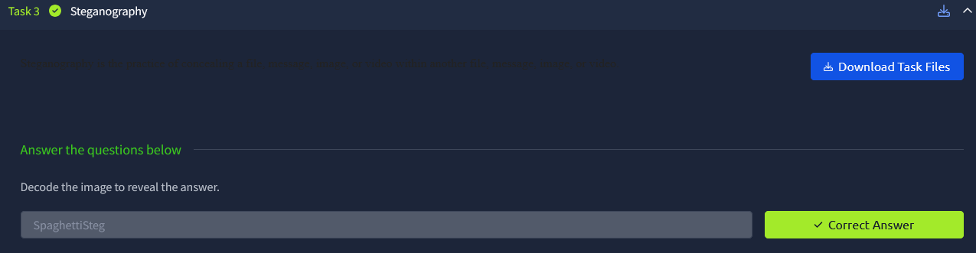

Q2: Get inside the archive and inspect the file carefully. Find the hidden text.
Ans: AHH_YOU_FOUND_ME!
Poc:
strings meme_1559010886025.jpg
The strings command extracts and displays readable text strings from the image file. Reviewing the output reveals the hidden text/message embedded or appended within the file.
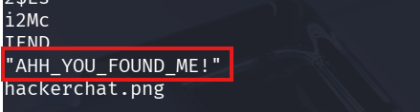

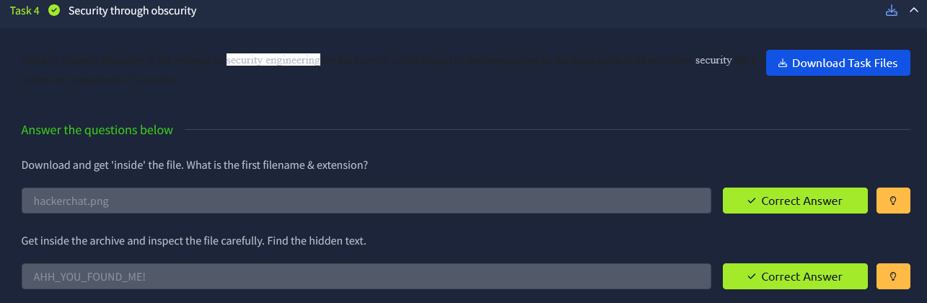

Room: Cicada-3301 Vol:1



Task 2: Analyze The Audio
Q1: What is the link inside of the audio?
Ans: https://pastebin.com/wphPq0Aa

Poc:
- Opening Sonic Visualiser and loading the provided audio file.
- Adding a Spectrogram layer to visualize the frequency spectrum of the audio.
- Observing the spectrogram carefully, a QR code appears embedded in the frequency patterns.
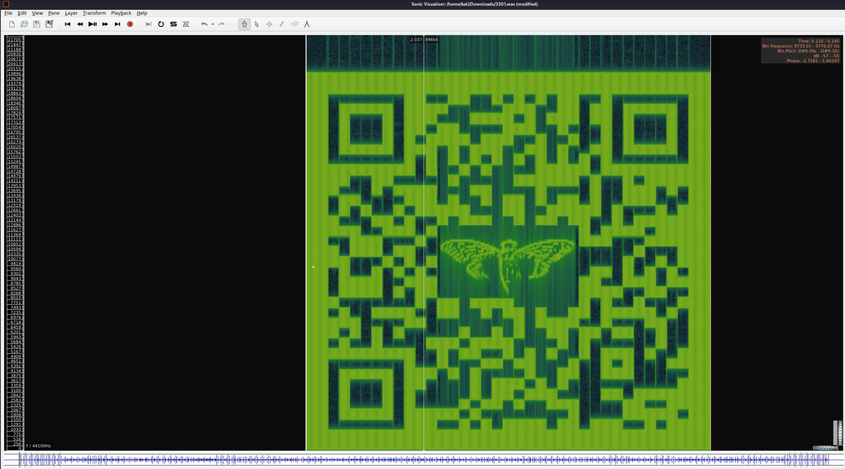
- Scanning the QR code using a QR scanner.
- The QR code reveals the following link: https://pastebin.com/wphPq0Aa
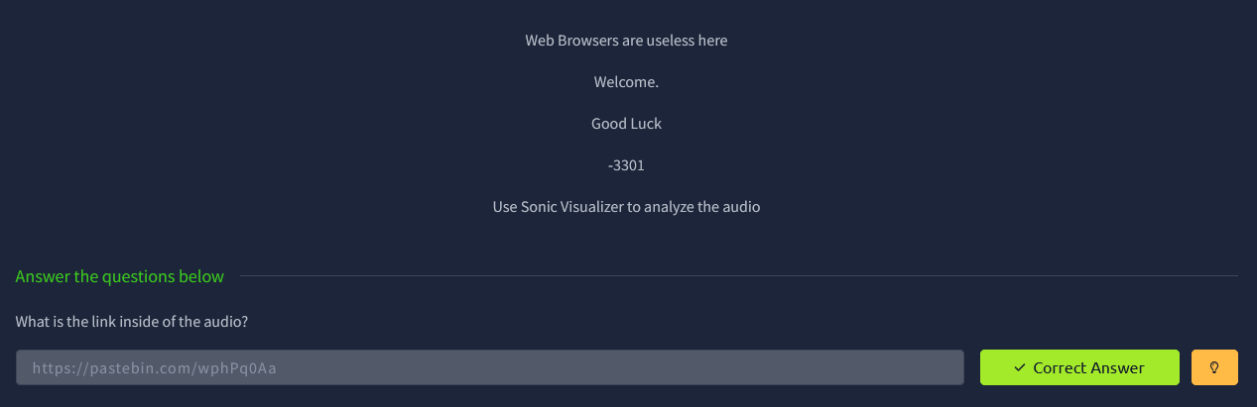

Task 3: Decode the Passphrase
Q1: What is the decrypted passphrase?
Ans: Hm5R_4_P455mhp453!
Poc:
- Opening the link obtained from the QR code:https://pastebin.com/wphPq0Aa. The encoded passphrase is found on this page.
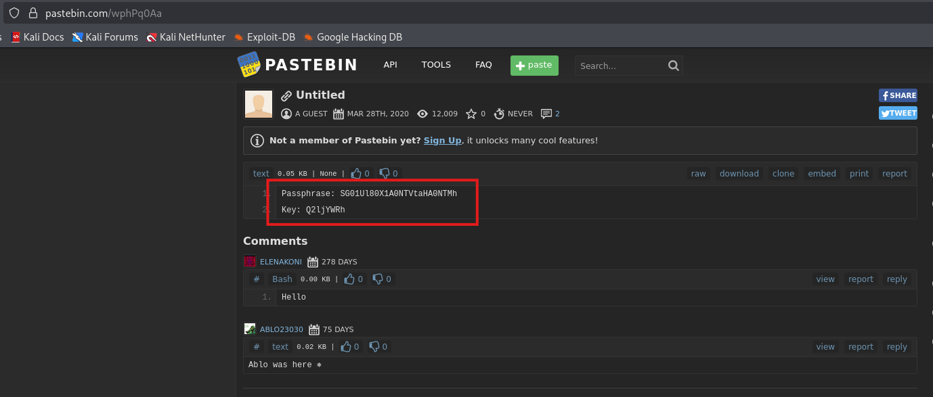
- Opening CyberChef: https://gchq.github.io/CyberChef/
- Pasting the encoded text into the input section of CyberChef.
- Using the Magic operation to automatically detect the encoding method and decode the text. The tool identifies the encoding as Base64 and performs the decoding.
- After decoding, the decrypted passphrase is obtained: Hm5R_4_P455mhp453!
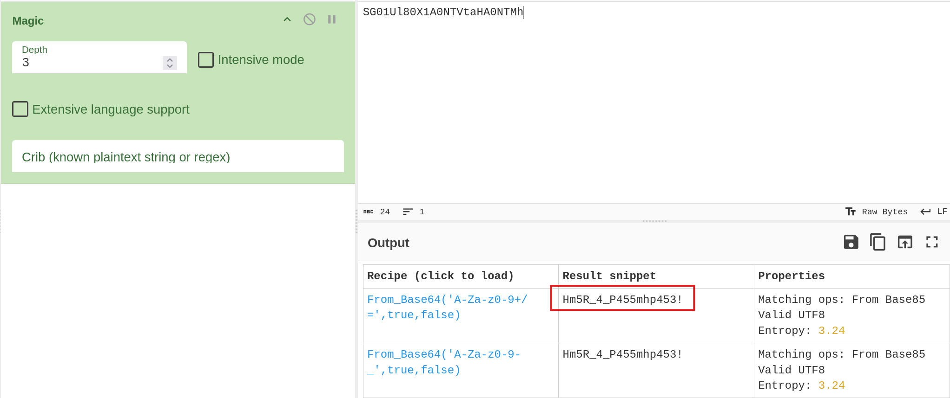
Q2: What is the decrypted key?
Ans: Cicada
Poc:
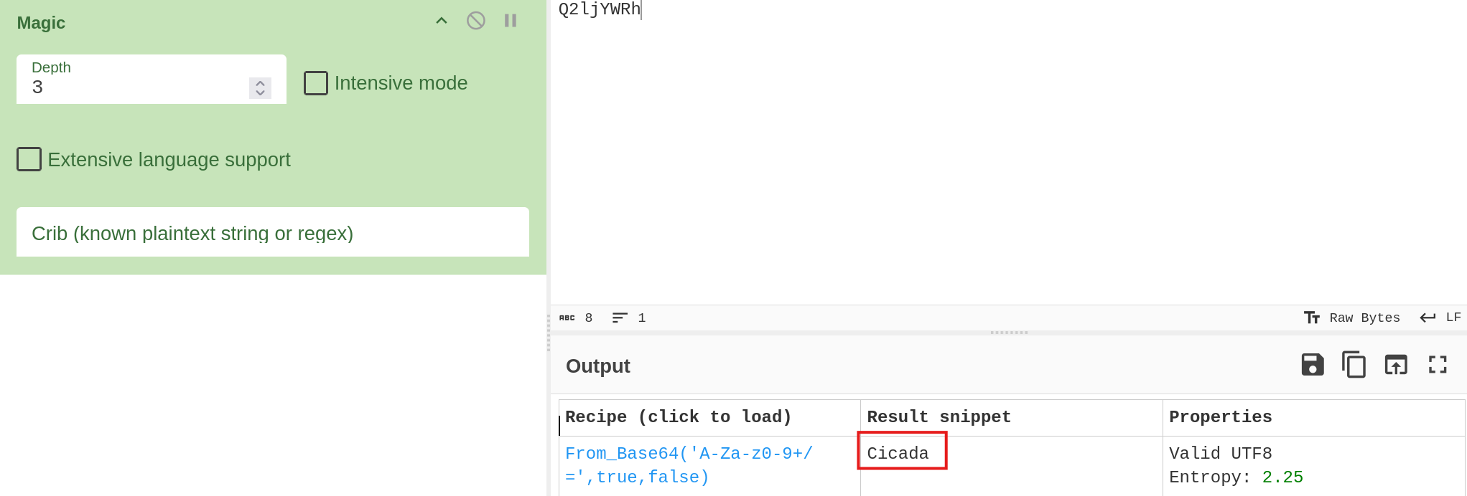
Q3: What is the final passphrase?
Ans: Ju5T_4_P455phr453!
Poc:
- Looking at the passphrase Hm5R_4_P455mhp453! and the key Cicada, it can be reasoned that a Vigenère Cipher is being used because:
  - The ciphertext contains letters and numbers in a repeating pattern.
  - A key is provided, which is typical for Vigenère encryption.
  - The structure suggests a substitution cipher rather than a simple shift or hash.
- Opening the Vigenère Cipher tool: https://www.dcode.fr/vigenere-cipher
- Entering the ciphertext: Hm5R_4_P455mhp453! Providing the key: Cicada
- Selecting the Decrypt option and running the decryption.
- The decrypted output obtained is: Ju5T_4_P455phr453!
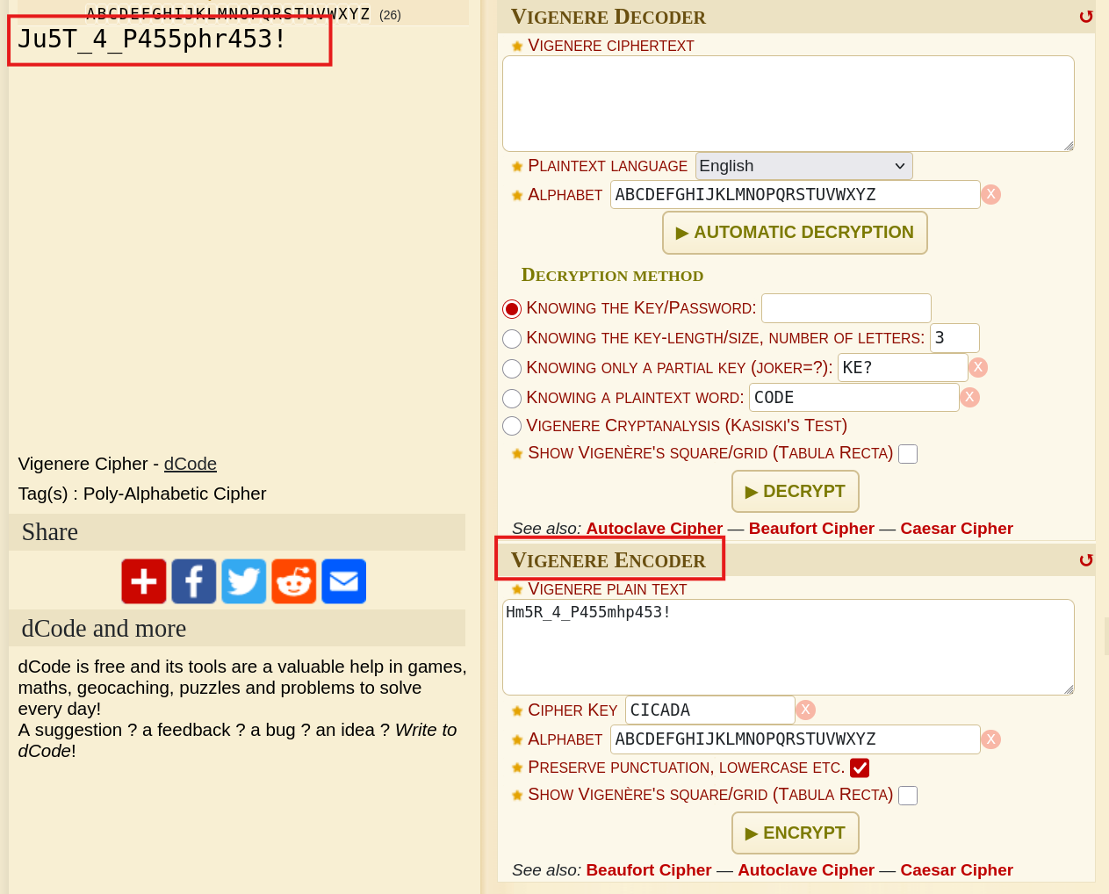
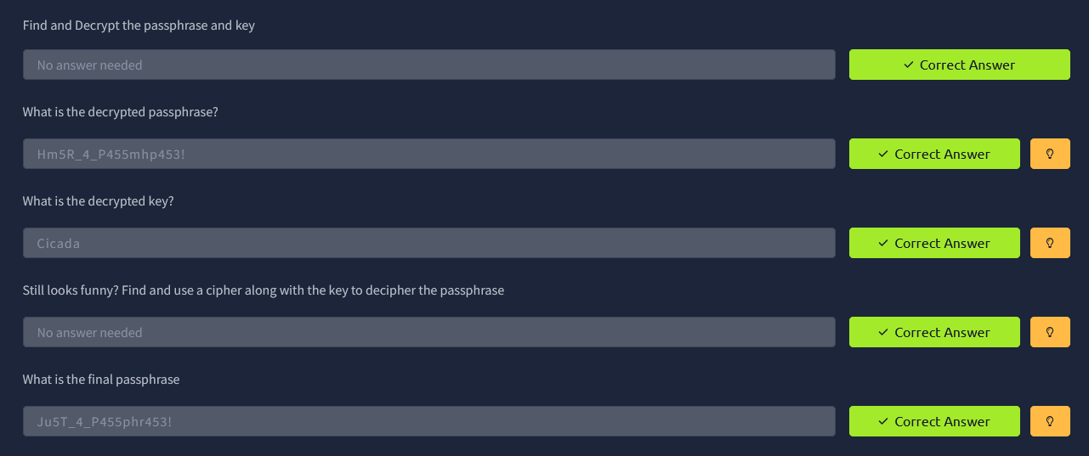

Task 4: Gather Metadata
Q1: What link is given?
Ans: https://imgur.com/a/c0ZSZga
Poc:
- Running the command: steghide extract -sf welcome.jpg
- Entering the passphrase: Ju5T_4_P455phr453!
- The hidden file Invitation.txt is extracted.
- Running the command: cat Invitation.txt
- The contents of the file reveal the embedded link.
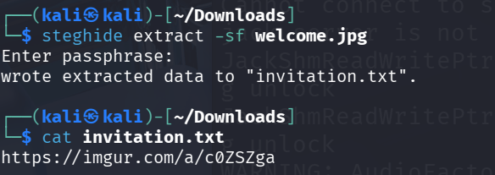
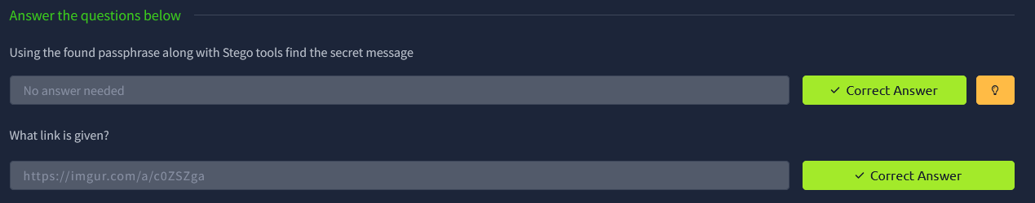

Task 5: Find Hidden Files
Q1: What tool did you use to find the hidden file
Ans: outguess
PoC:
- Opening the following webpage listing useful Cicada tools: https://uncovering-cicada.fandom.com/wiki/Useful_tools
- Looking through the list of steganography tools provided on the page.
- Observing that Outguess is listed as a tool described as: “Program for embedding and retrieving encrypted messages in JPEG images.”
- Based on this information, the tool used to find the hidden file is outguess.

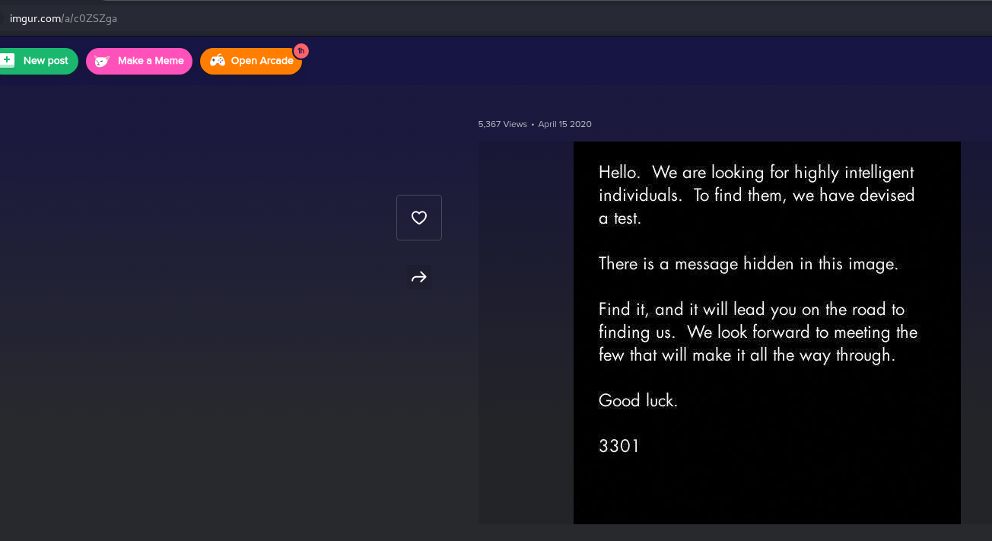

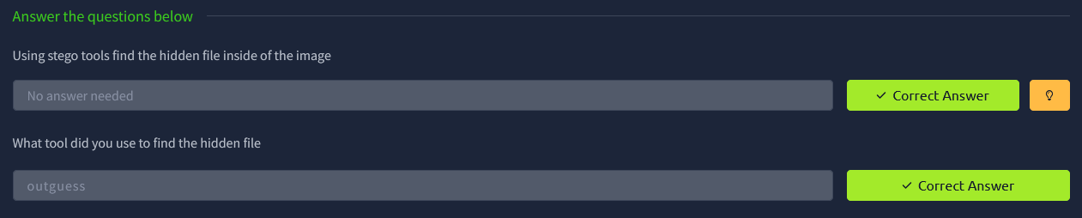

Task 6: Book Cipher
Q1: What is the Hash type?
Ans: SHA512
PoC:
- Running the command to extract hidden data from the image:
outguess -r 8580aQw.jpg extracted.txt
- The hidden content is extracted into extracted.txt, which contains the hash.
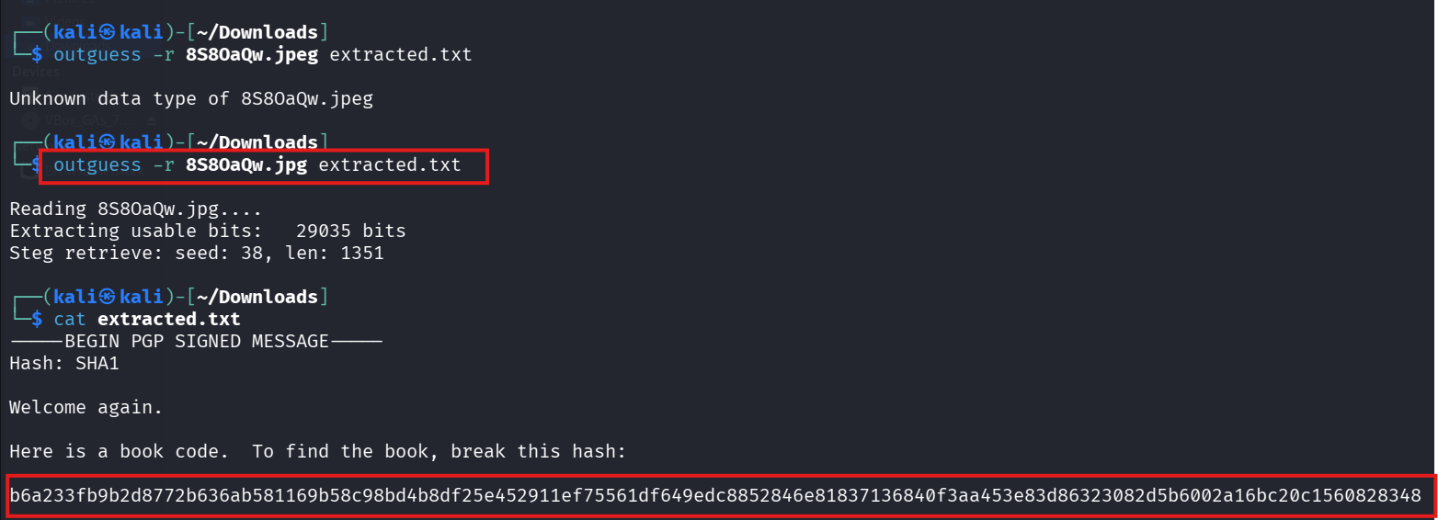
- Using a hash identification tool (hash-identifier) on the extracted hash.
- The tool identifies the hash type as: SHA512.
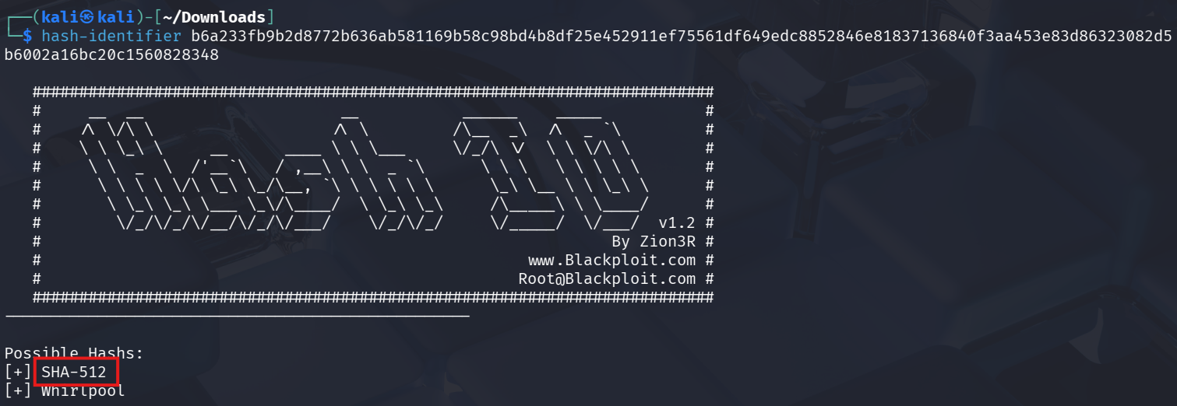
Q2: What is the Link from the hash?
Ans: https://pastebin.com/6FNiVLh5
PoC:
- Opening the SHA512 reverse lookup tool: https://md5hashing.net/hash/sha512/
- Pasting the hash into the search field and running the lookup.
- The lookup returns the decoded result, which reveals the link:
https://pastebin.com/6FNiVLh5
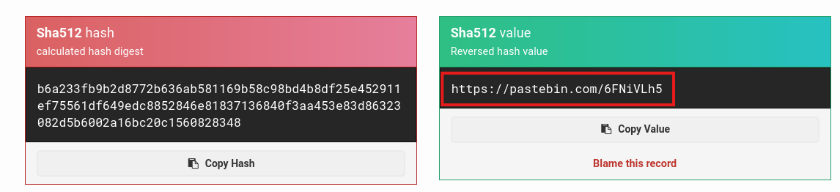

Q3: What is the link?
Ans: https://bit.ly/39pw2NH
PoC:
- Opening the link obtained from the SHA512 hash: https://pastebin.com/6FNiVLh5
- The page contains text with line numbers.
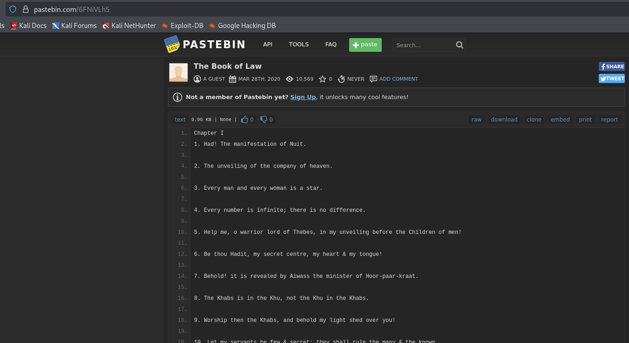
- The previously extracted extracted.txt file contains instructions specifying line numbers and letter positions.
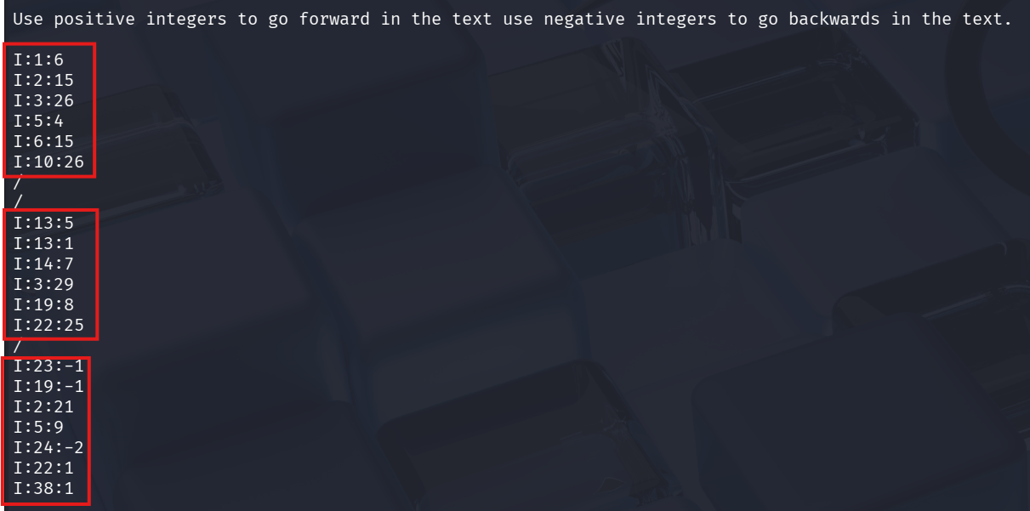
- Following these instructions, the correct letters are selected from each line to reconstruct the hidden message.
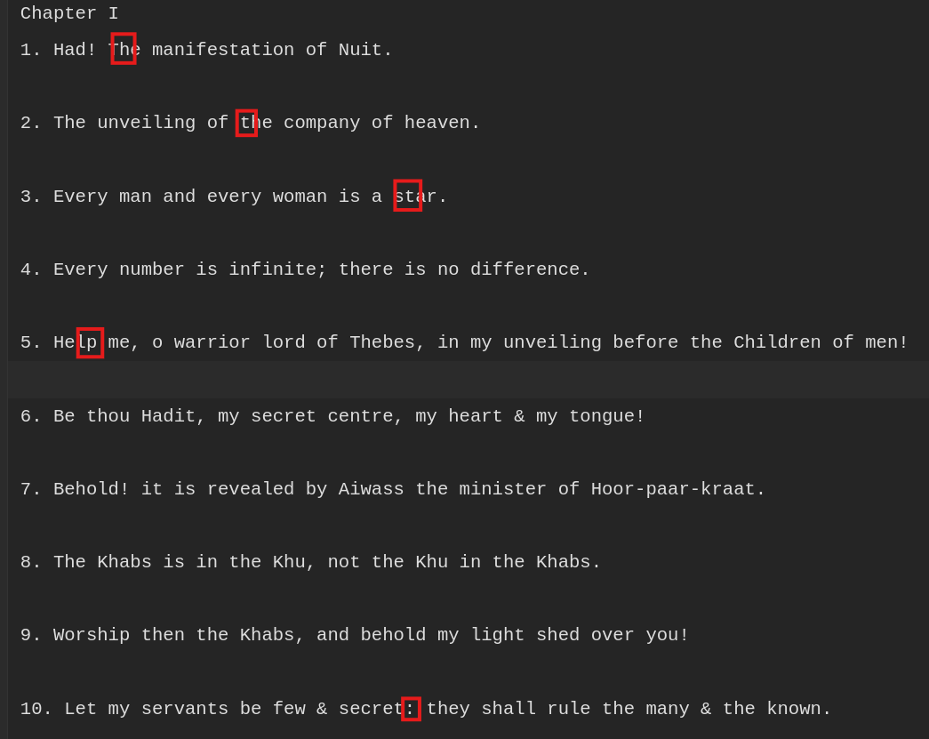
- The reconstructed message reveals the final link: https://bit.ly/39pw2NH

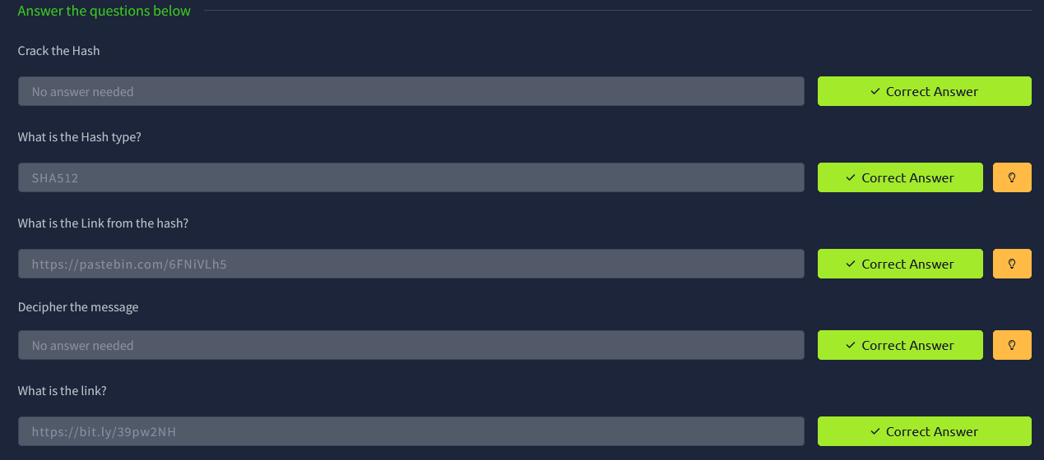

Task 7: The Final Song
Q1: What is the song linked?
Ans: The Instar Emergence

PoC:
- Opening the final link: https://bit.ly/39pw2NH
- The page contains information about a song.
- The song revealed from the link is: The Instar Emergence

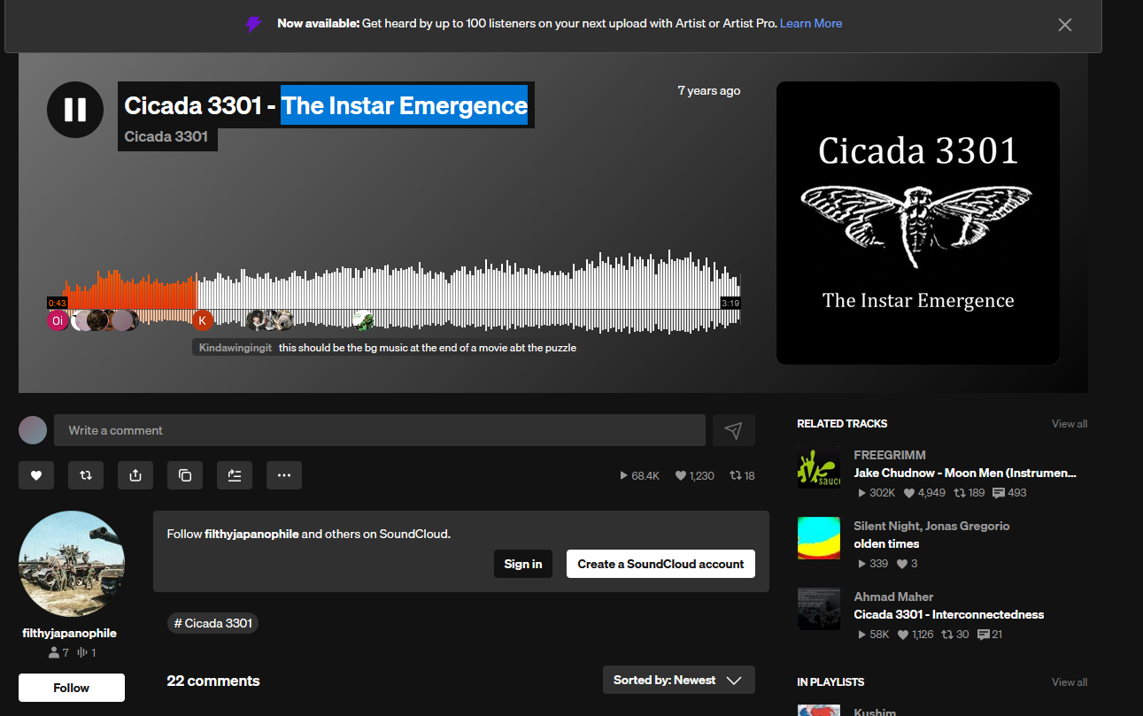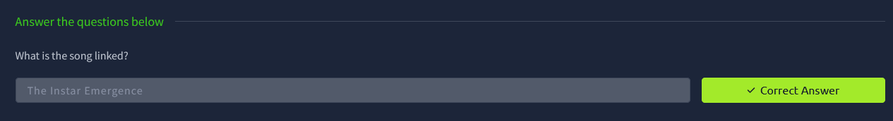

Room: Intro to Digital Forensics
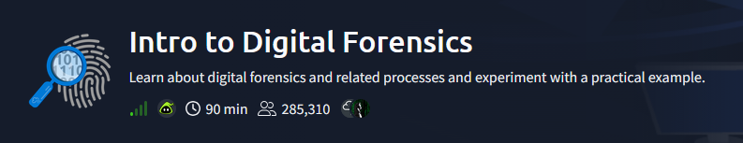

Task 1: Introduction To Digital Forensics
Q1: It is essential to keep track of who is handling it at any point in time to ensure that evidence is admissible in the court of law. What is the name of the documentation that would help establish that?
Ans: laptop
Poc:
By observing the desk in the scenario, several digital devices can be identified. In addition to the smartphone, camera, and SD cards, the laptop would also be of interest for digital forensics, as it may contain important digital evidence such as files, emails, or browsing activity.
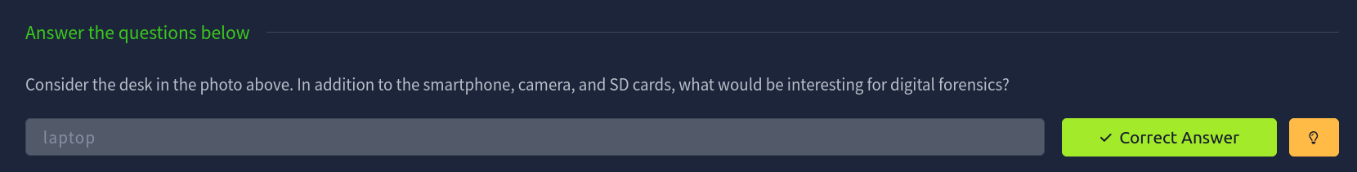

Task 2: Digital Forensics Process
Q1: It is essential to keep track of who is handling it at any point in time to ensure that evidence is admissible in the court of law. What is the name of the documentation that would help establish that?
Ans: Chain of Custody
Poc:
To ensure that digital evidence is admissible in court, it is necessary to document every person who handles the evidence at each stage of the investigation. This documentation records when the evidence was collected, transferred, stored, and analyzed. This process is known as maintaining the Chain of Custody, which ensures that the evidence has not been tampered with and has only been accessed by authorized personnel.
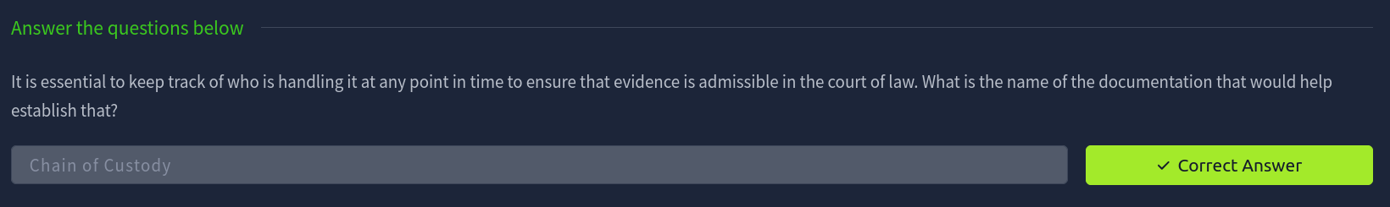

Task 3: Practical Example of Digital Forensics
Q1: Using pdfinfo, find out the author of the attached PDF file, ransom-letter.pdf.
Ans: Ann Gree Shepherd
Poc:

PoC:
Running the following command: pdfinfo ransom-letter.pdf. The pdfinfo tool displays the metadata information of the PDF file. From the output, the Author field shows the name Ann Gree Shepherd.
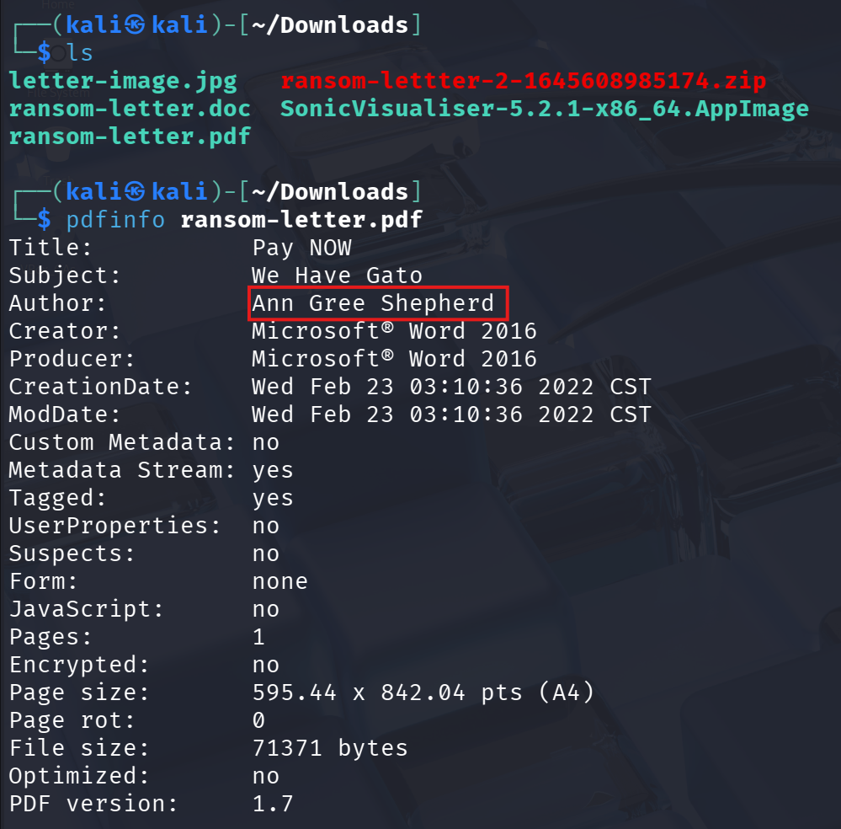
Q2: Using exiftool or any similar tool, try to find where the kidnappers took the image they attached to their document. What is the name of the street?
Ans: Milk Street
Poc:

PoC:
- Running the following command to view the metadata of the image: exiftool letter-image.jpg
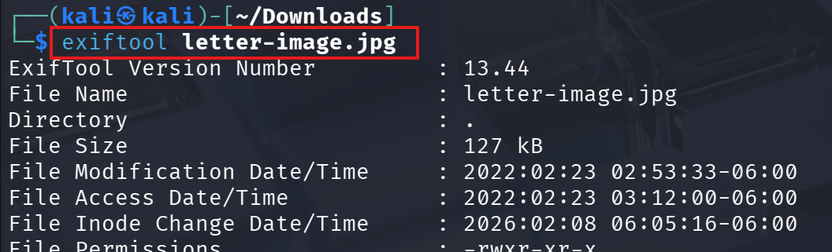
- The output displays various metadata fields, including the GPS Latitude and GPS Longitude coordinates.
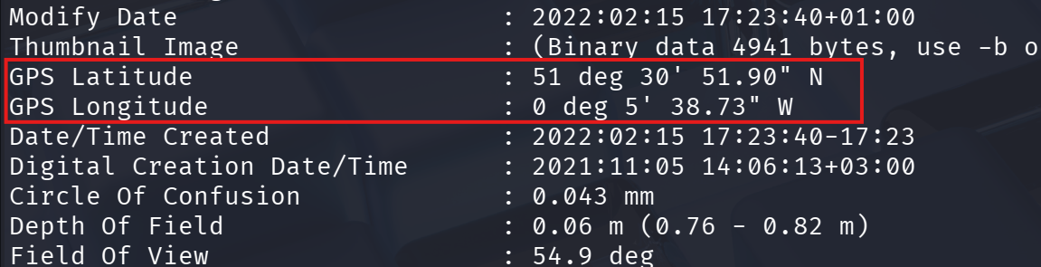
- Copying the GPS coordinates from the output.
- Opening Google Maps and pasting the coordinates into the search bar.
- The searched location reveals the street name as Milk Street.
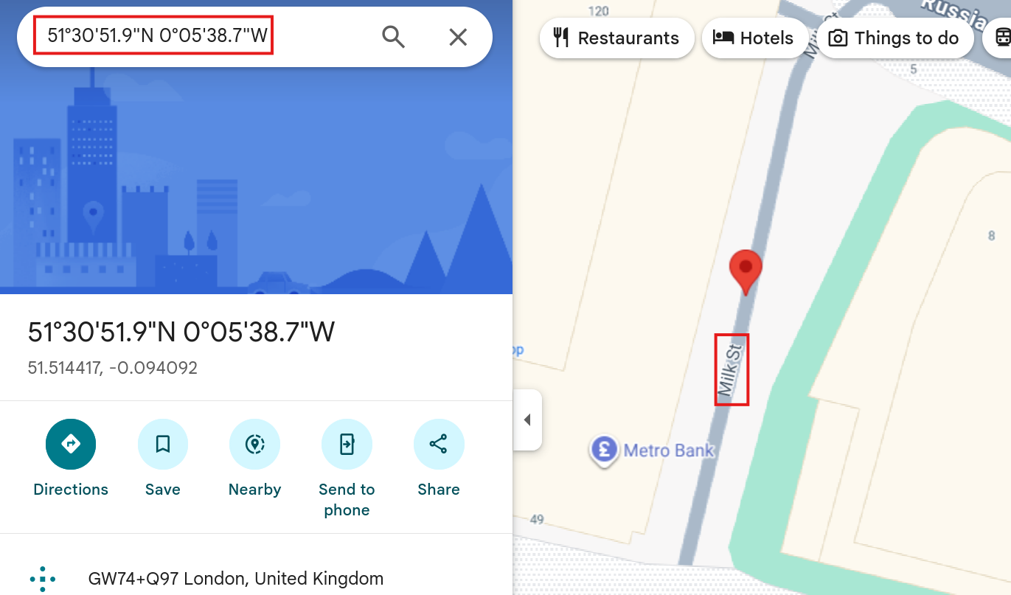

Q3: What is the model name of the camera used to take this photo?
Ans: Canon EOS R6
Poc:
- Running the following command to view the image metadata: exiftool letter-image.jpg
- The exiftool output displays various metadata fields of the image.
- Looking at the Camera Model Name field in the output.
- The model name identified is Canon EOS R6.
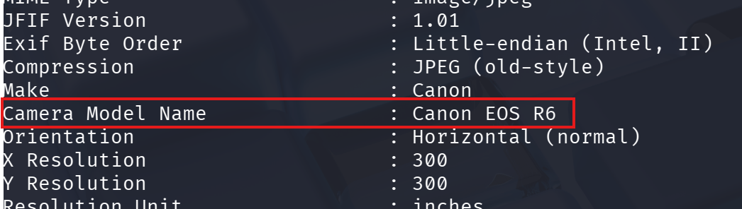
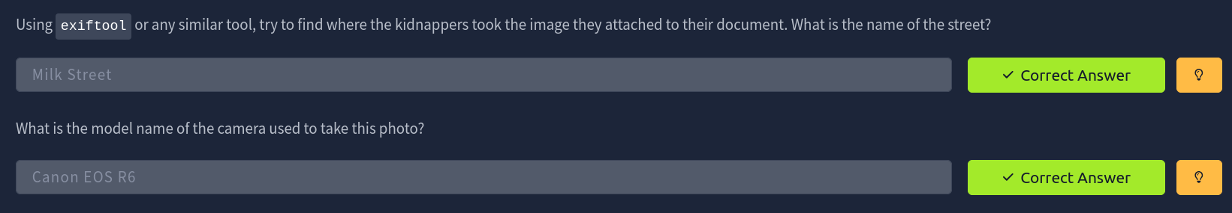

Room: Digital Forensics Case B4DM755
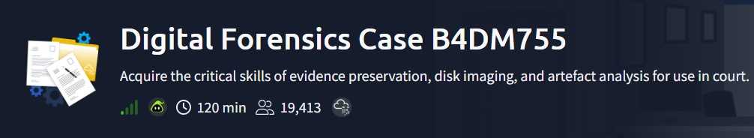

Task 2: Case B4DM755: Details of the Crime
Q1: What is your official role?
Ans: Forensics Lab Analyst
PoC:
From the given scenario, the role assigned at the law enforcement agency is mentioned as Forensics Lab Analyst, responsible for analysing artefacts collected from crime scenes.

Q2: What role was assigned to you for this specific scenario?
Ans: DFIR First Responder
PoC:
The scenario states that the agency assigned a DFIR (Digital Forensics & Incident Response) First Responder to handle the acquisition of digital artefacts during the operation.

Q3: What do you have to gather?
Ans: Digital artefacts and evidence
PoC:
According to the scenario, the assigned DFIR First Responder is responsible for collecting digital artefacts and evidence from the suspect and the crime scene for further forensic analysis.

Q4: What document is needed before performing any legal search?
Ans: Search warrant
PoC:
The scenario explains that the court issued a search warrant, which is the legal authorization required before conducting any search or evidence collection.
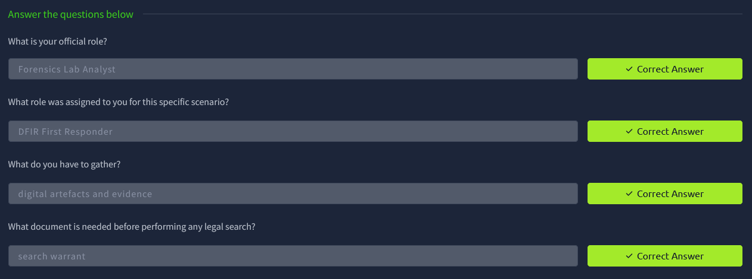

Task 3: Practical Application of the Digital Forensics Process
Q1: Before imaging drives, what must we check them for?
Ans: Drive encryption
PoC:
According to the forensic acquisition guidelines, before taking an image of any drive, it is necessary to check whether the drive is encrypted, as encryption may affect the imaging and analysis process.

Q2: What should be done to ensure and maintain the integrity of original files in the Chain of Custody?
Ans: Hash and copy
PoC:
To maintain the integrity of the original evidence, the obtained files should be hashed and copied, ensuring that the original data remains unchanged while analysis is performed on the copy.

Q3: What must be done before sending obtained artefacts to the Forensics Laboratory?
Ans: Bag, Seal, and Tag the obtained artefacts
PoC:
Before transferring the artefacts to the Forensics Laboratory, the collected evidence must be bagged, sealed, and tagged properly to ensure secure handling and proper chain of custody documentation.
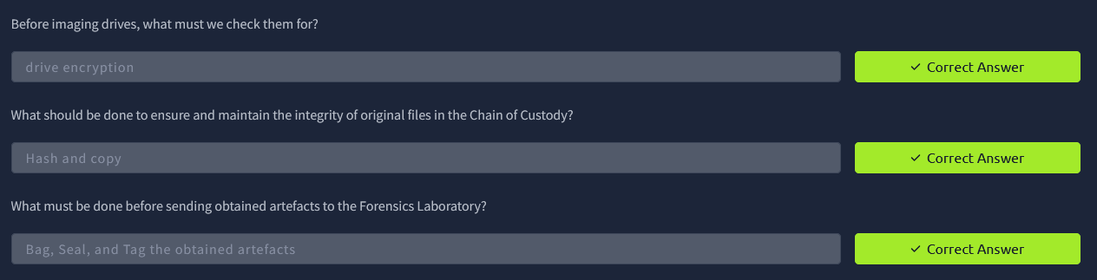

Task 4: Case B4DM755: At the Scene of Crime
Q1: What is the only possible artefact found in the suspect's residence?
Ans: Flash drive
PoC:
From the scenario, a flash drive was discovered under the suspect’s desk, attached to a key chain with the initials WSM, and no other digital artefacts were mentioned as being found at the residence.

Q2: Based on the scenario and the previous task, what should be done with that acquired suspect artefact?
Ans: Taking an image
PoC:
Following the digital forensics process, the acquired flash drive should undergo forensic imaging so that analysis can be performed on a copy without altering the original evidence.

Q3: What is the crucial aspect of the Chain of Custody that ensures individual accountability and guarantees a transparent and untainted transfer of artefacts and evidence?
Ans: Ensure proper documentation
PoC:
Proper documentation in the Chain of Custody records who handled the artefact at each stage, ensuring accountability and preventing any evidence tampering.
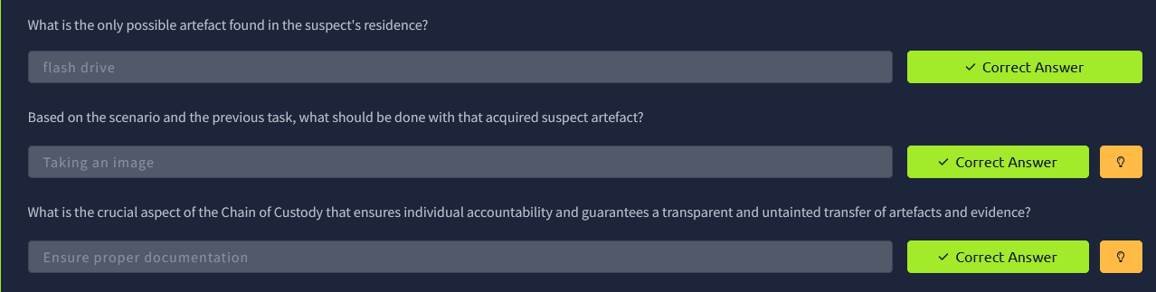

Task 5: Introduction to FTK Imager
Q1: What device will prevent tampering when acquiring a forensic disk image?
Ans: Write-blocking device
PoC:
A write-blocking device is used when connecting a suspect drive or forensic artefact to the analysis machine. It prevents any accidental changes to the original evidence while allowing access for imaging or examination.

Q2: What is the UI element of FTK Imager which displays a hierarchical view of the added evidence sources?
Ans: Evidence Tree Pane
PoC:
In FTK Imager, the Evidence Tree Pane shows a hierarchical view of all added evidence sources, such as hard drives, flash drives, or forensic image files, making it easier to navigate the data structure.

Q3: Is the attached flash drive encrypted? (Y/N)
Ans: N
PoC:
After detecting EFS encryption on the attached virtual flash drive through File > Detect EFS Encryption, the tool indicates that the drive is not encrypted.

Q4: What is the UI element of FTK Imager which displays a list of files and folders?
Ans: File List Pane
PoC:
The File List Pane in FTK Imager displays all the files and folders contained in the selected directory from the Evidence Tree Pane, allowing the analyst to view the content of the evidence.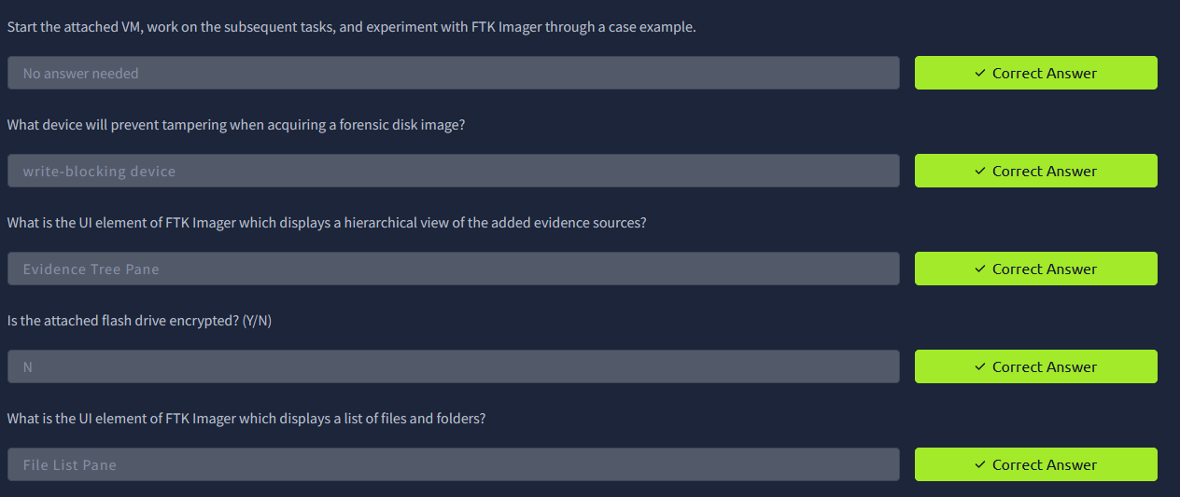

Task 6: Using FTK Imager to Acquire Digital Artefacts and Evidence
Q1: What is the UI element of FTK Imager which displays the content of selected files?
Ans: Viewer Pane
PoC:
The Viewer Pane displays the content of selected files from either the Evidence Tree Pane or File List Pane, allowing the analyst to examine files without modifying the original evidence.

Q2: What is the SHA1 hash of the physical drive and forensic image?
Ans: d82f393a67c6fc87a023b50c785a7247ab1ac395
PoC:
Following the FTK Imager instructions, the SHA1 hash of both the physical drive and the forensic image was calculated to verify the integrity of the evidence.
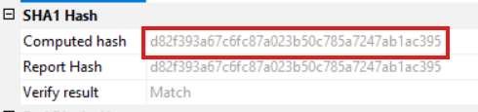

Q3: Including hidden files, how many files are currently stored on the flash drive?
Ans: 8
PoC:
Counting all regular and hidden files in FTK Imager, the flash drive contains a total of 8 files.
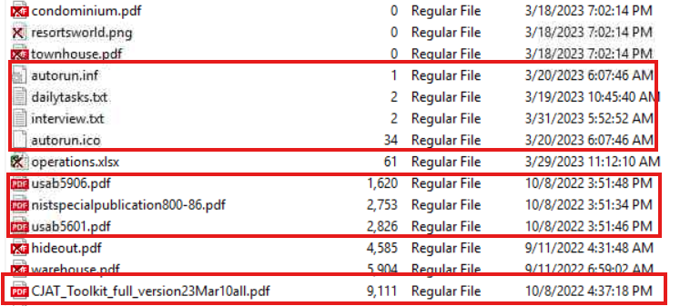

Q4: How many files were deleted in total?
Ans: 6
PoC:
Deleted files are marked with a cross in FTK Imager. Counting these marked files shows a total of 6 deleted files.
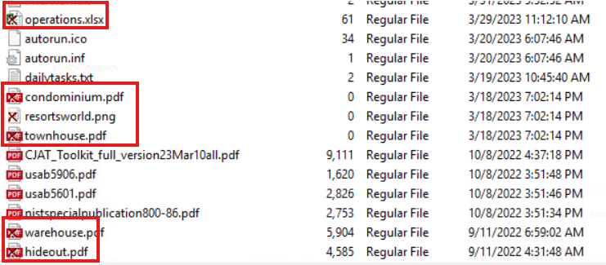

Q5: How many recovered files are corrupted (e.g., 0 file size)?
Ans: 3
PoC:
Among the recovered files, 3 files are corrupted, as their file size is 0, indicating they cannot be accessed or used.
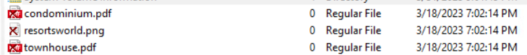
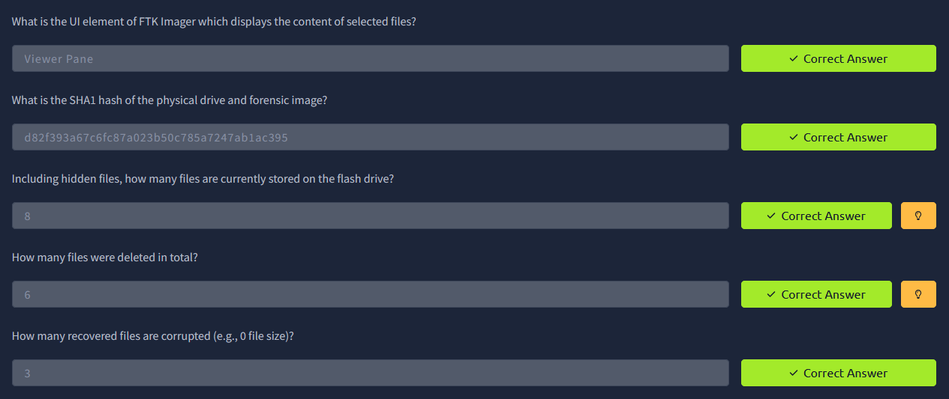

Task 7: Case B4DM755: At the Forensics Laboratory
Q1: Aside from FTK Imager, what is the directory name of the other tool located in the tools directory under Desktop?
Ans: exiftool-12.47
Poc:
Navigating to C:/tools and running a directory listing shows the folder exiftool-12.47 alongside other tools.
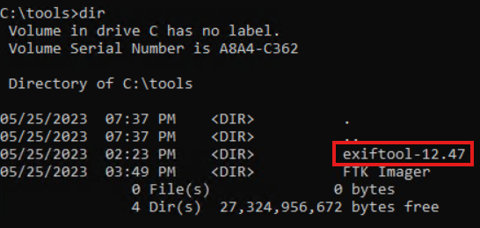

Q2: What is the visible extension of the "hideout" file?
Ans: .pdf
Poc:

Q3: View the metadata of the "hideout" file. What is its actual extension?
Ans: .jpg
Poc:
Using exiftool on the hideout file displays its metadata, revealing that the actual file type is .jpg.
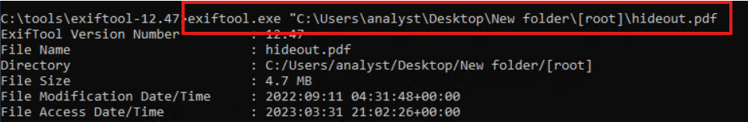

Q4: A phone was used to photograph the "hideout". What is the phone's model?
Ans: ONEPLUS A6013
Poc:
Checking the metadata of the hideout file with exiftool also reveals the phone model used to take the photo, which is ONEPLUS A6013.

Q5: A phone was used to photograph the "warehouse". What is the phone's model?
Ans: Mi 9 Lite
Poc:
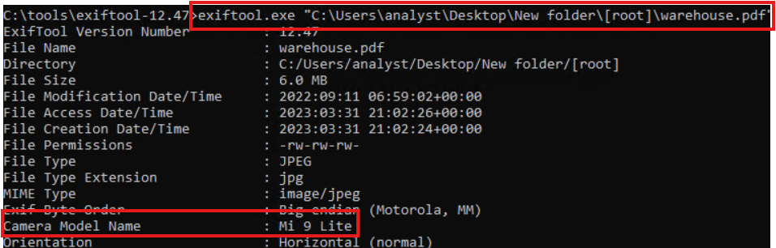

Q6: Are there any indications that the suspect is involved in other illegal activity? (Y/N)
Ans: Y
Poc:
During forensic analysis, a file was found that was misleading in nature (appeared as one type but contained different hidden data). Further inspection revealed suspicious hidden/obfuscated content, indicating possible involvement in other illegal activities beyond the primary case.

Q7: Who was the point of contact of Mr William S. McClean in 2022?
Ans: Karl Renato Abelardo
Poc:
Examining the metadata of operation.xlsx revealed a hidden file named notes.txt. By renaming the file to operation.zip and extracting it, the notes.txt file was recovered, which contained the name Karl Renato Abelardo as the point of contact.
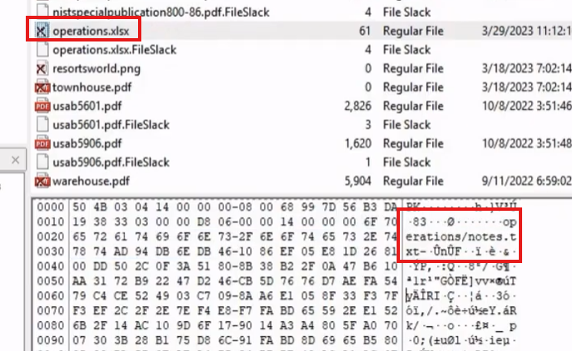
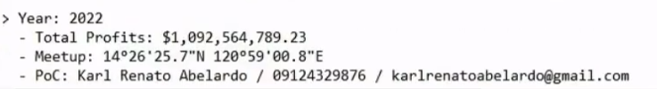

Q8: A meetup occurred in 2022. What are the GPS coordinates during that time?
Ans: 14°26'25.7"N 120°59'00.8"E
Poc:
The GPS coordinates were found in the notes.txt file recovered from the hidden content inside operation.xlsx (renamed and unzipped). They indicate the location of the meetup in 2022.


Q9: What is the password to extract the contents of pandorasbox.zip?
Ans: DarkVault$Pandora=DONOTOPEN!K1ngCr1ms0n!
Poc:
The password was located inside the notes.txt file recovered earlier, which contained the credentials needed to extract the contents of pandorasbox.zip.
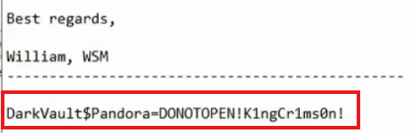

Q10: From which company did the source code in the pandorasbox directory originate?
Ans: SwiftSpend Financial
Poc:
After extracting pandorasbox.zip using the recovered password, the HFT_Algorithm folder was opened. Viewing the contents of main.py revealed comments and identifiers indicating that the source code originated from SwiftSpend Financial.
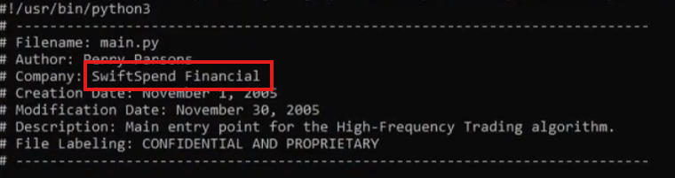

Q11: In one of the documents that the suspect has yet to sign, who was listed as the beneficiary?
Ans: Mr. Giovanni Vittorio DeVentura
Poc:
After extracting the evidence files, the MUST_CLean folder was examined. Opening the unsigned .odt document inside the folder revealed the beneficiary section, where Mr. Giovanni Vittorio DeVentura was listed as the beneficiary.
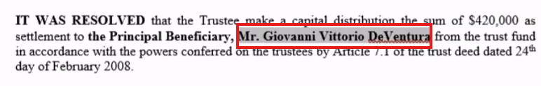

Q12: What is the hidden flag?
Ans: THM{sCr0LL_sCr0LL_cL1cK_cL1cK_4TT3NT10N_2_D3T41L5_15_CRUC14L!!}
Poc:
Inside the pandorasbox folder, there was a file named DONOTOPEN. This file was opened with a text editor, revealing the hidden flag text clearly written inside.
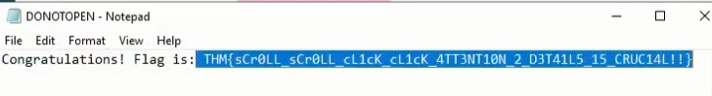


Task 8: Post-Analysis of Evidence to Court Proceedings
Q1: In which phase is a warrant obtained for search, seizure, and examination of the suspect's computer data due to violations of domestic and international laws?
Ans: Pre-search
PoC:
According to the procedure, a warrant for search, seizure, and examination is obtained during the Pre-search phase before any data collection or inspection begins.

Q2: In which phase is a forensic analysis performed on the acquired digital evidence requested from various sources?
Ans: Post-search
PoC:
After acquiring the digital artefacts and evidence, a forensic analysis is conducted in the Post-search phase to examine the collected data for relevant findings.

Q3: Which phase involves presenting forensic artefacts and evidence with proper documentation in a court of law?
Ans: Trial
PoC:
During the Trial phase, the collected forensic artefacts and evidence, along with proper documentation, are presented in court to support legal proceedings.
