
Assignment-02
Web Pentesting and Bug Hunting - Batch-20

Basic Cryptography & Steganography

SUBMITTED BY
Md Sayem Mottakee
Student Id: CB-2025-862

SUBMITTED To

Mahfujur Rahman
Instructor, Cyber Bangla Academy

MD Tarik Anam
course coordinator, Cyber Bangla Academy

Room: Active Reconnaissance 3
Task 2: Web Browser 3
Task 3: Ping 3
Task 4: Traceroute 5
Task 5: Telnet 6
Task 6: Netcat 7
Room: Passive Reconnaissance 8
Task 2: Passive Versus Active Recon 8
Task 3: Whois 9
Task 4: nslookup and dig 10
Task 5: DNSDumpster 10
Task 6: Shodan.io 11

Room: Active Reconnaissance
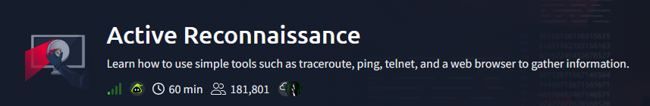

Task 2: Web Browser
Q1: Browse to the following website and ensure that you have opened your Developer Tools on AttackBox Firefox, or the browser on your computer. Using the Developer Tools, figure out the total number of questions.
Ans: 8
Poc:
Going to the given website and opening it in the browser, then pressing F12 to open Developer Tools. After that, navigating to the Debugger section and opening the script.js file. Inside the script, the question list shows the total number of questions is 8.
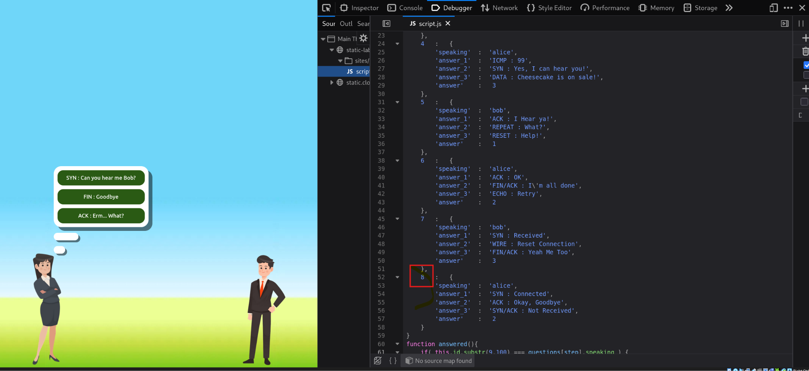

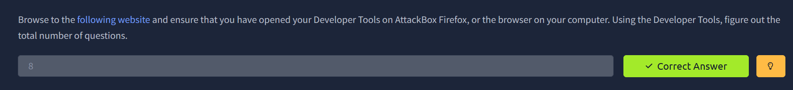

Task 3: Ping
Q1: Which option would you use to set the size of the data carried by the ICMP echo request?
Ans: -s
PoC:
In the terminal, running man ping and checking the options shows that -s is used to specify the packet data size.

Q2: What is the size of the ICMP header in bytes?
Ans: 8
PoC:
Reading the man ping manual page shows that the ICMP header size is 8 bytes.

Q3: Does MS Windows Firewall block ping by default? (Y/N)
Ans: Y
PoC:
From the task description and Windows default firewall configuration, ICMP echo requests are blocked by default.

Q4: How many ping replies did you get back after running ping -c 10 MACHINE_IP?
Ans: 10
PoC:
Running ping -c 10 MACHINE_IP in the AttackBox terminal shows 10 packets transmitted and 10 received, meaning 10 replies were received.
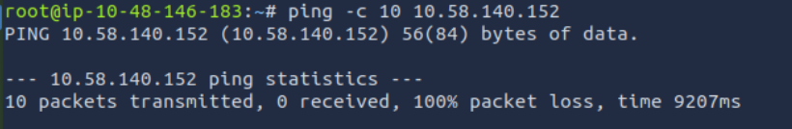
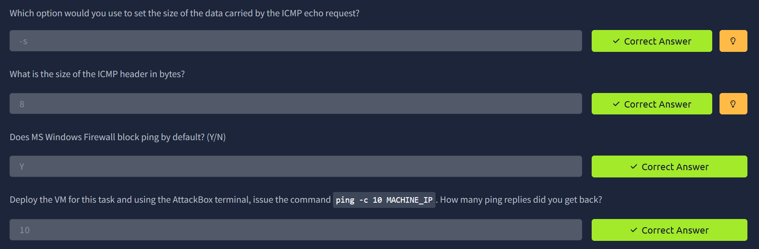

Task 4: Traceroute
Q1: In Traceroute A, what is the IP address of the last router/hop before reaching tryhackme.com?
Ans: 172.67.69.208
PoC:
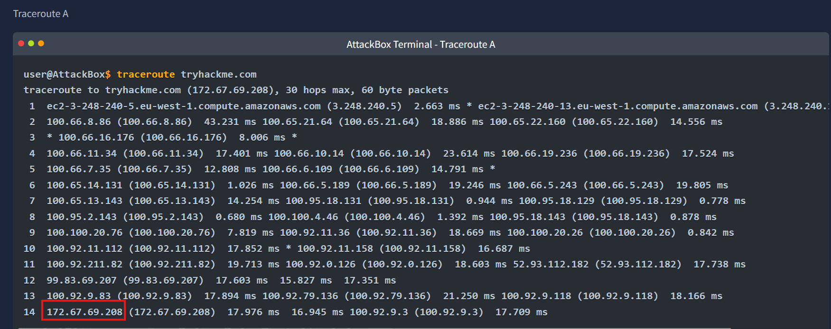

Q2: In Traceroute B, what is the IP address of the last router/hop before reaching tryhackme.com?
Ans: 104.26.11.229
PoC:
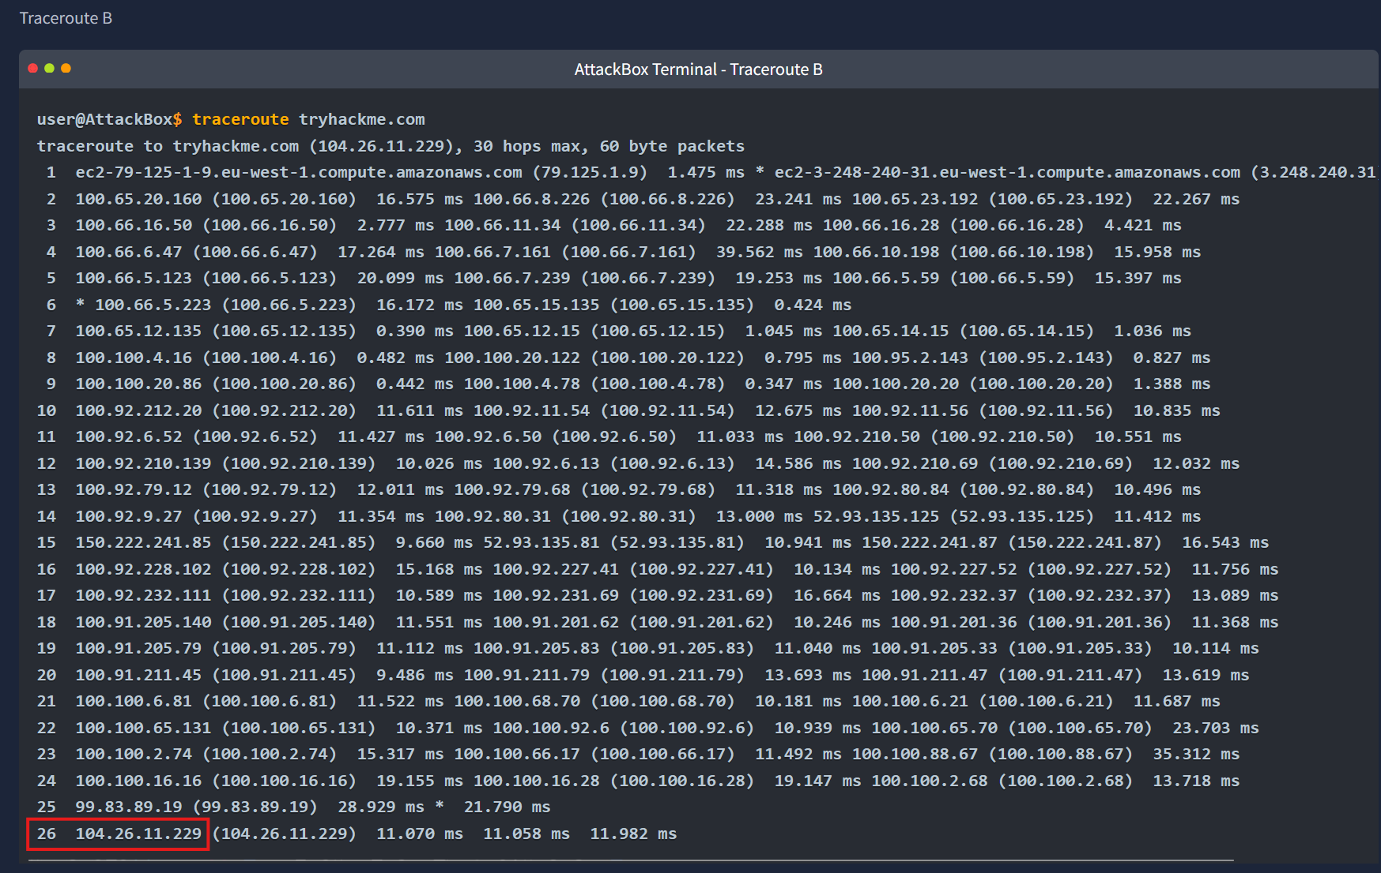

Q3: In Traceroute B, how many routers are between the two systems?
Ans: 26
PoC:

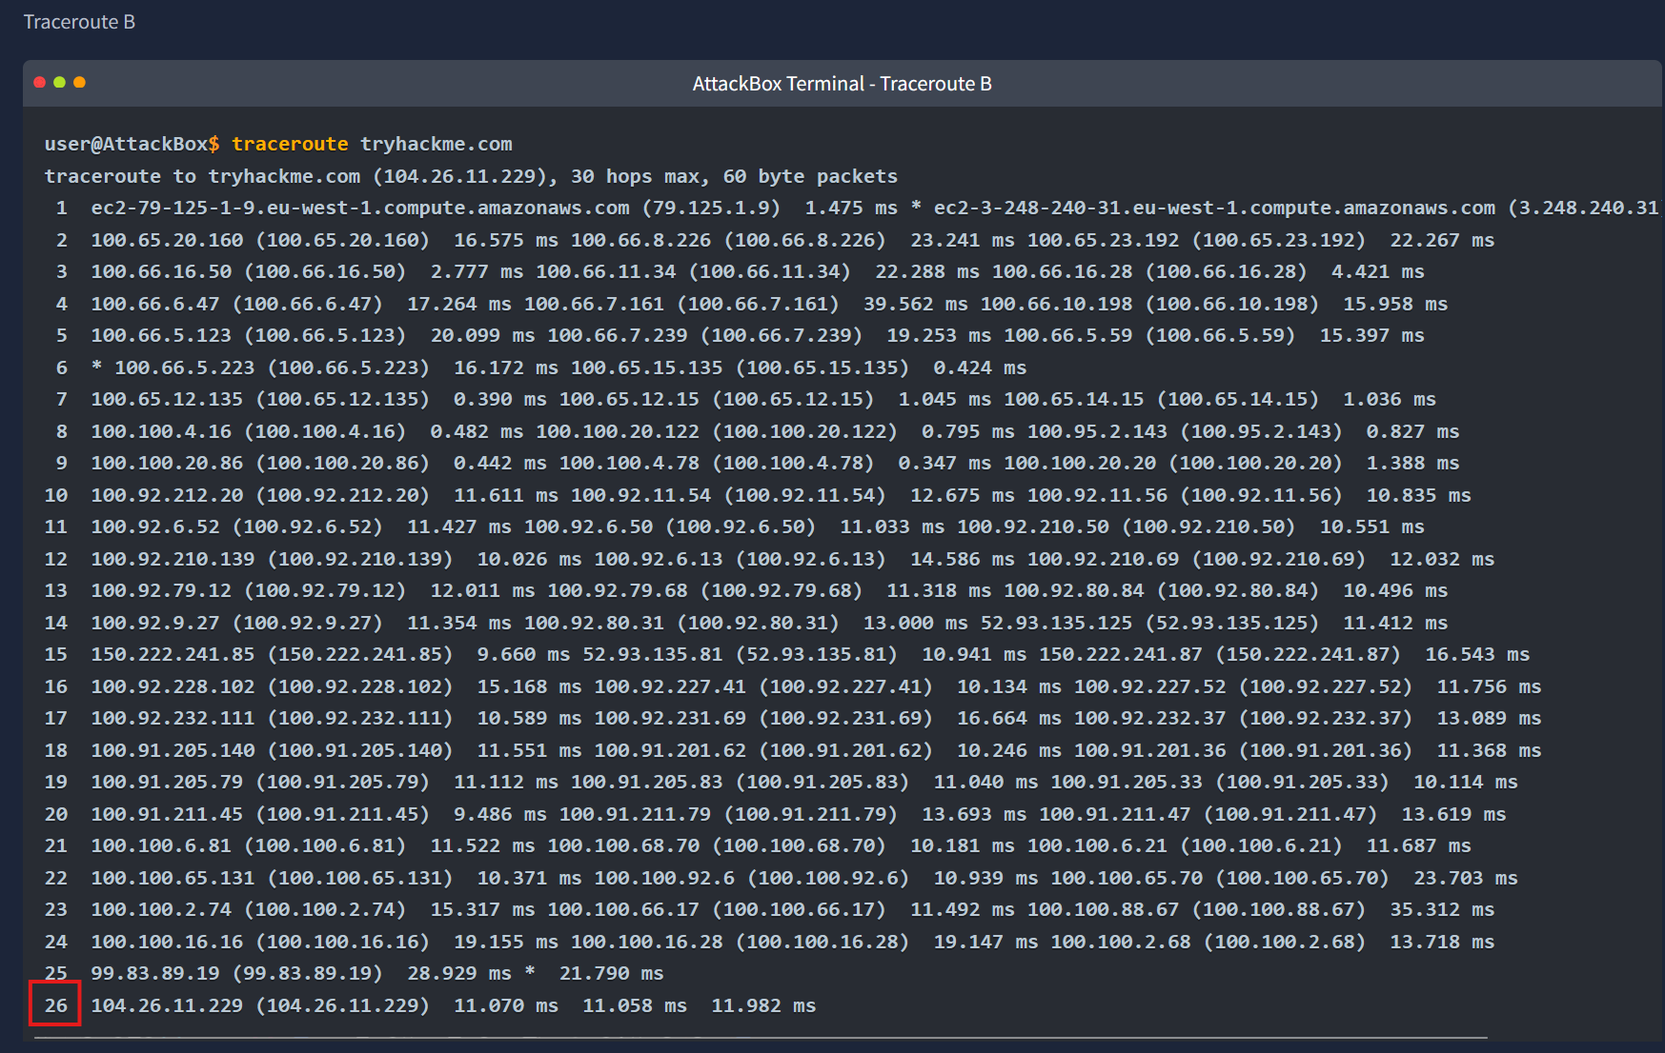
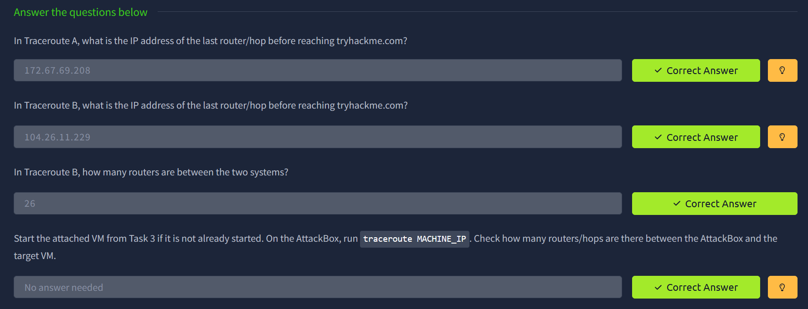

Task 5: Telnet
Q1: What is the name of the running server (on port 80)?
Ans: Apache

Q2: What is the version of the running server (on port 80 of the VM)?
Ans: 2.4.61
PoC:
Using telnet 10.48.140.152 80, the HTTP response header displayed Server: Apache/2.4.61, which confirms the server version.
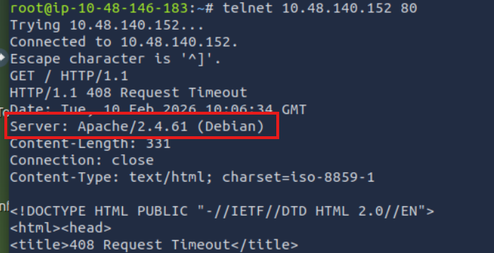
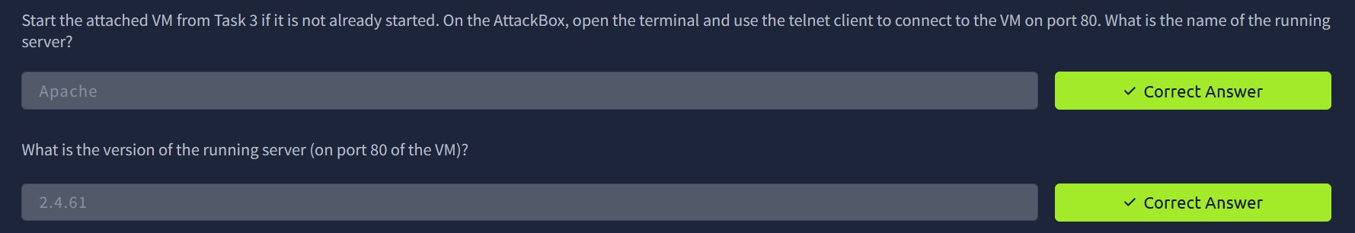

Task 6: Netcat
Q1: What is the version of the running server on port 21?
Ans: 0.17
Poc:
Using the AttackBox terminal, I ran the command nc 10.49.181.18 21 to connect to the FTP service. After the connection was established, the FTP server banner appeared on the screen, which showed the running server version as 0.17.
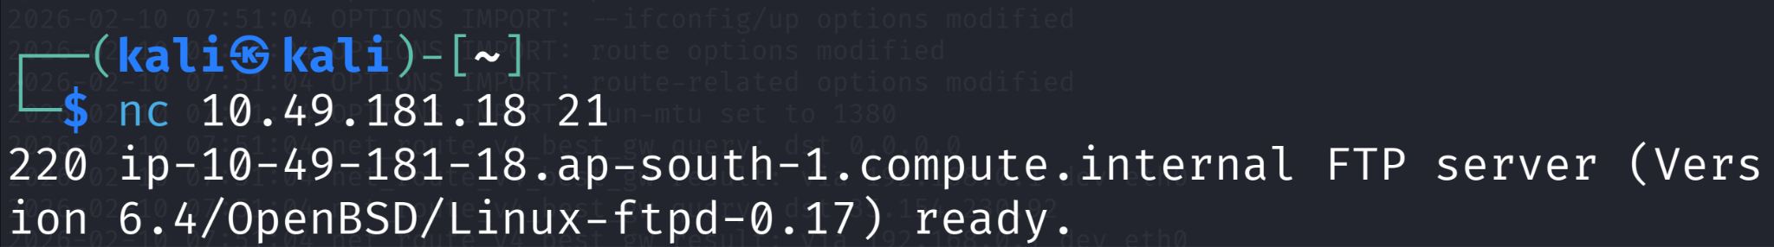

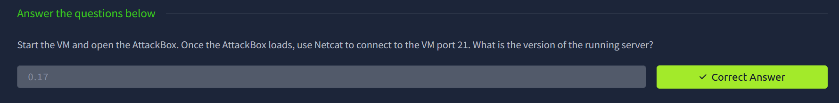

Room: Passive Reconnaissance
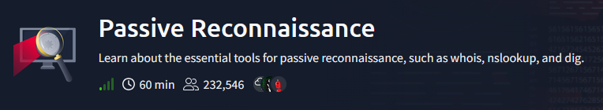

Task 2: Passive Versus Active Recon
Q1: You visit the Facebook page of the target company to get employee names. What kind of reconnaissance is this?
Ans: P
PoC:
This activity relies on publicly available information without any direct engagement with the target’s systems or infrastructure. By viewing the company’s Facebook page, information is gathered passively, making this an example of passive reconnaissance.

Q2: You ping the IP address of the company webserver to check if ICMP is blocked. What kind of reconnaissance is this?
Ans: A
PoC:
Pinging the company’s webserver requires sending ICMP packets directly to the target system to test its response. Since this involves direct interaction with the target, it is classified as active reconnaissance.

Q3: You meet the IT administrator and use social engineering to get system details. What kind of reconnaissance is this?
Ans: A
PoC:
Using social engineering to obtain information involves direct engagement with a company employee. Due to this direct interaction with the target organization, the activity falls under active reconnaissance.
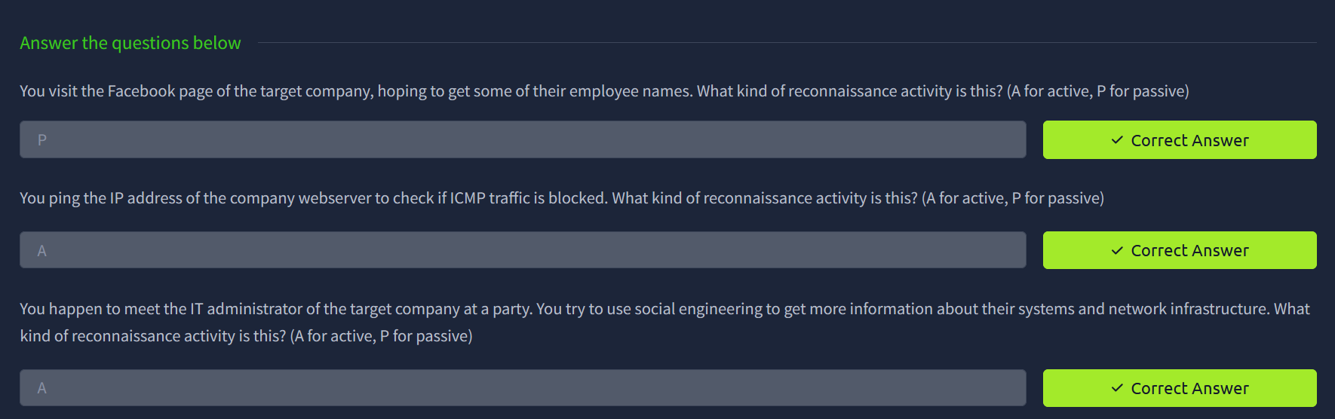

Task 3: Whois
Q1: When was TryHackMe.com registered?
Ans: 20180705

Q2: What is the registrar of TryHackMe.com?
Ans: namecheap.com

Q3: Which company is TryHackMe.com using for name servers?
Ans: cloudflare.com

PoC:
Using the WHOIS protocol, the domain information for tryhackme.com was queried from a WHOIS server over TCP port 43. The response revealed the domain’s registration details, including the creation date (2018‑07‑05), the registrar (Namecheap) responsible for maintaining the WHOIS records, and the name servers provided by Cloudflare. This information was obtained by inspecting the WHOIS output returned for the domain.
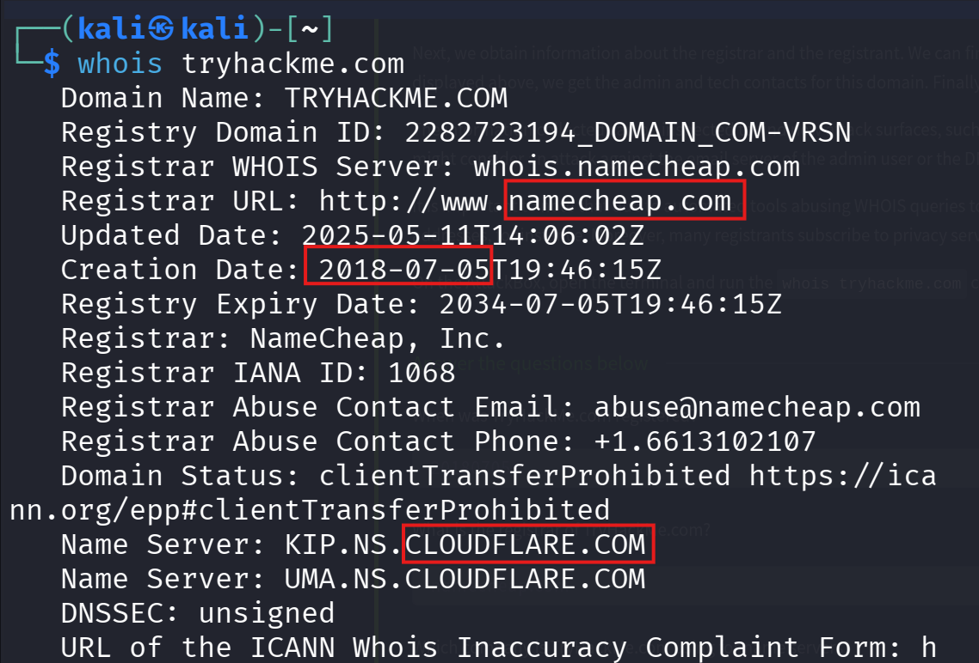
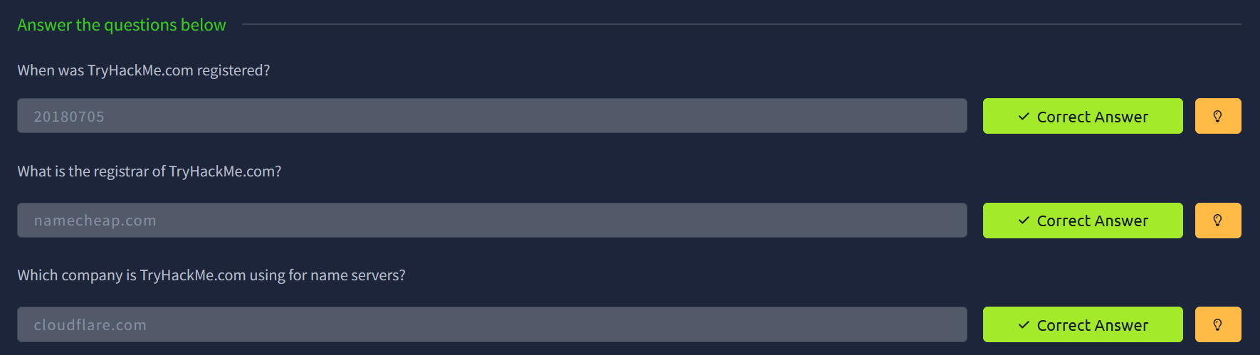

Task 4: nslookup and dig
Q1: Check the TXT records of thmlabs.com. What is the flag there?
Ans: THM{a5b83929888ed36acb0272971e438d78}
PoC:
Using nslookup -type=txt thmlabs.com, the TXT records were queried, and the flag was found directly in the output.
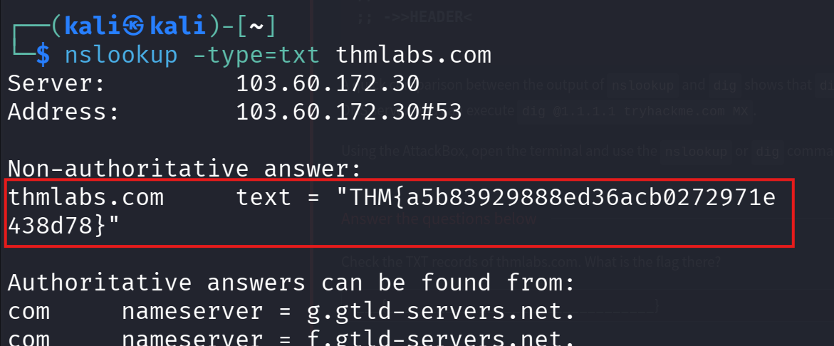
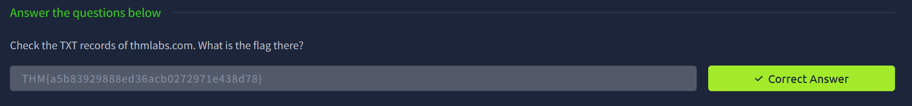

Task 5: DNSDumpster
Q1: Lookup tryhackme.com on DNSDumpster. What is one interesting subdomain discovered (other than www and blog)?
Ans: remote
PoC:
Opening DNSDumpster in the browser and searching for tryhackme.com displayed multiple subdomains. From the results, remote.tryhackme.com was identified as an additional subdomain besides www and blog.
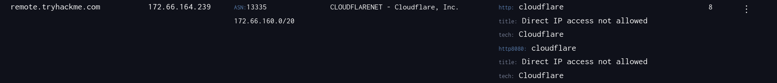
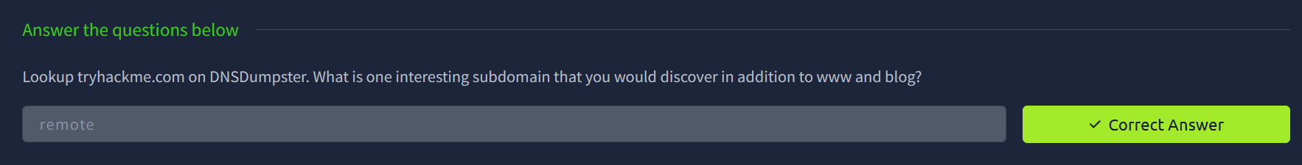

Task 6: Shodan.io
Q1: According to Shodan.io, what is the first country in the world in terms of the number of publicly accessible Apache servers?
Ans: United States
PoC:
Opening Shodan.io and searching for Apache displayed global statistics, where the United States appeared as the top country with the highest number of publicly accessible Apache servers.

Q2: Based on Shodan.io, what is the 3rd most common port used for Apache?
Ans: 8080
PoC:
Using Shodan.io to review Apache-related statistics showed that port 8080 is listed as the third most commonly used port for Apache servers.
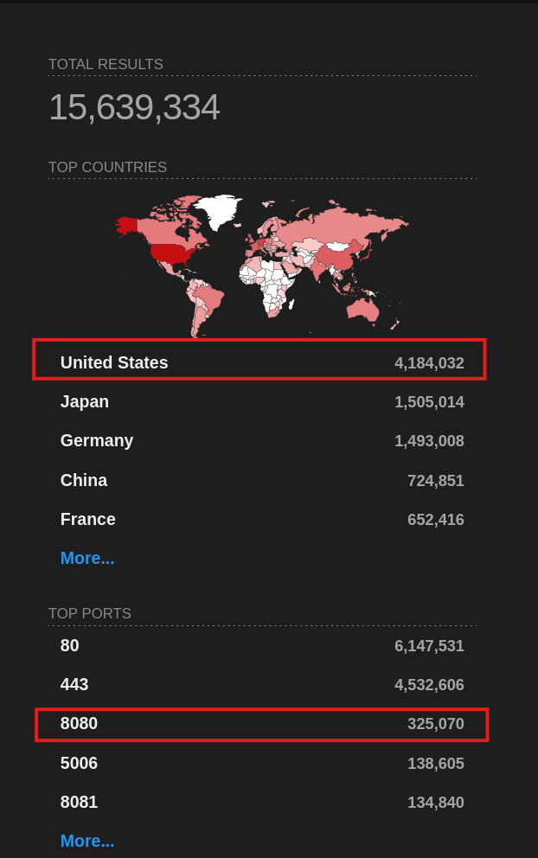

Q3: Based on Shodan.io, what is the most common port used for nginx?
Ans: 80
PoC:
Checking nginx statistics on Shodan.io showed that port 80 is the most commonly used port for nginx servers.

