Assignment-03
Cyber Bangla (CB)



Cyber Bangla Batch 20
Web Pentesting and Bug Hunting

SUBMITTED BY
Name: Md Sayem Mottakee
Batch Id: CB-2025-862

Room: Nmap 2
Task 2: Introduction 2
Task 3: Nmap Switches 3
Task 5: Scan Types TCP Connect Scans 8
Task 6: Scan Types SYN Scans 9
Task 7: Scan Types UDP Scans 10
Task 8: Scan Types NULL, FIN and Xmas 11
Task 9: Scan Types ICMP Network Scanning 12
Task 10: NSE Scripts Overview 12
Task 11: NSE Scripts Working with the NSE 13
Task 12: NSE Scripts Searching for Scripts 14
Task 13: Firewall Evasion 16
Task 14: Practical 17
Room: OWASP Top 10 2025: IAAA Failures 19
Task 2: What is IAAA? 19
Task 3: A01: Broken Access Control 19
Task 4: A07: Authentication Failures 20
Task 5: A09: Logging & Alerting Failures 22

Room: Nmap
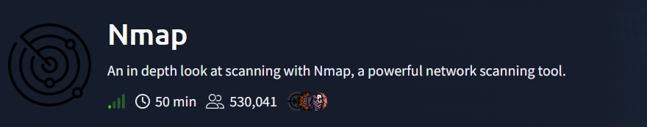
https://tryhackme.com/room/furthernmap

Task 2: Introduction

Q1: What networking constructs are used to direct traffic to the right application on a server?
Answer: Ports

PoC:
Ports: Ports are networking constructs used to identify and direct network traffic to the correct application or service running on a server. Each service listens on a specific port number, allowing the operating system to route incoming connections to the appropriate process.

Q2: How many of these are available on any network-enabled computer?
Answer: 65,535

PoC:
Port Range: A network-enabled computer supports ports numbered from 0 to 65,535. This large range allows multiple services and simultaneous network connections to operate without conflict.

Q3: [Research] How many of these are considered “well-known”?
Answer: 1,024

PoC:
Well-Known Ports: Well-known ports range from 0 to 1023 and are reserved for standard services such as HTTP (80), HTTPS (443), FTP (21), and SSH (22). These ports are commonly targeted during enumeration because they usually indicate specific, predictable services.

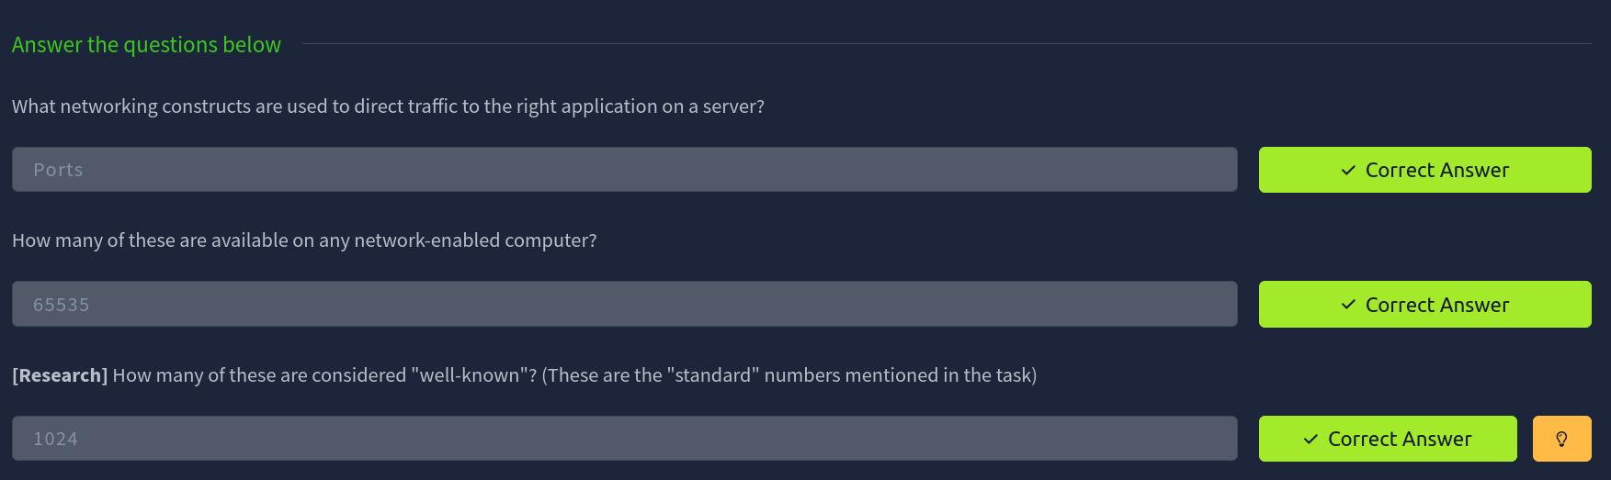

Task 3: Nmap Switches

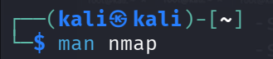

Q1: What is the first switch listed in the help menu for a “Syn Scan”?
Answer: -sS

PoC:
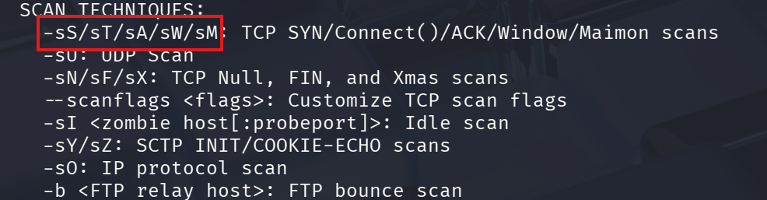

Q2: Which switch would you use for a “UDP scan”?
Answer: -sU

PoC:
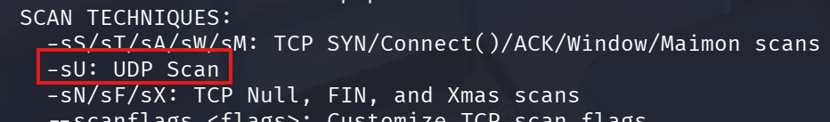

Q3: If you wanted to detect which operating system the target is running on, which switch would you use?
Answer: -O

PoC:
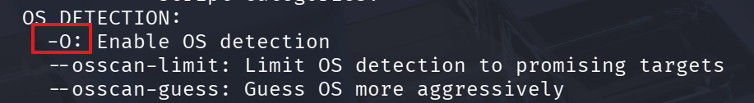

Q4: Nmap provides a switch to detect the version of the services running on the target. What is this switch?
Answer: -sV

PoC:

Q5: How would you increase the verbosity?
Answer: -v

PoC:
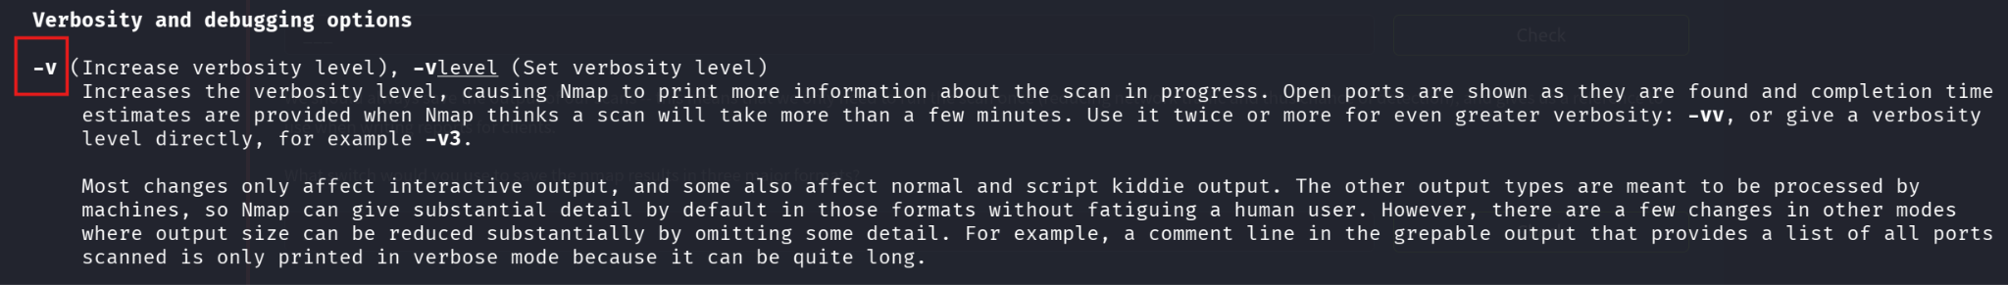

Q6: How would you set the verbosity level to two?
Answer: -vv

PoC:

Q7: What switch would you use to save the nmap results in three major formats?
Answer: -oA

PoC:

Q8: What switch would you use to save the nmap results in a “normal” format?
Answer: -oN

PoC:

Q9: How would you save results in a “grepable” format?
Answer: -oG

PoC:

Q10: How would you activate “aggressive” mode?
Answer: -A

PoC:

Q11: How would you set the timing template to level 5?
Answer: -T5

PoC:

Q12: How would you tell nmap to only scan port 80?
Answer: -p 80

Q13: How would you tell nmap to scan ports 1000–1500?
Answer: -p 1000-1500

Q14: How would you tell nmap to scan all ports?
Answer: -p-

PoC:

Q15: How would you activate a script from the nmap scripting library?
Answer: --script

PoC:
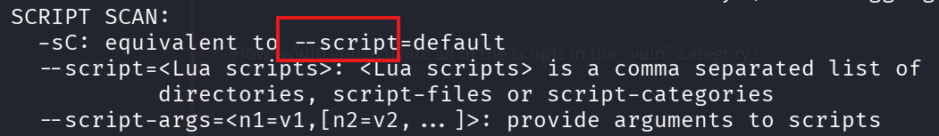

Q16: How would you activate all of the scripts in the “vuln” category?
Answer: --script=vuln

PoC:
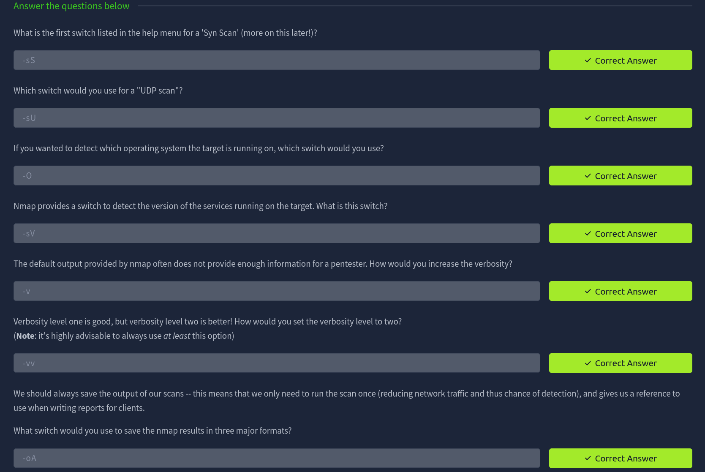

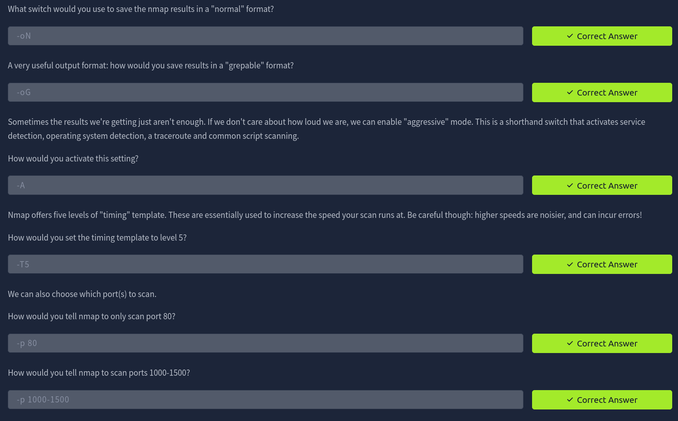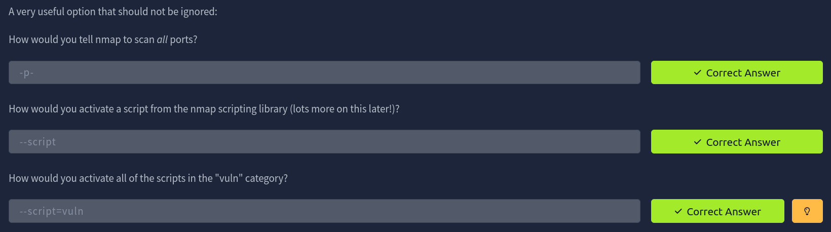

Task 5: Scan Types TCP Connect Scans

Q1: Which RFC defines the appropriate behaviour for the TCP protocol?
Answer: RFC 9293

PoC:
RFC 9293 defines the core specification of the TCP protocol, including how systems should behave during connection establishment, data transfer and connection termination. It describes expected responses such as SYN, SYN/ACK, ACK and RST flags, which are essential for understanding how TCP Connect scans (-sT) interpret open, closed and filtered ports.

Q2: If a port is closed, which flag should the server send back to indicate this?
Answer: RST

PoC:
When Nmap sends a TCP SYN packet to a closed port, the target system responds with a TCP packet containing the RST flag.
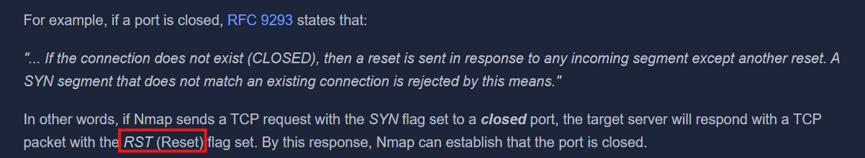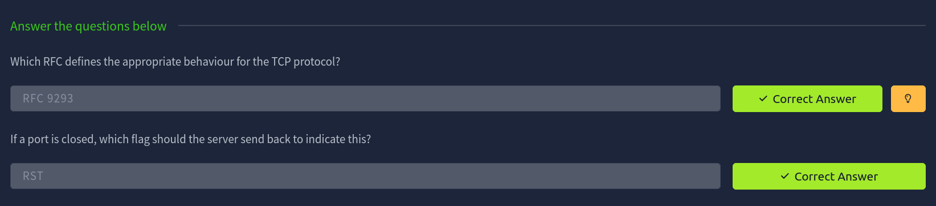

Task 6: Scan Types SYN Scans

Q1: There are two other names for a SYN scan, what are they?
Answer: Half-open scan, Stealth scan

PoC:
A SYN scan (-sS) does not complete the full TCP three-way handshake. After receiving a SYN/ACK from an open port, Nmap sends an RST packet instead of completing the connection. Because the connection is never fully established, these scans are often less logged by applications and were historically harder for IDS systems to detect, hence the names half-open and stealth scans.

Q2: Can Nmap use a SYN scan without Sudo permissions (Y/N)?
Answer: No

PoC:
SYN scans require the ability to create raw packets, which on Linux systems is restricted to the root user. Without sudo, Nmap cannot perform a SYN scan and will fall back to a TCP Connect scan (-sT).

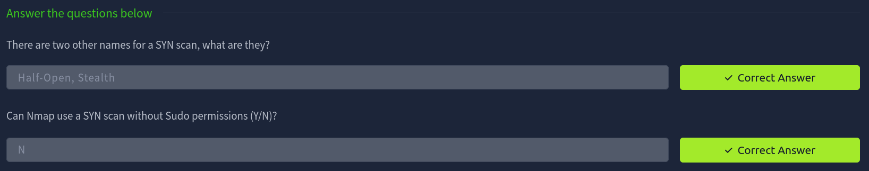

Task 7: Scan Types UDP Scans

Q1: If a UDP port doesn't respond to an Nmap scan, what will it be marked as?
Answer: Open | Filtered

PoC:
UDP is a stateless protocol and does not require a response from an open port. If Nmap sends a UDP packet and receives no reply, it cannot be sure whether the port is open or being blocked by a firewall. Therefore, Nmap marks such ports as open|filtered, indicating uncertainty between these two states.

Q2: When a UDP port is closed, by convention the target should send back a "port unreachable" message. Which protocol would it use to do so?
Answer: ICMP

PoC:
When a UDP packet is sent to a closed port, the target system responds with an ICMP. This ICMP response clearly indicates that the UDP port is closed, allowing Nmap to confidently classify the port state.
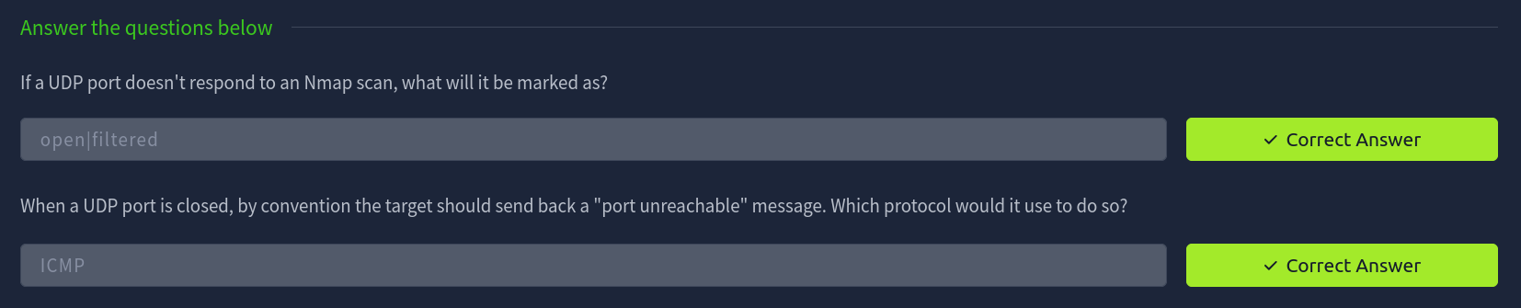

Task 8: Scan Types NULL, FIN and Xmas

Q1: Which of the three shown scan types uses the URG flag?
Answer: Xmas scan

PoC:
An Xmas scan sets the PSH, URG and FIN flags in the TCP packet. The presence of the URG flag (along with PSH and FIN) gives the packet a “lit up” appearance in packet capture tools like Wireshark, which is why it is called an Xmas scan.

Q2: Why are NULL, FIN and Xmas scans generally used?
Answer: Firewall evasion

PoC:
NULL (-sN), FIN (-sF), and Xmas (-sX) scans do not use the SYN flag, which many firewalls watch to detect new connections. Because they send unusual packets without SYN, they can sometimes bypass basic firewalls and IDS, making them useful for stealthy port scanning.
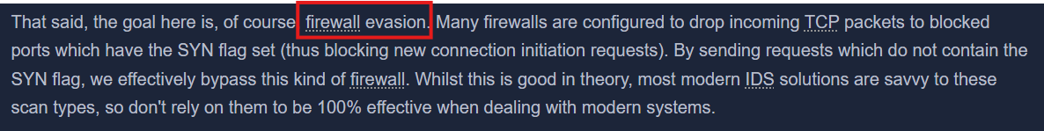

Q3: Which common OS may respond to a NULL, FIN or Xmas scan with a RST for every port?
Answer: Microsoft Windows

PoC:
Microsoft Windows systems often respond to malformed TCP packets with a RST packet for both open and closed ports. This behavior causes all ports to appear closed, reducing the effectiveness of these scan types against Windows-based targets.
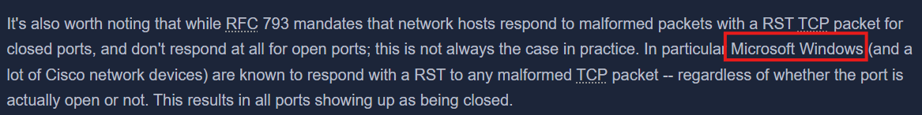

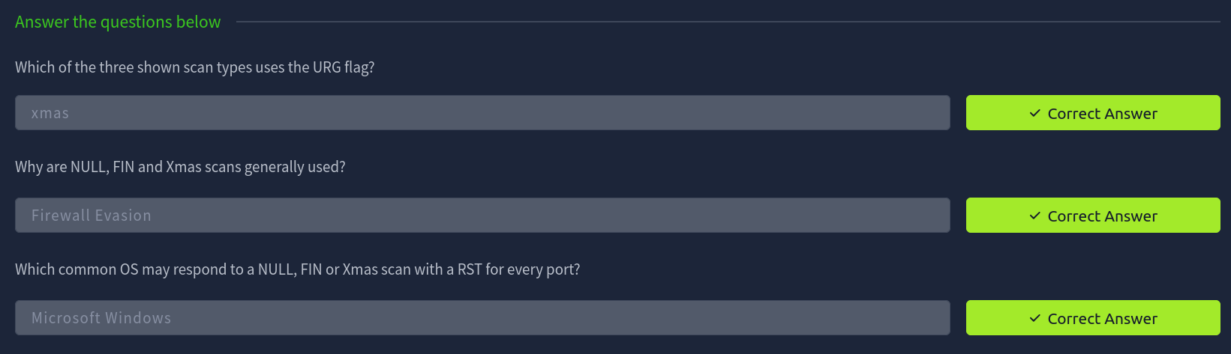

Task 9: Scan Types ICMP Network Scanning

Q1: How would you perform a ping sweep on the 172.16.x.x network (Netmask: 255.255.0.0) using Nmap? (CIDR notation)
Answer: nmap -sn 172.16.0.0/16

PoC:
The -sn switch tells Nmap to perform a host discovery scan without scanning ports. Using the CIDR notation /16 corresponds to the netmask 255.255.0.0, which covers the entire 172.16.x.x network range. Nmap sends ICMP echo requests (and related probes) to identify which hosts are alive, helping create an initial map of active systems on the network.
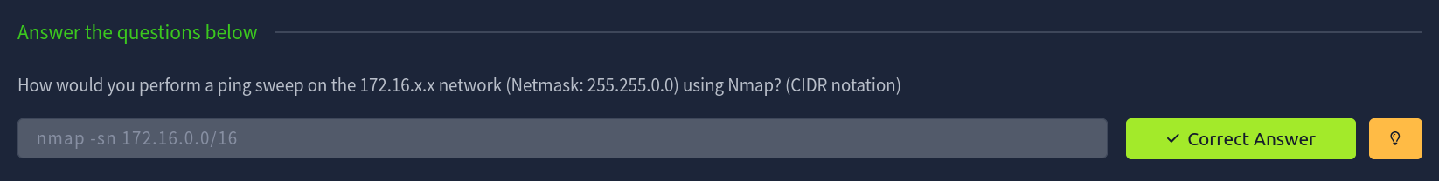

Task 10: NSE Scripts Overview

Q1: What language are NSE scripts written in?
Answer: Lua

PoC:
The Nmap Scripting Engine (NSE) uses the Lua programming language, which is lightweight, fast and well-suited for writing network scanning, discovery and vulnerability detection scripts integrated directly into Nmap.
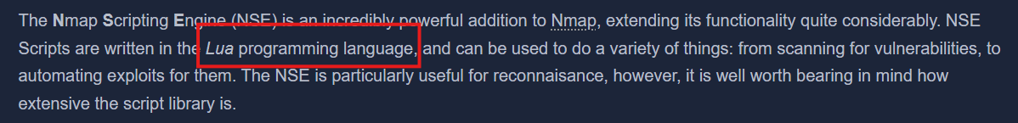

Q2: Which category of scripts would be a very bad idea to run in a production environment?
Answer: intrusive

PoC:
Scripts in the intrusive category are designed to actively interact with target services in ways that may disrupt operations, cause crashes or modify system behavior. Running these scripts in a production environment can lead to downtime, data loss or service instability, making them unsafe outside controlled testing environments.
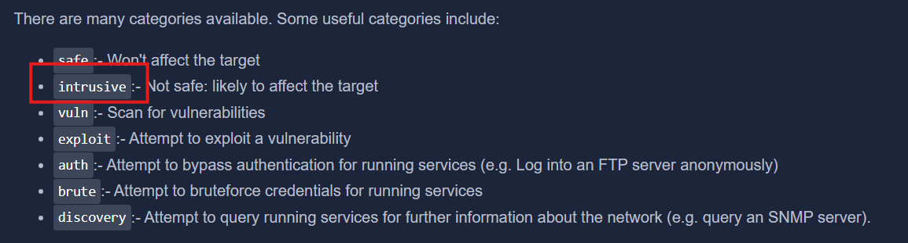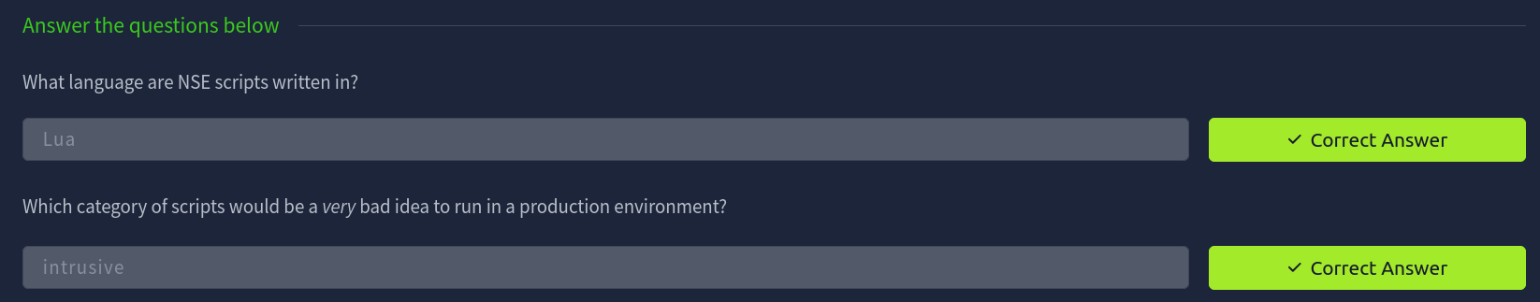

Task 11: NSE Scripts Working with the NSE

Q1: What optional argument can the ftp-anon.nse script take?
Answer: ftp-anon.maxlist

Poc:
- Open the terminal.
- Run the command:
nmap --script-help ftp-anon.nse
- Read the output shown in the terminal.
- Locate the documentation link provided by Nmap for the script.
- Open the link.
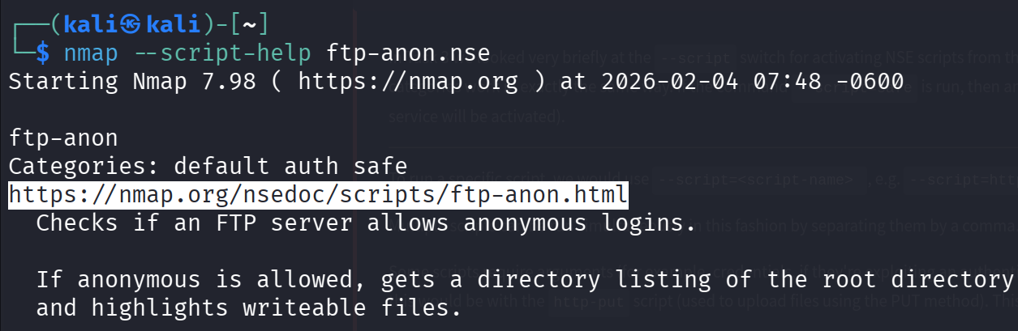
- On the webpage, scroll to the Script Arguments section.
- Observe that ftp-anon.maxlist is listed as an optional argument.
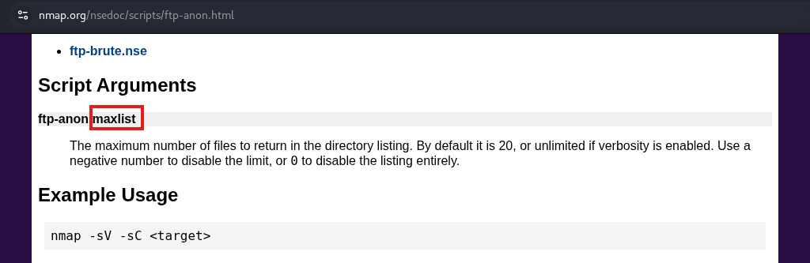
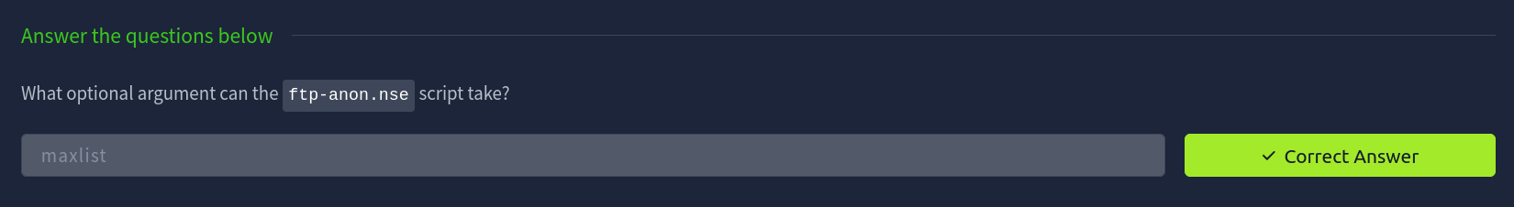

Task 12: NSE Scripts Searching for Scripts

Q1: Search for "smb" scripts in the /usr/share/nmap/scripts/ directory.
What is the filename of the script which determines the underlying OS of the SMB server?
Answer: smb-os-discovery.nse

PoC:
- Open the terminal.
- Run the command: cat /usr/share/nmap/scripts/script.db | grep "smb"
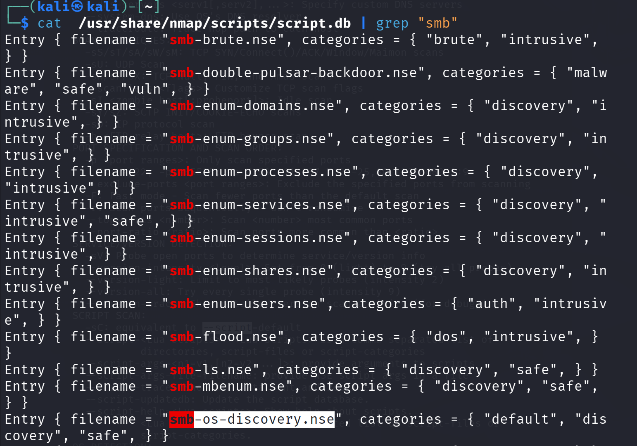
- Review the listed SMB-related scripts.
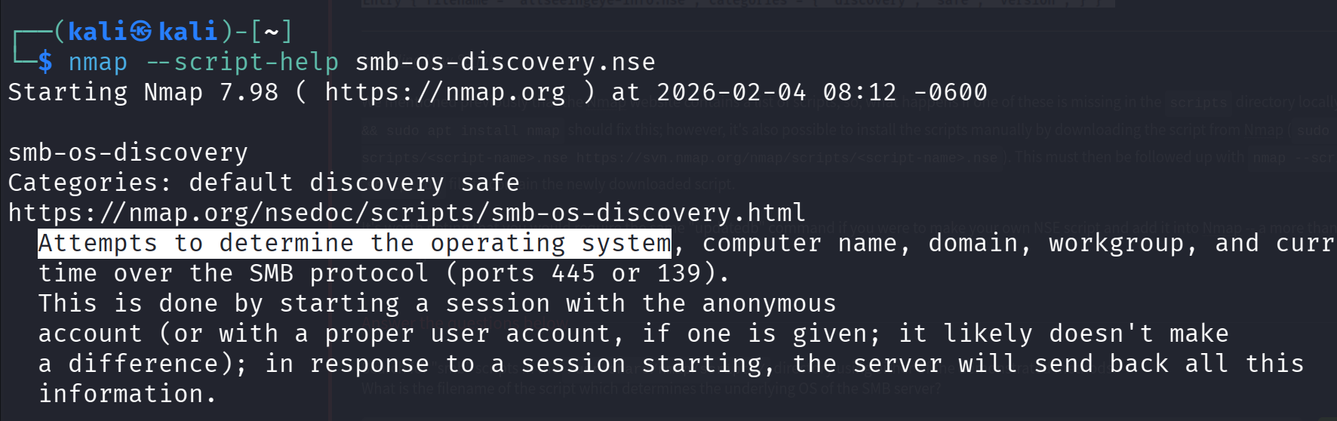

Q2 Read through this script. What does it depend on?
Answer: smb-brute

PoC:
- Open the script file: cat /usr/share/nmap/scripts/smb-os-discovery.nse
- Search for dependencies: cat /usr/share/nmap/scripts/smb-os-discovery.nse | grep "dependencies"

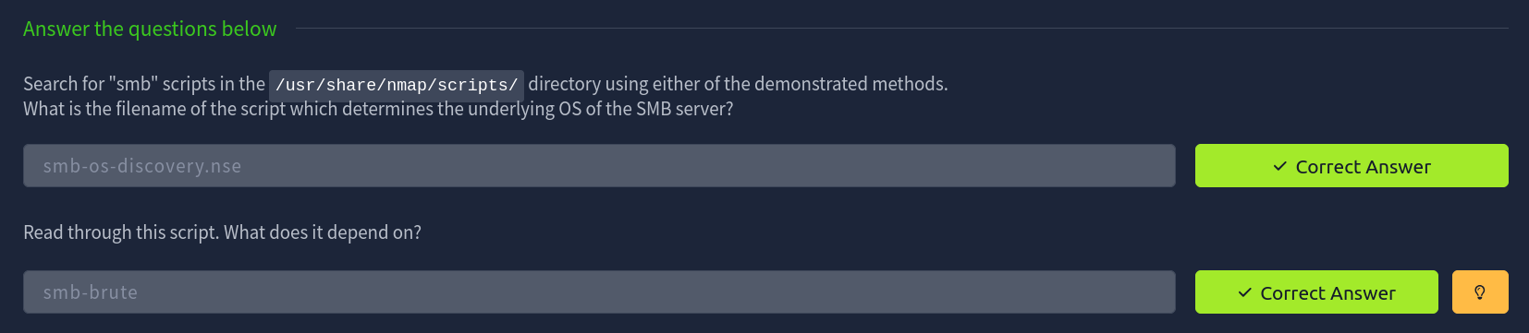

Task 13: Firewall Evasion
Q1: Which simple (and frequently relied upon) protocol is often blocked, requiring the use of the -Pn switch?
Answer: ICMP

PoC:
Many Windows hosts block ICMP packets by default using the firewall. Nmap normally uses ICMP echo requests (ping) to check if a host is alive. If ICMP is blocked, Nmap may mark the host as dead and skip scanning.
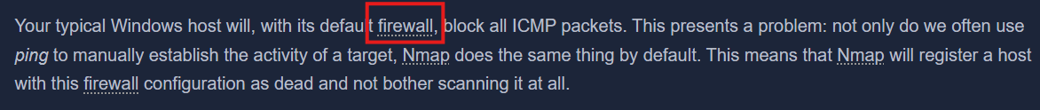

Question 2
[Research] Which Nmap switch allows you to append an arbitrary length of random data to the end of packets?
Answer: --data-length

PoC:
Nmap provides the --data-length <number> switch, which appends a specified amount of random data to the end of packets. By checking the help menu using nmap --help | grep "random", the mention of random data confirms that this option is intended for packet manipulation and firewall evasion during reconnaissance.

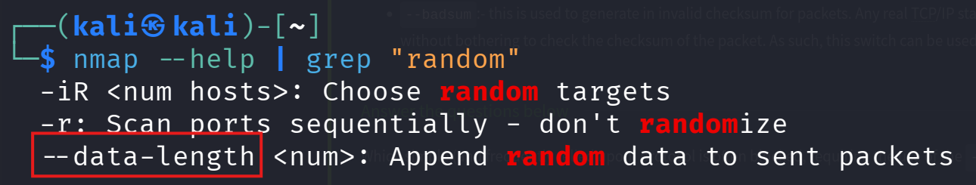

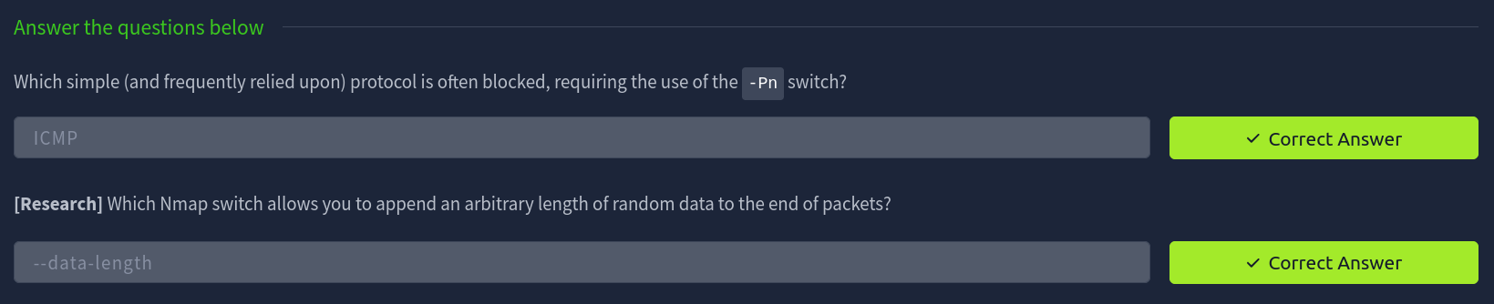

Task 14: Practical

Q1: Does the target IP respond to ICMP echo (ping) requests (Y/N)?
Answer: N

PoC:
The target does not respond to ICMP echo requests because ICMP is blocked by the firewall. Nmap therefore requires the -Pn switch to skip host discovery and treat the host as alive.

Q2: Perform an Xmas scan on the first 999 ports of the target – how many ports are shown to be open or filtered?
Answer: 999

PoC:
Using the command nmap -vv -sX -Pn -p 0-999 10.48.135.16 all 999 scanned ports are marked as open|filtered, meaning Nmap received no response from the target for these ports.
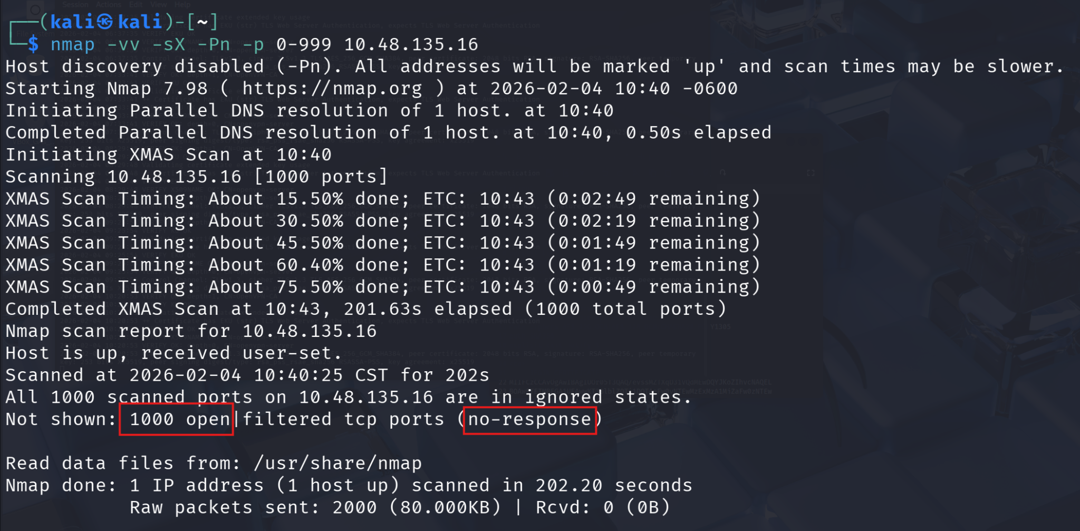

Q4: Perform a TCP SYN scan on the first 5000 ports of the target — how many ports are shown to be open?
Answer: 5

PoC:
Running nmap -vv -sS -Pn -T3 -p 0-5000 10.48.135.16 reveals two open ports. SYN scans accurately identify open ports by receiving a SYN/ACK response from the target.

Q5: Deploy the ftp-anon script against the box. Can Nmap login successfully to the FTP server on port 21? (Y/N)
Answer: Y

PoC:
The ftp-anon NSE script confirms that anonymous FTP login is enabled on port 21. Nmap successfully logs in without credentials, indicating misconfigured FTP access.
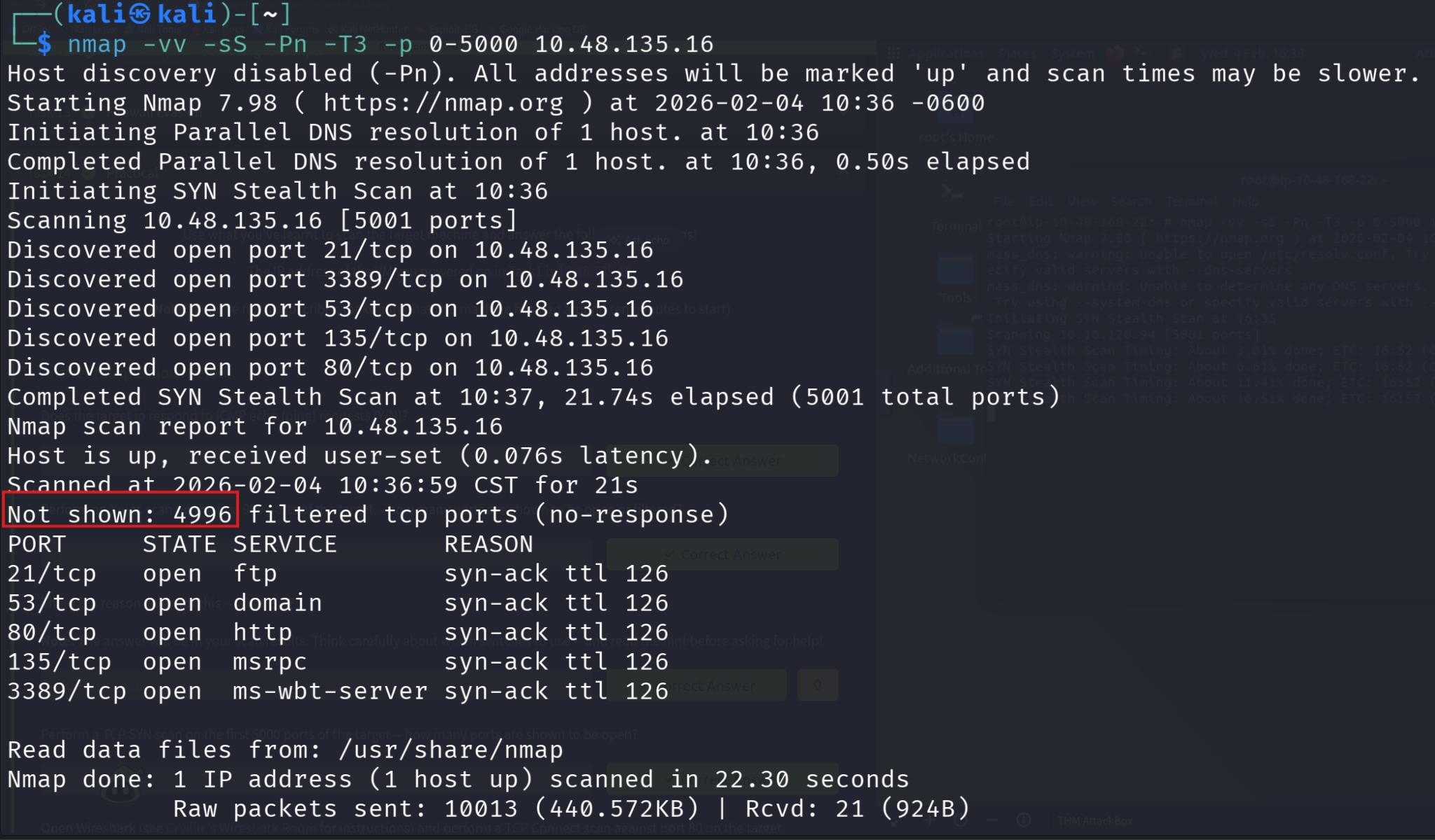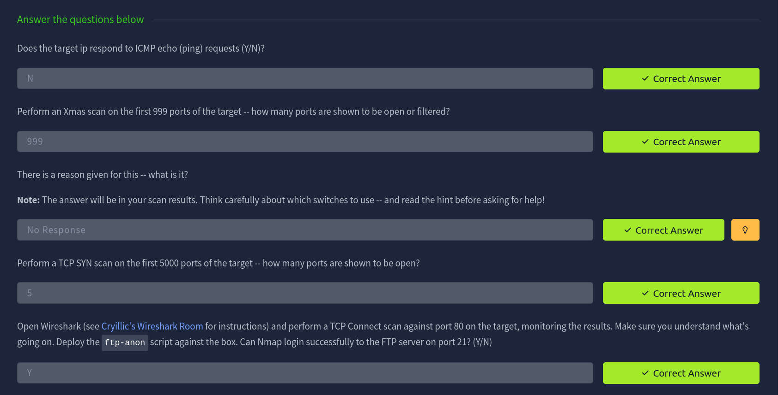

Room: OWASP Top 10 2025: IAAA Failures
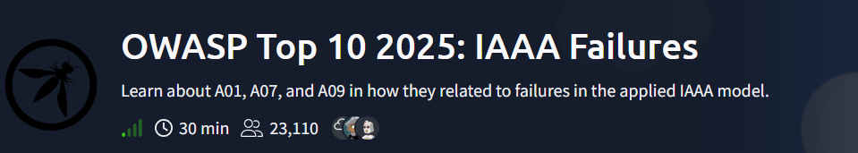
https://tryhackme.com/room/owasptopten2025one

Task 2: What is IAAA?

Q1: What does IAAA stand for?
Answer: Identity, Authentication, Authorisation, Accountability
PoC:
IAAA stands for:
- Identity refers to the unique account representing a person or service.
- Authentication is the process of proving that identity, such as with passwords, OTPs or passkeys.
- Authorisation defines what the identity is allowed to do within the system.
- Accountability involves recording and alerting on who performed what actions, when, and from where.
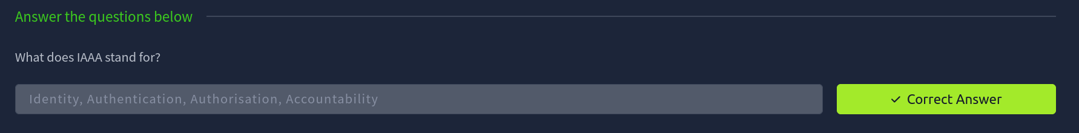

Task 3: A01: Broken Access Control
Q1: If you don't get access to more roles but can view the data of another user, what type of privilege escalation is this?
Answer: Horizontal

PoC:
Horizontal privilege escalation occurs when a user can access or manipulate data belonging to another user with the same privilege level.

Q2: What is the note you found when viewing the user's account who had more than $1 million?
Answer: THM{Found.the.Millionare!}
PoC:
By manipulating the accountID parameter in the URL, it was possible to enumerate and access different user accounts. One of these accounts (which is id=7) contained a balance exceeding $1 million, along with the hidden note THM{Found.the.Millionare!}.
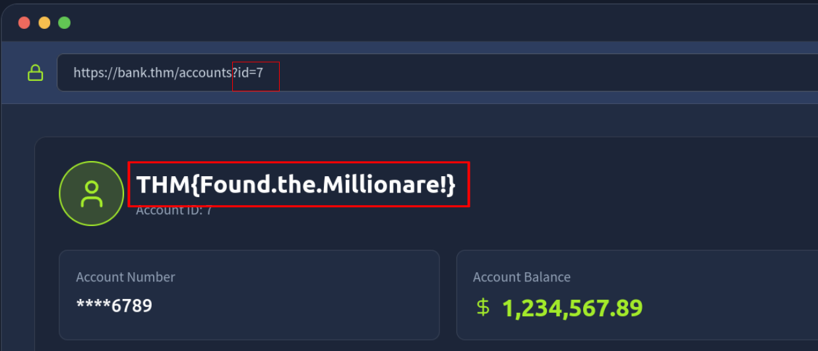

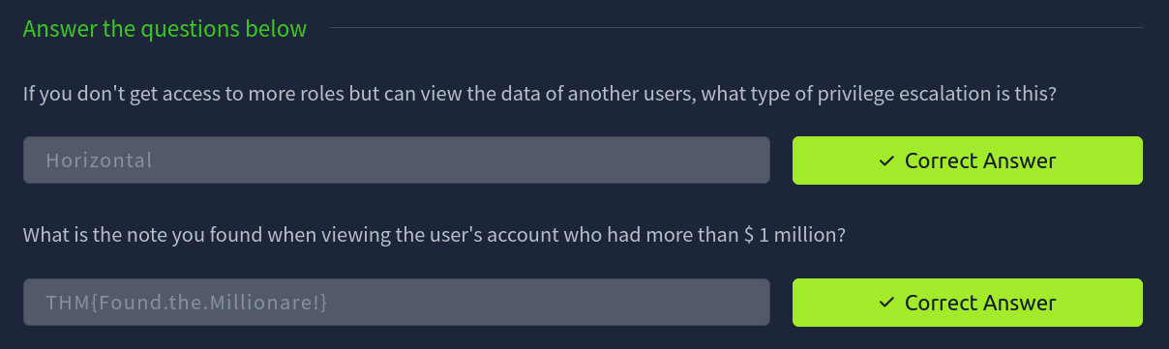

Task 4: A07: Authentication Failures

Q1: What is the flag on the admin user's dashboard?
Answer: THM{Account.confusion.FTW!}

PoC:
- The application performs case‑sensitive username checks during registration but case‑insensitive checks during login.
- A new user is registered with the username aDmiN, bypassing proper username uniqueness validation.
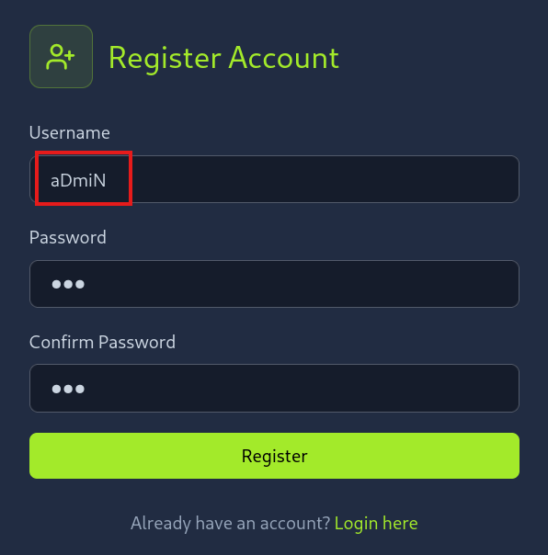
- When logging in, the application treats aDmiN and admin as the same user.
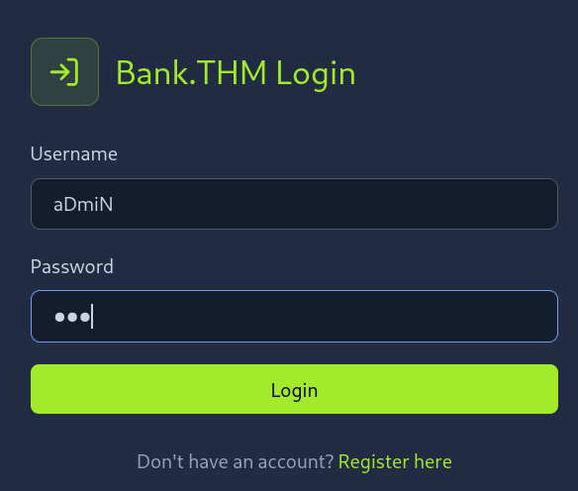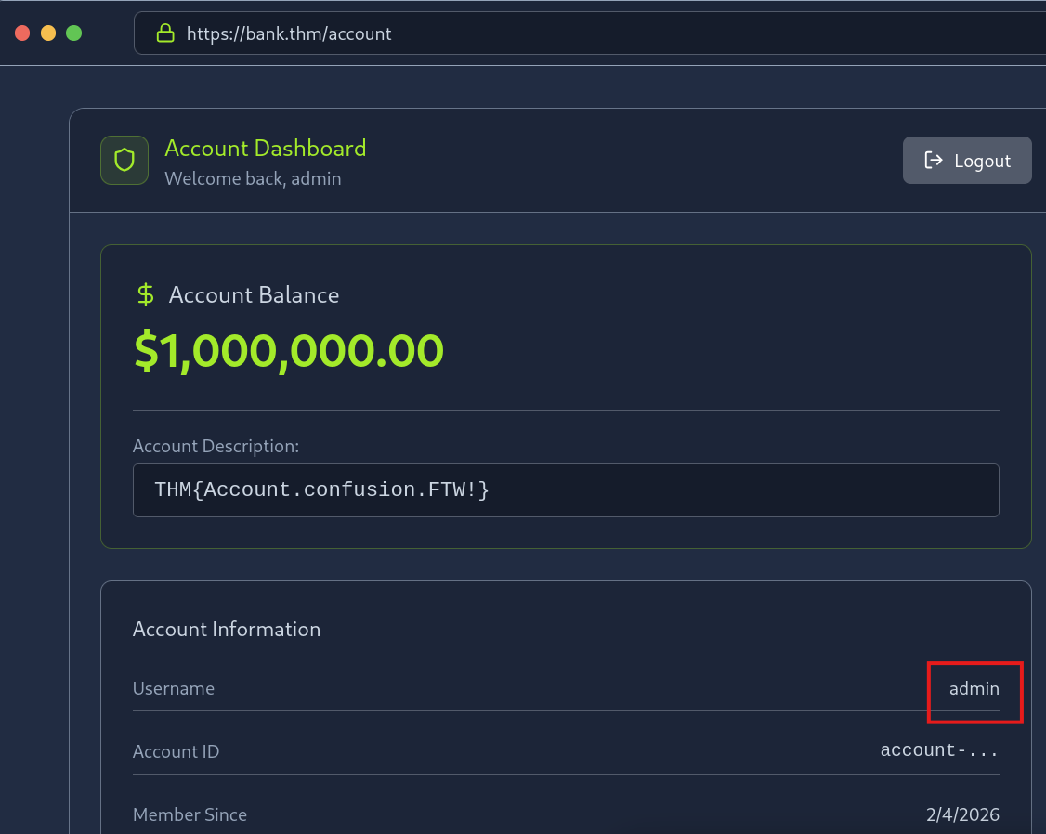
- This logic flaw allows access to the admin account without knowing the real admin password.
- After logging in, the admin dashboard is displayed, where the flag is revealed.
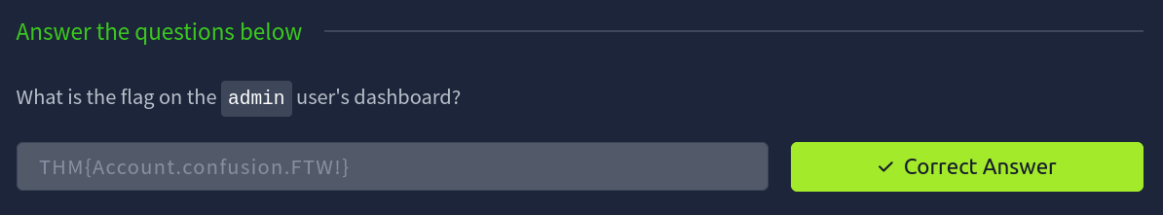

Task 5: A09: Logging & Alerting Failures

Q1: It looks like an attacker tried to perform a brute-force attack, what is the IP of the attacker?
Answer: 203.0.113.45
PoC:
Multiple failed login attempts (401 Unauthorized) are recorded from the same IP address 203.0.113.45 against the /login endpoint using different passwords in a short time frame, which clearly indicates a brute-force attack.
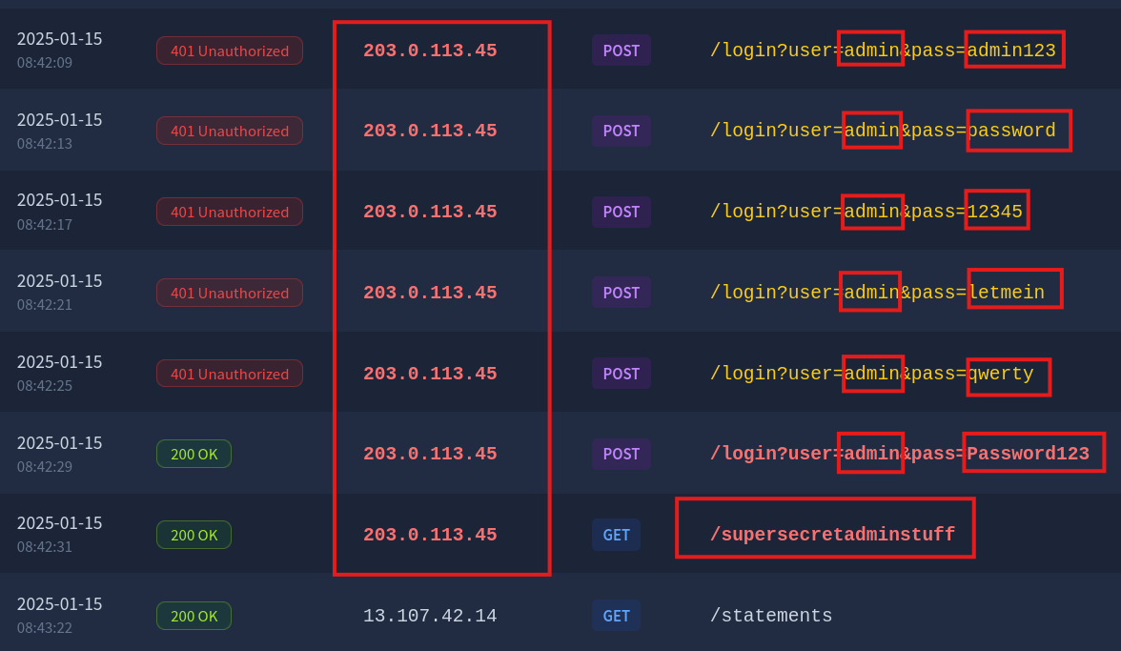

Q2: Looks like they were able to gain access to an account! What is the username associated with that account?
Answer: admin
PoC:
After several failed attempts, a 200 OK response is logged for a login request with the username admin, confirming that the attacker successfully authenticated to this account.
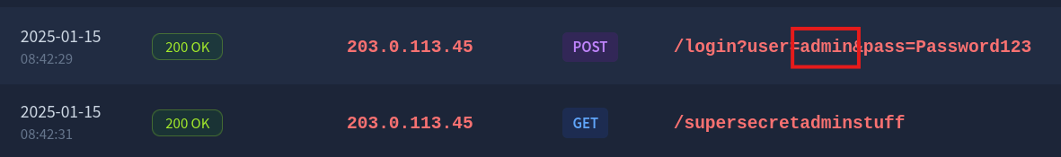

Q3: What action did the attacker try to do with the account? List the endpoint they accessed.
Answer: /supersecretadminstuff
PoC:
Following successful authentication, the logs show a GET request to /supersecretadminstuff, indicating the attacker attempted to access sensitive admin-only functionality.

