
Assignment-04
Web Pentesting and Bug Hunting - Batch-20

Local File Inclusion

SUBMITTED BY
Md Sayem Mottakee
Student Id: CB-2025-862

SUBMITTED To

MD Foysal Hossain
Mentor, Cyber Bangla Academy

MD Tarik Anam
Co-ordinator, Cyber Bangla Academy

Lab1: File path traversal, traversal sequences blocked with absolute path bypass 3
Lab2: File path traversal, validation of file extension with null byte bypass 5

Lab1: File path traversal, traversal sequences blocked with absolute path bypass

Poc:
1) Opened a product image and intercepted the request: GET /image?filename=38.jpg HTTP/2
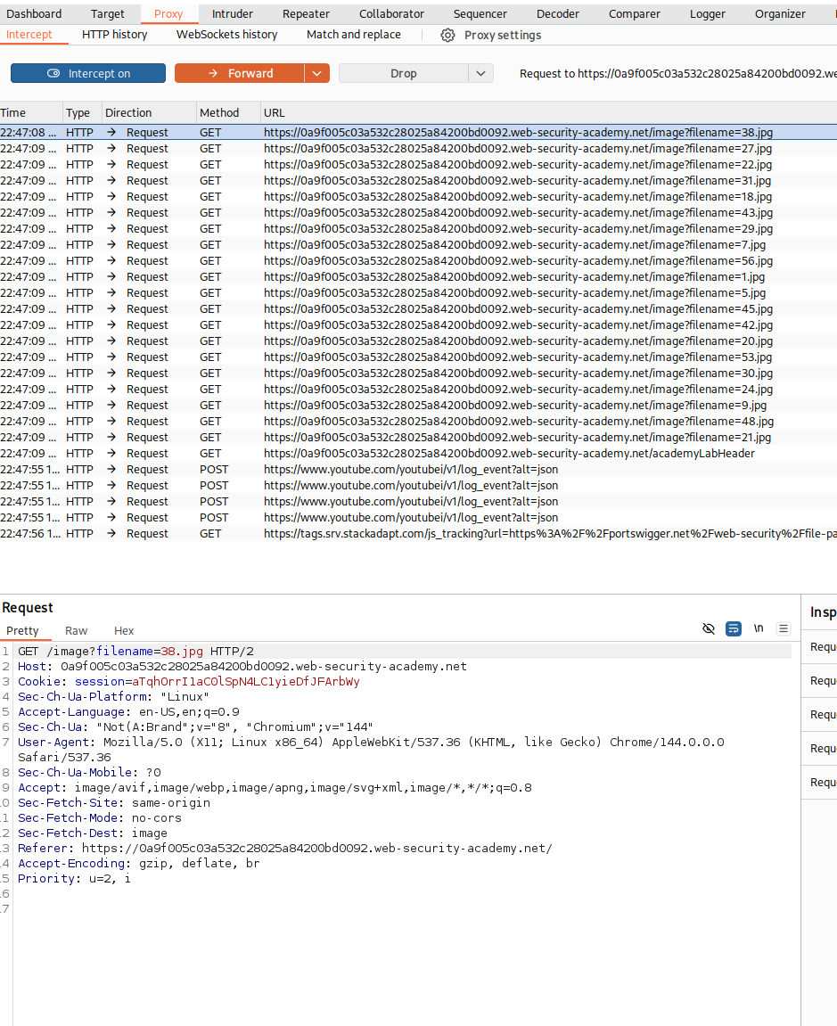
2) Observed that the application loads files using the filename parameter to retrieve images from the server.
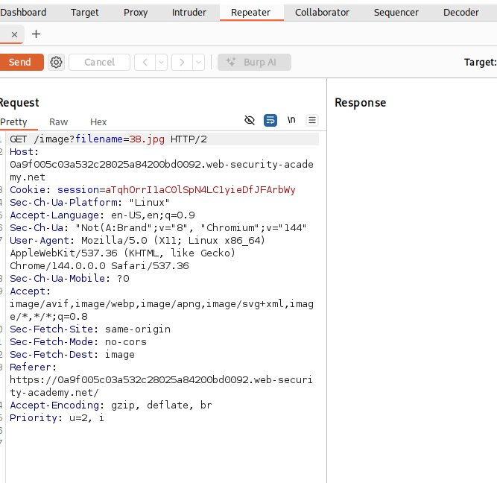
3) Since the lab mentions a path traversal vulnerability, tested whether arbitrary files could be accessed through this parameter.
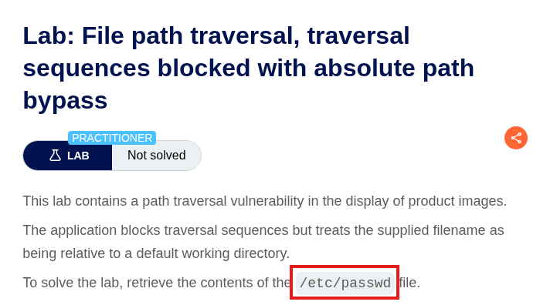
4) Traversal sequences like ../ were blocked, so the filename was replaced with an absolute path to attempt bypassing the restriction.

5) Modified the request to: GET /image?filename=/etc/passwd HTTP/2
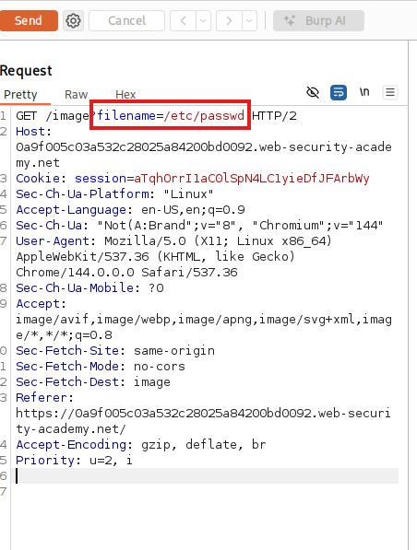
6) The server responded with the contents of /etc/passwd, confirming successful exploitation of the path traversal vulnerability. This means the application allows access to sensitive system files outside the intended directory, proving that arbitrary files on the server can be read without proper authorization.
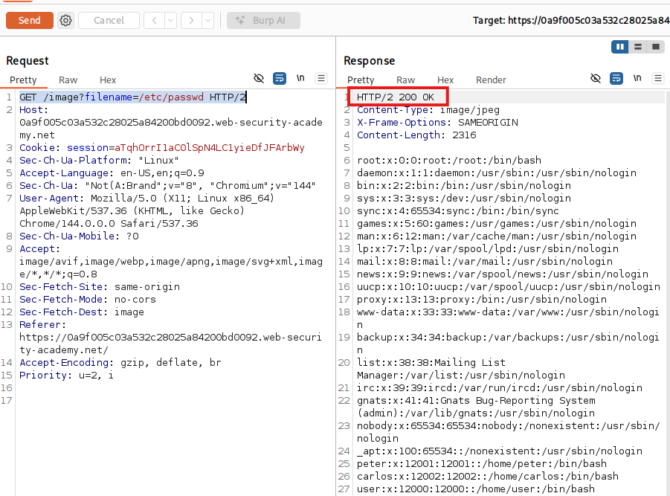

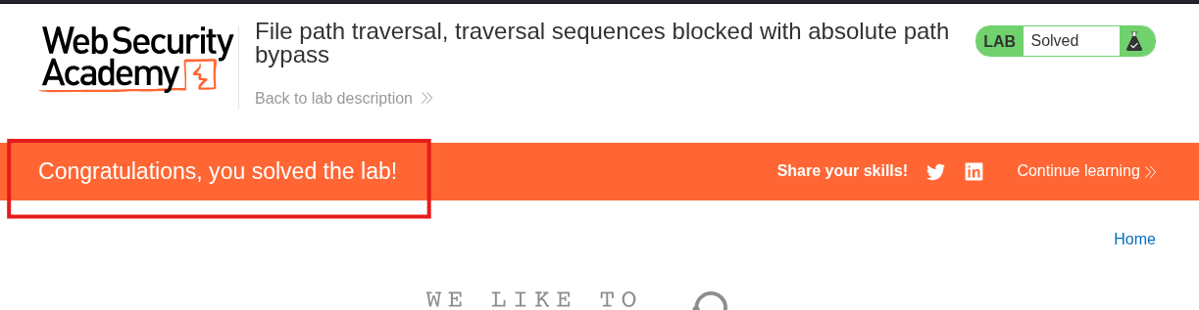

Lab2: File path traversal, validation of file extension with null byte bypass

Poc:
1) Opened a product image and observed the original request: GET /image?filename=1.jpg HTTP/2

2) Identified that the application loads image files using the filename parameter.

3) Since traversal sequences are blocked, attempted to bypass the restriction using directory traversal combined with a null byte injection.

4) Modified the request to: GET /image?filename=../../../etc/passwd%001.jpg HTTP/2

5) The ../../../ sequence attempts to move up directories to reach the root, /etc/passwd targets a sensitive system file and %00 (null byte) is used to terminate the string before .jpg so the server ignores the forced file extension.

6) The server responded with the contents of /etc/passwd, confirming that the filter was bypassed and arbitrary files on the system can be accessed, proving successful exploitation of the path traversal vulnerability.
