Assignment-06
Web Pentesting and Bug Hunting - Batch-20

Secure Code Review

SUBMITTED BY
Md Sayem Mottakee
Student Id: CB-2025-862

SUBMITTED TO

Tareq Ahamed
Mentor, Cyber Bangla Academy

Trik Anam
Co-ordinator, Cyber Bangla Academy

SUBMISSION DATE
28/02/26

Table of Contents

CodeReviewLab 2
Application Overview 2
Finding 1: Hardcoded Secret Key 3
Finding 2: Server-Side Template Injection (SSTI) 4
Finding 3: SQL Injection 6
Finding 4: Path Traversal / Unrestricted File Upload 8
Finding 5: Insecure Deserialization 9
Finding 6: Command Injection 11
Finding 7: Debug Mode in Production 14

CodeReviewLab
Link: https://github.com/itztrq/labs/tree/main/CodeReviewLab

Application Overview
The CodeReviewLab application is a deliberately vulnerable Flask based web application developed for security training purposes. The application demonstrates seven common web security vulnerabilities including SQL Injection, Server-Side Template Injection, Command Injection, Insecure Deserialization, Command Injection and Debug Mode in Production.

The objective of this code review engagement was to identify and analyze security weaknesses through static source code review and assess their potential impact.

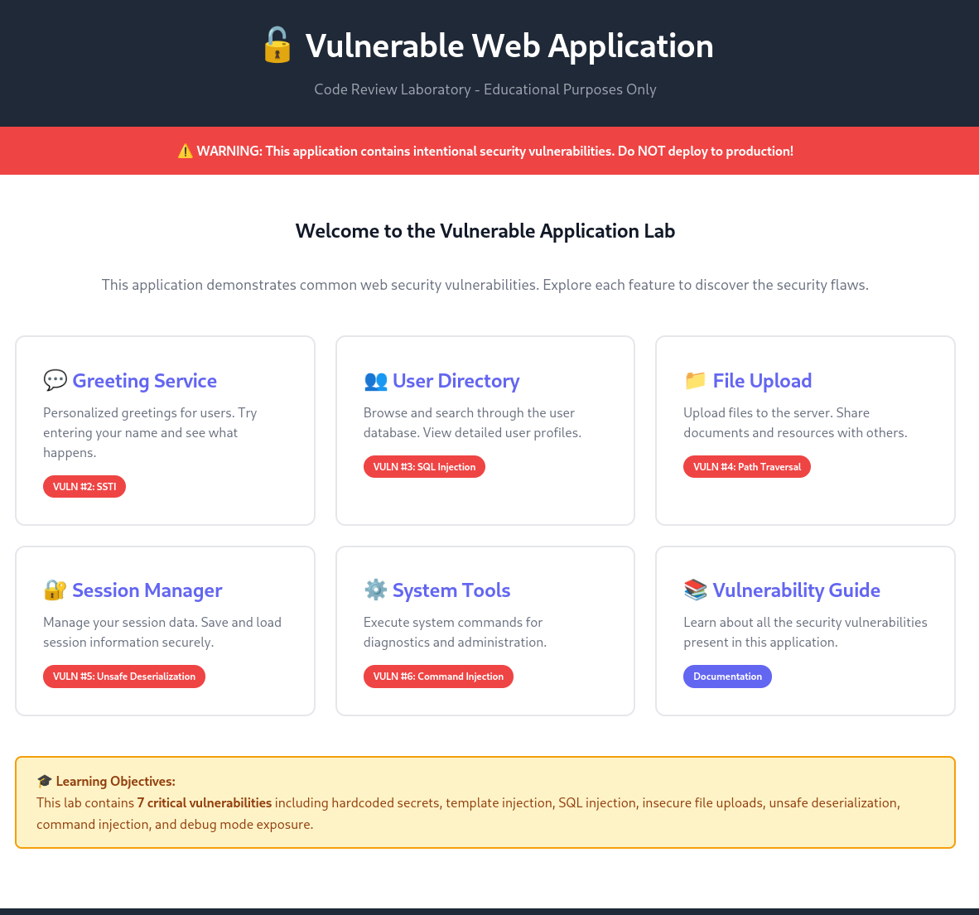

Finding 1: Hardcoded Secret Key

Description:
The Flask application uses a hardcoded SECRET_KEY in app.py. This exposes sensitive information that can be used to forge session cookies and compromise authentication.

CVSS Score:
7.0 - 8.9 (High)

Tools Used:
- Manual code review
Reference:
- CWE-798: Use of Hard-coded Credentials
- OWASP Top 10: A02 – Sensitive Data Exposure

Payload:
- N/A
Steps to Reproduce:
- Open app.py
- Locate: app.config['SECRET_KEY'] = 'dev_secret_123'
PoC:
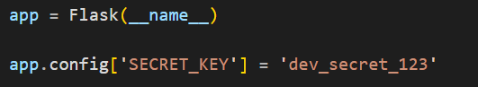
Remediation:
- Store secrets in environment variables or use a secure secret management system.

Finding 2: Server-Side Template Injection (SSTI)

Description:
User input (name) is directly passed to render_template_string() without escaping, allowing arbitrary code execution on the server.

CVSS Score:
9.0 - 10 (Critical)

Tools Used:
- Browser
Reference:
- CWE-94: Improper Control of Generation of Code (‘Code Injection’)
- OWASP Top 10: A03 – Injection

Payload:
- {{7*7}}
- {{config.items()}}

Steps to Reproduce:
- Start the Flask application locally.
- Open a browser and navigate to: http://127.0.0.1:5000/greet?name={{7*7}}
- Observe that the response renders: Hello 49! This confirms that the template engine is evaluating user-supplied input.
- Navigate to: http://127.0.0.1:5000/greet?name={{config.items()}}
- Observe that the server configuration details are displayed in the response, indicating information disclosure.
PoC:
- Enter {{7*7}}
- Output renders Hello 49!
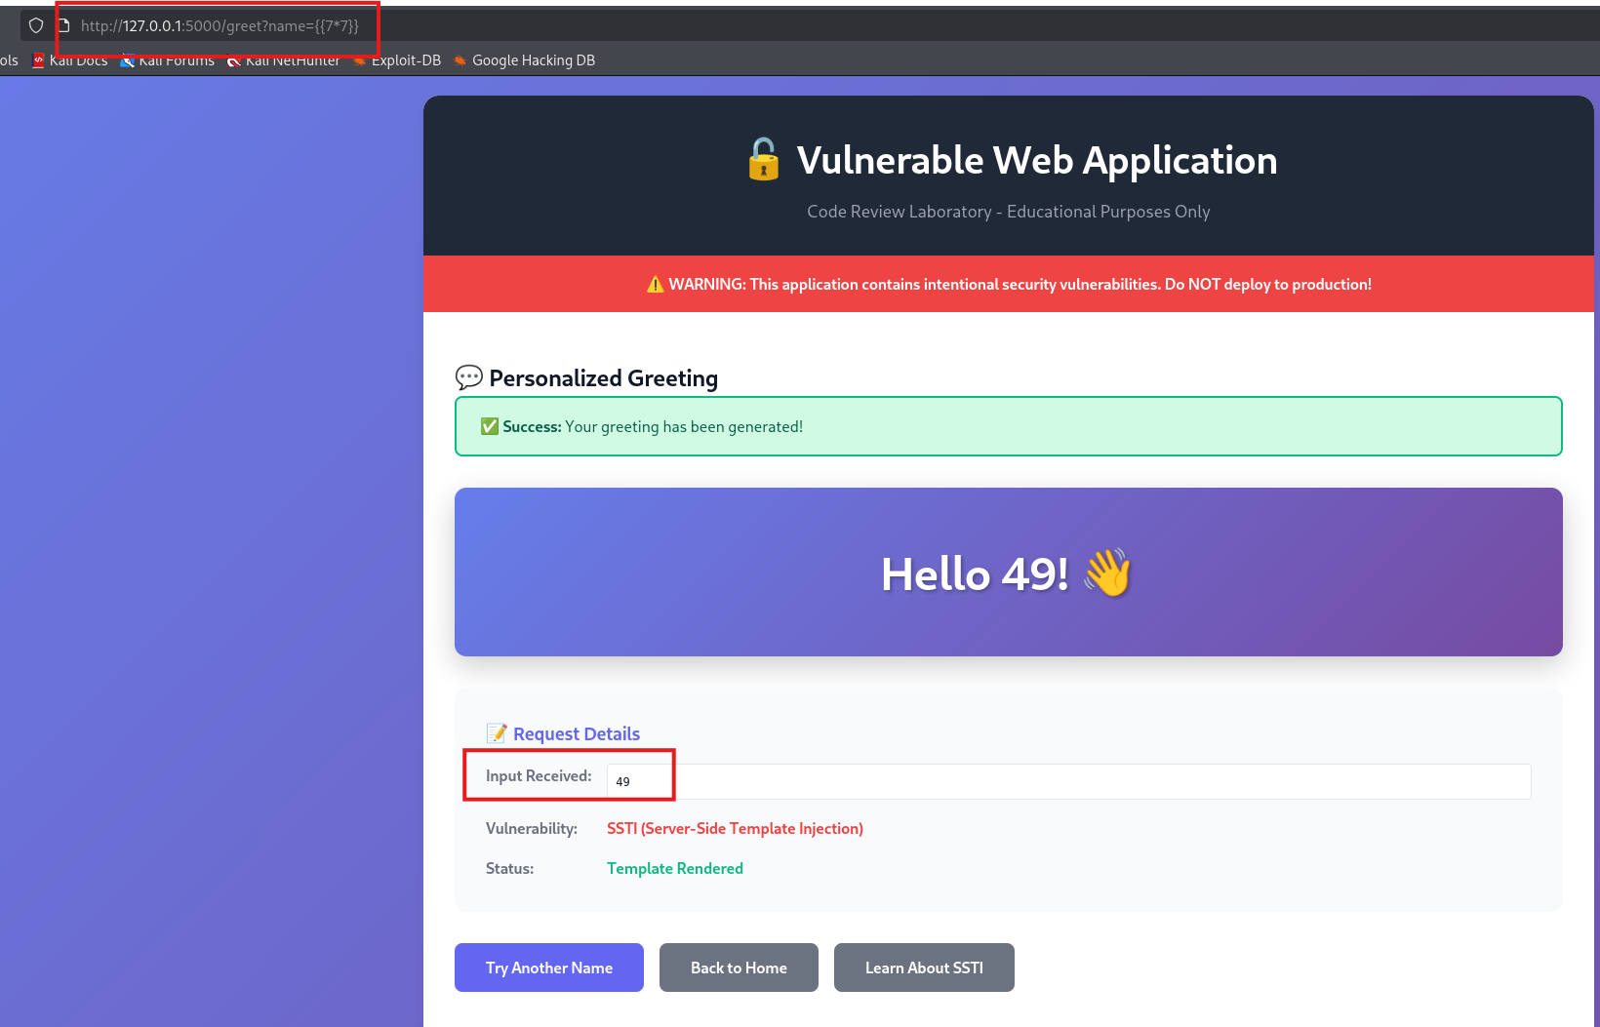
- Enter {{config.items()}}
- Server configuration exposed
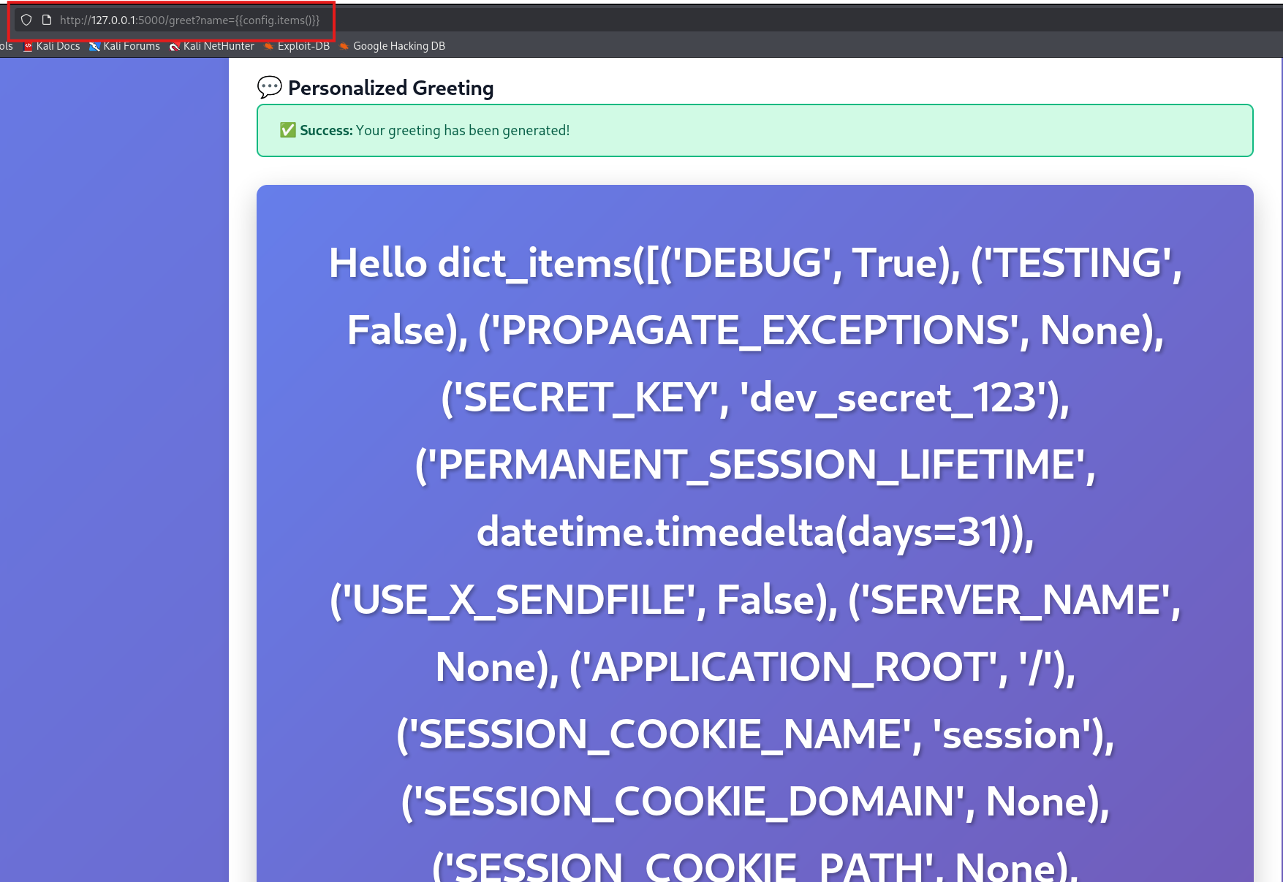

Remediation:
- Use render_template() instead of render_template_string()
- Never render raw user input directly in templates

Finding 3: SQL Injection

Description:
The endpoint /user/<user_id> builds SQL queries using string formatting: query = f"SELECT * FROM users WHERE id = {user_id}" This allows attackers to manipulate database queries.
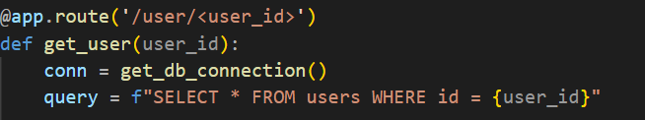

CVSS Score:
9.0 - 10 (Critical)

Tools Used:
- Browser
- SQLMap
Reference:
- CWE-89: SQL Injection
- OWASP Top 10: A03 – Injection

Payload:
- /user/1 OR 1=1
- /user/1 UNION SELECT 1,2,3,4,5,6

Steps to Reproduce:
- Navigate to http://127.0.0.1:5000/user/1 OR 1=1
- Then navigate to http://127.0.0.1:5000/user/1 UNION SELECT 1,2,3,4,5,6
- Observe that all user data may be returned
PoC:
- /user/1 OR 1=1 - The query becomes: SELECT * FROM users WHERE id = 1 OR 1=1. Since 1=1 is always true, the condition evaluates to true for all rows in the table. This demonstrates that the attacker can manipulate the WHERE clause logic.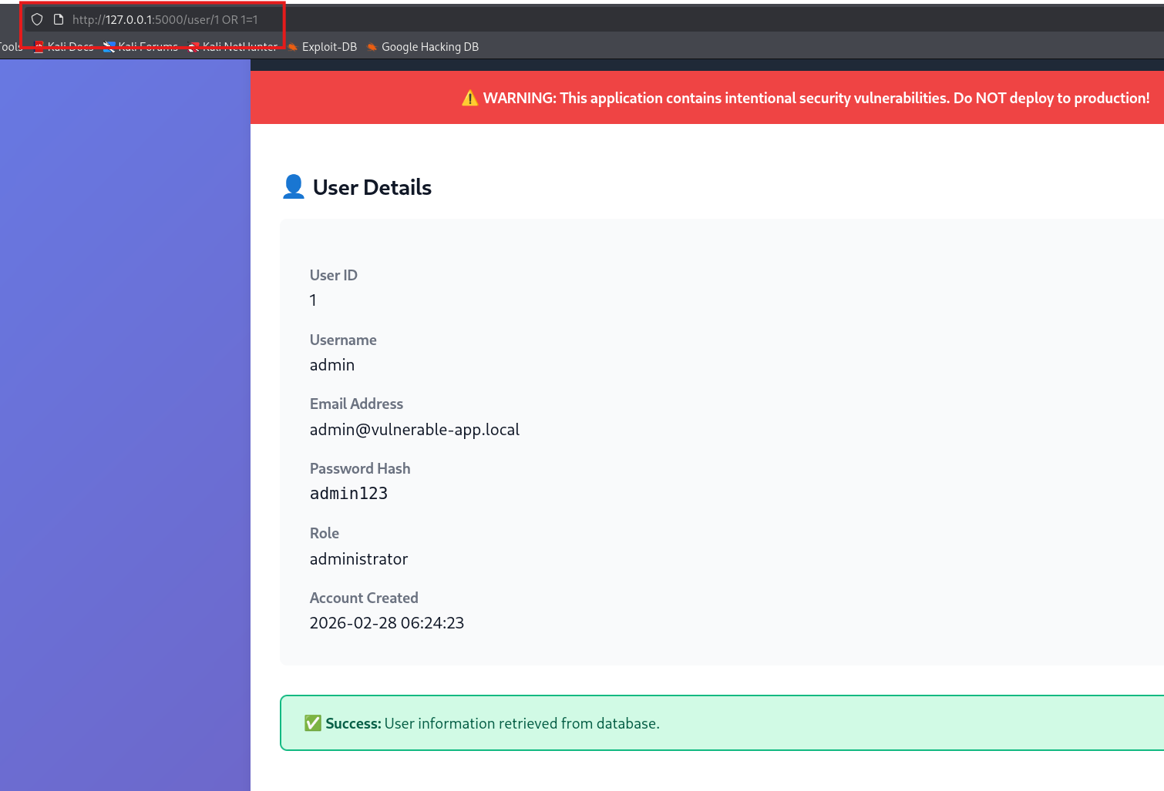
- /user/1 UNION SELECT 1,2,3,4,5,6 - The query becomes: SELECT * FROM users WHERE id = 1 UNION SELECT 1,2,3,4,5,6. This query executes with arbitrary values.
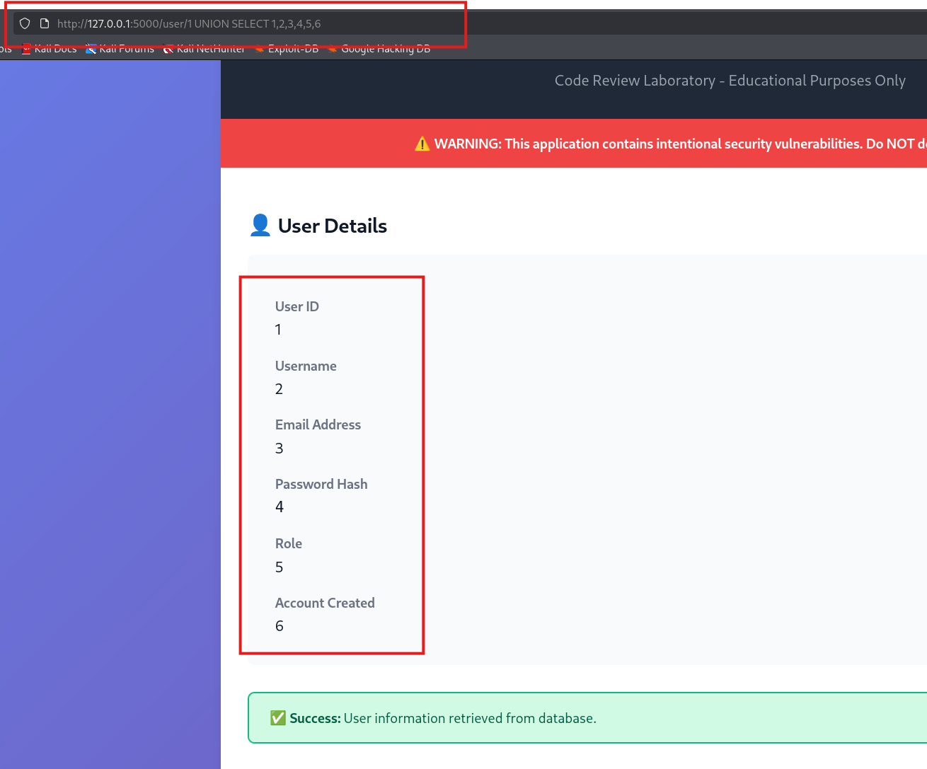
Remediation:
- Use parameterized queries or ORM: conn.execute("SELECT * FROM users WHERE id = ?", (user_id,))

Finding 4: Path Traversal / Unrestricted File Upload

Description:
Uploaded files are saved directly without sanitizing the filename: file.save(f'uploads/{file.filename}') This allows arbitrary file writes and potential server compromise.
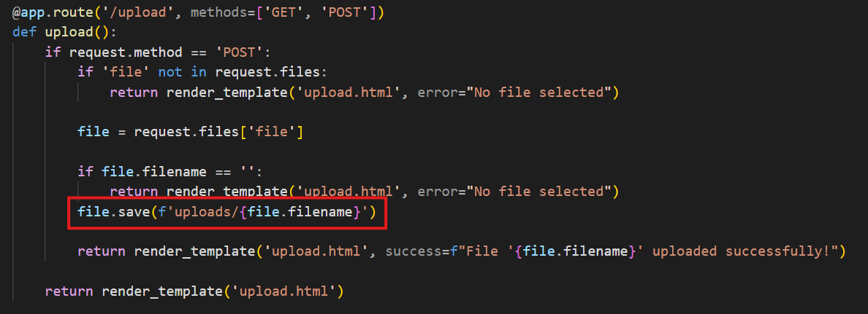
CVSS Score:
7.0 - 8.9 (High)

Tools Used:
- Browser testing

Reference:
- CWE-22: Improper Limitation of a Pathname to a Restricted Directory (‘Path Traversal’)
- OWASP Top 10: A05 – Security Misconfiguration

Payload:
- ../../../test.txt

Steps to Reproduce:
- Navigate to /upload
- Upload file named ../../../test.txt (touch ../../../test.txt)
- File is saved outside the intended directory
PoC:
- File appears outside the uploads folder. Arbitrary write confirmed
Remediation:
- Restrict allowed file types
- Save files in a safe directory

Finding 5: Insecure Deserialization

Description:
User-controlled cookie data is deserialized using pickle.loads():
data = pickle.loads(base64.b64decode(data_cookie))
This allows attackers to execute arbitrary code on the server.
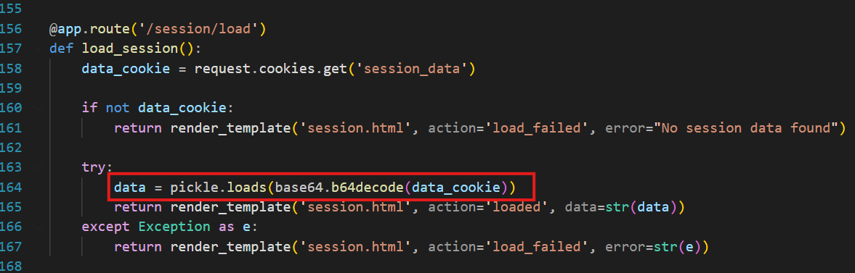

CVSS Score:
9.0 - 10 (Critical)

Tools Used:
- Manual review
- Python scripts for payload generation
Reference:
- CWE-502: Deserialization of Untrusted Data
- OWASP Top 10: A08 – Software and Data Integrity Failures

Payload:
- Malicious pickle payload encoded in base64
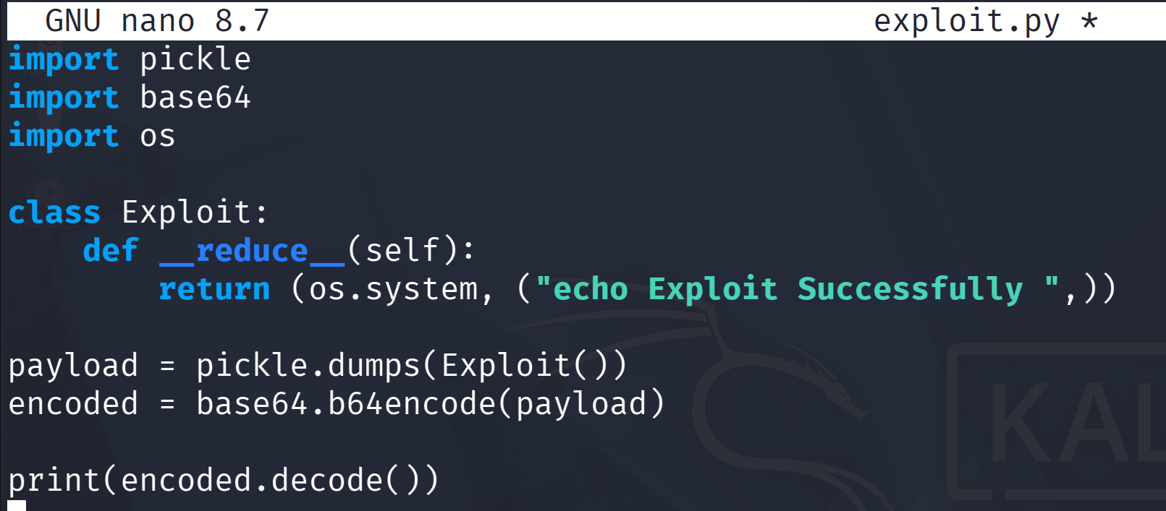

Steps to Reproduce:
- Modify session_data cookie
- Insert a crafted pickle payload
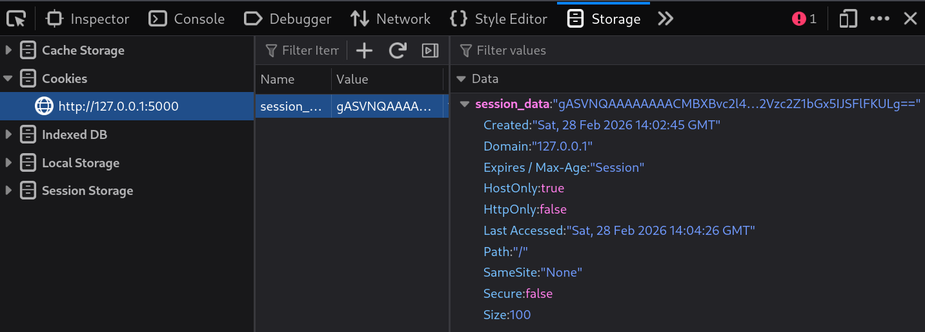
- Server executes code

PoC:
- The session_data cookie accepts malicious payloads that can result in arbitrary Python code execution on the server.
Remediation:
- Use safe serialization formats like JSON instead of pickle

Finding 6: Command Injection

Description:
User input is directly executed using: output = os.popen(cmd).read(). This allows execution of arbitrary system commands.
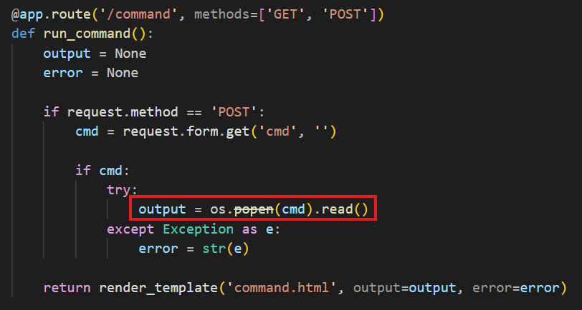

CVSS Score:
9.0 - 10 (Critical)

Tools Used:
- Browser
- Burp Suite (optional)
Reference:
- CWE-78: Improper Neutralization of Special Elements used in an OS Command (‘OS Command Injection’)
- OWASP Top 10: A03 – Injection

Payload:
- dir & whoami
- ifconfig

Steps to Reproduce:
- Navigate to /command
- Enter dir, whoami & ifconfig in the command form
- Observe system command output
PoC:
- The payload dir, whoami & ifconfig executes system commands on the server, returning the directory listing along with the current system user.
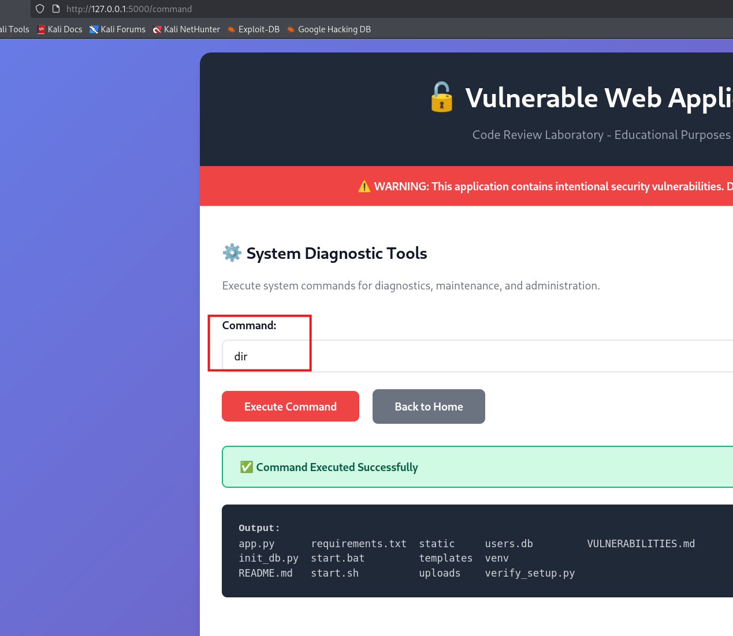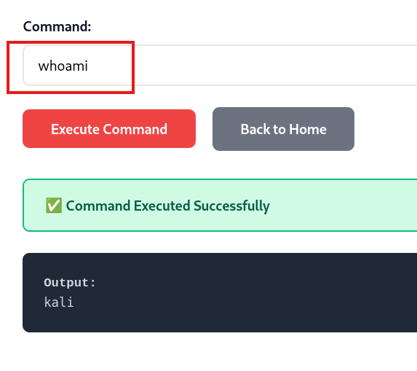
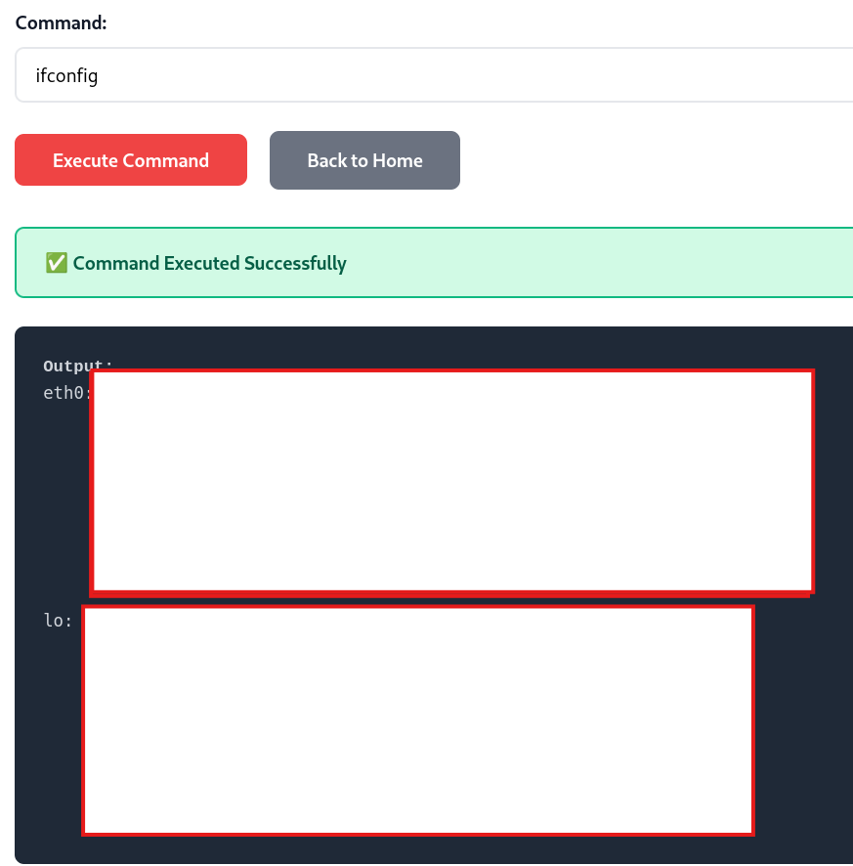
Remediation:
- Never execute user input
- Use allowlists or remove command execution functionality

Finding 7: Debug Mode in Production

Description:
Flask application runs with debug=True: app.run(debug=True). Exposes interactive debugger and source code in case of error.
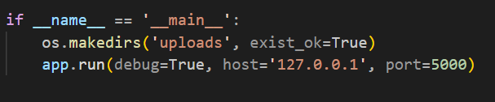

CVSS Score:
7.0 - 8.9 (High)

Tools Used:
- Browser (manual testing)

Reference:
- CWE-489: Active Debug Code
- OWASP Top 10: A06 – Security Misconfiguration

Payload:
http://127.0.0.1:5000/user/abc

Steps to Reproduce:
- Start the application.
- Open a browser and navigate to:
http://127.0.0.1:5000/user/abc
- Observe the detailed database error message displayed.
PoC:
- When accessing /user/abc, the application returns: Database error: no such column: abc
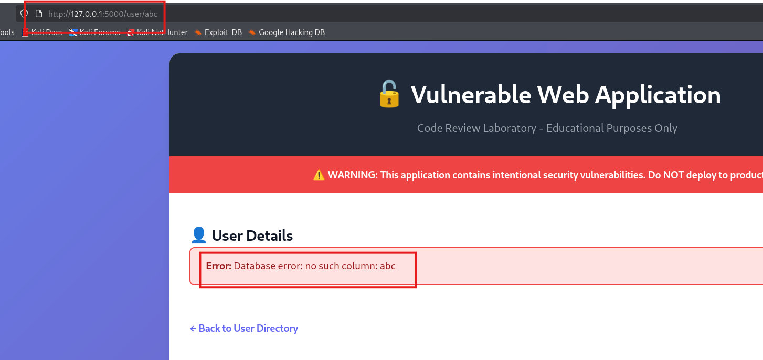
- This confirms that internal database errors are exposed to users, which can help attackers understand database structure and craft further attacks.

Remediation:
- Set debug=False before deploying.
- Do not expose internal error messages to users.
- Implement proper error handling and logging.

