
Assignment-07
Web Pentesting and Bug Hunting - Batch-20
Business login and race condition

SUBMITTED BY
Md Sayem Mottakee
Student Id: CB-2025-862

SUBMITTED TO
Tareq Ahamed
Mentor, Cyber Bangla Academy

SUBMISSION DATE
19/03/26

Table of Contents
Lab 1: Low-level logic flaw 2
Lab 2: Insufficient workflow validation 7
Lab 3: Exploiting time-sensitive vulnerabilities 9
Lab 4: Bypassing rate limits via race conditions 14
Lab: Weak isolation on dual-use endpoint 18

Lab 1: Low-level logic flaw
Description:
The application does not properly validate the quantity parameter, allowing integer overflow in price calculation. This can make the total price negative and allow purchasing items at unintended prices.

Severity:
High

Affected url/subdomain:
POST /cart

Step of reproduce:
- Log in with wiener:peter.
- Add the leather jacket to cart and intercept POST /cart.
- Send the request to Burp Intruder.
- Set quantity=99
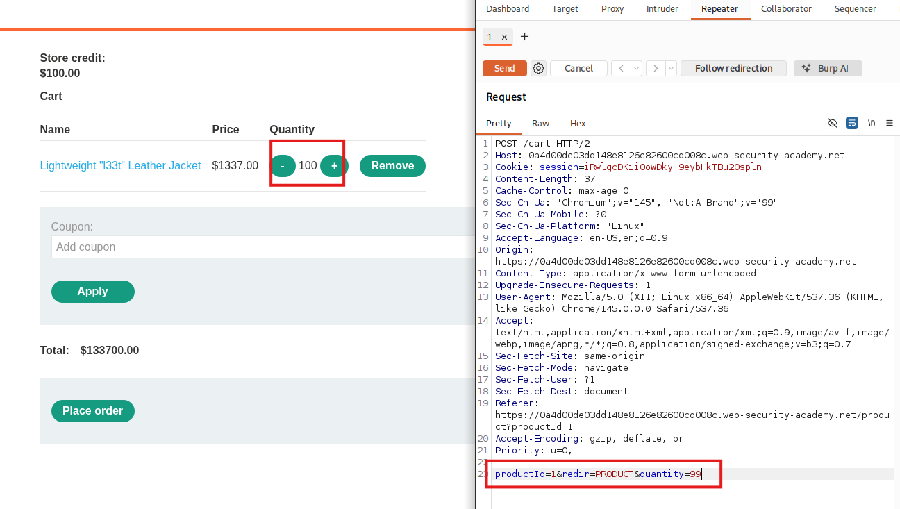
- Payload type Null payloads and run the attack.
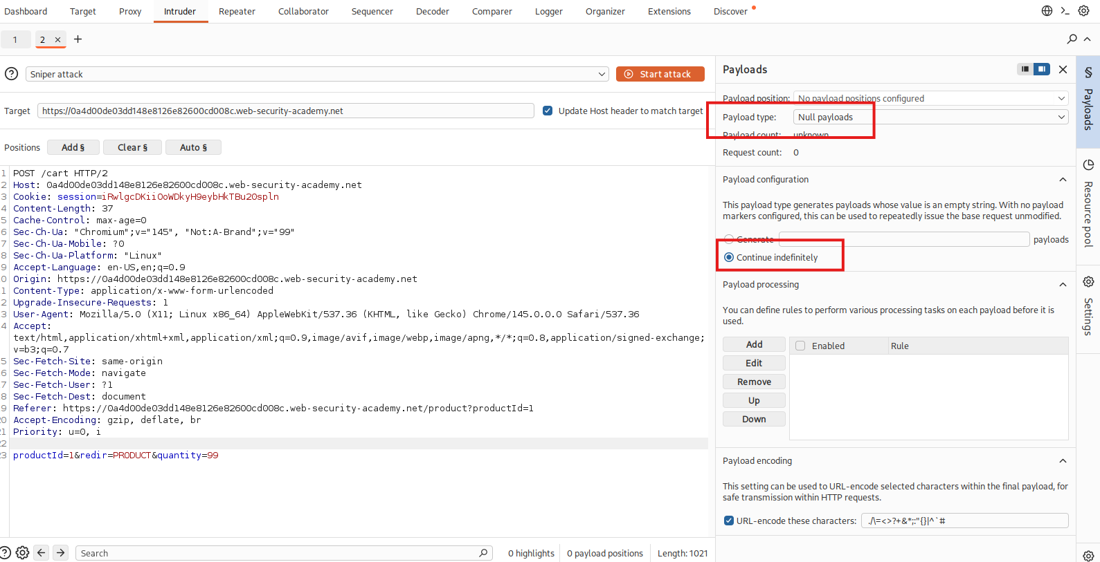
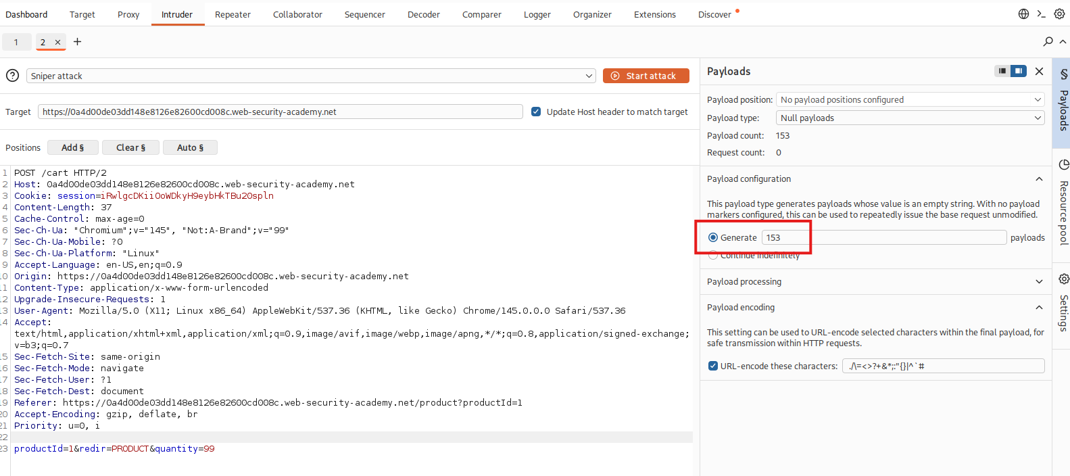
- Refresh the cart and observe the total becomes negative due to integer overflow.
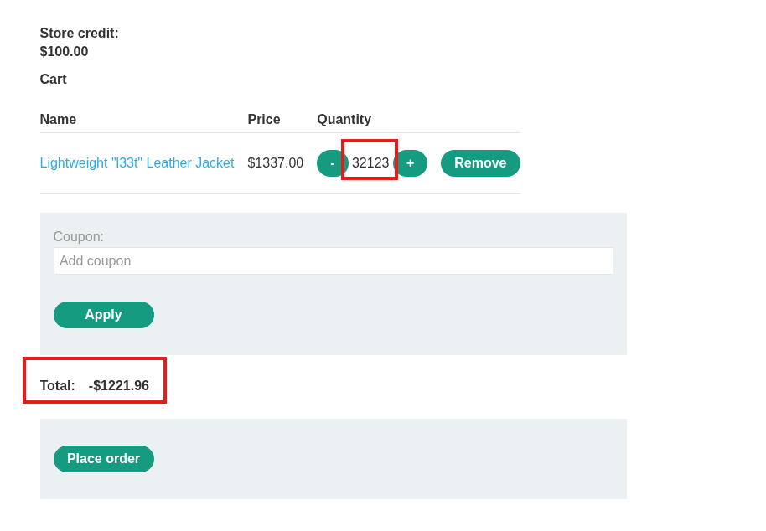
- Adjust the cart total using additional items to fall within store credit.
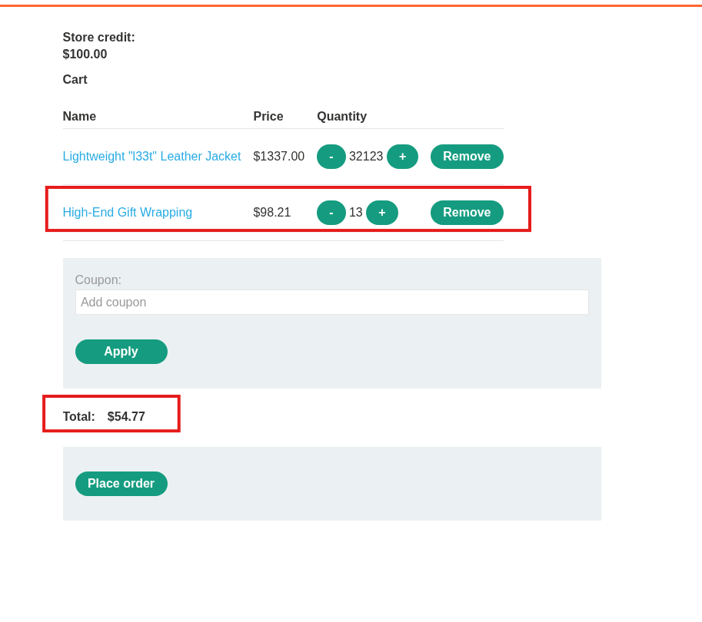
- Place the order successfully.
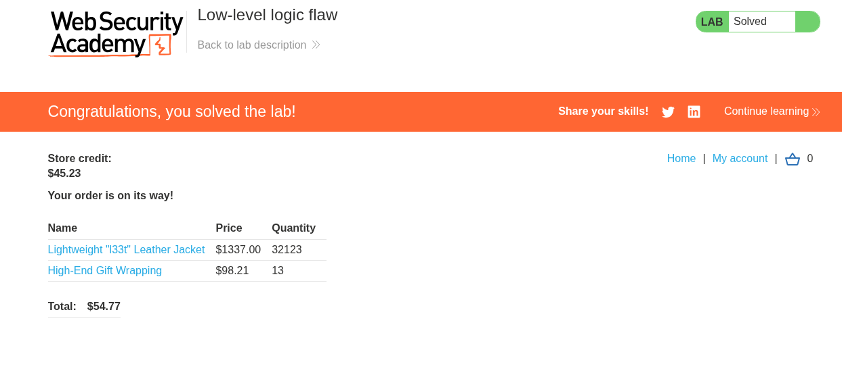
Proof of Concept (PoC):
- Intercepted request:
POST /cart
productId=1&quantity=99

- Sent multiple requests using Burp Intruder
- Integer overflow occurred (value exceeded limit)
- Total price became negative

Impact:
Attackers can buy expensive items at very low or negative prices, causing financial loss.

Fix:
- Validate quantity input on the server side
- Set maximum limit for quantity values
- Prevent integer overflow in calculations
- Reject negative or abnormal total prices

Lab 2: Insufficient workflow validation
Description:
The application does not properly validate the order workflow. It allows users to access the order confirmation step directly without completing the payment process, leading to unauthorized purchases.

Severity:
High

Affected URL/Subdomain:
GET /cart/order-confirmation?order-confirmed=true

Steps to Reproduce:
- Log in with wiener:peter.
- Purchase any affordable item normally.
- Intercept and observe the request flow in Burp Suite.
- Notice the redirection to the order confirmation endpoint.
- Add the Lightweight "l33t" Leather Jacket to the cart.
- Replay the order confirmation request using Burp Repeater.
- The order is placed without deducting store credit.
Proof of Concept (PoC):
- Observed request: GET /cart/order-confirmation?order-confirmed=true

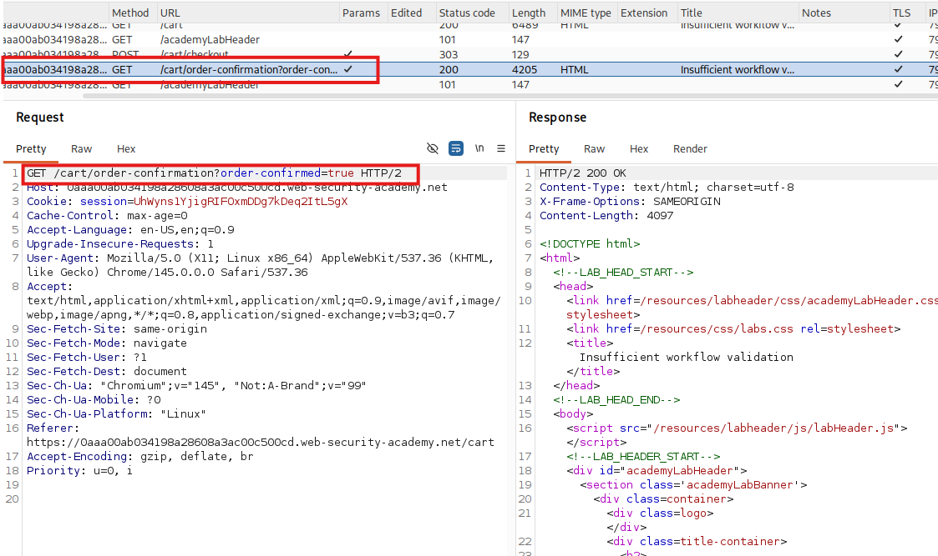
- Replayed the request using Burp Repeater

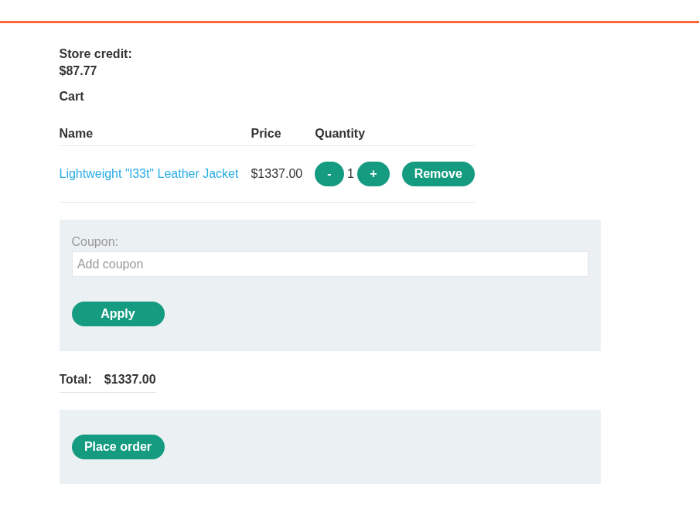
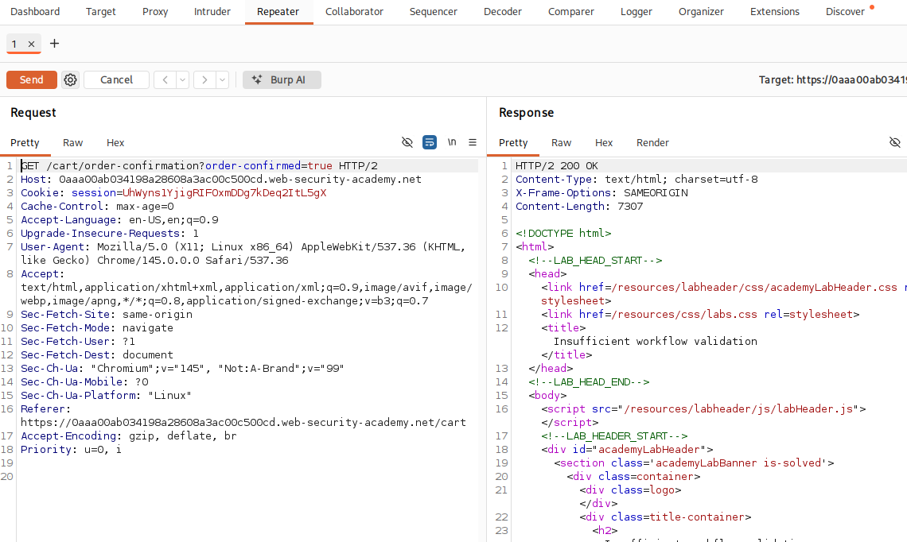
- Order completed without payment verification
- Expensive item purchased without reducing store credit
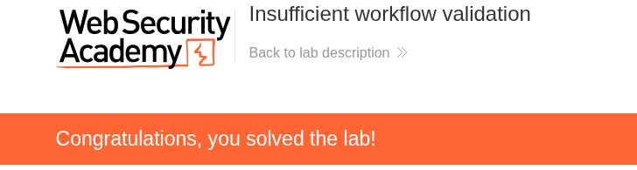
Impact:
Attackers can bypass the payment process and purchase items for free, causing financial loss.

Fix:
- Enforce proper workflow validation on the server side
- Ensure payment is verified before confirming orders
- Use session/state validation for each step
- Prevent direct access to order confirmation endpoint

Lab 3: Exploiting time-sensitive vulnerabilities
Description:
The password reset mechanism uses predictable token generation based on time. Due to improper session handling and lack of randomness, identical tokens can be generated for different users when requests are sent simultaneously, allowing account takeover.

Severity:
High

Affected URL/Subdomain:
POST /forgot-password
GET /forgot-password

Steps to Reproduce:
- Log in with wiener:peter.
- Send multiple password reset requests and observe different tokens.

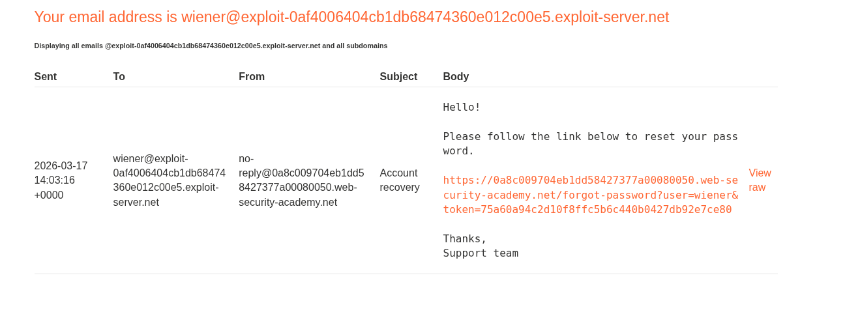
- Remove session cookie from GET /forgot-password to create a new session.

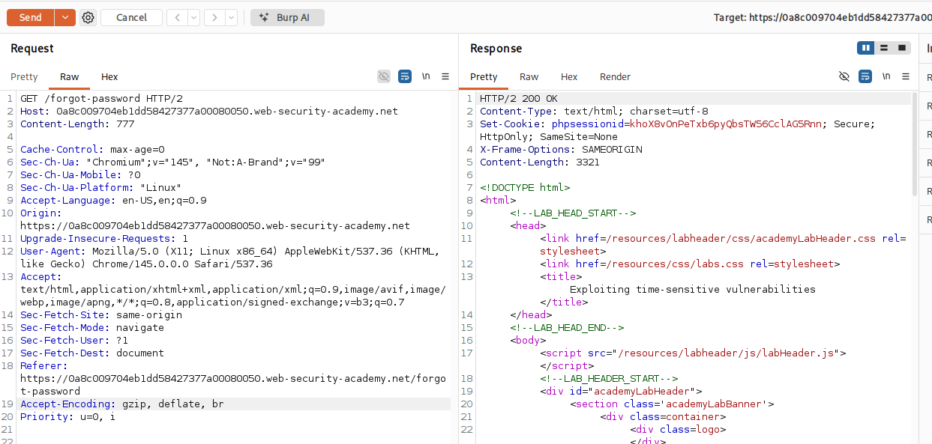
- Use two different sessions to send reset requests in parallel.
- Modify one request with username carlos.

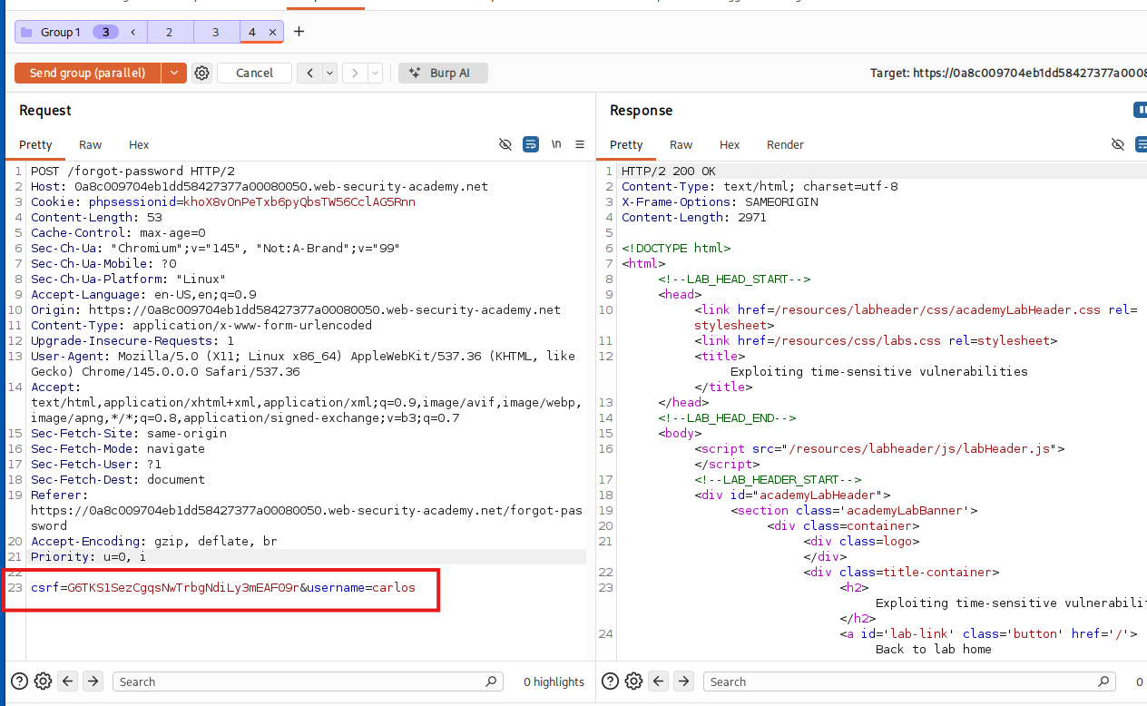
- Send both requests at the same time.
- Use the received token and change username to carlos in the reset link.
- Reset Carlos’s password and log in.

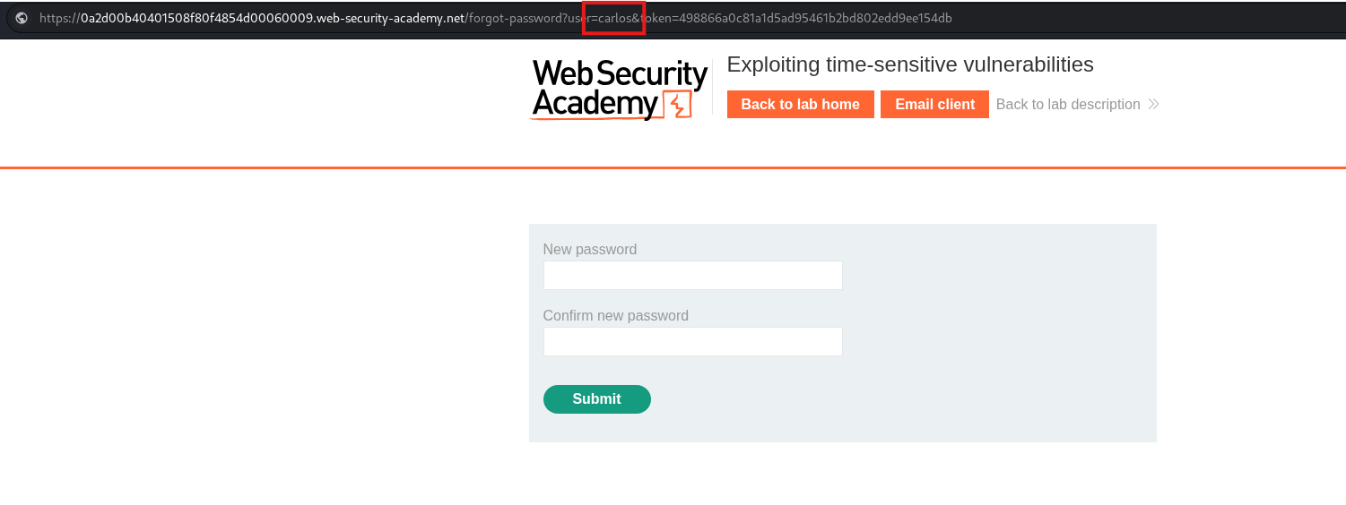
- Access the admin panel and delete user carlos.
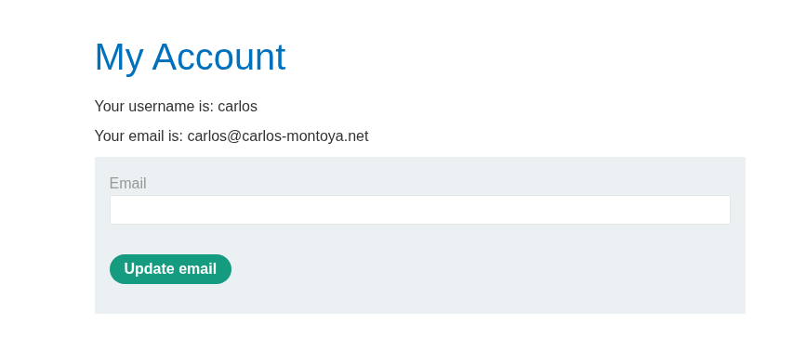
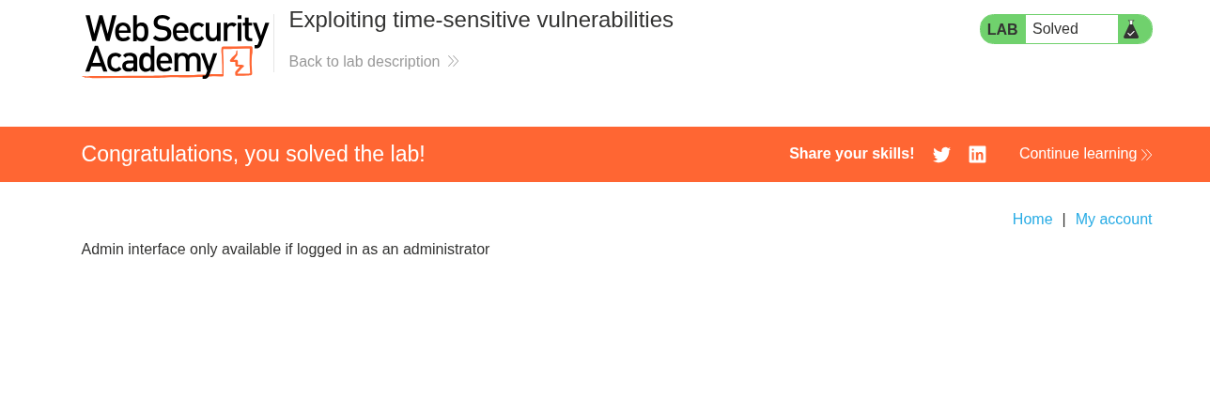
Proof of Concept (PoC):
- Sent parallel requests:
  - POST /forgot-password
username=wiener
  - POST /forgot-password
username=carlos
- Used different sessions (different cookies)
- Both requests generated identical reset tokens
- Modified reset link:
/forgot-password?username=carlos&token=TOKEN


- Successfully reset Carlos’s password and logged in

Impact:
Attackers can reset passwords of other users and take over accounts without authorization.

Fix:
- Bind tokens to specific users
- Prevent token reuse across accounts
- Enforce strict session handling and rate limiting

Lab 4: Bypassing rate limits via race conditions
Description:
The login functionality implements rate limiting per username, but due to a race condition, multiple login attempts can be processed before the failed-attempt counter is updated. This allows bypassing the rate limit and performing brute-force attacks.

Severity:
High

Affected URL/Subdomain:
POST /login

Steps to Reproduce:
- Try to log in with carlos:1234 and observe rate limiting after multiple failed attempts.

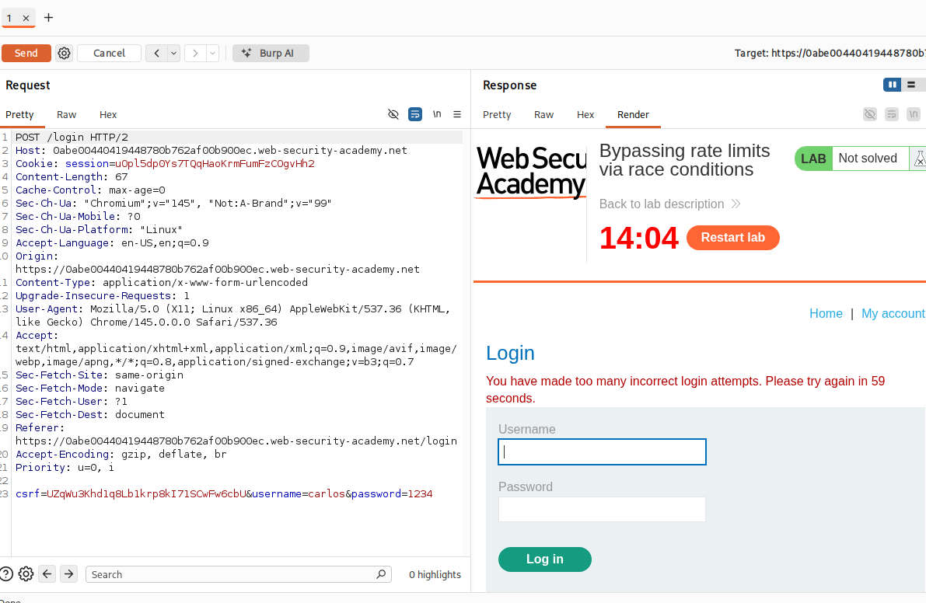
- Intercept a failed login request and send it to Turbo Intruder.
- Use a password wordlist as payload.
- Configure a race condition attack (single-packet attack).
- Send all login requests simultaneously.
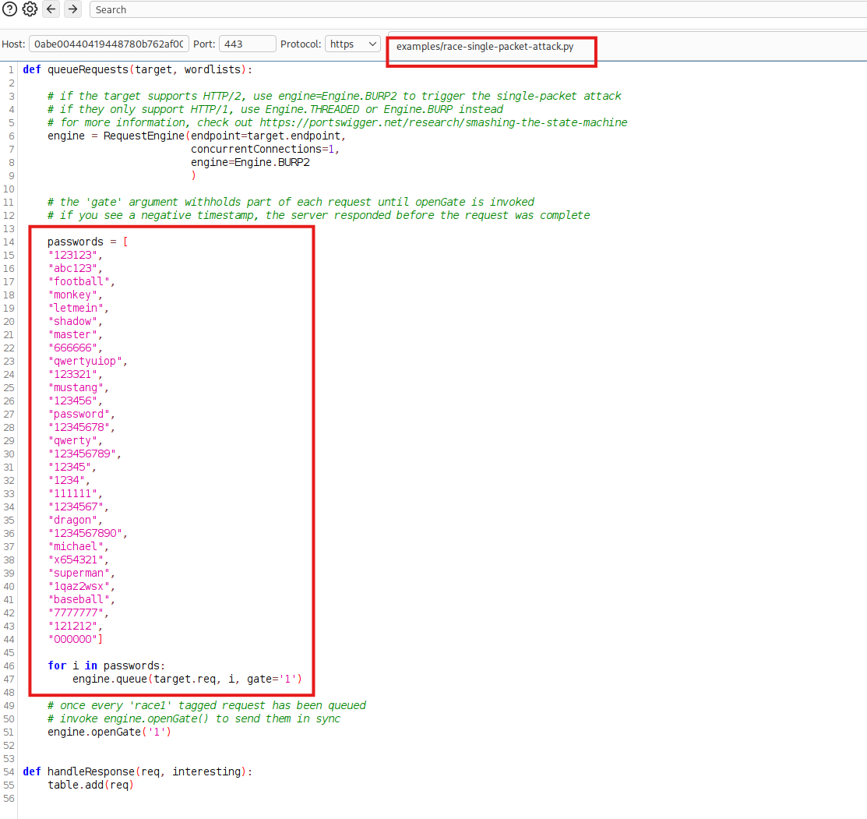
- Observe that multiple attempts bypass the rate limit.
- Identify the correct password from a successful response.
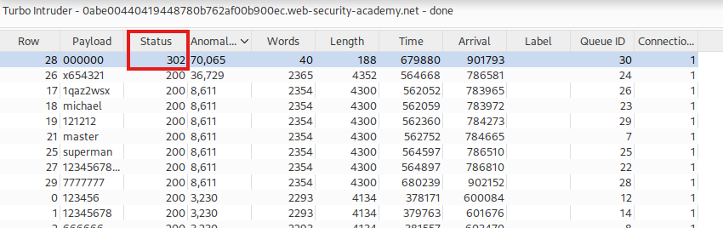
- Log in as carlos and access admin panel.
- Delete the user carlos.
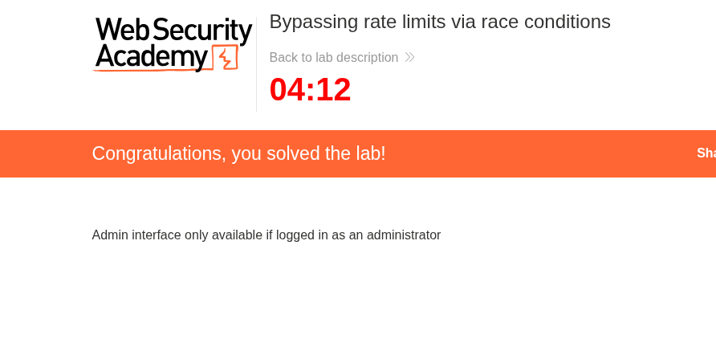

Proof of Concept (PoC):
- Intercepted request:
POST /login
username=carlos&password=$payload
- Sent multiple login attempts simultaneously using Turbo Intruder
- Race condition allowed more than allowed attempts before lock
- Received successful response (302 redirect) for correct password
Impact:
Attackers can bypass rate limiting and brute-force passwords, leading to account takeover.

Fix:
- Implement atomic operations for login attempt counters
- Enforce rate limiting before authentication processing
- Use proper locking mechanisms to prevent race conditions
- Add CAPTCHA or additional brute-force protections

Lab 5: Weak isolation on dual-use endpoint
Description:
The application fails to properly validate user identity in the password change functionality. By manipulating the username parameter and removing the current password check, an attacker can change the password of any user, leading to account takeover.

Severity:
High

Affected URL/Subdomain:
POST /my-account/change-password

Steps to Reproduce:
- Log in with wiener:peter.
- Go to account settings and attempt to change password.
- Intercept the request in Burp Suite.
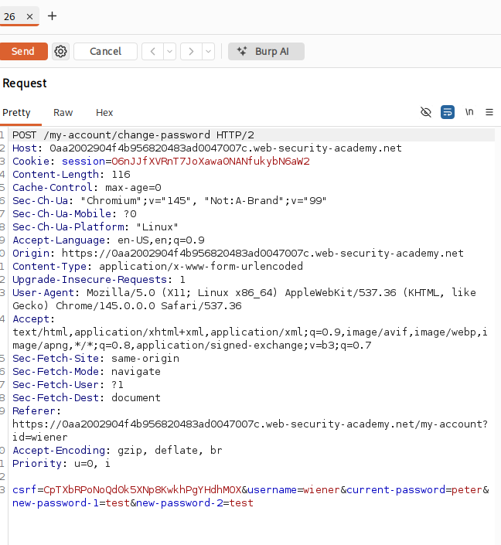
- Remove the current-password parameter.
- Change username=administrator.
- Send the modified request.
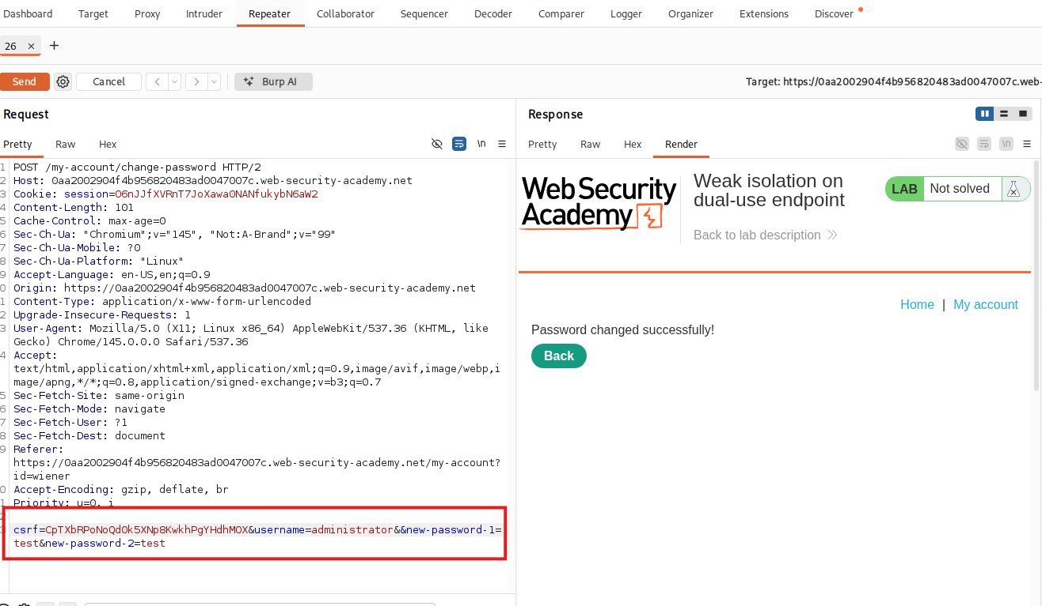
- Log out and log in as administrator using the new password.
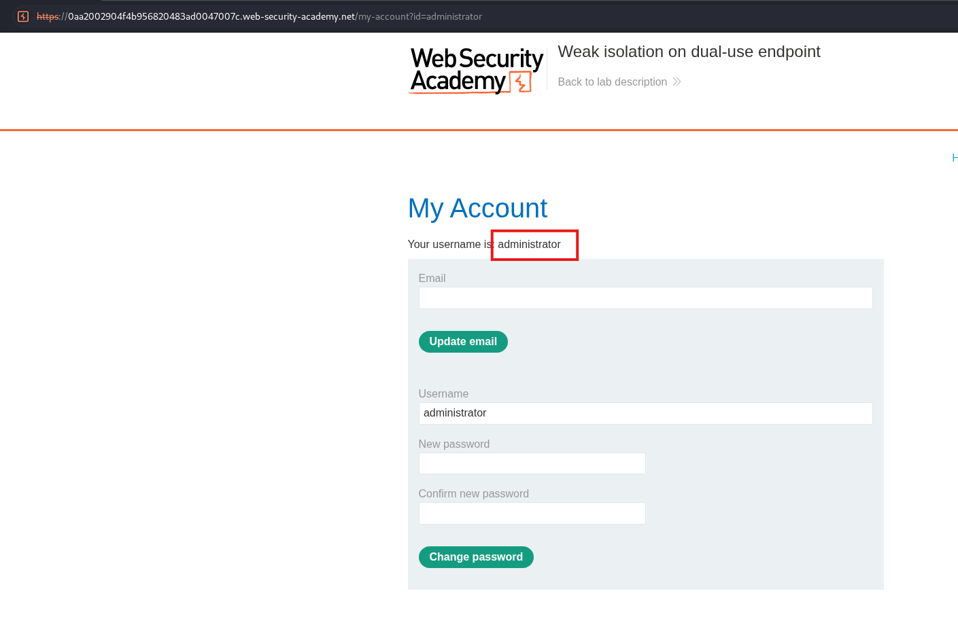
- Access admin panel and delete user carlos.
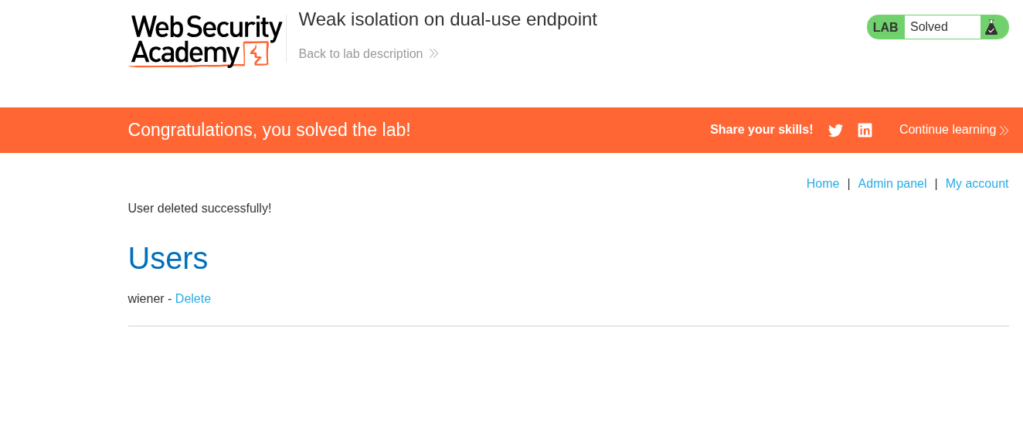
Proof of Concept (PoC):
- Modified request:
POST /my-account/change-password
csrf=****&username=administrator&new-password-1=test&new-password-2=test
- Removed current-password parameter
- Password successfully changed for administrator
- Logged in with new credentials
Impact:
Attackers can take over any account, including admin accounts, leading to full system compromise.

Fix:
- Require current password verification for password changes
- Validate user identity server-side
- Ignore or securely handle the username parameter
- Enforce proper authorization checks

