Date : 19th Nov,2019

TO,

Editor

Dainik Purbokone,

971/A CDA Avenue,

East Nasirabad,Chittagong.

**Sub : Application for the post of Content Developer in Dainik Purbokone.**

With Regards,

I wish to apply for the post of **“Content Developer”.** I think of myself as a candidate for this posts. Attached herewith my C.V and Passport size photograph for your kind consideration.

I therefore, pray and hope that you would kindly consider all these and appoint me in the post prayed for.

Yours faithfully

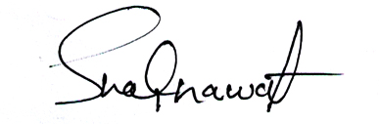

**________________**

**(Shakhawat Hosen)**