Game Design Document

Fill up the following document

1. Write the title of your project.

Parkour

1. What is the goal of the game?

You need to save your friend Garcello

1. Write a brief story of your game.

You and your friend have been kidnaped by ROMBO gang and

Are kept in seprate buildings. You nee to parkour and jump on

Buildings to save him.

1. Which are the playing characters of this game?

* Playing characters are the ones who respond to the user based on the input from the user.
* Cars, monkeys, dinos, wizards, etc., are the playing characters in the game.

|  |  |  |
| --- | --- | --- |
| Number | Character Name | What can this character do? |
| 1 | Keith | Jump,Run,Skit |
| 2 |  |  |
| 3 |  |  |
| 4 |  |  |
| 5 |  |  |
| 6 |  |  |
| 7 |  |  |
| 8 |  |  |

1. Which are the Non-Playing Characters of this game?

* Non-Playing characters are the ones that don't have an action or behavior when the user interacts with the game.
* Hurdles, stones, bananas, coins, etc., are non-playing characters in the game.

|  |  |  |
| --- | --- | --- |
| Number | Character Name | What can this character do? |
| 1 | Coin | Player can get points from this |
| 2 | Enemy1 | Shoot |
| 3 | Enemy2 | Shoot |
| 4 | Garcello | Sve him and win the game |
| 5 | Bullets | Can kill player |
| 6 |  |  |
| 7 |  |  |
| 8 |  |  |

Draw your imagination of this game. What does this game look like?

* Draw the game either on your computer or on paper.
* Add images of the game scenes to show each of the playing and non-playing characters at least once.

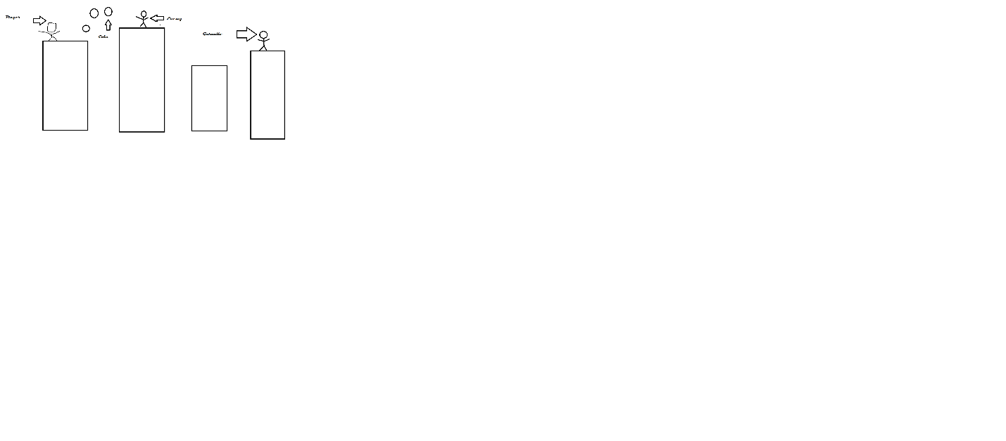

How do you plan to make your game engaging?

Music, adventure, etc.