METHODOLOGY
Governing Equations
Continuity equation and Navier-stokes equations were assigned to describe the blood flow through the carotid artery. These equations were solved using ‘fluent‘(Ansys 15).
Continuity equation: $∇⋅\overline{U}=0, \frac{∂u}{∂ϰ}+\frac{∂v}{∂y}+\frac{∂w}{∂z}=0$
Navier-stokes equation: $\frac{∂\overline{U}}{∂t}+\overline{U}⋅∇\overline{U}=-\frac{ΔP}{ρ}+μ∇^{2}\overline{U}$

Model Construction
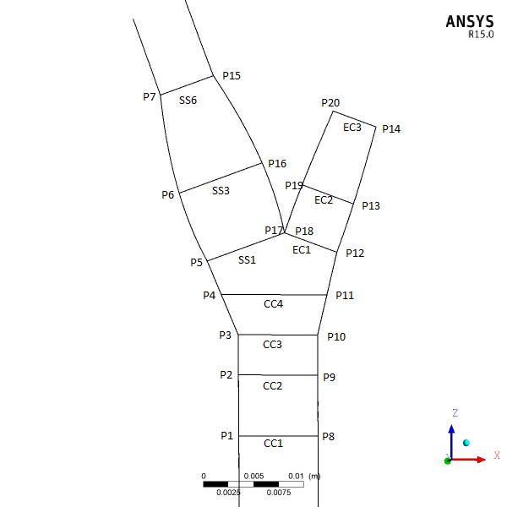 | 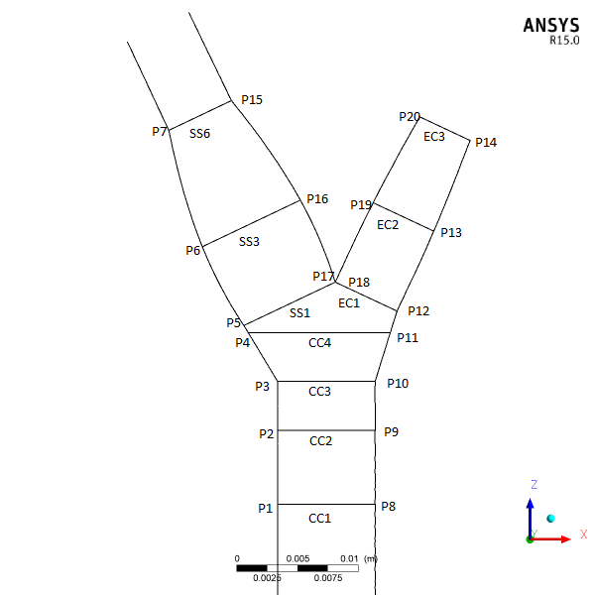
- Model 1 | b) Model 2

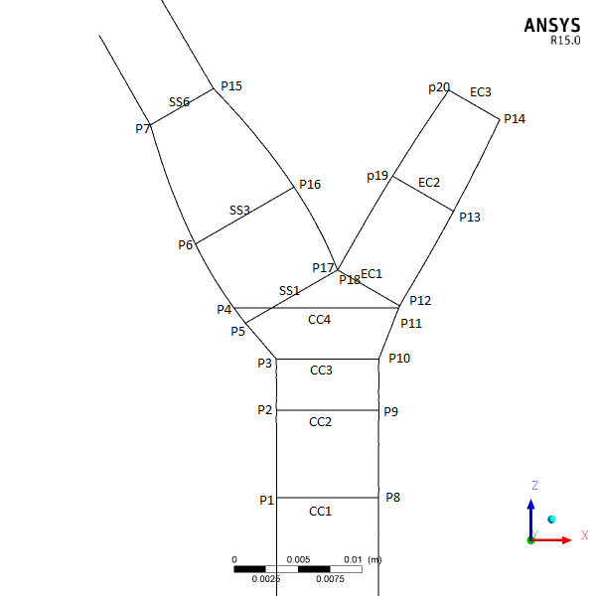
c) Model 3
Fig.3.1: Bifurcation plane of model arteries.

Model 2 has been taken from Bharadvaj et al., 1982 []. And Model 1 and Model 3 differ from Model 1 in bifurcation angle. Model 1 and Model 3 have 40⁰ and 60⁰ bifurcation angle respectively. For both cases the bifurcation angles are symmetric about CCA axis. The length of the CCA has been taken 130 mm as it is the average length of CCA according to Bharadvaj et al., 1982. All geometric models are three dimensional and have circular cross sections. Asides from those information given in the above all basic geometrical data for the Model 2 and Model 3 has been taken from Bharadvaj et al., 1982. Solidworks 2017 was used to construct those models.

Grid Independency Test
Grid sensitivity tests were also performed for all the geometric models. Tetrahedrons cells are adopted for meshing purpose. Out flow ratio, Non-Newtonian, Pulsatile velocity wave form.
 | Model 1 |  | Model 2 |  | Model 3
 | Elements | Nodes | Elements | Nodes | Elements | Nodes
Test 1
Test 2
Test 3

Number of nodes and elements are respectively 696328 and 389467 for model 1. For model 2 number of nodes and elements are respectively 735776 and 407191. And For model 3 number of nodes and elements are respectively 680772 and 379956.

Validation
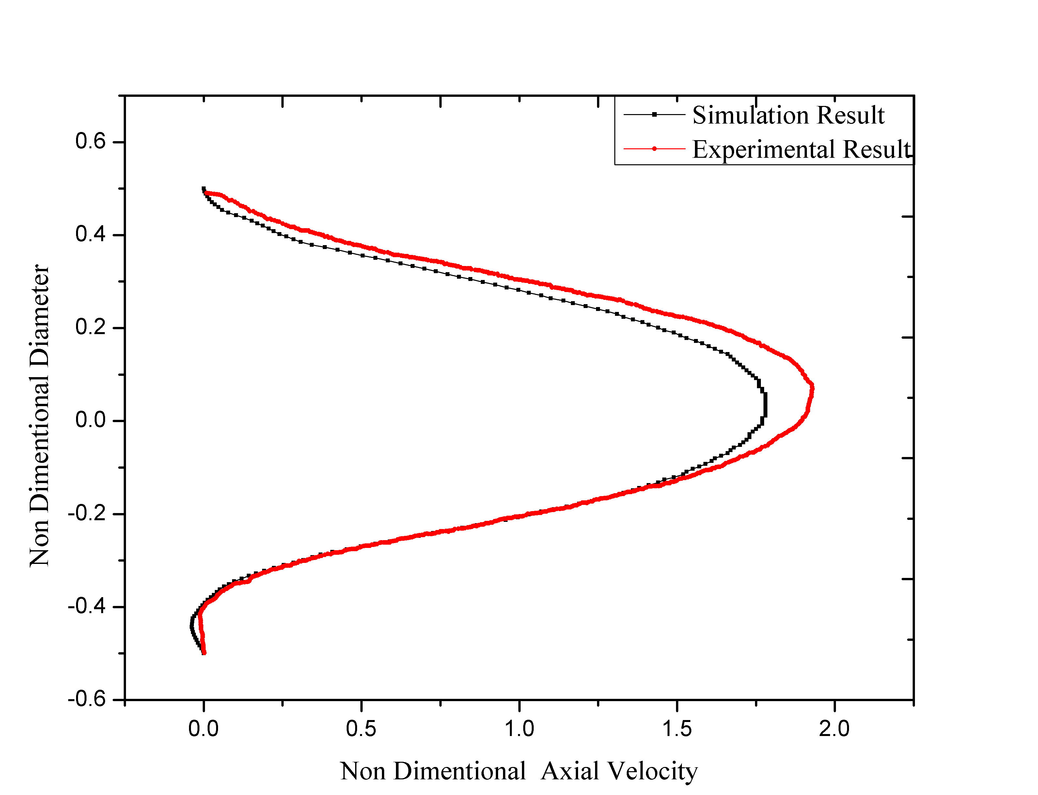 | 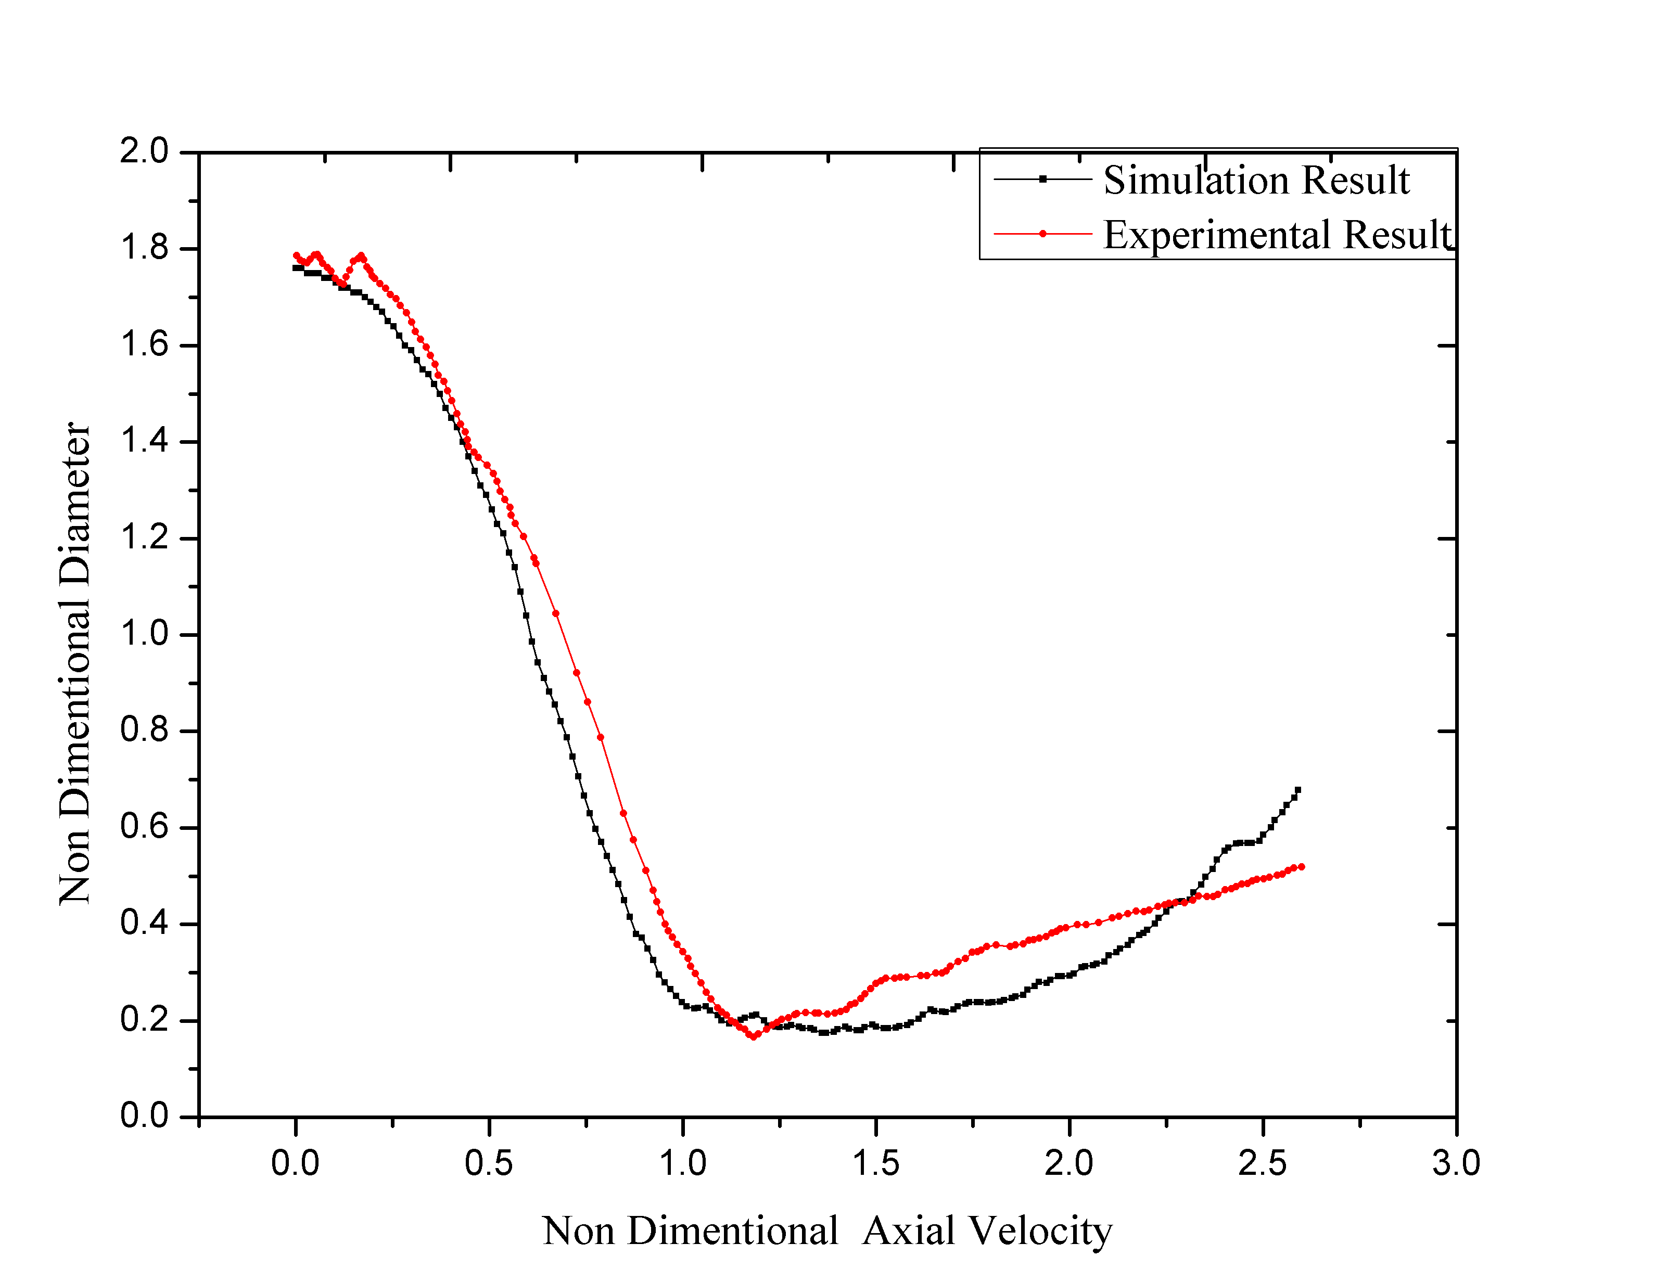
a) At CC4, on Bifurcation Plane, Reynolds 400, 70% Flow through ICA | b) Along the Axis of ECA, on Bifurcation Plane, Reynolds 800, 80% Flow through ICA
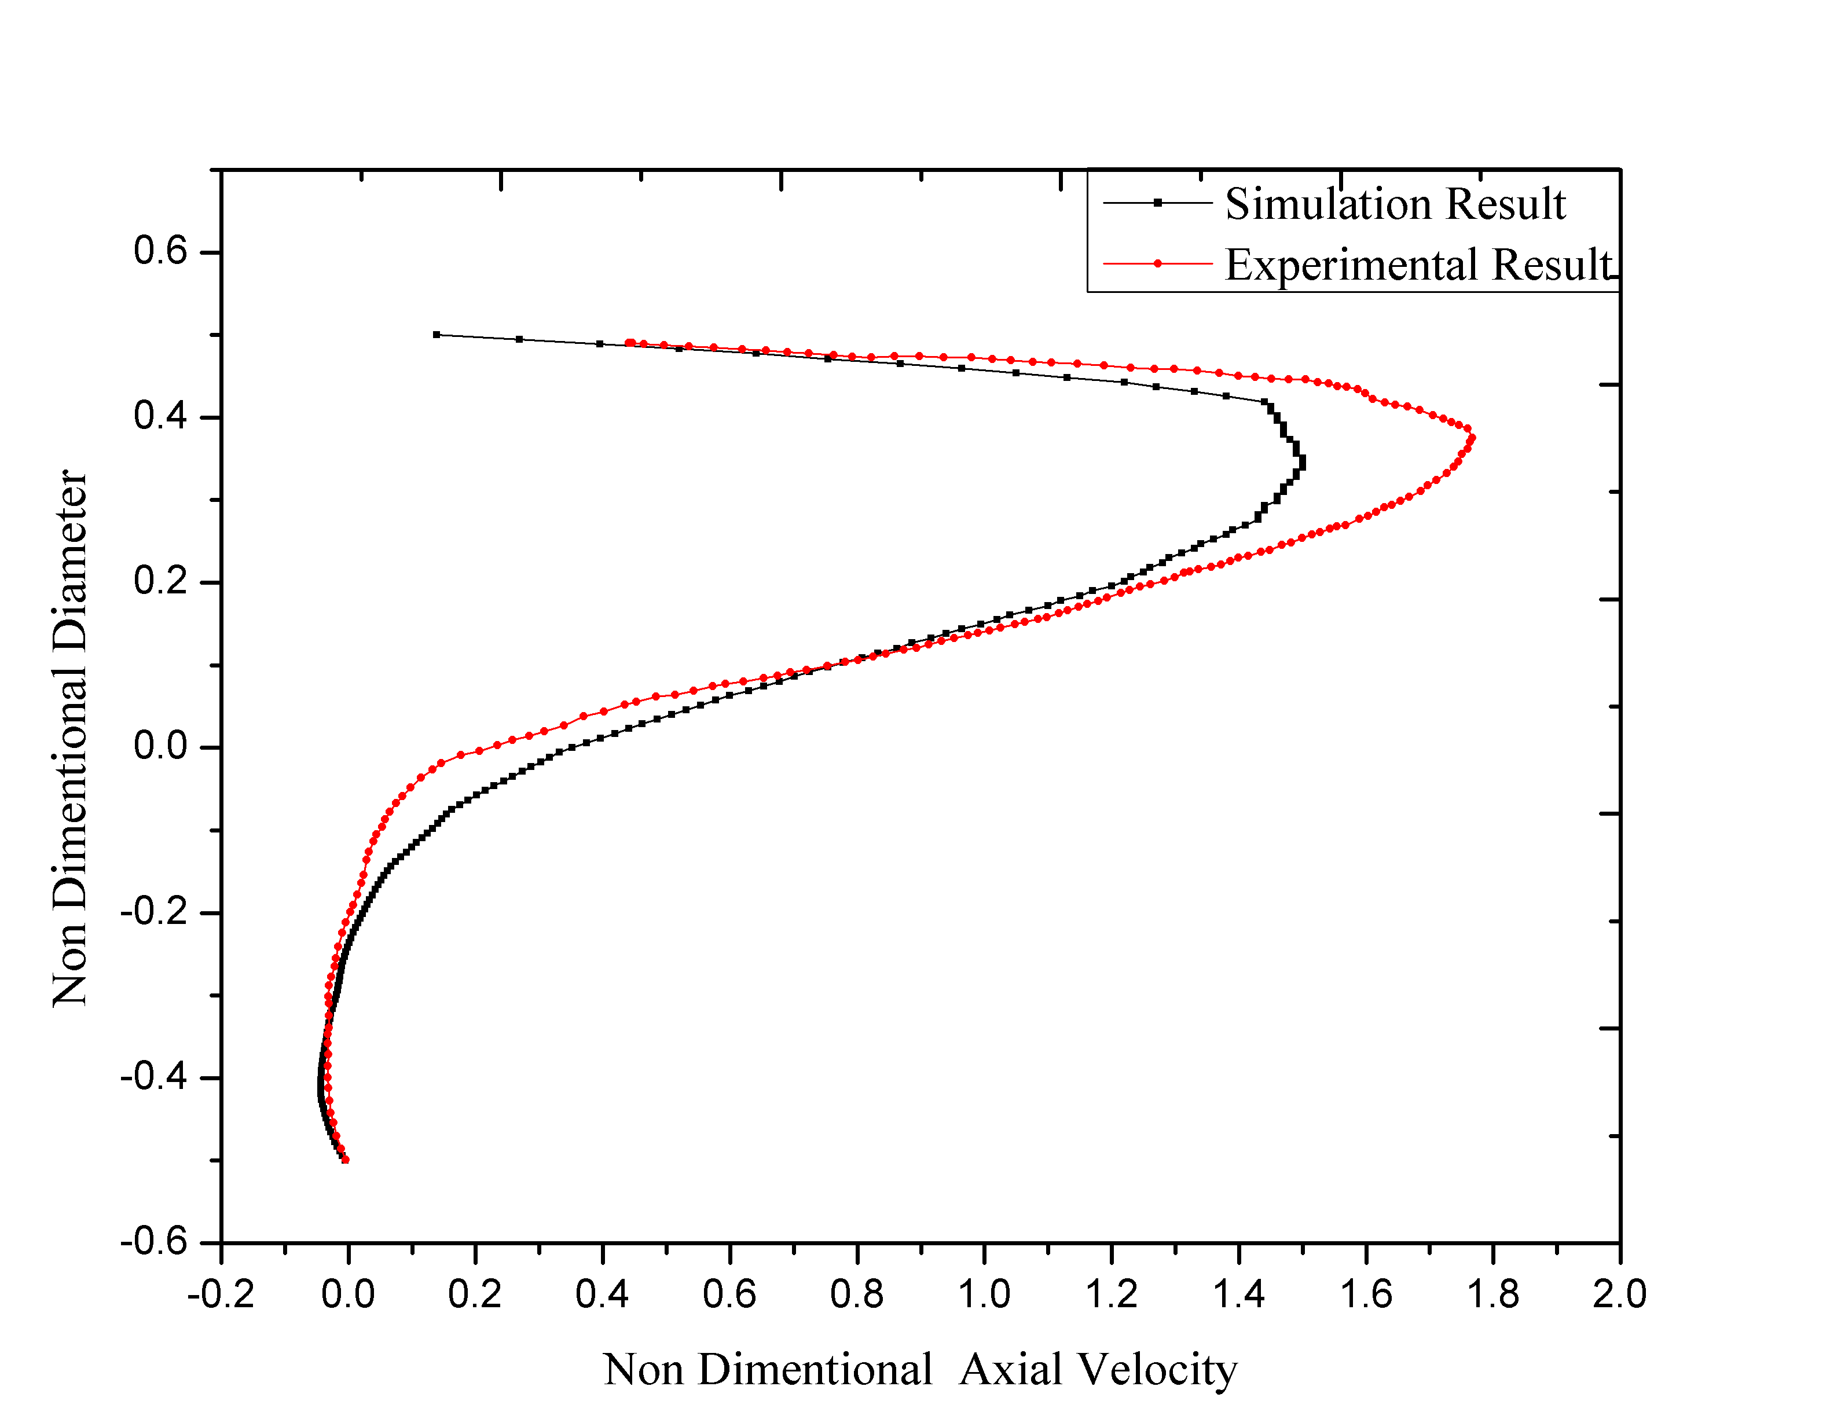 | 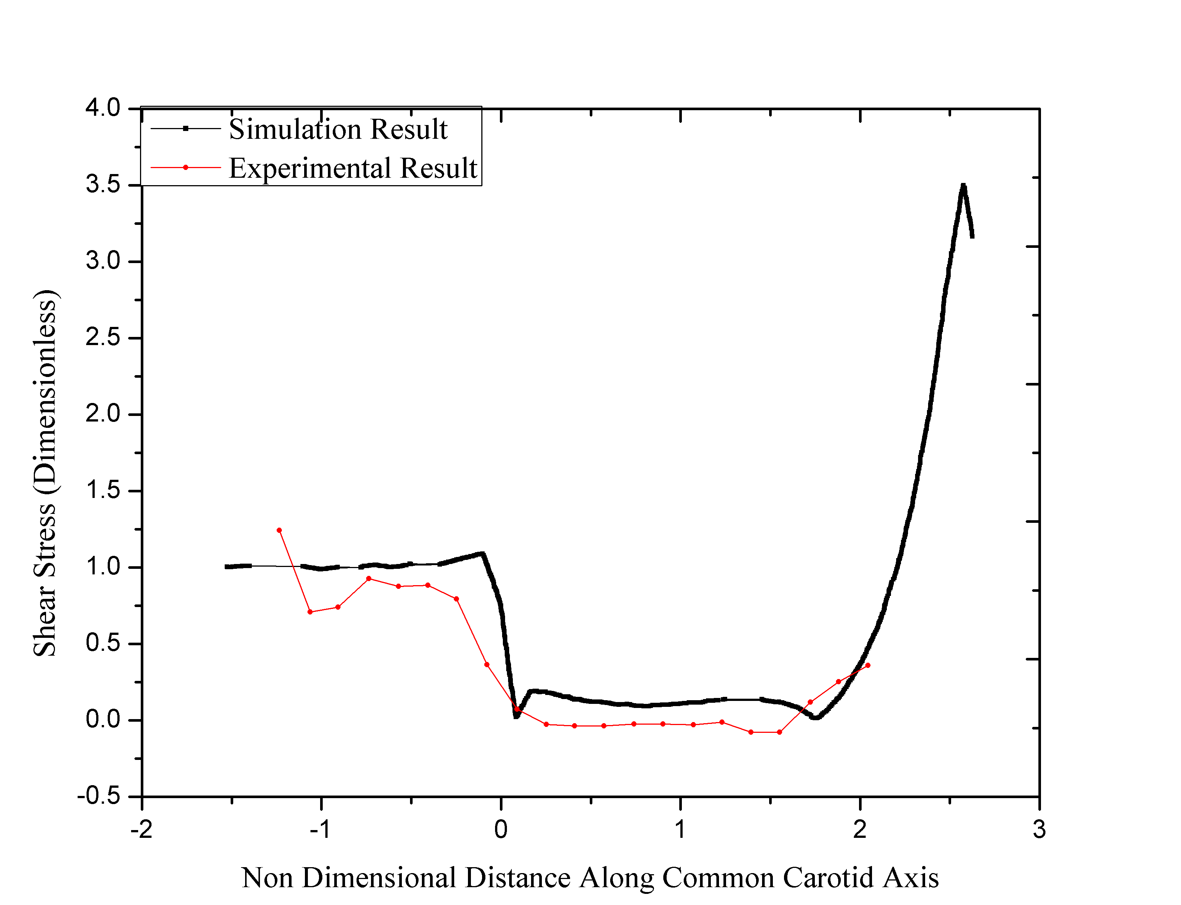
c) At SS3, on Bifurcation Plane, Reynolds 400, 70% Flow through ICA | d) WSS along CCA-ICA wall, on Bifurcation Plane, Reynolds 400, 60% Flow through ICA

Quantitative comparison has been done with the results of Bharadvaj et al., 1982 []. There is a good agreement between the results obtained by Bharadvaj et al., 1982 and current CFD simulations.
Numerical Method
Large Eddy Simulation (LES) has been used as viscous model and bounded second Order Implicit option was used as Transient Formulation. A total of 86 uniform time steps per cardiac cycle were used and all the simulations were carried out over six cardiac cycles. The convergence for each time step in the simulations was based on the residual in continuity falling below a prescribed value (₁₀⁻⁶). Under those conditions, differences in velocities between successive cycles were smaller than ₁₀⁻⁵.

Boundary Conditions
Carreau model has been imposed to describe the Non-Newtonian Behavior of blood. And blood density has been taken 1050 kg/m³.
Carreau model: $\frac{μ-μ_{∞}}{μ_{0}-μ_{∞}}={\left[1+{\left(λγ\right)}^{2}\right]}^{\frac{n-1}{2}}$
Where $μ_{∞}$= 0.0035 kg/m-s, $μ_{0}$= 0.056 kg/m-s, n = 0.3568 and λ= 3.313 s (Shibeshi, 2005; Seo, 2005)

A pulsatile velocity waveform was specified at the inlet of the CCA []. At the outlets, the outflow boundary conditions were applied to the ICA to the ECA outlet. The walls of carotid artery bifurcation are considered as rigid walls and no-slip boundary conditions were imposed on the walls.

