# PABNA UNIVERSITY OF SCIENCE AND TECHNOLOGY

Department of Information and Communication Engineering (ICE)

Faculty of Engineering and Technology

**Lab-Report**

COURSE CODE: ICE-3102

COURSE TITLE: Artificial Intelligence & Robotics Sessional

|  |
| --- |
| Md.Sarwar Hosain  Assistant Professor  Dept. of Information and Communication Engineering (PUST)  *signature* |

Submitted by: Submitted to:

Nazmul Hasan

ID:170628

Session: 2016-17

3rd year 2nd semester

Dept. of Information and

Communication Engineering (PUST)

*Date: 21/06/2020*

**Strowger Switching Systems**

Definition

Several electromechanical switching system were developed around 1880-1890 to eliminate the limitations of manual exchanges and to establish automatic exchanges to improve the speed and carry more leads (subscribers). Among those electromechanical automatic switches, strowger's step by step switching system was the most pupular and widely used and even now in some part of the world, it is in use.

There are two types of basic elements which performs most of the functions of the [strowger switching system](https://en.wikipedia.org/wiki/Strowger_switch). They are (a) Uniselectors and (b) Two motion selectors.

Uniselectors. A uniselector is a one which has a single rotary switch with a bank of contacts. Depending upon the number of switching contacts, uniselectors are identified as 10 outlet or [24 outlet uniselectors](http://www.expertsmind.com/questions/24-outlet-uni-selector-30199615.aspx). A single 10 outlet or 24 outlet uniselector can be used as a switching element for 10 or 24 subscribers. Several uniselectors can be graded together so that multiple incoming circuits can be connected to multiple outgoing circuits.

To Design a strowger's step by step switching system  we need know about some parameter such as,

* Number of subscriber lines N
* Total Number of Switching Elements S
* Cost of The Switching System C

**C = S*Cs+Cc+Cch**

When,

* + Cs = Cost per Switching Element
  + Cc = Cost of the Common Control System
  + Cch = Cost of The Common Hardware
* Switching Capacity Sc
* Traffic Handling Capability TC
  + TC = (SC) / (theoretical maximum load)

= (2*SC)/N

* Equipment utilization factor, EUF
* EUF=(number of SE in operation) / (total number of SE)

(SE means Switching Element)

* Number of Switching Stages K
* Averages Switching time per stage Tst
* Call setup time, Ts
  + Ts= Tst * k + T0
* Cost Capacity Index, CCI
  + CCI = (N*SC)/C

**Problem 01**

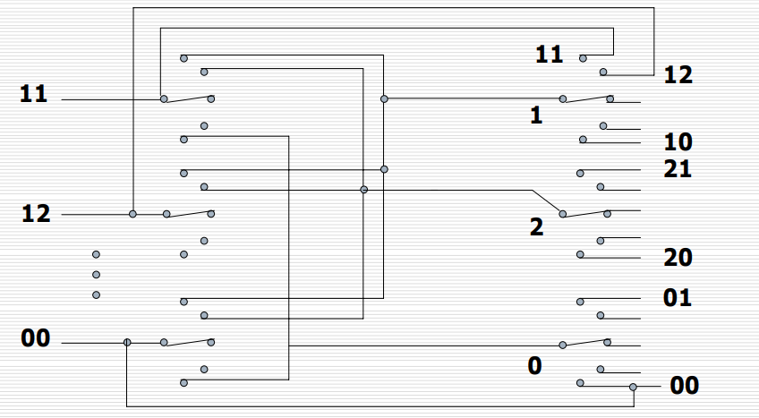

Figure 01

S = 110

SC = 10

K = 2

TC = 0.2

EUF = 0.18

C = 110

CCI = 9.09

Calculation :

*N = (2*SC)/TC = (2*10)/0.2 = 100

*CCI = (SC)/(C/N) = (10)/(110/100) = 9.09

*TC = (2*SC)/N = (2*10)/100 = 0.2

*EUF = (SC*K)/S = (10*2)/110 = 0.18

**Problem 02**

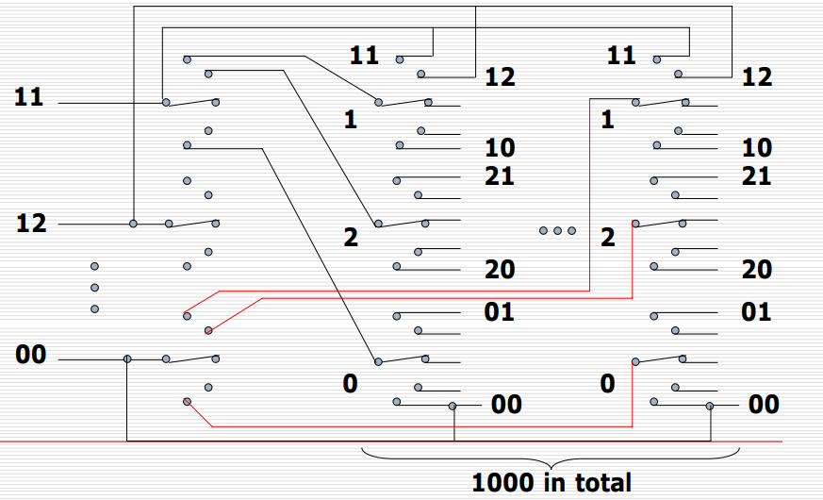

Figure 02

S = 1100

SC = 50

K = 2

TC = 1

EUF = 0.09

C = 1100

CCI = 4.54

Calculation :

*N = (2*SC)/TC = (2*50)/1 = 100

*CCI = (SC)/(C/N) = (50)/(1100/100) = 4.54

*TC = (2*SC)/N = (2*50)/100 = 1

*EUF = (SC*K)/S = (50*2)/100 = 0.09

**Problem 03**

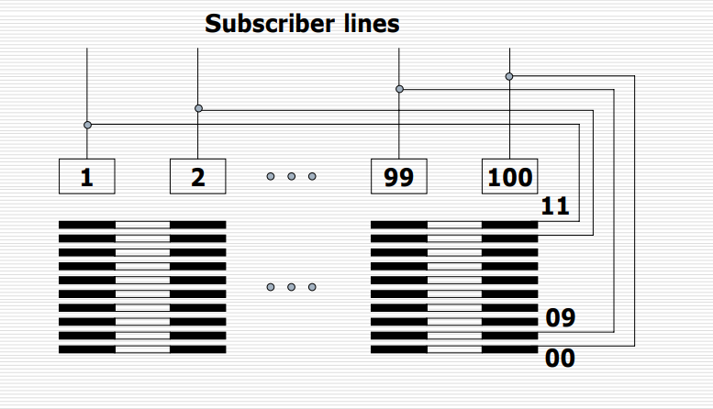

Figure 03

S = 100

SC = 50

K = 1

TC = 1

EUF = 0.5

C = 200

CCI = 25

Calculation :

*N = (2*SC)/TC = (2*50)/1 = 100

*CCI = (SC)/(C/N) = (50)/(200/100) = 25

*TC = (2*SC)/N = (2*50)/100 = 1

*EUF = (SC*K)/S = (50*1)/100 = 0.5

**Problem 04**

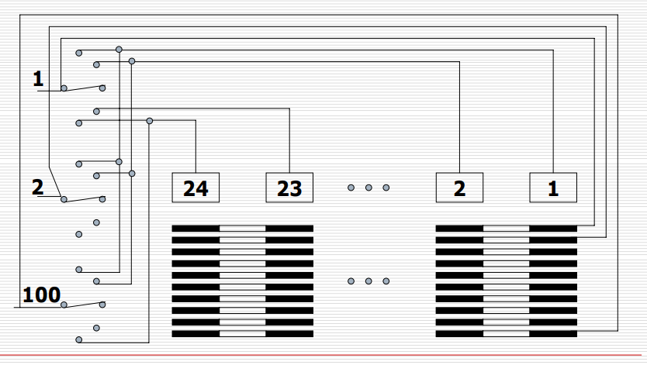

Figure 04

S = 100(uniS) +24(Two-motion)

SC = 24

K = 2

TC = 0.48

EUF = 0.58

C = 148

CCI = 16.2

Calculation :

*N = (2*SC)/TC = (2*24)/0.48 = 100

*CCI = (SC)/(C/N) = (24)/(148/100) = 16.216

*TC = (2*SC)/N = (2*24)/100 = 0.48

*EUF = (SC*K)/S = (24*2)/124 = 0.38

**Problem 05**

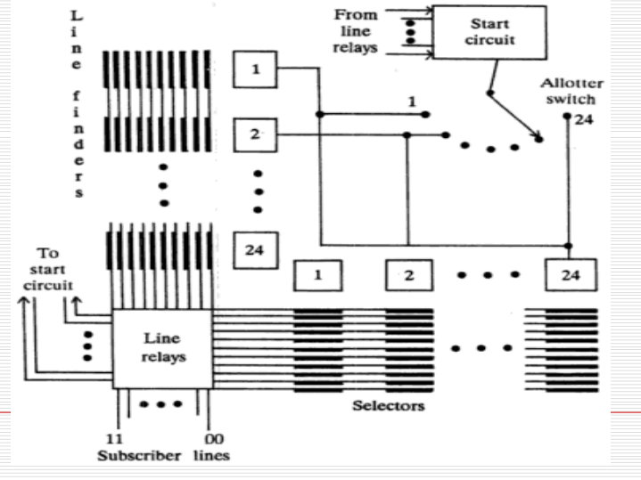

Figure 05

S = 48

SC = 24

K = 1

TC = 0.48

EUF = 1

C = 96

CCI = 25

Calculation :

*N = (2*SC)/TC = (2*24)/0.48 = 100

*CCI = (SC)/(C/N) = (24)/(96/100) = 25

*TC = (2*SC)/N = (2*24)/100 = 0.48

*EUF = (SC*K)/S = (24*1)/48 = 0.5