**Gender classification based on neural network Introduction:** Before the neural network algorithm we have been teaches other algorithm like …. But neural network is the most efficient algorithm I have ever seen. It’s mostly like as linear regression but it is not totally like it.

**Description:** Human brain is made of neurons. Each neuron has each works. One can help for taking food taste another helps us for our optical sights. More or less I can say that neural network has the work where I can train my robot and make him to take the decision. For example, if I want to go outside side and do my work I can make robot by using this neural network is it useful to us to go outside by telling the weather knowledge. We use them in function approximation, or regression analysis, including time series prediction and modeling. Second, classification, including pattern and sequence recognition, novelty detection and sequential decision making. At last data processing, including filtering, clustering, blind signal separation and compression. For another example suppose there are three inputs, x1,x2,x3. In general it could have more or fewer inputs. Rosenblatt proposed a simple rule to compute the output. He introduced weights, w1,w2,…, real numbers expressing the importance of the respective inputs to the output. The neuron's output, 0 or 1, is determined by whether the weighted sum ∑jwjxj is less than or greater than some threshold value. Just like the weights, the threshold is a real number which is a parameter of the neuron. To put it in more precise algebraic terms:.



Let me give an example. It's not a very realistic example, but it's easy to understand, and we'll soon get to more realistic examples. Suppose the weekend is coming up, and you've heard that there's going to be a cheese festival in your city. You like cheese, and are trying to decide whether or not to go to the festival. You might make your decision by weighing up three factors:

Is the weather good?

Does your boyfriend or girlfriend want to accompany you?

Is the festival near public transit? (You don't own a car).

By using neural network we can solve these type of question and our robot can easily get us the answer. This basic description.

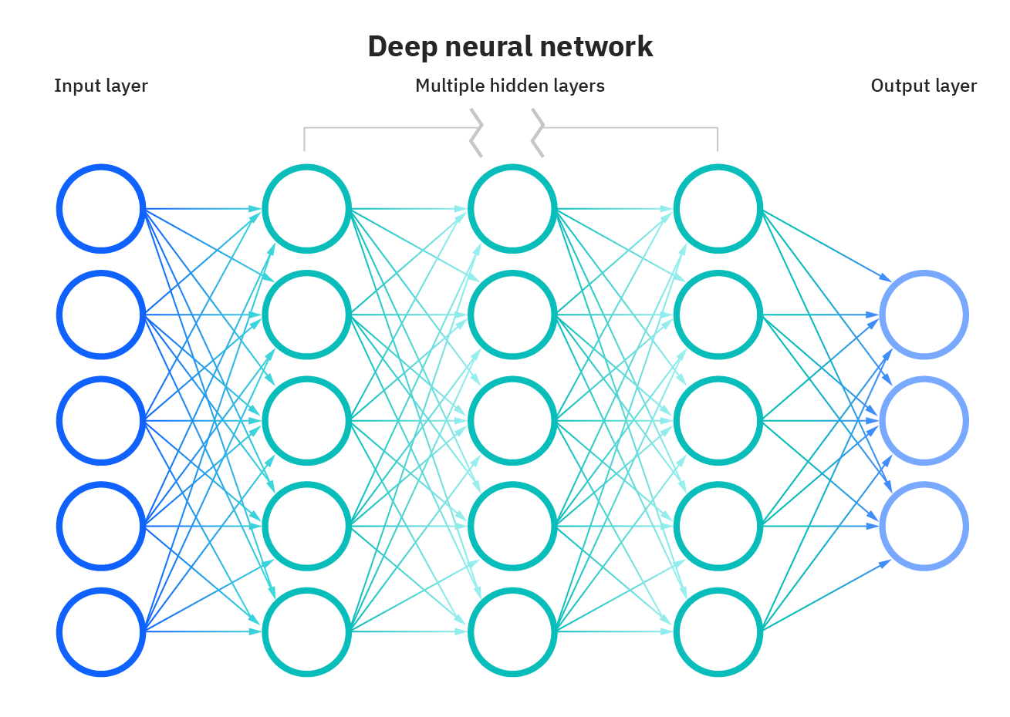**Theory:** Neural is working in a layers first input layer, second hidden layer and third is output layer. The whole theory is explaining by using the below diagram.

Fig-1

In this network, the first column of description - what we'll call the first layer of description - is making three very simple decisions, by weighing the input evidence. What about the description in the second layer? Each of those description is making a decision by weighing up the results from the first layer of decision-making. In this way a descriptionh in the second layer can make a decision at a more complex and more abstract level than description in the first layer. And even more complex decisions can be made by the description in the third layer. In this way, a many-layer network of description can engage in sophisticated decision making.

Incidentally, when I defined description I said that a description has just a single output. In the network above the description look like they have multiple outputs. In fact, they're still single output. The multiple output arrows are merely a useful way of indicating that the output from a description is being used as the input to several other description. It's less unwieldy than drawing a single output line which then splits.

Let's simplify the way we describe description. The condition ∑jwjxj> threshold is cumbersome, and we can make two notational changes to simplify it. The first change is to write ∑jwjxj as a dot product, w⋅x≡∑jwjxj. where w and x are vectors whose components are the weights and inputs, respectively. The second change is to move the threshold to the other side of the inequality, and to replace it by what's known as the description's bias, b≡−threshold. Using the bias instead of the threshold, the description rule can be rewritten:



You can think of the bias as a measure of how easy it is to get the description to output a 1. Or to put it in more biological terms, the bias is a measure of how easy it is to get the description to fire. For a description with a really big bias, it's extremely easy for the description to output a 1. But if the bias is very negative, then it's difficult for the description to output a 1. Obviously, introducing the bias is only a small change in how we describe description, but we'll see later that it leads to further notational simplifications. Because of this, in the remainder of the book we won't use the threshold, we'll always use the bias.

After that we need to use an activation function and get this type of graph:

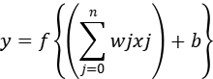

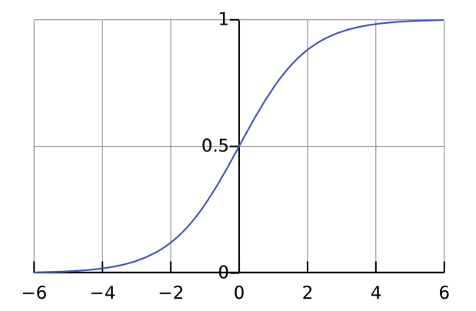

Then we use an loss function:

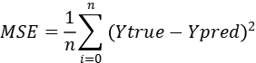

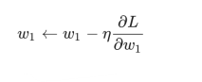After that we will use Stochastic Gradient Descent(SGD):

**APPLICATIONS OF Neural Network:** They can perform tasks that are easy for a human but difficult for a machine –

1. Autopilot aircrafts, aircraft fault detection.
2. Automobile guidance systems.
3. Weapon orientation and steering, target tracking, object discrimination, facial recognition, signal/image identification.
4. Code sequence prediction, IC chip layout, chip failure analysis, machine vision, voice synthesis.
5. Real estate appraisal, loan advisor, mortgage screening, corporate bond rating, portfolio trading program, corporate financial analysis, currency value prediction, document readers, credit application evaluators.
6. Manufacturing process control, product design and analysis, quality inspection systems, welding quality analysis, paper quality prediction, chemical product design analysis, dynamic modeling of chemical process systems, machine maintenance analysis, project bidding, planning, and management.
7. Cancer cell analysis, EEG and ECG analysis, prosthetic design, transplant time optimizer.
8. Speech recognition, speech classification, text to speech conversion.
9. Image and data compression, automated information services, real-time spoken language translation.
10. Truck Brake system diagnosis, vehicle scheduling, routing systems.
11. Pattern Recognition in facial recognition, optical character recognition, etc.
12. Neural networks are used to make predictions on stocks and natural calamities.
13. Neural networks can be trained to process an audio signal and filter it appropriately in the hearing aids.
14. Neural networks are often used to make steering decisions of physical vehicles.
15. As Neural networks are expert at recognizing patterns, they can also be trained to generate an output when something unusual occurs that misfits the pattern.

**My Topic and Neural Network:** My topic is gender classification in neural network. In this project I will take some data from kraggle.com. Gender classification is to determine a person’s gender, e.g., male or female, based on his or her biometric cues. Usually facial images are used to extract features and then a classifier is applied to the extracted features to learn a gender recognizer. It is an active research topic in Computer Vision and Biometrics fields. The gender classification result is often a binary value, e.g., 1 or 0, representing either male or female. Gender recognition is essentially a two-class classification problem. Although other biometric traits could also be used for gender classification, such as gait, face-based approaches are still the most popular for gender discrimination.

**Advantages:** It involves human like thinking. They handle noisy or missing data. They can work with large number of variables or parameters. They provide general solutions with good predictive accuracy. System has got property of continuous learning. They deal with the non-linearity in the world in which we live. A neural network can perform tasks that a linear program cannot. When an element of the neural network fails, it can continue without any problem by their parallel nature. A neural network learns and does not need to be reprogrammed. It can be implemented in any application. It can be implemented without any problem.

**Disadvantages:** The neural network needs training to operate. The architecture of a neural network is different from the architecture of microprocessors therefore needs to be emulated. Requires high processing time for large neural networks.

**Datasets:**

**Conclusion:** The computing world has a lot to gain from neural networks. Their ability to learn by example makes them very flexible and powerful. Furthermore there is no need to devise an algorithm in order to perform a specific task; i.e. there is no need to understand the internal mechanisms of that task. They are also very well suited for real time systems because of their fast response and computational times which are due to their parallel architecture. Neural networks also contribute to other areas of research such as neurology and psychology. They are regularly used to model parts of living organisms and to investigate the internal mechanisms of the brain. Perhaps the most exciting aspect of neural networks is the possibility that someday 'conscious' networks might be produced. There is a number of scientists arguing that consciousness is a 'mechanical' property and that 'conscious' neural networks are a realistic possibility.

Finally, we can say that even though neural networks have a huge potential we will only get the best of them when they are integrated with computing, AI, fuzzy logic and related subjects.

**References:**

1. <https://www.researchgate.net/publication/221803158_Technical_report_Neural_network_and_principal_component_regression_in_non-destructive_soluble_solids_content_assessment_A_comparison>
2. <https://www.investopedia.com/terms/n/neuralnetwork.asp#:~:text=A%20neural%20network%20is%20a,organic%20or%20artificial%20in%20nature>.
3. <https://en.wikipedia.org/wiki/Neural_network>
4. <https://www.youtube.com/watch?v=ob1yS9g-Zcs>
5. https://towardsdatascience.com/adventure-of-the-neurons-theory-behind-the-neural-networks-5d19c594ca16.