

**Project Report**

**Course:** CSE301

**Course Title:** Database System

**Section:** 02

**Semester:** Spring-2021

**Project Title:** Restaurant Management System

**Group No.: 07**

**Submitted to:**

**Md Mostofa Kamal Rasel**

**Assistant Professor,**

**Department of Computer Science & Engineering,**

**East West University.**

**Submitted by:**

|  |  |
| --- | --- |
| Name & ID | Responsibilities % |
| Md. Tanvir Hassan  2018-1-60-236 | **33.34%** |
| Sohel Rana  2017-3-60-043 | **33.33%** |
| Nur-A-Rayana  2018-1-60-131 | **33.33%** |

**Date of Report Submission:** **25 May, 2021**

**Contents**

1. **Introduction**
2. **Data types**
3. **Data Requirements**
   * 1. **Entities**
     2. **Attributes**
4. **Entity Relationship Diagram**
5. **Schema Diagram**
6. **Relation table**
7. **Conclusion**

**1.Introduction:**

The Restaurant management system is a web application system which are generally small or medium in size and this system is to automate day to day activity of a resturanr. It is basically used by restaurants to manage the restaurants record using the employee details, customer details address, order details, item list, Offer, delivery man details etc.

It uses different entities to provide best service to customer.

**2. Data Types:**

**1. Integer:** One optional sign character (+ or -) followed by a least one digit (0-9).

Leading and trailing blanks are ignored. No other character is allowed.

**2. Varchar:** It used to store alpha numeric characters. In this data type we can set the

maximum number of characters up to 8000 ranges by defaults SQL server will set the size to 50 characters range.

**3. Date:** The DATE data type accepts date values. No parameters are required when

declaring a DATE data type. Date values should be specified in the form:

YYYY-MM-DD. However, point base will also accept single digits entries foe month and day values.

**4. Time:** The TIME data type accepts time values. No parameters are required when

declaring a TIME data type. Date values should be specified in the form: HH:MM: SS. An optional fractional value can be used to represent nanoseconds.

**3.Data requirements:**

* **Entities:**
  + - * Customer
      * Orders
      * Address
      * Employee
      * Payment
      * Offer
      * Item
      * Delivery Man
* **Attributes:**
* **Customer:**
  + ID
  + Name
  + Email
  + Status
  + Phone Number
  + Address
* **Orders:**
  + Order_ ID
  + Order _time
  + Customer_ id
  + Total purchase
  + Order _date
  + Del_status
* **Payment:**
* P_id
* Card
* bkash
* **Item:**
* Item_id
* Item_name
* Price
* Description
* **Delivery Man:**
* ID
* Area code
* Name
* Phone
* **Address:**
* Address_id
* city
* Post_code
* Street
* Road_No
* House_No
* **Employee:**
  + Emp_id
  + Name
  + Salary
  + Adress
  + Phone Number
  + Status
* **Offer:**
  + Offer_Id
  + Status

**4.Design Description:**

In our Restaurant management system’s design, we want to give an online service. We have eight entities. Customers can order through online and able to see our items and quality. We have another entity delivery man to manage the delivery to the particular address. The delivery man has an area code to give service in a particular area according to area code. In this design, we have a payment entity and Offer entity. Two types of payment are available that is card and bkash. Offer is available according to customer.

**4.Entity-Relationship- Diagram:**

An Entity Relationship Diagram (ERD) is a visual representation of different entities within a system and how they relate to each other.

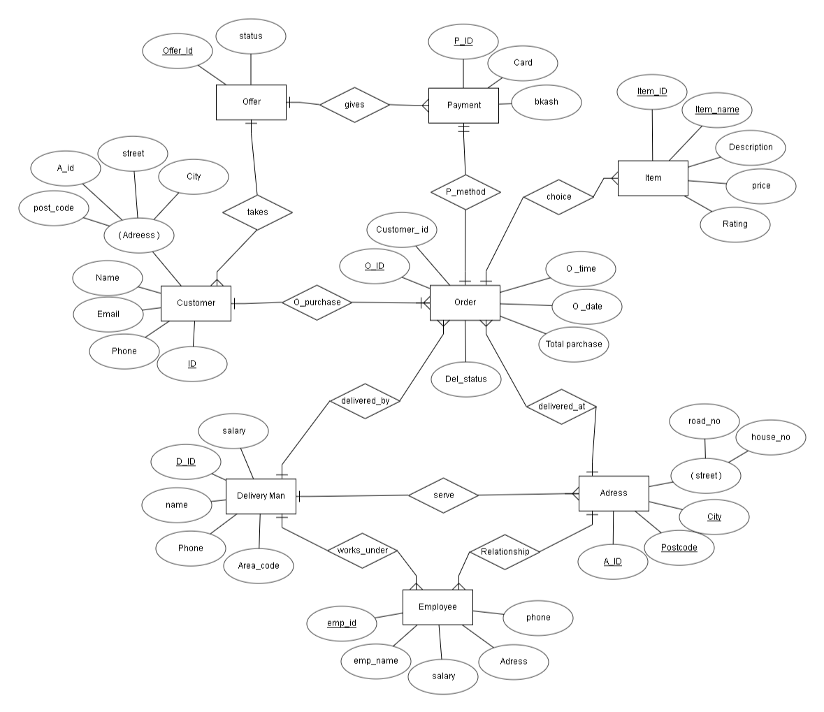

Here in the diagram, we have eight Entities**: customer, address, employee, delivery boy, item, payment, offer and order.**

**Customer** has five attributes: ID, User Name, phone, Email and address. Phone. **ID** is the primary key, and address is composite attribute

**Address** has four attributes: A_id, City, post_code, and street. **A_id** and **city** are primary key and **street** is composite attribute.

**Employee** has five attributes: emo_id,emp_name, status, salary, address. Here **emp_id** is primary key.

**Delivery man** has five attributes: D_ID, Area_code, name,salary and phone. Here, **D_ID** is primary key.

**Item** has five attributes: item_id, item_name, price, description, and rating. **item_id** and **item_name** are primary key.

**Payment** has three attributes: P_id, card, bkash. Here, **p_id** is primary key.

**Offer** has two attributes: offer_id, and status. Here, **offer_id** is primary key.

**Orders** has six attributes: O_ID, O_time, O_date, customer_id,del_status, total_purchase. Here, **O_ ID** is primary key.

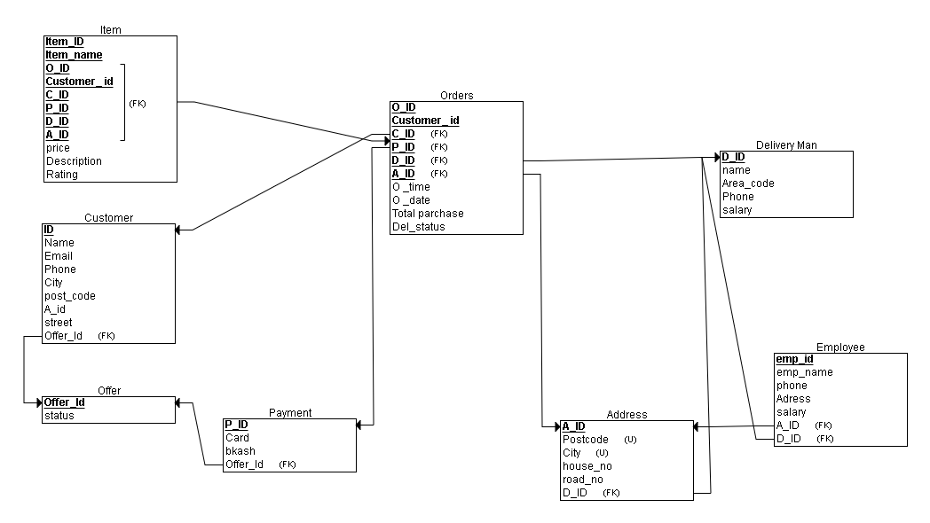

**6.Relationship table:**

|  |  |
| --- | --- |
| Entity | Relationship |
| Customer-Offer |  |
|  |  |
|  |  |
|  |  |
|  |  |
|  |  |
|  |  |
|  |  |
|  |  |
|  |  |

**7.Conclusion:**

SQL database the board application which is very much utilized in the advanced world in getting sorted out and controlling a database. Despite the fact that SQL doesn't have the GUI interface like Microsoft access is having and they all deal with the database agreeable. Contingent upon the client or clients, on the off chance that an association has different clients, at that point they should go for SQL worker-based application. This undertaking tells the best way to make tables in SQL and how to make basic information control language and information definition language with how to execute them. It likewise shows how connections are set up with the ideas of essential and unfamiliar key inside a table. Finally, the undertaking shows how questions are made in SQL worker, inquiries like the make order, see, update, modify and so on.

In conclusion, the Restaurant Management system helps the customer to order online and help the restaurant work to run the restaurant business.