James Schwartz:

James has been with AltaLink for 20 years and is currently in the role of Principal Engineer - Power Systems. He is a registered professional engineer in the province of Alberta.

Michael Anderson
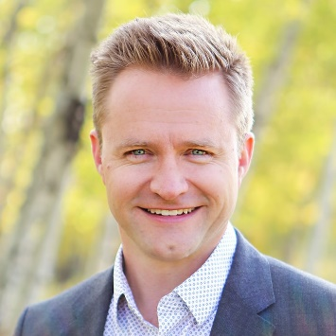
Michael Anderson is an Electrical Engineer with AltaLink, having spent a decade and a half focused on Major Equipment, HVDC and FACTS systems. He is a project engineer, an idealistic dreamer, and a self-proclaimed earworm champion.

