Nanjing University of Information Science and Technology

Software testing final project

Name: Emon Md Wahiduzzaman

Student id no: 201853082030

**Table of content:**

* ABSTRACT

1. **INTRODUCTION**

* ABOUT THE PROJECT

1. **SYSTEM REQUIREMENT**

* HARDWARE REQUIREMENT
* SOFTWARE REQUIREMENT

4. **DATABASE**

**5.** **MODULE DISCRIPTION AND SCREENSHOTS**

**6. INVALID TEST CASES:**

* VALIDATION CHECK
* SUCCESSFUL

**7. CONCLUSION AND EVALUATION**

* CONCLUSION
* EVALUATION

**ABSTRACT**

The adoption of Electronic Banking by commercial enterprises has been in existence since the mid 90’s, much greater in number due to lower operating costs associated with it. Electronic banking has initially been in the form of automatic teller machines and telephone transactions. More recently a new delivery channel for banking services that benefits both customers and banks is in implementation i.e. using computers.

In this proposed interface, manager and accountant have access to the customer’s account, and manager have special preference to access all details of banking system.

Banking system services can include:

* Client
* Front Office Advisors
* Managers

**INTRODUCTION**

About The Project-

A Bank is a commercial or state institution that provides financial services, including issuing money in form of coins, bank notes or debit cards, receiving deposits of money, lending money and processing transections. A commercial bank accepts deposits from customers and in turn makes loan based on those deposits.

This project is basically providing a full service user friendly interface primarily specializing in Banking System;

We are using following details of clients to open their account:

* Account Number
* MICR No
* Pin No
* Account Type
* Gender
* Address
* Amount
* Name
* Date Of Birth
* Nationality
* Caste
* Mobile Number
* Security Question

The bank will provide following functionalities to clients:

* Create his account
* View and modify their personal information
* View the balance and transaction history of their accounts
* Make a Transfer(Internal or external)
* Feed and account
* Viewing transections of deposit.
* Customer List
* Change Pin

The bank will provide the functionalities to the Front office advisers:

* See the list of clients
* View clients personal information
* View the balance and transaction history of all client accounts

The bank will provide following functionalities to managers:

* + View the sum of customer deposit in defined period
  + Generate reports on customer activities in defined period
* We will provide an alert to the customer after the account creation providing them with their account numbers.
* We will also provide alert for each deposit and withdrawal of money from his/her account.

**SYSTEM REQUIREMENTS**

HARDWARE REQUIREMENT

* Laptop or Desktop Intel i3 6th Gen clock speed 2.00GHz and above.
* Hard disk: min. 10 GB
* Ram: 4 GB
* Monitor resolution: 800 X 600
* System Type-64-bit operating system, x64-based processor

SOFTWARE REQUIREMENT

* ANY Operating System (Windows 10 / 8 / 7, Linux, Mac)
* JDK 8 (Java Development Kit)
* JRE 8 (Java Runtime Environment)
* Language Used : JAVA 8
* NetBeans
* Database SQLite

**PROBLEM DEFINITION AND PROPOSAL**

INTRODUCTION

In proposed system, the management needs not to keep any type of registers, which they use to keep in old one. They have work only with one computer. All the details are stored in computer files. The dual entries are done very quickly as entry in one file only, affects the other file where it has to record. In the way there is no need to record the computer operator.

The working through registers system is not only very laborious and time consuming, but there are number of errors found. In comparison to old system the proposed system of computer processes many advantages.

Some of the merits of proposed system are as follows:-

* **Accuracy:-**

It is one of the features of computer that it provides accuracy result. It is often said, “Man does mistakes but machines never”. When a man works there seems numbers of errors and mistakes in performing calculation and other things, while it is not in case with computers.

* **Security:-**

|  |  |  |  |  |
| --- | --- | --- | --- | --- |
| The | Security is maintained vary comfortably in computers. | | Secretes | are |
| not | disclosed off, as there are password settings in | the | Computers. | So |
| the firm can get the benefit of non-disclosure of | | its | secrets to | the |
| outsider competitors as well as other non-authorized | | Persons. | |  |

* **Time saving:-**

The computerized system is time saving. On an immediate inquiry, the operator or any authorized person has to just click some switches and get the information in few seconds.

**Database**

For account details:

CREATE TABLE "AccountDetails" (

"Acc" INTEGER NOT NULL,

"Name" CHAR,

"DOB" INTEGER,

"Pin" NUMERIC,

"Acc_type" CHAR,

"Nationality" CHAR,

"Caste" CHAR,

"MICR_NO" INTEGER,

"Gender" CHAR,

"Mobile" INTEGER,

"Adress" CHAR,

"Sec_Q" CHAR,

"Sec_A" CHAR,

"Balance" INTEGER,

PRIMARY KEY("Acc")

For Balances:

CREATE TABLE "Balances" (

"Name" CHAR,

"Acc" INTEGER,

"MICR_No" INTEGER,

"Balance" INTEGER

)

**MODULES DESCRIPTION AND SCREENSHOTS**

WELCOME FRAME

This page will redirect to login page. This page is common for client, advisor & Manager.

Data Constraints to create a new a new account successfully all the conditions below must be met, if not a warning window will appear:

1. All fields must not be empty

2. PIN must be a 6-digit number

3. Confirm PIN must matches the PIN

4. Name can’t have any numeric digits or symbol.

5. Must choose one of the three account type (saving account, credit account, and checking account)

6. Interest rate fields (if the account type chosen is a saving account), credit line fields (if the account type chosen is a credit account),

7. Deposit must be a number

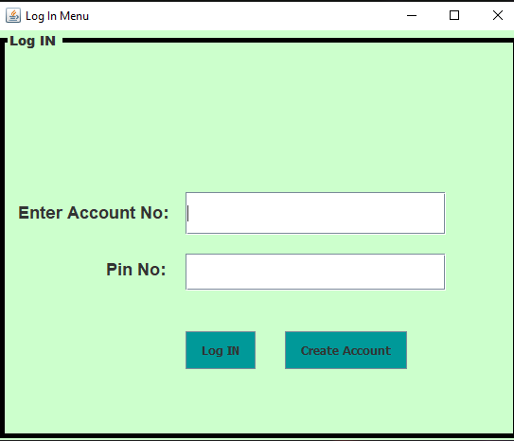

Creating an Account:

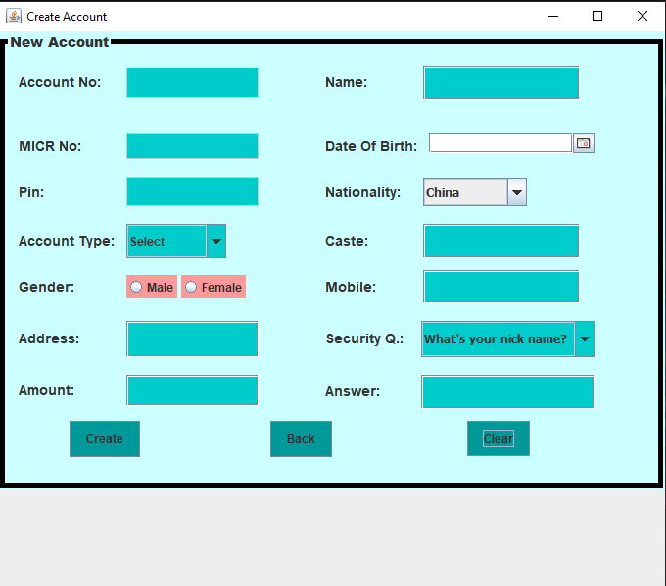

CLIENT INFORMATION:

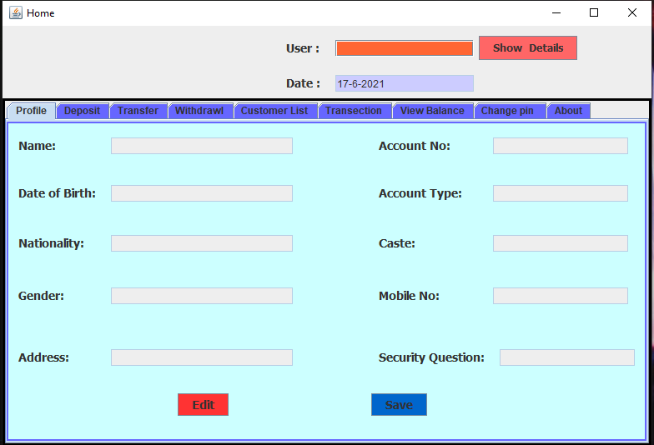

LODING PAGE:

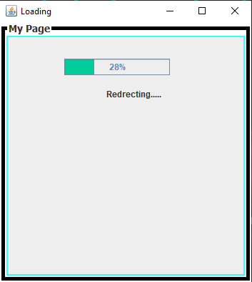

CLIENT PERSONAL DETAILS EDIT:

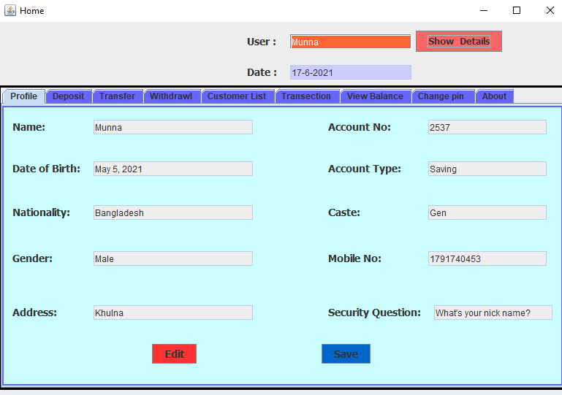

TRANSACTION DETAILS:

Here we can see total transaction details including with benefices details.

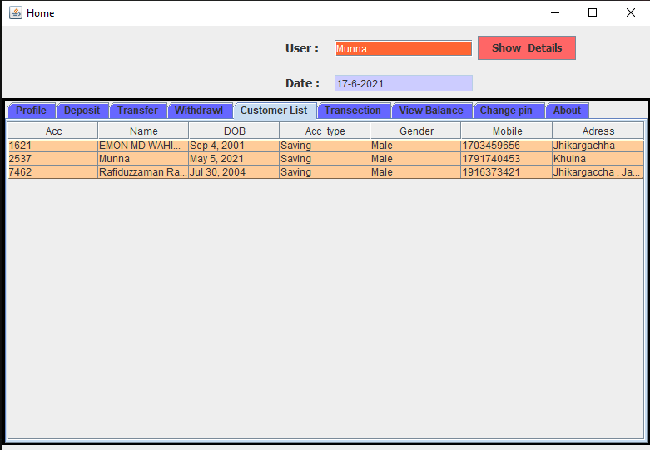

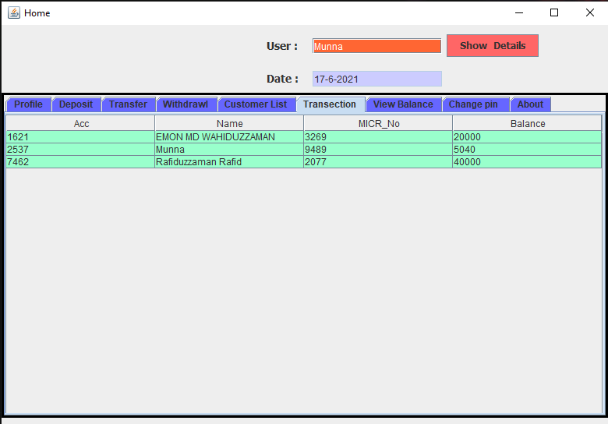

DEPOSIT MONEY:

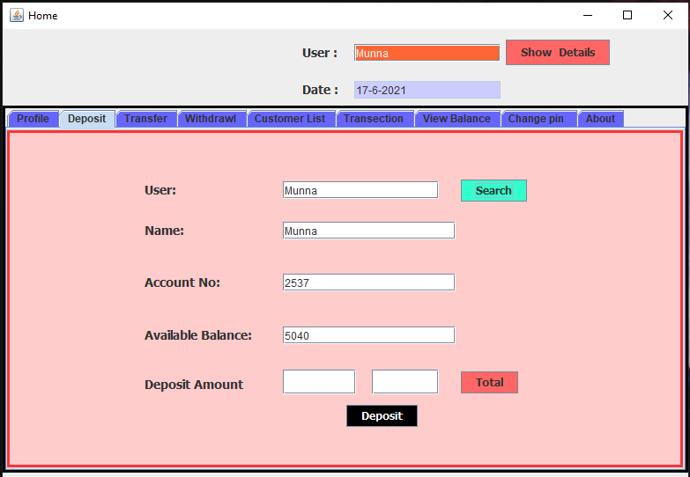

TRANSFER MONEY:

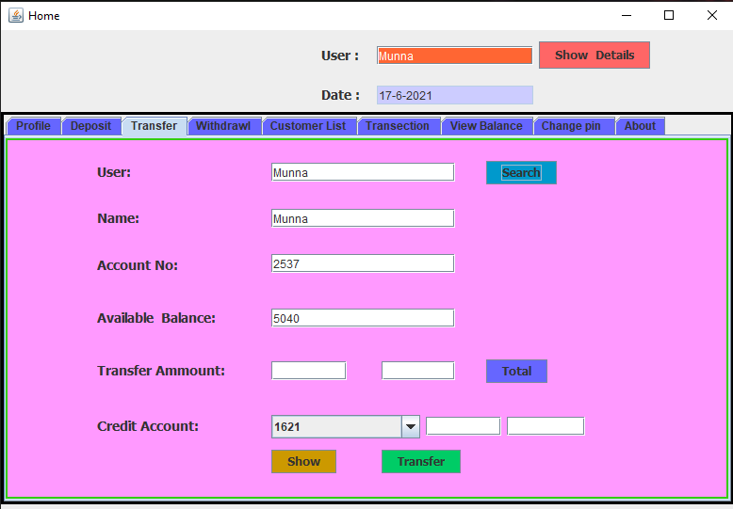

CHANGE PIN:

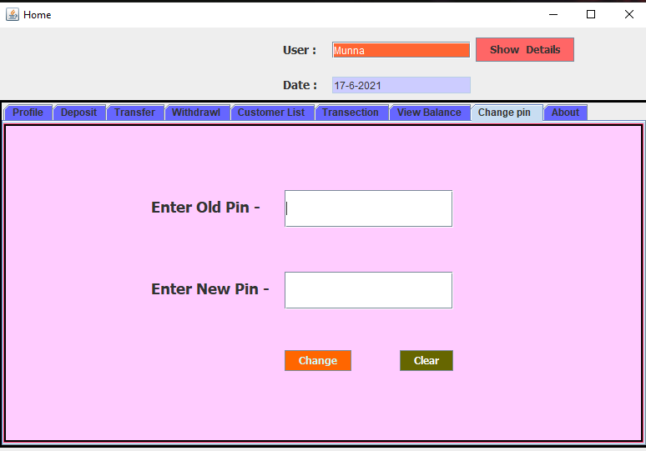

ABOUT:

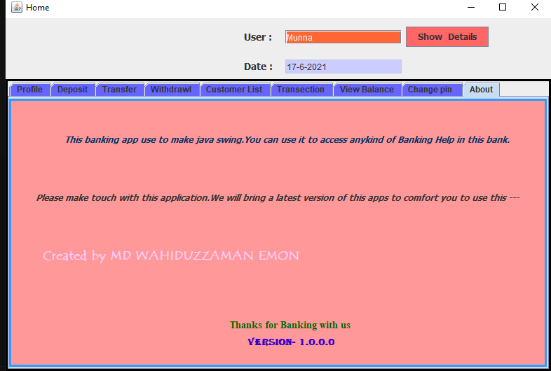

**Invalid Test Cases:**

List of valid customers’ account number and its PIN in the database:

• Account number: 1621, PIN: 1234

• Account number: 2537, PIN: 130011

• Account number: 7462, PIN: 7278

Following message box will display when there is a violation of field validation.

* When the user Account No or Pin No is empty or incorrect-

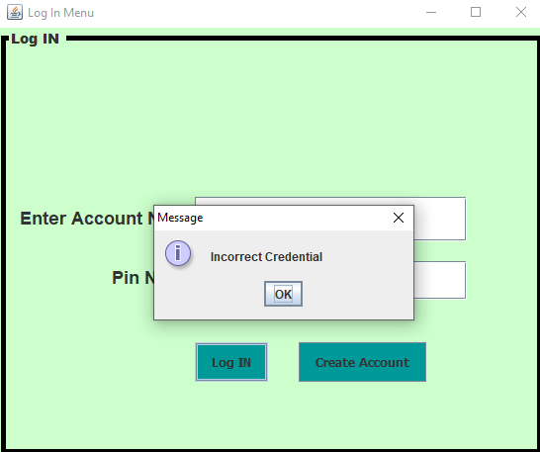

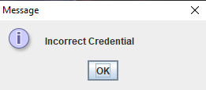

* When the user Create account page is empty-

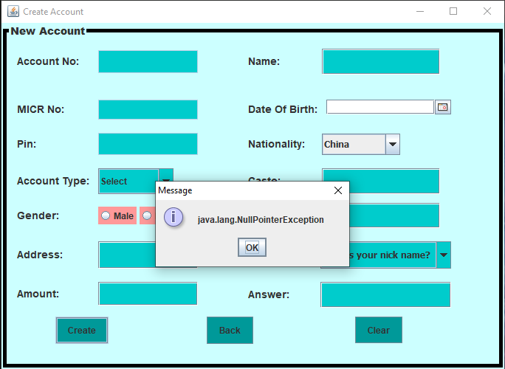

* When the customer name field is empty or wrong (it is a mandatory field);

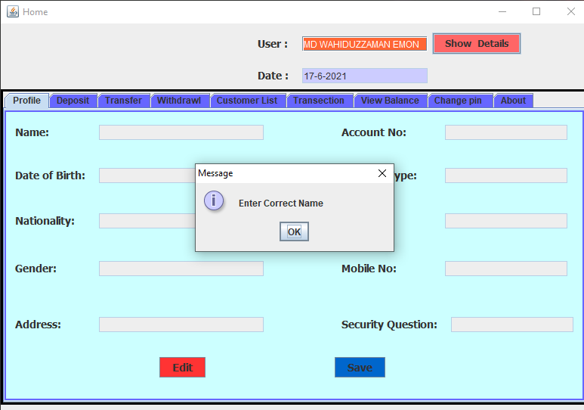

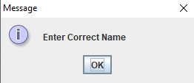

SUCCESSFUL:

When you gave correct account id or pin number-

Deposit Successfully:

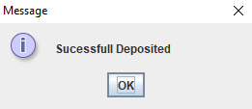

Transfer Successfully:

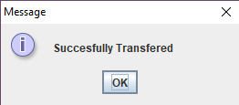

Withdraw successfully:

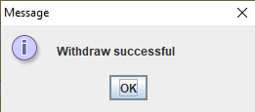

When successfully changed pin:

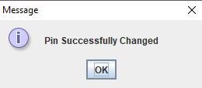

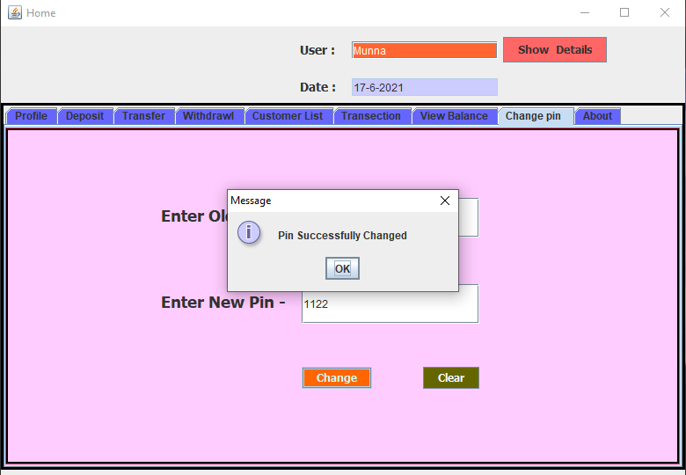

The table below lists the test cases on the customer’s window (balance inquiry tab):

|  |  |  |  |
| --- | --- | --- | --- |
| Test case ID | Test Content | Execution times | Test Results |
| BalInq-0 | Click the balance inquiry tab after login | 5 | Achieve the expected result |
| BalInq-1 | Click the balance inquiry tab after depositing | 4 | Achieve the expected result |
| BalInq-2 | Click the balance inquiry tab after withdrawing | 4 | Achieve the expected result |
| BalInq-3 | Click the balance inquiry tab after transferring | 2 | Achieve the expected result |

**BALANCE INQUIRY TEST CASES**

The table below lists the test cases on the customer’s window (deposit tab):

|  |  |  |  |
| --- | --- | --- | --- |
| Test case ID | Test Content | Execution times | Test Results |
| Dep-0 | Click the deposit tab after login | 5 | Achieve the expected result |
| Dep-1 | Click the deposit tab after login | 4 | Achieve the expected result |
| Dep-2 | Click the deposit tab after transferring | 4 | Achieve the expected result |
| Dep-3 | Deposit some amount of money into the account | 2 | Achieve the expected result |
| Dep-4 | Attempt to deposit with an invalid amount (not a positive number which is greater than 0) | 3 | Achieve the expected result |
| Dep-5 | Click enter after inputting the amount to deposit | 3 | Achieve the expected result |
| Dep-6 | Click deposit button with an empty amount | 2 | Achieve the expected result |

The table below lists the test cases on the customer’s window (withdraw tab):

|  |  |  |  |
| --- | --- | --- | --- |
| Test case ID | Test Content | Execution times | Test Results |
| WD-0 | Click the withdraw tab after login | 5 | Achieve the expected result |
| WD-1 | Click the withdraw tab after depositing | 4 | Achieve the expected result |
| WD-2 | Click the withdraw tab after transferring | 4 | Achieve the expected result |
| WD-3 | Withdraw some amount of money from the account | 2 | Achieve the expected result |
| WD-4 | Attempt to withdraw with an invalid amount (not a positive number which is greater than 0) | 3 | Achieve the expected result |
| WD-5 | Attempt to withdraw with an amount greater than the balance (exception for credit account, as long as the balance after withdrawal is greater and equal to 0 – the credit line) | 3 | Achieve the expected result |
| WD-6 | Click enter after inputting the amount to withdraw | 2 | Achieve the expected result |
| WD-7 | Click withdraw button with an empty amount | 4 | Achieve the expected result |

The table below lists the test cases on the customer’s window (transfer tab):

|  |  |  |  |
| --- | --- | --- | --- |
| Test case ID | Test Content | Execution times | Test Results |
| Transfer-0 | Click the transfer tab after login | 5 | Achieve the expected result |
| Transfer -1 | Click the transfer tab after depositing | 4 | Achieve the expected result |
| Transfer -2 | Click the transfer tab after withdrawing | 4 | Achieve the expected result |
| Transfer -3 | Transfer some amount of money to an existing target account, with a description | 2 | Achieve the expected result |
| Transfer -4 | Transfer some amount of money to an existing target account, without any description | 3 | Achieve the expected result |
| Transfer -5 | Transfer some amount of money to a non-existing target account, with or without description | 3 | Achieve the expected result |
| Transfer -6 | Transfer some amount of money to itself, with or without description | 2 | Achieve the expected result |
| Transfer -8 | Transfer some amount of money to an invalid target account (not a number) , with or without description | 4 | Achieve the expected result |
| Transfer -9 | Attempt to transfer with an invalid amount (not a positive number which is greater than 0) | 3 | Achieve the expected result |
| Transfer -10 | Attempt to transfer with an amount greater than the balance | 3 | Achieve the expected result |
| Transfer -11 | Click the transfer button after inputting a valid amount to withdraw (without inputting ) | 4 | Achieve the expected result |
| Transfer -12 | Click the transfer button without inputting anything in all the three fields (empty amount field, empty target account field, empty description field) | 5 | Achieve the expected result |

**CONCLUSION AND EVALUATION**

**CONCLUSION**

We conclude to build a sealable interface that simplifies the banking system handling. It has the following objectives:

▪ Improved access to all transection and other operation. ▪ Easy access and handling of customer’s account. 

▪ Detailed access of customer is easy for accountant and all customer and accountant details access is simple for Manager.

 

**EVALUATION**

Below are some of the summary of the project:

1. The software is a simple bank application. It is developed using NetBeans IDE 8.2 Software, java language version 1.8.0_111, and SQLite as its database. Both the tester and the developer use Windows 10 Home Single Language as its Operating System.
2. The software has complete functions. It provides functions such as login, create account, search accounts, deposit, withdraw, transfer, transaction history and other functions. It is comprehensive, reliable, and an easy-to-use software.
3. It is easy to change the functions because they are relatively independent.

4. The system is reliable. It has clear permission restrictions for different users, accurate error, warning, or information prompts.

5. The operation is convenient and easy to comprehend. The interface of each function of the system is simple, the style is consistent and the layout is convenient for users to use.

6. Based on the tests that are performed, all the output of the tests achieves the expected result.