- Signout is not working
- Change the company and site selection process like in EMS
- Navigation is not working from recent RFPs in dashboard
- Screen size is not fitting properly
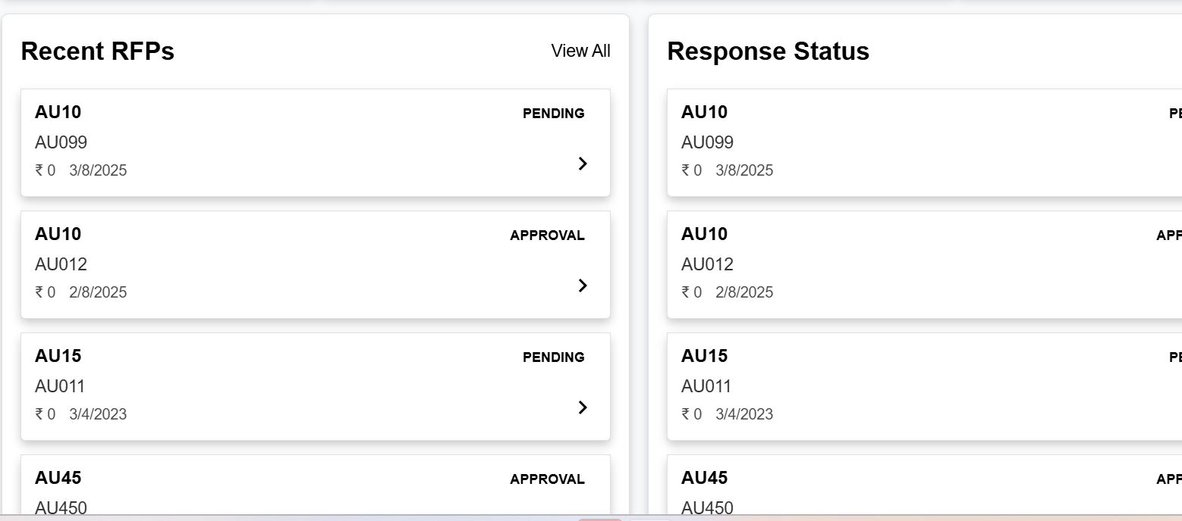
- What will be the criteria for Closing soon. My suggestion would be, Add one parameter under settings called “Days for closing RFP”, based on number of days we select the system has to find the due date and if due date is less than from the current date then should be in closing soon.
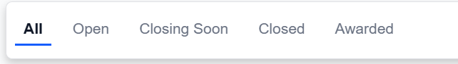
- Folders have to be Blurr by default unless place the cursor over on it.
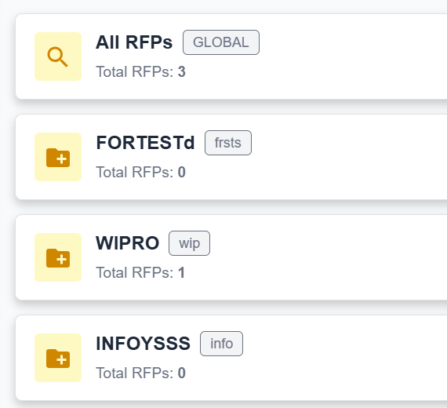
- Reduce the size of these buttons
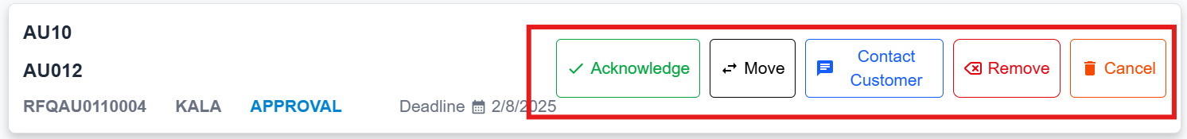
- Nothing is happening when we click on acknowledge button other than popup box. When we click on acknowledge button and popup the box which is happening now and need to add small text like acknowledge and with date & time below the button.
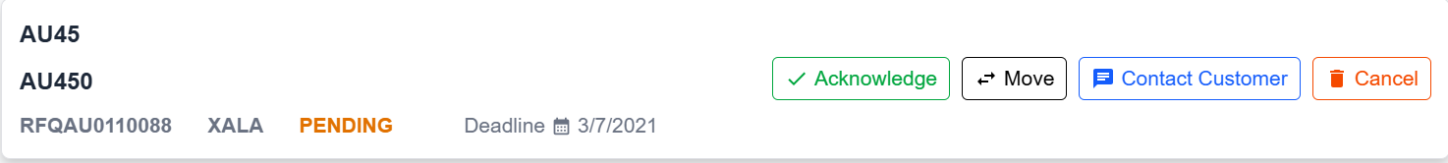

- Should be able to attach a images and documents to response to customer.
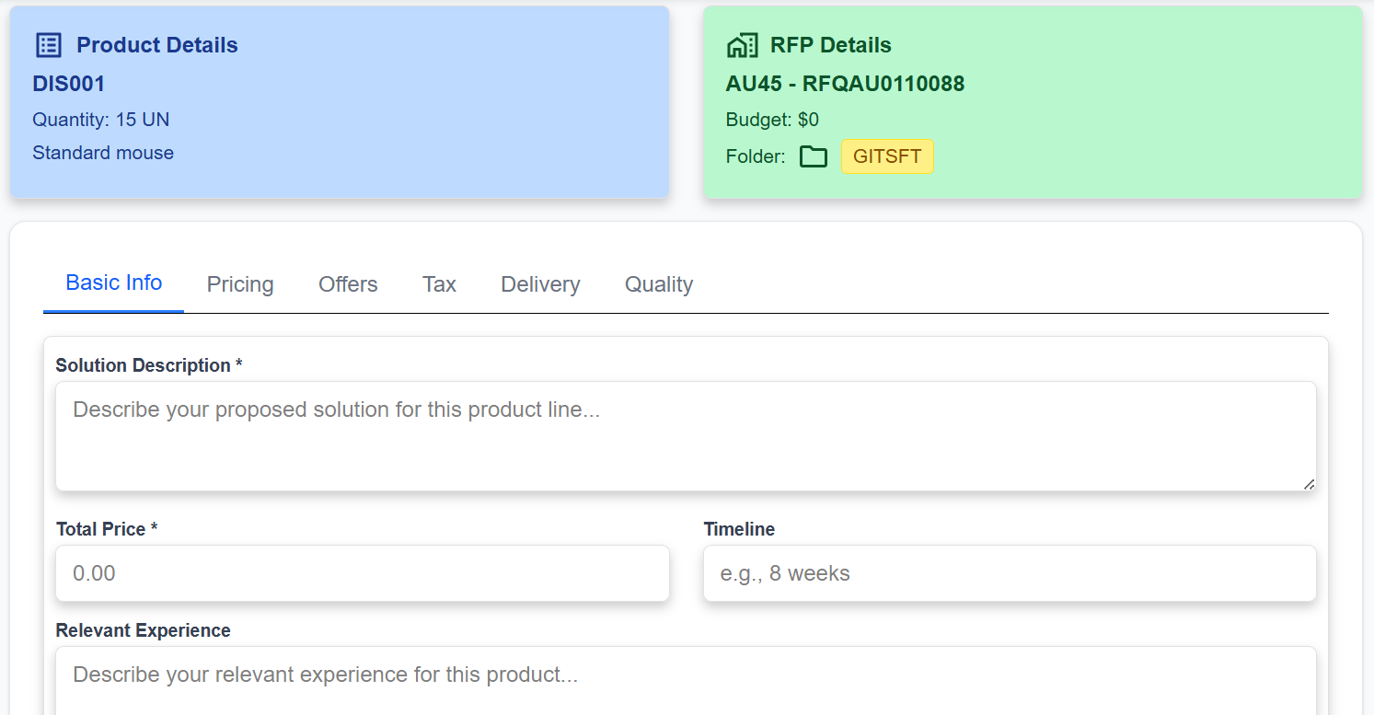
- Make this visible more clear
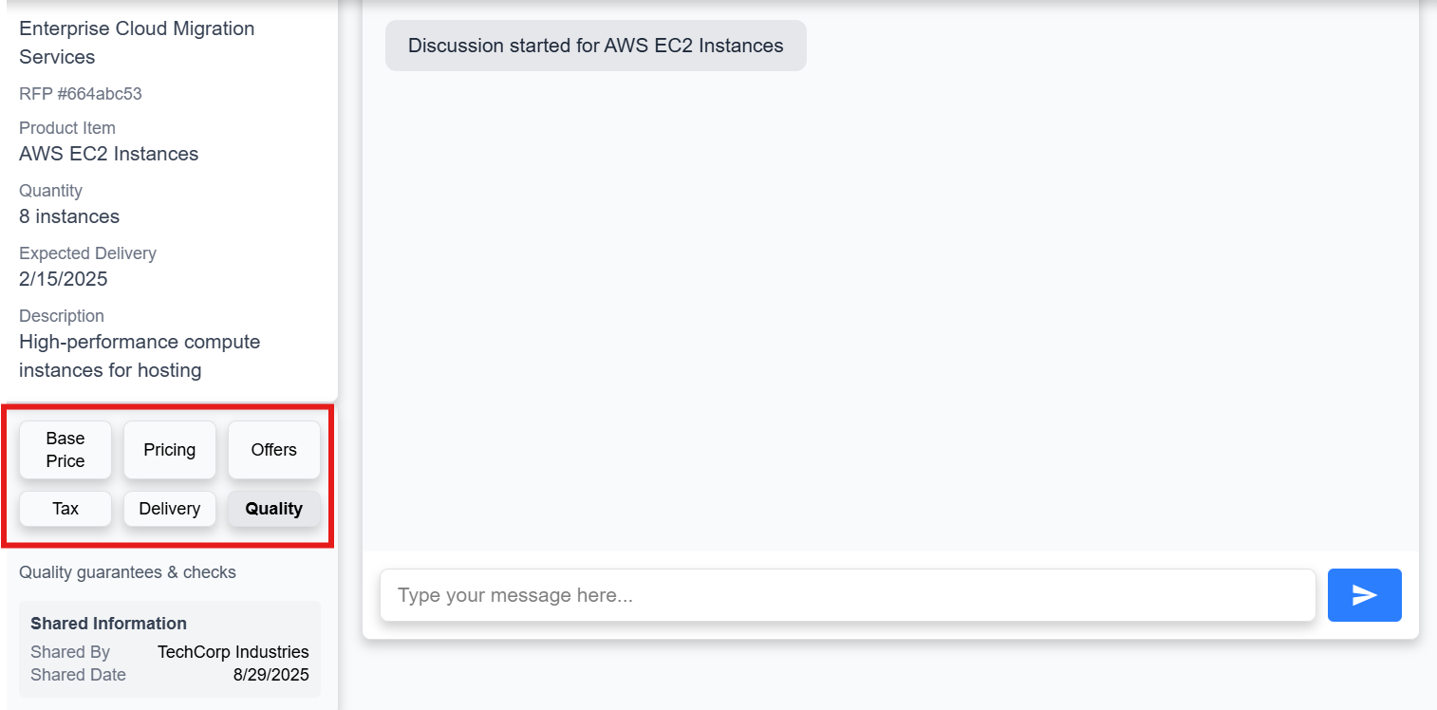
- There is no back button. Need to display few more details.
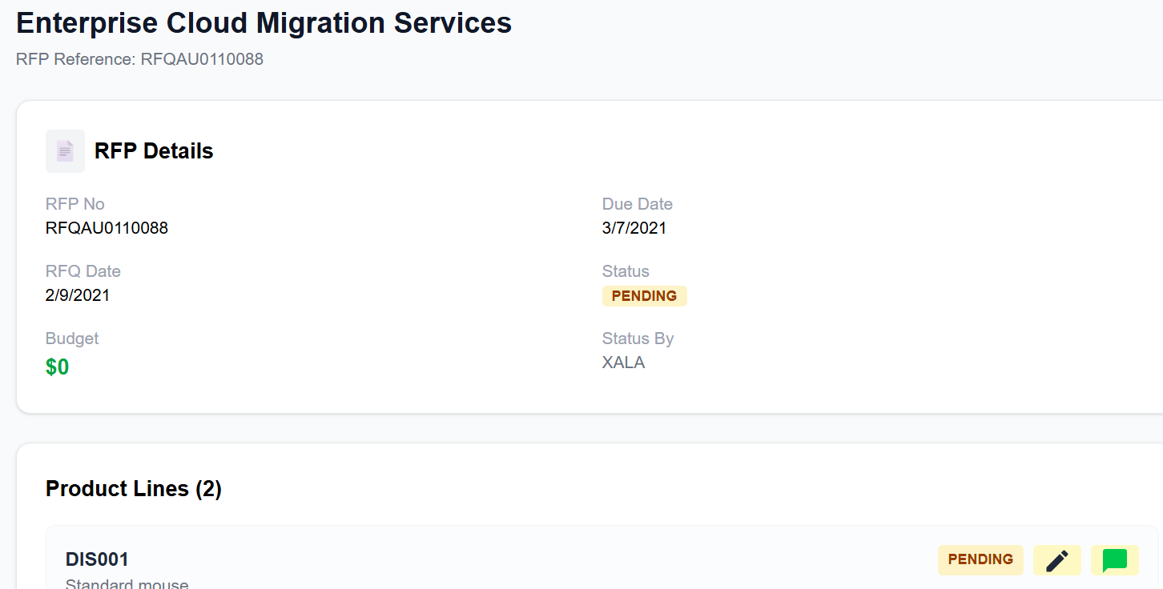

- Change it to Due date
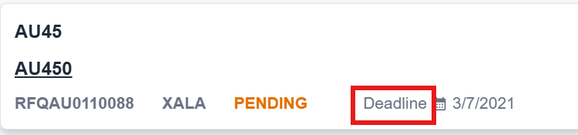
- Add another button “Send to approval”
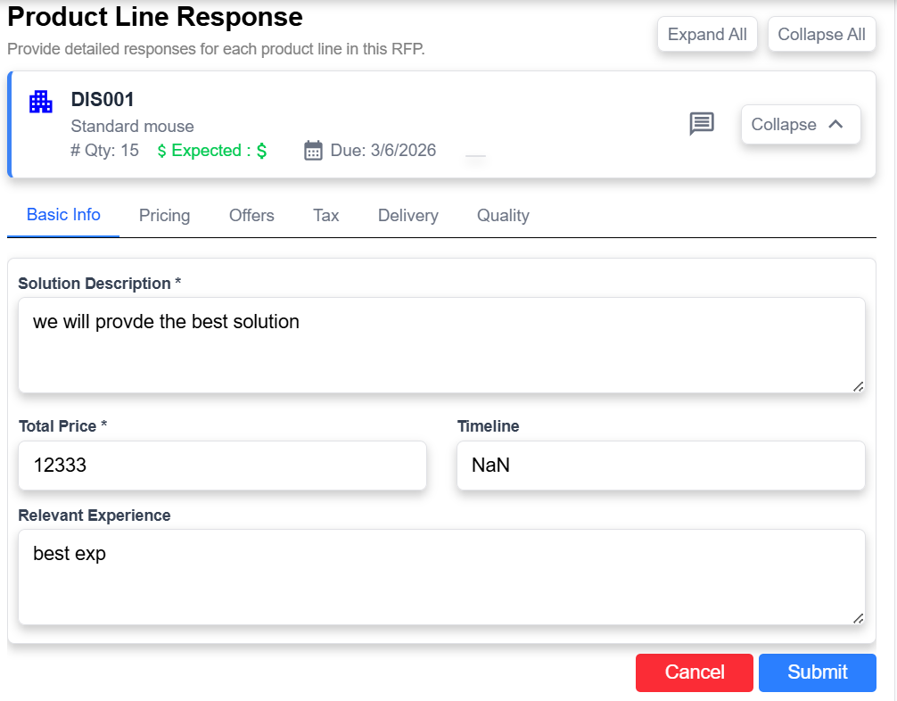
- What is purpose of these two buttons,
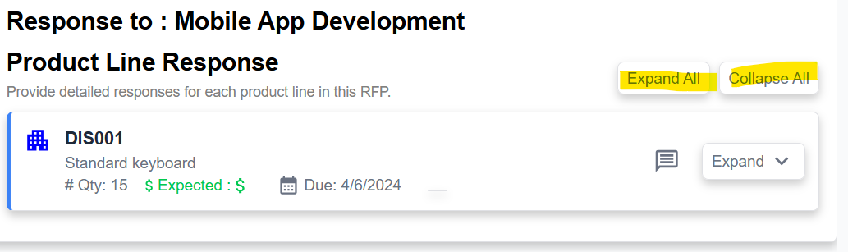

- Quick actions are not working
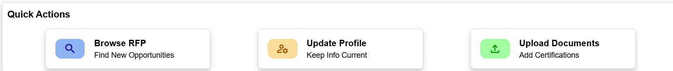
- Need to add modify and delete option to folder
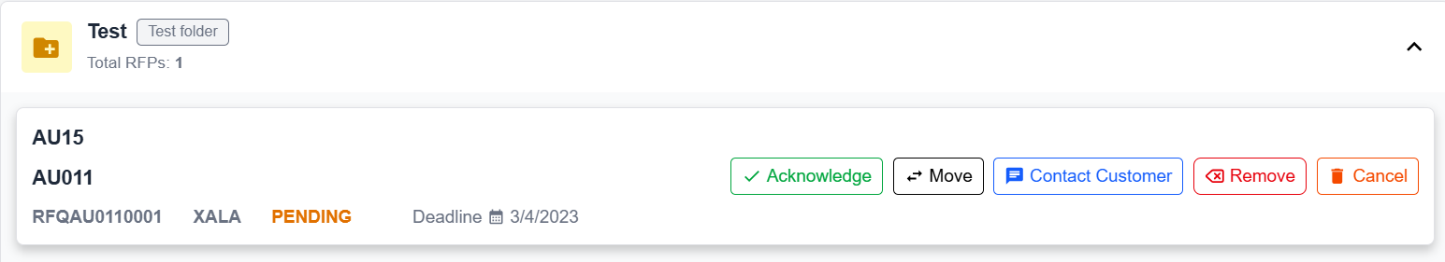
- It is not sending a message when we click button from the keyboard
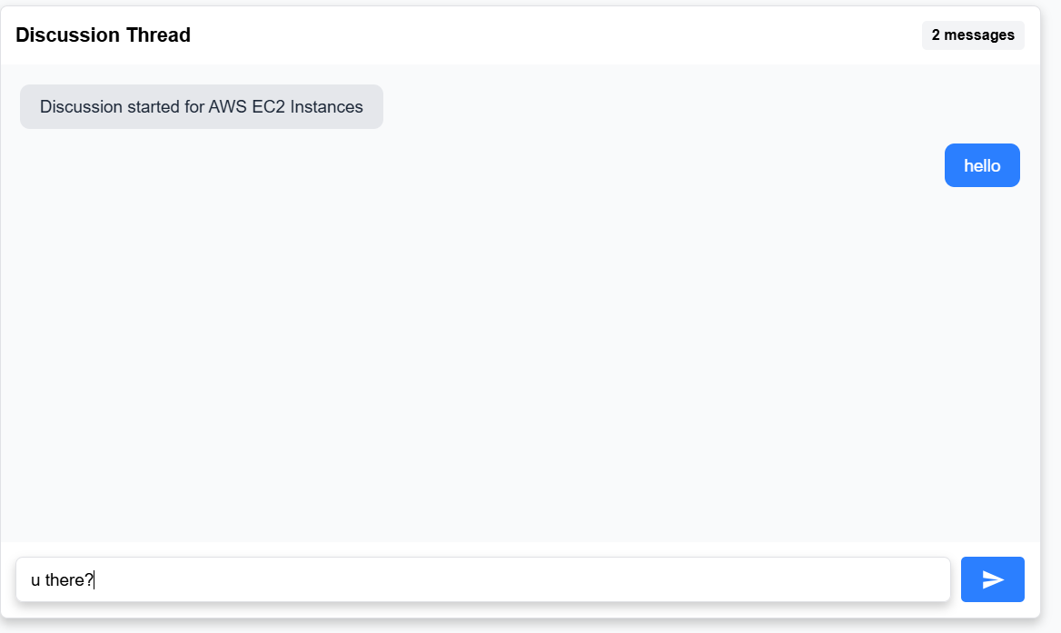

Submit response:
This list has to be represented under the RFPs list which are ready to submit in the left list. When we click on RFP then it has to expand with list of products in left list only.
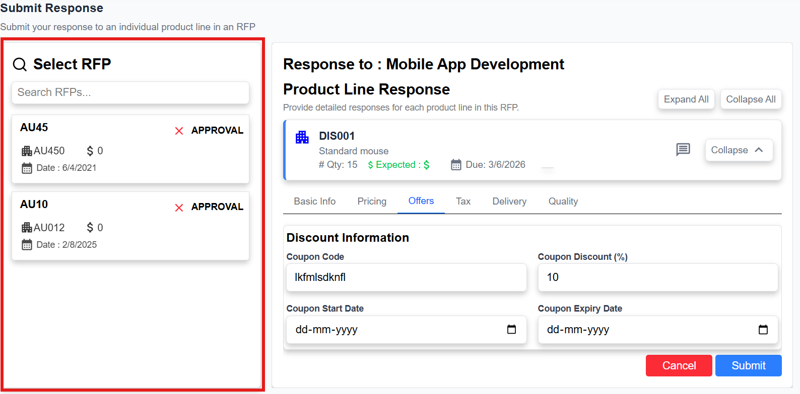
My responses:
This list has to be listed by RFP
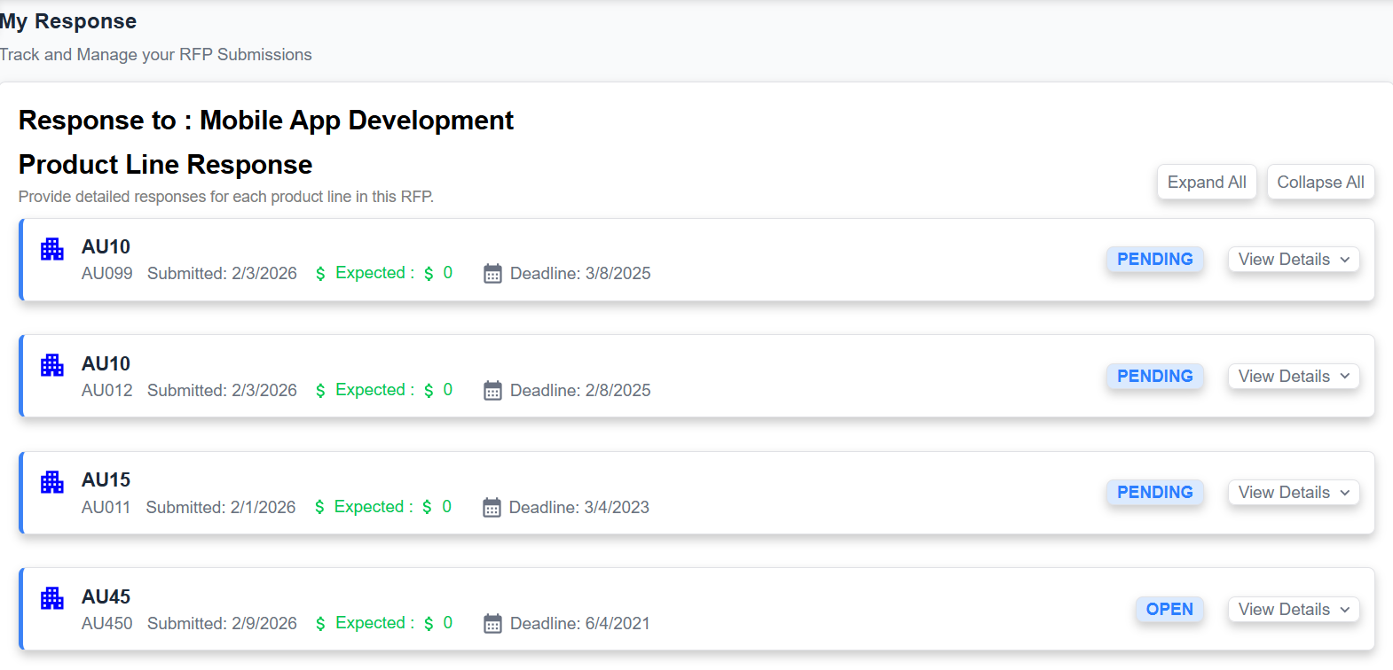
My response is not clear and not working as expected.
Add search by RFP in My response

Notifications:
Notifications should be come in following situations
- When supplier receives new RFP
- Any modifications requested by customer by chat or something
- After approval or rejected of any RFP
- Manager should receive a notification whenever user requested for approval process for any RFP.
- When customer cancelled or approved the RFP
- When RFP get dispatched
- When RFP get closed
Documents
Documents upload is not working
