**Program-1**

import java.util.Scanner;

public class Demo {

public static void main(String args[]){

Scanner reader = new Scanner (System.in);

String name;

System.out.println("Enter your name:");

name=reader.next();

System.out.println("Your name is:"+name);

}

}

**Output:**

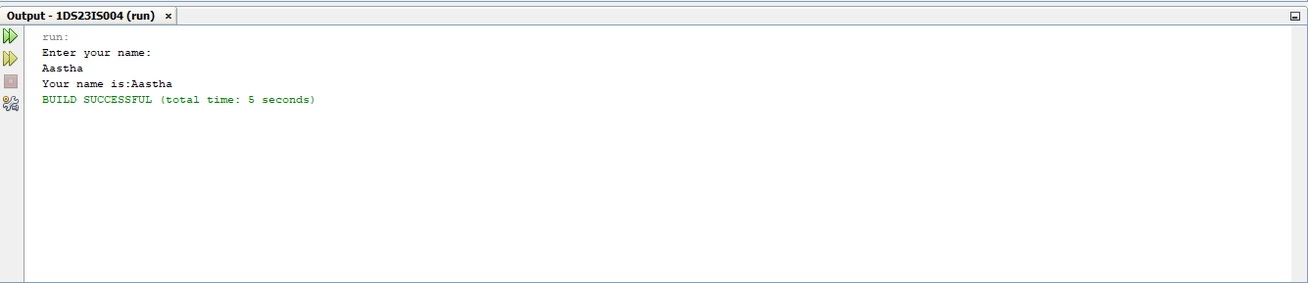

**Program-2:**

abstract class Vehicle{

public abstract void wheels();

public abstract void brakes();

public abstract void seating();

}

class Car extends Vehicle{

public void wheels(){

System.out.println("Car has four wheels");

}

public void brakes(){

System.out.println("Car has power brakes");

}

public void seating(){

System.out.println("Car has 4 seatings");

}

}

class Bike extends Vehicle{

public void wheels(){

System.out.println("Bike has 2 wheels");

}

public void brakes(){

System.out.println("Bike has Disc brakes");

}

public void seating(){

System.out.println("Bike has 2 seatings");

}

}

class Demo{

public static void main(String args[]){

Vehicle v=new Car();

Vehicle v1=new Bike();

v.wheels();

v.brakes();

v.seating();

v1.wheels();

v1.brakes();

v1.seating();

}

}

**Output:**

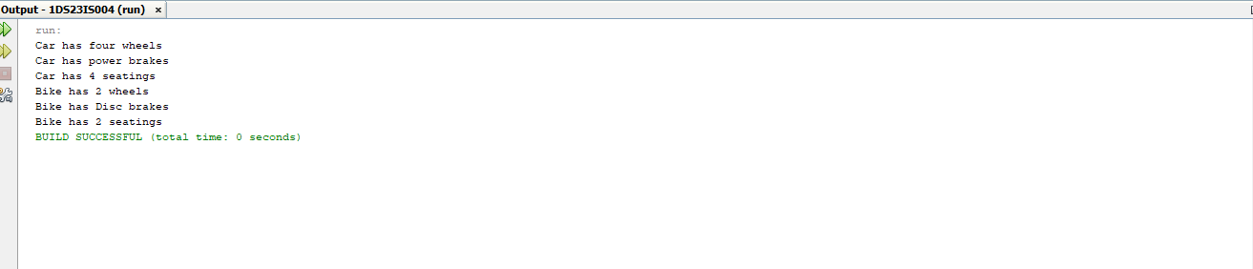

package balance;

import java.io.*;

public class Account

{

long acc,bal;

String name;

public void read()throws Exception

{

DataInputStream in=new DataInputStream(System.in);

System.out.println("Enter the name :");

name=in.readLine();

System.out.println("Enter the account number :");

acc=Long.parseLong(in.readLine());

System.out.println("Enter the account balance :");

bal=Long.parseLong(in.readLine());

}

public void disp()

{

System.out.println("~~~~~~~~~~~~~~~~~~~~~~~~~~~~~~~");

System.out.println("--- Account Details ---");

System.out.println("~~~~~~~~~~~~~~~~~~~~~~~~~~~~~~~");

System.out.println("Name :"+name);

System.out.println("Account number :"+acc);

System.out.println("Balance :"+bal);

}

}

import balance.*

public class Bankbal {

public static void main(String arg[]){

try{

balance.Account a=new balance.Account();

a.read();

a.disp();

}

catch (Exception e){

System.out.println(e);

}

}

}

**Output:**

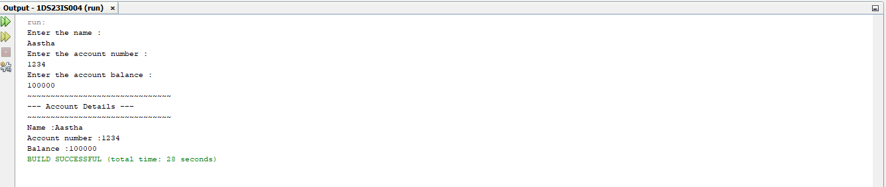

**Program-3:**

import java.util.Scanner;

class Employee

{

String empId;

String empName;

long empPhone;

float empSalary;

public void accept()

{

Scanner scanner = new Scanner(System.in);

System.out.print("Enter Staff Id: ");

empId = scanner.next();

System.out.print("Enter Name: ");

empName = scanner.next();

System.out.print("Enter Phone: ");

empPhone = scanner.nextLong();

System.out.print("Enter Salary: ");

empSalary = scanner.nextFloat();

}

public void display()

{

System.out.println("Staff Id: " + empId);

System.out.println("Name: " + empName);

System.out.println("Phone: " + empPhone);

System.out.println("Salary: " + empSalary);

}

}

class Teaching extends Employee

{

String domain;

int n;

public void accept()

{

super.accept();

Scanner scanner = new Scanner(System.in);

System.out.print("Enter Domain: ");

domain = scanner.next();

System.out.print("Enter Number of Publications: ");

n = scanner.nextInt();

System.out.println("\n");

}

public void display()

{

super.display();

System.out.println("Domain: " + domain);

System.out.println("Publications:" + n);

System.out.println("\n");

}

}

class Technical extends Employee

{

String skill;

public void accept()

{

super.accept();

Scanner scanner = new Scanner(System.in);

System.out.print("Enter technical Skills: ");

skill = scanner.nextLine();

System.out.println("\n");

}

public void display()

{

super.display();

System.out.println("Technical Skills: " + skill);

System.out.println("\n");

}

}

class Contract extends Employee {

int period;

public void accept()

{

super.accept();

Scanner scanner = new Scanner(System.in);

System.out.print("Enter Period: ");

period = scanner.nextInt();

System.out.println("\n");

}

public void display()

{

super.display();

System.out.println("Contract Period: " + period);

}

}

class EmployeeFour

{

public static void main(String[] args) {

Teaching teaching = new Teaching();

System.out.println("Enter the details of Teaching Staff");

teaching.accept();

Technical technical = new Technical();

System.out.println("Enter the details of Technical Staff");

technical.accept();

Contract contract = new Contract();

System.out.println("Enter the details of Contract Staff");

contract.accept();

System.out.println("The details of Teaching Staff");

teaching.display();

System.out.println("The details of Technical Staff");

technical.display();

System.out.println("The details of Contract Staff");

contract.display();

}

}

**Output:**

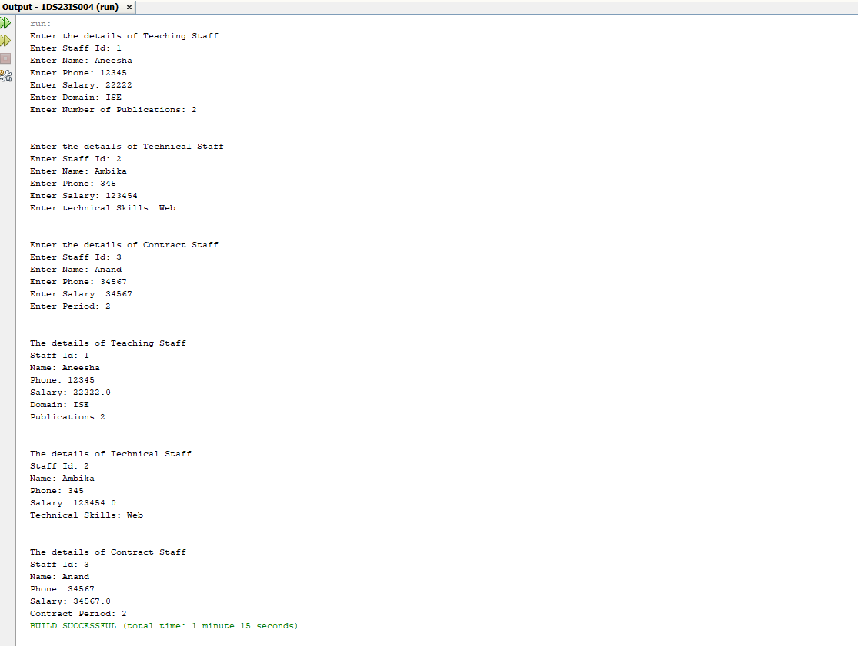

**Program-4**

import java.util.Scanner;

class ExceptionDivision

{

public static void main(String[] args)

{

int a,b,result;

Scanner input =new Scanner(System.in);

System.out.println("Input two integers");

a=input.nextInt();

b=input.nextInt();

try

{

result=a/b;

System.out.println("Result="+result);

}

catch(ArithmeticException e)

{

System.out.println("exception caught: Divide by zero error"+e);

}

}}

Output:

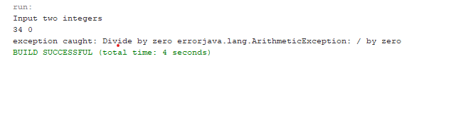

**Program-5**

import java.net.URL;

public class URLMain {

public static void main(String[] args)

{

try

{

URL url = new

URL("https://www.example.com/path/to/file.html?key=value#fragment");

System.out.println("Protocol: " + url.getProtocol());

System.out.println("Host: " + url.getHost());

System.out.println("Port: " + url.getPort());

System.out.println("Path: " + url.getPath());

System.out.println("Query: " + url.getQuery());

System.out.println("Fragment: " + url.getRef());

}

catch (Exception e)

{

System.out.println("Error: " + e.getMessage());

}

}

}

**Output:**

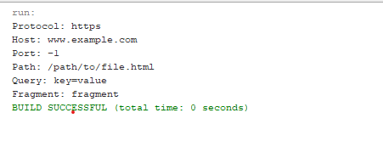

**Program-6**

**ServerSide.java**

import java.io.*;

import java.net.*;

public class ServerSide

{

public static void main(String[]args)

{

try

{

ServerSocket ss=new ServerSocket(3306);

Socket s=ss.accept();//establishes connection

DataInputStream dis=new DataInputStream(s.getInputStream());

String str=(String)dis.readUTF();

System.out.println("message= "+str);

ss.close();

}

catch(Exception e)

{

System.out.println(e);}

}

}

# ClientSide.java

import java.io.*;

import java.net.*;

public class ClientSide

{

public static void main(String[] args)

{

try

{

Socket s=new Socket("localhost",3306);

DataOutputStreamdout=new DataOutputStream(s.getOutputStream()); dout.writeUTF("Hello Server");

dout.flush()

dout.close();

s.close();

}

catch(Exception e)

{

System.out.println(e);}

}

}

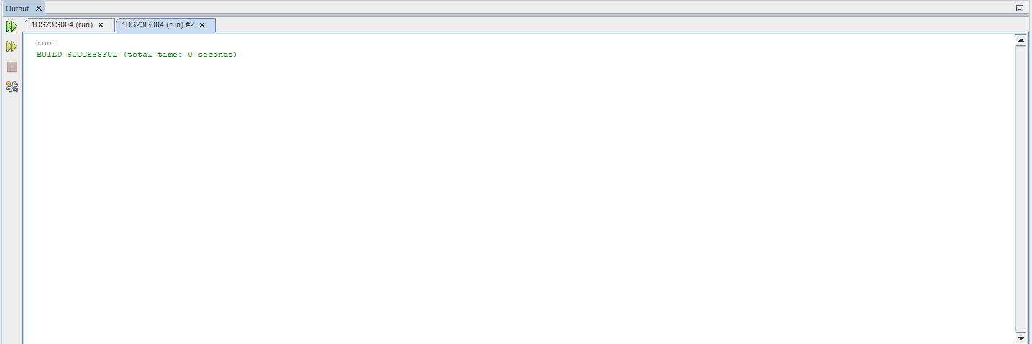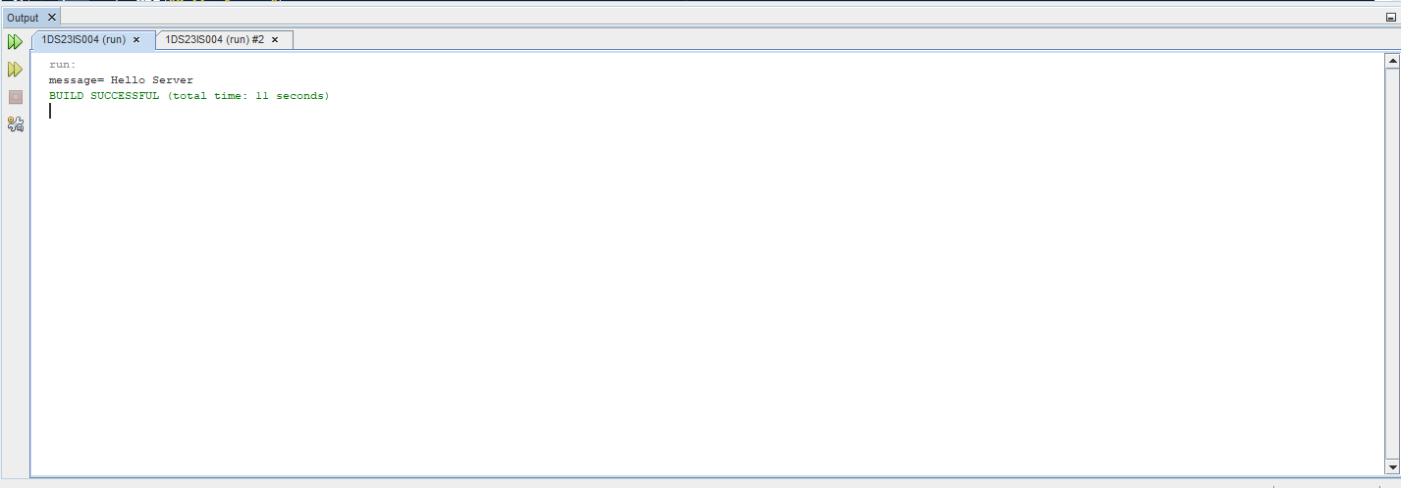**Output:**

**Program-7:**

**import java.sql.*;**

**public class InsertDemo {**

**// JDBC driver name and database URL**

**static final String JDBC_DRIVER = "com.mysql.cj.jdbc.Driver";**

**static final String DB_URL = "jdbc:mysql://localhost:3306/";**

**// Database credentials**

**static final String USER = "root";**

**static final String PASS = "root";**

**static final String db_Name = "jdbctest";**

**public static void main(String[] args) { Connection conn = null;**

**Statement stmt = null;**

**try{**

**//STEP 2: Register JDBC driver**

**Class.forName("com.mysql.cj.jdbc.Driver");**

**//STEP 3: Open a connection**

**System.out.println("Connecting to a selected database...");**

**conn = DriverManager.getConnection(DB_URL+db_Name,USER,PASS);**

**System.out.println("Connected database successfully...");**

**//STEP 4: Execute a query**

**System.out.println("Inserting records into the table...");**

**stmt = conn.createStatement();**

**String sql = "INSERT INTO employees " + "VALUES ('5001', '30', 'Surendra', 'K','Coimbatore')";**

**stmt.executeUpdate(sql);**

**sql = "INSERT INTO employees " + "VALUES ('5002', '21', 'Athul', 'K','Wayanad')";**

**stmt.executeUpdate(sql);**

**sql = "INSERT INTO employees " + "VALUES ('5003', '20', 'Yadhu', 'K T','Palakkad')";**

**stmt.executeUpdate(sql);**

**sql = "INSERT INTO employees " + "VALUES ('5004', '23', 'Pravin', 'K P','Thrissur')";**

**stmt.executeUpdate(sql);**

**sql = "UPDATE employees " + "SET age = 21 WHERE EMP_ID in (5003, 5004)";**

**stmt.executeUpdate(sql);**

**System.out.println("Inserted records into the table...");**

**String sql2="DELETE FROM employees where EMP_ID=5004";**

**stmt.executeUpdate(sql2);**

**System.out.println("deleted records in the table where id is 5004...");**

**ResultSet rs= stmt.executeQuery("select * from employees");**

**while(rs.next()){**

**System.out.println(rs.getString(1)+ " "+rs.getString(2)+ " "+rs.getString(3)+ " "+rs.getString(4)+ " "+rs.getString(5)+" ");**

**}**

**}catch(SQLException se){**

**//Handle errors for JDBC**

**se.printStackTrace();**

**}**

**catch(Exception e){**

**//Handle errors for Class.forName**

**e.printStackTrace();**

**}**

**finally{**

**//finally block used to close resources**

**try{**

**if(stmt!=null) conn.close();**

**}**

**catch(SQLException se){**

**}// do nothing**

**try{**

**if(conn!=null) conn.close();**

**}**

**catch(SQLException se){**

**se.printStackTrace();**

**}//end finally try**

**}//end try System.out.println("Goodbye!");**

**}//end main**

**}**

**Output:**

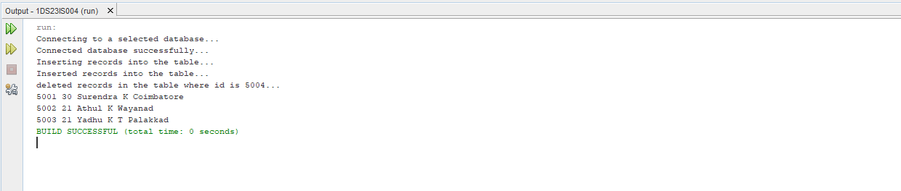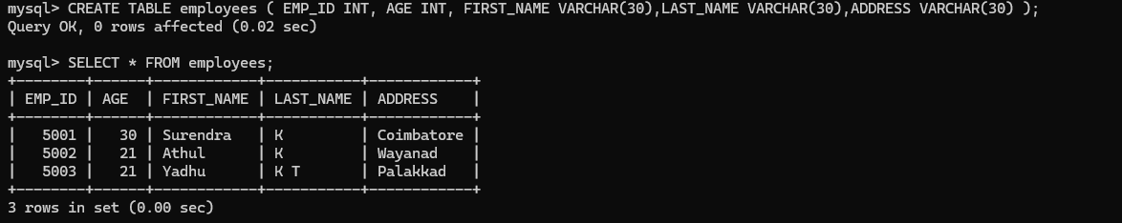

**Program-8:**

**Login.html**

Top of Form

Top of Form

<html>

<head>

<title>Login</title>

<meta charset="UTF-8">

<meta name="viewport" content="width=device-width, initial-scale=1.0">

</head>

<body>

<form action="login.jsp" method="post" id="styleform">

<h2>Login Authentication</h2><hr color="black"><br> Username: <input type="text" name="user"/><br><br> Password: <input type="password" name="pwd"/><br><br><br>

<input type="submit" value="Submit" id="stylesub"/>

</form>

</body>

</html>

Bottom of Form

Login.jsp

<!DOCTYPE html>

<html>

<head>

<meta http-equiv="Content-Type" content="text/html; charset=UTF-8">

<title>Login</title>

</head>

<body>

<%@ page import ="java.sql.*" %>

<%@ page import ="javax.sql.*" %>

<%String userid = request.getParameter("user");

String pwd = request.getParameter("pwd"); Class.forName("com.mysql.jdbc.Driver"); java.sql.Connection con =

DriverManager.getConnection("jdbc:mysql://localhost:3306/emp","users",""); Statement st= con.createStatement();

ResultSet rs= st.executeQuery("select * from users where user_id='"+userid+"'"); if(rs.next())

{if(rs.getString(2).equals(pwd)) { session.setAttribute("user",rs.getString(3));

String name=(String)session.getAttribute("user"); out.println("Welcome "+ name);

}else

System.out.println("Invalid password try again");

}

%></body>

</html>

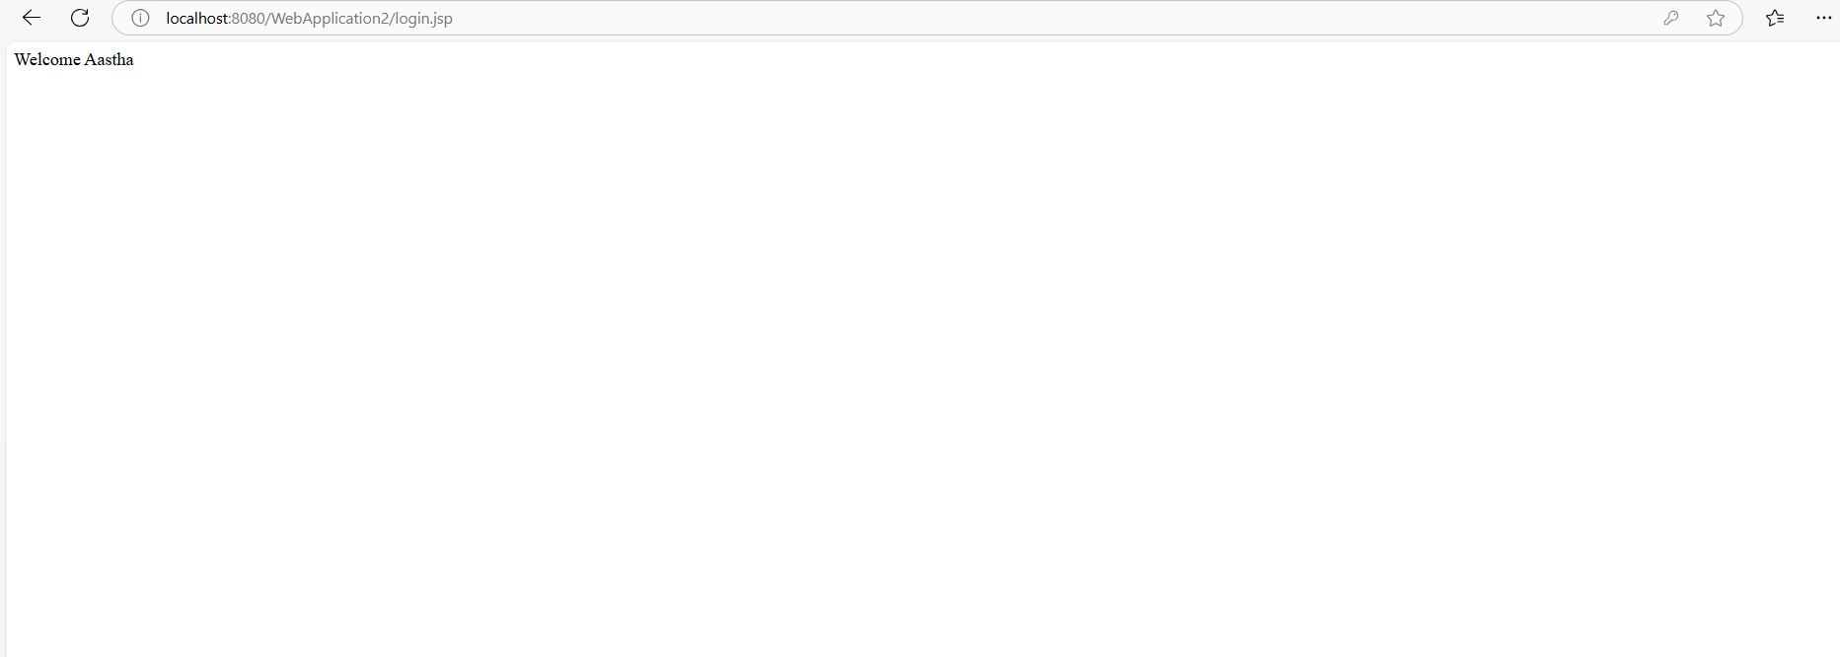**Output:**

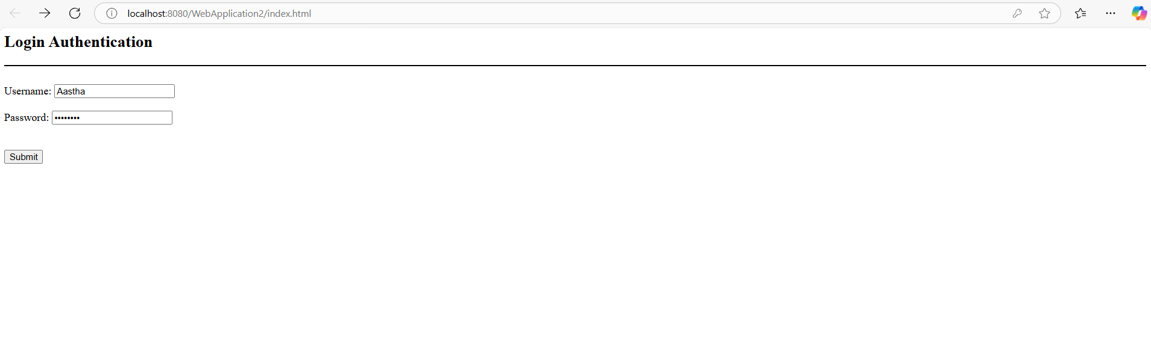

**Program-9:**

/*

* To change this license header, choose License Headers in Project Properties.

* To change this template file, choose Tools | Templates

* and open the template in the editor.

*/

import java.io.IOException;

import java.io.PrintWriter;

import javax.servlet.ServletException;

import javax.servlet.http.HttpServlet;

import javax.servlet.http.HttpServletRequest;

import javax.servlet.http.HttpServletResponse;

/**

*

* @author iselab5

*/

public class PageHitCounter extends HttpServlet {

/**

* Processes requests for both HTTP <code>GET</code> and <code>POST</code>

* methods.

*

* @param request servlet request

* @param response servlet response

* @throws ServletException if a servlet-specific error occurs

* @throws IOException if an I/O error occurs

*/

private int hitCount;

public void init() { hitCount = 0; }

protected void processRequest(HttpServletRequest request, HttpServletResponse response)

throws ServletException, IOException {

response.setContentType("text/html;charset=UTF-8");

hitCount++;

try (PrintWriter out = response.getWriter()) {

/* TODO output your page here. You may use following sample code. */

out.println("<!DOCTYPE html>");

out.println("<html>");

out.println("<head>");

out.println("<title>Servlet PageHitCounter</title>");

out.println("</head>");

out.println("<body>");

out.println("<h1>hitCount shows number of click on website</h1>");

out.println("<h2 align = \"center\">" + hitCount + "</h2>\n" );

out.println("</body>");

out.println("</html>");

}

}

// <editor-fold defaultstate="collapsed" desc="HttpServlet methods. Click on the + sign on the left to edit the code.">

/**

* Handles the HTTP <code>GET</code> method.

*

* @param request servlet request

* @param response servlet response

* @throws ServletException if a servlet-specific error occurs

* @throws IOException if an I/O error occurs

*/

@Override

protected void doGet(HttpServletRequest request, HttpServletResponse response)

throws ServletException, IOException {

processRequest(request, response);

}

/**

* Handles the HTTP <code>POST</code> method.

*

* @param request servlet request

* @param response servlet response

* @throws ServletException if a servlet-specific error occurs

* @throws IOException if an I/O error occurs

*/

@Override

protected void doPost(HttpServletRequest request, HttpServletResponse response)

throws ServletException, IOException {

processRequest(request, response);

}

/**

* Returns a short description of the servlet.

*

* @return a String containing servlet description

*/

@Override

public String getServletInfo() {

return "Short description";

}// </editor-fold>

}

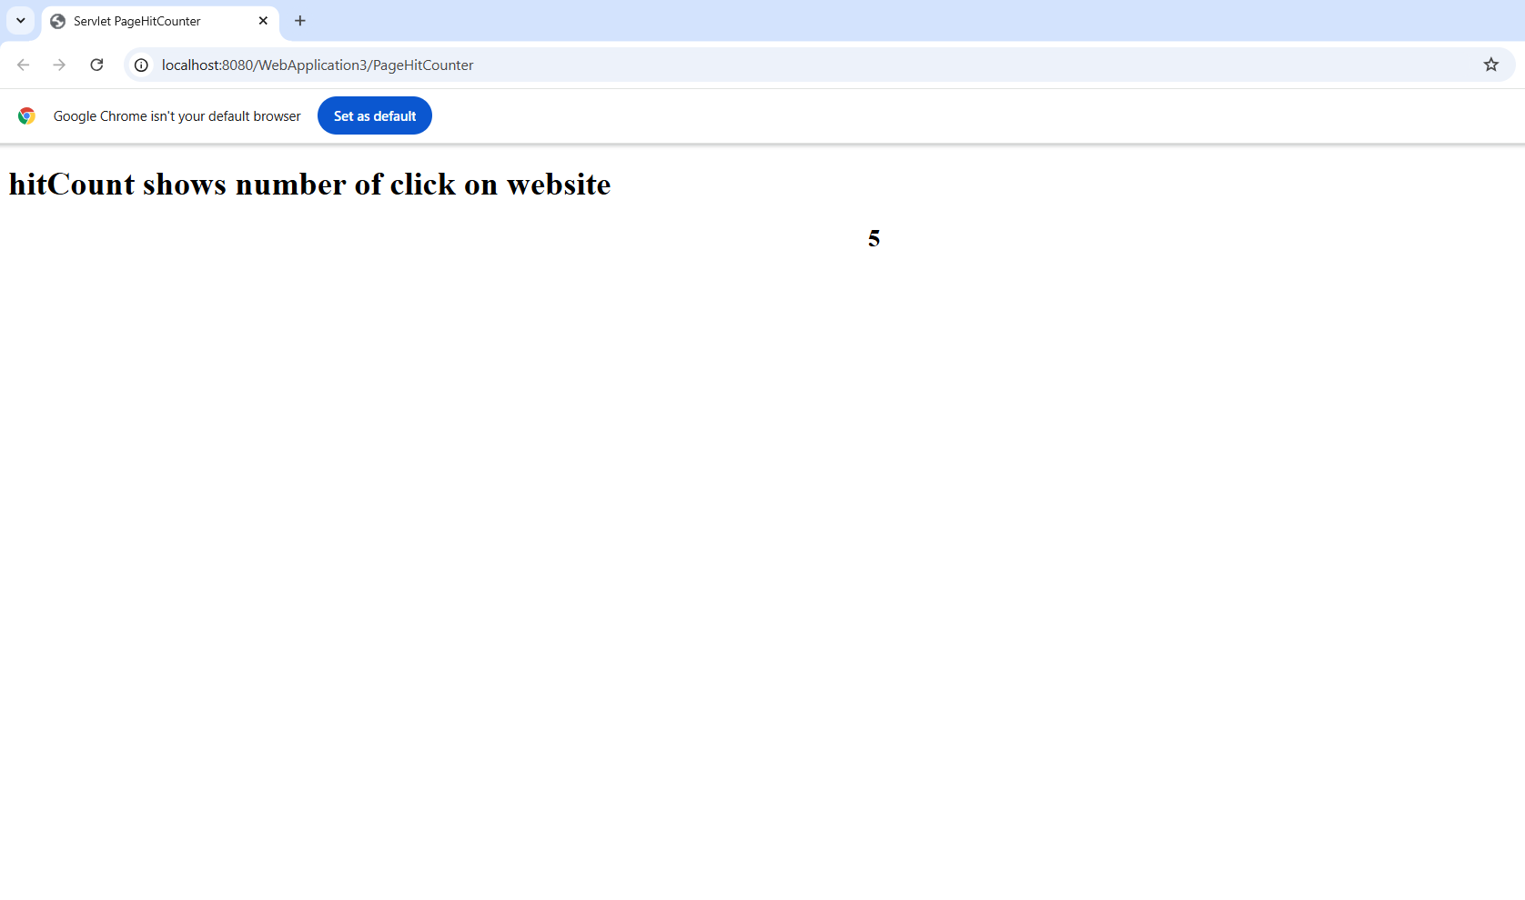

**Program-10**

**import java.io.IOException;**

**import java.io.PrintWriter;**

**import javax.servlet.ServletException;**

**import javax.servlet.http.HttpServlet;**

**import javax.servlet.http.HttpServletRequest;**

**import javax.servlet.http.HttpServletResponse;**

**import java.sql.*;**

**public class P9_DatabaseAccess extends HttpServlet**

**{**

**public void doGet(HttpServletRequest request, HttpServletResponse**

**response) throws ServletException, IOException**

**{**

**String JDBC_DRIVER = "com.mysql.jdbc.Driver";**

**String DB_URL="jdbc:mysql://localhost/STUDENT";**

**String USER = "root";**

**String PASS = "root";**

**response.setContentType("text/html");**

**PrintWriter out = response.getWriter();**

**String title = "Database Result";**

**String docType =**

**"<!doctype html public \"-//w3c//dtd html 4.0 " + "transitional//en\">\n";**

**out.println(docType +**

**"<html>\n" +**

**"<head><title>" + title + "</title></head>\n" +**

**"<body bgcolor = \"#f0f0f0\">\n" +**

**"<h1 align = \"center\">" + title + "</h1>\n");**

**try**

**{**

**Class.forName("com.mysql.jdbc.Driver");**

**Connection conn = DriverManager.getConnection(DB_URL, USER,PASS);**

**Statement stmt = conn.createStatement();**

**String sql;**

**sql = "SELECT * from stu";**

**ResultSet rs = stmt.executeQuery(sql);**

**out.println("<table border=1>");**

**out.println("<tr><th>ID</th><th>Name</th><th>Age</th></tr>");**

**while(rs.next())**

**{**

**int id = rs.getInt(1);**

**String name = rs.getString(2);**

**int age = rs.getInt(3);**

**out.println(**

**"<tr><td>"+id+"</td><td>"+name+"</td><td>"+age+**

**"</td></tr>");**

**out.println("<br>");**

**}**

**out.println("</body></html>");**

**rs.close();**

**stmt.close();**

**conn.close();**

**}**

**catch(SQLException se)**

**{**

**out.println(se);**

**se.printStackTrace();**

**}**

**catch(Exception e)**

**{**

**e.printStackTrace();**

**out.println(e);**

**}**

**}**

**}**

**Note:  
Steps to create :**

**STEP 1: File->New Project->Java Web->next->next->Finish**

**STEP 2: right click on Webapplication(whatever name given)->New->Servlet->tick the Add info ->Finish**

**STEP 3:Right click Libraries->Add Library->Java DB Driver**

**STEP 4:Right click Libraries->Add JAR ->**

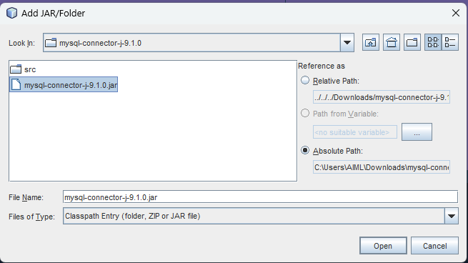

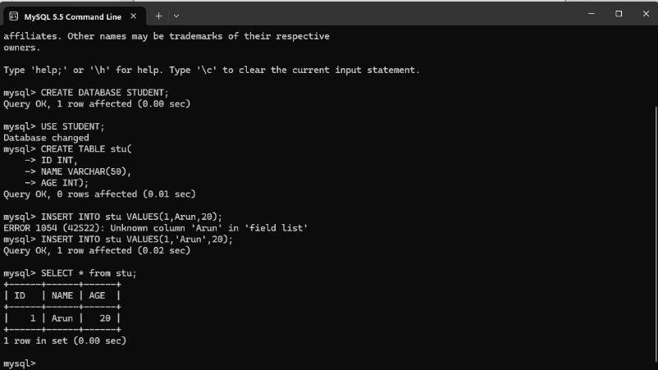**STEP 5:In mysql**

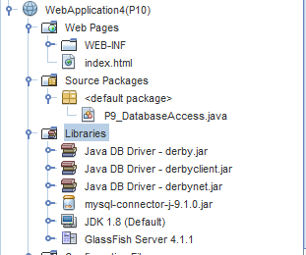

**Output:  
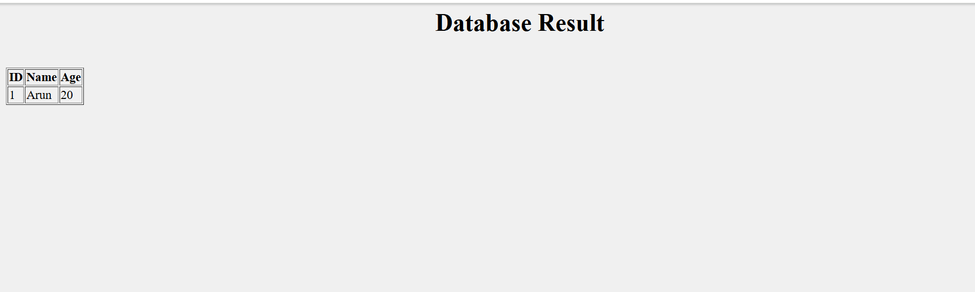**

Modifications

Program-8:  
Add register page

login.html

<html>

<head>

<title>Login</title>

<meta charset="UTF-8">

<meta name="viewport" content="width=device-width, initial-scale=1.0">

</head>

<body>

<form action="login.jsp" method="post" id="styleform">

<h2>Login Authentication</h2><hr color="black"><br>

Username: <input type="text" name="user"/><br><br>

Password: <input type="password" name="pwd"/><br><br><br>

<input type="submit" value="Submit" id="stylesub"/>

<p>Don't have an account? <a href="Register.html">Register here</a></p>

</form>

</body>

register.html

<html>

<head>

<title>Register</title>

<meta charset="UTF-8">

<meta name="viewport" content="width=device-width, initial-scale=1.0">

</head>

<body>

<form action="register.jsp" method="post" id="styleform">

<h2>User Registration</h2><hr color="black"><br>

Username: <input type="text" name="user" required/><br><br>

Password: <input type="password" name="pwd" required/><br><br>

Confirm Password: <input type="password" name="confirm_pwd" required/><br><br><br>

Full Name: <input type="text" name="full_name" required/><br><br><br>

<input type="submit" value="Register" id="stylesub"/>

<p>Already have an account? <a href="Login.html">Login here</a></p>

</form>

</body>

</html>

Login.jsp

<%@page contentType="text/html" pageEncoding="UTF-8"%>

<!DOCTYPE html>

<html>

<head>

<meta http-equiv="Content-Type" content="text/html; charset=UTF-8">

<title>Login</title>

</head>

<body>

<%@ page import ="java.sql.*" %>

<%@ page import ="javax.sql.*" %>

<%String username = request.getParameter("user");

String pwd = request.getParameter("pwd");

Class.forName("com.mysql.jdbc.Driver");

java.sql.Connection con =

DriverManager.getConnection("jdbc:mysql://localhost:3306/emp","root","root");

Statement st= con.createStatement();

ResultSet rs= st.executeQuery("select * from users where user_id='"+username+"'");

if(rs.next())

{if(rs.getString(2).equals(pwd)) {

session.setAttribute("user",rs.getString(1));

String name=(String)session.getAttribute("user");

out.println("Welcome "+ name);

}else

System.out.println("Invalid password try again");

}

%></body>

</html>

Register.jsp

<%@ page import ="java.sql.*" %>

<%@ page import ="javax.sql.*" %>

<%

String userid = request.getParameter("user");

String pwd = request.getParameter("pwd");

String confirmPwd = request.getParameter("confirm_pwd");

String fullName = request.getParameter("full_name");

if (!pwd.equals(confirmPwd)) {

out.println("Passwords do not match. Please go back and try again.");

return;

}

try {

Class.forName("com.mysql.jdbc.Driver");

java.sql.Connection con = DriverManager.getConnection("jdbc:mysql://localhost:3306/emp","root","root");

PreparedStatement ps = con.prepareStatement("insert into users (user_id, password, full_name) values (?, ?, ?)");

ps.setString(1, userid);

ps.setString(2, pwd);

ps.setString(3, fullName);

int i = ps.executeUpdate();

if (i > 0) {

out.println("Registration successful! You can now <a href='Login.html'>login here</a>.");

} else {

out.println("Registration failed. Please try again.");

}

ps.close();

con.close();

} catch (Exception e) {

e.printStackTrace();

out.println("An error occurred during registration: " + e.getMessage());

}

%>

OUTPUT:  
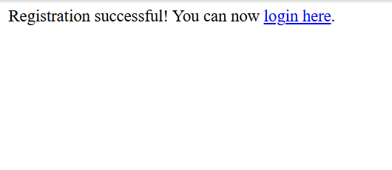

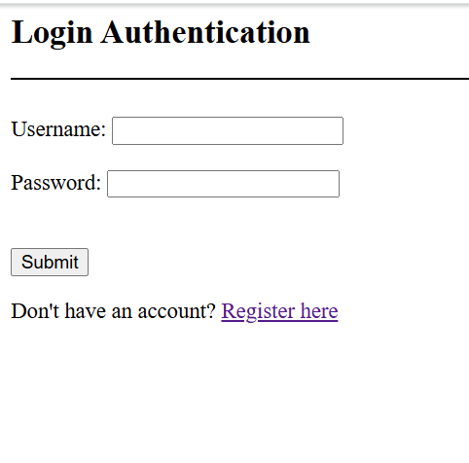

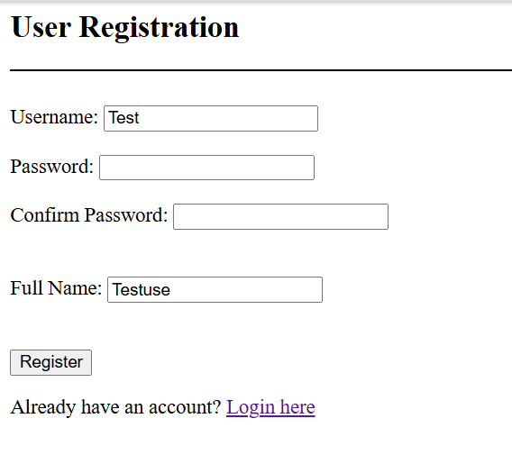</html>Bottom of Form

Program-10

import java.io.IOException;

import java.io.PrintWriter;

import javax.servlet.ServletException;

import javax.servlet.http.HttpServlet;

import javax.servlet.http.HttpServletRequest;

import javax.servlet.http.HttpServletResponse;

import java.sql.*;

public class Student extends HttpServlet {

// Database connection details

String JDBC_DRIVER = "com.mysql.jdbc.Driver";

String DB_URL = "jdbc:mysql://localhost/ise";

String USER = "root";

String PASS = "root";

// doGet method to handle both displaying records and operations (insert, update, delete)

public void doGet(HttpServletRequest request, HttpServletResponse response) throws ServletException, IOException {

response.setContentType("text/html");

PrintWriter out = response.getWriter();

String title = "Database Result";

String docType =

"<!doctype html public \"-//w3c//dtd html 4.0 " + "transitional//en\">\n";

out.println(docType +

"<html>\n" +

"<head><title>" + title + "</title></head>\n" +

"<body bgcolor = \"#f0f0f0\">\n" +

"<h1 align = \"center\">" + title + "</h1>\n");

// Get the action parameter for delete or update

String action = request.getParameter("action");

String id = request.getParameter("id");

try {

// Establish database connection

Class.forName("com.mysql.jdbc.Driver");

Connection conn = DriverManager.getConnection(DB_URL, USER, PASS);

// Handle delete operation

if ("delete".equals(action) && id != null) {

String deleteSQL = "DELETE FROM student WHERE id = ?";

PreparedStatement stmt = conn.prepareStatement(deleteSQL);

stmt.setInt(1, Integer.parseInt(id));

stmt.executeUpdate();

stmt.close();

response.sendRedirect("Student"); // Redirect to show updated records

return; // End execution after redirect

}

// Handle update operation

if ("update".equals(action) && id != null) {

String name = request.getParameter("name");

String age = request.getParameter("age");

String updateSQL = "UPDATE student SET name = ?, age = ? WHERE id = ?";

PreparedStatement stmt = conn.prepareStatement(updateSQL);

stmt.setString(1, name);

stmt.setInt(2, Integer.parseInt(age));

stmt.setInt(3, Integer.parseInt(id));

stmt.executeUpdate();

stmt.close();

response.sendRedirect("Student"); // Redirect to show updated records

return; // End execution after redirect

}

// Display records from the student table

Statement stmt = conn.createStatement();

String sql = "SELECT * FROM student";

ResultSet rs = stmt.executeQuery(sql);

out.println("<table border=1>");

out.println("<tr><th>ID</th><th>Name</th><th>Age</th><th>Actions</th></tr>");

while (rs.next()) {

int studentId = rs.getInt(1);

String name = rs.getString(2);

int age = rs.getInt(3);

out.println("<tr><td>" + studentId + "</td><td>" + name + "</td><td>" + age +

"</td><td><a href='?action=delete&id=" + studentId + "'>Delete</a> | " +

"<a href='?action=update&id=" + studentId + "&name=" + name + "&age=" + age + "'>Update</a></td></tr>");

}

out.println("</table><br>");

// Display Insert Form (Allow ID input as user will enter it manually)

out.println("<h2>Insert New Student</h2>");

out.println("<form action='Student' method='POST'>" +

"ID: <input type='number' name='id' required><br>" +

"Name: <input type='text' name='name' required><br>" +

"Age: <input type='number' name='age' required><br>" +

"<input type='submit' value='Insert Student'>" +

"</form>");

out.println("</body></html>");

rs.close();

stmt.close();

conn.close();

} catch (SQLException | ClassNotFoundException se) {

out.println(se);

se.printStackTrace();

}

}

// doPost method to handle Insert operation

public void doPost(HttpServletRequest request, HttpServletResponse response) throws ServletException, IOException {

response.setContentType("text/html");

PrintWriter out = response.getWriter();

String id = request.getParameter("id");

String name = request.getParameter("name");

String age = request.getParameter("age");

// Insert Student into the database

if (id != null && name != null && age != null) {

try {

Class.forName("com.mysql.jdbc.Driver");

Connection conn = DriverManager.getConnection(DB_URL, USER, PASS);

String insertSQL = "INSERT INTO student (id, name, age) VALUES (?, ?, ?)";

PreparedStatement stmt = conn.prepareStatement(insertSQL);

stmt.setInt(1, Integer.parseInt(id));

stmt.setString(2, name);

stmt.setInt(3, Integer.parseInt(age));

stmt.executeUpdate();

stmt.close();

conn.close();

response.sendRedirect("Student"); // Refresh the page to show new records

} catch (SQLException | ClassNotFoundException e) {

out.println(e);

e.printStackTrace();

}

}

}

}

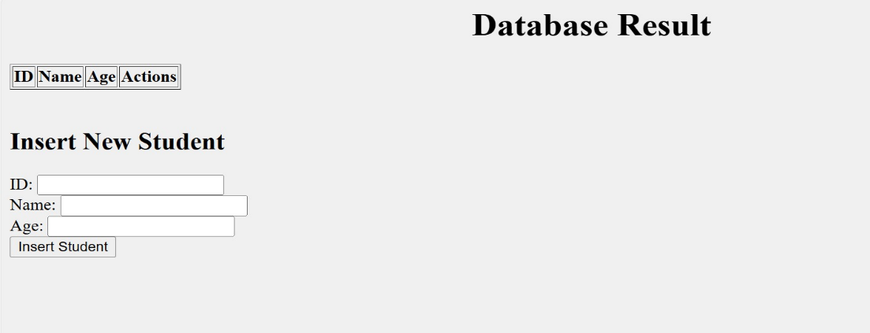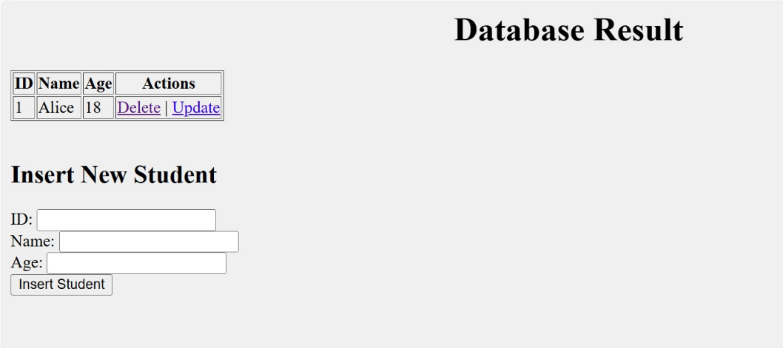OUTPUT:

