**Project Part 1: Reflection**

This project aims to provide a clear understanding of how wildfires can impact air quality, with a specific focus on West Odessa. The first phase involves the careful extraction and organization of data from the sciencebase.gov database, ensuring that it's well-prepared for in-depth analysis. Following this, I move on to the visualization of data using various charts and graphs, which will help us uncover patterns, trends, and correlations within the dataset. The ultimate objective of this part is to develop a predictive score that can anticipate the extent of wildfire impact on air quality in future. This score will be particularly valuable for the residents of West Odessa, offering insights into potential air quality changes during wildfire events. As we progress through these stages, we are committed to shedding light on the intricate relationship between wildfires, air quality, and the well-being of West Odessa's community.

**A histogram showing the number of fires occurring every 50-mile distance from my assigned city up West Odessa to the max specified distance (1250 miles).**

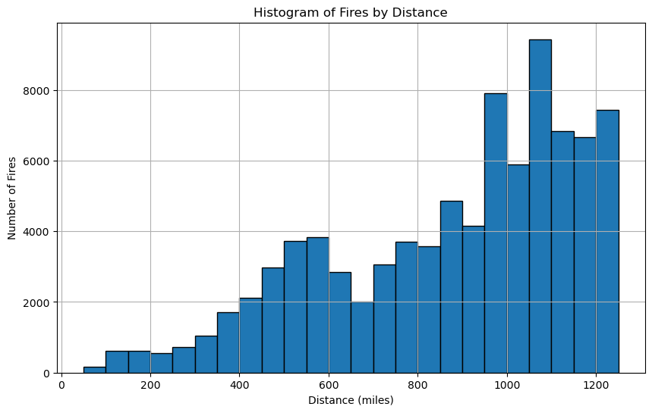

The graph is a histogram, a data visualization method that categorizes information into intervals or "bins." It's used to analyze data related to spatial distances, focusing on distances between locations.

The graph organizes data into distance intervals, such as "Within 50 miles," "Within 50-100 miles," "Within 100-150 miles," and so on, in 50-mile increments. This approach allows for a clear view of data distribution based on spatial proximity.

Notably, the graph doesn't consider specific years; instead, it offers a general overview of spatial relationships between locations, making it a valuable tool for understanding geographical patterns and relationships without temporal constraints.

**A time series graph of total acres burned per year for the fires occurring in the specified distance (1250 miles) from West Odessa**

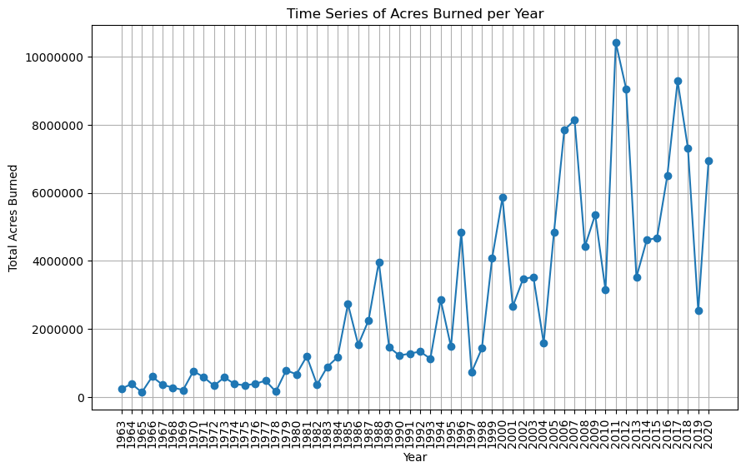

The graph is a time series representation that provides an insightful look into the annual dynamics of fires occurring within a 1250-mile radius of West Odessa. It focuses on the total acres burned each year, making it a valuable tool for understanding the patterns and trends in fire activity in this particular geographic region. By plotting time (years) on the x-axis and the total acres burned on the y-axis, this graph allows us to track the variations in fire intensity over time. This information can be invaluable for assessing the impact of fires on the local environment, as well as for developing strategies to manage and mitigate fire-related risks. The geographical criterion of 1250 miles from West Odessa narrows the scope of the data, making this graph a valuable resource for understanding the dynamics of fires in this specific area over the years.

**A time series graph containing my fire smoke estimate for my city (West Odessa) and the AQI estimate.**

**Correlation: 0.2325**

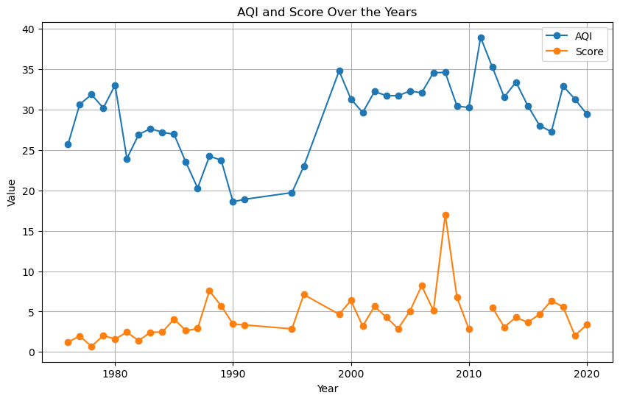

The time series graph provides a comprehensive overview of air quality conditions in West Odessa, integrating two significant components: a customized fire smoke score and the official Air Quality Index (AQI) retrieved from authoritative government resources. The custom-created fire smoke score is a unique estimate developed from specific data sources and methodology, serving as an indicator of localized fire-related air quality. In contrast, the AQI is derived from official government data, encompassing a broader range of pollutants and environmental factors.

By plotting these two distinct metrics over time, the graph allows for a comparative analysis of the custom fire smoke score and the standardized AQI. This visualization offers valuable insights into how your localized fire smoke estimates align with the broader government-recognized air quality assessments. It becomes a valuable resource for discerning trends and discrepancies, thereby enhancing our understanding of air quality dynamics in West Odessa and the specific impact of fire events on local air quality.

Note that the **correlation** between the Score and the AQI is **0.2325**.

The factors that I have taken into consideration while creating the Score (estimate of fire impact are the area of the fire and the distance of the fire). The area is given the magnitude of 2 as the larger the area the higher the impact. Whereas the distance is given a magnitude of 1. I reached these number through doing some research over the internet and specifically looking at the paper (Jaffe et al., 2020).

References:

*Jaffe, D. A., O'Neill, S. M., Larkin, N. K., Holder, A. L., Peterson, D. L., Halofsky, J. E., & Rappold, A. G. (2020). Wildfire and prescribed burning impacts on air quality in the United States. Journal of the Air & Waste Management Association (1995), 70(6), 583–615. https://doi.org/10.1080/10962247.2020.1749731*