

**CSE 341**

**Micro-processor**

**Project Report: Smart Street Light**

**Date: 31th September’19**

**Submitted by:**

|  |
| --- |
| Md Asif Talukdar (ID: 17101305)  Syed Mahbubuz Zaman (ID: 16201017)  Quazi Fahmiduzzaman (ID: 17101307)  Wasiu Abtahee (ID: 17304141)  Mamur Taharat (ID: 17101282) |
|  |
| **Submitted to:** |
| **Mohshi Masnad**  Lecturer  Department of Computer Science and Engineering  ABSTRACT  Our manuscript aims to develop a system which will lead to energy conservation and by doing so; we would be able to lighten few more homes. The proposed work is accomplished by using Arduino microcontroller and sensors that will control the electricity based on night and object's detection. Meanwhile, a counter is set that will count the number of objects passed through the road. The beauty of the proposed work is that the wastage of unused electricity can be reduced, lifetime of the streetlights gets enhance because the lights do not stay ON during the whole night, and also helps to increase safety measurements. We are confident that the proposed idea will be beneficial in the future applications of microcontrollers and sensors etc. |

Introduction

The most natural solution is to control the street lights according to the outside lighting condition. This is what our paper is aiming for in smart lighting system in which the street lights will be turned OFF when there are no motion detections or day-time, otherwise the lights will be remained Dim/ON. Our proposed design is aimed at efficiently replacing any light systems that are manually controlled, and this is accomplished with the properly arrangements of microcontroller Arduino Uno, IR obstacle avoidance sensor, LDR, and Resistors. In this scenario, when the intensity of sunlight impinges with LDR, street lights can be further controlled as per the desired requirement, automatically. Most importantly, a counter is set to count the number of vehicles/objects passing through the road, which will be displayed on the serial monitor of Arduino IDE. Moreover, the high-intensity discharge street bulbs are replaced with LEDs to further reduce the power consumption. An automatic street light system does not help us in reducing the power consumption only, but also to reduce accidents, criminal activities and maintenance costs.

Background

Today, street lighting commonly uses high-intensity discharge lamps. Low-pressure sodium lamps became commonplace after World War II for their low power consumption and long life. Late in the 20th century HPS high pressure sodium lamps were preferred, taking further the same virtues. Such lamps provide the greatest amount of photopic illumination for the least consumption of electricity. However, white light sources have been shown to double driver peripheral vision and improve driver brake reaction time by at least 25%; to enable pedestrians to better detect pavement trip hazards and to facilitate visual appraisals of other people associated with interpersonal judgements. Studies comparing *metal halide and high-pressure sodium lamps have shown that at equal photopic light levels, a street* scene illuminated at night by a metal halide lighting system was reliably seen as brighter as and safer than the same scene illuminated by a high pressure sodium system.

New street lighting technologies, such as LED or induction lights, emit a white light that provides high levels of scotopic lumens allowing street lights with lower wattages and lower photopic lumens to replace existing street lights. However, there have been no formal specifications written around Photopic/Scotopic adjustments for different types of light sources, causing many municipalities and street departments to hold back on implementation of these new technologies until the standards are updated. Eastbourne in East Sussex UK is currently undergoing a project to see 6000 of its street lights converted to LED and will be closely followed by Hastings in early 2014.

Our Proposal

The traditional lighting system has been limited to two options ON and OFF only, and it is not efficient because this kind of operations meant power loss due to continuing working on maximum voltage. Hence, wastage of power from street lights is one of the noticeable power loss, but with the use of automation, it leads to many new methods of energy and money saving. In this regard, controlling lighting system using Light Dependent Resistor (LDR), IR obstacle detector sensor and Arduino together is proposed in the past. In the meanwhile, the importance of smart light system has motivated a lot of studies and the series of research work has been done. In previous works, the street light systems are based on LDR and most of them are passive infrared receiver based systems that are controlled with timers and analog circuits. Sun tracking sensors are also utilized to power OFF the street lights by the detection of the sunlight luminance. Distinguished from turning ON/OFF the electricity, another approach is introduced to dim the light in fewer traffic hours that might be useful to reduce the power consumption, but the electric bulbs are in continuous usage condition. To the best of our knowledge, a need is still existed to design a system that controls the dim light, connect the power ON/OFF with the vehicle’s motion detection, calculate the total number of vehicles passed through the road, and control the entrance gate at night to reduce criminal activities.

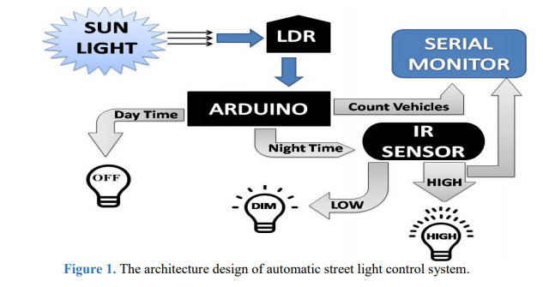

For the simplicity of discussion, Fig. 1 illustrates the overall working mechanism and the features of the proposed lighting concept. Firstly, LDR will sense the intensity value of sunlight and send it to Arduino. Arduino will judge if the received value is above the threshold level (which is set independently by the user from the discrete value: 0-2023), then it will consider it as daytime and LEDs will remain OFF, or if the received value below the threshold level, Arduino will consider it as a night-time. In the night-time, if the value of IR obstacle detector sensor is LOW and detects no object, then DIM LEDs (half of its maximum voltage) will glow, or if IR obstacle detector value is HIGH and detects any object, then HIGH LEDs (full of its maximum voltage) will glow. Arduino will also count the total number of vehicles that crossed the street in the nighttime with the help of IR obstacle detection sensor and will demonstrate it to the serial monitor.

**Components:**

A. Light Dependent Resistor (LDR)

B. Arduino Uno

C. LEDs

D. IR Obstacle Avoidance Sensor

E. Resistors

**Design:**

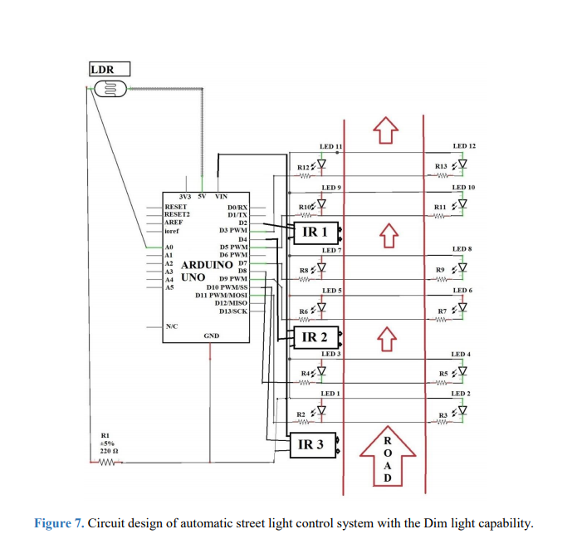

CONCLUSION

The proposed streetlight automation system is a cost effective and the safest way to reduce power consumption. It helps us to get rid of today's world problems of manual switching and most importantly, primary cost and maintenance can be decreased easily. The LED consumes less energy with cool-white light emission and has a better life than high energy consuming lamps. Moving to the new & renewable energy sources, this system can be upgraded by replacing conventional LED modules with the solar-based LED modules. With these efficient reasons, this presented work has more advantages which can overcome the present limitations. Keep in mind that these long-term benefits; the starting cost would never be a problem because the return time of investment is very less. This system can be easily implemented in street lights, smart cities, home automation, agriculture field monitoring, timely automated lights, parking lights of hospitals, malls, airport, universities and industries etc.