**1.0 Project Plan**

**1.1 Work Breakdown Structure**

1. Gather Information (5days)
2. Analysis (2days)
3. Document and verify project requirements (6days)
4. Submit SRS for approval (1day)
5. Create Mockups/Develop Prototype (10days)
6. Alpha Testing/QA (5days)
7. Develop Final Product (18days)
8. Final Testing/QA (5days)
9. Collect feedback from beta-users (2days)
10. Fix bugs (5days)
11. Launch app (1day)
12. Project complete

**1.2 Task, Duration and Dependencies**

|  |  |  |
| --- | --- | --- |
| Task | Duration | Dependencies |
| T1 | 5days |  |
| T2 | 2days | T1 |
| T3 | 6days |  |
| T4 | 1day | T2 |
| T5 | 10days | T2, T4 |
| T6 | 5days | T4, T5 |
| T7 | 18days | T6 |
| T8 | 5days | T6, T7 |
| T9 | 2days | T7, T8 |
| T10 | 5days | T6, T7, T8 |
| T11 | 1day | T6 |
| T12 | 1day | T10, T11 |

*Table 1: Task, Dependencies and Duration for the project*

**1.3 Activity Network**

**1.4 Gantt Chart**

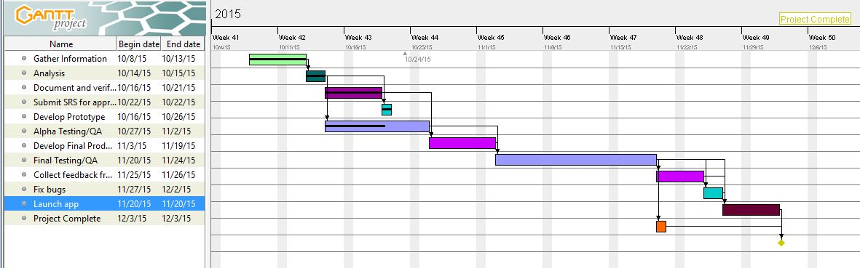

*Figure 1: Gantt Chart for Quiwave app*

*Source: Author*

**1.5 Risk Analysis**

|  |  |  |
| --- | --- | --- |
| Risk | Probability | Effects |
| Ambiguity of requirements | Moderate | Catastrophic |
| The methodology to solve the problem can't work in a proper manner | Moderate | Serious |
| Packages and Development tools are not enough | Low | Serious |
| End-users resist system | Moderate | Insignificant |
| Customer will change requirement | High | Tolerable |
| Staff Inexperience | Low | Catastrophic |

*Table 2: Risk Analysis*