7. API and communication
Line references are to commit dd8e4a7. Example values are illustrative. The field names and shapes come from the code.

Summary
Channel | Type | Direction | Authentication
Monitoring server | HTTP/1.1 on TCP 8787, read-only | Other machines to Emerald | None
Timecode client | HTTP GET, every 500 ms | Emerald to the timecode service | None
Single-instance handoff | Named pipe Emerald.App.Activate | Second launch to first | None, local
ffmpeg recording video | stdin pipe | Emerald to ffmpeg | N/A
ffmpeg recording audio | Named pipe edlcap_<pid>_<guid> | Emerald to ffmpeg | N/A
ffmpeg decoded video and audio, waveform PCM | stdout pipe | ffmpeg to Emerald | N/A
ffprobe | stdout pipe, JSON | ffprobe to Emerald | N/A
ffmpeg diagnostics | stderr pipe | ffmpeg to Emerald | N/A
Everything else | In-process method calls and C# events |  | N/A

WebSockets: Not found in the codebase. Server-sent events: Not found. UDP: Not found. Authentication anywhere: Not found.
readme.md says Emerald has "no server, no network transport". That is out of date.

Communication diagram
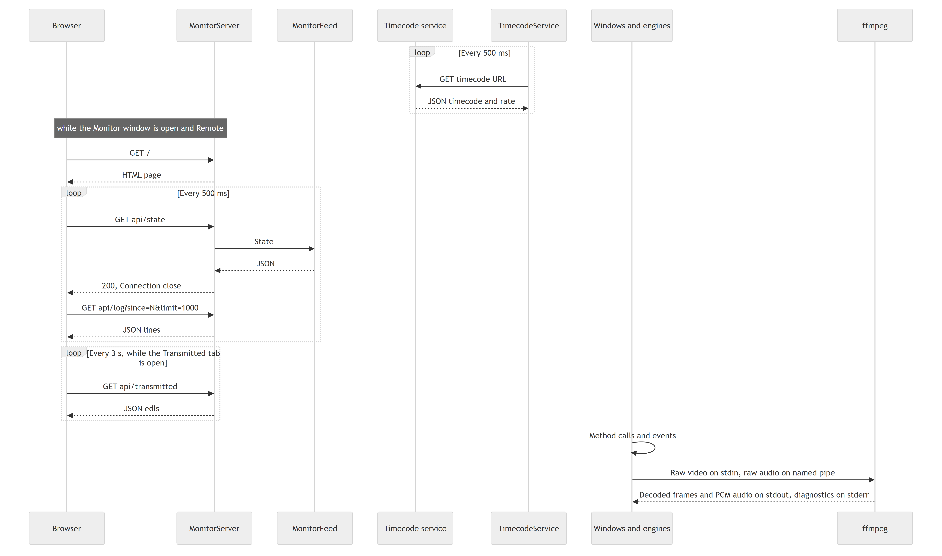

Monitoring server
src/Emerald.Core/MonitorServer.cs, MonitorFeed.cs, MonitorPage.cs.
Transport. A raw TcpListener on IPAddress.Any (src/Emerald.Core/MonitorServer.cs:115), so all IPv4 interfaces. HttpListener was avoided because it needs elevation or a URL reservation for non-localhost.
Switching it on. The RemoteToggle in the Monitor window. If monitorApi is true it restarts when that window next opens. Closing the window stops it. It is off by default.
Port. monitorApiPort, default 8787. No UI edits it, so changing it means editing settings.json with Emerald closed. installer/install.bat opens TCP 8787 in Windows Firewall, and installer/edl/install.bat adds no rule. A different port needs its own rule, and the Monitor window shows the netsh command to run.
Protocol. One request per connection. Every response has Content-Length, Cache-Control: no-store, Access-Control-Allow-Origin: * and Connection: close. Paths are matched exactly and are case-sensitive, so /API/state and /api/state/ return 404.
Limits. 8 KiB request head, 64 KiB body drain, 5-second read timeout, limit clamped to 1 to 2000. A head over the limit or a read timeout closes the connection with no HTTP status. There is no limit on connections and no write timeout.

Routes
Method | Route | Response
GET | /, /index.html | 200, text/html, the page
GET | /api/health | 200, JSON
GET | /api/state | 200, JSON
GET | /api/log?since=&limit= | 200, JSON. Defaults: since 0, limit 500.
GET | /api/transmitted | 200, JSON
GET | /api/memory | 200, JSON. For developers: one memory snapshot.
GET | anything else | 404, no such thing here
 | unparseable request line | 400, bad request
other | any | 405, read-only

HEAD is routed like GET, and it wrongly returns a body too.

GET /api/health
{"ok":true,"name":"PLANT-PC","started":"2026-11-05T08:00:01.123+08:00","version":1}
name is the machine name. version is the feed's version, not the app's.

GET /api/state
{
"at": "2026-11-05T20:57:26.5+08:00",
"timecode": "20:57:26:12",
"lastSeq": 1842,
"dropped": 0,
"recording": true,
"capture": {"headline": "RECORDING", "detail": "media - board 0 RX0", "level": "Ok", "idle": false},
"edl": {"headline": "idle", "detail": "", "level": "Info", "idle": true},
"onAir": {"headline": "idle", "detail": "", "level": "Info", "idle": true},
"ingest": {"headline": "idle", "detail": "", "level": "Info", "idle": true},
"delay": {"phase": "OnAir", "detail": "On air, 2 min behind the receiver.", "behind": "2 min",
"fill": 1, "framesToAir": 0, "targetFrames": 3000},
"frames": {"recorded": 90000, "notEncoded": 0, "notDelayed": 0, "aired": 87000,
"repeated": 0, "skipped": 0, "resyncs": 0}
}
timecode is omitted when the clock is unavailable. That includes a process started with --monitor alone, because the Monitor window does not call TimecodeLink.Connect. level is Info, Ok, Warn or Error. delay.phase is the TidalLockState name.
ingest is always idle, and Live Edit's transmission does not appear. See the assessment.

GET /api/log?since=1840&limit=1
{
"lastSeq": 1842,
"count": 1,
"lines": [{
"seq": 1841,
"at": "2026-11-05T20:57:26.1+08:00",
"time": "20:57:26.100",
"timecode": "20:57:26:02",
"source": "CAPTURE",
"level": "Ok",
"message": "SAVED segment 3 - ...",
"event": "capture.segment",
"id": "9f31c07a",
"file": "media_1105262057_3.mov",
"path": "D:\\store\\high\\...\\media_1105262057_3.mov",
"detail": "segment 3\nduration 300.00 s\n..."
}]
}
timecode, event, id, path and detail are omitted when null. id is the correlation ID. file is always present and is "" when the line names no file. lastSeq is the newest line in the log, not the newest line returned. Seq restarts from 1 each time the process starts. Transient lines are included, though they are not in the log file.

GET /api/memory
One MemorySnapshot (src/Emerald.Core/MemoryMonitor.cs), taken when asked. Sizes are bytes. It never asks for a garbage collection.
{
"At": "2026-11-06T03:10:00+11:00", "UptimeSeconds": 3120,
"WorkingSetBytes": 44249481216, "PrivateBytes": 534773760,
"ManagedHeapBytes": 61865984, "ManagedCommittedBytes": 98566144,
"Gen0Bytes": 0, "Gen1Bytes": 1048576, "Gen2Bytes": 20971520,
"LargeObjectHeapBytes": 37748736, "PinnedHeapBytes": 0, "FragmentedBytes": 2097152,
"PrivateOutsideManagedHeapBytes": 436207616,
"Gen0Collections": 25, "Gen1Collections": 4, "Gen2Collections": 0,
"GcPauseMsTotal": 39.0, "GcPausePercent": 0.0,
"AllocatedBytesTotal": 364904448, "AllocatedBytesPerSecond": 209715,
"Handles": 1310, "Threads": 37,
"Children": [{ "Id": 512, "Name": "ffmpeg", "Role": "capture encoder", "PrivateBytes": 380633088, "WorkingSetBytes": 347078656, "Threads": 37 }],
"Gauges": [{ "Module": "Delay", "Name": "ring mapped (tidal-21716-....ring)", "Value": 44132466688, "Unit": "bytes" }]
}
The values above are an example of the shape, not a measurement.
- WorkingSetBytes includes every touched page of a delay ring, which is a mapped file. PrivateBytes is the figure to watch for growth.
- Children lists only ffmpeg and ffprobe processes this process started. Role is capture encoder, video decoder, audio decoder or unnamed.
- Gauges are what modules report about themselves: ring bytes mapped, idle frame buffers, cache entry counts, Live Edit's segments, waveforms and open players. The managed heap itself can't be divided by module without a profiler.

GET /api/transmitted
{
"edls": [{
"id": "a1b2c3d4",
"headline": "...",
"files": [{
"kind": "VIDEO", "track": 0, "label": "", "channels": "",
"name": "promo.mxf", "path": "D:\\media\\promo.mxf",
"state": "AIRED", "times": 1, "timesText": "once",
"lastAired": "20:01:10", "queued": "2026-11-05T19:55:00+08:00"
}]
}]
}
track 0 is picture, 1 to 8 are audio. state is QUEUED or AIRED. kind is VIDEO or AUDIO n. label and channels are empty for video. queued is omitted when the queue line was not seen. lastAired and timesText are "-" until the file has aired. Files with no EDL come under id "" and headline Not under an EDL. Only the in-memory log ring is folded, so items that age out of the ring disappear from this view.

Security properties
Good:
- No route changes state, and no file serving exists, so there is nothing to traverse.
- It is off by default.
Weak:
- Anyone who can reach the port can read the log, including full media paths, file names, operator text and exception messages.
- Access-Control-Allow-Origin: * lets any web page in a browser on that network read it. Browser private-network rules: Not verified.
- Plain HTTP.

Timecode client
src/Emerald.Core/TimecodeService.cs, with TimecodeLink.cs as the single process-wide owner.
URL. timecodeApiUrl, default http://10.0.0.31:8888/api/timecode. TrySetUrl requires an absolute http or https URI.
Request. GET {url} every 500 ms, 3-second timeout.
Expected response. Field matching is case-insensitive.
{
"timecode": "20:57:26:12",
"frameRate": 25,
"sourceStatus": "LOCKED",
"timecodeType": "LTC",
"mode": "...",
"serverRole": "...",
"timeSource": "...",
"connectedReaders": 1,
"localTime": "...",
"serverIp": "...",
"timestampUtc": "2026-11-05T12:57:26Z"
}
Field | Use
timecode | Required. Parsed with frameRate.
frameRate | Rounded to an integer. 0 or below falls back to 25.
sourceStatus | Compared with LOCKED for display
timecodeType, mode, serverRole, timeSource, connectedReaders | Display only
localTime, serverIp, timestampUtc | Not used after parsing. A value of the wrong JSON type in any typed field, such as an unparseable timestampUtc, fails the whole poll and takes the link Offline.

The real service's response was not available for this document, and timecodeType's example value is illustrative.
Free-wheeling. Between polls the clock runs on a Stopwatch. On each sample, an error within a quarter second corrects by at most 1 frame. A larger one snaps. Displays never step backward by less than a second.
Failure. Any failed poll sets the state to Offline and clears the baseline, so TryGetCurrent returns false immediately. It retries on the next tick. Consumers react differently: the EDL plays immediately, and ingest waits.

Single-instance handoff
src/Emerald.App/App.xaml.cs:204, :223. Mutex Emerald.App.SingleInstance, session-local. Pipe Emerald.App.Activate. The message is one UTF-8 line: --edl, --ingest, --monitor or empty. There is no acknowledgement.

EDL record format
src/Emerald.EDL/EdlCommand.cs, documented in PROTOCOL.md. It is a JSON record of a playout command, for Copy JSON. It is not sent anywhere.
{
"type": "edl.command",
"version": 3,
"id": "0bf97576dc984246854faec55c53a688",
"issuedAt": "2026-08-27T21:56:00.0000000+10:00",
"capture": {"board": {"index": 1, "model": "DELTA-12G-elp-h 20", "type": 15}, "port": "RX3", "index": 3},
"playback": {"board": {"index": 0, "model": "DELTA-3G-elp-d 22", "type": 6}, "port": "TX1", "index": 1},
"timing": {"frameRate": 25, "startTimecode": "21:56:00:00", "som": "00:01:00:00", "eom": "00:11:00:00",
"duration": "00:10:00:00", "postPlay": "blackScreen", "loop": true},
"media": {"kind": "folder", "source": "D:\\media\\promo", "fileCount": 3, "files": ["a.mxf", "b.mov", "c.mp4"]},
"audio": [{"label": "English", "kind": "file", "source": "D:\\audio\\en.wav", "fileCount": 1,
"files": ["en.wav"], "offsetMs": 100, "channels": "1-2", "stream": -1}]
}
timing is shortened here. PROTOCOL.md differs from the code in these ways:
PROTOCOL.md | Code
Audio table omits stream | Always written: -1 for a bed, 0 or above for an embedded stream
Main example has no audio key | "audio": null is written
Audio example has "D:\audio\en.wav" | Invalid JSON. The serialiser writes \\.
"Copy JSON" copies what was played | After SEND it copies the next pending command
issuedAt is when it was issued | The copied value is the last preview rebuild time
capture reads as what happened | Filled in even with recording off

EDL handshake
Between Live Edit's sender and the on-air state, in-process. src/Emerald.Core/LiveEdl.cs, EdlLedger.cs, LiveAir.cs.
{
"Version": 12,
"TransactionId": "7a0c...",
"Kind": "Conform",
"Cues": ["...every LiveCue..."],
"AudioEdits": ["...every AudioEdit..."],
"IssuedAt": "2026-11-05T12:00:00Z",
"EditIds": ["..."]
}
This is the shape of the EdlRevision record, shown as JSON for readability. It is not serialised on the wire. Kind is Update, Conform or Retry.
LiveAir.Submit (src/Emerald.Core/LiveAir.cs:269) answers in this order:
Verdict | Condition | Effect
Duplicate | Same transaction as the last accepted | Nothing. Counts as taken.
Stale | Version not above the accepted version | Nothing
NotLive | State Off or Failed | Nothing
TooLate | Earliest change is at or before the committed frame | Nothing
Accepted | Otherwise | Replaces cues and levels

Accepted is not applied. AppliedVersion moves in CuesForAir, which the transmitter calls on every pass.
Retries. EdlLedger.Poll allows 2 seconds per attempt, with 3 attempts. A retry sends the latest state at a new version. After that the header shows NOT ACKNOWLEDGED, and Ctrl+Shift+E resends.
A Stale verdict is reissued once, above the newer version, inside the same send. A manual resend continues the attempt count, so it gets no automatic retries. The next edit starts again at attempt 1. A late acknowledgement still clears the failure. Nothing is sent unless Live Air is CountingDown, OnAir or Draining.
Edit status: NotConformed to start with. When a conform is sent, a taken revision sets Conforming and a refused one sets Rejected. Conforming becomes Conformed when playback picks up that version. An edit changed after that keeps its status until its next conform is sent, which sets Conforming or Rejected again.

In-process events
Raiser | Event | Listeners | Handler's thread
RxPreview | Status, FrameReady | Shell, Playback | UI
RxPreview | FormatChanged | Shell | UI
RxPreview | Audio | AudioMonitor.Push | Preview
SdiCapture | Message, Finished | Shell, IngestRecorder | Capture
SdiCapture | PreviewFrame, FormatDetected, Rolled | Shell | Capture
SdiCapture | Audio | AudioMonitor.Push, wired by the shell | Capture
SdiCapture | Frame | DelayLine.Offer | Capture
TidalLock.Shared | Changed | Shell, Playback, Monitor, Live Edit | Raiser's; handlers marshal
LiveAir.Shared | Changed | Shell, Live Edit | Raiser's; handlers marshal
PipelineState.Shared | Changed | Playback, Monitor | Raiser's
SdiPorts.Shared | Changed | Playback | Raiser's
ActivityLog.Shared | Line | Shell, Playback, Monitor, EDL, Live Edit, LiveLogWindow | The thread that called Write, not the disk writer thread
RxLease (static) | Freed | Each RxPreview | Releaser's
TimecodeLink (static) | UrlChanged | Shell, EDL, Ingest | Raiser's
DelayTransmitter, LiveAirTransmitter | Status | Playback, Live Edit | Transmitter
PlayoutService | Progress | EDL, Playback | Worker
PlayoutService | QueueChanged | EDL | Worker, or the caller of Enqueue or StopAll
IngestSchedulerService | QueueChanged, JobChanged | Ingest window, which marshals | Scheduler, or the caller of Enqueue, Cancel or Remove
IngestLog | Entry | Ingest window, which marshals | Caller of Write
IIngestRecorder | Message, Finished | IngestSchedulerService | Capture, or the simulator task
EdlLogger.Shared | Logged | None | Caller of Write
DropMarks.Shared | Changed | Live Edit | Raiser's

Activity log as an event stream
Most windows treat the log as their display, filtering ActivityLog.Line. TransmissionTally even derives "what aired" from event tags, so changing an event tag can break a feature.
Tags in use:
Area | Tags
App | app.started, app.crashed, app.softwarerender, log.dropped, monitor.api.*, monitor.readfailed
Board and RX | board.scanned, board.scanfailed, rx.stuck, rx.taken
Media | media.limit, media.limitfailed, media.pruned, media.codecs
Capture | capture.started, .finished, .segment, .dropped, .format, .folder, .source, .problem, .newday, .rollfailed, .profile, .audio.pairs, .audio.added, .audio.removed, .audio.level, .audio.detected, .audio.pair, .audio.listen
Delay | delay.<phase>, delay.ready, .readyfailed, .dropped, .segment, .fromstart, .trouble, .releasefailed, .stopfailed
Lock | tidallock.<state>, liveair.<state>, liveair.<phase>, liveair.cue.*, liveair.releasefailed
EDL | edl.queued, edl.video, edl.audio, edl.recordonair, and edl.<action> from EdlLogger
Playout | playout.video, .audio, .audiofailed, .audioonair, .videoload, .drop, .frames, .videoend, .<state>
Preview | preview.audiodrift
Live Edit | liveedit.*, around 30 tags
Untagged | Every IngestLog line and every SdiCapture.Report and Fail line

Adding to the API
See the developer guide.

