4. System workflows
Each workflow is in chronological order. Line references are to commit dd8e4a7. Where a step behaves differently from what its comments or UI suggest, it links to the assessment.

Starting up
src/Emerald.App/App.xaml.cs:
- App.Settings is initialised from AppSettings.Load() (:49).
- App_Startup takes the first argument starting with --, lower-cased (:63). It allows nothing, --edl, --ingest or --monitor. Anything else shows a message and exits with code 1.
- It takes the named mutex Emerald.App.SingleInstance (:80). If another process owns it, Handoff connects to the pipe Emerald.App.Activate with a 2 second timeout and writes the mode as one line. On success this process exits. On failure it carries on as a second instance (:90).
- DelayLine.SweepOrphans deletes tidal-<pid>-*.ring files whose process is gone (:95).
- StartActivityLog (:126) sweeps old logs, starts the writer, hooks DispatcherUnhandledException and logs app.started.
- Software rendering applies if softwareRendering is set or EMERALD_SOFTWARE_RENDER=1 (:101).
- StartListening starts the pipe server (:223).
- OpenModule shows the window (:159). If a shell exists it delegates to shell.OpenModule.
When the shell loads (ShellWindow_Loaded, src/Emerald.App/ShellWindow.xaml.cs:204), it fills fields from settings, loads the profile, shows storage use, connects TimecodeLink, starts _clock and _tick, starts the capture log panel, then awaits ScanBoards, which picks a board and port and calls StartPreview.
Modules open through ShowModule<T> (:2550), which creates the window or activates the existing one.
Standalone modes. --edl, --ingest and --monitor open through App.OpenModule with no shell, so ShowModule<T> does not apply. Playback and Live Edit can be reached only from the shell, and rings only open when the shell records.

Shutting down
ShellWindow_Closing (src/Emerald.App/ShellWindow.xaml.cs:2583):
- Stops timers and closes the player.
- Calls _capture.Stop() synchronously. A running recording stops with no confirmation.
- Disposes the preview and audio monitor.
- Unsubscribes from TimecodeLink, TidalLock, LiveAir and ActivityLog.
- Saves deck settings.
- Closes _edl, _liveEdit, _ingest, _playback and _monitor.
App.OnExit (src/Emerald.App/App.xaml.cs:259) shuts down the timecode link, cancels the listener and releases the mutex. WPF's default OnLastWindowClose applies, so a window that refuses to close keeps the process alive.
Each module has its own close behaviour:
Window | On close
Playback | Disarms tidal lock, stops the feed, saves TX board and ports
EDL | Stops capture and playout with no confirmation
Ingest | Prompts if a job is recording. Pending jobs do not run while it is closed.
Live Edit | Prompts if armed, filling, on air or draining, then ends the transmission. If the prompt cannot be shown, which the code expects when the shell is closing it, the transmission ends with no prompt.
Monitor | Stops timers and the remote server

Gaps here are verified issues: rings are left on disk when the shell closes during a recording, and the activity log is never flushed.
The shell stops its capture before asking modules to close, and never cancels its own close. If a module then refuses to close, the recording has already stopped, the shell still closes, and the process stays alive for that window.

Capture deck: recording
StartRecording (src/Emerald.App/ShellWindow.xaml.cs:995):
- Requires a board and port.
- Resolves StoreFolder and creates it.
- Writes the profile, rate, folder and limit into settings, then AppSettings.SaveCaptureFolder so Live Edit can follow.
- Collects added audio beds with CurrentCaptureAudio.
- RecordingSequence.Next(DateTime.Now, title) produces the folder name and file stem.
- RecordingSetup.TryBuild validates and builds the CaptureRequest. Failure shows a sentence and, if tidal lock is Armed, calls TidalLock.Fail. An armed Go Live is left waiting.
- _capture.Start(request with { Names = naming }) starts the SDI capture thread.
- A SegmentWatch starts following the new folder.
- PipelineState is updated and the UI shows RECORDING.
On the capture thread, SdiCapture.Run takes the receiver, displacing the preview, and locks to the signal. It then raises FormatDetected.
OnCaptureFormat (:1597) sets PipelineState.RecordingStart, then posts three actions in order: OpenReadyLine, TryOpenDelayLine, TryOpenLiveLine.
While recording:
- The preview tap draws frames to the deck, with at most one in flight.
- _capture.Audio feeds the meters.
- OnTick runs every 500 ms. Every 20 ticks it calls EnforceStorageLimit, ShowStorage and AnnounceSegments.
- Set Duration is checked against the wall clock in OnTick, so it stops within about 500 ms rather than on a frame.
Stopping (StopRecording, :1483):
- Marks the deck as not recording.
- await Task.Run(_capture.Stop).
- ReleaseDelayLine, ReleaseLiveLine, ReleaseReadyLine, in that order. The first two tell their lock (RecordingStopped) and release their claim on a task. A private ring is sealed first. A claim on the shared ready ring is not sealed there: ReleaseReadyLine seals it afterwards and tells no lock. The transmitter holds its own reference, so the delayed programme is meant to keep going.
- Restarts the preview.
OnCaptureFinished (:1549) runs on the capture thread after ffmpeg closes. It clears the recording picture, logs capture.finished and makes a final segment announcement.
If the capture dies on its own, OnTick notices within 500 ms (:2404) and runs a copy of the stop sequence.
See media processing for what happens inside SdiCapture.

The three rings
Up to three ring references exist per recording, and they can be the same file:
Field | Purpose | Opened by | Size
_readyLine | Always filling, so a lock armed mid-recording goes straight to air | OpenReadyLine (:1257) if keepDelayReady | Tries max(300, liveDelay + headroom) seconds, then 300, then 120
_delayLine | Tidal lock | OpenDelayLine (:1113) | Takes the ready ring if it is big enough, otherwise its own
_liveLine | Live Edit | TryOpenLiveLine (:1406) | Delay plus headroom, same reuse

Rings are reference counted. Each holder calls AddRef and Release, and the last release deletes the file.

Playback deck: tidal lock
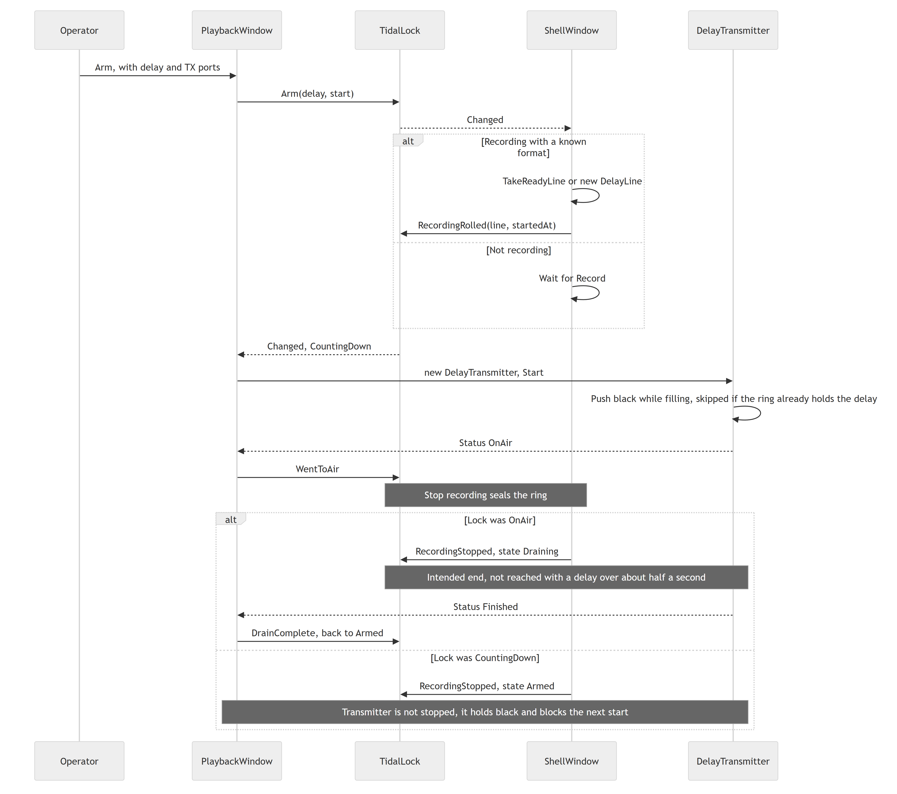
- Arm_Click is at src/Emerald.App/PlaybackWindow.xaml.cs:595, StartDelayTransmitter at :656, OnDelayStatus at :700.
- Delay options come from RenderDelayOptions (:517): 30 s, 1, 2 or 5 minutes, From first segment, When first segment is ready, and No delay only while recording.
- The deck's PlayoutService instance is never given a message. It is used only for its ffmpeg check and StopAll, so OnPlayoutProgress and the close prompt at PlaybackWindow.xaml.cs:146 can never run. Clip audition does not exist in this window: the class comment describing it (PlaybackWindow.xaml.cs:23) is stale.
- Disarm and Stop Output both disarm the lock and call StopDelayedFeed. The shell then runs ReleaseDelayLine on Off or Failed (ShellWindow.xaml.cs:1661).
- Closing the deck while the delayed feed is on air takes it off air with no prompt.
There is a verified fault in the drain, in both transmitters. After sealing, DelayPacer returns Repeat once the remaining lag is more than half a second below target, so the feed freezes on a silent frame about half a second after the recording stops, rather than finishing. It then reports Holding, not Draining.
Tidal lock and Live Air stop differently. From CountingDown, tidal lock returns to Armed and Live Air goes to Draining. They can share a ring while their states stay separate.

EDL Generator: composing and playing out
Composition (src/Emerald.EDL/EdlWindow.xaml.cs):
- The operator sets boards and ports, start timecode, SOM, EOM or duration, post play, media and audio tracks. SOM and EOM are offsets from the head of the media, and duration = EOM - SOM. EOM equal to SOM means open-ended.
- Choosing media creates one audio row per embedded stream, up to 8 tracks. List order sets the channel pair.
- Every edit runs UpdatePreviewAndValidation (:648), which calls BuildCommand (:667). The first problem shows under SEND.
- SEND (:888) builds the command, logs it and calls StartPlayout (:1320), which builds a PlayoutEntry and calls Enqueue. RecordManifest writes edl.queued, edl.video and edl.audio to the activity log.
Playout (src/Emerald.EDL/PlayoutService.cs):
- Enqueue (:279) adds the entry and starts the SDI playout thread if needed.
- Run (:331) takes the next queued entry. With nothing queued and an output open, HoldFill carries the post-play picture.
- The output opens when the (board, tx) pair changes (:366).
- WaitForCue (:897) computes the frames until the start once, then pushes exactly that many filler frames, paced by the card. A start more than 12 hours ahead, or a missing clock, means it plays immediately.
- Audio beds open, then the video decoder. There is no pre-roll.
- PlayWithVideo (:662) loops: read frame, AdvanceBeds (:594), PushFrame. Track n, counted from 1, goes on channels 2n-1 and 2n. A message with no video runs PlayAudioOnly (:852) instead: black picture, the same AdvanceBeds and PushFrame.
- Gain, solo, mute and offset are read per frame from lock-free arrays, so changes apply to air immediately.
- A message with a duration ends when framesOut == DurationFrames (:702). Files loop as needed to fill the duration. An open-ended message has no target and loops until STOP, so nothing queued behind it starts.
- Post play holds black or the last frame until the next cue or STOP.
Recording the return feed is UI logic. UpdateCapture (EdlWindow.xaml.cs:1522) starts a recording on the first Playing status of a message if the tick box is on and the capture folder box is filled in, with no retry during that message. It stops on Finished, Stopped or Failed. Each message gets its own folder.

Ingest Controller: scheduled recording
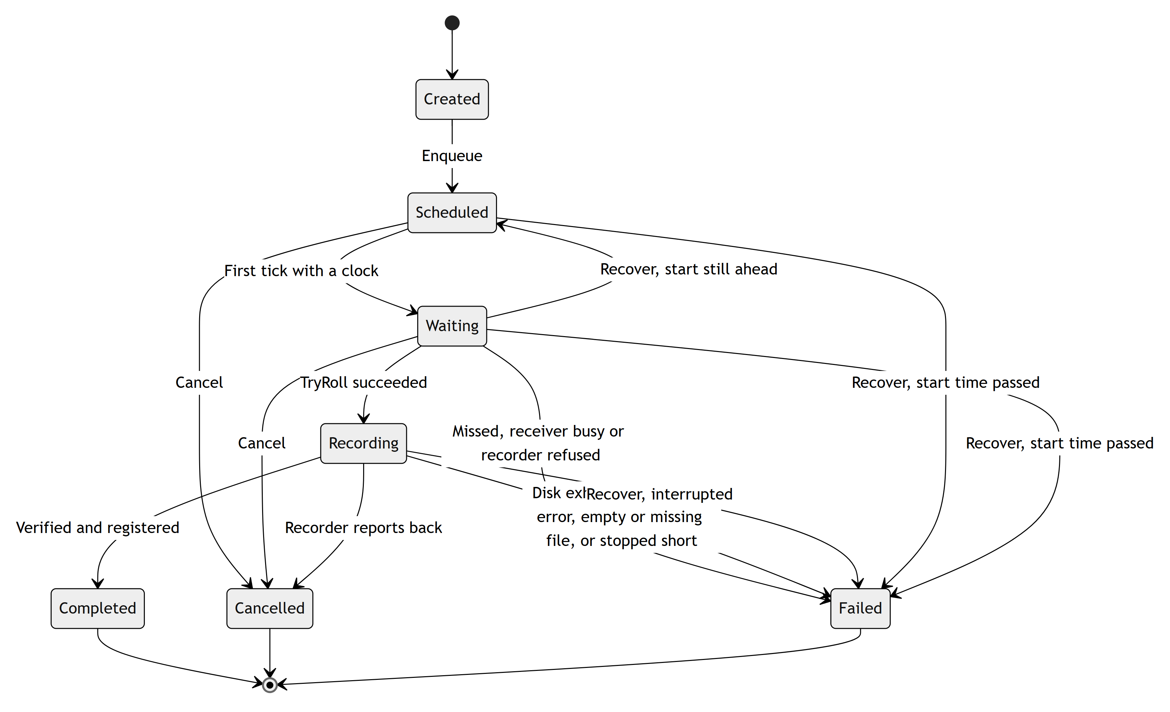
The rules also allow Created to Cancelled or Failed, but no code path does it: a job is Scheduled in the call that queues it. Recover writes the status directly rather than through Move. IngestStatus forbids Waiting to Scheduled, so the code comment that Move is "the only way" a status changes is untrue.
- Every form change runs IngestControllerService.Build (src/Emerald.Ingest/Services/IngestControllerService.cs:216). It checks board and port, frame rate, reference timecode, SOM, EOM or duration (up to 12 hours, warning over 2), audio tracks (at most 8, each file must exist), clip name, write access, existing files, disk space, the clock and clashes.
- START enqueues. There is no date field: FramesUntil counts forward, so a time just past means tomorrow.
- IngestSchedulerService.RunAsync (src/Emerald.Ingest/Services/IngestSchedulerService.cs:217) loops every 20 ms: DrainCompletions, EvaluateWaiting, UpdateRunning.
- Due (:296) decides. More than 3 s away means waiting, and more than 5 s past means missed. Then it compares timecode.
- TryRoll (:328) creates a recorder, starts it, and sets a deadline of length plus 30 s.
- SdiIngestRecorder.TryStart (src/Emerald.Ingest/Services/IngestRecorder.cs:73) builds a request with frameLimit, singleFile: true and startTimecode: SOM, then starts its own SdiCapture.
- UpdateRunning (IngestSchedulerService.cs:382) copies progress, enforces the deadline, and every 5 s checks disk: under 1 GiB stops the job and under 5 GiB warns. Passing the deadline stops the recorder without marking the job cancelled, so it ends as Failed for stopping short.
- DrainCompletions (IngestSchedulerService.cs:438) disposes the recorder, calls Register, saves the recording and moves the job. "Registered" means a database row and a log line.
- Recovery (IngestControllerService.Recover, IngestControllerService.cs:128) runs when the window opens, and again when SIMULATE is toggled. Jobs that were recording become Failed. Jobs whose time has passed become Failed. The rest are re-queued.
The scheduler lives only while the window is open. This is a verified limitation. Closing the window with a job recording prompts first. Answering Yes drops the recorder with no result row, and the job stays Recording in the store until the next open marks it Failed.

Live Edit: building the timeline
- _watch runs CheckStore (src/Emerald.LiveEdit/LiveEditWindow.xaml.cs:587) every 2 seconds.
- FollowTheDate runs first, then FollowCaptureFolder, then a Signature of the proxy folder (file count, plus the count and size of everything but the newest file).
- A changed signature calls LoadClips (:670), which runs MediaLibrary.List on a task and then Place (:739).
- Place keeps clips of the current day, plus the later segments of any recording with a clip on that day, so a recording past midnight stays whole. It narrows to one recording folder (the on-air one, otherwise the newest). It creates a Placed(clip, FrameOn(StartsAt), frames) for each.
Coordinates. Three frame numbers are in use. Confusing them is the most likely source of bugs here.
Coordinate | Origin | Used by
Ruler frame | Midnight of the day shown, at _rate, including inserts | _at, marks, bookmarks, on-air mark, zone
Captured frame | Same origin, ignoring inserts and cuts | Placed.StartFrame, IngestPlan.StartFrame, _audioEdits
Recording frame | Since the recording rolled, at the ring's rate | LiveCue, air-side AudioEdit, LiveAirPosition

Conversions are IngestTimeline.At, IngestTimeline.RulerFrameOf, and DayToRecording/RecordingToDay (LiveEditWindow.Live.cs:532-534).
Day changes. FollowTheDate calls FollowAir, which moves the timeline when the on-air mark leaves it for a later day. Otherwise, while _followToday holds, it moves to today once no mark, hand playback or pending segment holds it back. RollOver calls GoToDay, which shifts overlays and audio edits by whole days and clears undo.

Live Edit: viewing
- Player: PlayerA and PlayerB are WPF MediaElements playing proxies. _standby opens the next segment ahead of time and swaps by opacity, for seamless cuts.
- Growing files: an open segment is never opened by the player. If a ring still holds the frame, ShowHeld draws it through HeldPicture, picture only. Further back than the ring reaches, the screen shows a "still being recorded" sentence.
- REC view: key R shows newest preview frames from RecordingPicture.
- Chase: PlayOnAir locks the playhead to the on-air mark. Chase re-seeks when more than half a second off.

Live Edit: editing
Action | What happens
Marks | Keys I and O set _markIn and _markOut in ruler frames, logged through LogMark.
Place ingest | Drag to the timeline. Overlay_Drop probes the length and shows IngestDropDialog (mode, tracks, start timecode).
Delete Scene | DeleteScene (LiveEditWindow.Live.cs:743) creates or changes a Blank overlay.
Levels | [ and ] move by 1 dB. On a piece of the audio lane (key C divides the sound at the playhead) the change is sent as AudioEdits. On a selected ingest item it changes the item's GainDb, sent on its LiveCue.
Undo | Whole-state, 50 levels. Refused if it would change the no edit zone.
Export | Export_Click (LiveEditWindow.xaml.cs:4570) cuts a range with RangeExport. The recording only: edits are not applied, and a segment still being written is left out. PlanRange compares ruler-frame marks with captured frames with no conversion, so after an insert the range does not match the ruler.
Bookmarks | One JSON file per day, B opens the dialog.

Placement modes are in src/Emerald.Core/IngestPlacement.cs:
Mode | Starts | Delay | Reachable
Overlay | Typed timecode, pre-filled with the drop point | Unchanged | Yes, drop dialog
Fit to fill | Mark in, retimed to the range | Unchanged | Yes, drop dialog, only with a marked range
Replace | Mark in, own speed | Unchanged | Yes, drop dialog, only with a marked range
Insert | Typed timecode, pre-filled with the drop point | Grows by the length, refused past the room chosen at Go Live | Yes, drop dialog
Blank | Marked range | Unchanged | Yes, the Delete Scene button only, not the dialog. Refused over an ingest item.
Cut |  | Shrinks | No: kept in the model, nothing creates it

Nothing placed on the timeline is saved to disk. Closing the window loses it.

Live Edit keys
Ignored while a text box has focus (LiveEditWindow.xaml.cs:3381).
Key | Action
Space | Play or pause
Arrows | One frame. Ctrl: one second. Shift: one zoom step.
Home, End | Start or end
Plus, Minus | Zoom
A | Go to air
Shift+A | Play on air
Shift+S | Sync to air
I, O | Mark in, mark out. Pressing again on the same frame clears the mark, and a conflicting opposite mark is cleared. A day change clears both.
R | REC view
B | Bookmark dialog
Up, Down | Step through bookmarks
M | Mute
C | Cut the sound at the playhead. Local only: it changes nothing on air.
[, ] | Level down, up
Delete, Backspace | Remove the selected item
Ctrl+Z, Ctrl+Y, Ctrl+Shift+Z | Undo and redo
Ctrl+Shift+E | Resend the EDL

Live Edit: Go Live and the EDL
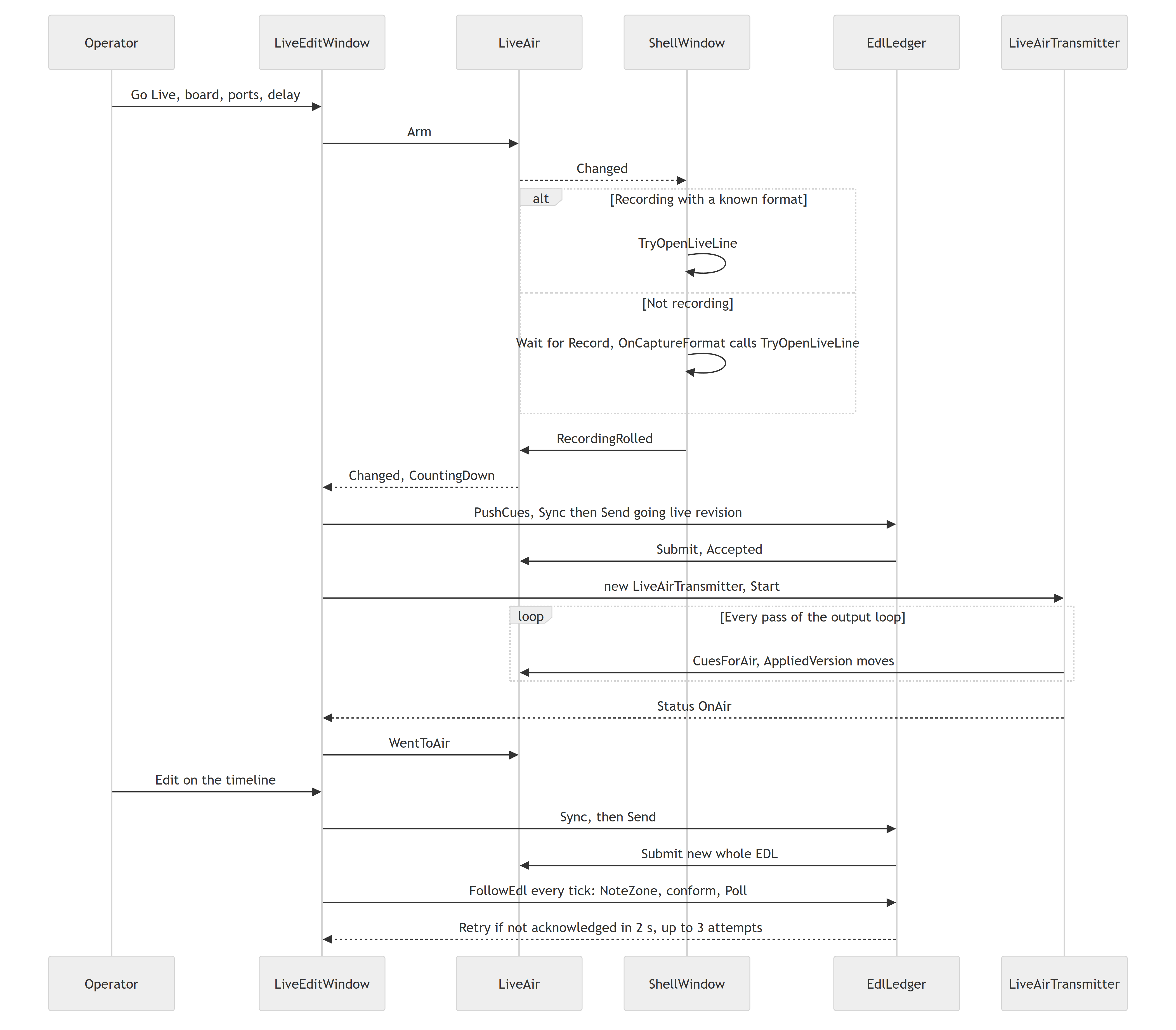
- Every edit that changes air calls PushCues (LiveEditWindow.Live.cs:273), which calls _edl.Sync and SendEdl. Cutting the sound with C does not, and neither does a day change, which leaves the ledger's selections in the old day's frames until the next push. SendEdl does nothing unless Live Air is active, so edits made before going live reach air only through the going-live send.
- A revision is the whole EDL with a rising version and a unique transaction ID. See the handshake.
- Accepted is not applied. AppliedVersion moves only when the transmitter reads the list.
- Conform: while on air or draining, when an edit's first frame reaches air plus 10 seconds and its last frame has not gone by, the EDL is sent as a CONFORM. Each revision of an edit is conformed once, even if refused. An Update sent while an edit is due also goes as a CONFORM.
- No edit zone: the UI refuses changes inside the next 10 seconds. LiveAir.Submit is the second guard (TooLate). A refusal shows "PLAYBACK REFUSED THE EDL", and air stays on the last accepted version, so the timeline can differ from air until the change is undone.
Going off air:
- By the operator: EndLive then LiveAir.Stop.
- Recording stopped: state Draining, from OnAir or CountingDown. DelayPhase.Finished is meant to lead to LiveAir.Stop, but with a delay over about half a second the drain fault freezes the picture, and a recording stopped during the fill holds black. The operator then ends it with End Live.
- Failure: DelayPhase.Failed leads to LiveAir.Fail.
Overlays stay on the timeline after going off air.

Monitor and remote monitoring
- The strip redraws at 200 ms and on change, from PipelineState and TidalLock.
- The Activity tab queues ActivityLog.Line events and drains them every 25 ms, with filters by source, level, search text and correlation ID.
- The Transmitted tab folds today's log file plus new lines through TransmissionTally.
- The remote toggle (MonitorWindow.xaml.cs:433) starts a MonitorServer. If monitorApi is true the server starts when this window loads, not when the app starts, and stops when it closes.

Files and media
The recorder writes files directly. Nothing is copied or transcoded afterwards. Files are discovered by listing folders rather than through a database, except ingest jobs. See data and storage.

Error handling
The patterns, with a diagram, are in the architecture document.
Pattern | Example
Operator problem: a sentence | SetStatus(text, true) logs capture.problem
Engine problem: a status event, then a state change | DelayPhase.Failed then TidalLock.Fail
Real-time subscriber exception: swallowed | SdiCapture.cs:434
UI thread crash: logged, then process ends | App.xaml.cs:134

