6. Hardware integration
Line references are to commit dd8e4a7. No DELTACAST SDK headers are in this repository. Numeric values are as written in the code. SDK behaviour is marked "Not verified" unless the code states it, and nothing here was run on a card for this document.

Devices and SDK
Item | Detail | Evidence
Vendor SDK | DELTACAST VideoMaster | src/Emerald.Deltacast/VideoMasterHD.cs:13
Video library | VideoMasterHD.dll, installed in System32 by DELTACAST's own driver installer | installer/READ-ME-FIRST.txt
Audio library | VideoMasterHD_Audio.dll, used for two calls. Its install location: Not verified. install.bat checks only the video DLL. | src/Emerald.Deltacast/VideoMasterHD.cs:166
Binding | Plain DllImport by name, StdCall | src/Emerald.Deltacast/VideoMasterHD.cs:121
Bitness | x64 only. BadImageFormatException is translated to a sentence. | src/Emerald.Deltacast/BoardService.cs:34
Models named | DELTA-3G-elp-d 22, DELTA-3G-elp-h-22, DELTA-12G-elp-h-20 | src/Emerald.Deltacast/BoardInfo.cs:12, src/Emerald.Ingest/Services/IngestHardware.cs:63
Other tool | dCARE, DELTACAST's utility. It must be closed to free a receiver. | src/Emerald.Deltacast/RxLease.cs:14

Board types known to VideoMasterHD.BoardTypeName: 0 DELTA-hd, 5 Mixed interfaces, 6 DELTA-3G, 7 DELTA-key 3G, 8 DELTA-h4k, 10 DELTA-asi, 11 DELTA-ip, 12 DELTA-h4k2, 13 FLEX-dp, 14 FLEX-sdi, 15 DELTA-12G, 16 FLEX-hmi.
The readme says the DELTA-12G-elp-h 20 has 8 RX. The ingest simulator gives it 4 RX. Not verified which is right.

RX and TX workflow
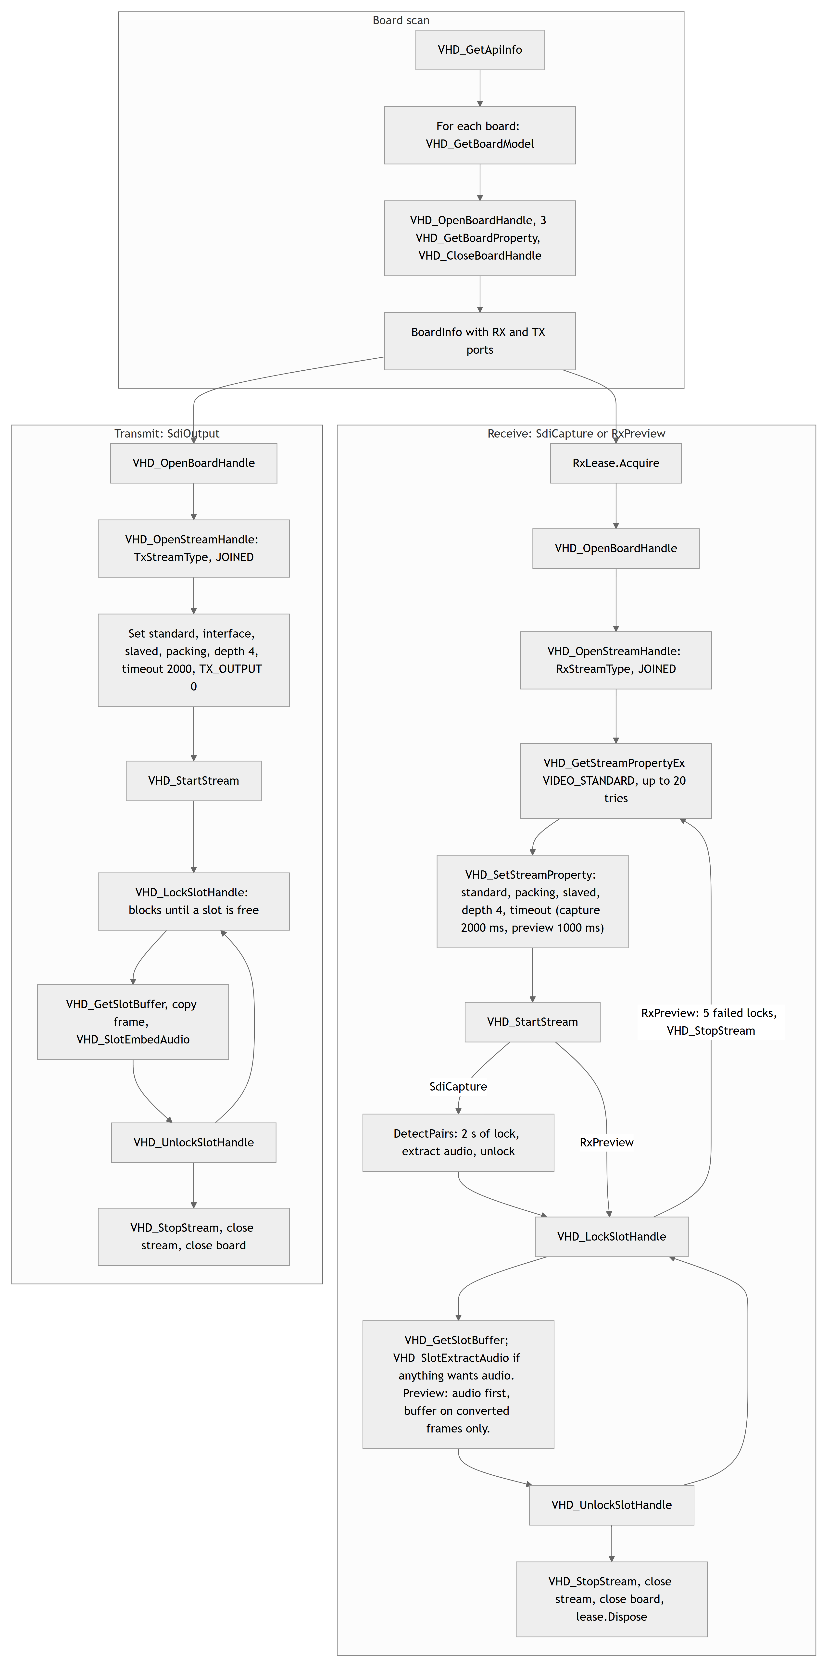

P/Invoke surface
src/Emerald.Deltacast/VideoMasterHD.cs:121-173. Only BoardService, SdiOutput, SdiCapture, RxPreview and SdiAudioReader call the SDK.
Import | Purpose, from how it's used | Callers
VHD_GetApiInfo | API version and board count | BoardService
VHD_GetBoardModel | Model string | GetBoardModelString
VHD_OpenBoardHandle, VHD_CloseBoardHandle | Open and close a board | BoardService, SdiOutput, SdiCapture, RxPreview
VHD_GetBoardProperty | Type and channel counts | BoardService
VHD_OpenStreamHandle, VHD_CloseStreamHandle | Open and close an RX or TX stream | SdiOutput, SdiCapture, RxPreview
VHD_SetStreamProperty | Configure a stream | SdiOutput, SdiCapture, RxPreview
VHD_GetStreamProperty | Slot counters | SdiOutput.SlotCounters, which has no callers
VHD_GetStreamPropertyEx | Signal and standard detection | SdiCapture, RxPreview
VHD_StartStream, VHD_StopStream | Run and stop | SdiOutput, SdiCapture, RxPreview
VHD_LockSlotHandle, VHD_UnlockSlotHandle | Take and return one frame slot | SdiOutput, SdiCapture, RxPreview
VHD_GetSlotBuffer | Video buffer of a slot | SdiOutput, SdiCapture, RxPreview
VHD_SlotEmbedAudio (audio DLL) | Embed audio into a TX slot | SdiOutput
VHD_SlotExtractAudio (audio DLL) | Extract audio from an RX slot | SdiAudioReader

Not imported: VHD_SetBoardProperty, any event-based API, direct ANC access.

Constants
Bases: EnumBaseCore = 0x01000000, EnumBaseSdi = 0x02000000 (src/Emerald.Deltacast/VideoMasterHD.cs:15-77).
Group | Values
Board properties | BOARD_TYPE Core+4, NB_RXCHANNELS Core+13, NB_TXCHANNELS Core+14
Stream properties | TRANSFER_SCHEME +2, IO_TIMEOUT +3, TX_OUTPUT +4, SLOTS_COUNT +5, SLOTS_DROPPED +6, BUFFERQUEUE_DEPTH +7, BUFFER_PACKING +10
SDI properties | VIDEO_STANDARD Sdi+1, INTERFACE Sdi+5
Processing | VHD_SDI_STPROC_JOINED Sdi+1 (always used), DISJOINED_VIDEO Sdi+2 (unused)
Audio | VHD_AM_OFF 0, VHD_AM_MONO 1, VHD_AF_16 1
Other | VHD_TRANSFER_SLAVED 1, VHD_BUFPACK_VIDEO_YUV422_8 0, VHD_SDI_BT_VIDEO 0
Errors | VHDERR_NOERROR 0. Code 18 is hard-coded as "channel in use".

Stream types are not contiguous, so they are a table:
Channel | 0 | 1 | 2 | 3 | 4 | 5 | 6 | 7 | 8 | 9 | 10 | 11
TX | 2 | 3 | 11 | 12 | 33 | 34 | 35 | 36 | 48 | 49 | 50 | 51
RX | 0 | 1 | 9 | 10 | 20 | 21 | 22 | 23 | 44 | 45 | 46 | 47

MaxChannels is 12. Channels past that throw ArgumentOutOfRangeException. The scan warns and filters them out of the port lists, so this is not normally reachable from the UI.

Device initialisation
BoardService.Scan (src/Emerald.Deltacast/BoardService.cs:18), with ScanAsync wrapping it in a task:
- VHD_GetApiInfo. A missing DLL, wrong bitness or SDK error becomes a sentence.
- Zero boards returns "No DELTACAST board detected on this system."
- For each board, read the model, open it, read 3 properties, close it. A board that cannot be opened stays listed with 0 RX and 0 TX, plus a warning.
There is no shared board handle. The scan, each SdiOutput, SdiCapture and RxPreview each open their own, so a fan of N ports holds N handles. All close in finally or Dispose, stream before board.

Receive
Used by SdiCapture.Run (thread SDI capture) and RxPreview.Run (thread RX preview).
Signal detection. Up to 20 calls of VHD_GetStreamPropertyEx(VIDEO_STANDARD, allowSignalDetection=1), 100 ms apart. Capture then fails with "no signal on RXn after 2s". Preview keeps trying and reports "No signal on RXn." once per dark period.
Only the standard is detected. The interface is never read on RX. There is no clock-divisor property, so 1080p30 and 29.97 cannot be told apart in this layer.
Standard | Name | Raster | Rate
0 | 1080p25 | 1920x1080 | 25
1 | 1080p30 | 1920x1080 | 30
2 | 1080i50 | 1920x1080 | 25, interlaced
3 | 1080i60 | 1920x1080 | 30, interlaced
4 | 720p50 | 1280x720 | 50
5 | 720p60 | 1280x720 | 60
6 | PAL | 720x576 | 25
7 | NTSC | 720x486 | 30
8 | 1080p24 | 1920x1080 | 24
9 | 1080p60 | 1920x1080 | 60
10 | 1080p50 | 1920x1080 | 50
other | standard n | 1920x1080 assumed | fallback

Table: CaptureFormat.FromStandard, src/Emerald.Video/SdiCapture.cs:1098. FrameBytes = W × H × 2.
Pixel format. UYVY: bytes U Y0 V Y1. UyvyPreview.ToBgra converts for display using BT.709 limited range. Defaults are half size and every frame up to 50 fps. Comments elsewhere saying 4:1 and twelve frames a second are out of date.
Preview signal loss. Five failed locks in a row mean signal lost. The worker stops the stream and detects again on the same handle, so a format change is picked up.
Capture signal loss is not reported once frames have arrived. See the assessment.
Relays and loopback. No bypass or relay code exists. The board's default relay state: Not verified.

Transmit
SdiOutput.Open (src/Emerald.Deltacast/SdiOutput.cs:37). Every step goes through Check(), which throws SdiOutputException("<call> failed (error n)."), and Open disposes on failure.
Output formats, src/Emerald.Deltacast/VideoFormat.cs:34. All are 1920x1080 at 4,147,200 bytes per frame.
Rate | Name | Standard | Interface | Samples per frame at 48 kHz
24 | 1080p24 | 8 | 2, HD-292 | 2000
30 | 1080p30 | 1 | 2, HD-292 | 1600
50 | 1080p50 | 10 | 4, 3G-A | 960
60 | 1080p60 | 9 | 4, 3G-A | 800
anything else | 1080p25 | 0 | 2, HD-292 | 1920

VideoFormat.ForFrameRate silently falls back to 1080p25. DelayFormats.TryMatch guards against that for raw delay.
Pacing. PushFrame (SdiOutput.cs:99) blocks in VHD_LockSlotHandle. A failure, usually the 2-second IO timeout per the code comment, returns false and no caller retries.
Pre-roll. There is no SDK-level pre-fill. VHD_StartStream runs before the first frame. Pre-roll exists only in the application: PlayoutService.WaitForCue and LiveAirTransmitter.PreRolled.
Genlock. Nothing configures it. "Every port is on the same board and therefore the same genlock" is an assertion in a comment (SdiOutputFan.cs:28), with no SDK property behind it in this repository. Effective clock reference: Not verified.
Black. BlackFrame (SdiOutput.cs:219) is U=128, Y=16, V=128, Y=16, cached.
Fan-out. SdiOutputFan (src/Emerald.Deltacast/SdiOutputFan.cs) implements ISdiOutput over several ports on one board. Open is all-or-nothing. PushFrame goes to each in turn and fails if any port fails.
Driver | Thread | Fan-out in use
PlayoutService | SDI playout | No: TxChannels is never set by a caller
DelayTransmitter | tidal lock TX, AboveNormal | Yes
LiveAirTransmitter | live edit TX, AboveNormal | Yes

Arbitration

RxLease: a real lock, per process
src/Emerald.Deltacast/RxLease.cs. A static table of (board, channel) to the current holder.
Holder | Claimant | Result
None | Any | Granted
Not yielding | Any | RxBusyException
Yielding | Yielding | RxBusyException
Yielding | Not yielding | Holder is displaced

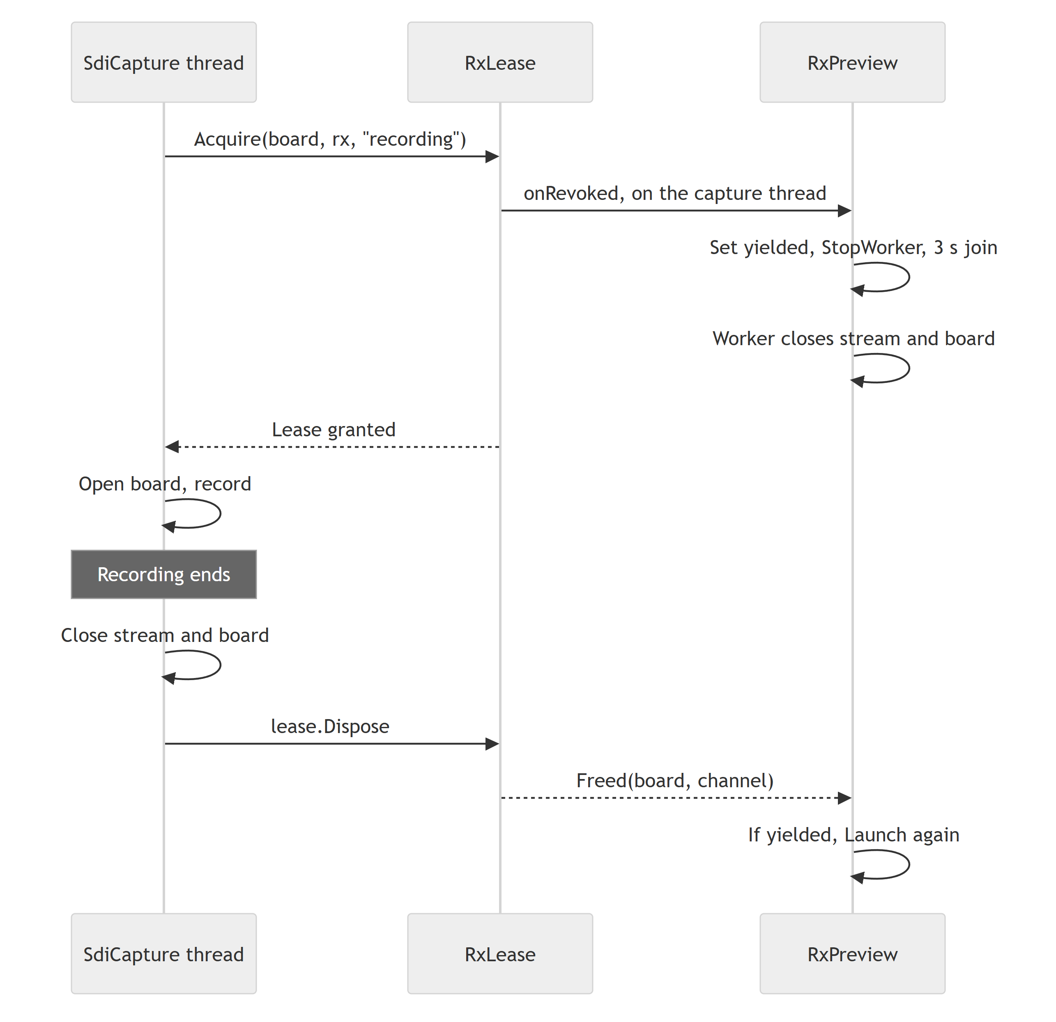
Other applications appear as SDK error 18. Across Emerald processes, the single-instance mutex is the guard.

SdiPorts: advisory, TX only
src/Emerald.Core/SdiPorts.cs. "A courtesy, not a lock": the driver is the authority.
Owners are EDL playout, tidal lock (board n) and live edit (board n). Only LiveAirTransmitter treats a failed hold as a refusal. PlaybackWindow and GoLiveDialog use it to grey out ports.

Port selection
There is no string parsing into an index. Single-port selectors are combo boxes bound to ChannelPort objects from BoardInfo. The playback deck uses TxPortRow toggles and Go Live uses check boxes. In every case .Index is passed down. Settings store names such as RX0 and TX0, with several TX names separated by |, restored by name match.

Audio on the wire
- 48 kHz, 16-bit API sample format, mono per channel. The SDI word length: Not verified.
- Up to 16 channels: 4 groups of 4, so 8 stereo pairs. Channel i maps to group i/4, channel i%4.
- VHD_AUDIOINFO is hand-built: 1600 bytes, 400 per group, channel array at offset 64, 80 per channel, with Mode at +0, Format at +4, DataSize at +68 and Data at +72. A code comment says this was verified against the SDK on a DELTA-3G.
TX embed (SdiOutput.EmbedAudio, SdiOutput.cs:155). PlayoutService puts each bed on channels i*2 and i*2+1. The delay and Live Edit transmitters send one stereo pair.
RX extract (SdiAudioReader). Unused channels return full zero buffers, so a pair counts as present only if a sample is non-zero. SdiCapture.DetectPairs watches for 2 seconds and takes the highest count, minimum 1. The count runs from the first pair and stops at the first silent one, so audio on pairs 1 and 3 with pair 2 empty records one pair. No caller passes audioPairs, so pairs are always auto-detected.
Known fault. On feeds with more than one pair, the delay paths treat multichannel audio as stereo. See the assessment.

Error handling by layer
Layer | Condition | Result
Scan | DLL missing | "VideoMasterHD.dll was not found. Install the DELTACAST VideoMaster driver."
Scan | Wrong bitness | "...could not be loaded. The application must run as 64-bit."
Scan | No board | "No DELTACAST board detected on this system."
Scan | Board will not open | Warning, board stays listed with 0 ports
RX open | Error 18 | Capture: "Capture: RXn is already open in another application - close dCARE and try again." Preview: "Preview: RXn is open in another application - close dCARE to see it here."
RX in-process | RxBusyException | Non-yielding holder: "RXn on board b is in use by owner." Yielding holder and claimant: "RXn on board b is already previewing in owner." Capture prefixes "Capture: ".
RX no signal | At start | Capture aborts; preview waits
RX signal lost | Running | Preview: "Signal lost on RXn." Capture: not reported. Tidal lock: at a delay of 0.5 s or less, fails after 10 s of no frames. At any longer delay, plays on for the buffered frames until lag falls half a second below target, then holds the last frame muted until stopped.
TX open | SDK failure | SdiOutputException naming the call. Error 18 is not translated on TX.
TX push | Returns false | Depends on the path: see the assessment

Stop timeouts: SdiCapture 2 s then 6 s, transmitters 5 s, preview 3 s. All abandon the thread on expiry.

Simulated hardware
Only the Ingest Controller has it.
- SimulateToggle chooses MockIngestHardware or DeltacastIngestHardware (src/Emerald.Ingest/Views/IngestControllerWindow.xaml.cs:187).
- MockIngestRecorder runs for at most 20 real seconds, compressing long jobs, and writes text placeholder files at the real paths.
- It cannot be toggled while a job is pending or recording.
There is no simulator for the capture deck, EDL, playback deck or Live Edit, and no fake ISdiOutput in production code.

