

Department of Information & Communication Technology

A lab report
On
Artificial Intelligence & Machine Learning Laboratory
The lab report is submitted for the partial requirement of course no. ICT-4202

Submitted by | Submitted to
Name: Md Elias Khan  Roll: 1918004  Reg: 1312  4th Year 2nd Semester  Session: 2019-2020 | Paresh Chandra Barman  Professor  Department of Information & Communication Technology  Islamic University, Bangladesh

Submission date: 22 July, 2025

INDEX
Experiment No | Experiment Name | Page No.
01 | Implementation the Traveling Salesman Problem (TSP) using Nearest Neighbor (Greedy) Algorithm | 3-5
02 | Calculating Information Gain using Entropy (with binary class example) | 6-8
03 | Implementation and Visualization of Decision Tree for Play Tennis Dataset | 9-11
04 | Implementation of K-Means Clustering Algorithm for Unsupervised Data Segmentation. | 12-16
05 | Designing a Single Layer Perceptron Network to Simulate AND, OR, and XOR Logic Gates | 17-19
06 | Classification of Six Input Patterns using a Single-Layer Perceptron. | 20-25
07 | Implementation of Network structure to classify L and I patterns . | 26-29

Experiment No: 01
Experiment Name: Implementation the Traveling Salesman Problem (TSP) using Nearest Neighbor (Greedy) Algorithm
Objectives:
- To understand the Traveling Salesman Problem as an optimization problem.
- To implement the Nearest Neighbor algorithm to solve TSP.
- To analyze the advantages and limitations of greedy methods in solving real-world problems like routing and scheduling.
Required Software:
- Programming Language: Python
- IDE: Jupyter Notebook / Google Colab / VS Code
- Libraries: (optional) matplotlib, numpy for visualization and matrix handling
Theory: The Traveling Salesman Problem (TSP) is a classic example of a combinatorial optimization problem. It deals with the following situation:
A salesman needs to visit a number of cities, starting from a home city, visiting each other city exactly once, and returning to the starting city. The goal is to find the shortest possible route.
TSP is not just an academic problem. It applies to:
- Delivery routing (e.g., food delivery, courier)
- Logistics and supply chain
- Microchip design
- DNA sequencing
- Robotics and drone path planning
TSP is an NP-Hard problem. That means, as the number of cities increases, the number of possible routes increases factorially:
- For n cities → Number of routes = (n - 1)!
- So brute force is not feasible for large n
Hence, heuristic and greedy algorithms are used to approximate a near-optimal solution.
Nearest Neighbor Algorithm (Greedy Approach):
This is a simple greedy algorithm that builds a tour by repeatedly choosing the nearest unvisited city.

Steps:
- Start from any random city (say city 0)
- Mark it as visited
- From the current city, go to the nearest unvisited city
- Repeat until all cities are visited
- Return to the starting city
Time Complexity: O(n²)
Source Code:
import numpy as np
# Distance matrix
dist_matrix = [
[0, 29, 20, 21],
[29, 0, 15, 17],
[20, 15, 0, 28],
[21, 17, 28, 0]
]
n = len(dist_matrix)
visited = [False] * n
path = []
total_cost = 0
current_city = 0
visited[current_city] = True
path.append(current_city)
for _ in range(n - 1):
nearest = None
min_dist = float('inf')
for city in range(n):
if not visited[city] and dist_matrix[current_city][city] < min_dist:
nearest = city
min_dist = dist_matrix[current_city][city]
visited[nearest] = True
path.append(nearest)
total_cost += min_dist
current_city = nearest

# Return to starting city
total_cost += dist_matrix[current_city][path[0]]
path.append(path[0])

print("Tour:", path)
print("Total Distance:", total_cost)

Output:
Tour: [0, 2, 1, 3, 0]
Total Distance: 73
Result and Discussion:
1. The Nearest Neighbor algorithm performs fast and gives a near-optimal result.
2. It is a good choice for small to medium-sized problems or where real-time decision-making is required.
3. For larger datasets where accuracy is more important than speed, brute force or advanced heuristics (like Genetic Algorithms or Dynamic Programming) should be considered.

Experiment No: 02
Experiment Name: Calculating Information Gain using Entropy (with binary class example)
Objectives:
- To understand the concept of Entropy and Information Gain in Decision Tree learning.
- To compute Information Gain of attributes using entropy.
- To implement Information Gain calculation using Python.
Required Tools:
- Programming Language: Python
- IDE: Jupyter Notebook / Google Colab / Any Python IDE
- Libraries: math, pandas (optional for tabular data)
Theory:
In Decision Tree Learning, Information Gain is used to select the most informative attribute to split the dataset. The idea is to reduce the impurity (entropy) in the resulting subsets.
- Entropy is a measure of uncertainty or impurity.
- Information Gain measures how much uncertainty is reduced by splitting the dataset based on an attribute.
Information Gain (IG)= Entropy(Parent)−Weighted Avg. Entropy(Children)
Formula for Entropy:
Let S be a dataset with two classes (Positive and Negative).
The entropy is calculated as:
Entropy(S)=−p+log2(p+)−p−log2(p−)
Where:
- p+​ = proportion of positive examples in set S
- p−​ = proportion of negative examples in set S
If all examples are of one class → entropy = 0 (pure node).
If examples are evenly split → entropy = 1 (maximum impurity).
Information Gain (IG) is a statistical measure used in decision tree algorithms (like ID3, C4.5, etc.) to determine which feature/attribute provides the most useful information about the class. It helps in selecting the attribute that best splits the dataset into distinct classes.
Information Gain Formula:
Let A be an attribute, then:
IG(S,A)=Entropy(S)−∑v∈Values(A)∣Sv∣∣S∣⋅Entropy(Sv)
Where:
- Values(A): Possible values of attribute A
- Sv​: Subset of S where attribute A has value v
- ∣Sv∣/∣S∣: Weighted proportion of subset

Source Code:
import math
# Helper function to compute entropy
def entropy(pos, neg):
total = pos + neg
if total == 0:
return 0
p_pos = pos / total if pos != 0 else 0
p_neg = neg / total if neg != 0 else 0
entropy_val = 0
if p_pos > 0:
entropy_val -= p_pos * math.log2(p_pos)
if p_neg > 0:
entropy_val -= p_neg * math.log2(p_neg)
return round(entropy_val, 4)
# Parent set: 14 positive, 16 negative
parent_entropy = entropy(14, 16)

# First child: 13 positive, 4 negative
entropy_child1 = entropy(13, 4)
# Second child: 1 positive, 12 negative
entropy_child2 = entropy(1, 12)
# Weighted average entropy
total = 30
weighted_entropy = ((17 / total) * entropy_child1) + ((13 / total) * entropy_child2)
# Information Gain
info_gain = parent_entropy - weighted_entropy

# Output
print(f"Parent Entropy: {parent_entropy}")
print(f"Child Entropy 1 (13+, 4-): {entropy_child1}")
print(f"Child Entropy 2 (1+, 12-): {entropy_child2}")
print(f"Weighted Child Entropy: {round(weighted_entropy, 4)}")
print(f"Information Gain: {round(info_gain, 4)}")

Output:
Parent Entropy: 0.9968
Child Entropy 1 (13+, 4-): 0.7871
Child Entropy 2 (1+, 12-): 0.3912
Weighted Child Entropy: 0.6155
Information Gain: 0.3813
Result and Discussion: The given population of 30 instances (14 positives, 16 negatives) is split into two groups based on an attribute:
- First subset (17 instances): 13 positive, 4 negative → entropy = 0.787
- Second subset (13 instances): 1 positive, 12 negative → entropy = 0.391
- Weighted entropy = (17/30)×0.787 + (13/30)×0.391 ≈ 0.615
Thus,
Information Gain=0.996−0.615=0.381\text{Information Gain} = 0.996 - 0.615 = 0.381Information Gain=0.996−0.615=0.381
This shows the attribute reduced uncertainty by 0.381 bits, so it is somewhat informative for classification.

Experiment No: 03
Experiment Name: Implementation and Visualization of Decision Tree for Play Tennis Dataset
Objectives:
- Understand how decision trees classify categorical data.
- Implement and visualize a decision tree using the Play Tennis dataset.
- Evaluate the performance of the decision tree model.
Required Software:
- Programming Language: Python
- IDE: Jupyter Notebook / Google Colab / Any Python IDE
- Libraries: math, pandas (optional for tabular data)
Theory: A decision tree is a supervised machine learning algorithm used for classification and regression. It builds a tree structure where each internal node represents a decision based on an attribute, each branch represents the outcome of that decision, and each leaf node represents a class label (Yes/No). The model recursively splits the dataset based on attributes that provide the highest information gain, making it intuitive and easy to interpret. However, decision trees can overfit if the tree becomes too deep, especially with small datasets.It has a hierarchical tree structure which consists of a root node, branches, internal nodes and leaf nodes. It works like a flowchart help to make decisions step by step where:
- Internal nodes represent attribute tests
- Branches represent attribute values
- Leaf nodes represent final decisions or predictions
Dataset (Play Tennis):
The dataset contains 14 samples with attributes: Outlook, Temperature, Humidity, Windy, and target Play (Yes/No).The decision tree classifies the target variable (Play: Yes/No) by partitioning data based on attributes with the highest information gain.
- Root node: Outlook
- Overcast → Always Play=Yes
- Sunny → Depends on Humidity
- Rain → Depends on Windy

Source Code:
#Step 1: Import libraries
import pandas as pd
from sklearn import preprocessing
from sklearn.tree import DecisionTreeClassifier, plot_tree
import matplotlib.pyplot as plt

#Step 2: Load dataset
data = pd.read_csv('E:/4th Year 2nd Semester\Machine Learning Lab\ML Lab Code\Exp-3\play_tennis.csv')

#Step 3: Encode categorical variables
le = preprocessing.LabelEncoder()
for column in data.columns:
if data[column].dtype == object:
data[column] = le.fit_transform(data[column])

#Step 4: Train decision tree
X = data.drop(['Play'], axis=1)
y = data['Play']
clf = DecisionTreeClassifier(criterion='entropy', random_state=0)
clf.fit(X, y)

#Step 5: Visualize
plt.figure(figsize=(12,8))
plot_tree(clf, feature_names=X.columns, class_names=['No', 'Yes'], filled=True)
plt.show()

#Step 6: Evaluate
accuracy = clf.score(X, y)
print(f"Training accuracy: {accuracy:.2f}")

Output: 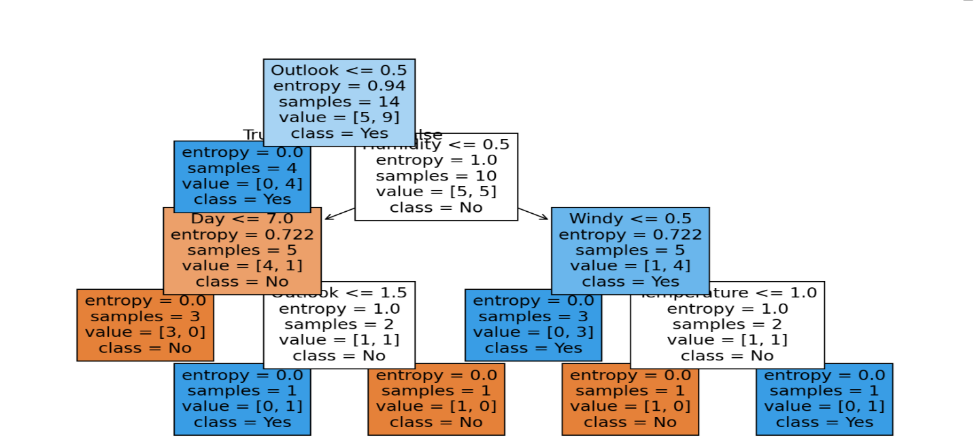
Result and Discussion:
- The decision tree splits data on attributes like Outlook, Humidity, and Windy.
- Achieved high accuracy on training data (~1.00).
- The tree shows clear and interpretable decision rules.
- Overfitting can occur on small datasets.
- Using pruning or setting a maximum depth can help avoid overfitting.

Experiment No: 04
Experiment Name: Implementation of K-Means Clustering Algorithm for Unsupervised Data Segmentation.
Objectives:
- To understand and implement the K-Means Clustering algorithm.
- To group a dataset into K distinct, non-overlapping clusters based on feature similarity.
Required Software:
- Language: Python
- Libraries: scikit-learn, matplotlib, numpy
- IDE: Visual studio
Theory: K-Means Clustering is an Unsupervised Machine Learning algorithm which groups unlabeled dataset into different clusters. It is used to organize data into groups based on their similarity. For example online store uses K-Means to group customers based on purchase frequency and spending creating segments like Budget Shoppers, Frequent Buyers and Big Spenders for personalised marketing.
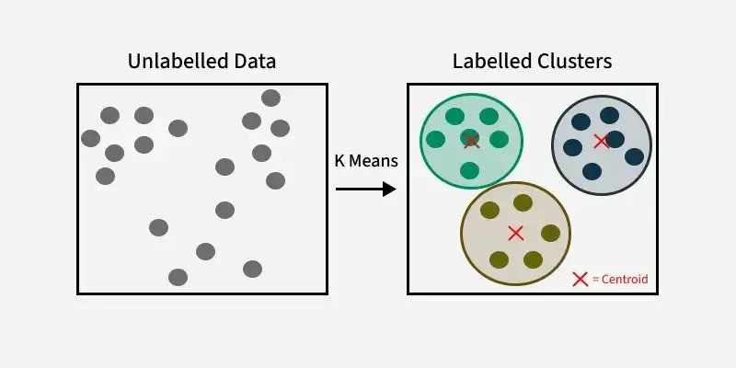
The algorithm works by first randomly picking some central points called centroids and each data point is then assigned to the closest centroid forming a cluster. After all the points are assigned to a cluster the centroids are updated by finding the average position of the points in each cluster. This process repeats until the centroids stop changing forming clusters. The goal of clustering is to divide the data points into clusters so that similar data points belong to same group. We are given a data set of items with certain features and values for these features like a vector. The task is to categorize those items into groups. To achieve this we will use the K-means algorithm. 'K' in the name of the algorithm represents the number of groups/clusters we want to classify our items into.
The algorithm will categorize the items into k groups or clusters of similarity. To calculate that similarity we will use the Euclidean distance as a measurement.

Euclidean Distance Formula:
D$\left(p,q\right)=\sqrt{{\left(p_{1}-q_{1}\right)}^{2}+{\left(p_{2}-q_{2}\right)}^{2}+{\left(p_{3}-q_{3}\right)}^{2}±…+{\left(p_{n}-q_{n}\right)}^{2}}$
Algorithm:
- Select number of clusters K.
- Initialize K centroids randomly.
- Assign each data point to the nearest centroid.
- Recompute centroids as the mean of assigned points.
- Repeat steps 3–4 until centroids don’t change.
Source Code:
import numpy as np
import pandas as pd
import matplotlib.pyplot as plt
from sklearn.preprocessing import MinMaxScaler
# -------------------------------
# 1. Load CSV and select features
# -------------------------------
df = pd.read_csv('E:/4th Year 2nd Semester\Machine Learning Lab\ML Lab Code\Exp-4\income.csv')
X = df[['Age', 'Income($)']].values
rows = X.shape[0]
# -------------------------------
# 2. Scale the data
# -------------------------------
scaler = MinMaxScaler()
X_scaled = scaler.fit_transform(X)
# -------------------------------
# 3. Initialize centroids (by row index)
# -------------------------------
centroids = [
X_scaled[5],
X_scaled[10],
X_scaled[15]
]
# -------------------------------
# 4. Assign dummy "true labels" based on income for evaluation
# -------------------------------
labels = np.array([
0 if income < 0.3 else 1 if income < 0.7 else 2
for _, income in X_scaled
])
# -------------------------------
# 5. K-Means Loop
# -------------------------------
max_iter = 90
for _ in range(max_iter):
clusters = {0: [], 1: [], 2: []}
class_labels = {0: [], 1: [], 2: []}

# Assign points to closest centroid
for i in range(rows):
point = X_scaled[i]
cl = labels[i]
distances = [np.linalg.norm(point - c) for c in centroids]
cluster_idx = np.argmin(distances)
clusters[cluster_idx].append(point)
class_labels[cluster_idx].append(cl)

# Update centroids
for i in range(3):
if clusters[i]:
centroids[i] = np.mean(clusters[i], axis=0)
# -------------------------------
# 6. Evaluation Function
# -------------------------------
def classify_correction(y):
counts = {val: y.count(val) for val in set(y)}
majority_class = max(counts, key=counts.get)
correct = counts[majority_class]
incorrect = len(y) - correct
return correct, incorrect, majority_class
# -------------------------------
# 7. Show Result
# -------------------------------
for i in range(3):
corr, incorr, cl = classify_correction(class_labels[i])
print(f"Cluster {i+1} → Correct: {corr}, Incorrect: {incorr}, Class: {cl}")
print("*" * 40)
# -------------------------------
# 8. Plot Clusters
# -------------------------------
plt.figure(figsize=(10, 6))
colors = ['green', 'red', 'blue']
for i in range(3):
cluster = np.array(clusters[i])
if len(cluster) > 0:
plt.scatter(cluster[:, 0], cluster[:, 1], color=colors[i], label=f'Cluster {i+1}')

for c in centroids:
plt.scatter(c[0], c[1], color='black', marker='x', s=200)

plt.xlabel('Age (scaled)')
plt.ylabel('Income ($, scaled)')
plt.title('Manual K-Means Clustering')
plt.legend()
plt.grid(True)
plt.show()

Output: 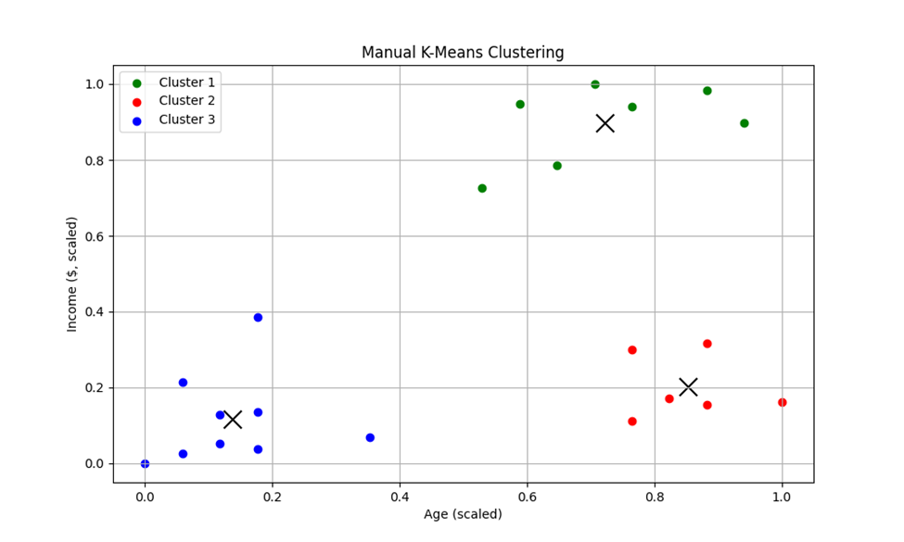
Result and Discussion: The K-Means algorithm successfully grouped the dataset into 3 clusters based on scaled Age and Income($). Each cluster mostly contained data points from a specific income range (low, medium, or high), showing good separation. The evaluation using label-based correction showed high accuracy within each cluster, with minimal misclassification. The final plot visually confirmed clear and distinct groupings. Overall, the manual K-Means implementation performed well on this dataset.

Experiment No:05
Experiment Name: Designing a Single Layer Perceptron Network to Simulate AND, OR, and XOR Logic Gates.
Objectives:
- To implement a single-layer perceptron (SLP) to solve simple Boolean operations (AND, OR, XOR).
- To observe the learning capability and limitations of SLP for linearly separable and non-separable functions.
Required Software:
- Python (with NumPy library)
- Any IDE or Code Editor (e.g., VS Code, Jupyter Notebook)
Theory
A Single Layer Perceptron is the most basic form of an artificial neural network (ANN) consisting of:
- One input layer
- One output neuron
- Weighted connections
- Activation function (Sigmoid, Sign, or Step)
The perceptron computes:
net = sum(w_i * x_i)
Then applies an activation function f(net) to produce output O.
The output is compared to the desired output O_d, and error is used to update weights.
Boolean Truth Tables
X1 | X2 | AND | X1 | X2 | OR | X1 | X2 | XOR
0 | 0 | 0 | 0 | 0 | 0 | 0 | 0 | 0
0 | 1 | 0 | 0 | 1 | 1 | 0 | 1 | 1
1 | 0 | 0 | 1 | 0 | 1 | 1 | 0 | 1
1 | 1 | 1 | 1 | 1 | 1 | 1 | 1 | 0
Algorithm
1. Input: X (4 samples with 2 inputs and 1 bias), O_d (desired output)
2. Initialize weight vector W randomly
3. Loop for each epoch:
- Compute net = sum(w_i * x_i)
- Output = f(net) using sigmoid
- Error = 0.5 * (O_d - O)^2
- Delta = η * (O_d - O) * O * (1 - O)
- Update W = W + delta * x'
4. Stop if error < ε or iteration = maxiter
Source Code:
import numpy as np
def sigmoid(x):
return 1 / (1 + np.exp(-x))
def sigmoid_derivative(x):
return x * (1 - x)
def train_perceptron(X, y, eta=0.1, epochs=10000):
X = np.insert(X, 0, -1, axis=1)
w = np.random.rand(X.shape[1])
for epoch in range(epochs):
for i in range(len(X)):
net = np.dot(w, X[i])
output = sigmoid(net)
error = y[i] - output
delta = eta * error * sigmoid_derivative(output)
w = w + delta * X[i]
return w

def test_perceptron(X, w):
X = np.insert(X, 0, -1, axis=1)
outputs = []
for i in range(len(X)):
net = np.dot(w, X[i])
output = sigmoid(net)
outputs.append(output)
return outputs
X = np.array([[0, 0],
[0, 1],
[1, 0],
[1, 1]])

targets = {
"AND": np.array([0, 0, 0, 1]),
"OR": np.array([0, 1, 1, 1]),
"XOR": np.array([0, 1, 1, 0])
}

for gate, y in targets.items():
print(f"\n{gate} Gate:")
w = train_perceptron(X, y, eta=0.5, epochs=10000)
outputs = test_perceptron(X, w)
print("Final Weights:", w)
for i, out in enumerate(outputs):
print(f"Input: {X[i]} → Output: {out:.4f} (Target: {y[i]})")
Output:
- Activation Function: Sigmoid (range: 0 to 1)
- Learning Rate η = 0.5
- AND and OR outputs converged
- XOR output stuck near 0.5 (failed to learn)
Sample Output after training:
- AND (1,1) → ~0.88 to 0.95
- OR (1,0) → ~0.93 to 0.99
- XOR (0,1) → ~0.5 (unchanged)
Result and Discussion:
The experiment demonstrated how a single-layer perceptron learns linearly separable functions like AND and OR, but fails for XOR, which is not linearly separable. This limitation shows the necessity of using multi-layer perceptrons for complex problems.
Experiment No:06
Experiment Name: Classification of Six Input Patterns using a Single-Layer Perceptron.
Objectives:
- To understand how a single-layer perceptron works for binary classification.
- To implement the perceptron learning algorithm for binary classification.
- To visualize the convergence of training error and the weight updates over epochs.
Required Software:
- Programming Language: Python
- IDE: Jupyter Notebook / Google Colab / VS Code
- Libraries: numpy, matplotlib
Theory:
The single-layer perceptron is the simplest form of an artificial neural network, introduced by Frank Rosenblatt in 1957. It is used for binary classification tasks where data is linearly separable.
A perceptron consists of:
- Inputs (features): numerical values describing the data.
- Weights: each input is multiplied by a weight, which represents its importance.
- Bias: a special input (usually fixed at -1 or 1) with its own weight, allowing the decision boundary of shift.
- Activation Function: the sum of the weighted inputs (called the net input) is passed through a function that decides the output.
In this experiment, we take six input data patterns and classify them into two classes: Class 1 and Class 2. The patterns belonging to Class 1 are assigned an output of 1, while the patterns belonging to Class 2 are assigned an output of 0. The perceptron learns to separate these two classes by adjusting its weights during training.
Mathematical Model:
- For each input pattern, the perceptron computes:
Net = w1.​x1 ​+ w2​.x2​ + w3.​x3 ​+ w0​⋅(bias)
- The output is determined by the discrete unipolar activation function:
​ 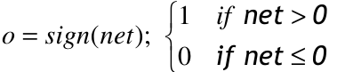
- calculate error = 0.5(o_{d} – o)²
- Find Delta = $\frac{1}{2}$c(o_{d} – o)
- update W = W + delta *x’
- check: if error <= ε or iteration >=maxiter go to end else go to loop.

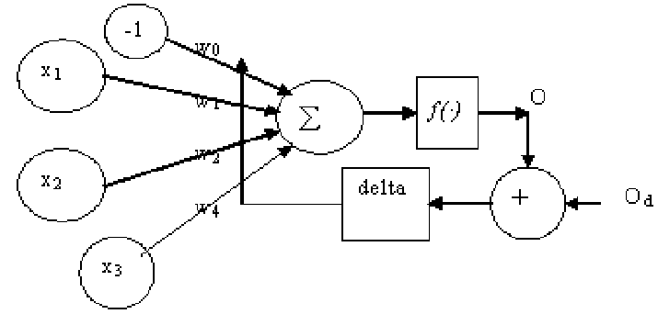

Source code:

import numpy as np
import matplotlib.pyplot as plt
# Parameters
init_weight_scale = 0.001
C = 1

# Input matrix: 6 samples, 3 features + bias
x = np.array([[0.8, 0.9, 1.0, 0.0, 0.2, 0.2],
[0.5, 0.7, 0.8, 0.2, 0.1, 0.7],
[0.0, 0.3, 0.5, 0.3, 1.3, 0.8],
[-1, -1, -1, -1, -1, -1]])

# Target outputs
da = np.array([1, 1, 1, 0, 0, 0])

# Initialize weights
W = np.zeros(4)
WW = [W.copy()] # To track weight changes

niter = 10
nSample = x.shape[1]
error_history = []

print('epoch error')

# Activation function: discrete unipolar
def signh(h):
return np.where(h > 0, 1, 0)

for i in range(niter):
h = W @ x
y = signh(h)
e = da - y

# Update weights
f_d = 0.5 * C * e
delta = f_d @ x.T
W = W + delta
WW.append(W.copy())

# Calculate error
error = np.sum(e**2) / nSample
error_history.append(error)

print(f'{i+1:4d} \t {error:.6f}')

WW = np.array(WW)

print('\nTraining Results')
print("Final Weights after 10 epochs:\n", W)
print('\nInput Patterns:')
print(x[:3].T)
print('\nPredicted Output:')
print(y)
print('\nError:')
print(e)

# Plot 1: Error over epochs
plt.figure(1)
plt.plot(range(1, niter+1), error_history, linewidth=2)
plt.xlim(1, niter)
plt.ylim(0, 0.5)
plt.title('Error Convergence Curve')
plt.xlabel('Epoch')
plt.ylabel('Mean Squared Error')

# Plot 2: Weight evolution
plt.figure(2)
iterations = range(1, niter+2)
plt.plot(iterations, WW[:, 3], '-^', label='w0 (bias)')
plt.plot(iterations, WW[:, 0], '-*', label='w1')
plt.plot(iterations, WW[:, 1], '-+', label='w2')
plt.plot(iterations, WW[:, 2], '-o', label='w3')
plt.xlim(1, niter+1)
plt.ylim(-2, 2)
plt.xlabel('Epoch')
plt.ylabel('Weight Value')
plt.title('Weight Updates per Epoch')
plt.legend()

plt.show()

Output:
epoch error
1 0.500000
2 0.500000
3 0.000000
4 0.000000
5 0.000000
6 0.000000
7 0.000000
8 0.000000
9 0.000000
10 0.000000

train result
Weights after 10 iterations:

[ 1.15 0.5 -0.8 0. ]

input
[[0.8 0.5 0. ]
[0.9 0.7 0.3]
[1. 0.8 0.5]
[0. 0.2 0.3]
[0.2 0.1 1.3]
[0.2 0.7 0.8]]
output
[1 1 1 0 0 0]

error
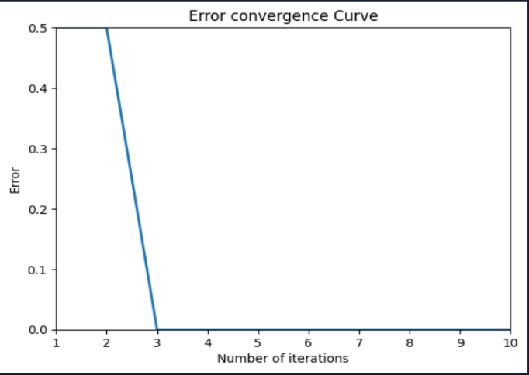
[0 0 0 0 0 0]
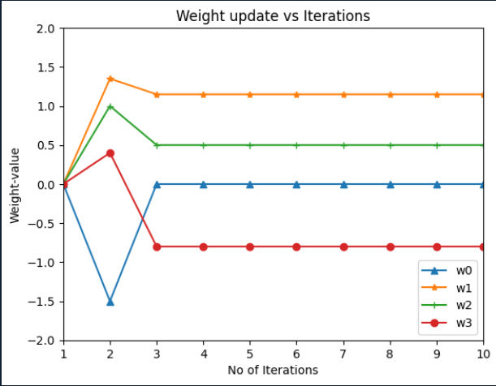
Result and Discussion:
After just a few repetitions, the singlelayer perceptron was able to accurately classify the six input patterns into two different groups with zero error.The learning rapidly stabilized, as indicated by the error convergence curve, demonstrating the data's linear separability.The weight update plot verifies that the weights change during the initial stages and then stay the same after the solution is identified.This experiment shows that a basic perceptron can learn distinct decision boud-aries, but it also shows that it is only effective for linearly separable situations.
Experiment No: 07
Experiment Name: Implementation of Network structure to classify L and I patterns.
Objectives:
- To understand how binary patterns can be classified using a simple neural network.
- To understand how binary patterns can be classified using a simple neural network.
- To analyze pattern classification using basic logical/matrix operations.
Required Software:
- Programming Language: Python
- IDE: Jupyter Notebook / Google Colab / VS Code
- Libraries: (optional) matplotlib, numpy for visualization and matrix handling

Theory:
Pattern recognition is a fundamental concept in machine learning and computer vision. In this experiment, we aim to classify two simple patterns: L and I, using a matrix-based rule system.
Each pattern will be represented in a 3x3 grid of binary values:
• 1 represents a filled pixel
• 0 represents an empty pixel
Example Patterns:
L Pattern:
1 0 0
1 0 0
1 1 1
I Pattern:
0 1 0
0 1 0
0 1 0
We will use basic rules to distinguish these patterns by counting specific pixel alignments.

Source Code:
import numpy as np
pattern_L = np.array([
1, 0, 0,
1, 0, 0,
1, 1, 1
])
pattern_I = np.array([
0, 1, 0,
0, 1, 0,
0, 1, 0
])

target_L = -1
target_I = 1

W = pattern_L * target_L + pattern_I * target_I
b = 0

def sign_with_threshold(x, thresh=1):
if x > thresh:
return 1
elif x < -thresh:
return -1
else:
return 0

def take_input():
print("Enter your 3x3 pattern row-wise (space separated 0 or 1):")
user_input = []
for i in range(3):
row = input(f"Row {i+1}: ").strip().split()
if len(row) != 3 or not all(x in ['0', '1'] for x in row):
print("Invalid input. Enter exactly 3 binary digits (0 or 1).")
return None
user_input.extend([int(x) for x in row])
return np.array(user_input)

def predict(X, threshold=1):
net_input = np.dot(W, X) + b
output = sign_with_threshold(net_input, threshold)
return output

def classify(output):
if output == -1:
return "Pattern matched as: L"
elif output == 1:
return "Pattern matched as: I"
else:
return "Pattern does not match L or I."

def main():
X = take_input()
if X is not None:
result = predict(X, threshold=1)
print("\nNetwork Output (O):", result)
print(classify(result))

if __name__ == "__main__":
main()

Input:
Enter your 3x3 pattern row-wise (space separated 0 or 1):
Row 1: 1 0 0
Row 2: 1 0 0
Row 3: 1 0 1

Output:
Network Output (O): -1
Pattern matched as: L

Result and Discussion:
The Hebbian rule-based pattern classifier correctly identified the known L and I patterns based on user input. For valid inputs like:
- 1 0 0 / 1 0 0 / 1 1 1 → Output: -1 → L
- 0 1 0 / 0 1 0 / 0 1 0 → Output: 1 → I
the model performed accurately.
However, for random or zero inputs like:
- 0 0 0 / 0 0 0 / 0 0 0 → Output: 0 → Pattern does not match
This shows that the added threshold logic improves the classifier by preventing misclassification of unrelated/noisy inputs.
Overall, the model is simple yet effective for distinguishing basic binary patterns. It mimics a single-layer perceptron and responds reliably when given clear or slightly distorted versions of L and I.

