Chimera
- Instructions to set background colour as white
Open Chimera
Select Tools > General Control > Command Line
- Instructions for rainbow depiction of a 3D structure
Select Tool > Depiction > Rainbow
Click Apply from the dialogue box
- Instructions for superposition of 3D structures and Match/Assess
Select File > open > select downloaded “pdb” file
Select File > Fetch by Id > enter the PDB ID of the structure to open
We now have both structures for superposition opened in our window.
To Supuerimpose
Select > Tools > Structure Comparison > Match Maker
From the resultant dialogue, in the reference structure column
Select native structure (example ‘3P49’)
In the “Structure to match” column
Select the predicted structure (pdb file) to match.
Click > Apply
From Tools > Structure Comparison > select Match -> Align
From resultant dialogue box, Select Structure > Assess Match
Click OK
From the resultant Dialogue box, Select Attribute > mavRMSDca
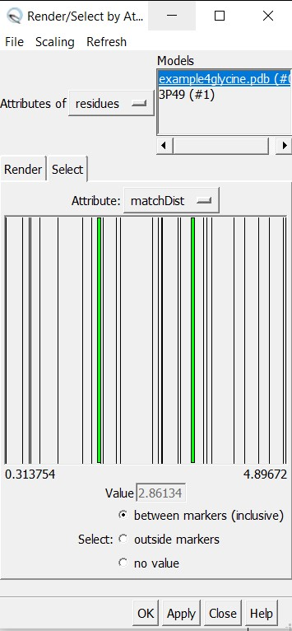
This window displays RMSD value of the residues. In this case, the RMSD values of residues of predicted structure lies between 0.313754 and 4.89672.

