**Task-2**

**Unit Title: Web and Mobile Applications**

Project Overview:

ByteForge is a software agency that specializes in web and mobile application development. The goal of the project is to create a website for ByteForge that showcases their services, portfolio, and contact information.

Client and User Requirements:

1. Homepage:

- Introduction to ByteForge.

- Overview of services offered.

- Call to action for potential clients to get in touch.

2. Services Page:

- Detailed descriptions of the services provided by ByteForge (e.g., web development, mobile app development, UI/UX design).

- Showcase past projects related to each service.

3. About Us Page:

- Information about the company, its mission, and values.

- Bios of key team members.

4. Contact Us Page:

- Contact form for potential clients to reach out.

- Contact information (email, phone number, address).

- Social media links.

5. Responsive Design:

- The website should be responsive and accessible on various devices.

**Design Wireframe:**

Here's a basic wireframe structure for the website:

1. Homepage:

- Header with logo, navigation links, and call to action button.

- Hero section with a brief introduction and image.

- Services section showcasing different services offered.

- About Us section with team member bios.

- Contact Us section with a contact form and information.

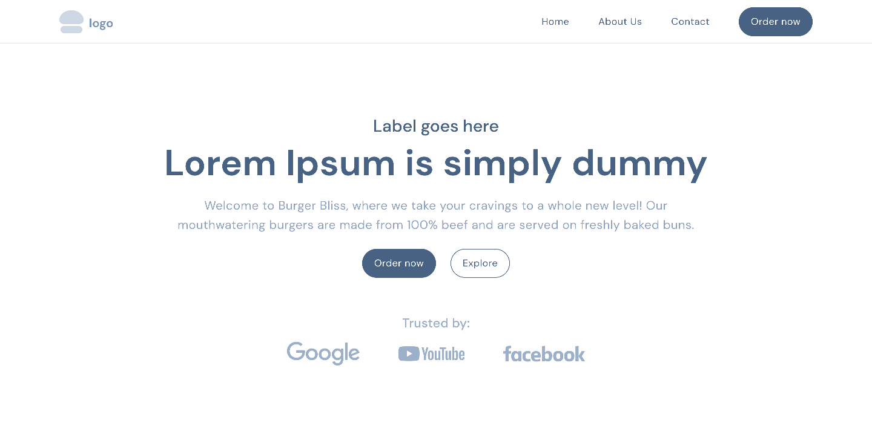

2. Services Page:

- Header and navigation.

- Section for each service with detailed descriptions and related projects.

3. About Us Page:

- Header and navigation.

- Company overview and mission statement.

- Team member bios in a card layout.



4. Contact Us Page:

- Header and navigation.

- Contact form.

- Contact information and social media links.

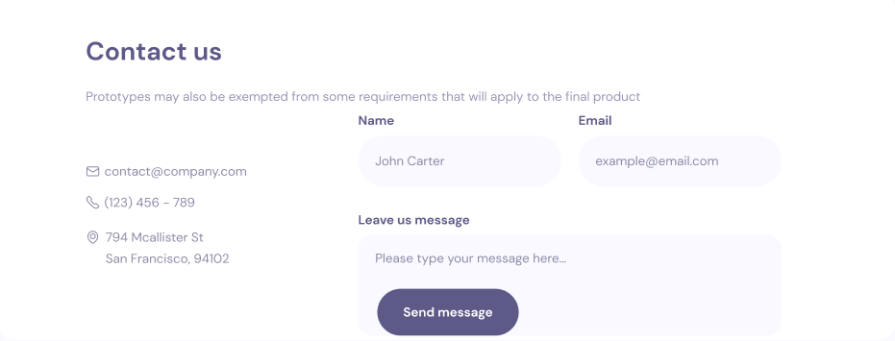

**Development:**

Develop the website using HTML, CSS, and JavaScript for the front-end. You can use a framework like Bootstrap for responsiveness and styling. For the back-end, you may use Node.js with Express.js or any other server-side technology of your choice.

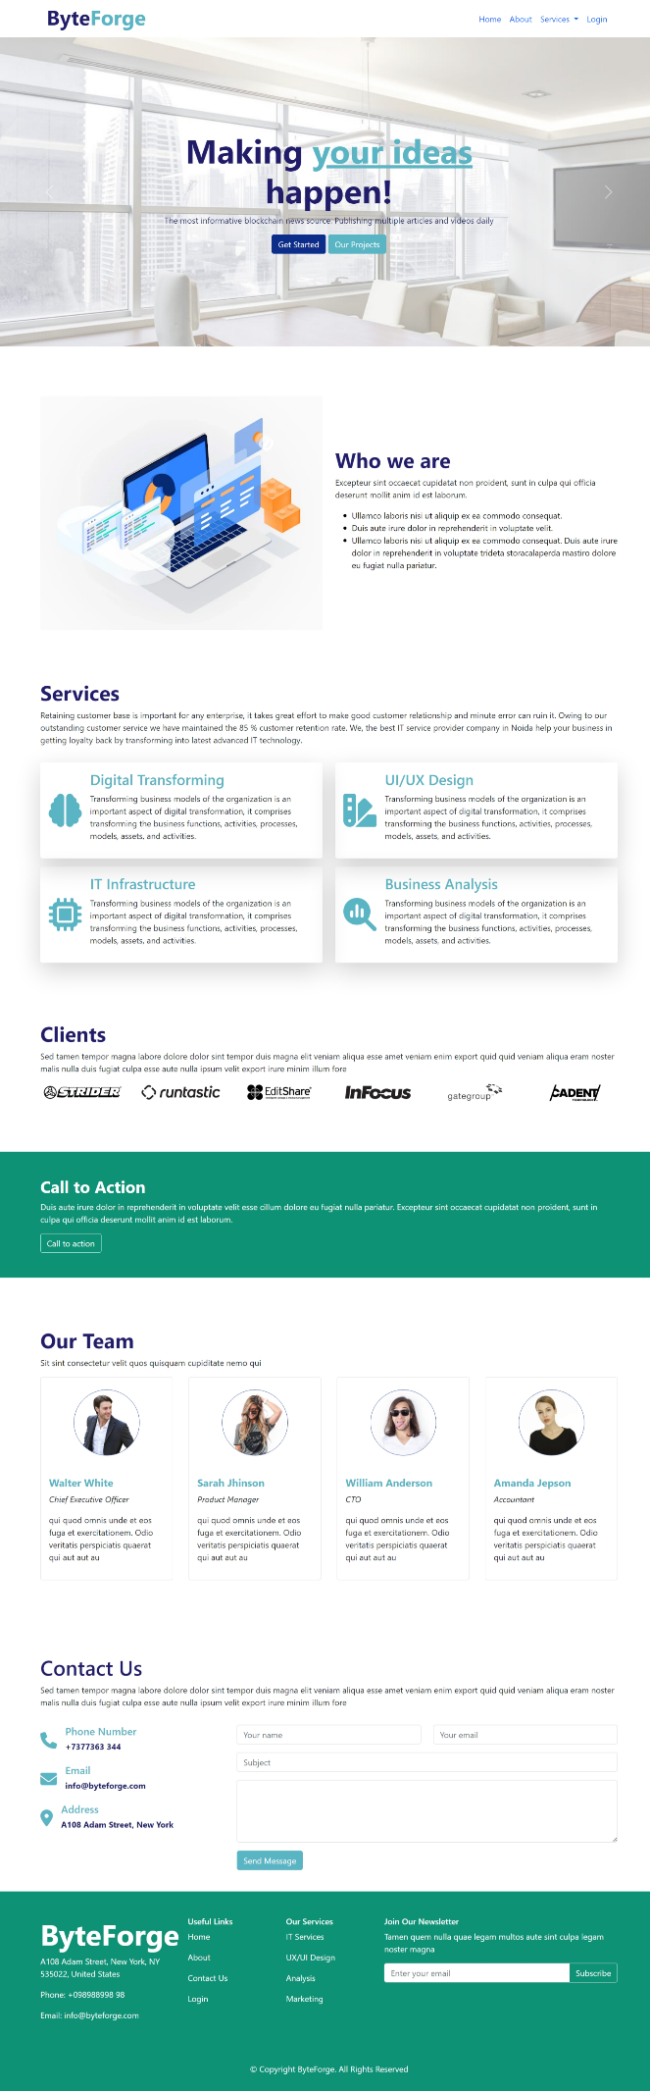

**Test Plan:**

1.Functionality Testing: Test all website features including navigation, contact form submission, and responsive design.

2.Compatibility Testing: Ensure the website works well on different browsers (Chrome, Firefox, Safari) and devices (desktop, tablet, mobile).

3.Performance Testing: Test the loading speed of pages and optimize images and code for better performance.

4.User Experience Testing: Gather feedback from users to ensure the website is intuitive and easy to navigate.

5.Security Testing: Check for vulnerabilities like XSS and CSRF and ensure data privacy for contact form submissions.

**Evaluation:**

Evaluate the success of the ByteForge website based on:

- Completion of client and user requirements.

- Performance and usability of the website.

- Feedback from user testing and any necessary improvements made based on it.

This framework should provide a solid foundation for developing and evaluating the ByteForge website. Make sure to adjust details and features according to specific project needs and client preferences.