Nguyễn Huỳnh Trí_1250080210
12DHCNTT4
1. SELECT * FROM NHANVIEN
WHERE TenNV = 'Huynh';
2. SELECT NV.MaNV, NV.HoNV, NV.TenNV, NV.DiaChi
FROM NHANVIEN NV
JOIN PHONGBAN PB ON NV.Phong = PB.MaPhong
WHERE PB.TenPhong = 'Hành Chính';
3. SELECT NV.MaNV, NV.HoNV, NV.TenNV, NV.DiaChi
FROM NHANVIEN NV
JOIN PHONGBAN PB ON NV.Phong = PB.MaPhong
WHERE PB.TenPhong IN ('Hành Chính', 'Tài Vụ');
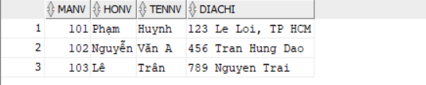
4. SELECT NV.MaNV, NV.HoNV, NV.TenNV, DA.TenDA
FROM NHANVIEN NV
JOIN PHANCONG PC ON NV.MaNV = PC.MaNV
JOIN DEAN DA ON PC.MaDA = DA.MaDA;
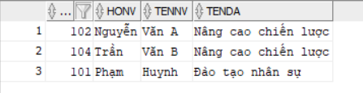
5. SELECT DA.MaDA, DA.TenDA, PB.TenPhong, PB.TruongPhong AS MaTruongPhong, TP.HoNV || ' ' || TP.TenNV AS TenTruongPhong
FROM DEAN DA
JOIN PHONGBAN PB ON DA.Phong = PB.MaPhong
JOIN NHANVIEN TP ON PB.TruongPhong = TP.MaNV;
6. SELECT NV.MaNV, NV.HoNV, NV.TenNV
FROM NHANVIEN NV
JOIN PHANCONG PC ON NV.MaNV = PC.MaNV
WHERE PC.MaDA = 1 AND PC.ThoiGian > 30;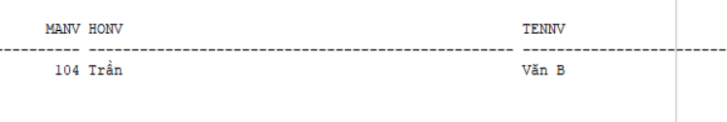
7. SELECT NV.MaNV, NV.HoNV, NV.TenNV
FROM NHANVIEN NV
JOIN NVIEN_TNHAN NVTN ON NV.MaNV = NVTN.MaNV
JOIN THANHNHAN TN ON NVTN.MaTN = TN.MaTN
WHERE NV.TenNV = TN.TenTN;
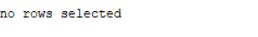
8. SELECT NV.MaNV, NV.HoNV, NV.TenNV
FROM NHANVIEN NV
JOIN PHONGBAN PB ON NV.Phong = PB.MaPhong
JOIN NHANVIEN TP ON PB.TruongPhong = TP.MaNV
WHERE TP.HoNV = 'Phạm' AND TP.TenNV = 'Huynh';
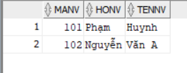
9. SELECT NV.MaNV, NV.HoNV, NV.TenNV
FROM NHANVIEN NV
JOIN NHANVIEN QL ON NV.MaNQL = QL.MaNV
WHERE QL.HoNV = 'Phạm' AND QL.TenNV = 'Huynh';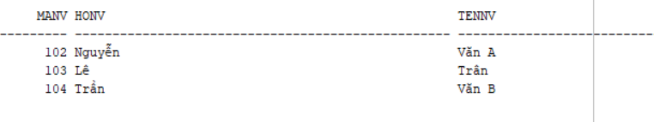
10. SELECT NV.MaNV, NV.HoNV, NV.TenNV
FROM NHANVIEN NV
JOIN PHANCONG PC ON NV.MaNV = PC.MaNV
GROUP BY NV.MaNV, NV.HoNV, NV.TenNV
HAVING COUNT(DISTINCT PC.MaDA) = (SELECT COUNT(*) FROM DEAN);
11. SELECT MaNV, HoNV, TenNV
FROM NHANVIEN
WHERE MaNV NOT IN (SELECT DISTINCT MaNV FROM PHANCONG);
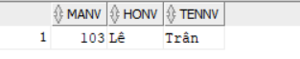
12. SELECT AVG(Luong) AS Luong_Trung_Binh
FROM NHANVIEN;
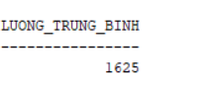
13. SELECT AVG(Luong) AS Luong_TB_Nam
FROM NHANVIEN
WHERE Phai = 'Nam';
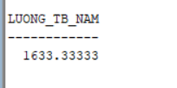
14. SELECT COUNT(*) AS Tong_So_De_An
FROM DEAN;
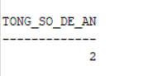
15. SELECT DA.MaDA, DA.TenDA, COUNT(PC.MaNV) AS So_Luong_NV
FROM DEAN DA
LEFT JOIN PHANCONG PC ON DA.MaDA = PC.MaDA
GROUP BY DA.MaDA, DA.TenDA;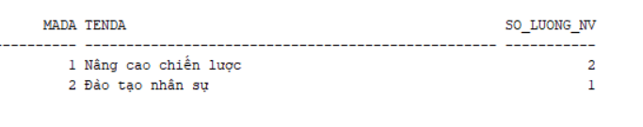
16. SELECT DA.MaDA, DA.TenDA, COUNT(PC.MaNV) AS So_Luong_NV_Nu
FROM DEAN DA
JOIN PHANCONG PC ON DA.MaDA = PC.MaDA
JOIN NHANVIEN NV ON PC.MaNV = NV.MaNV
WHERE NV.Phai = 'Nữ'
GROUP BY DA.MaDA, DA.TenDA;
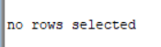
17.
UPDATE PHANCONG
SET ThoiGian = ThoiGian + 4
WHERE MaNV IN (
SELECT MaNV
FROM NHANVIEN
WHERE Phai = 'Nam'
);
18.
DELETE FROM NHANVIEN WHERE Luong < 500000;

