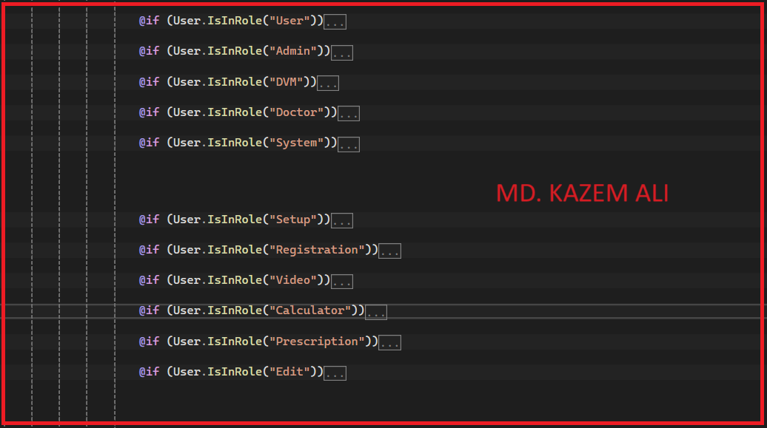

User

Admin

DVM

Doctor

System

Setup

Registration

Video

Calculator

Prescription

Edit