HR ATTRITION
ANALYSIS
Excel-Based Data Analysis Project Report

Project | HR Attrition Analysis
Prepared by | Mohammad Khubaib Abdullah
Tool used | Microsoft Excel
Workbook | HR_Attrition_Analysis.xlsx

1. Project Overview
This project analyses employee attrition using an HR dataset containing 6,000 employee records. The workbook was prepared in Microsoft Excel and includes data cleaning, helper columns, PivotTables, summary analysis, hypothesis tests, an interactive dashboard, retention recommendations and an illustrative replacement-cost estimate.

2. Project Objectives
- Measure the overall employee attrition rate.
- Compare attrition across departments, salary bands, job levels, business units, regions and education levels.
- Summarise the results using PivotTables and an interactive dashboard.
- Use statistical tests to check whether selected employee categories have a statistically significant association with attrition.
- Suggest practical areas for further HR investigation and estimate replacement cost under an explicitly stated assumption.

3. Dataset Description
The dataset contains 6,000 employee records. Fields include employee ID, hire date, department, business unit, region, role title, job family, job level, employment status, start and end dates, termination type, tenure, age band, education level, commute band, latest review score and outcome, review count and base salary.

4. Data Cleaning and Preparation
The workbook includes a Cleaning_Log sheet. The checks recorded in the workbook show no blank cells, no duplicate employee IDs and consistent employment-status values (active and terminated). Additional helper columns were created for numeric salary, salary band, tenure band, engagement index, active salary and terminated salary.
The engagement index is only a numeric proxy based on the latest review outcome; it is not a validated employee-engagement survey measure. The tenure-band helper column contains an inconsistency for one record (employee E000014), so tenure-band findings were excluded from the reported conclusions.
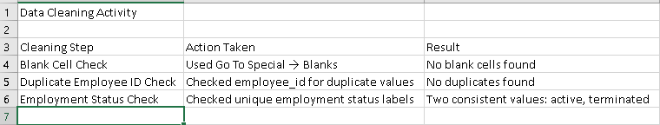
Figure 1. Data cleaning checks recorded in the Cleaning_Log sheet.

5. Analysis Methodology
- Calculated overall attrition as terminated employees divided by total employees.
- Used PivotTables to compare active and terminated employee counts and attrition rates across selected categories.
- Created an Excel dashboard with KPI cards, charts and slicers for interactive filtering.
- Performed four Chi-Square tests of independence for department, salary band, job level and business unit against employee attrition.
- Prepared a replacement-cost scenario using 50% of average base salary as an illustrative assumption.

6. Key Findings
Metric | Result | Interpretation
Total employees | 6,000 | Dataset size
Active employees | 4,975 | Employees currently active
Terminated employees | 1,025 | Employees marked terminated
Overall attrition rate | 17.08% | Terminated employees / total employees
Highest department attrition | 18.80% | Customer Success and Sales (tie)
Lowest department attrition | 14.80% | Legal & Compliance
Highest salary-band attrition | 18.13% | High salary band
Highest job-level attrition | 17.89% | Specialist
Highest business-unit attrition | 18.27% | Revenue
Highest region attrition | 17.28% | North America (NA)
Highest education-level attrition | 18.16% | High school
The department results show the highest attrition in Customer Success and Sales (18.80% each), while Legal & Compliance has the lowest rate (14.80%). The High salary band has an attrition rate of 18.13%, and the Revenue business unit has the highest business-unit rate at 18.27%. These are descriptive comparisons and do not establish that any category causes attrition.

7. Statistical Testing
Four Chi-Square tests were recorded. The null hypothesis for each test states that there is no statistically significant association between the selected category and employee attrition.
Comparison | P-value | Conclusion
Department vs Attrition | 0.85189 | Fail to reject H0
Salary Band vs Attrition | 0.42039 | Fail to reject H0
Job Level vs Attrition | 0.37735 | Fail to reject H0
Business Unit vs Attrition | 0.35703 | Fail to reject H0
All four p-values are greater than 0.05. Therefore, the tests do not show a statistically significant association at the 5% significance level. This does not prove that no relationship exists.
A separate active-versus-terminated salary t-test entry is included in the workbook. Its p-value was calculated using an approximate degrees-of-freedom approach after the direct Excel T.TEST formula returned an error. It should therefore be treated as an approximate result, not an exact Welch t-test.
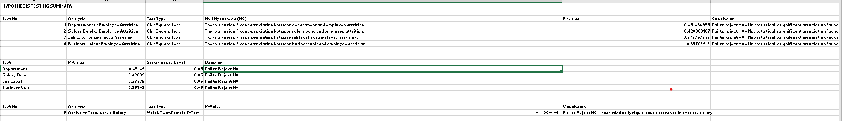
Figure 2. Hypothesis-testing summary and Chi-Square results.
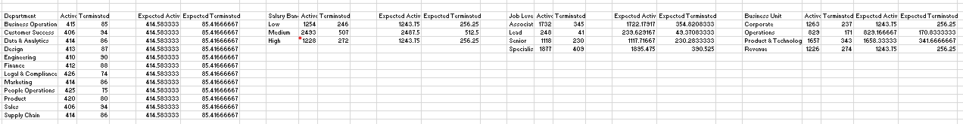
Figure 3. Additional hypothesis-test result recorded in the workbook.

8. Dashboard
The dashboard presents total employees, active employees, terminated employees and overall attrition rate. It includes charts for department, salary band, job level, business unit and region, along with slicers for department, salary band, job level and business unit.
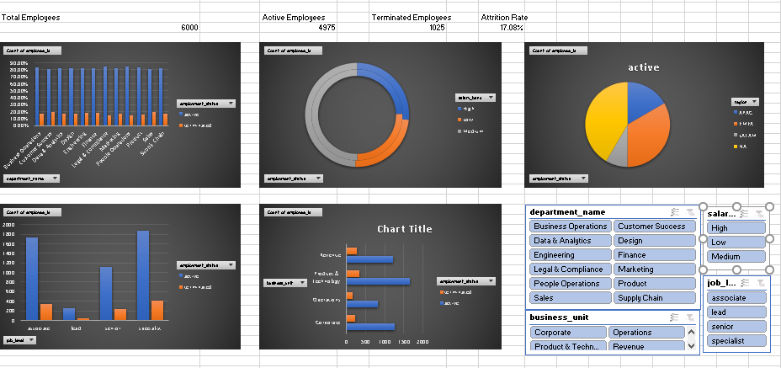
Figure 4. HR Attrition Analysis Dashboard.
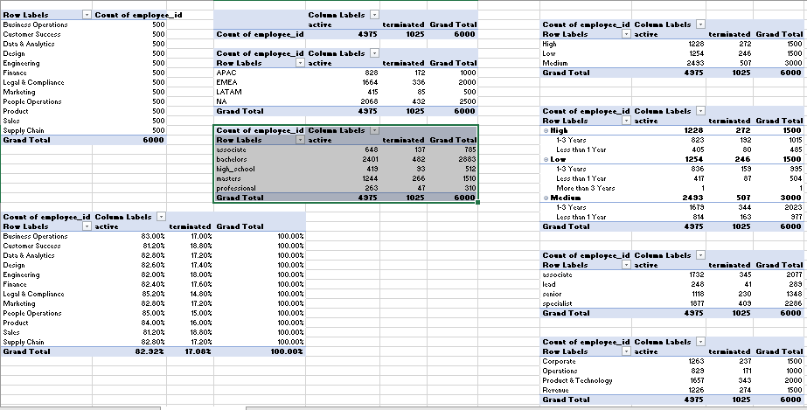
Figure 5. PivotTable analysis used to support the dashboard.

9. Retention Recommendations
- Review exit feedback and working conditions in Customer Success and Sales, which have the highest department attrition rates.
- Investigate career development, role clarity, workload and manager support across teams.
- Review compensation, benefits and recognition practices in the High salary band; the descriptive result alone does not show that salary causes attrition.
- Monitor attrition regularly by department, job level and business unit using a consistent dashboard.
- Evaluate retention initiatives over time using clearly defined measures and reliable employee feedback.
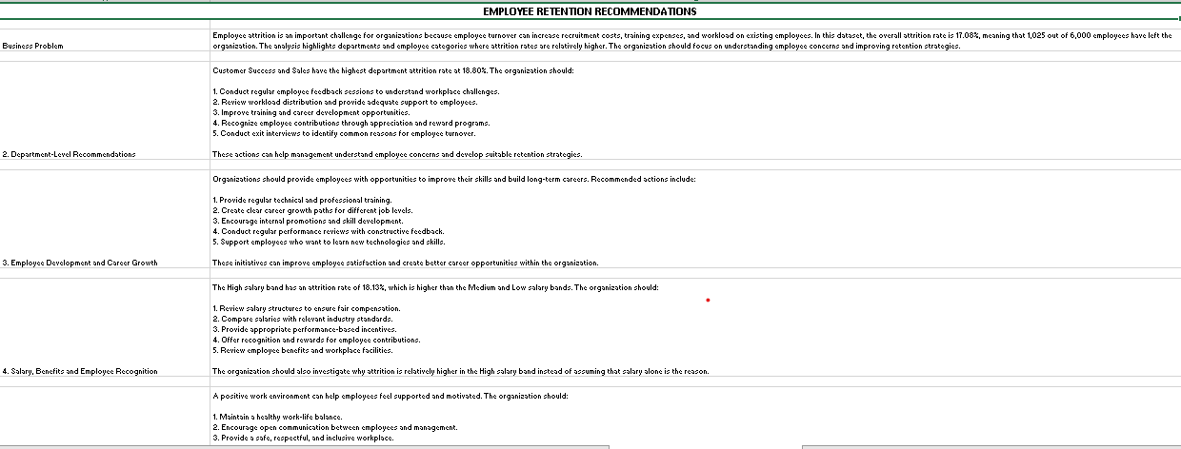
Figure 6. Retention recommendations – first section.
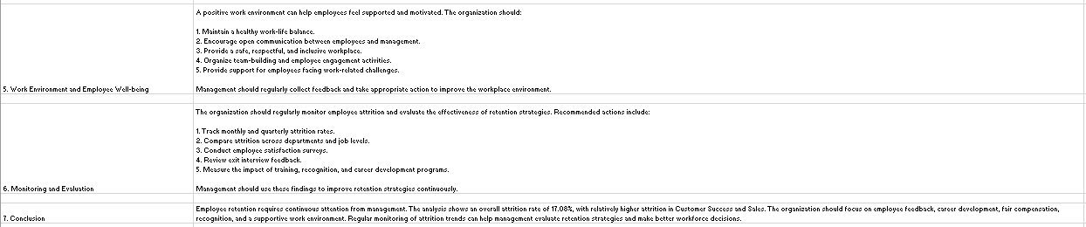
Figure 7. Retention recommendations – continuation.

10. Replacement-Cost Scenario
The Replacement_Cost sheet estimates a scenario in which replacement cost is assumed to be 50% of average base salary per terminated employee. This is an illustrative planning assumption because actual recruitment, onboarding, training and productivity costs were not supplied in the dataset.
The sensitivity table models potential cost savings if attrition were reduced by 2%, 5% or 10%. These values are scenario estimates, not guaranteed savings or observed financial outcomes.
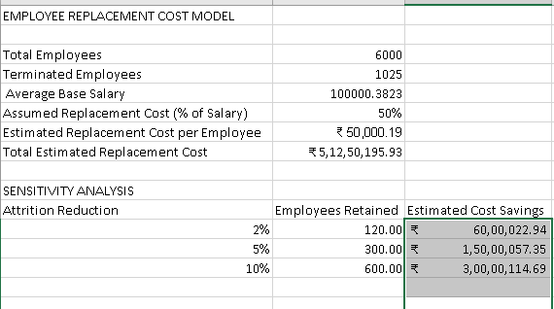
Figure 8. Illustrative replacement-cost and sensitivity analysis.

11. Limitations
- The dataset does not include manager information, overtime, promotion dates or a direct employee-engagement survey.
- The engagement index is derived from review outcomes and should not be interpreted as a validated engagement score.
- One tenure-band helper value requires correction; tenure-band conclusions were not used.
- The Chi-Square results indicate no statistically significant association in the tested categories at the 5% level, but do not prove the absence of relationships.
- The replacement-cost calculation depends on an assumed 50% salary factor and is not based on actual company cost records.
- The salary t-test result is approximate because the degrees of freedom used were approximate.

12. Conclusion
The analysis found an overall attrition rate of 17.08% among 6,000 employee records. Department and business-unit comparisons highlight areas that HR may investigate further. The dashboard and PivotTables provide a structured way to review the data, while the statistical tests and stated limitations help prevent over-interpreting descriptive differences. Further analysis using exit interviews, manager data, workload indicators and employee-engagement surveys could provide deeper insight.

13. Workbook Structure
- Raw_Data – original employee dataset and helper columns
- Cleaning_Log – data-quality checks
- Pivot_Tables – category-wise summaries
- Analysis_Summary – consolidated findings
- Hypothesis_Tests – statistical test results
- Dashboard – KPI cards, charts and slicers
- Documentation – project notes and methodology
- Retention_Recommendations – proposed HR actions
- Replacement_Cost – illustrative cost scenario

