Forecasting and Trend Analysis Using Advanced Excel Functions
Week 4 Assignment Report
Dataset: Shopping Trends
Student Name: ______________________________
Class / Roll Number: _________________________
Submission Date: ____________________________

1. Introduction
Forecasting and trend analysis help organisations understand historical performance and make informed decisions. Retail businesses may analyse purchase amounts to compare customer spending, identify differences between groups, and plan inventory or promotions. Microsoft Excel offers accessible functions for summarising data and building simple statistical models. Functions such as SUMIF, AVERAGEIF, COUNTIF, AVERAGE, SLOPE, INTERCEPT, RSQ and FORECAST.LINEAR allow students to practise core analytical techniques in a spreadsheet.
This assignment applies these functions to a Shopping Trends dataset. The analysis summarises purchase amounts by season, calculates a three-period moving average, and fits a basic linear regression using a numbered sequence for the four seasons. It also uses charts to present the results clearly. An important limitation must be stated at the start: the supplied dataset has a Season field but does not have a transaction date, month, or year field. Therefore, it does not provide a true chronological time series. Moving-average and regression results are exploratory demonstrations, not validated predictions of future sales.

2. Objectives
The objectives are to summarise total purchase amounts by season; calculate average purchase amounts and record counts; demonstrate a three-period moving average; calculate regression slope, intercept and R-squared; produce charts for comparison; and discuss the strengths and limitations of using Excel for forecasting. A further objective is to distinguish observed results from estimates so that the report does not present an illustrative model output as a confirmed business forecast.

3. Dataset Description
The dataset is named Shopping Trends. It contains customer and purchase-related variables, including Customer ID, Age, Gender, Item Purchased, Category, Purchase Amount (USD), Location, Size, Color, Season, Review Rating, Subscription Status, Payment Method, Shipping Type, Discount Applied, Promo Code Used, Previous Purchases, Preferred Payment Method and Frequency of Purchases. The relevant source columns for this analysis are Purchase Amount (USD), in column F, and Season, in column J of the Raw_Data worksheet.
The summary includes 3,900 records. The seasonal record counts are Spring 999, Summer 955, Fall 975 and Winter 971. These counts total 3,900. The seasonal purchase totals add to USD 233,081. The dataset is useful for describing differences among seasonal categories, but without dates it cannot show whether purchases increased from one month to the next, whether the same pattern repeated across years, or how sales changed over time.

4. Methodology and Excel Functions
A worksheet named Forecast Analysis was used to organise the calculations. The raw data was grouped using the season labels. SUMIF adds purchase amounts for rows whose Season value matches a selected label. AVERAGEIF calculates the average purchase amount for the matching records. COUNTIF counts how many records match each season. These formulas provide a repeatable summary that updates if the raw data changes.
The main formulas were:
• Total purchase amount: =SUMIF(Raw_Data!$J$2:$J$3901,A2,Raw_Data!$F$2:$F$3901)
• Average purchase amount: =IFERROR(AVERAGEIF(Raw_Data!$J$2:$J$3901,A2,Raw_Data!$F$2:$F$3901),0)
• Number of records: =COUNTIF(Raw_Data!$J$2:$J$3901,A2)
• Moving average: =AVERAGE(G2:G4) and =AVERAGE(G3:G5)
• Slope: =SLOPE(K2:K5,J2:J5)
• Intercept: =INTERCEPT(K2:K5,J2:J5)
• R-squared: =RSQ(K2:K5,J2:J5)
• Illustrative estimate at x = 5: =FORECAST.LINEAR(5,K2:K5,J2:J5)
The season order was represented by numbers 1 to 4: Spring = 1, Summer = 2, Fall = 3 and Winter = 4. This numeric coding was used only to practise regression. It should not be interpreted as actual elapsed time.

5. Seasonal Summary and Interpretation
The seasonal summary is shown in the table below. Fall has the highest total purchase amount, USD 60,018, and the highest average purchase amount, approximately USD 61.56. Summer has the lowest total, USD 55,777, and the lowest average, approximately USD 58.40. Spring totals USD 58,679 and Winter totals USD 58,607. The difference between the highest and lowest seasonal totals is USD 4,241.
The number of records is not exactly equal across seasons, so total purchase amounts should be considered alongside average purchase amounts. Fall remains highest on both measures in this dataset. Spring and Winter have similar totals, differing by only USD 72. These figures describe this dataset; they do not prove that the season caused the observed spending differences. Other variables, such as product category, discount use, customer composition or sampling choices, could also be associated with purchase amount. Figure 1 compares the total amounts visually and makes the relative size of each season easier to see.

6. Three-Period Moving Average
A moving average calculates the average of a group of neighbouring observations. It is commonly used with chronological data to reduce short-term variation and make a broader trend easier to see. In this exercise, the three-period averages calculated from adjacent seasonal totals are USD 58,158 for Spring, Summer and Fall, and approximately USD 58,134 for Summer, Fall and Winter. In the displayed table, these are associated with the middle positions Summer and Fall. A centred three-value window cannot be calculated for the first and last positions without changing the window placement or using a different convention.
The two moving-average values are very close, differing by about USD 24. This suggests that the averages of these two groups of three seasonal totals are similar. However, because the four observations are seasonal categories rather than dated sequential periods, the calculation is only an educational demonstration. It should not be used to claim that sales are stable over time or to predict future sales. Figure 2 displays the two calculated values.

7. Regression Analysis
A simple linear regression fits a straight line to the relationship between a numeric x variable and a y variable. In Excel, SLOPE calculates the line's slope, INTERCEPT calculates its intercept, and RSQ gives the coefficient of determination. The results from the worksheet were slope = 402.5, intercept = 57,264, and R-squared = 0.084807569, or about 8.48%.
The positive slope means that the fitted line increases by USD 402.50 for each one-unit increase in the assigned season order. The intercept is the line's mathematical value when x equals zero; it is not an observed seasonal purchase amount. The R-squared value is low: the linear model explains only about 8.5% of the variation among these four seasonal totals. This indicates that the straight line is not a strong description of the differences in the observations.
The model estimates for the four assigned season positions are Spring USD 57,666.5, Summer USD 58,069, Fall USD 58,471.5 and Winter USD 58,874. Extending the line to x = 5 gives USD 59,276.5. This is an extrapolated value generated by the mathematical line, not a reliable next-season forecast. The order of the seasons is categorical and does not represent a continuous timeline. Figure 3 compares the observed seasonal totals with the fitted estimates, but the chart should be interpreted as a demonstration of regression rather than a business prediction.

8. Simulation and Forecasting Considerations
A spreadsheet simulation explores how results respond to changes in inputs or assumptions. For this exercise, a simple classroom demonstration could vary the assumed season-order number and observe how the regression line produces different estimates. Any hypothetical values should be labelled clearly and kept separate from observed values. The available analysis does not include a validated probability model, repeated time periods, or a tested simulation design, so this report does not claim to have produced a statistically validated simulation.
A stronger forecasting workflow would start with data containing transaction dates or sales totals aggregated by day, week or month. The analyst would check missing dates, duplicate records and unusual values, plot the historical series, and divide the data into training and test periods in chronological order. A simple baseline forecast could then be compared with moving-average and regression methods. Forecast error metrics such as Mean Absolute Error (MAE) or Root Mean Squared Error (RMSE) would help determine whether the model predicts unseen periods accurately. If multiple years of dated data were available, recurring seasonal patterns could be investigated more credibly.

9. Strengths and Limitations
The main strength of this approach is accessibility. Excel functions are relatively easy to learn, reproduce and audit. The seasonal summary is understandable, and charts communicate differences quickly. The analysis also introduces important statistical ideas: averages describe typical values, moving averages smooth adjacent observations, and regression fits a line that can be evaluated using R-squared.
There are several important limitations. First, the dataset has no date, month or year field, so chronological trends cannot be measured. Second, regression is based on only four aggregated observations, which is too little information for a dependable forecasting model. Third, the R-squared value is low, meaning the fitted line explains little of the variation in the totals. Fourth, season order is arbitrary for a regression model; a different numeric order could change the fitted line. Fifth, the summary cannot prove causation or explain why seasonal differences occur. Finally, the moving-average values are exploratory calculations rather than validated time-series forecasts. These limitations should be included in any interpretation of the results.

10. Conclusion
This assignment demonstrated how advanced Excel functions can be used to summarise and explore a retail-style dataset. SUMIF, AVERAGEIF and COUNTIF were used to calculate seasonal totals, average purchase amounts and record counts. The results showed that Fall had the highest total purchase amount at USD 60,018 and the highest average at approximately USD 61.56. Summer had the lowest total at USD 55,777. The three-period moving averages were approximately USD 58,158 and USD 58,134 for the two middle positions.
The regression exercise produced a slope of 402.5, an intercept of 57,264 and an R-squared value of approximately 0.085. The fifth-position estimate of USD 59,276.5 is illustrative only. The central lesson is that Excel can make analysis accessible, but a forecast is only as reliable as the data structure and model behind it. To make a genuine future sales forecast, the dataset should include dates and sufficient historical observations, and the model should be evaluated against data that was not used to fit it.

Seasonal Summary Table
Season | Total Purchase Amount (USD) | Average Purchase Amount (USD) | Number of Records
Spring | 58,679 | 58.74 | 999
Summer | 55,777 | 58.41 | 955
Fall | 60,018 | 61.56 | 975
Winter | 58,607 | 60.36 | 971
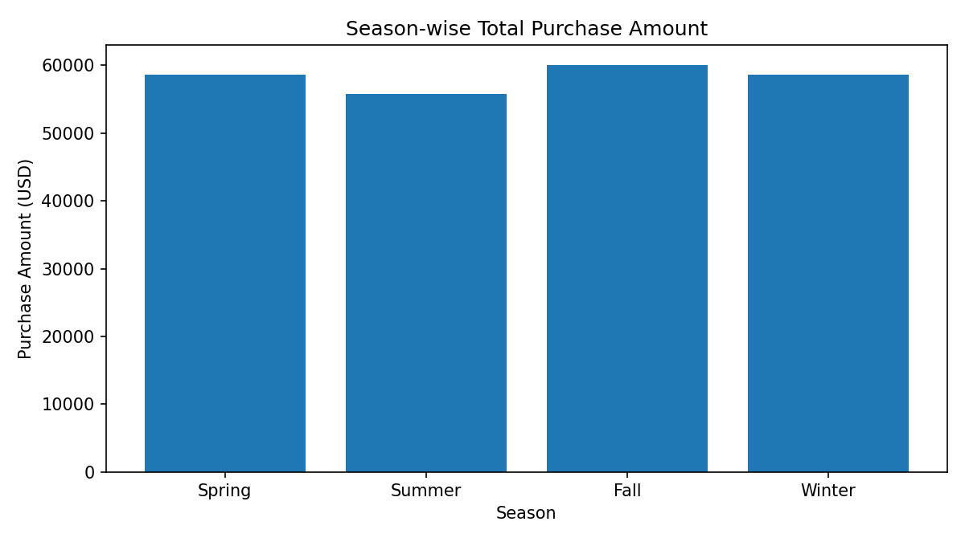
Figure 1. Total purchase amount by season.
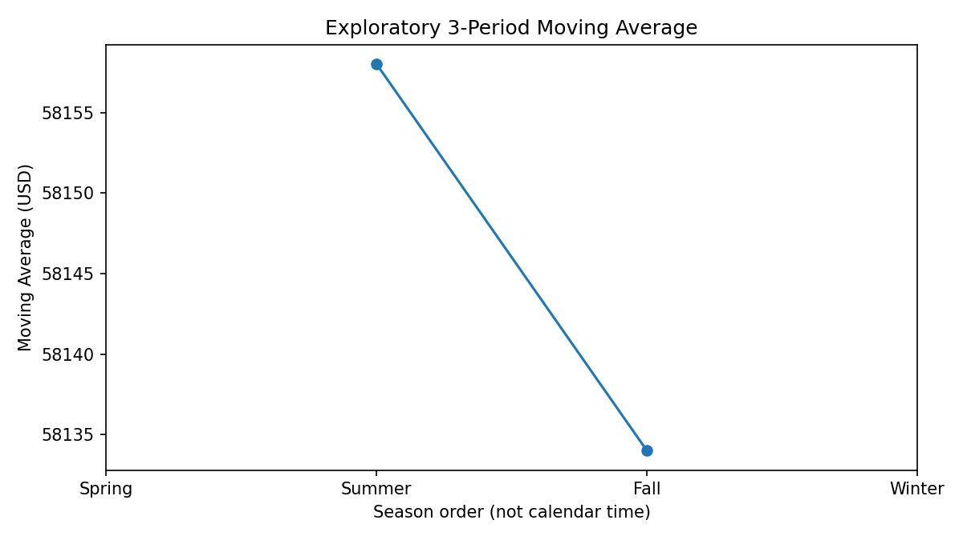
Figure 2. Exploratory three-period moving-average values.
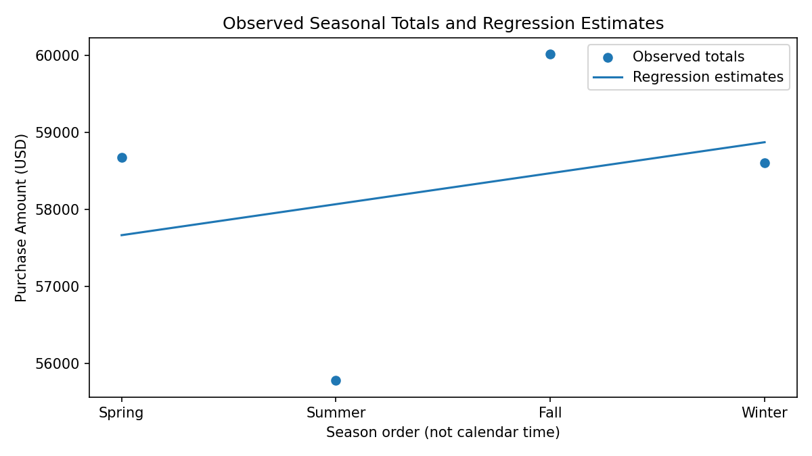
Figure 3. Observed seasonal totals and linear regression estimates.

Key Results at a Glance
- Total records: 3,900
- Total purchase amount: USD 233,081
- Highest seasonal total: Fall, USD 60,018
- Lowest seasonal total: Summer, USD 55,777
- Regression slope: 402.5
- Regression intercept: 57,264
- R-squared: 0.084807569
- Illustrative estimate at x = 5: USD 59,276.5

