WEEK 5
COMPREHENSIVE REPORTING
AND INSIGHT COMMUNICATION
Shopping Trends Analysis

Prepared by: ______________________________
Internship: Yuvaintern – Junior Data Analytics
Submission date: __________________________

Table of Contents
1. Executive Summary
2. Introduction and Objectives
3. Dataset Overview
4. Data Preparation and Quality Notes
5. Overall Performance Indicators
6. Product Category Analysis
7. Seasonal Performance Analysis
8. Dashboard and Pivot Table Interpretation
9. Forecasting and Trend Analysis
10. Business Implications
11. Recommendations and Next Steps
12. Limitations
13. Conclusion

1. Executive Summary
This report brings together the shopping-trends analysis prepared during the previous internship weeks. The purpose is to convert spreadsheet outputs into a clear business story for a reader who may not work with Excel every day. The supplied workbook screenshots show a dataset containing 3,900 customer records and a total Purchase Amount of 233,081. The source field is labelled “Purchase Amount (USD)”; therefore, this report treats the amount as USD when discussing the underlying dataset.
The category Pivot Table shows Clothing as the largest category by purchase amount at 104,264, followed by Accessories at 74,200, Footwear at 36,093 and Outerwear at 18,524. The seasonal summary shows Fall at 60,018, Spring at 58,679, Winter at 58,607 and Summer at 55,777. The overall average purchase amount is approximately 59.76, and the dashboard displays an average rating of 3.75.
The analysis suggests that Clothing and Accessories are the main contributors to recorded purchase value, while Fall is the strongest of the four displayed seasons. These findings can guide stock planning, merchandising and campaign timing. However, the seasonal differences are not large enough on their own to prove why customers purchase more in one season. The regression output also has a low R-squared value of about 0.0848, so its estimate should be treated as exploratory rather than a reliable forecast.
One presentation issue requires attention: the raw data heading specifies USD, but the dashboard and some forecast tables display the rupee symbol. The report preserves the original field definition and recommends standardising all workbook number formats before final stakeholder use.

2. Introduction and Objectives
Retail businesses collect information about products, customer preferences, purchase amounts, ratings, seasons, payment methods and delivery choices. Such data can help a business understand what customers buy and where management attention may be useful. The value of analysis is not only in calculating totals. It is also in explaining what those totals mean and connecting them to practical decisions.
The objective of this Week 5 report is to integrate the earlier Excel work into one organised narrative. It summarises the dataset, reviews the major sales indicators, interprets category and seasonal Pivot Tables, discusses the dashboard and forecasting output, and proposes realistic next steps. The report uses the screenshots supplied from the Week 4 workbook as its evidence. It does not claim that the observed patterns prove customer motivations or future outcomes.

3. Dataset Overview
The Raw_Data screenshot shows a tabular shopping dataset with 19 visible fields, including Customer ID, Age, Gender, Item Purchased, Category, Purchase Amount, Location, Size, Color, Season, Review Rating, Subscription Status, Payment Method, Shipping Type, Discount Applied, Promo Code, Previous Purchases, Preferred Payment Method and Frequency of Purchases. These fields provide several ways to examine shopping behaviour.
The workbook's dashboard and Pivot Tables report 3,900 records. Purchase Amount is the main numeric measure used in the sales summaries. Category and Season are grouping fields that allow the data to be summarised for comparisons. Rating provides a customer-feedback measure, while fields such as payment method, shipping type and subscription status could support further analysis in a later phase.
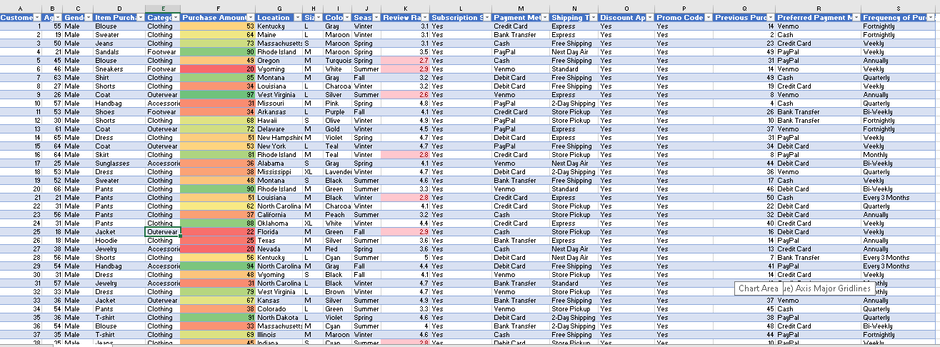
Figure 1. Raw shopping dataset preview showing customer, product, purchase and preference fields.

4. Data Preparation and Quality Notes
The earlier data-cleaning work was intended to prepare a consistent table for analysis. The supplied screenshots show structured column headings and records arranged in an Excel table. The Pivot Tables and dashboard use the same overall record count of 3,900, which provides a useful consistency check across the displayed summaries.
For a complete quality review, a business analyst should confirm that Customer ID values are not unintentionally duplicated, that important fields do not contain blanks, that Purchase Amount is stored as a numeric value, and that category and season labels use consistent spelling. The screenshots alone do not expose every validation step or every row, so this report does not claim to independently re-audit the entire workbook.
A visible formatting inconsistency should be corrected before the workbook is presented externally. The raw data column is labelled Purchase Amount (USD), while the dashboard KPI shows a rupee symbol and the seasonal summary screenshot also displays rupee formatting. A number format does not change the underlying value, but it can mislead readers about the currency. The recommended correction is to use USD formatting consistently, or to document a verified currency conversion if the figures have intentionally been converted.

5. Overall Performance Indicators
Indicator | Value shown in workbook | Interpretation
Total records / customers | 3,900 | The dashboard reports 3,900 records as Total Customers.
Total purchase amount | 233,081 | The source field is labelled USD; confirm consistent currency formatting.
Average purchase amount | 59.76 | Average purchase value across the 3,900 records.
Average rating | 3.75 / 5 | A moderate-to-positive average rating; investigate rating distribution for more detail.

The total purchase amount provides a high-level view of the value represented in the dataset. The average purchase amount adds context by showing the typical amount per record. The average rating gives a separate view of customer feedback. These measures should be read together: a high sales total does not automatically mean that every customer is satisfied, and an average rating does not explain the reasons behind the rating.
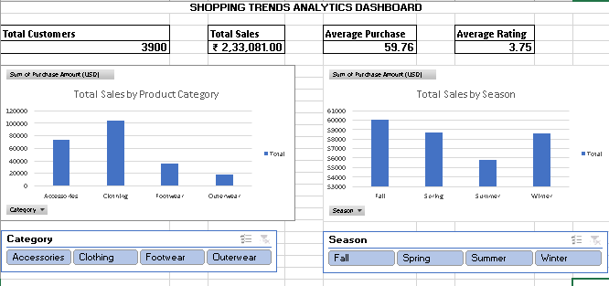
Figure 2. Shopping Trends Analytics Dashboard with headline KPIs, category and seasonal charts, and slicers.

6. Product Category Analysis
The category Pivot Table reports the following total purchase amounts: Accessories 74,200; Clothing 104,264; Footwear 36,093; and Outerwear 18,524. The grand total is 233,081. Clothing is the largest category, contributing approximately 44.7% of the total shown. Accessories contribute approximately 31.8%, Footwear approximately 15.5%, and Outerwear approximately 7.9%. Percentages are calculated from the displayed category totals and rounded.
Category | Purchase amount | Approx. share
Clothing | 104,264 | 44.7%
Accessories | 74,200 | 31.8%
Footwear | 36,093 | 15.5%
Outerwear | 18,524 | 7.9%
Grand Total | 233,081 | 100.0%

The result indicates that Clothing and Accessories together account for approximately 76.5% of the total purchase amount in this dataset. This concentration is useful for merchandising and inventory planning. A retailer may want to monitor availability and popular product variants in these categories. At the same time, the smaller totals for Footwear and Outerwear should not automatically lead to reduced investment: category size, profit margin, seasonality, stock availability and customer demand would need to be considered before changing budgets.
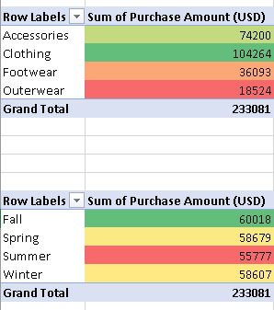
Figure 3. Category-wise Pivot Table showing purchase amount by product category.

7. Seasonal Performance Analysis
The seasonal Pivot Table reports Fall at 60,018, Spring at 58,679, Winter at 58,607 and Summer at 55,777, with a grand total of 233,081. Fall is the highest of the four seasons and Summer is the lowest. The difference between the highest and lowest seasonal totals is 4,241, which is approximately 7.6% of the Summer total.
Season | Total purchase amount | Average purchase amount | Number of customers
Fall | 60,018 | 61.56 | 975
Spring | 58,679 | 58.74 | 999
Winter | 58,607 | 60.36 | 971
Summer | 55,777 | 58.41 | 955

The average purchase amount is highest in Fall at 61.56 and lowest in Summer at 58.41. The customer counts shown are relatively close, ranging from 955 in Summer to 999 in Spring. This suggests that the seasonal difference in total purchase amount is not explained only by a very large difference in record count. Average purchase amount also varies by season.
The result can support planning, but it should be interpreted carefully. The dataset screenshot does not show dates or multiple years of history. It is therefore not possible to conclude from these totals alone that the same seasonal pattern will repeat every year, or to identify the cause of the differences. Promotions, product mix, regional factors and customer needs could all contribute, but these explanations require additional evidence.
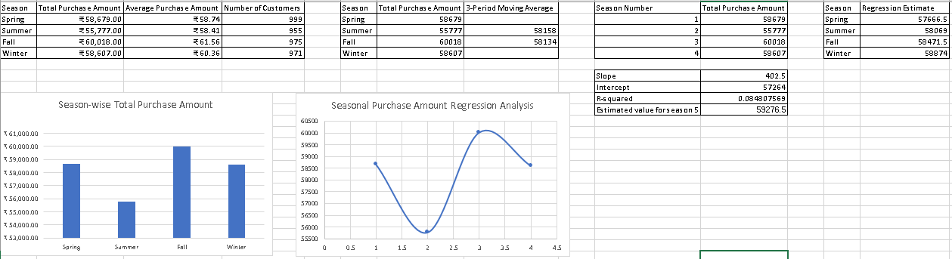
Figure 4. Seasonal purchase summary, moving-average values and regression analysis displayed in the Forecast Analysis sheet.

8. Dashboard and Pivot Table Interpretation
The dashboard combines headline KPIs with two charts: total sales by product category and total sales by season. It also includes Category and Season slicers. These controls are useful because they allow a reader to filter the view and explore a subset of the data without manually rebuilding the summary. For a stakeholder presentation, the dashboard should be checked to ensure that all slicers are connected to the intended Pivot Tables and charts.
The Pivot Tables provide the numerical detail behind the charts. The supplied Pivot Tables screenshot shows category totals and average purchase amounts, a location-based purchase amount summary, and a subscription count summary. The subscription summary shows 2,847 records marked No and 1,053 marked Yes, for a total of 3,900. This is a useful descriptive split, but the screenshot does not establish whether subscription status causes higher or lower spending.
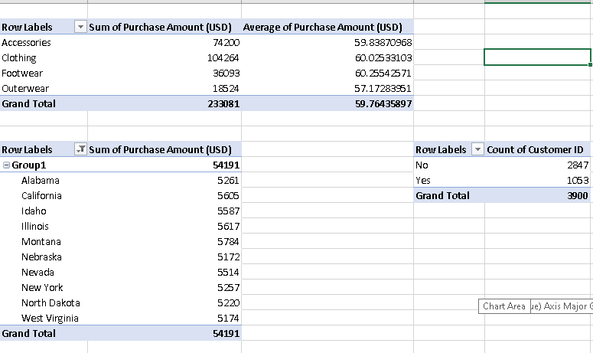
Figure 5. Pivot Tables showing category totals and averages, a location summary, and subscription counts.
A useful presentation practice is to place the visual first, then explain the key takeaway in one or two sentences. Captions should identify what is being measured, while the surrounding paragraph should explain why the finding matters. The dashboard and Pivot Tables should use matching currency formats, clear titles and readable labels.

9. Forecasting and Trend Analysis
The Forecast Analysis sheet contains a three-period moving-average column and a regression calculation based on season numbers 1 to 4. The displayed moving-average values are 58,158 for the Spring–Summer–Fall window and 58,134 for the Summer–Fall–Winter window. These values smooth some of the variation across adjacent seasonal totals and provide a simple summary of the overall level.
The regression output displays a slope of 402.5, an intercept of 57,264 and an R-squared value of approximately 0.0848. The estimated value for season number 5 is 59,276.5. The low R-squared value indicates that the straight-line model explains only a small proportion of the variation in the four seasonal observations. In addition, seasons are cyclical categories rather than a continuous time series. For these reasons, the season-5 estimate should be described as a simple exploratory calculation, not as a dependable forecast for the next year or business period.
A stronger forecasting approach would require dated observations across several years or months, consistent time intervals, and a model that accounts for seasonality and other relevant factors. Forecast accuracy should then be checked against data that was not used to build the model.

10. Business Implications
First, the large contribution from Clothing suggests that product availability in this category deserves close attention. Stock-outs in a leading category may affect a substantial part of recorded purchase value. Managers could review product-level demand, size availability and replenishment lead times before making inventory decisions.
Second, Accessories are also an important contributor. The business could examine whether accessories are frequently purchased with clothing or other products. If transaction-level or basket-level data is available, a product-bundle analysis could test whether cross-selling offers are appropriate. The current category totals alone do not prove that customers buy these items together.
Third, Fall has the highest seasonal purchase amount in the supplied summary. Marketing teams could review what products and campaigns were active during Fall and compare them with other seasons. The purpose would be to identify repeatable practices rather than assume that the season itself caused the higher amount.
Fourth, the average rating of 3.75 provides an opportunity for a deeper customer-experience review. The business should examine rating distributions and compare ratings by category, shipping type and discount use. This can help determine whether the average hides specific areas of dissatisfaction.
Finally, the subscription count shows more records marked No than Yes. This may justify exploring customer engagement and subscription communication, but any campaign should be based on customer consent and a measured test. The current screenshot does not show conversion rates or the spending difference between subscribers and non-subscribers.

11. Recommendations and Next Steps
- Prioritise Clothing availability. Review item-level sales, size demand and stock-outs in Clothing because it is the largest category by purchase amount. Use reorder points based on actual product demand and supplier lead times.
- Review Accessories cross-selling opportunities. Analyse transaction-level baskets to test whether accessories are commonly purchased with Clothing. Run a small, measurable pilot only if the data supports a bundle opportunity.
- Investigate Fall performance. Compare Fall campaigns, product mix, discounts and inventory with the other seasons. Repeat successful actions only after confirming what contributed to the result.
- Study customer ratings in more detail. Create rating distributions and category-wise or shipping-wise rating summaries. Focus service improvements on groups with consistently lower ratings.
- Evaluate subscription engagement. Compare average purchase amount and repeat-purchase behaviour for Yes and No subscription groups. Use permission-based communication and measure opt-in and conversion outcomes.
- Standardise currency and dashboard formatting. Use USD consistently because the raw purchase field is labelled USD. Confirm the underlying data and number formats before presenting totals to stakeholders.
- Improve forecasting evidence. Collect dated monthly or weekly sales over multiple years, then test an appropriate forecasting method and measure its error on a holdout period.

12. Limitations
This report is based on the screenshots supplied from the Excel workbook, not a complete independent audit of every row, formula, Pivot Table connection or source file. The screenshots support the totals and summaries quoted here, but they do not show every cleaning check or formula. The analysis is descriptive and does not establish cause and effect. Seasonal totals cover four season categories but do not provide a dated multi-year history. The regression model has a low R-squared value and uses a small number of seasonal observations, so its estimate is not suitable for confident operational forecasting. Currency formatting is inconsistent between the raw field label and some displayed visuals and should be corrected in the workbook.

13. Conclusion
The integrated shopping-trends analysis provides a useful starting point for business decisions. Across 3,900 records, the workbook reports a total purchase amount of 233,081 and an average purchase amount of approximately 59.76. Clothing and Accessories are the largest categories by purchase amount, and Fall is the strongest season in the displayed seasonal summary. The dashboard and Pivot Tables make these patterns easier to review, while the forecasting sheet provides an exploratory moving-average and regression view.
The most practical next step is to use these findings to guide further investigation rather than treat them as final answers. The business should validate currency formatting, review product-level demand, investigate the drivers of seasonal differences, examine customer ratings and subscription behaviour, and collect stronger time-based data for forecasting. Clear communication of both findings and limitations helps stakeholders make better-informed decisions.

Appendix: Screenshot Evidence
The following visuals were supplied from the Week 4 Excel workbook and incorporated as evidence in the report. Before submission, confirm that the screenshots are readable at normal zoom and that the workbook currency formatting has been corrected or explained.
Figure 1 – Raw dataset preview
Figure 2 – Analytics dashboard
Figure 3 – Category-wise Pivot Table
Figure 4 – Forecast Analysis
Figure 5 – Pivot Tables

