Lab - 4

Two Dimensional Arrays

**Task #1 Print Array to Console.**

**Task #2 Set All Elements in A Row to A Specified Value**

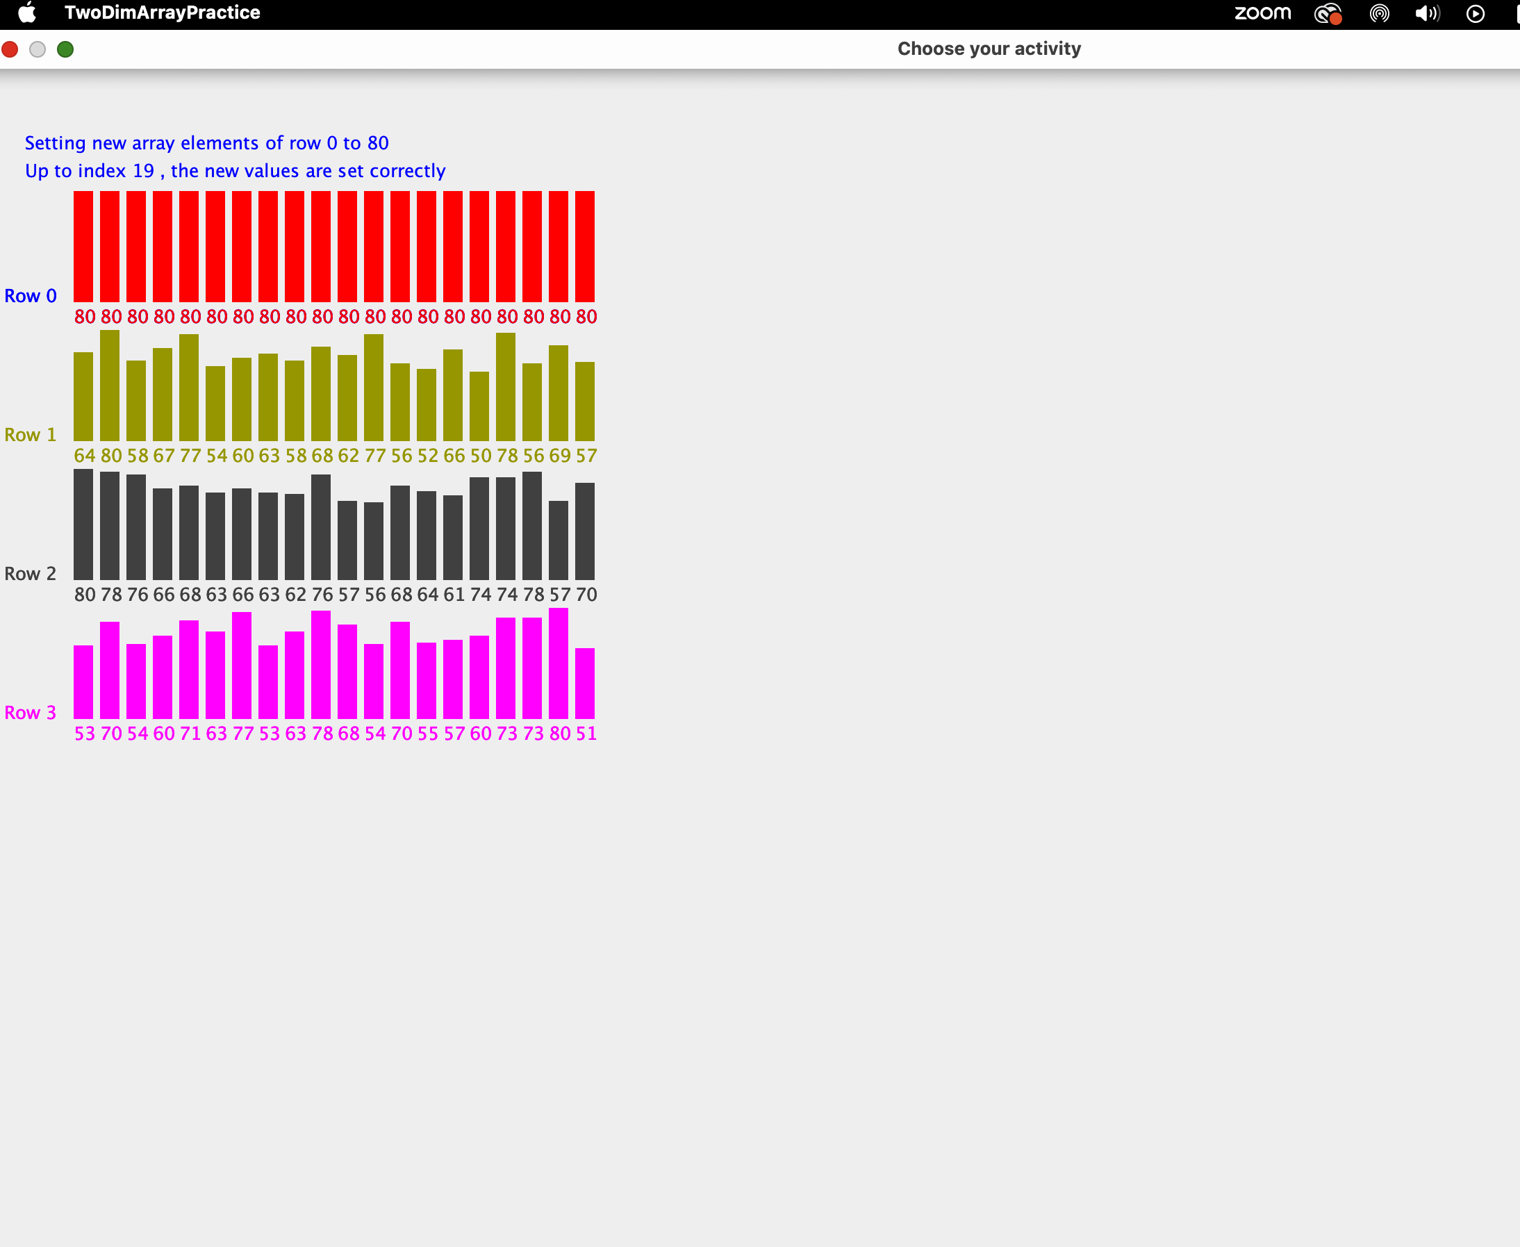

**Task #3 Find Minimum Value in the Specified Column**

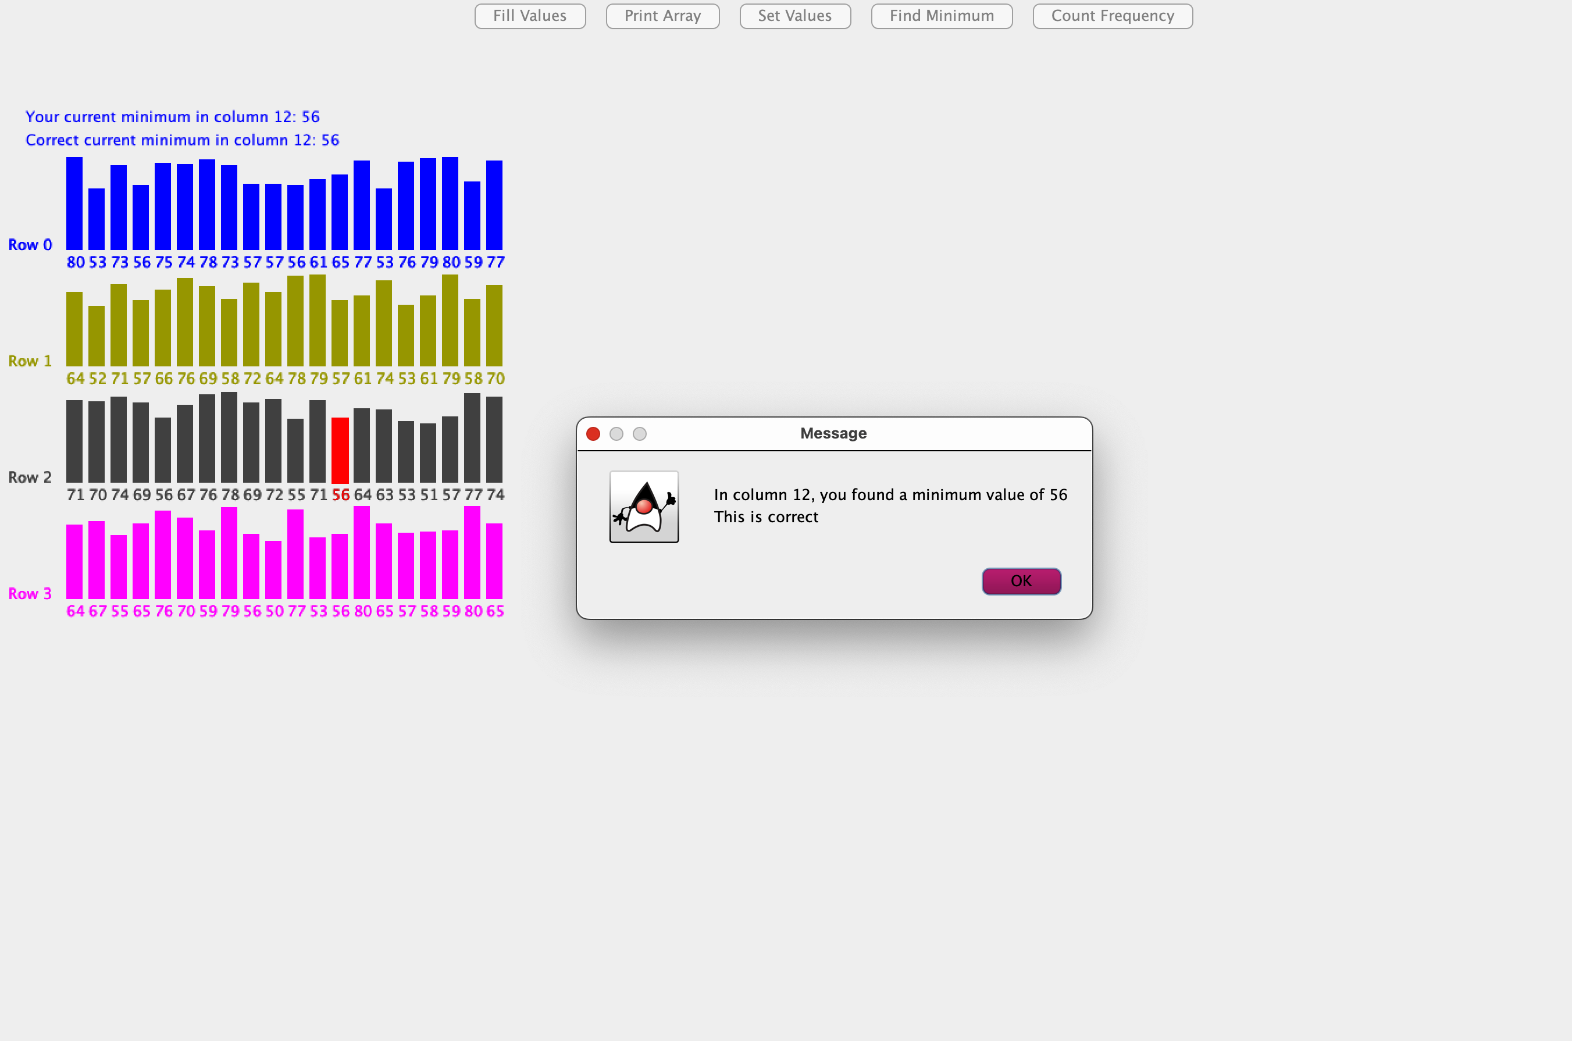

**Task #4 Find Frequency of a Given Value in the Array**

