SQL-Harjoitukset (Vaativammat kyselyt)
- Write a query to find the addresses (location_id, street_address, city, state_province, country_name) of all the departments.
Use JOIN and tables are departments and locations
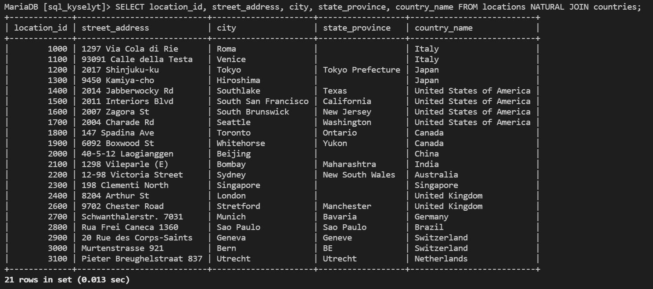

- Write a query to find the names (first_name, last_name), job, department number, and department name of the employees who work in London
Use JOIN and tables are departments and locations
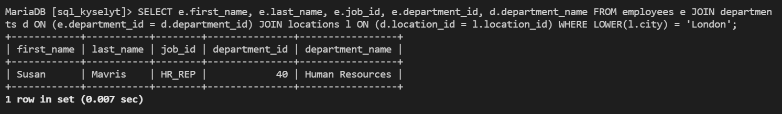

- Write a query to find the names (first_name, last name), department ID and name of all the employees. Use JOIN and tables are departments and locations
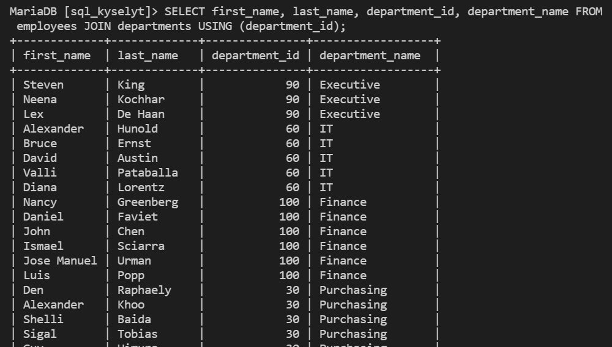

- Write a query to find the employee id, name (last_name) along with their manager_id, manager name (last_name). Table is employees.
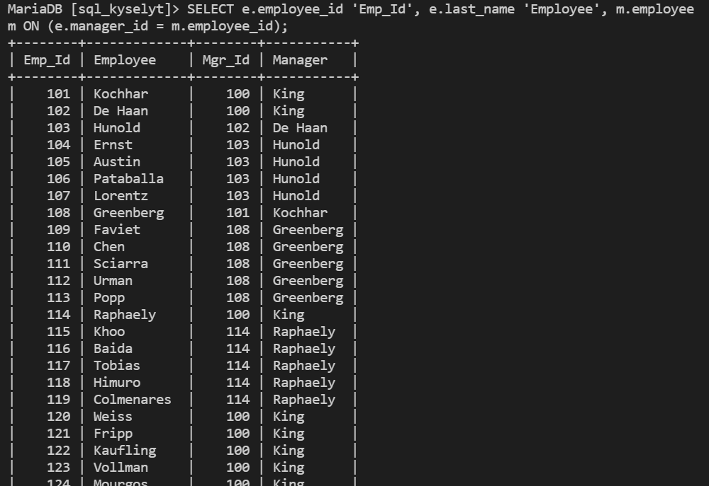
- Write a query to get the department name and number of employees in the department and order result by department name. Table are employees and departments. Use INNER JOIN
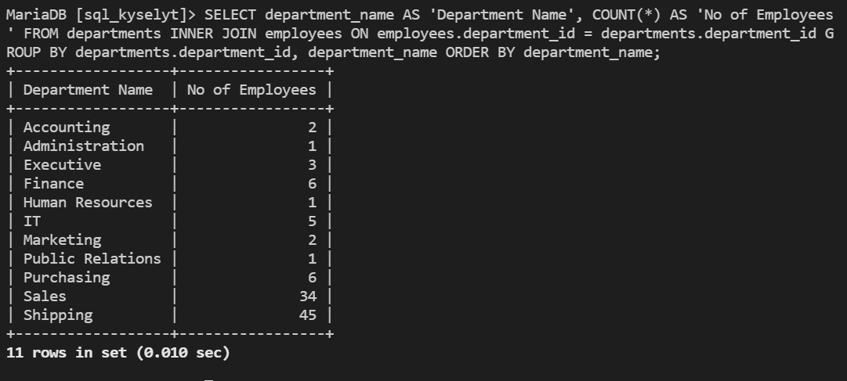
- Find the employee ID, job title, number of days between ending date and starting date for all jobs in department 90 from job history. Table is employees. Use NATURAL JOIN AND WHERE depatment_id=90
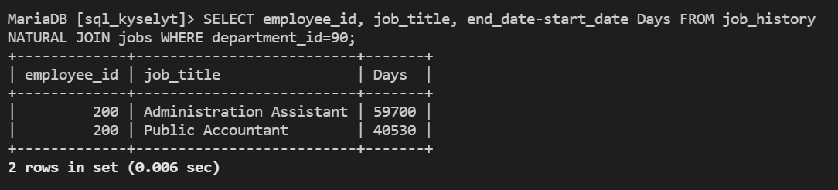
- Write a query to display the department name, manager name, and city. Tables are departments, locations and employees.
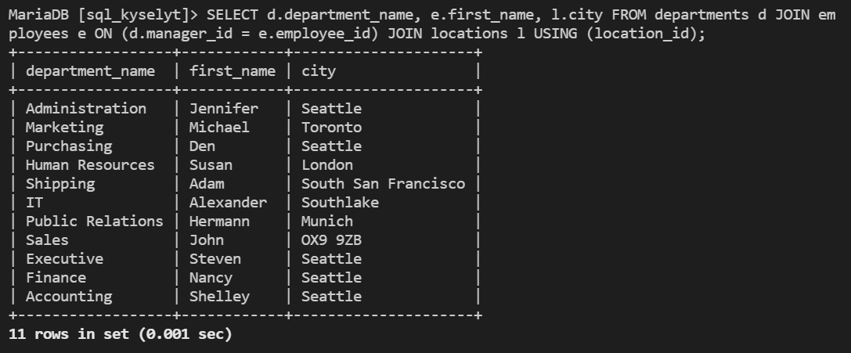
- Write a query to get the current date in the following format.
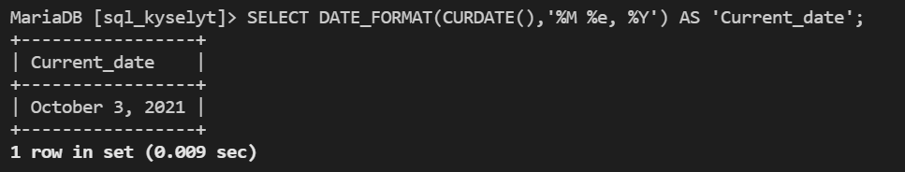
- Write a query to get the years in which more than 10 employees joined. Table is job_history.
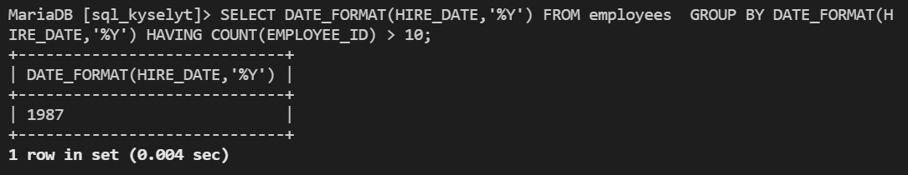
- Write a query to get employee ID, last name, and date of first salary of the employees. Table is employees.
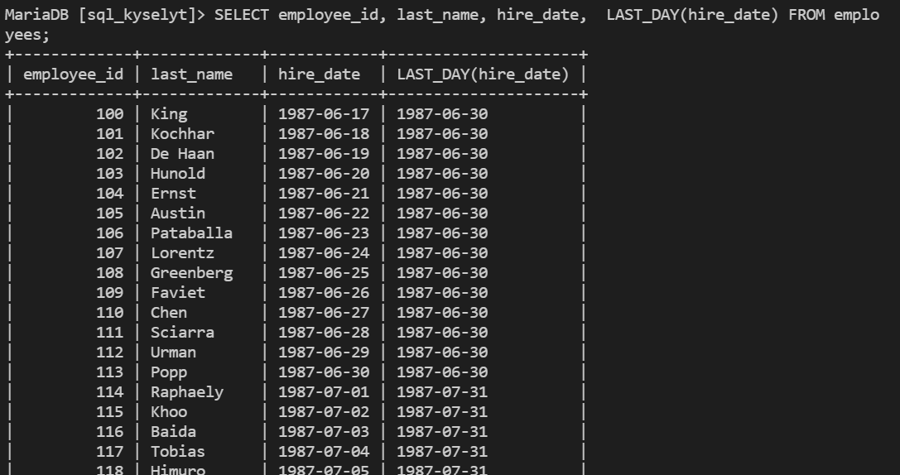
- Write a query to get the job_id and related employee's id. Table is employees. Use GROUP_CONCAT command.
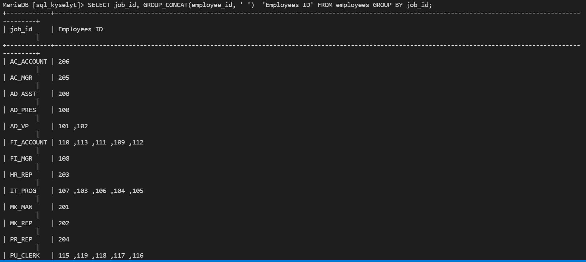
- Write a query to update the portion of the phone_number in the employees table, within the phone number the substring '124' will be replaced by '999'. Use REPLACE and LIKE %124% to find current string.
- Write a query to get the employee id, email id (discard 0 characters).
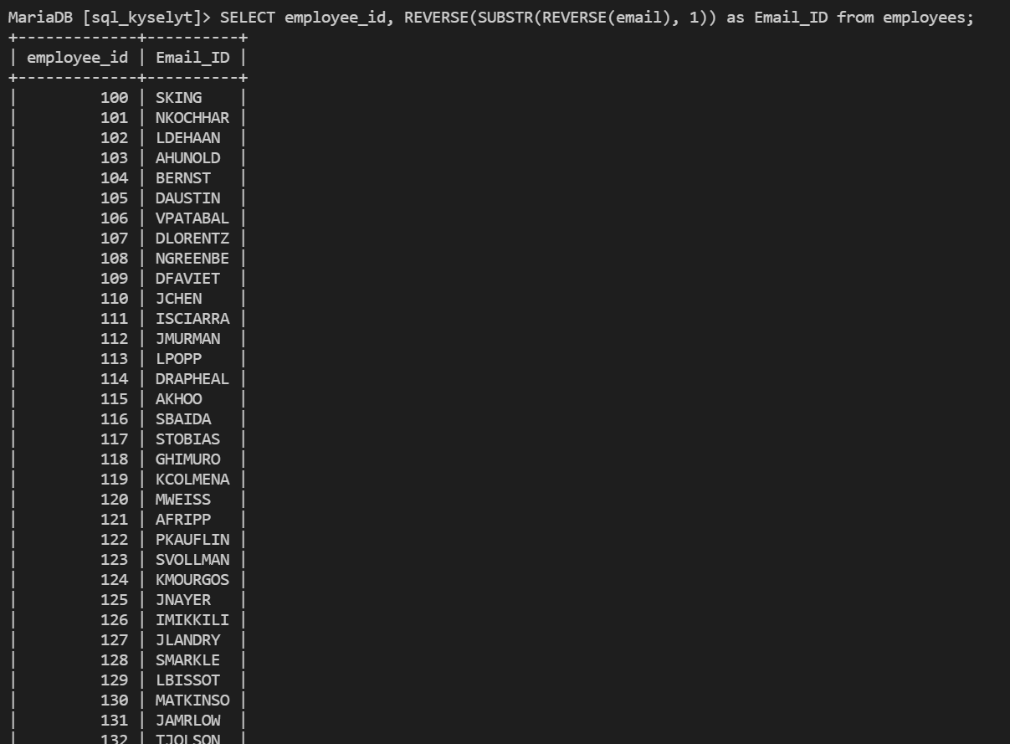
- Find the names (first_name, last_name) of all employees who works in the IT department. Use subquery
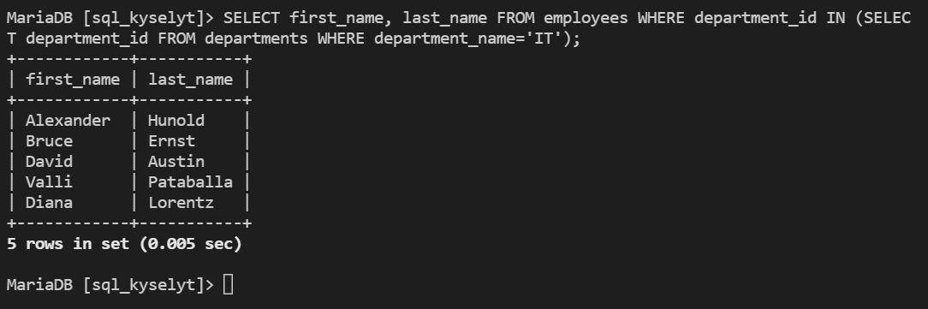
- Write a query to get the maximum salary of an employee working as a Programmer. Job_id is IT_PROG.
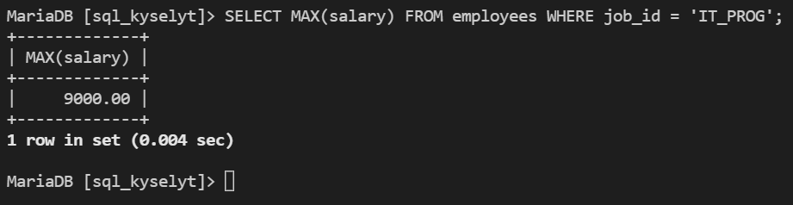
- Write a query to get the highest, lowest, sum, and average salary of all employees.
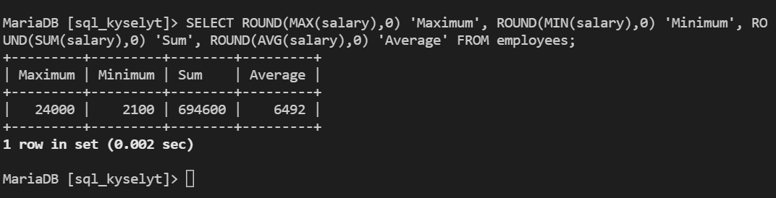
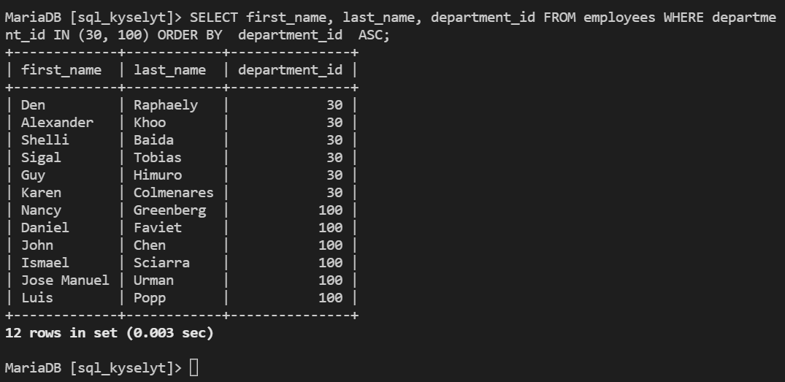
- Write a query to display the names (first_name, last_name) and department ID of all employees in departments 30 or 100 in ascending alphabetical order by department ID.

