Module-02
Software Development Life Cycle (SDLC) in the Age of AI

Q1. SDLC Lifecycle Diagram and Workflow
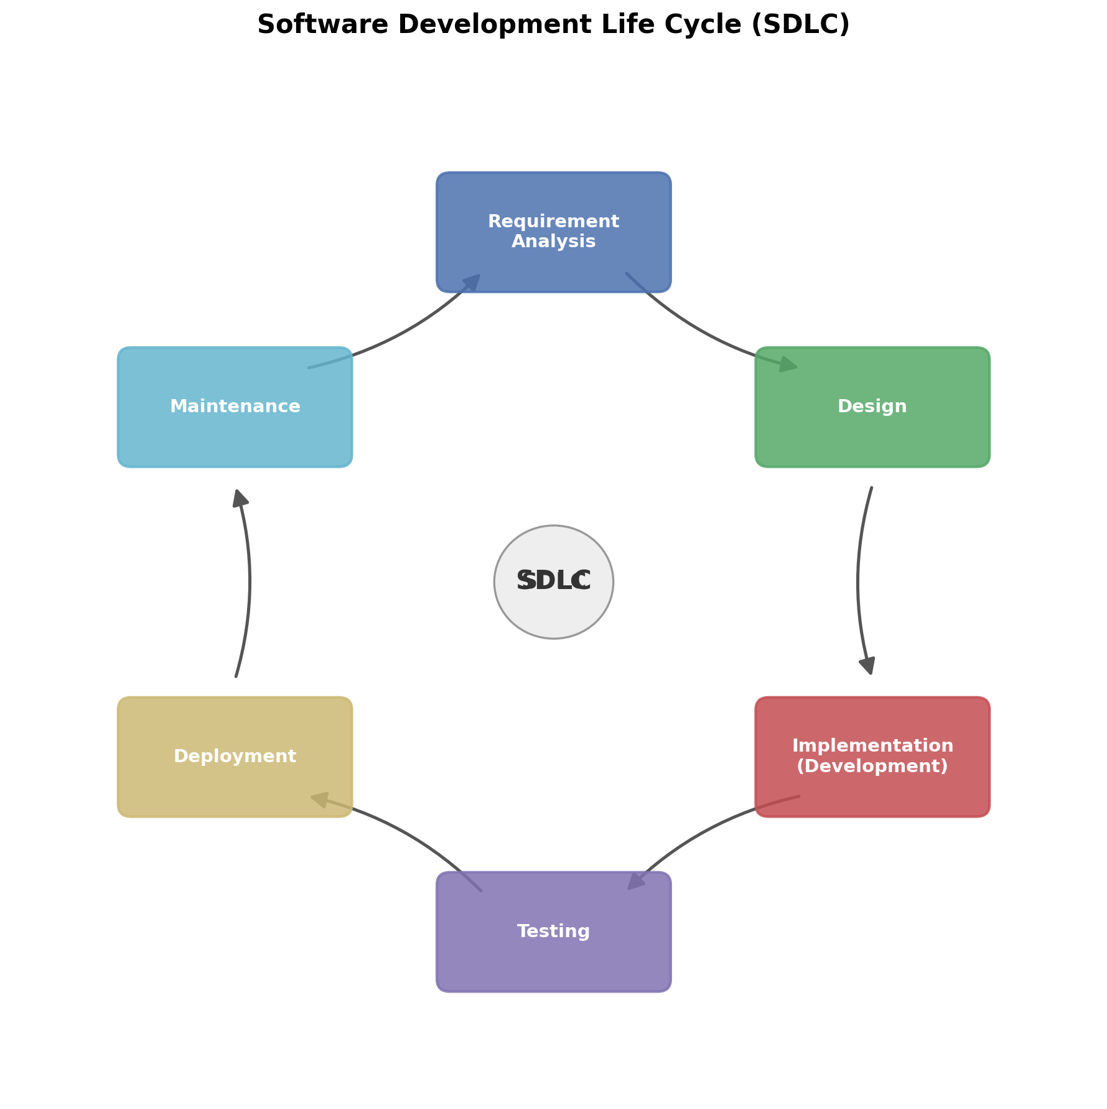
The Software Development Life Cycle (SDLC) is a step-by-step process that a software team follows to plan, build, test, release, and maintain an application. It is shown as a cycle because maintenance work and user feedback from one project often turn into new requirements for the next version, so the process keeps repeating rather than stopping at deployment.

Brief Workflow of Each Phase
- Requirement Analysis - The team talks to clients and stakeholders to understand what the software should do. Business and user requirements are gathered and written down in documents such as the BRD (Business Requirement Document) and SRS (Software Requirement Specification). This phase sets the foundation - if requirements are wrong here, the mistake carries through the whole project.
- Design - Once requirements are approved, the team plans how the system will actually be built. This includes High-Level Design (overall architecture) and Low-Level Design (module-level logic), along with database design, API design, and UI/UX design. No coding happens yet; this is the blueprint stage.
- Implementation (Development) - Developers write the actual source code based on the design documents. This phase also includes code review, unit testing, and using version control (like Git) so that multiple developers can work together without overwriting each other's work.
- Testing - QA engineers check whether the software actually works the way it was supposed to. This covers functional testing, regression testing, automation testing, performance testing, security testing, and User Acceptance Testing (UAT) before the product is considered ready.
- Deployment - The tested application is released to the production environment so real users can access it. This includes database migration, configuration updates, smoke testing right after release, and having a rollback plan in case something goes wrong.
- Maintenance - After release, the team keeps fixing bugs, patching security issues, and improving performance based on real user feedback. This phase never really "ends" - it continues until the software is retired, and the feedback gathered here often becomes the requirement input for the next cycle.
In short, the workflow moves in one direction - Requirement Analysis → Design → Implementation → Testing → Deployment → Maintenance - but the loop back from Maintenance to Requirement Analysis is what makes SDLC a continuous cycle instead of a one-time process.

Q2. Practical AI Exercise
AI Tool used: Claude (Anthropic)
For this exercise, I used Claude to generate user stories, acceptance criteria, and a sprint backlog for a sample E-commerce application, then reviewed and refined the output myself.

Step 1: Five User Stories for an E-commerce Application
- As a customer, I want to search for products by name or category, so that I can quickly find the items I am looking for.
- As a customer, I want to add products to a shopping cart, so that I can purchase multiple items in a single checkout.
- As a customer, I want to pay using multiple payment options (card, mobile banking, cash on delivery), so that I can choose the method that is most convenient for me.
- As a registered user, I want to view my past order history, so that I can track what I have already ordered and re-order easily.
- As an admin, I want to add, edit, and remove products from the inventory, so that the store listing always stays accurate and up to date.

Step 2: Acceptance Criteria for User Story #2 (Add to Cart)
Selected User Story: "As a customer, I want to add products to a shopping cart, so that I can purchase multiple items in a single checkout."
- Given a product page, when the customer clicks "Add to Cart", the item is added to the cart with a default quantity of 1.
- The cart icon in the header updates immediately to reflect the new total item count after an item is added.
- If a product is out of stock, the "Add to Cart" button is disabled and shows an "Out of Stock" label instead.
- From the cart page, the customer can increase or decrease item quantity, and the subtotal recalculates automatically without a full page reload.
- For a logged-in user, cart contents are saved to their account and persist even if they log out and log back in later; for a guest user, the cart persists at least for the current browsing session.

Step 3: AI-Generated Sprint Backlog
I asked Claude to convert the five user stories into a Sprint Backlog for a 2-week sprint, with story points and task breakdown.
User Story | Story Points | Sprint Tasks
Search products by name/category | 5 | Design search UI; build search API; connect to product database; write unit tests
Add products to cart | 5 | Build cart data model; implement Add to Cart button/API; update cart icon; handle stock check
Multiple payment options | 8 | Integrate card gateway; integrate mobile banking; add COD option; test payment failures
View order history | 3 | Design order history page; fetch past orders API; add pagination
Admin: manage inventory | 5 | Build admin panel CRUD screens; add validation; write access-control checks

Total Sprint Capacity: 26 story points (assumed team velocity for a 2-week sprint).

Step 4: What the AI Did Well
- Generated grammatically correct, properly formatted user stories following the standard "As a [role], I want [goal], so that [benefit]" structure.
- Covered a good spread of roles (customer and admin) instead of only focusing on the customer side.
- The acceptance criteria were specific and testable, not vague - for example, it correctly thought about edge cases like out-of-stock items and guest vs. logged-in users.
- Organized the sprint backlog into a clean table with story points and a task breakdown, which saved a lot of manual formatting time.

Step 5: Corrections I Made Manually
- The AI's first draft of story points felt inconsistent - for example, it originally gave the payment story the same weight as the search story, even though payment integration is clearly more complex. I adjusted the points to better reflect real effort.
- One of the initial user stories was too generic ("As a user, I want a good shopping experience"), which is not testable. I rewrote it into the more specific "view order history" story.
- I added the acceptance criterion about guest users vs. logged-in users, since the AI's first version only considered logged-in users and ignored guest checkout, which is a common real-world case.
- I reordered the sprint tasks under each story into a more logical build sequence (e.g., design/UI before API integration) since the AI had listed them in a random order.

Step 6: Why Human Review Is Still Necessary
- AI does not know the actual business context, team velocity, or technical constraints of a specific company, so story point estimates and priorities need to be validated by the team.
- AI can miss edge cases that come from real domain experience (like the guest-checkout case above) unless it is specifically prompted to think about them.
- Requirements can be ambiguous, and only a human stakeholder can confirm what the client actually meant - AI can only work with what it is given.
- Final accountability for what gets built and shipped to users has to rest with the human team, not the AI tool, especially for decisions involving cost, security, and compliance.

Screenshots of AI Interaction
[Attach screenshots of your actual conversation with the AI tool here - e.g., screenshots showing the prompts you gave and the AI's generated user stories, acceptance criteria, and sprint backlog.]

