This week has been good, to start with I took a better/ more professional photo for my LinkedIn account, and to use on my portfolio site. I then updated both sites to have the photo, so I no longer have a bad quality photo of me and my 2 mates.

I also wrote the final version of the about me page, so it actually says stuff about me, idk if its any good tho or if there is too much detail or not enough detail in the correct places.

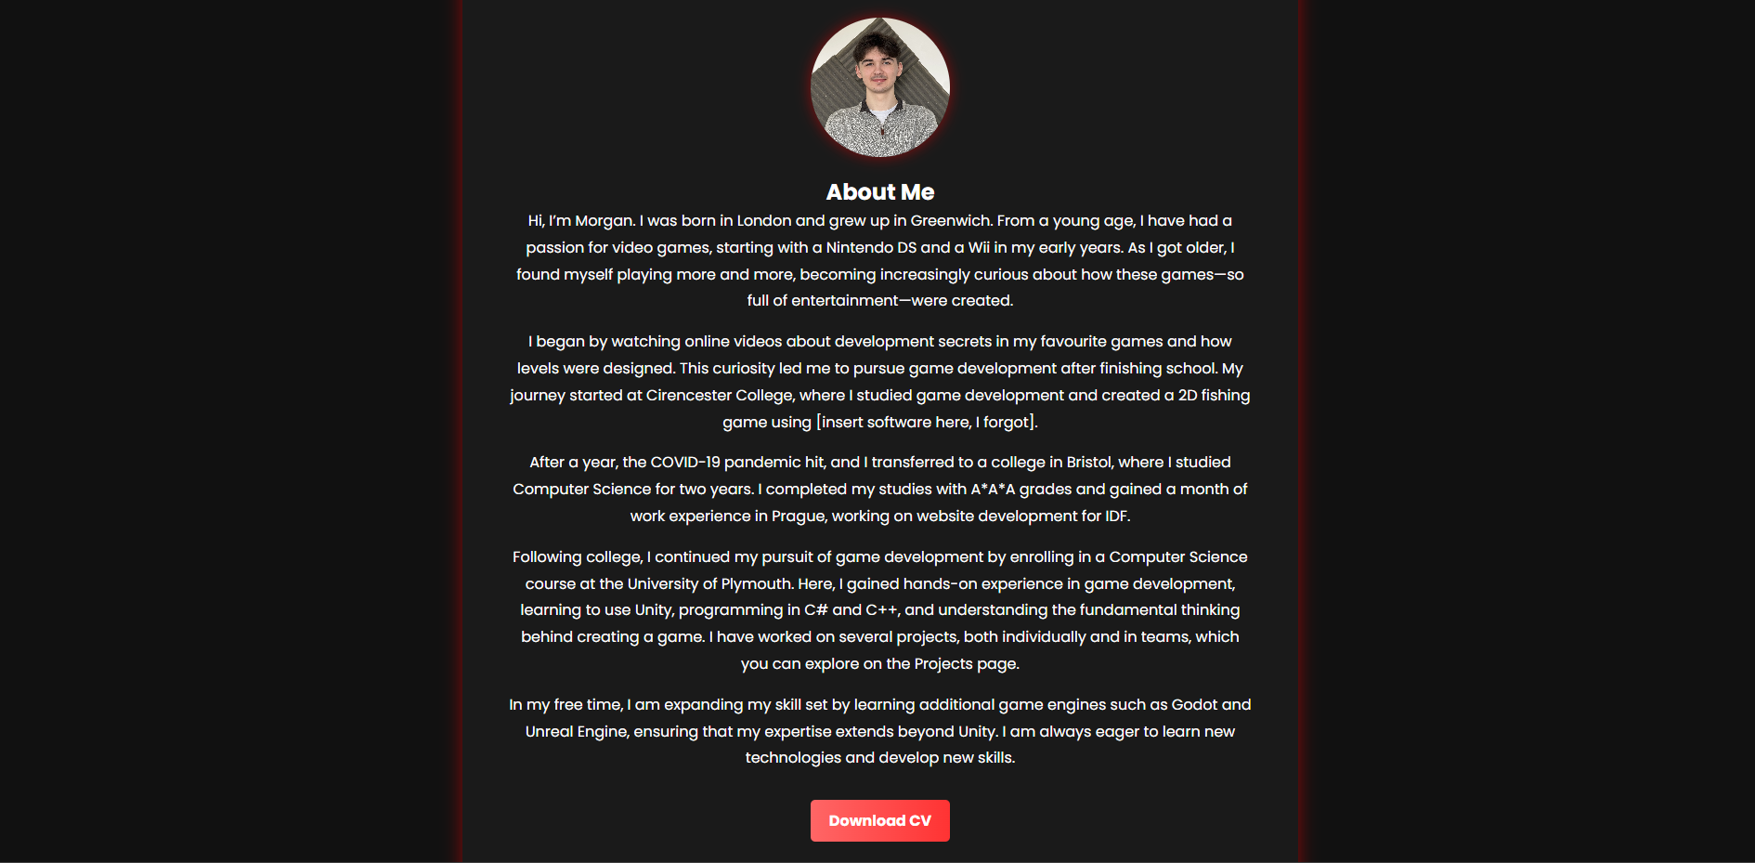

My website is almost done I just want to modify the home page, change the profile pic and change the text. After that I think its just tweaking some visual stuff. The websites here if anyone wants to check it <https://morganhodge.netlify.app/>

This week I also engaged with the industry , I went to digital Plymouth. It was pretty fun , I spoke to some people, wish I spoke to more and I wish I could remember that polish duded name. But yeh the event was cool, it was interesting to hear what people had to say and tony talk was very magical.

When I got back, I connected with like 5-10 people from the event on likdin , so that’s good I managed to get some connections out of it too. I still need to make a post on my account tho saying I went and stuff so I might do that in a min.

Useful Resources for anyone who is making a website

<https://chakra-ui.com/playground>

<https://tailwindcss.com/>

<https://mui.com/material-ui/>