I started by removing spotlights, fog, and bliimphong from my scene so it was a fresh slate with just models and movement
I then implemented 2 new modles , a table and a wall
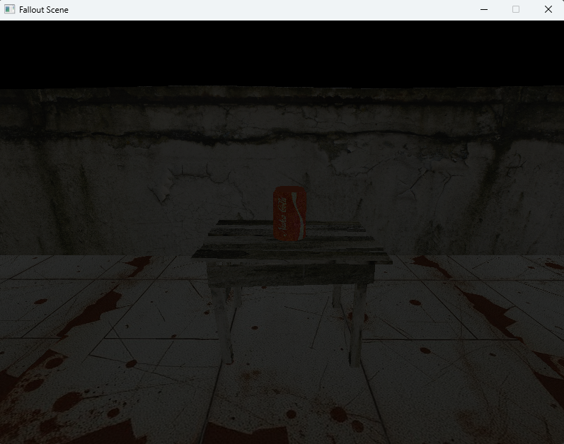
What my initial plan was – was to create a more alive fallout scene by having fire particles burning in the background, bloom effect for some lighting, and particle fountine for background liquid?

