GDD, Testing, Trello, UI IMAGES AND MORE , asset list f6isnext

Wait is it even called view in appendix

Make sure I did say I did do agile sprints – change dat

# 10. Appendix

## Links :

### Itch - https://morganhodge.itch.io/timeline-takedown

### Trello -

Appendix 1 : Game Design Document (2.3)

The Game Design Document can be found within this OneDrive Link :

## Appendix 2: Inkscape Designs (4.4)

Inkscape was used to create a variety of assets for Timeline Takedown, such as canvases, UI elements, Powerups, Pause Menu, and more.

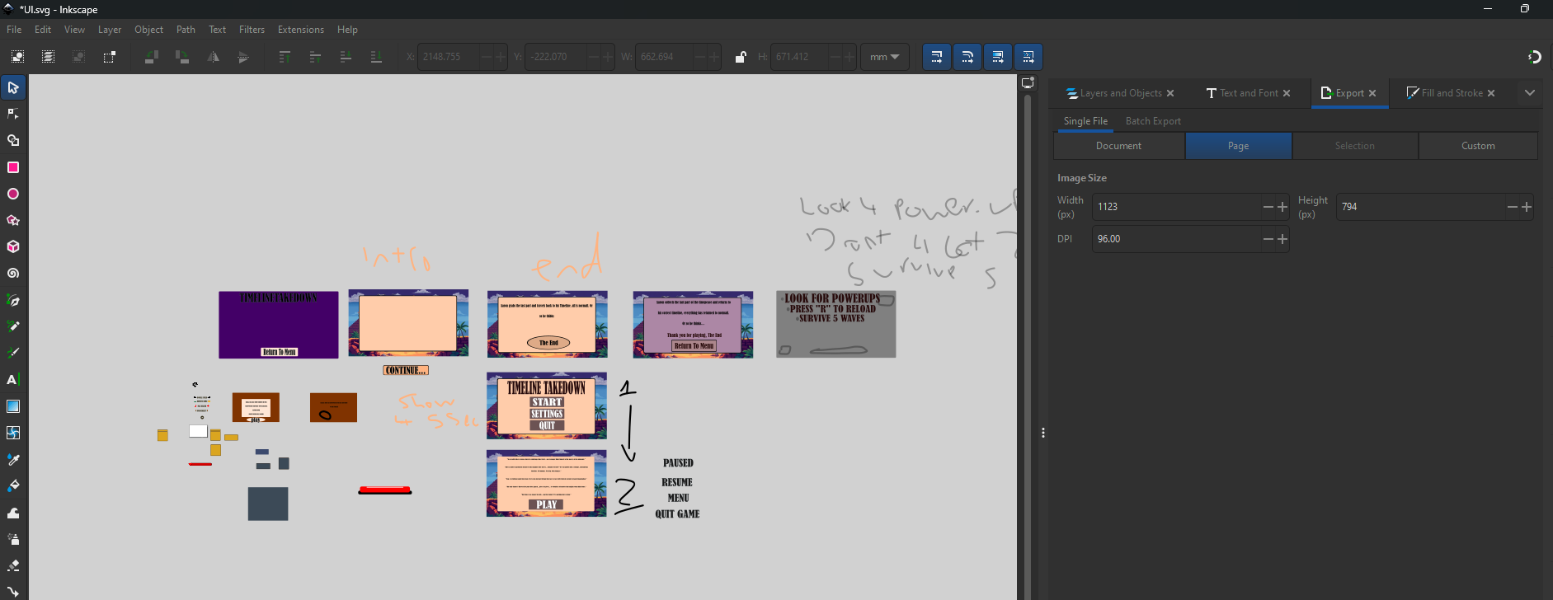

*Figure X : An overview of the UI page*

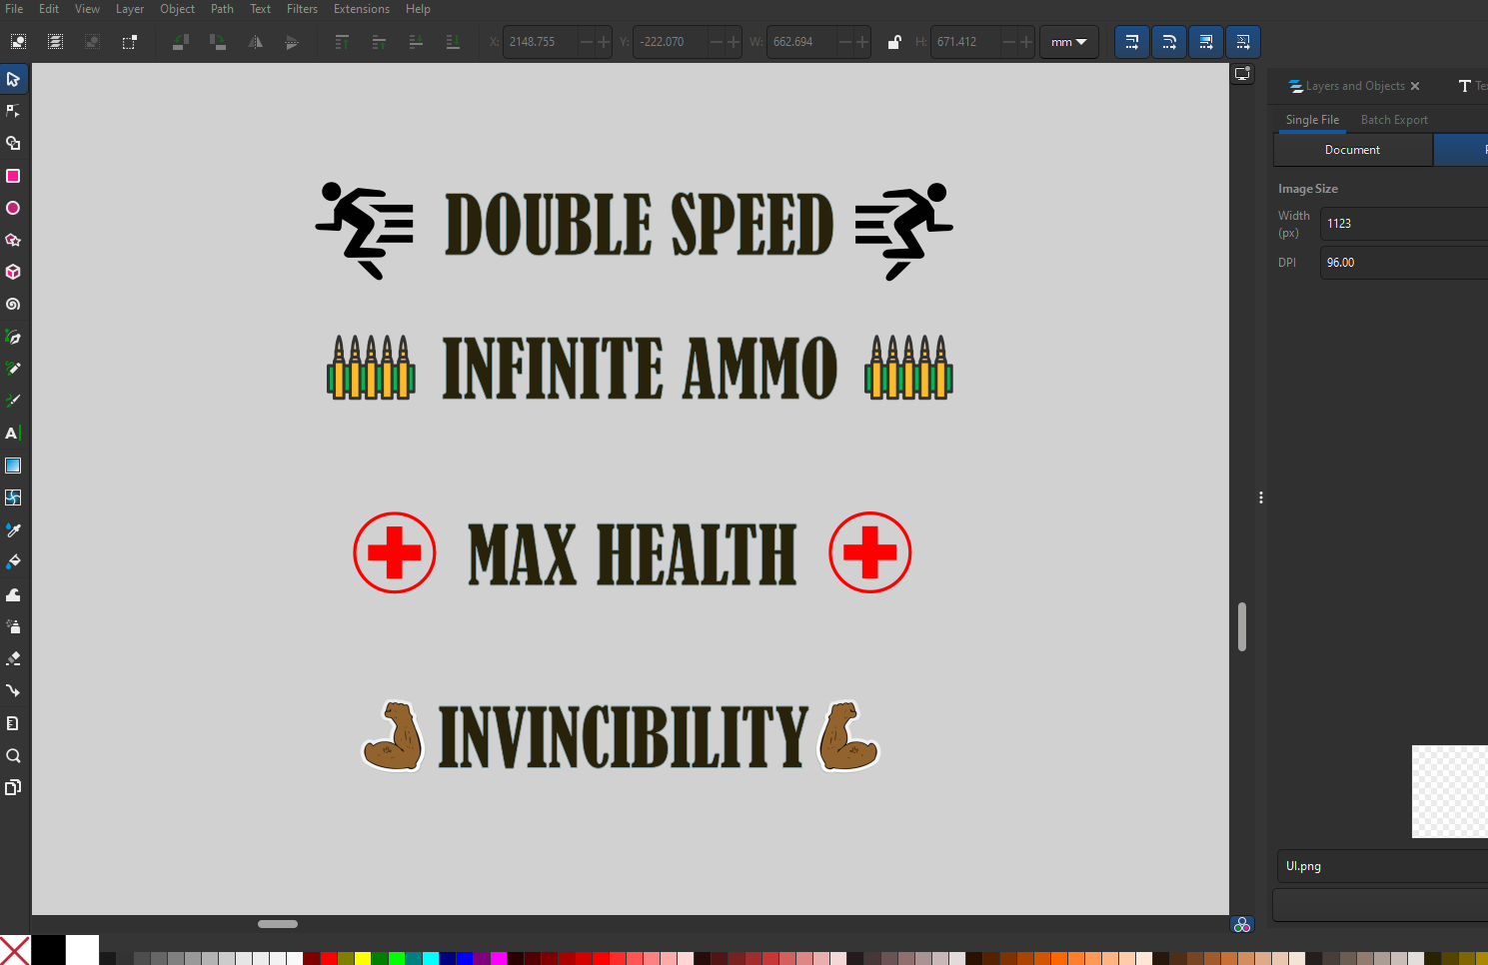

*Figure X : PowerUp Messages*

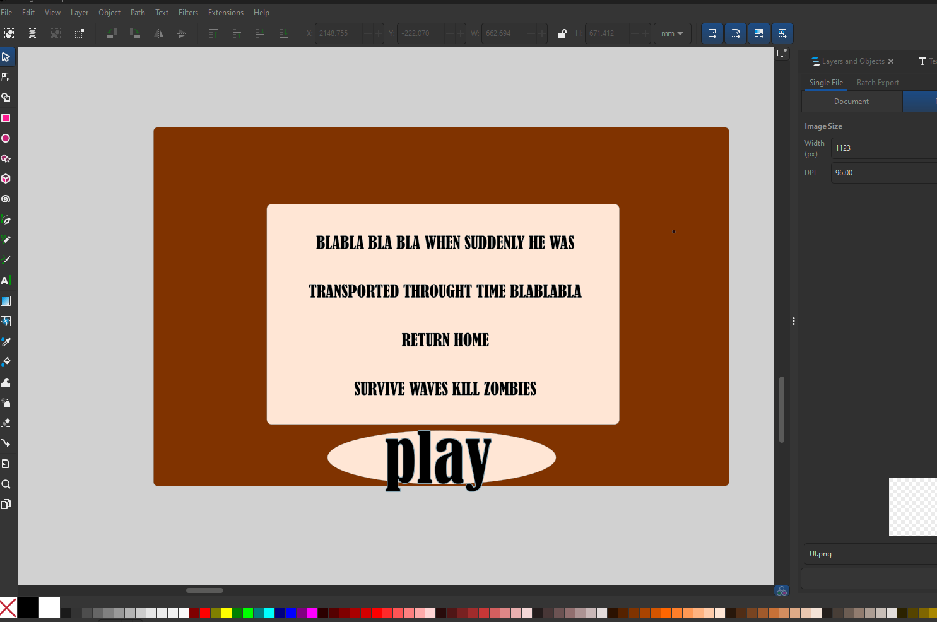

*Figure X: Initial Start Screen idea*

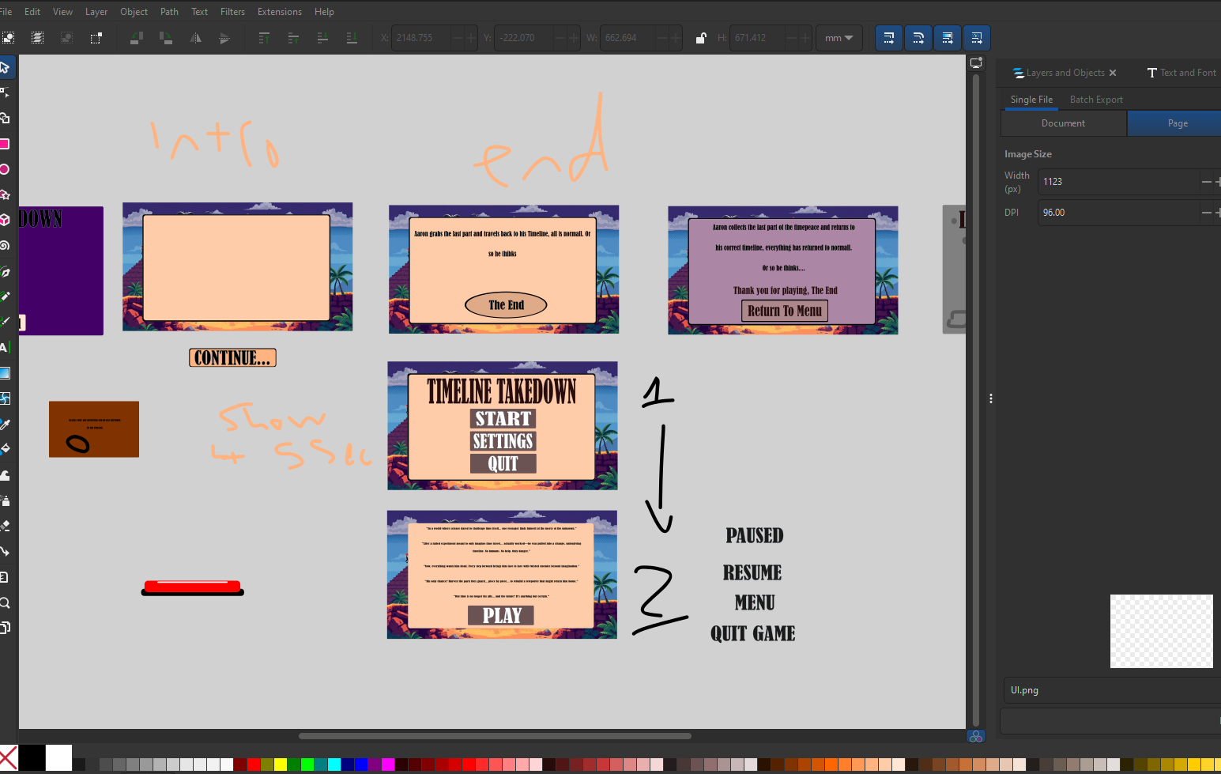

*Figure X: Scene Flow Plan*

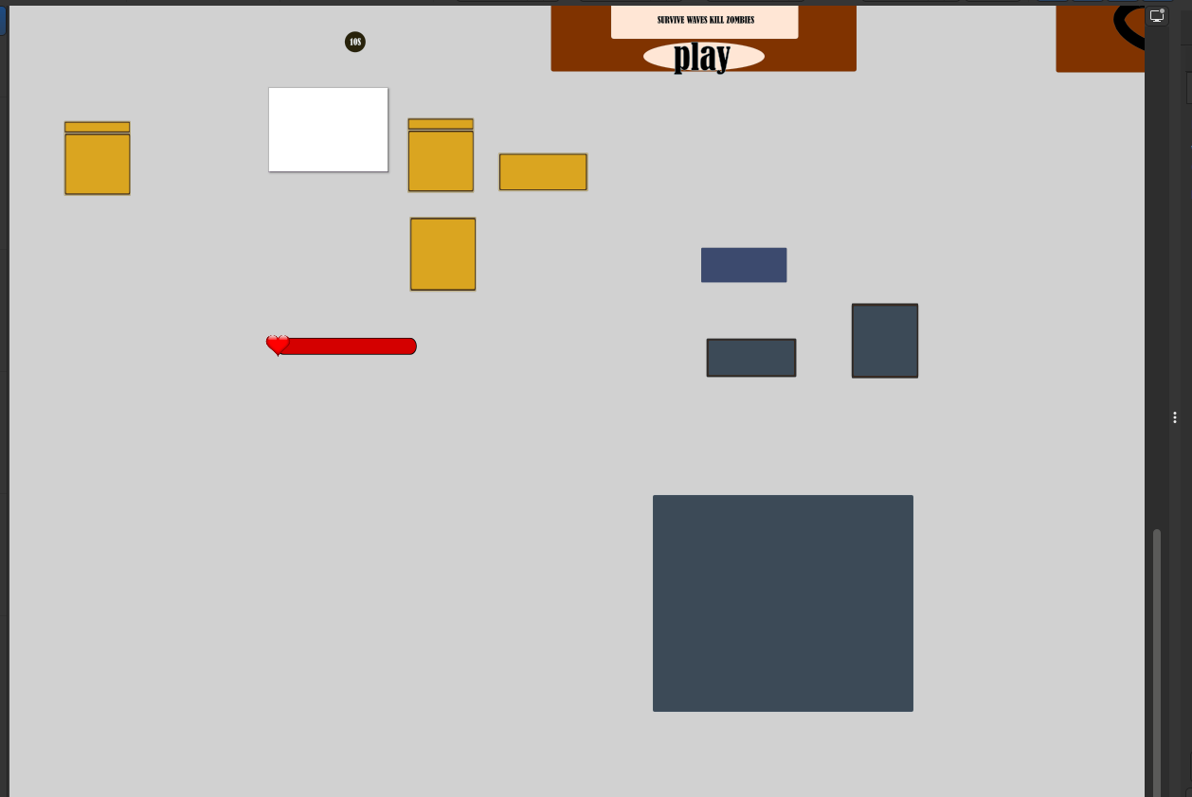

*Figure X: Boxes used for on screen UI such as ammo count and wave count*

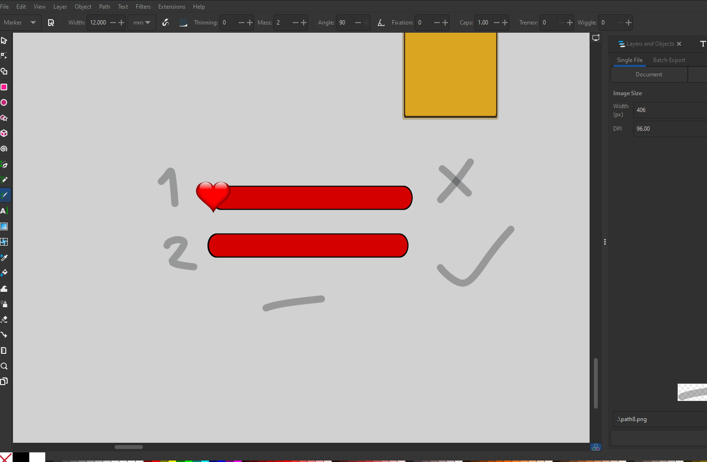

*Figure X: Health Bar*

## Appendix 3: Devlogs (4.4)

Every Development Log recorded is below:

Devlog 1: https://youtu.be/Su4Demj-MFw

Devlog 2: https://youtu.be/RXlF7QE14os

Devlog 3: https://youtu.be/vxEHmGPZ-y4

Devlog 4: https://youtu.be/lJwd-J0-sTs

Devlog 5: https://youtu.be/2hVWVUD5KXo

Devlog 6: https://youtu.be/nWcjUrmOtSQ

Devlog 7: https://youtu.be/-r5FLIDuMCo

## Appendix 4: CMD DESIGNS (4.4)

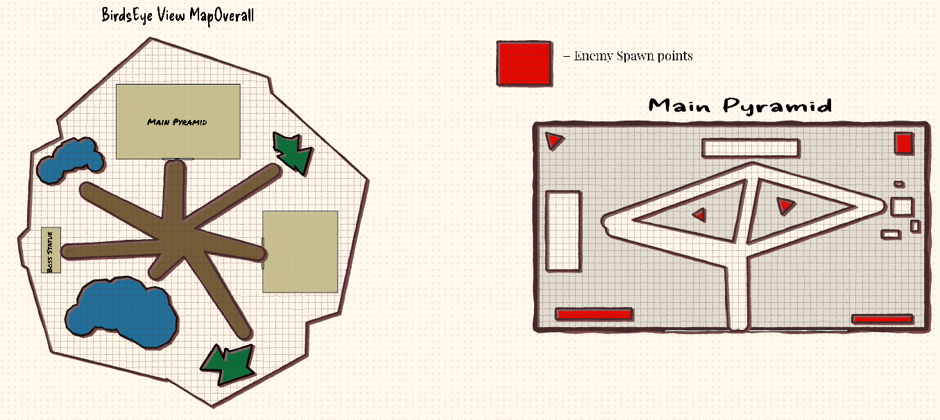

*Figure X: Level 1*

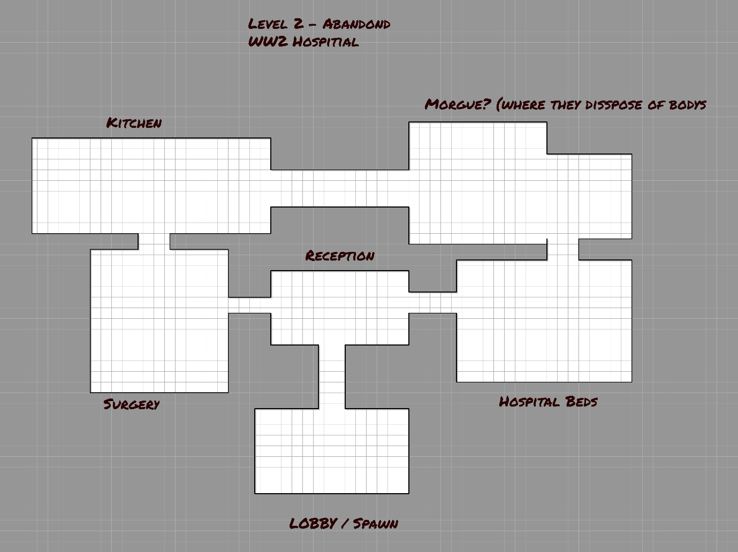

*Figure X: Level 2*

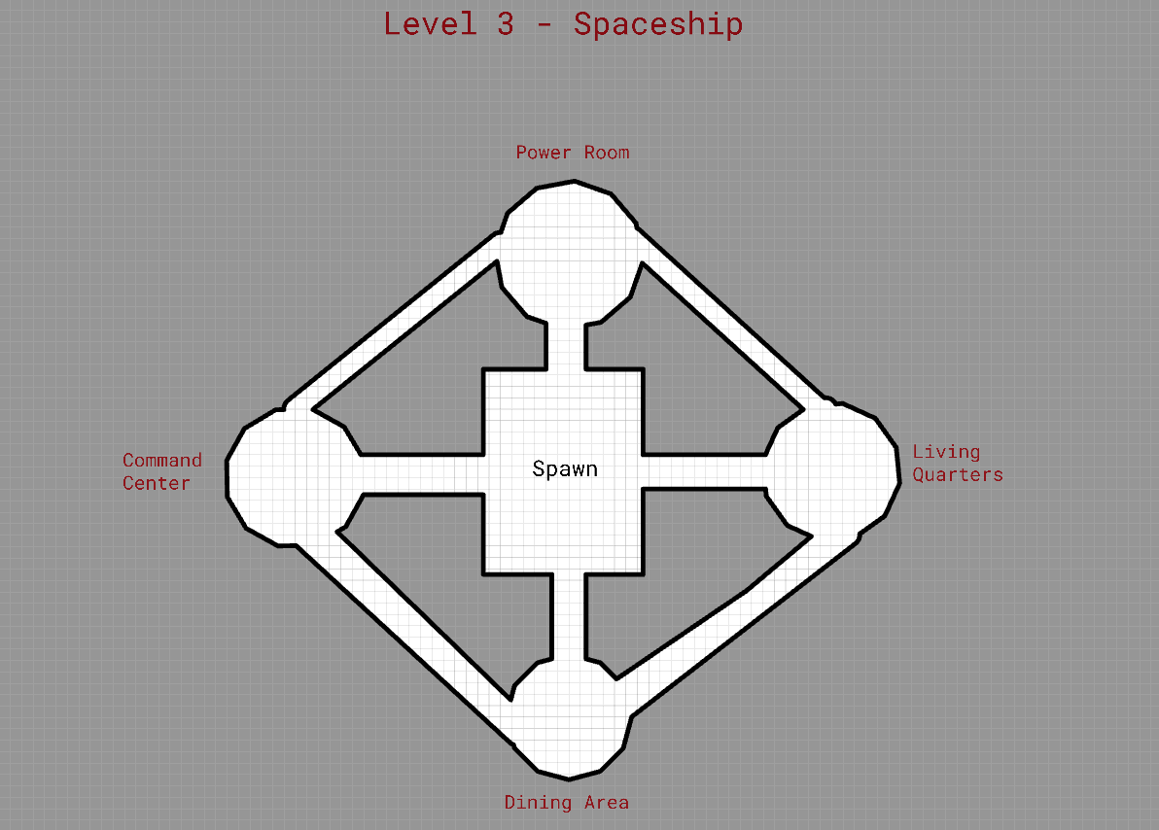

*Figure X: Unreleased Level 3 Plans*

## Appendix 5: Breakdown of technology and tools (4.5)

### Hardware

Timeline Takedown was created on a PC that had the specs of:

KEYBORD

SCREEN

ETC

### Software

INKSCAPE

DUNGEON

TRELLO

YOUTUBE

GITHUB

UNITY

ITCH

## Appendix 6: All paper designs

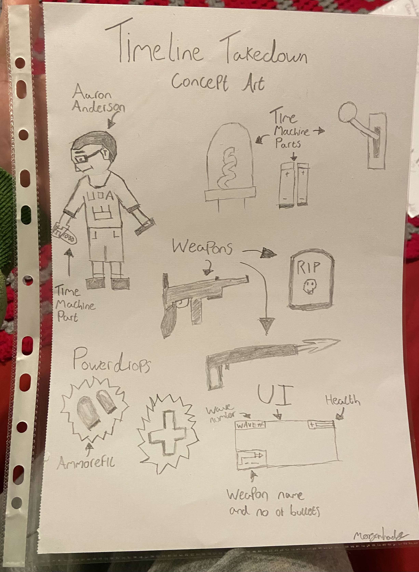

*Figure X: Concept Art for Timeline Takedown*

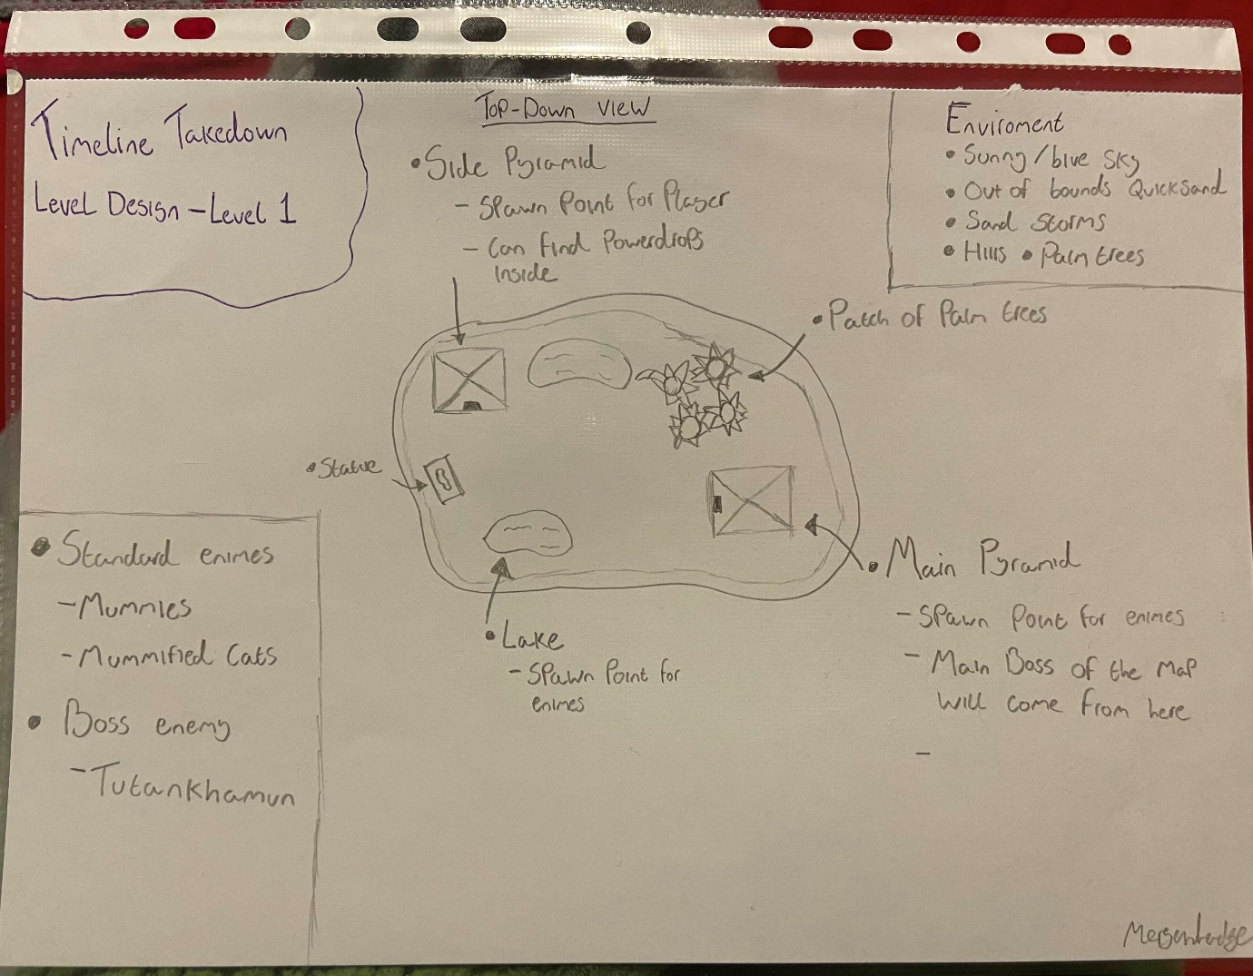

*Figure X: Level Art for Timeline Takedown Level 1*

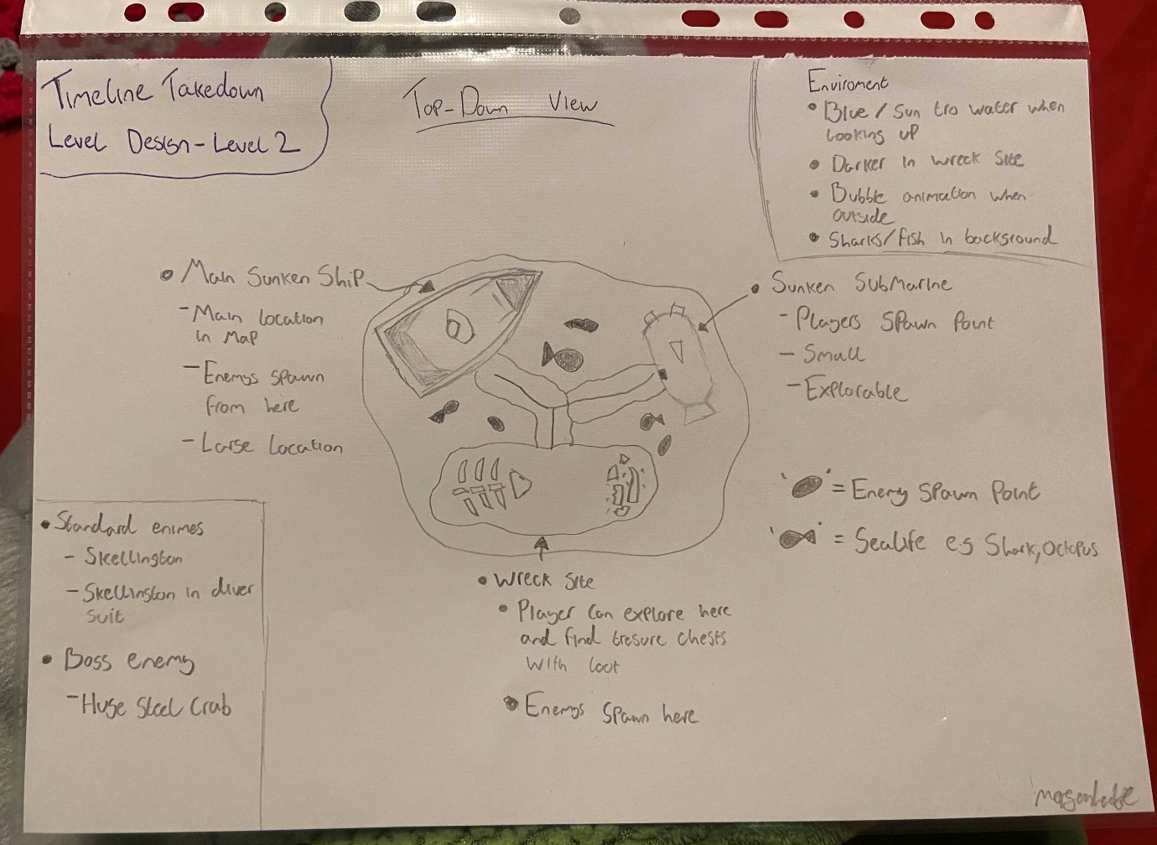

*Figure X: Level Art for Timeline Takedowns scrapped Level 2*

## Appendix 7: Asset list

Please note that some of these assets may not have been used within Timeline Takedown and were simply noted as assets that have potential use for the future development.

## Appendix 8: University Ethics Policy

## Appendix 9: Trello board

## Appendix 10: Testing

### Feature Testing and Sprint Testing:

Feature and sprint testing was often conducted by the developer, this meant there was often no professional testing plan as feature testing was conducted after every iteration and did not need to be recorded. However, there are still some documents that have collected notes from the feature testing , and other information that was noted during this testing throughout the project.

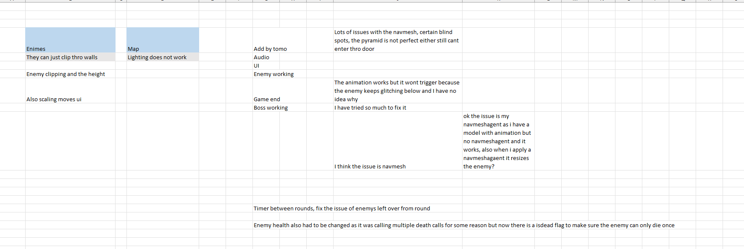

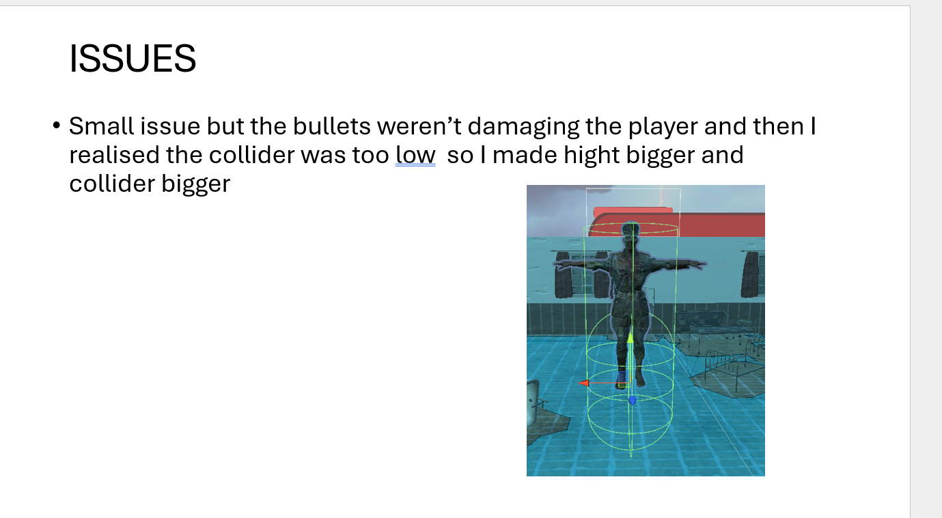

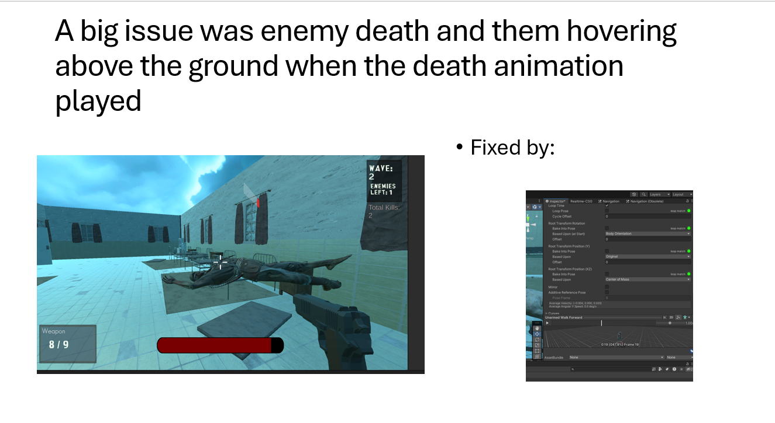

### User Testing:

This testing method consisted of real humans

## Apendx 11: Poster Creation