# 5 – Legal, Social, Ethical and Professional issues

Throughout the development of this project, I had to constantly consider legal, social, ethical and professional issues to make sure that I was developing my project in a professional and responsible manner.

## 5.1 Legal

Legally, the most important consideration for me was checking that the assets I used in my game were safe and compliant as almost all of the game would be made from online resources, except the building models. When building my asset list (Appendix 3), I made sure that all assets had either public domain licenses or clear usage rights. This applied not just to 3D models but also tools, audio clips, and animations. Since I used a wide variety of audio and animations throughout the project, I made sure to source them from reliable websites like Maximo and royalty free audio sites.

I also experimented with AI generated artwork for loading screens and various UI elements using DeepAI. However, before doing this I reviewed the licensing terms which confirmed that the content could be used commercially and legally within my project.

Itchio page and distribution

## 5.2 Social

Socially I was aware that including war themes and enemies into Timeline Takedown could be a sensitive area. A well-known example is Call Of Duty World at War, which originally included Nazi memorabilia like swastikas. Due to public backlash and the risk of causing offense, these were later removed and replaced in the new remastered version of the game Zombie Chronicles with other images as shown in figure xyz. Keeping this in mind, I was careful when sourcing World War 2 era solider assets for level 2. I made sure the models I used didn’t feature any explicit or offensive symbols. This made sure that I maintained a respectful and inclusive approach while still delivering the intended theme.

Try find something online to citate

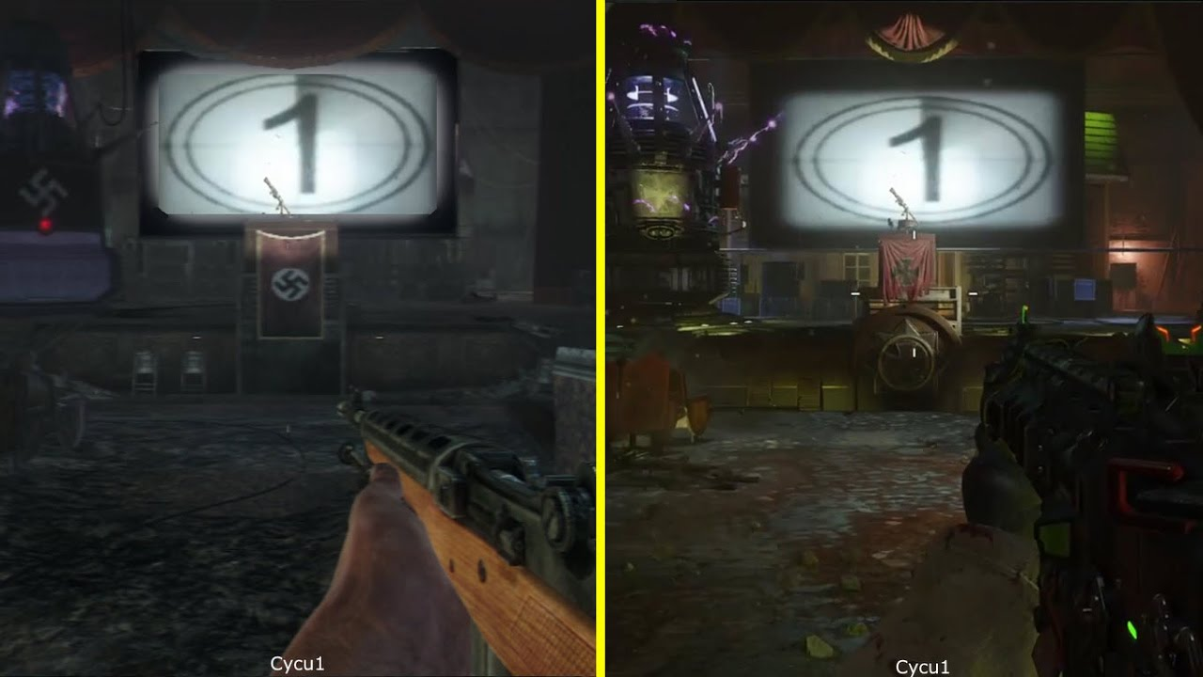

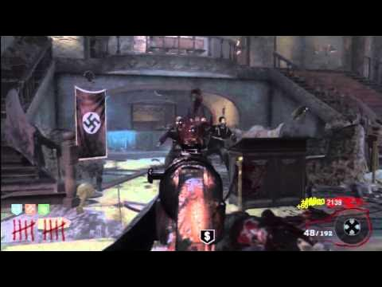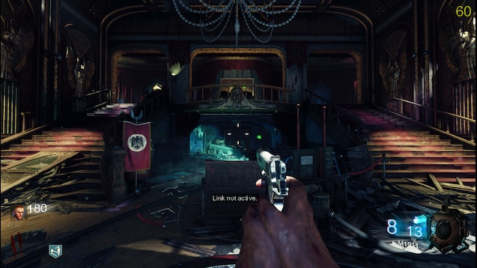

*Figure XYZ ; Swastickas being removed*

Epelepsie no flashing lights

## 5.3 Ethical

Ethically, I ensured all playtesting remained completely anonymous to conform to the University’s Ethics policy. No personal data was asked for or collected from testers. One exception was when I used an image of a classmate for playtesting for promotional purposes however, he did give me consent for this. To still respect his privacy and keep him anonymous, his face was not visible, and I did not name him.

Additionally, I took care not to use any plagiarised material within this project. All assets, code, audio, and animations were sourced from legitimate platforms with appropriate licensing, and I avoided using any work from other developers without clear permission or usage rights.

Maybe talk about usage rights in apendix

## 5.4 Professional

• **Using Version Control / Documentation**:  
If you used version control (Git, Unity Collab) or kept detailed devlogs, this is a great place to show professionalism.

• **Responding to Supervisor Feedback**:  
You took advice from your supervisor about using AI art for prototyping and acted on it, showing professional collaboration and adaptation.