# 7 – Implementation

Research

The

## 7.1 Project Setup and Design - Sprint 1 (8.11.2024 – 22.11.2024)

Overview

This was the first sprint of the project, after attending the required seminar, I chose the type of software project I wanted to develop – that being a game, and selected an assistant supervisor to support the project. The choice of creating a game came easy to me as I aspire to work in the games development industry after graduating, with this project complete it would stand as a solid portfolio piece I can show to employers and display on my portfolio website (morganhodge.co.uk). This project would also strengthen my skills as a game developer, through project management , good use of version control, and 3D Unity skills.

During this first sprint I focused on outlining the initial concept, goals, and setting up my workspace. Following guidance from the seminar, I began drafting the Game Design Document(GDD), which would act as a foundational reference throughout the development process.

Sprint Tasks

* Set Up Work Environment
  + Create Github Repository
  + Set up Github Desktop
  + Create new Trello board and give access to supervisor
  + Gather all required information such as briefs and required documentation and add them to the repository
* Level Design (Paper Based)
  + Level 1
  + Level 2
* Basic Player Movement
* First Person Camera Movement (Mouse)
* First Person Walking Movement (Keyboard)
* Test Scene Created

Summary Of Actions

The player movement created for this first sprint was required as I wouldn’t be able to proceed with the development or test anything I would be implementing if I could not move around the scene.

The code implementation shown in Figure XYZ demonstrates how player movement was set up. One of the strengths of this system is its flexibility, key parameters such as movement speed, jump force, and jump cooldown are easily adjustable. This allowed for efficient playtesting and balancing throughout development, without the need to rewrite core logic.

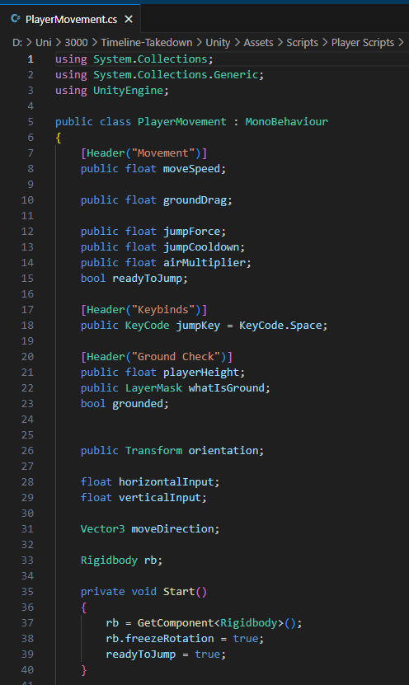 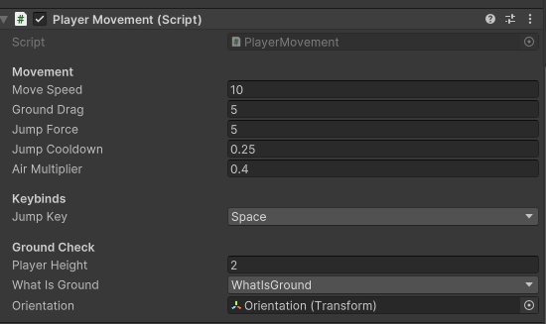

Figure XYZ FIGURE XYZ

Additionally, the paper-based level designs were created in this sprint but were not displayed until the Devlog 1.

## 7.2 Research and Game states - Sprint 2 (22.11.2024 – 6.12.2024)

Overview

This second sprint mostly consisted of setting up game states such as a Start Screen, Pause menu and settings tab.

Research was also conducted in this sprint, exploring art styles I could use as well as potential assets for the enemy type – this was documented within the Devlog 1.

During my research into art styles and visual design within video games, I was recommended several books that would be relevant to game development. As a fan of the franchise they are based on, I was eager to purchase these books and learn from them. The books I purchased during this sprint and studied included:

* The Art of Fallout 4 – A detailed look at the environment and character design choices made in fallout 4 , this was useful reference material for post-apocalyptic and sci-fi aesthetics.
* Elden Ring Art Book Vol1 – This book offered insight to the world building , creature design and atmospheric art direction that was used in Elden Ring, this helped me understand how to setup an atmosphere in a level using certain colours and audio.
* Blood Sweat and Pixels by Jason Schreier – This is not an art book but was highly recommended within the game’s development community. This was an insightful read as it provided a look on how games are really constructed and the struggles and triumphs of game development across multiple different studios. This was a strong motivational resource during my own development.

Sprint Tasks

* Devlog 1 created – <https://www.youtube.com/watch?v=Su4Demj-MFw>
* Paper Based Concept Art
* Created basic UI on Inkscape
* Game states created Menu-Start-Pause
* Movement tweaking

Summary Of Actions

Concept art was sketched up, this was the result:

*Figure X, Concept Art*

The UI elements were initially created using Inkscape. I approached this stage knowing that these assets would just act as placeholder visuals, rather than the final design. The goal at this stage was to have functional UI in place for testing gameplay mechanics and user interactions. An example of this early placeholder Art can be found below in figure XYZ.

*Figure X , Basic UI created in inkscape*

When researching into how to create the different game states (such as main menu, pause, game over) I thought I would have to create separate Unity scene for each state and manage them using scene indexes in the build settings. However, through further research and advice from online resources, I learnt that using separate canvas objects with a single scene was a much more efficient approach. This method allowed for better performance, 0 loading time, easier UI management and smoother transitions between game states.

## 7.3 Assets and Online Resources - Sprint 3

Overview

This sprint

Sprint Tasks

* Devlog 2 –
* Created Document of assets
* Created a test level and imported certain assets
* Used tools to generate UI and Loading Screens
* Blockout levelwww

Summary Of Actions

## 7.4 Enemy AI & Player Health - Sprint 4

Overview

At this stage I was working on the games functionality you could now end the game by picking up end game part

Sprint Tasks

* Devlog 3 –
* Health Functionality
* Enemy UI – FOLLOWS PLAYER – SPEED TOGGLE
* Learning Navmesh
* End game with timepiece
* UI
* Map Design On Dungeon Scrawl

Summary Of Actions

## 7.5 Enemy & Main Game Loop - Sprint 5

Overview

At this stage I was working on the games functionality

Sprint Tasks

* Devlog 3 –
* Health Functionality
* Enemy UI – FOLLOWS PLAYER – SPEED TOGGLE
* Learning Navmesh
* End game with timepiece
* Started work on wave manager
* UI
* Map Design On Dungeon Scrawl

Summary Of Actions

## 7.6 Minimum Viable Product - Sprint 6

Overview

At this stage the game was in its MVP Phase where it was at the minimum stage for it to be passed as a working product

Sprint Tasks

* Public Play Test
* Devlog 4
* Level 1 Pretty much completed
* Modeling Pyramid

Summary Of Actions

## 7.7 Finish Level1 - Sprint 7

Overview

Sprint Tasks

* Test

Summary Of Actions

## 7.8 Poster & Level 2 - Sprint 8

Overview

Sprint Tasks

* Test

Summary Of Actions

## 7.9- Sprint 9

Overview

Sprint Tasks

* Devlog 5

Summary Of Actions

## 7.10- Sprint 10

Overview

Sprint Tasks

* Devlog 6

Summary Of Actions

## 7.11- Sprint 11

Overview

Sprint Tasks

* Devlog 7
* Polishing everything

Summary Of Actions

## 7.12 Uploading the Game – Sprint 12

Minimal Viable Product

Minimum Awesome Product