E-COMMERCE SALES,
CUSTOMER & PRODUCT ANALYTICS
Power BI Business Intelligence Project Report

1. Executive Summary
This project develops an interactive Power BI analytics solution for an e-commerce business. It combines customer profiles, product details, order information and order-item transactions to examine sales performance, customer behaviour, product/category performance, order outcomes, payment patterns and customer retention. The aim is to turn raw transactional data into useful business information for decision-making.
The report contains six pages: Sales Performance, Customer Analytics, Product & Category Analytics, Orders & Payment Analytics, Customer Value & Retention, and Executive Summary. Insert your dashboard screenshots in the marked spaces.

2. Business Background and Problem Statement
The e-commerce business sells products across multiple categories and serves customers from different cities in India. Orders use multiple payment methods and have different statuses. Management needs a consolidated view of sales trends, customer purchasing behaviour, product demand, payment preferences, order fulfilment and repeat purchasing.

3. Project Objectives
- Understand and profile the available datasets.
- Clean and transform data in Power Query and check data quality.
- Create a relational data model with appropriate table relationships.
- Define business KPIs using DAX measures and calculated columns.
- Build six objective-based Power BI report pages.
- Identify meaningful findings and provide practical recommendations based on the report.

4. Dataset Description
The project uses four tables:
Table | Purpose | Key fields
Customers | Customer profile and registration information | customer_id, customer_name, city, country, signup_date
Products | Product details, categories, prices and stock | product_id, product_name, category, price, stock
Orders | Order-level information | order_id, customer_id, order_date, status, payment_method
Order Items | Products and quantities in each order | order_item_id, order_id, product_id, quantity, unit_price
These tables are connected in Power BI so that customer, product and order-item information can be analyzed together.

5. Data Understanding and Cleaning
The four CSV files were imported into Power BI Desktop using Text/CSV. Data profiling and transformation were performed in Power Query before loading the data into the model.
- Reviewed column names, data types, valid values and column quality.
- Applied Trim and Clean transformations to relevant text fields.
- Checked missing values, errors, duplicate records and key columns.
- Checked foreign-key references between related tables.
- Set date and numeric columns to suitable data types.
- Created Order_value in Order Items as quantity × unit_price.
- Created Stock Status in Products to classify inventory levels.

Data Cleaning Evidence
Paste a screenshot showing the Power Query tables and Applied Steps pane.
Product Table Dataset Cleaning:
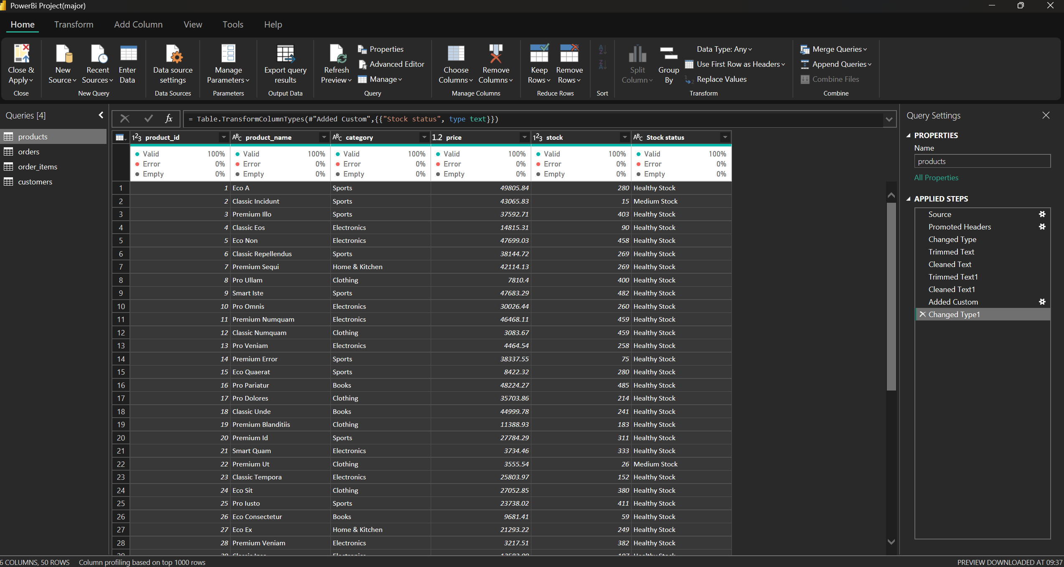
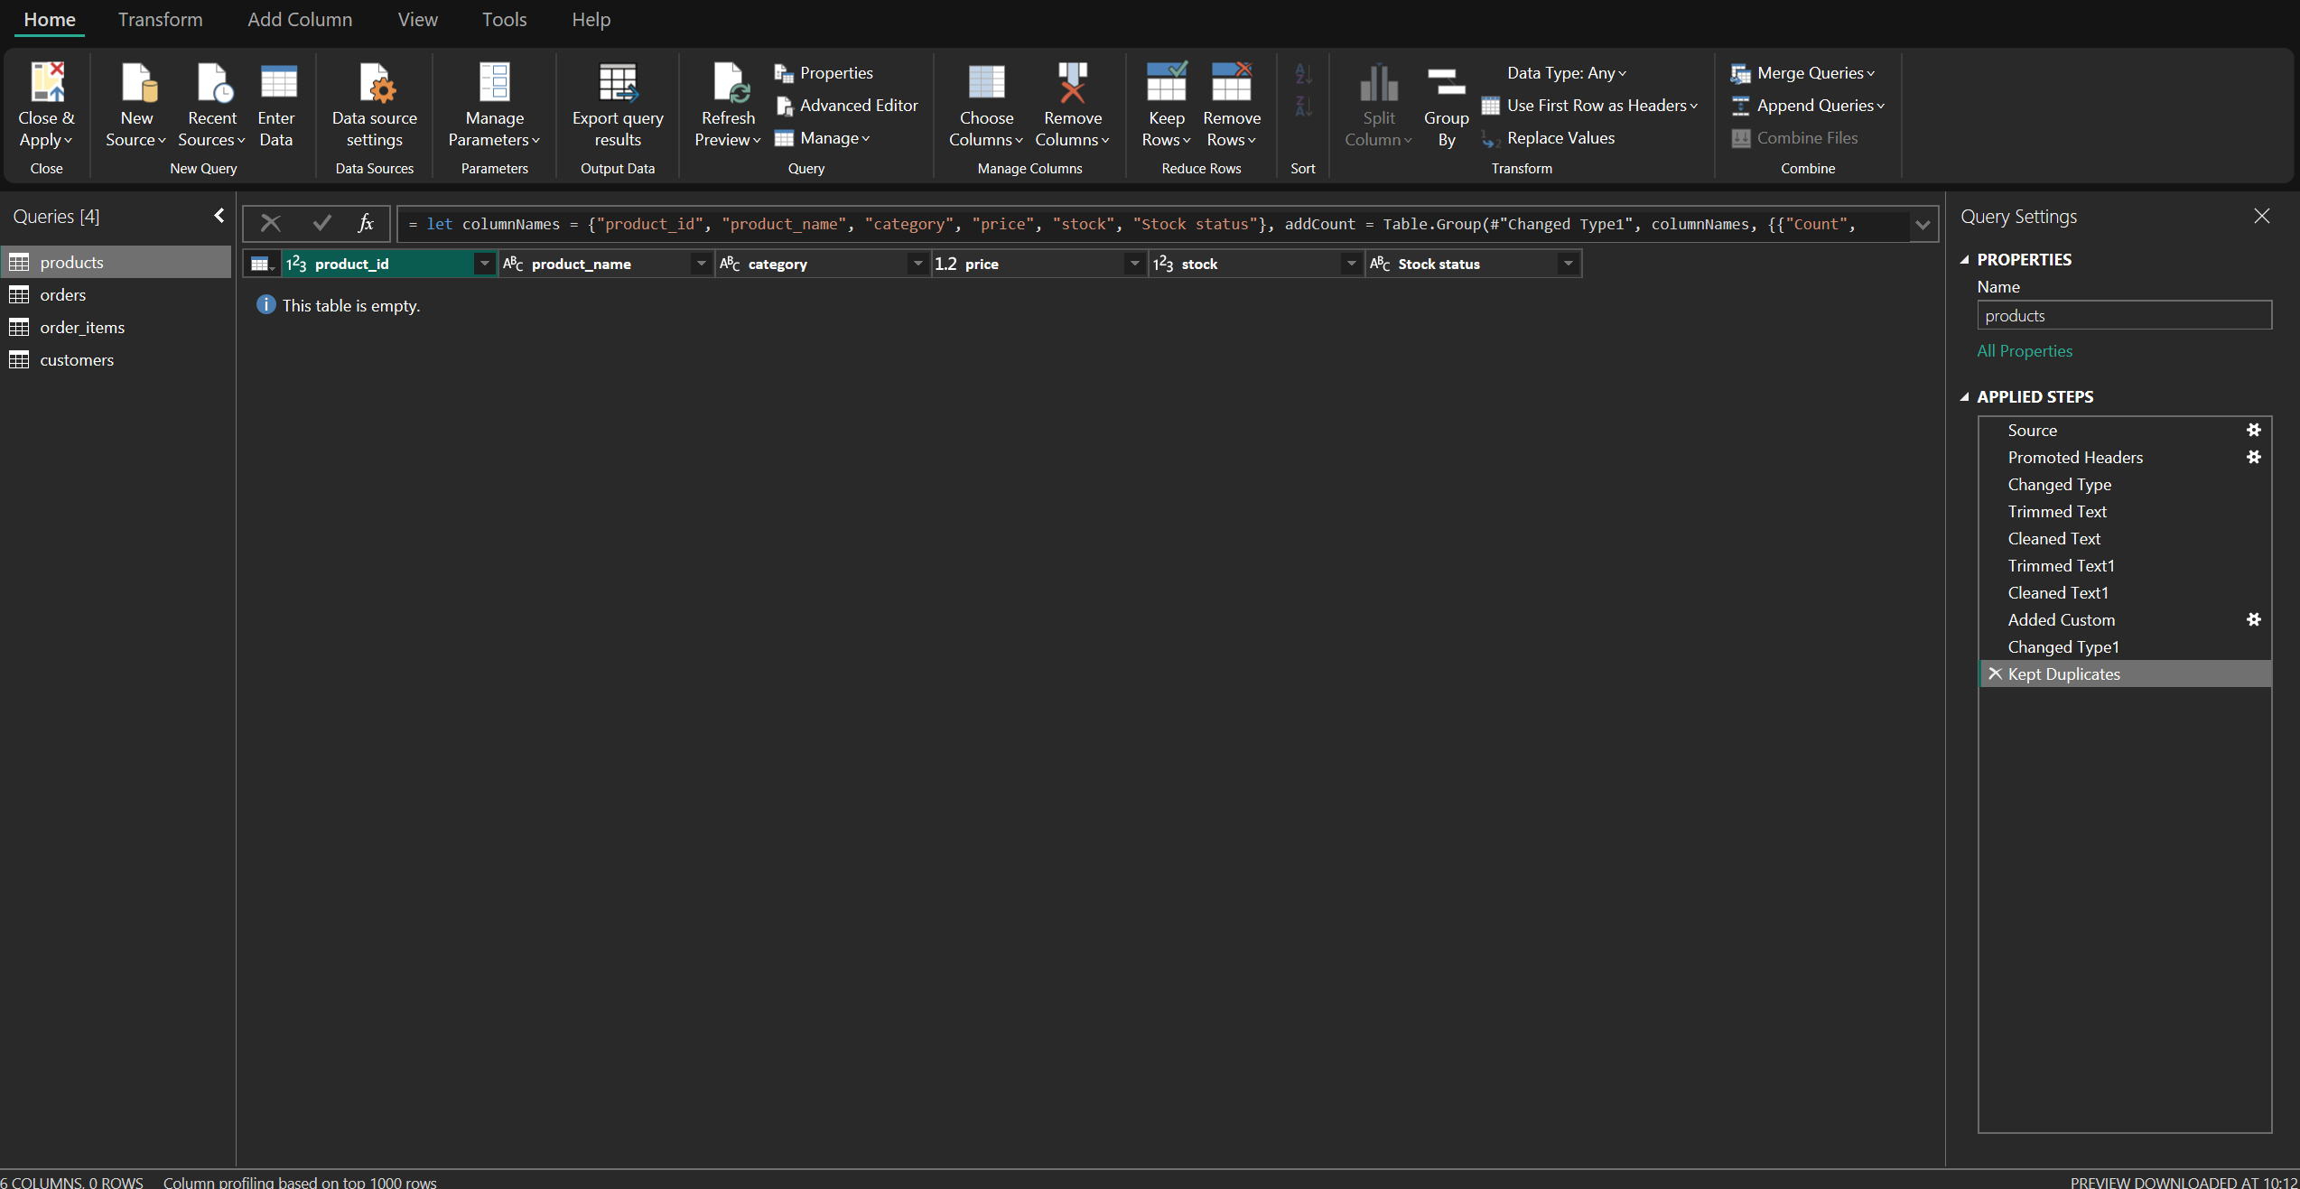
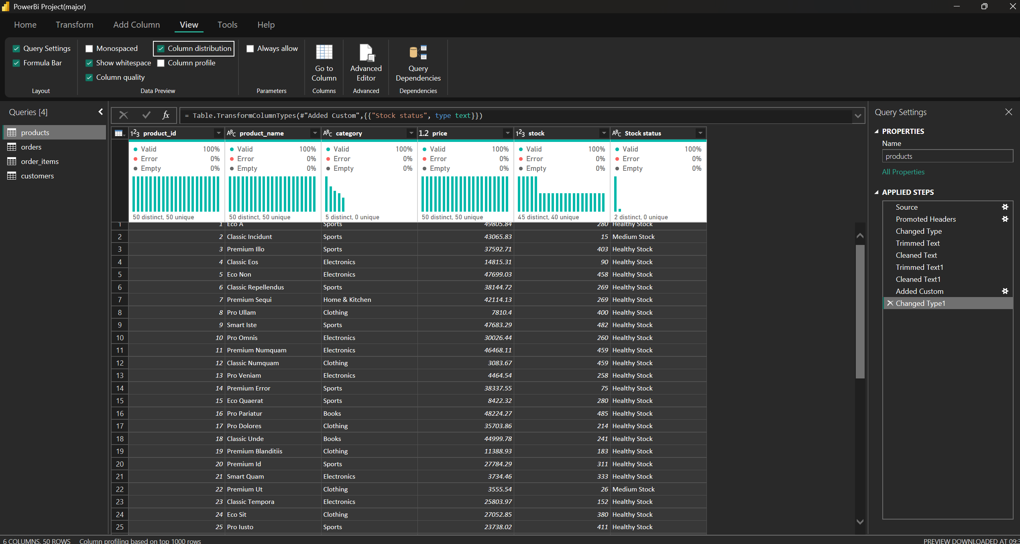

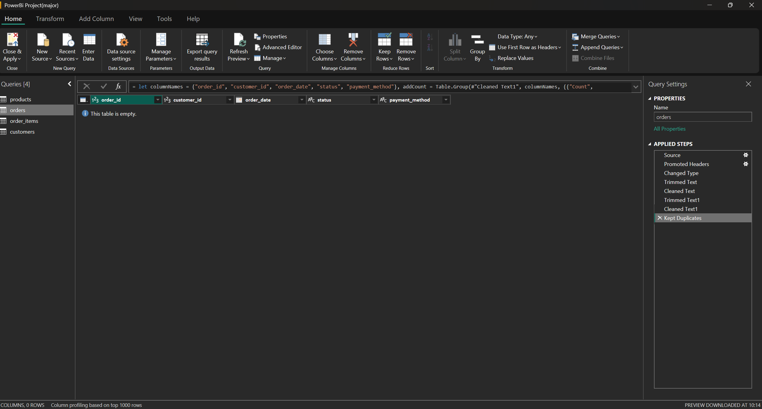
Orders Dataset Table Cleaning:

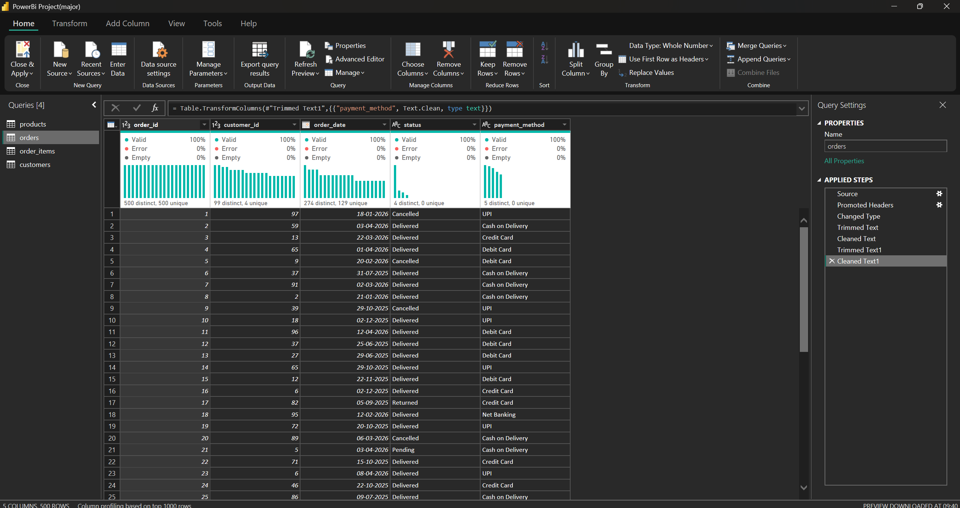

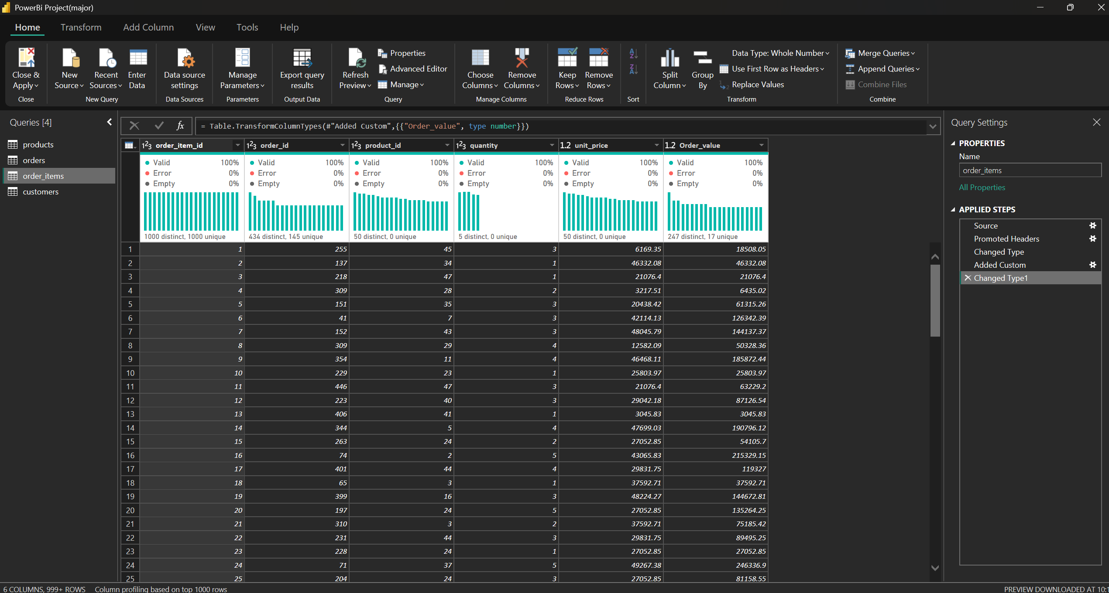
Order_item Dataset Table Cleaning:

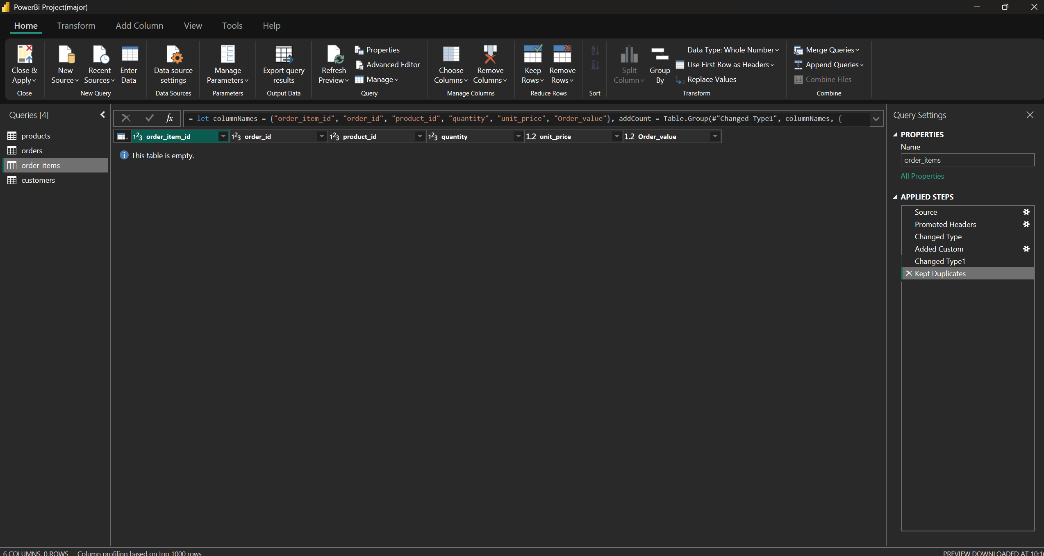

Customer Dataset Table Cleaning:
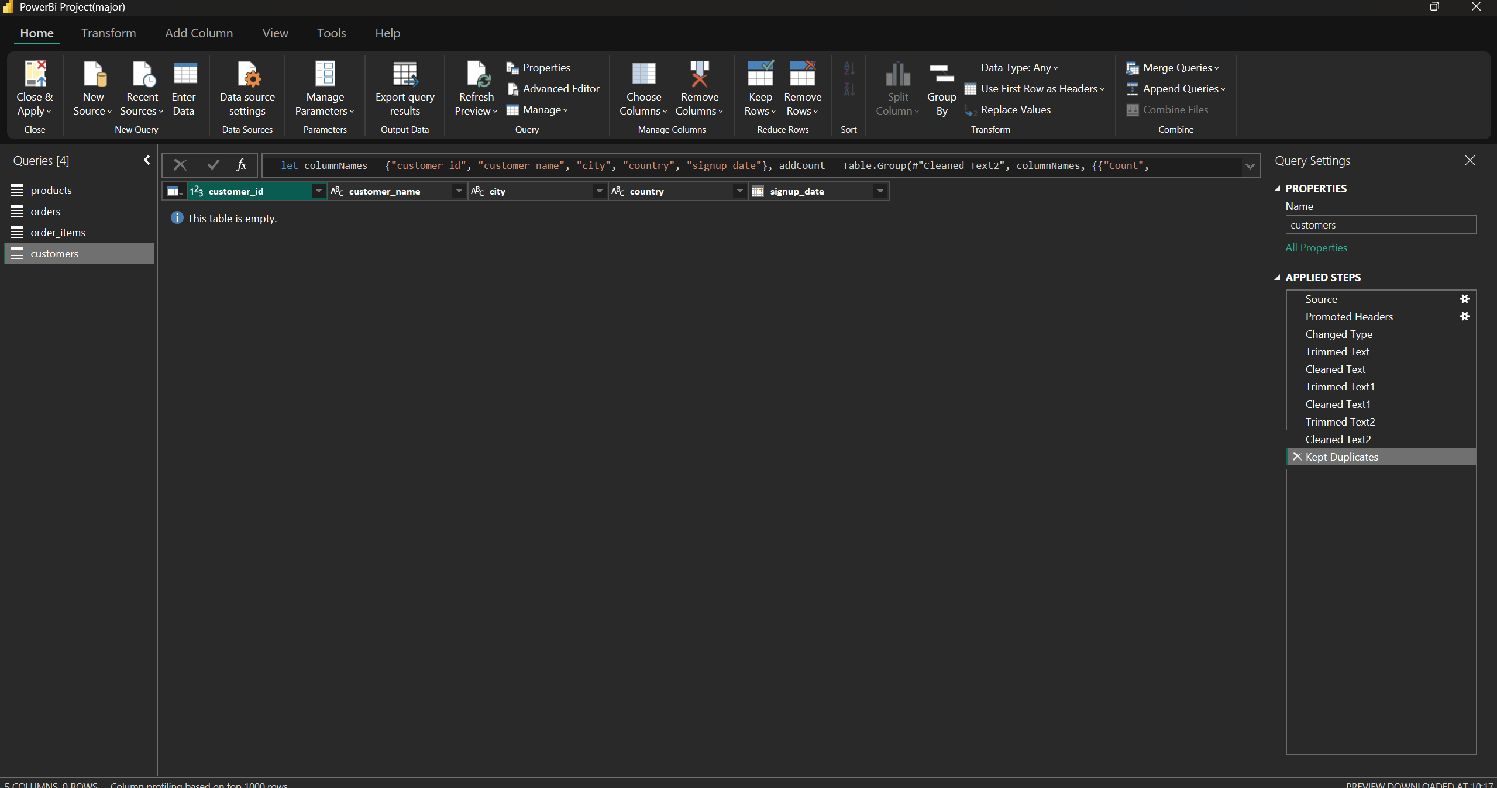
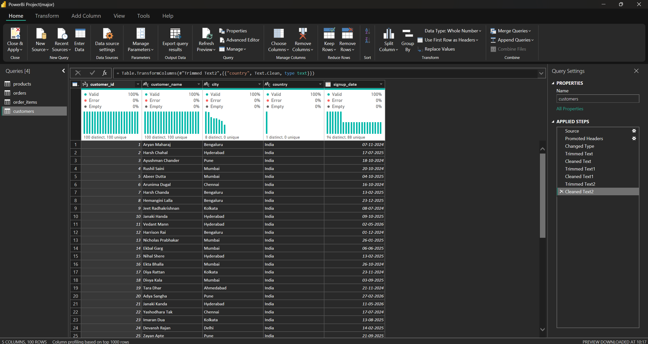

6. Data Model and Relationships
A relational model connects Customers, Products, Orders and Order Items. A separate DateTable supports date-based reporting.
- Customers[customer_id] → Orders[customer_id]
- Orders[order_id] → Order_Items[order_id]
- Products[product_id] → Order_Items[product_id]
- DateTable[Date] → Orders[order_date]
DateTable includes Year, Quarter, Month and MonthNumber fields. Month is sorted by MonthNumber to keep months in calendar order.

Data Model Evidence
Paste a screenshot of Power BI Model View showing tables and relationships.
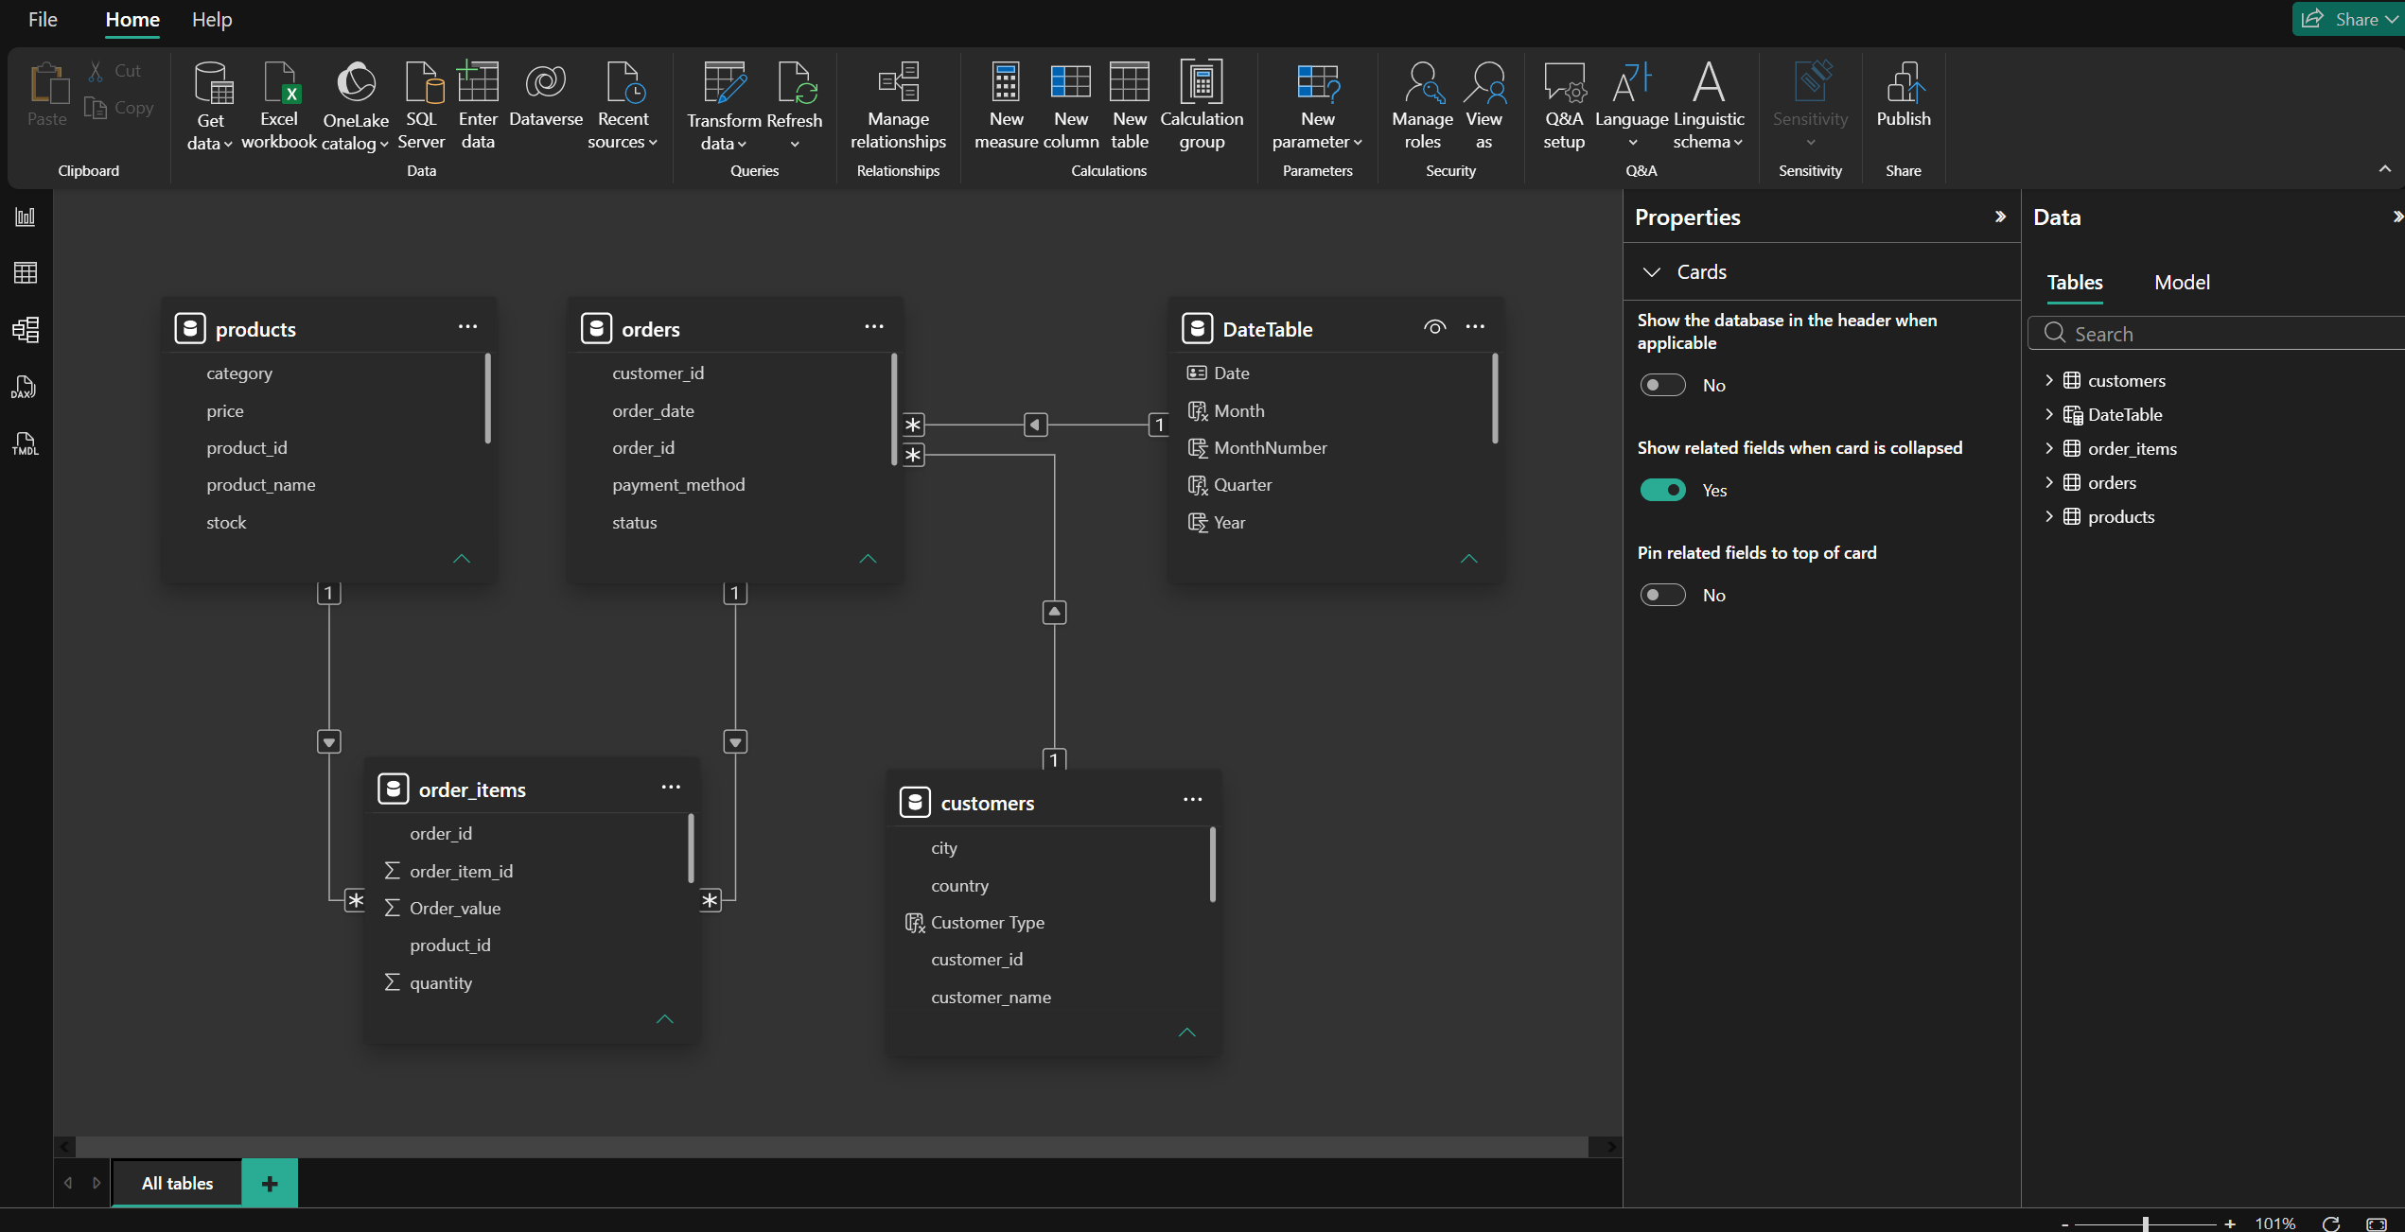

7. DAX Measures and Calculated Columns
DAX measures calculate KPIs and support interactive analysis. Main measures used in the report include:
- Total Revenue — sum of Order_value.
- Total Orders — distinct count of order_id.
- Average Order Value — Total Revenue divided by Total Orders.
- Total Quantity Sold — sum of quantity.
- Total Customers — distinct count of customer_id.
- New Customers and Repeat Customers — examine customer acquisition and repeat purchasing.
- Repeat Customer Rate — repeat customers divided by the relevant customer count.
- Revenue per Customer — revenue divided by customer count.
- Total Products, Total Categories and Average Product Price.
- Delivered Orders, Cancelled Orders, Cancellation Rate and Delivery Rate.
Derived fields include Order_value in Order Items and Stock Status in Products. Profit is not calculated because product cost data is not available in the supplied dataset.

8. Dashboard Design and Analysis
Each report page addresses a business objective. Insert the matching Power BI screenshot in each section and write the main finding in the space below it.

8.1 Sales Performance Dashboard
Purpose: Monitor revenue, order volume, average order value, quantity sold, revenue trends, category and product performance, order status and payment-method performance.
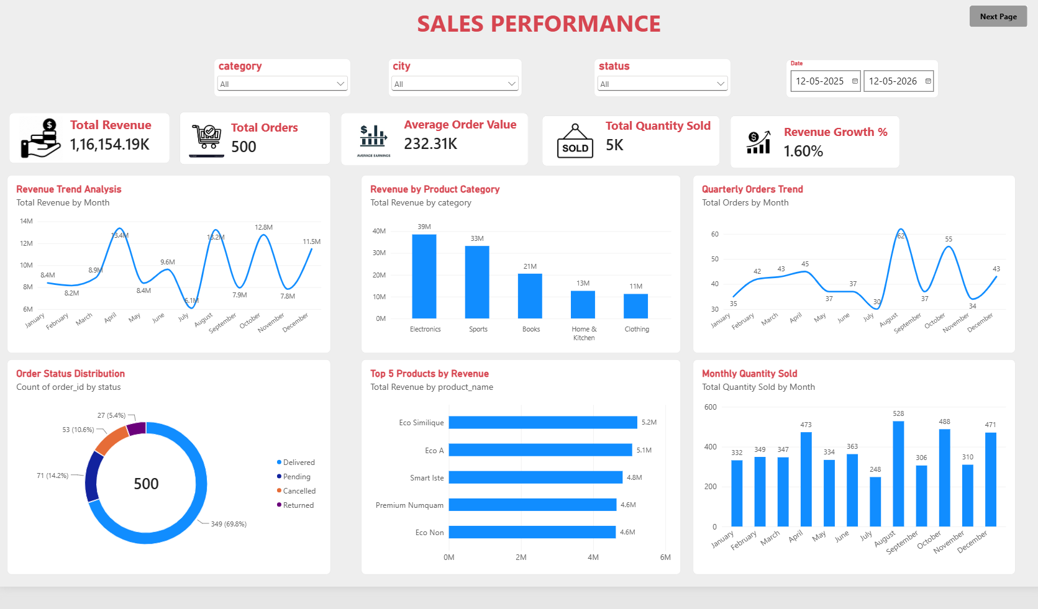
Key observation from this dashboard:
- Total Revenue: The business generated a total revenue of 116.15M across 500 orders.
- Average Order Value: The average order value is 232.31K, indicating the average revenue generated per order.
- Revenue Growth: The dashboard shows a revenue growth of 1.60%.
- Top Category: Electronics generated the highest revenue at 39M, followed by Sports at 33M.
- Order Status: Out of 500 orders, 349 (69.8%) were delivered, 71 (14.2%) were pending, 53 (10.6%) were cancelled, and 27 (5.4%) were returned.
- Top Product: Eco Similique generated the highest product revenue at approximately 5.2M, followed by Eco A at 5.1M.
- Monthly Sales Trend: Revenue peaked at approximately 13M in April and August, while July recorded the lowest revenue at around 6.1M.
- Order Trend: August recorded the highest monthly order count at 62 orders.
- Quantity Sold: August had the highest quantity sold at 528 units, while July had the lowest at 248 units.

8.2 Customer Analytics Dashboard
Purpose: Examine customer count, new and repeat customers, customer revenue, segmentation, customer distribution by city, top customers and signup trends.
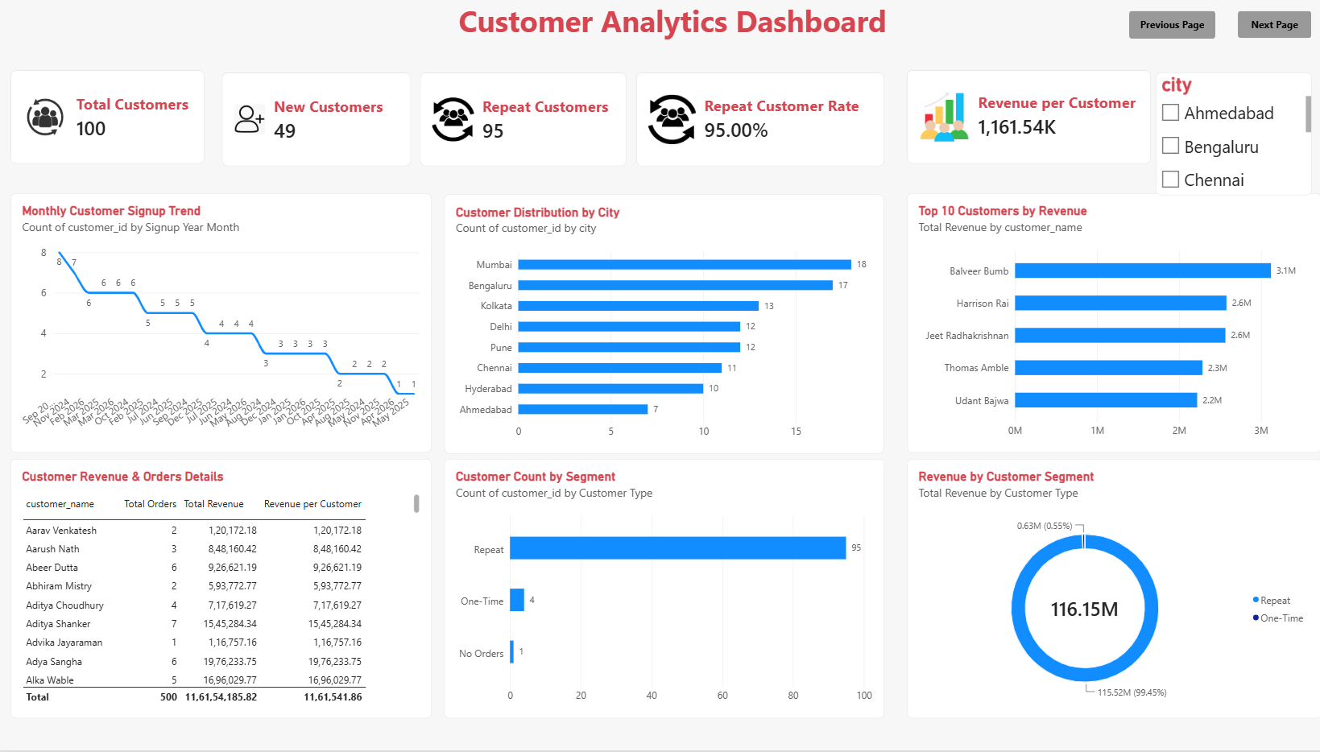
Key observation from this dashboard:
- Total Customers: The business has 100 customers, providing an overview of its customer base.
- New Customers: A total of 49 new customers were recorded, highlighting customer acquisition.
- Repeat Customers: 95 customers are classified as repeat customers, indicating strong repeat-purchase activity.
- Repeat Customer Rate: The dashboard shows a repeat customer rate of 95%, suggesting high customer retention.
- Customer Distribution: Mumbai has the highest number of customers at 18, followed by Bengaluru with 17 and Kolkata with 13.
- Top Customer: Balveer Bumb generated the highest revenue among the displayed top customers, contributing approximately 3.1M.
- Customer Segmentation: The dashboard classifies 95 customers as Repeat, 4 as One-Time, and 1 as No Orders.
- Revenue by Segment: Repeat customers generated approximately 115.52M, accounting for 99.45% of total revenue.
- Signup Trend: Monthly customer signups vary over time, with the highest displayed value being 8 and the lowest being 1.
- Customer Revenue Details: The customer-level table provides information about total orders, total revenue, and revenue per customer, helping identify valuable customers.

8.3 Product & Category Analytics Dashboard
Purpose: Compare revenue by category, quantity sold, top and bottom products, stock levels, average selling price and category contribution. Highlight products that may need attention.
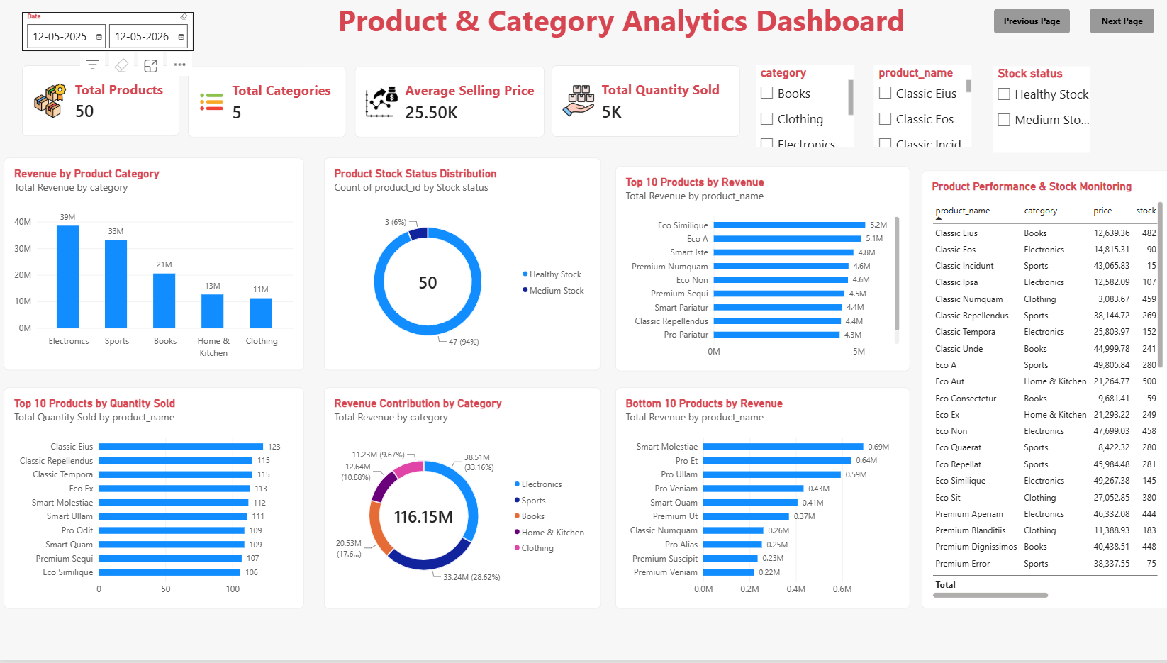
Key observation from this dashboard:
- Product Availability: The dataset contains 50 products across 5 categories.
- Top Revenue Category: Electronics generated the highest revenue of approximately 39M, followed by Sports at 33M.
- Lowest Revenue Category: Clothing generated the lowest category revenue at approximately 11M.
- Average Selling Price: The average product selling price is approximately 25.50K.
- Stock Status: Out of 50 products, 47 (94%) have Healthy Stock, while 3 (6%) have Medium Stock.
- Top-Selling Product by Revenue: Eco Similique generated the highest revenue of approximately 5.2M, followed by Eco A at 5.1M.
- Top Product by Quantity: Classic Eius recorded the highest quantity sold, with 123 units.
- Lowest Revenue Products: Premium Veniam generated approximately 0.22M, the lowest revenue among the displayed bottom 10 products.
- Category Contribution: Electronics contributed approximately 33.16% of total revenue, while Sports contributed 28.62%.
- Business Recommendation: Focus on high-revenue categories such as Electronics and Sports, and review low-revenue products to identify opportunities for improvement.

8.4 Orders & Payment Analytics Dashboard
Purpose: Analyze total, delivered and cancelled orders; cancellation rate; payment-method distribution; revenue by payment method; order trends and cancellation patterns.
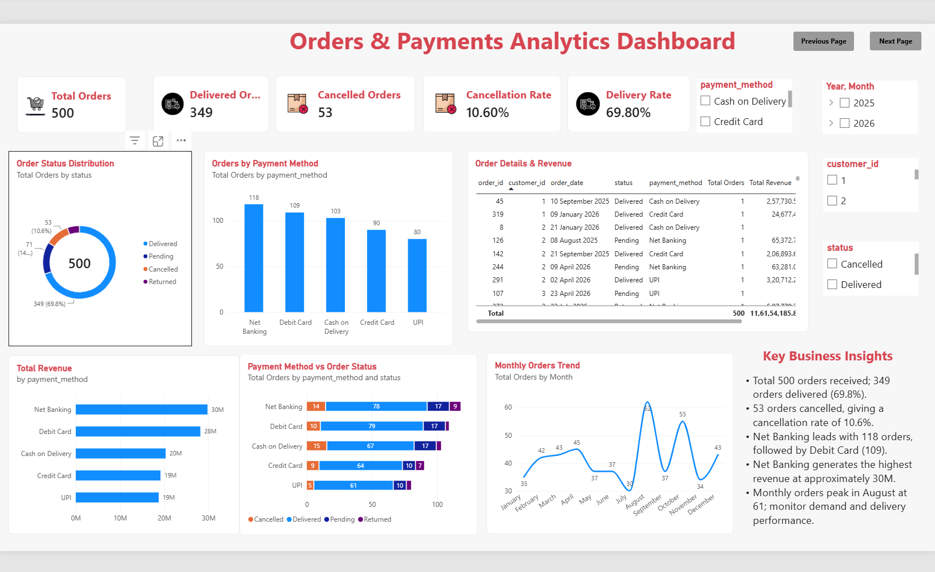
Key observation from this dashboard:
- Order Performance: Out of 500 total orders, 349 orders were delivered, achieving a delivery rate of 69.8%.
- Order Cancellations: 53 orders were cancelled, resulting in a cancellation rate of 10.6%.
- Payment Methods: Net Banking recorded the highest number of orders (118), followed by Debit Card (109).
- Revenue by Payment Method: Net Banking generated the highest revenue at approximately 30M, followed by Debit Card at 28M.
- Monthly Order Trend: August recorded the highest number of orders (61), followed by October with 55 orders.
- Order Status: A total of 71 orders were pending, indicating a need to monitor order processing and fulfilment.
- Business Recommendation: Improve delivery efficiency, reduce cancellations, and monitor pending orders to enhance overall customer satisfaction.

8.5 Customer Value & Retention Dashboard
Purpose: Identify repeat and high-value customers, purchasing frequency, revenue per customer and revenue contribution by customer segment.
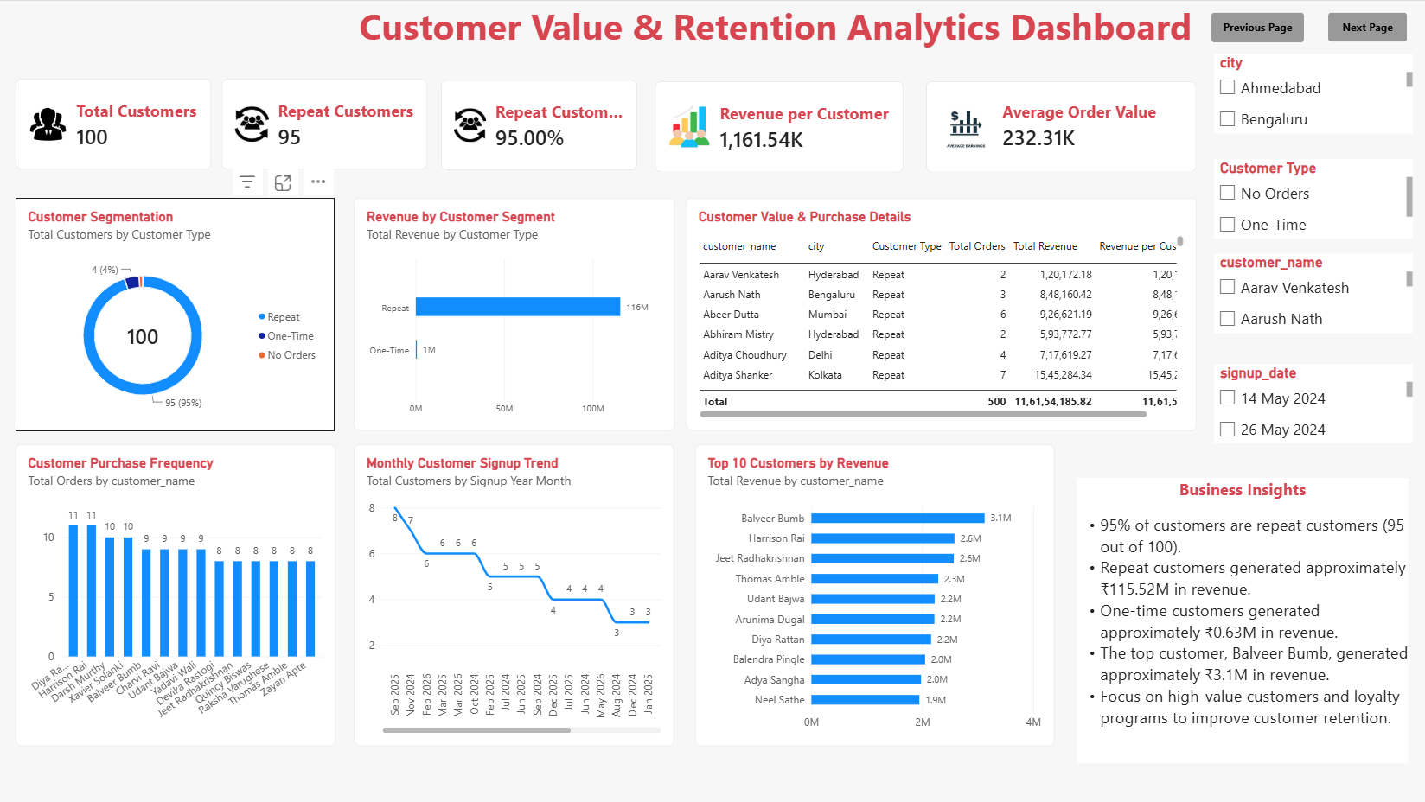Key observation from this dashboard:
- Customer Retention: 95 out of 100 customers are repeat customers, resulting in a repeat customer rate of 95%.
- Revenue Contribution: Repeat customers generated approximately ₹115.52M in revenue, while one-time customers contributed around ₹0.63M.
- Top Customer: Balveer Bumb is the highest-revenue customer, contributing approximately ₹3.1M.
- Purchase Frequency: The highest purchase frequency shown is 11 orders per customer, indicating frequent purchasing activity among some customers.
- Customer Acquisition: Monthly customer signups vary over time, with the chart showing a peak of 8 signups in September 2025.
- Average Order Value: The average order value is approximately ₹232.31K, indicating substantial average spending per order.
- Business Recommendation: Maintain loyalty programs for repeat customers and develop targeted campaigns to convert one-time customers into repeat buyers.

8.6 Executive Summary Dashboard
Purpose: Present the most important KPIs and a management-level overview of sales, customers, order outcomes and business opportunities.
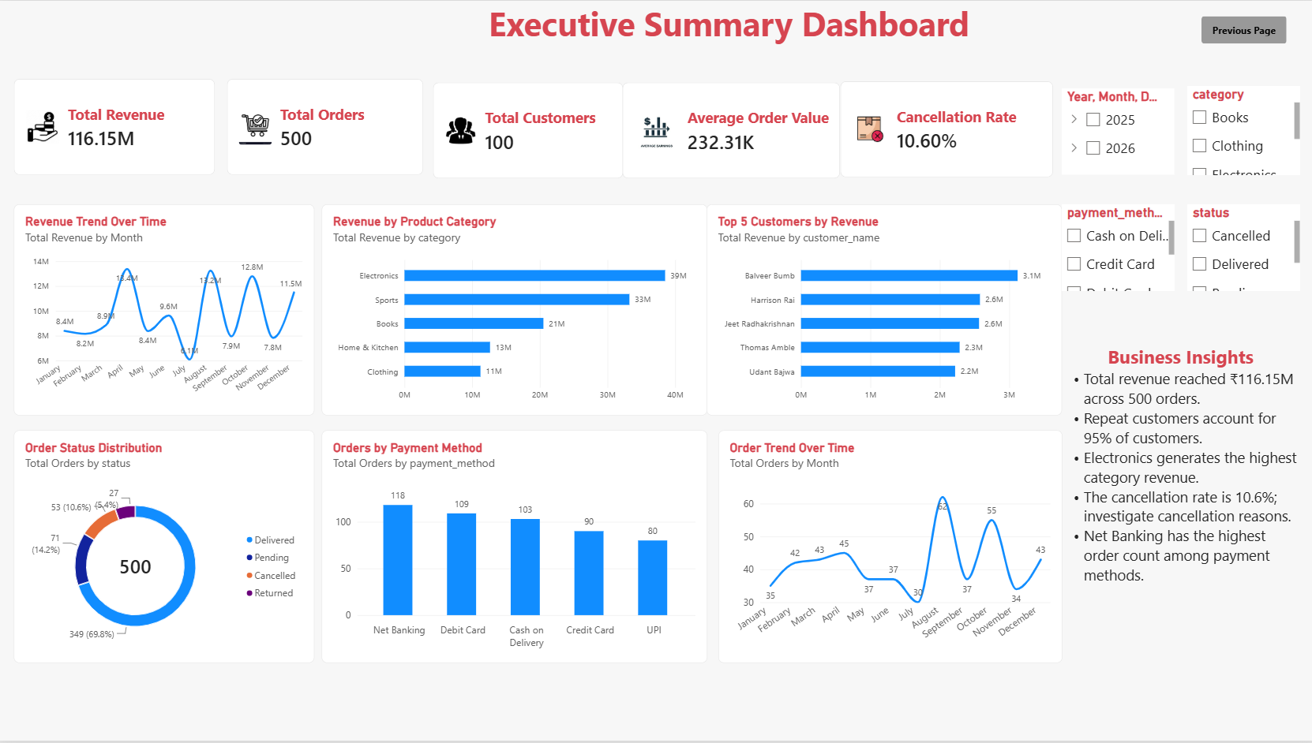
Key observation from this dashboard:
- Overall Revenue: The business generated ₹116.15M in revenue from 500 orders.
- Customer Retention: Repeat customers account for 95% of the total customer base, indicating strong customer loyalty.
- Top Category: Electronics generated the highest category revenue at approximately ₹39M, followed by Sports at ₹33M.
- Order Status: Out of 500 orders, 349 were delivered (69.8%), while 53 were cancelled (10.6%).
- Payment Methods: Net Banking recorded the highest number of orders (118), followed by Debit Card (109).
- Revenue Trend: Monthly revenue peaked at approximately ₹13.4M in April, while August recorded the highest order volume with 61 orders.
- Top Customer: Balveer Bumb contributed approximately ₹3.1M in revenue, making them the highest-revenue customer.
- Business Recommendation: Focus on reducing cancellations, improving delivery performance, and maintaining customer loyalty to support sustainable growth.

9. Business Recommendations
Finalize recommendations using the findings recorded above:
- Focus marketing efforts on categories and products that demonstrate strong performance.
- Create retention campaigns for repeat and high-value customers based on the identified segments.
- Investigate order statuses, payment methods or customer groups associated with elevated cancellations.
- Review low-stock products and align replenishment with observed demand.
- Use city-level customer and revenue patterns to prioritize suitable growth opportunities.
- Monitor KPIs periodically to assess whether actions improve sales, retention and order outcomes.
These are recommendation options; keep or revise them only where the dashboard findings support them.

10. Conclusion
This project demonstrates an end-to-end business intelligence workflow: business understanding, data profiling, data cleaning, data modelling, KPI definition, DAX calculations, interactive visualization and business interpretation. The six-page Power BI report provides a structured view of sales, customers, products, orders, payments and retention. Its value comes from using validated findings to support better business decisions.

