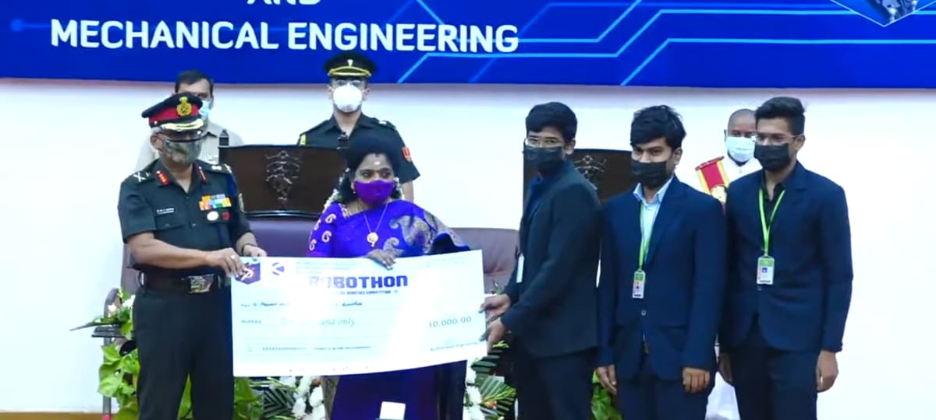

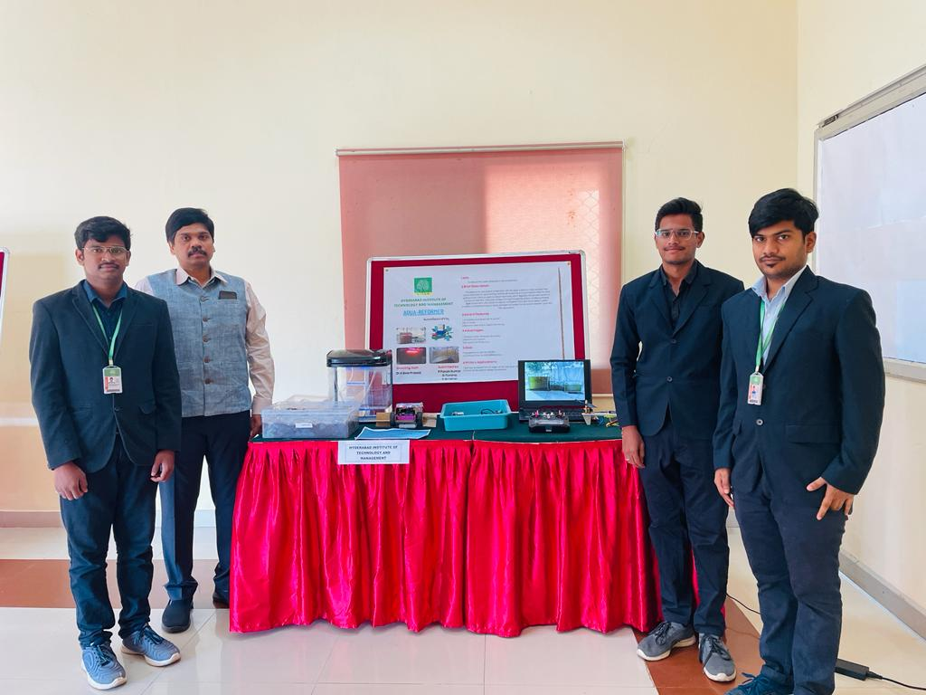

Won cash award and title of Best Expo Project at Military College Of Electronics and Mechanical Engineering (MCEME)'s Robothon Contest 2021, Felicitated by the Governor of Telangana, Dr. Tamilisai Soundararajan.  
  
FIRST PROTOTYPE: PHOTOBIOREACTOR- It is used for the cultivation of algae as it has high demand in the present market.  
  
SECOND PROTOTYPE: AQUA-FARMING SETUP consists of a fish tank included with a photobioreactor in which it is used for aquafarming