MD ZAHIN AFSAR

Daka,Bangladesh

**Mobile:+8801787849609** **E-mail:** afsarzahin@gmail.com

Profile Picture

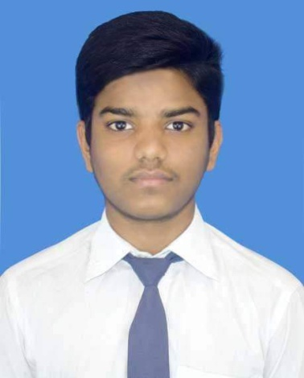

Achievements

* empty

Education

**[2018 – 2020]** [science] [Donia University College ]

**Grade achieved:**

**[2016 – 2018]** [science] [Barnomala Ideal High School]

**Grade achieved: [GPA-5]**

**[2015 – 2016]**  [New Vision School And College]

**Grade achieved: [GPA-5]**

**Skills**

**Technical:** Computer,Electronics.

**Interpersonal: ........**

**Other: playing**

**Hobbies and Interests**

Using Computer,playing,reading.......

Referees

**[MD. Nuruzzaman]**

[C.E.O / Deffodil Company]

**Address:** Dhanmondi.Bangladesh

**Tel:**\*\*\*\*\*\*\*\*\*\*

**Email:** ***********