HolidayHub 2D Game - Technical Design Document (TDD)

Contents
1. Architecture Overview 3
1.1 System Architecture Diagram 3
1.2 Technology Stack 3
2. Module Architecture 4
3. Game Loop & Data Flow 5

1. Architecture Overview

1.1 System Architecture Diagram
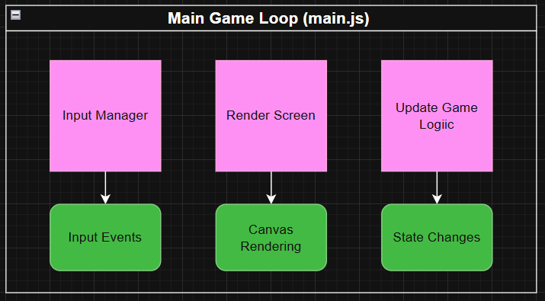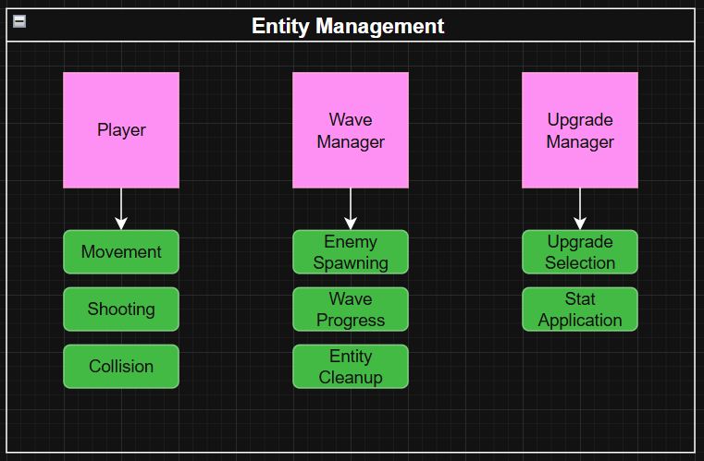

1.2 Technology Stack
Layer | Technology | Purpose
Frontend | HTML5 Canvas | Rendering graphics
Language | JavaScript (ES6 Modules) | Game logic implementation
Runtime | Web Browser | Execution environment
Data Format | JSON | Configuration storage
Asset Format | PNG (images), JSON (data) | Game resources

2. Module Architecture
Core Modules
main.js
- Responsibilities: Game loop, state management, event dispatch, transitions, bullet arrays, score tracking.
- Key Exports: addEnemyBullet(), addPlayerBullet(), getScreenActive(), isGamePaused()
Player.js
- Properties: Position, Dimensions, Health, Movement, Combat, Defensive, Animation, Scale
- Methods: move(), shoot(), takeDamage(), upgrade(), update(), render()
- Upgrades: Speed, Max Health, Dodge, Crit Chance, Fire Rate, Damage
UFO.js
- Enemy AI, Level scaling, Combat, Movement, Rendering
- Methods: constructor(), startShootLoop(), move(), shoot(), takeDamage(), update(), cleanup(), render()
Bullet.js
- Properties: Position, Velocity, Direction, Sprite, Speed, Owner
- Methods: update(), render(), isOffscreen()
- Collision Behavior: Player → Enemy, Enemy → Player, Offscreen removal
WaveManager.js
- Manages wave progression, enemy spawning
- Properties: waves[], ufos[], wave, outOfWaves
- Methods: spawnNextWave(), update(), render(), reset(), clearUfos(), getUfos(), getWaveNumber(), isOutOfWaves()
UpgradeManager.js
- Handles upgrade selection
- Properties: possibleUpgrades[], currentUpgradeOptions[], active, upgradeButtons[], selectedUpgrade
- Methods: startSelection(), handleClick(), getRandomUpgrades(), render(), isActive(), cleanup()
InputManager.js
- Handles keyboard & mouse input
- Properties: keysPressed, mouseX, mouseY, isMousePressed, lastEventType
- Methods: update(), isKeyPressed(), getDirection(), handleMouseMove(), handleMouseClick(), handleKeyDown(), handleKeyUp(), addInputListener()
ScreenRenderer.js
- Renders UI and screens: Home, Game, Upgrade, Game Over, Victory
- Methods: render(), renderHomeScreen(), renderGameScreen(), renderUpgradeScreen(), renderGameOverScreen(), renderVictoryScreen(), drawIcon(), drawText(), drawUpgradeButton()
Canvas.js
- Provides canvas element & context
- Exports: getCanvas(), getContext(), initCanvas()
MapHandler.js
- Loads & renders tilemap
- Properties: mapData, tileset, tileWidth, tileHeight, layers[]
- Methods: constructor(), render(), getTile(), update()
Utils.js
- Helper functions: checkCollision(), LoadImage(), LoadJson(), random(), clamp()
Entity.js
- Base class for Player, UFO, Bullet
- Properties: x, y, width, height, sprite, scale, health
- Methods: constructor(), update(), render(), takeDamage(), isAlive(), getCollisionBox()

3. Game Loop & Data Flow
- Input → Update → Render cycle
- Handles player movement, shooting, UFO AI, wave spawning, collision, upgrades, game state transitions
- 60 FPS target
Collision Detection: AABB (Axis-Aligned Bounding Box)
- PlayerBullets vs UFOs
- EnemyBullets vs Player
State Machine: Home → Playing → Upgrade → GameOver / Victory → Restart

4. Data Structures
- Player: Position, dimensions, health, movement, combat, defense, animation
- UFO: Level, health, combat, movement, rendering
- Bullet: Position, physics, owner, dimensions
- Wave: JSON structure with enemy types, levels, counts
- Upgrade: Icon, name, value, background color

5. Collision Detection & Resolution
- Player bullet hits UFO → apply damage, criticals, remove bullet
- Enemy bullet hits Player → apply damage, dodge chance, remove bullet

6. Performance Considerations
- Object pooling, dirty flag, requestAnimationFrame, optimized canvas clearing, sprite sheets
- Frame budget: 16.67ms per frame
- Memory optimization: reuse bullets, avoid new objects in hot loops

7. Asset Management
- Image: Player, UFO, Snowball, Laser, Tileset, Icons
- Data: waves.json, map.json
- Async loading, cached by browser

8. Browser APIs
- Canvas API: getContext(), drawImage(), fillRect(), fillText(), fillStyle, font
- Input: addEventListener for keyboard and mouse
- Timing: requestAnimationFrame, setInterval, performance.now()

9. Module Dependencies
- main.js depends on Player, InputManager, MapHandler, Utils, Canvas, ScreenRenderer, WaveManager, UpgradeManager
- Proper import order ensures initialization

10. Error Handling
- Asset loading errors: try/catch with fallback
- Game state validation: check object and wave validity
- Boundary checking: constrain player & bullet positions

11. Extensibility
- Add new enemy types by extending Entity
- Add new upgrades in Player.upgrade()
- Add difficulty modes by scaling wave parameters

12. Testing Strategy
- Unit Tests: collision detection, player upgrades, UFO health scaling
- Integration Tests: wave progression, upgrade application
- Manual Testing: movement, bounds, bullets, collisions, enemies, upgrades, scoring, game over, victory

13. Build & Deployment
- File structure: index.html, css/, scripts/, data/, assets/
- Deployment: static hosting (GitHub Pages, Netlify), local file:// for testing

14. Debugging & Development Tips
- Debug output: collision boxes, wave, enemies, HP
- Common issues: image loading, slow performance, collision inconsistencies, score/upgrades not updating

15. API Reference
- main.js: addEnemyBullet(), addPlayerBullet(), getScreenActive(), isGamePaused(), spritesheets, waves, possibleUpgrades
- Canvas.js: getCanvas(), getContext()
- Utils.js: checkCollision(), LoadImage(), LoadJson(), random(), clamp()

Document Version: 1.0
Last Updated: December 2025
Status: Complete - Ready for Development

