Technical Design Document

Table of Contents

Architecture overview 3
Engine 3
System Diagrams 3
System Diagrams 4
Player System 4
Ai System 4
Inventory System 4
Class and object description 5
Network info 6
Data structure 7
Performance 8
Platform-specific requirements 9

Architecture overview

Engine
Main loop
Fixed timestep for update (60 Hz) + variable timestep for render, update(dt) handles game logic and render(interp) handles drawing.

Window and input
LWJGL for window creation and keyboard/mouse/joystick input via GLFW.

Renderer
OpenGL pipeline with shader management, sprite batching (for 2D) or mesh/material pipeline (for 3D). Support basic PBR-lite (optional).

Resource Manager
Loads texture, meshes, shader, audio and caching. Uses reference counting and background loading for large assets.

Entity Manager
plain Java objects (PositionComponent, RenderComponent, PhysicsComponent, AIComponent, InventoryComponent).

Physics and Collision
Use a fast system to find objects near each other (broadphase), then use simple shapes to check collisions (narrowphase), and update movement with a lightweight physics formula.

Ui System
inventory, crafting. Keep UI separate from game world updates.

Audio Manager
Basic 2D 3D audio

Save/Load
Serialize persistent entity state and player inventory to JSON.

File layout
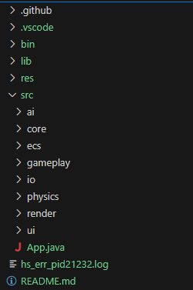

System Diagrams

High-level system diagram
Game loop
Updates
- Input manager
- Entity System (physics, ai, gameplay system)
- Renderer
- Audio

Resource manager
Provides assets to render and system.

Ui system
Overlays on top of renderer.

Save/Load
Reads/writes persistent components.

Player system
Handles input, movement, camera control, player stats (health, hunger, thirst, stamina), interactions (pickup, use, attack).

Key systems
PlayerControllerSystem (read input -> sets movement/commands)
PlayerStatsSystem (track hunger, thirst, health and applies passive decay)
InteractionSystem (raycast, proximity checks and pickup, open, examine)

Ai system
Handles npc behavior, wildlife, hostile mobs, path finding or behavior trees.

Key systems
PerceptionSystem (senses environment: sight radius, hearing events)
DecisionSystem (behavior tree or state machine per entity)
PathfindingSystem (movement tasks)

Inventory System
Handles Item storage, stacking rules, equipment and crafting input.

Key Systems
InventoryComponent (per entity, list of itemstack)
Inventory System (UI and logic for move, split, merge)
CraftingSystem (matches recipes against ingredients)

Class and object description
Core classes
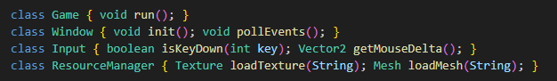
ECS/Component classes
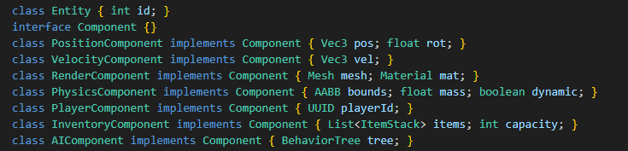
Systems
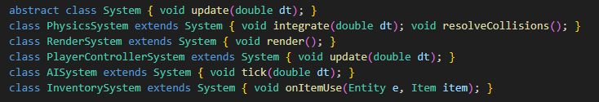
Gameplay objects

Data Structure
In memory structures
- Map<Class<? Extends Component>, Component> for quick component lookup.
- Mapping clls for collision and visibility queries.
- ResourceManager caches: Map<String, Texture>, Map<String, Mesh>.
- Item database: Map<String, ItemDefinition> loaded from JSON.

On disk formats
- Configs and Definitions in json (items, recipes, spawns)
- Save format Json (save contains player state, persistent world entity states, world time)

Example json for item
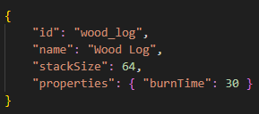

Performance
Target fps: 60 on mid range hardware

Rendering
- Batch draw calss where possible.
- Minemize state changes: group by shader/material.

CPU
- Fixed timestep updates to ensure consistent physics and gameplay.

Physics and collision
- Simplify collision shapes for npcs instead of mesh-mesh collisions.

Memory
- Use primitive arrays wherever possible, avoids creating lots of boxed objects every frame.

Platform-specific requirements
Target platform is Desktop (windows, macos, linux).

LWJGL
- Ensure native libraries for each target.

Input and fullscreen
- Use GLFW via LWJGL for consistent windowing and fullscreen modes.

