Ануфриев Андрей 465029 28.03.2025
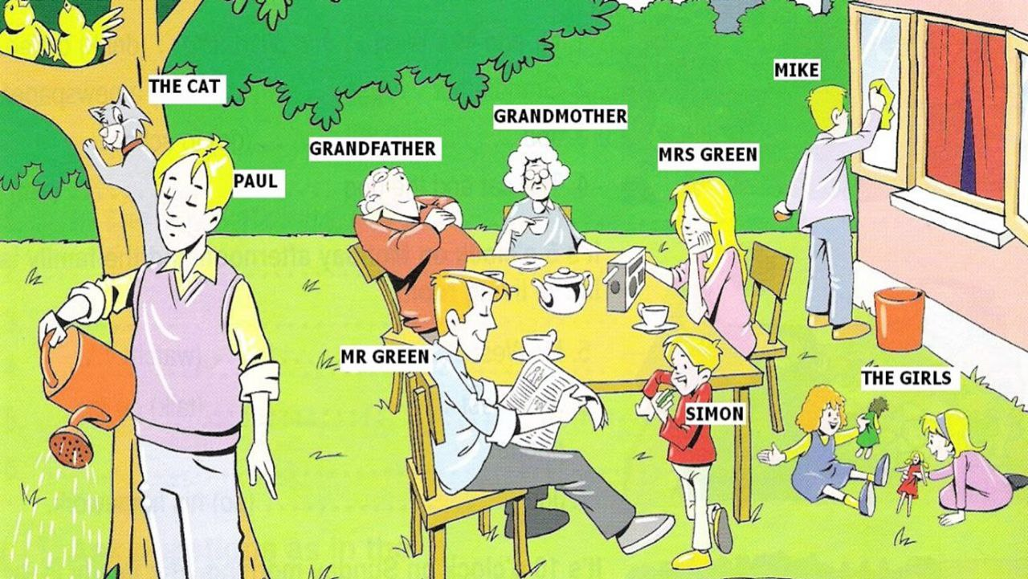
- Grandmother
  - Clothes: She is wearing a blue dress and black shoes.
  - What is she doing? She is sitting in a chair and smiling.
- Grandfather
  - Clothes: He is wearing a red shirt, brown trousers, and glasses.
  - What is he doing? He is sleeping.
- Mrs. Green
  - Clothes: She is wearing a pink blouse.
  - What is she doing? She's tuning up the radio.
- Mr. Green
  - Clothes: He is wearing a grey-blue shirt and grey pants.
  - What is he doing? He's reading the newspaper.
- Paul
  - Clothes: He is wearing a pink vest, yellow shirt and grey trousers.
  - What is he doing? He's watering the flowers.
- The Girls
- Clothes: One girl is wearing a blue dress, the other is wearing a pink dress.
- What are they doing? They're playing with dolls.
- Mike
- Clothes: He's wearing a white T-shirt, gray pants, and orange shoes.
- What is he doing? He's cleaning the window.
- Simon
- Clothes: He's wearing a red sweatshirt, white pants, and yellow pants.
- What is he doing? He's eating candy.
- The Cat (Mixie)
  - Clothes: No clothes! (Cats don’t wear clothes!)
  - What is it doing? It is hunting birds.

