Trevor Garrett P. Santos
BSIT-3C
Narrative Report
Global Immersion Program: A Collaborative Overseas Digital Engagement (CODE) - Student Exchange and Technical Bootcamp Program
AIT-CODE is a five-day international immersion program for students from Nueva Vizcaya State University, to become delegates of their educational institution from various programs and departments and to both further their character and broaden their vision of their learnings by collaborating with the Asian Institute of Technology (AIT), as it provides research conferences, specialized classes and sessions, and learning activities from various professors and scholars.
I participated in this exchange and technical bootcamp program, so that I could expand my knowledge on specific topics related to my course, experience an international academic venture, broaden my cultural literacy and to understand the influence of collaboration between not just different programs and colleges in a department, but also of different institutes and universities to develop bigger projects.

Day 1
The first day of the program, on September 6, 2026, began with Arthur Lance Gonzales, Program Officer from the Special Degree Program (SDP), introducing the students as they entered the AIT campus, in which they were registered to their respective rooms and given ample time to prepare for the morning tour of the library and the Language Center which will serve as the participating students’ main classroom.
After the tour, the students were then formally welcomed by Dr. Ranadheer Mandadi, Program Director for the Global Immersion and Study Abroad Program and Prof. Nitin Kumar Tripathi, Executive Director of SDP. During the opening ceremony, the students were oriented on what AIT was about and what it means to be there as a student; about the basic manners of being an international student, guidelines on facilities, and how to not get lost in the campus grounds.
After the orientation, the students were then introduced to their first professor, Dr. Prapas Thammaboribal, to teach about the basics of Thai language, and how to interact with Thai people. The activity went on as an interactive learning session as Thai culture was expanded upon, good tourist conduct was briefed and various experiences were shared, making sure the students learned as much of the practices as possible.
Following a lunch break, Dr. Mary Rose Sarausad, Acting Director of the AIT Language Center, continued the classes by discussing her topic: "From Data to Discourse: Research Writing and Ethical Standards." The lesson entailed a basic recourse of conducting research and then expanding on the contemporary concept of Artificial Intelligence and the ethical concerns of its usage in research. I was particularly interested in this activity because it allowed the students to collaborate with each other even though they were from different programs and departments, they shared their current capstone projects and project proposals, their ideas and their queries and forwarded them together until there was no time left.
On 4:00 PM, the class ended and the students were given the opportunity to meet the NVSU scholars pursuing their PhD studies at AIT, exchanging insights on research, graduate studies, and academic life abroad. Afterwards, given the time to explore the campus to their own leisure, one of the NVSU scholars, Sir Michael Lacar suggested that they could experience one of the “night markets” located nearby the campus instead. At the night market, various street foods and drinks like French fries, fruit arrangements, and iced fruit punches were present and one standout were the ice cream rolls that had so many options for flavor.
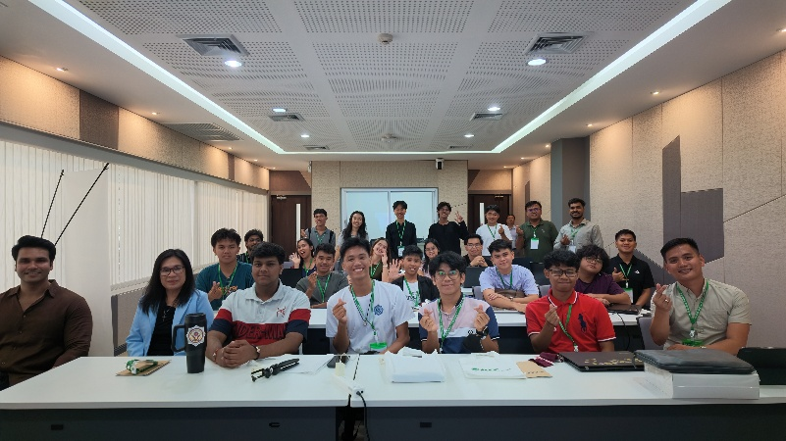
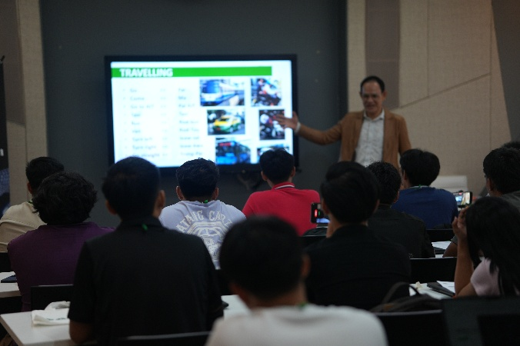
Photo Documentary:

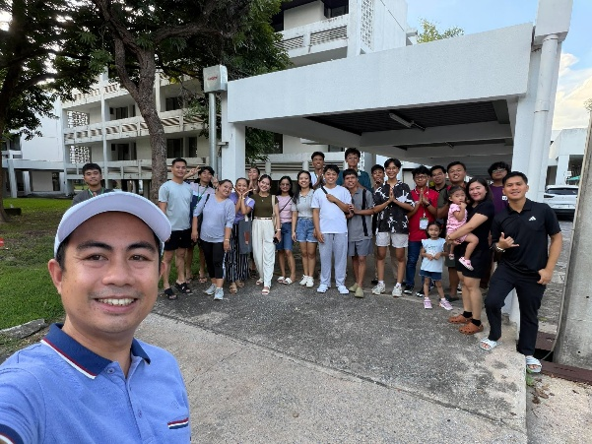
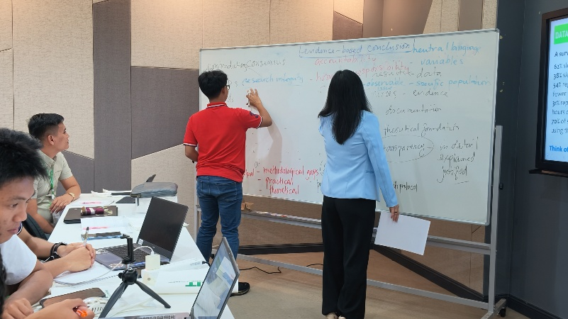

Day 2
The second day learning sessions started with a tour of the AI and Simulation Laboratory, where Prof. Anil Kumar Anal, Professor and Dean of the Faculty of Food, Agriculture,and Natural Resources at AIT, gave the students the opportunity to ask around the various displays around the lab and to clarify some of the student’s project concerns. After the tour, the professor also introduced some of the AI-related projects the institute has worked on, and also of the various systems they are currently developing.
Moving forward from the Laboratory, the next lesson was held in the classroom as Dr. Branesh Madhavan Pillai, Assistant Professor of Industrial Systems Engineering and Programme Chair of Biomedical Engineering at the Asian Institute of Technology (AIT), gave the topic “AI-Powered Diagnostics and IoT-Based Health Monitoring” as the continuation of AIT’s collaborative efforts to produce research in health and connecting them to the growing industry of AI tools and resources.
The session continued into the afternoon at the Center of Excellence in Nanotechnology, as Dr. Pillai briefly discussed more of the projects they are trying to develop in BART LAB as a collaborative company and then covering the lesson “AI-Powered Diagnostics and IoT-Based Health Rehabilitation and Hospital Services” together with his own students, and fellow researchers. It was during this time that students were included in the professor’s demonstration on why rehabilitation is just as important as surgical treatments. I was inspired by the honesty of Dr. Pillai in his endeavors and how his students handled teaching us their work, especially the demonstration of the 3D-printing process and the tools they used to determine some of the chemical composition of the substances they used.
After the lessons, the students met with more of the Filipino scholars in AIT and were treated to a drink in one of the campus’s coffee shops. The coffee shop had board games and card games for recreation, so while the students waited for their drinks, they played and conversed with the other Filipino students on AIT.
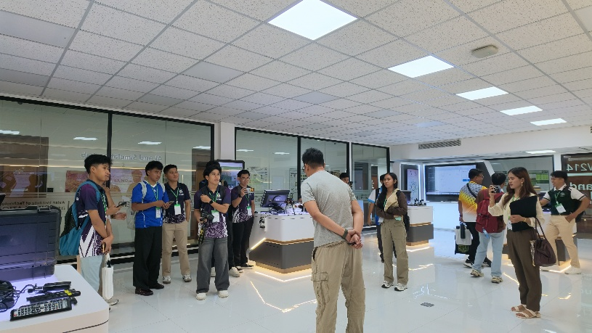
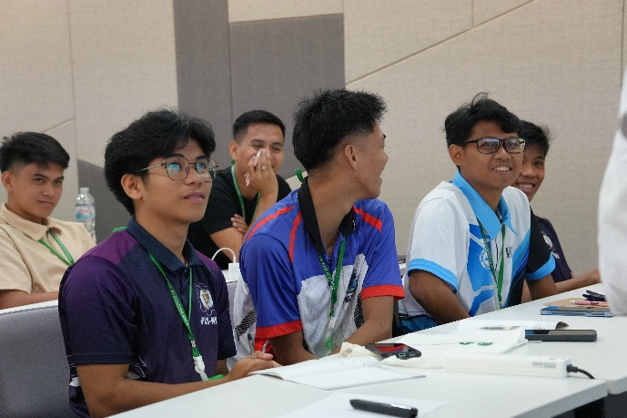
Photo Documentary:

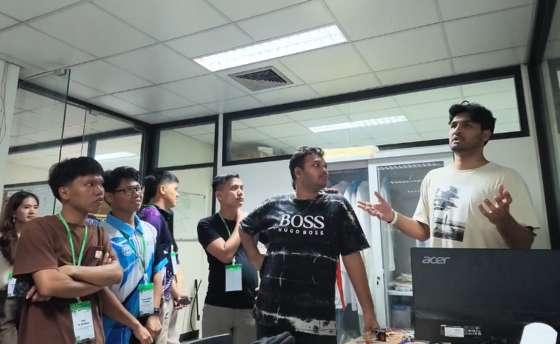
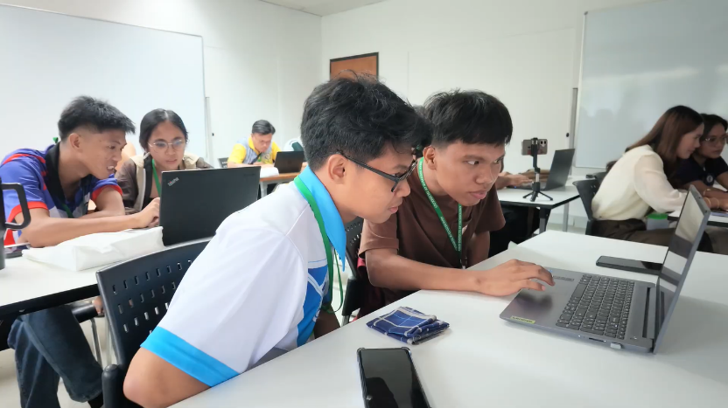

Day 3
September 9, 2026, was the third day of the program, and the learning was set outside of the campus, and the whole day is set so that the students would participate in cultural exchange activities, apply what they learned on the first day and take in the environment as a real-time hands-on exercise.
It started with the trip to Thailand’s National Science Museum which had exhibits on scientific concepts like weather and electricity, and technological breakthroughs in engineering and architecture, while also featuring creative displays on the history of robotics, Thai culture, prehistoric creatures and of the innovations of mankind towards exploring space.
The next destination stop after the museum was the Wat Ratchabophit Sathitmahasimaram Ratchaworawihan in Bangkok, one of Thailand's royal Buddhist temples, which was also classified as one of the nation’s historic first-class temples. The tour of the temple gave the students the chance view into the nation’s religion of Buddhism and the monastic life that most Thai people follow as they witnessed the temple’s grand architecture and displays on the history of Buddhist leaders and characters.
Continuing with the fieldtrip, the team went to ICONSIAM, the second largest shopping mall in Thailand, with a perfect view into the most important river in Thailand, the Chao Phraya River. Given the freedom to explore the mall as much as they could in 4 hours, the students were greeted with SOOKSIAM, the ground floor featuring a massive, air-conditioned indoor replica of a traditional floating market with cheap regional Thai snacks, plus giant art installations and outdoor riverfront dining.
When the afternoon settled on 5:00 PM, the students were rallied to board the Luxury White to Dinner Cruise along the Chao Phraya River. A buffet was prepared on the boat, and various live entertainment was displayed on the front of the stage. The standout event was the various boatside views and the impressive bridges we passed as the boat drove under each.
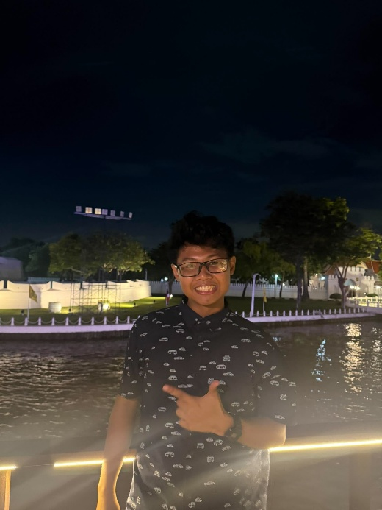
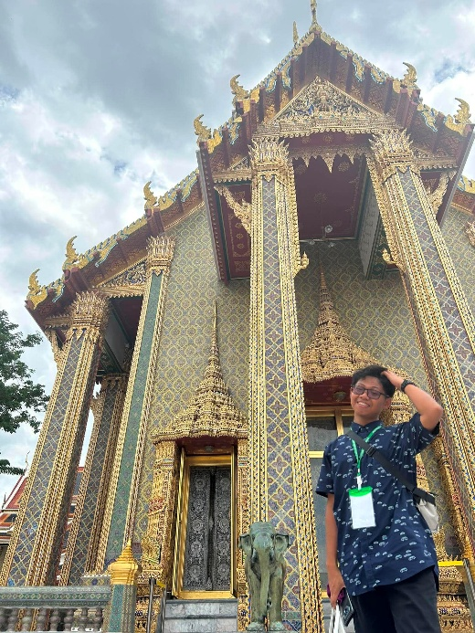
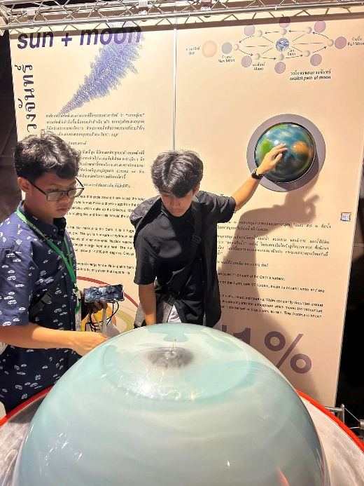
Photo Documentary:

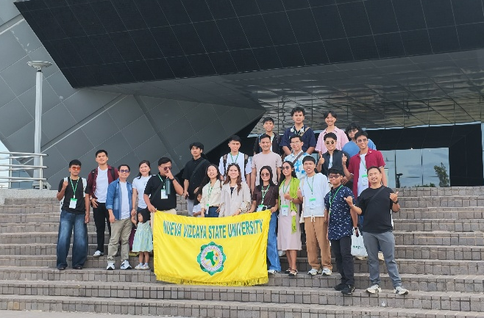
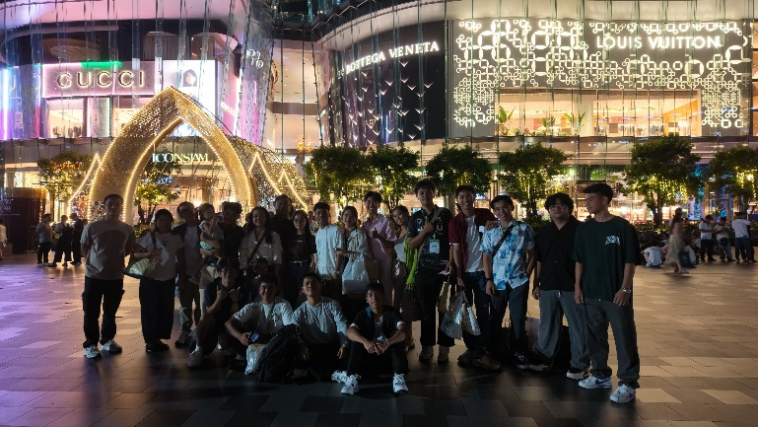

Day 4
The fourth day started with another tour of one of the core facilities of the AIT campus, which was the Hydraulics Laboratory that had situated itself as one of the first programs that the university had focused on before they expanded unto other branches of engineering. The students explored the various public research plans in the form of bulletin boards, project simulation areas, laboratory-classrooms and completed the tour with a discussion with one of the researchers working on the current simulation of a water-powered electric generator based in one of the riverbanks in Thailand.
After the quick tour, was the continuation of the technical bootcamp, with the title “Machine Learning for Health Data” that started on the second day of the program. Mr. Akraradet Sinsamersuk, a PhD student specializing in Raman Spectroscopy at the AIT Brain Lab, introduced participants to key concepts and applications of AI in Health Foundations. I was particularly surprised with how they utilized data science and that there was an entirely different history to how medical practitioners used computers to help them with managing data in their practice.
After being introduced to such topics, Mr. Sinsamersuk’s professor, Dr. Chaklam Silpasuwanchai, Founder of the AIT Brain Lab and Professor of Data Science and AI at the Faculty of Advanced Science and Technology, continued the lesson by sharing details of some of the projects the AIT Brain Lab has contributed and distributed as their research.
A short lunch break later, another student of Dr. Chaklam, Mr. Todsavad Tangtortan, assisted with the lessons as he continued with the discussion on Data Science, AI models, and Diagnostics, and turned it practical activity of sorts as he distributed one of the sample-programs they use to diagnose breast cancer. The hands-on activity was very fun because it made me understand the theory Mr. Tangtortan was trying to explain during the discussion.
The day ended with each student given the choice of exploring more of the campus, visiting the nearby shopping complex, “Future Park and ZPELL”, or going to Bangkok to shop around the Pratunam Market, in which I chose the last of the options.
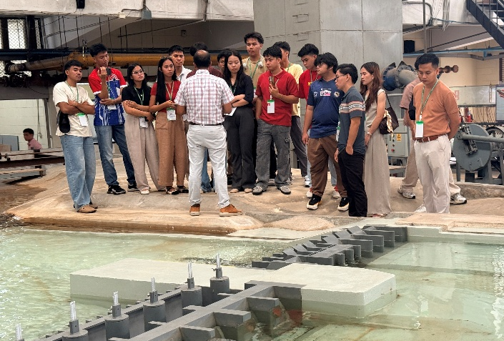
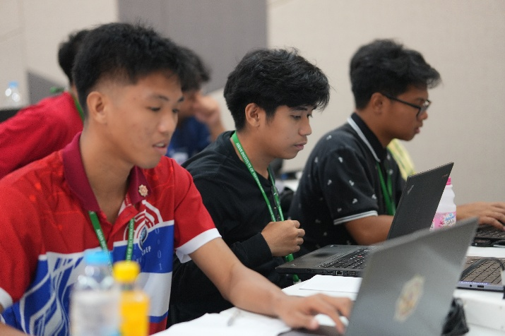
Photo Documentary:

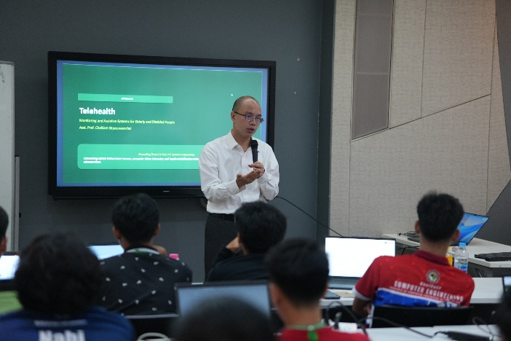
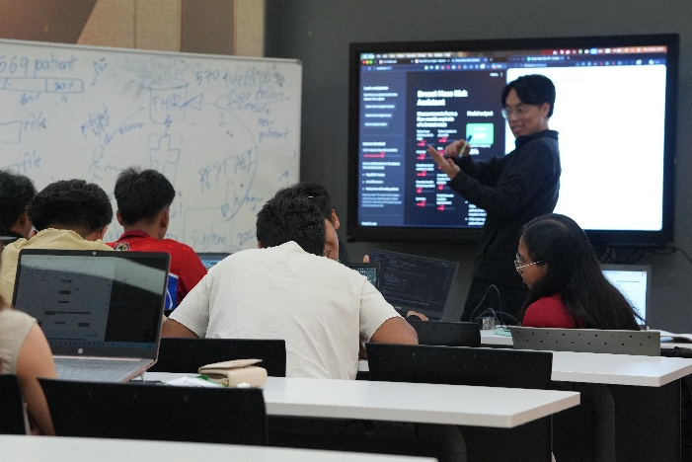

Day 5
The fifth and last day of the program on September 10, 2026, was the closing ceremony for the students to finalize their thoughts and experiences. We were given the chance to say thank you to the Executive Director of the Special Degree Programs (SDP), Prof. Nitin Kumar Tripathi, as he finished the closing message that directs the learnings of the past 5 days towards a better hope for each of the participants. We were also given the chance to speak up in a session entitled “Ways Forward and Key Takeaways” where representatives of each of the department present in our institute of NVSU gave a short but sweet personal speech about our academic journey in AIT.
The conclusion of the program gave me an opportunity to reflect on the experiences I had throughout the previous days. One of the most significant things I gained from the program was the connections I made with various students, international and local, as I have come to learn more about the essence of collaboration and social and interactive aspect of developing myself as an individual through sharing ideas, communicating topics, and debating with respect and responsibility.
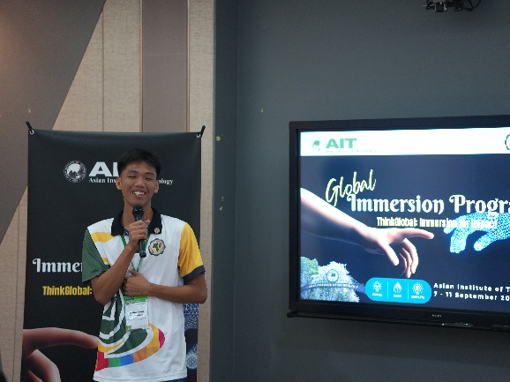
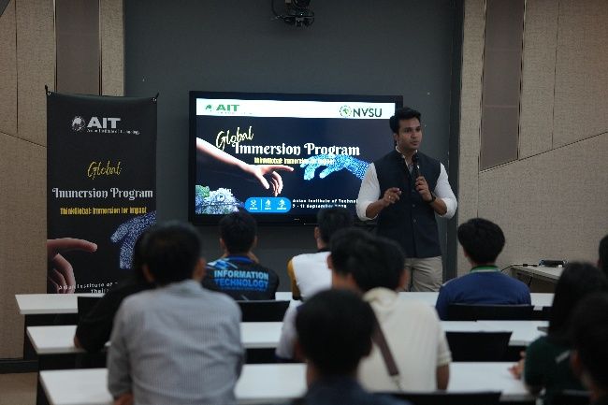
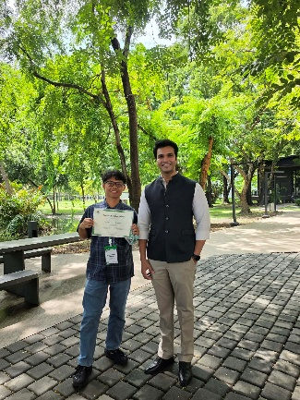
Photo Documentary:

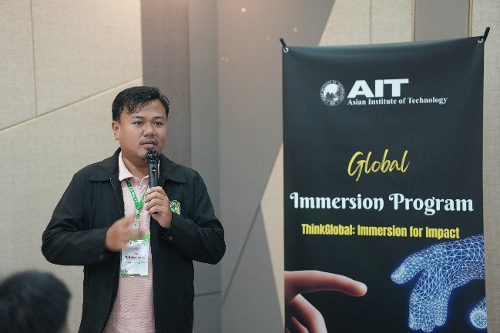
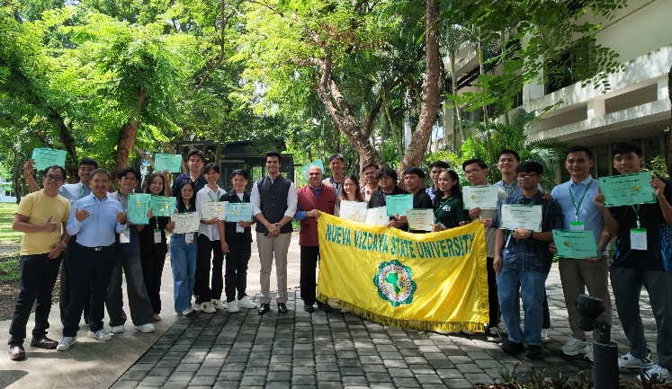

The Collaborative Overseas Digital Engagement (CODE) - Student Exchange and Technical Bootcamp Program was successfully conducted from September 6 to 11, 2026, bringing together students and representatives from NVSU, and AIT for a series of academic, cultural, and collaborative activities.
Throughout the five-day program, participating in the activities gave me an opportunity to experience learning in a setting outside the usual classroom environment, and I was able to interact with other students, participate in collaborative activities, and gain new perspectives regarding topics such as academic research, cultural literacy, and the various applications of AI in medicine and other technologies.
Overall, the program was a spectacular learning experience that complemented the knowledge and skills I have gained through my course, even though I am still a third-year student. The activities and interactions provided experiences, and through those I can hope to apply it to my perspective on life, and to both my academic studies and future activities.

