[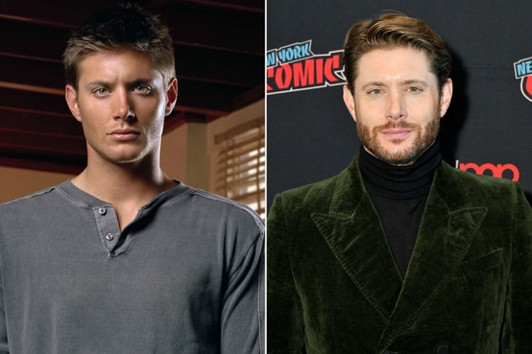](https://people.com/the-cast-of-supernatural-where-are-they-now-8673431)

For the subject for my fan page, I chose the actor Jensen Ackles. This photo is a comparison of what Jensen looked like in season 1 of *SUPERNATURAL* (2005), versus what he looks like now (2024).

One quote from this actor is “You are NOT making mistakes, You are NOT losing, You are either WINNING or LEARNING!” – Jensen Ackles. This shows that there is no problem with being wrong, it’s a learning experience. Another 2005 2024 quote is, “Be strong in the moments where you want to be weak because life itself is worth living for. If you’re not living the life that you want, fight for that life.” – Jensen Ackles. This is about not giving up when time gets tuff. If this life/lifestyle is not one that you want, fight for the one that makes you happy.